ASSIGNMENT NO.4(HTML-CSS)

1.How are inline and block elements different from each other?

Answer:
A block-level element always start on a new line and takes up full width available(stretches left and right as far as it can).
The <div></div> is a block level element.

A inline element always does not start on a new line and takes up as much as width necessary.
the <span></span> is a inline element.
HTML CODE
<!DOCTYPE html>
<html lang="en">
<head>
<meta charset="UTF-8">
<title>aa</title>
<meta name="viewport" content ="width=device width,initial-scale=1.0">
</head>
<body>
<div>
<p>This is <span>crazy(span)</span></p>
<p>This is <div>me(div)</div></p>
</div>
</body>
</html>
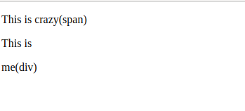

------------------------------------------------------------------------------------------------------------------------
2.Explain the difference between visibility:hidden and display:none

Answer:
display:none removes the element from the normal flow of the page, allowing other elements to fill in.

visibility:hidden leaves the element in the normal flow of the page such that is still occupies space.
HTML CODE
<!doctype html>
<html>
<head>
<title>
Display:none and Visibility:hidden
</title>
</head>
<body>
original: <a href="http://example.com">Link</a> <br>
1:<a href="http://example.com" style="display: none;">unseen</a> link.<br />
2:<a href="http://example.com" style="visibility: hidden;">unseen</a> link.<br />
</body>
</html>
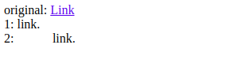

------------------------------------------------------------------------------------------------------------------------
3. Explain the clear and float properties.

Answer:
The float property is used for positioning and formatting content e.g. let an image float left to the text in a container.

The clear CSS property sets whether an element must be moved below (cleared) floating elements that precede it. The clear property applies to floating and non-floating elements.
HTML CODE
<!DOCTYPE html>
<html>
<head>
<style>
.a{
border: 1px solid black;
background-color: red;
display: inline-block;
height: 150px;
width: 150px;
}
.b{
border: 1px solid black;
background-color: yellow;
display: inline-block;
height: 150px;
width: 150px;
}
.c{
border: 1px solid black;
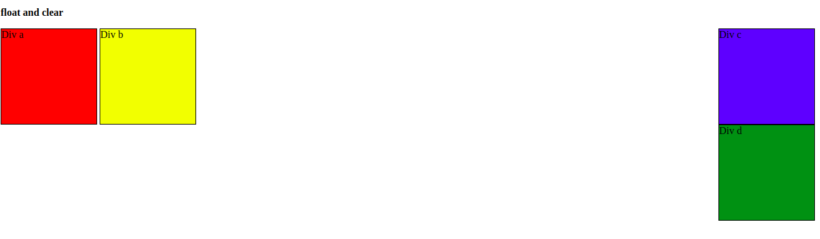
background-color: blue;
display: inline-block;
height: 150px;
width: 150px;
float:right;
}
.d{
border: 1px solid black;
background-color: green;
display: inline-block;
height: 150px;
width: 150px;
float:right;
clear: right;
}
</style>
</head>
<body>
<p><b> float and clear</b></p>
<div class="a">Div a</div>
<div class="b">Div b</div>
<div class="c">Div c</div>
<div class="d">Div d</div>
</body>
</html>

4. explain difference between absolute, relative,fixed and static.
Answer:
Relative:
An element with position: relative; is positioned relative to its normal position.
Setting the top, right, bottom, and left properties of the relative-positioned element will cause it to be adjusted away from its normal position.
Absolute:
An element with position: absolute; is positioned relative to the nearest positioned ancestor(instead of position relative to the viewport, like fixed)
However, if an absolute positioned element has no positioned ancestor, it uses the document body and moves along with page scrolling.
FIXED:
An element with position: fixed; is position relative to the viewport, which means it stays at the same place even if the page is scrolled.
Static:
An element with position: static; is not positioned in a special away but it is positioned according to the flow of the page:
They are not affected by properties like top, bottom, left, and right.
HTML elements are positioned static by default.
HTML CODE
<!DOCTYPE html>
<html>
<head>
<style>
div.static {
position: static;
border: 3px solid #73AD21;
}
div.relative {
position: relative;
left: 30px;
border: 3px solid #73AD21;
}
div.fixed {
position: fixed;
bottom: 0;
right: 0;
width: 300px;
border: 3px solid #73AD21;
}
div.absolute {
position: absolute;
top: 80px;
right: 0;
width: 200px;
height: 100px;
border: 3px solid #73AD21;
}
</style>
</head>
<body>
<h2>position: static;</h2>
<div class="static">
This div element has position: static;
</div>
<h2>position: relative;</h2>
<div class="relative">
This div element has position: relative;
</div>
<h2>position: fixed;</h2>
<div class="fixed">
This div element has position: fixed;
</div>
<h2>position: absolute;</h2>
<div class="relative">This div element has position: relative;
<div class="absolute">This div element has position: absolute;
</div>
</div>
</body>
</html>
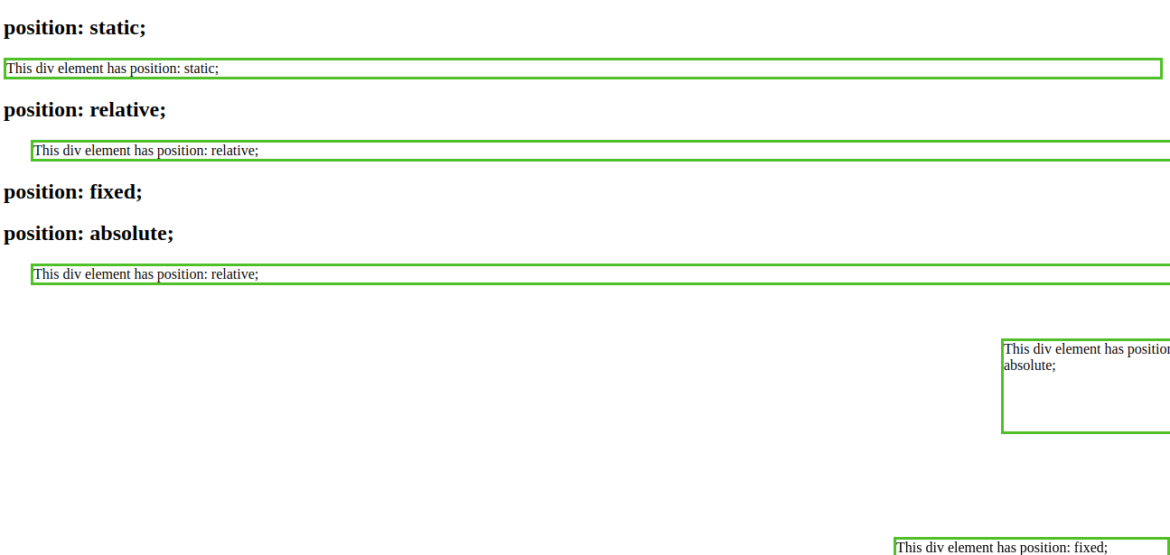
------------------------------------------------------------------------------------------------------------------------
5. Write the HTML code to create a table in which there are 4 columns( ID , Employee Name, Designation, Department) and at least 6 rows. Also do some styling to it.

Answer:
<!DOCTYPE html>
<html lang="en">
<head>
<body>
<meta charset="UTF-8">
<title>bootcamp</title>
<link rel="stylesheet" href="5.css">
<meta name="viewport" content ="width=device width,initial-scale=1.0">
<form width ="100%" border="1px solid" class="" action="">
<h1>BASIC TABLE IN HTML</h1>
<table style="width:100%">
<thead>
<tr>
<th>ID</th>
<th>EMPLOYEE NAME</th>
<th>DESGNATION</th>
<th>DEPARTMENT</th>
</tr>
</thead>
<tbody>
<tr>
<td>4000</td>
<td>Apoorva</td>
<td>Trainee</td>
<td>JVM</td>
</tr>
<tr>
<td>4001</td>
<td>Taru</td>
<td>Trainee</td>
<td>Front end</td>
</tr>
<tr>
<td>4002</td>
<td>Shubhanshi</td>
<td>Trainee</td>
<td>JVM</td>
</tr>
<tr>
<td>4003</td>
<td>Lovely</td>
<td>HR</td>
<td>Front end</td>
</tr>
<tr>
<td>4004</td>
<td>Ankita</td>
<td>HR</td>
<td>JVM</td>
</tr>
<tr>
<td>4005</td>
<td>Kasak</td>
<td>Admin</td>
<td>IT</td>
</tr>
</tbody>
</table>
</form>
</head>
</body>
</html>

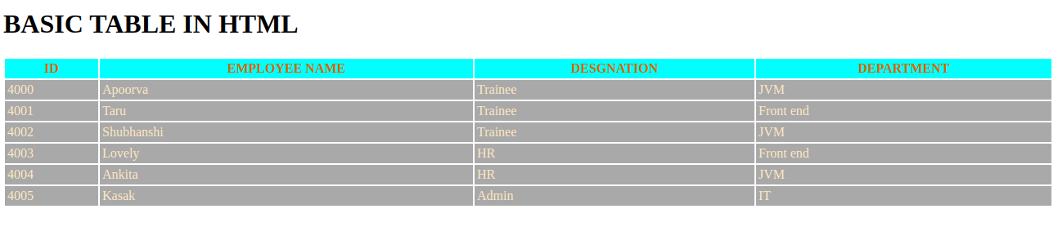
------------------------------------------------------------------------------------------------------------------------

6. Why do we use meta tags?

Answer:
Metadata is data about data.
The <meta> tag provides metadata about the HTML document. Metadata will not be displayed on the page, but will be machine parsable.
Meta elements are typically used to specify page description, keywords, author of the document, last modified, and other metadata.
The meta tag is used for the viewport i.e. user's visible area of the webpage.
Syntax:
<meta name="viewport"
content="width=device-width, user-scalable=no, initial-scale=1.0, maximum-scale=1.0, minimum-scale=1.0">
where width=device-width is the full width of the device we are working on.
HTML CODE
<!DOCTYPE html>
<html>
<head>
<meta charset="UTF-8">
<meta name="description" content="Metadata description">
<meta name="keywords" content="HTML,CSS">
<meta name="author" content="Parineeta Jain">
<meta name="viewport" content="width=device-width, initial-scale=1.0">
</head>
<body>
<p>This is a webpage describing meta tags in HTML</p>
</body>
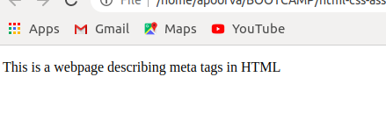
------------------------------------------------------------------------------------------------------------------------
7. Explain box model.

Answer:All HTML elements can be considered as boxes. In CSS, the term "box model" is used when talking about design and layout.
The CSS box model is essentially a box that wraps around every HTML element. It consists of: margins, borders, padding, and the actual content.
Explanation of the different parts:

Content - The content of the box, where text and images appear
Padding - Clears an area around the content. The padding is transparent
Border - A border that goes around the padding and content
Margin - Clears an area outside the border. The margin is transparent
HTML CODE
<!DOCTYPE html>
<html>
<head>
<style>
div {
background-color: lightgrey;
width: 300px;
border: 15px solid cadetblue;
padding: 50px;
margin: 20px;
}
</style>
</head>
<body>
<h2>Box Model</h2>
<p></p>
<div>BOX MODEL</div>
</body>
</html>

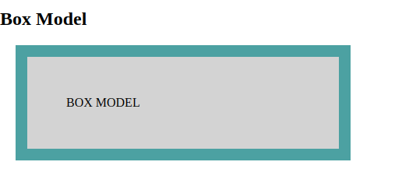

------------------------------------------------------------------------------------------------------------------------
8. What are the different types of CSS Selectors?

Answer:In CSS, selectors are patterns used to select the elements you want to style.
CSS Selectors are as follows:-
1.ID's are unique
->Each element can have only one ID
->Each page can have only one element with that ID
Syntax:
#id {property: value}
2.Classes are NOT unique
->You can use the same class on multiple elements.
->You can use multiple classes on the same element.
Syntax:
.class {property: value}
HTML CODE
<!DOCTYPE html>
<html>
<head>
<style>
* {
text-align: right;
color: yellow;
}
p {
color: blue;
}
h2, h3 {
text-align: left;
color: green;
}
#p {
text-align: center;
color: red;
}
.center {
text-align: center;
border:2px solid red;
}
</style>
</head>
<body>
<h1 class="center">This is a heading h1 uses class selector</h1>
<h2>This is a heading h2 uses group selector</h2>
<h3>This is a heading h3 uses group selector</h3>
<p>This paragraph uses id selector in</p>
<p id="p">CSS</p>
</body>
</html>
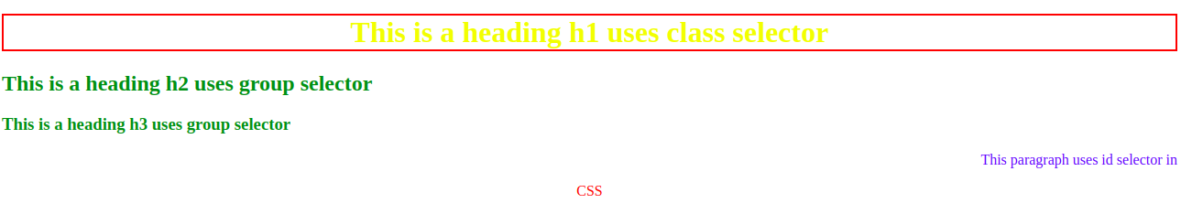
------------------------------------------------------------------------------------------------------------------------
9. Define Doctype.

Answer:Doctype is basically used to inform the browser that in which html version we are currently working.
------------------------------------------------------------------------------------------------------------------------
10. Explain 5 HTML5 semantic tags.
Answer:
1.<article> - Defines an article in the document

The <article> tag specifies independent, self-contained content.

An article should make sense on its own and it should be possible to distribute it independently from the rest of the site.

Potential sources for the <article> element:

Forum post
Blog post
News story
Comment

2.<aside> - Defines content aside from the page content like sidebar.

The <aside> tag defines some content aside from the content it is placed in.

The aside content should be related to the surrounding content.

3.<footer> - Defines a footer for the document or a section

The <footer> tag defines a footer for a document or section.

A <footer> element should contain information about its containing element.

4.<header> - Defines a header for the document or a section

The <header> element represents a container for introductory content or a set of navigational links.

A <header> element typically contains:

one or more heading elements (<h1> - <h6>)
logo or icon
authorship information

You can have several <header> elements in one document.

A <header> tag cannot be placed within a <footer> or another <header> element.

5.<nav> - Defines navigation links in the document

NOT all links of a document should be inside a <nav> element. The <nav> element is intended only for major block of navigation links.
HTML CODE
<!DOCTYPE html>
<html>
<hea>
<style type="text/css">

</style>
</head>
<body>
<h2>HTML 5 semantics tag</h2>
<article>
<header>
<h3>artice and header</h3>
<p>This is header</p>
</header>
<p>This is article tag</p>
</article>
<hr>
<section>
<h3>section</h3>
<p>This is section tag</p>
</section>
<hr>
<h3>nav</h3>
<nav class="nav">
<a href="#">About</a> |
<a href="#">Contact</a> |
<a href="#">Help</a>
</nav>
<hr>
<h3>figure and figcaption</h3>
<figure>
<img src="wallpaper" alt="image" style="width:150px; height: 100px;">
<figcaption>Fig.1 - leaf wallpaper</figcaption>
</figure>
<hr>
<h3>footer</h3>
<footer>
<p>Posted by: Apoorva Garg</p>
<p>Contact information: <a href="apoorva.garg@tothenew.com">apoorva.garg@tothenew.com</a>.</p>
</footer>
</body>
</html>
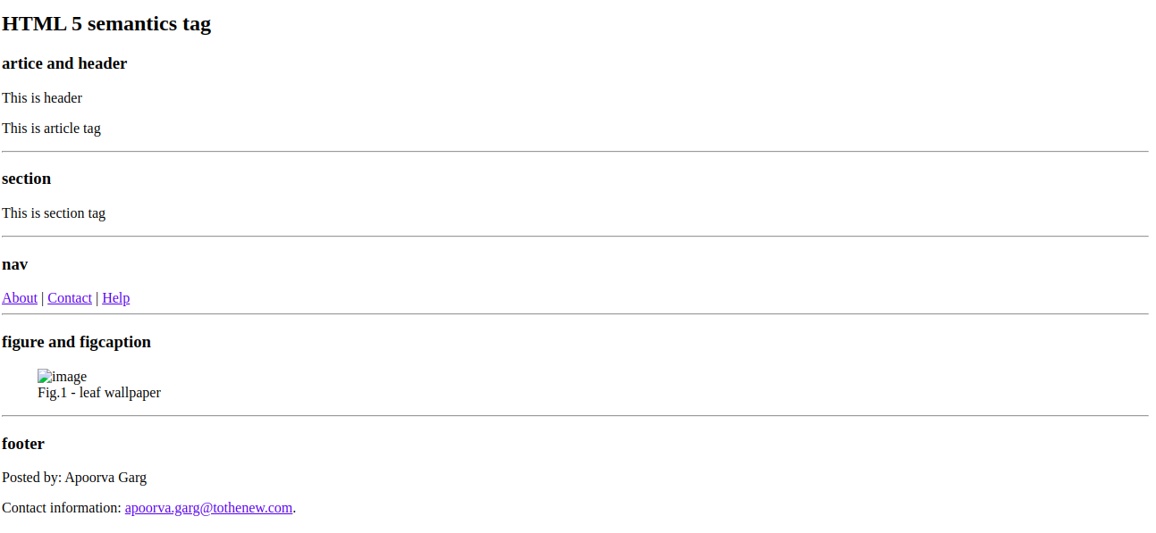
------------------------------------------------------------------------------------------------------------------------
11. Create HTML for web-page.jpg (check resources, highest weightage for answers)
Answer:
HTML CODE
<!doctype html>
<html lang="en">
<head>
<meta charset="UTF-8">
<meta name="viewport"
content="width=device-width, user-scalable=no, initial-scale=1.0, maximum-scale=1.0, minimum-scale=1.0">
<meta http-equiv="X-UA-Compatible" content="ie=edge">
<link rel="stylesheet" href="style.css">
<title>WEB_PAGE</title>
</head>
<body>
<section class="head">
<h1>To The New</h1>
<div class="navigation">
<nav>TEXT LINK</nav>
<nav>TEXT LINK</nav>
<nav>TEXT LINK</nav>
<nav>TEXT LINK</nav>
</div>
</section>
<section class="middle">
<p class="sec1">960x360px</p>
<p class="sec2">Lorem ipsum dolor sit amet, consectetur adipisicing elit. Autem blanditiis corporis distinctio iusto obcaecati, provident quam veritatis! Aliquam amet cupiditate debitis, eius eligendi facere illum inventore quae sed ullam? Atque!</p>
<a class="sec3">LATEST FROM THE GALLERY</a>
<hr>
<div class="item"><div class="part1">215x315px</div>
<div class="part2">IMAGE CAPTION HERE</div></div>
<div class="item"><div class="part1">215x315px</div>
<div class="part2">IMAGE CAPTION HERE</div></div>
<div class="item"><div class="part1">215x315px</div>
<div class="part2">IMAGE CAPTION HERE</div></div>
<div class="item"><div class="part1">215x315px</div>
<div class="part2">IMAGE CAPTION HERE</div></div>
</section>
<section class="footer">
<div class="left">copyright@ 2007-2017-All Right Reserved-TO THE NEW</div>
<div class="right">Web Layout by To The New</div>
</section>
</body>
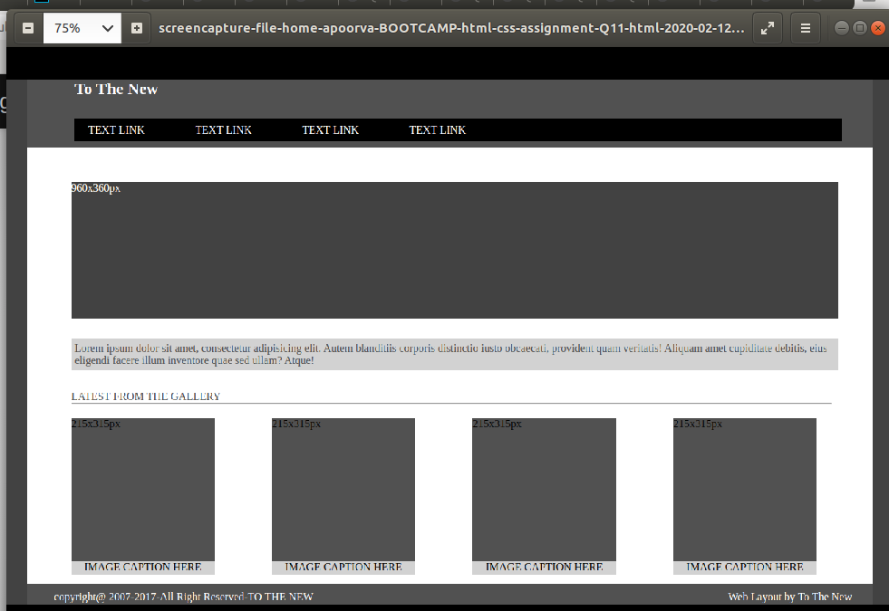
CSS file is
*
{
margin: 0px;
padding: 0px;
}
body
{
background-color: #404040;
}
h1
{
color: white;
padding-left: 70px;
padding-bottom: 30px;
}
.head
{
background-color: #505050;
margin: 0px 30px 0px 30px;
height: 100px;
}
.navigation
{
background-color: black;
height: 25px;
padding-top: 8px;
margin: 0px 45px 0px 70px;
}
nav
{
display: inline-block;
color: white;
margin-right: 50px;
padding-left: 20px;
}
.middle
{
background-color: white;
height: 600px;
margin: 0px 30px 0px 30px;
padding: 20px;
}
.sec1
{
background-color: #404040;
color: white;
height: 200px;
margin: 30px 30px 30px 45px;
}
.sec2
{
margin: 10px 30px 30px 45px;
background-color: lightgray;
color: #505050;
padding: 5px;
}
.sec3
{
margin: 10px 30px 30px 45px;
color: #505050;
}
hr
{
margin: 0px 40px 0px 45px;
}
.item
{
height: 230px;
width: 210px;
background-color: #505050;
display: inline-block;
margin: 20px 35px 30px 45px;
}
.part1
{
height: 210px;
width: 210px;
}
.part2
{
height: 20px;
width: 210px;
background-color: lightgray;
text-align: center;
color: black;
}
.footer
{
background-color: #505050;
margin: 0px 30px 0px 30px;
height: 30px;
}
.left
{
color: white;
float: left;
padding-left: 40px;
padding-top: 10px;
}
.right
{
color: white;
float: right;
padding-right: 30px;
padding-top: 10px;
}
-----------------------------------------------------------------------------------------------------------------------
12. Create HTML for form.png (check resources, highest weightage for answers)
Answer:
HTML CODE
<!doctype html>
<html lang="en" xmlns="http://www.w3.org/1999/html">
<head>
<meta charset="UTF-8">
<meta name="viewport"
content="width=device-width, user-scalable=no, initial-scale=1.0, maximum-scale=1.0, minimum-scale=1.0">
<meta http-equiv="X-UA-Compatible" content="ie=edge">
<link rel="stylesheet" href="style1.css">
<title>FORM</title>
</head>
<header>
<div class="Heading">TO THE NEW</div>
<nav class="links">Home</nav>
<nav class="links">Quick Help</nav>
</header>
<br>
<hr class="line">
<form class="form">
<div class="upper"><p class="bug"><strong>Bug Report</strong></p></div>
<br>
<div class="middle">
<label>Title:*</label><br>
<input type="text" class="tt" required><br>
<label>Description:*</label><br>
<textarea type=" text" rows="4" required></textarea><br>
<label>Operating system:</label><br>
<select name="drop_down" >
<option value="Windows XP">Windows XP</option>
<option value="Ms Dos">Ms Dos</option>
<option value="Linux">Linux</option>
</select><br>
<label>Product:*</label><br>
<select name="drop_down_2" required>
<option value="Formoid">Formoid</option>
<option value="Non_Formoid">Non Formoid</option>
</select><br>
<label>Version:*</label><br>
<textarea type="text" rows="3" class="ver" required></textarea><br>
<label>Licence:</label><br>
<input type="radio" name ="Licence" value="free"><a class="fr">free</a>
<input type="radio" name ="Licence" value="Business">Business
<br>
<label>Severity:</label><br>
<select name="drop_down3">
<option value="critical">Critical</option>
<option value="Non_Critical">Non_Critical</option>
</select><br>
<label>Attachments:</label><br>
<input type="file" class="attach">
</div>
<div class="footer"><button class="but">Send</button></div>
</form>
</body>
</head>
</html>
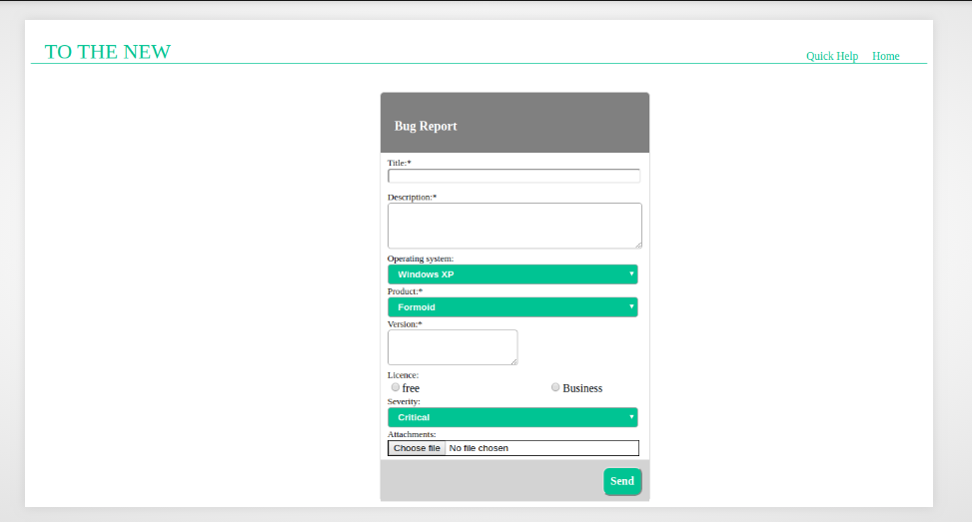
CSS file of this form is
header
{
color:#2bb78f;
margin-left: 20px;
margin-top: 20px;
padding-right: 20px;
}
.Heading
{
float:left;
font-size: 30px;
}
.links
{
float: right;
display: inline-block;
margin-right: 20px;
margin-top: 15px;
}
hr
{
clear: both;
border:0.5px solid #2bb78f;
margin-bottom: 40px;
}
.form
{
border:0.5px solid lightgray;
border-radius: 6px;
margin-left: 500px;
height: 100%;
width:30%;
margin-bottom: 0px;
background-color: gray;
}
.upper
{
background-color: gray;
height: 50px;
width: 100%;
}
.bug
{
color: white;
font-family: "Fira Code";
font-size: large;
padding-top: 20px;
padding-left: 20px;
}
.middle
{
padding: 5px 10px 5px 10px;
background-color: white;
}
.tt
{
width: 358px;
border-radius: 4px;
margin-bottom: 10px;
}
textarea
{
width: 358px;
border-radius: 4px;
}
select
{
width: 358px;
padding: 10px;
padding-top: 5px;
padding-bottom: 5px;
background-color: #2bb78f;
border-radius: 4px;
color: white;
font-weight: bolder;
}
label
{
margin-bottom: 10px;
font-size: small;
}
option
{
font-weight: bolder;
}
.ver
{
width: 180px;
}
.r_b
{
width: auto;
}
.fr
{
margin-right: 180px;
}
.attach
{
border: 1px solid black;
width: 358px;
}
.footer
{
height: 60px;
background-color: lightgray;
}
.but
{
float: right;
color: white;
background-color: #2bb78f;
font-family: "Fira Code";
font-weight: bolder;
font-size: medium;
margin: 10px;
padding: 10px;
border-radius: 10px;
}

