ASSIGNMENT NO 6
Q 1.Prompt for amount, interest rate and no. of years and calculate simple interest.
Answer:
JAVASCRIPT CODE:
function simpleinterest() {
var amt = prompt('Please enter your amount');
document.write("amount is :-" + amt);
document.write("<br>");
var rate = prompt('Please enter your rate of interest');
document.write("rate of interest is :-" + rate);
document.write("<br>");
var year = prompt('Please enter number of years');
document.write("number of years is :-" + year);
document.write("<br>");
var month = prompt('Please enter number of month');
document.write("number of years is :-" + month);
document.write("<br>");
var days = prompt('Please enter number of days');
document.write("number of years is :-" + days);
document.write("<br>");
var si;
si = ((amt * rate * year) + (amt * rate * month % 12) + (amt * rate + days % 365)) / 100
document.write("Calculated simple interest is " + si);
}
HTML CODE:
<!DOCTYPE html>
<html lang="en">
<head>
<meta charset="UTF-8">
<title>Title</title>
</head>
<body>
<script src="./app.js" charset="UTF-8"></script>
<script>simpleinterest()</script>
</body>
</html>
Q 2.is palindrome string
Answer:
JAVASCRIPT CODE:
function ispalindrome(str){
var str1="";
var str=document.getElementById("str").value;
var i =str.length;
for(var j=i; j>=0; j--){
str1 =str1+str.charAt(j);
}
if(str1 == str){
document.write("Palindrone String");
}
else{
document.write("Not palindrone String");
}
}
HTML CODE:
<!DOCTYPE html>
<html lang="en">
<head>
<meta charset="UTF-8">
<title>Title</title>
</head>
<body>
<script src="./app.js" charset="UTF-8"></script>
<script>ispalindrome()</script>
<form> "Enter a string":
str1 : <input type="text" id ="str" name="String">
<input type="submit" value="Check" onclick="ispalindrome(str)"/>
</form>
</body>
</html
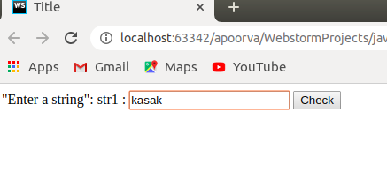
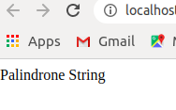

3.Area of circle
Answer:
JAVASCRIPT CODE:
function area_circle(int){
var rad=document.getElementById("int").value;
var area=((3.14)*rad*rad);
console.log(rad);
document.write("area of circle is "+area);
}
HTML CODE:
<!DOCTYPE html>
<html lang="en">
<head>
<meta charset="UTF-8">
<title>area</title>
</head>
<body>
<script src="./app.js" charset="UTF-8"></script>
<form>"Enter a radius": <input type="text" id ="int" name="rad">
<input type="submit" value="calculate" onclick="area_circle(int)"/>
</form>
</body>
</html>
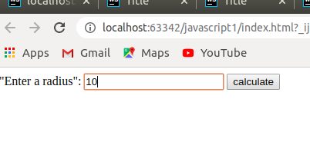
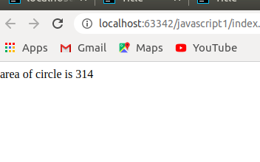

Q 4.Copy information of one object to another and log it to console.
Answer:
JAVASCRIPT CODE:
const square={
side: 1,
area(){
console.log('area');
}
};
console.log(square);
const clonesquare = Object.assign({},square);
console.log(clonesquare);
HTML CODE:
<!DOCTYPE html>
<html lang="en">
<head>
<meta charset="UTF-8">
<title>COPY</title>
</head>
<body>
<script src="./app.js" charset="UTF-8"></script>
</body>
</html>
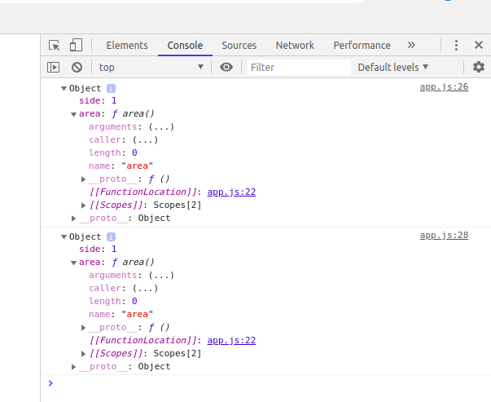
Q 5.create a list of objects of Employee with info as follow :
HTML CODE:
<!DOCTYPE html>
<html lang="en">
<head>
<meta charset="UTF-8">
<title>QUESTION 5</title>
</head>
<body>
<script src="./app.js" charset="UTF-8"></script>
</body>
</html>
  - Name, age, salary ,DOB
JAVASCRIPT CODE:
var list =[];
for(let i=0; i<2; i++) {
var employee ={};
employee['name']=prompt("Enter the name");
employee['age']=prompt("Enter age");
employee['salary']=prompt("Enter Salary");
employee['DOB']=prompt("Enter DOB");
list.push(employee);
}
console.log(list);
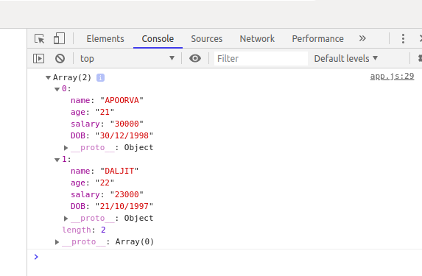

  - filter all employees with salary greater than 5000
JAVASCRIPT CODE:
console.log(list);
var list =[{Name:"apoorva",Age:21,salary:30000,DOB:"30/12/1998"},
{Name:"daljit",Age:22,salary:22500,DOB:"21/10/1997"},
{Name:"shubhanshi",Age:23,salary:60000,DOB:"05/06/1999"},]
for(let i=0; i<3; i++)
{
if(list[i].salary > 5000)
{
console.log(list[i].Name);
}
}
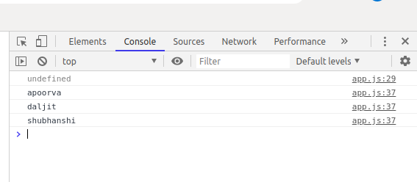
  - group employee on the basis of their age
JAVASCRIPT CODE:

var list =[{Name:"apoorva",Age:21,salary:15000,DOB:"30/12/1998"},
{Name:"daljit",Age:22,salary:22500,DOB:"21/10/1997"},
{Name:"shubhanshi",Age:23,salary:60000,DOB:"05/06/1999"},]
var group=[];
for(let i=0; i<3; i++)
{
if(list[i].salary < 60000)
{
group.push(list[i]);
}
}
console.log(group);
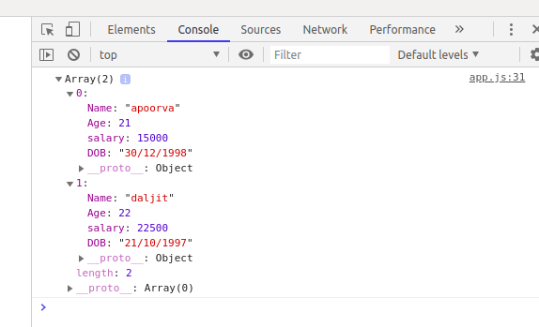

  - fetch employees with salary less than 1000 and age greater than 20. Then give them an increment 5 times their salary.
JAVASCRIPT CODE:
var list =[{Name:"apoorva",Age:21,salary:900,DOB:"30/12/1998"},
{Name:"daljit",Age:22,salary:22500,DOB:"21/10/1997"},
{Name:"shubhanshi",Age:23,salary:500,DOB:"05/06/1999"},]
var group=[];
for(let i=0; i<3; i++)
{
if(list[i].salary<1000 && list[i].Age >20)
{
var new_salary=5*list[i].salary;
list[i].salary=new_salary;
}
}
console.log("new incremented salary");
console.log(list);
