ASSINGMENT No.3(INTRODUCTION TO DATABASE)

Question 1:Create Database

Answer:

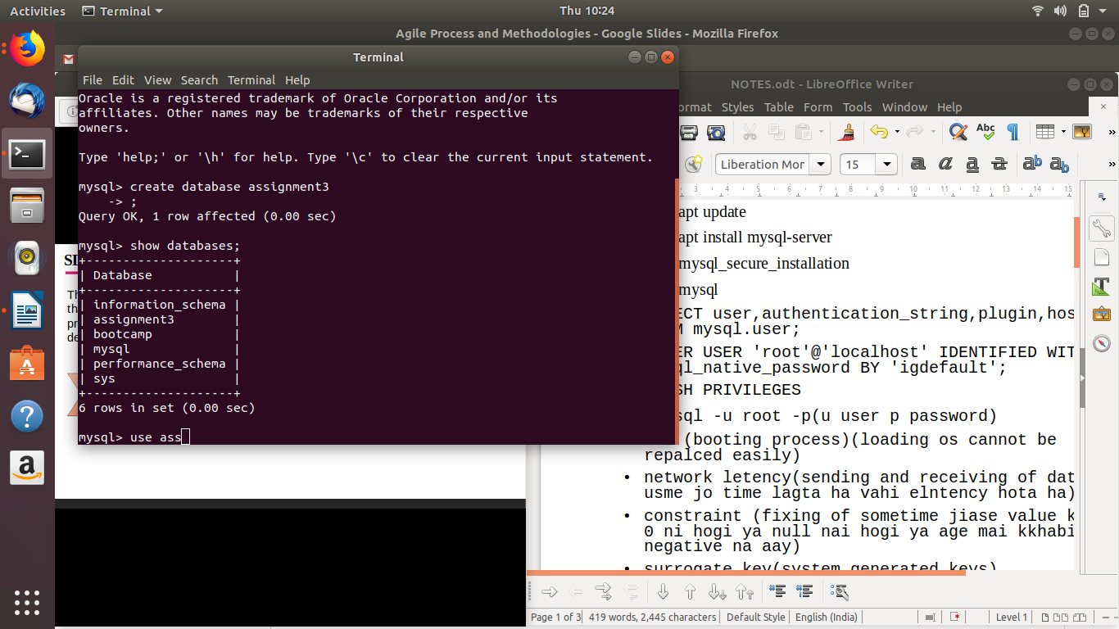

Question 2:Design Schema

Answer:

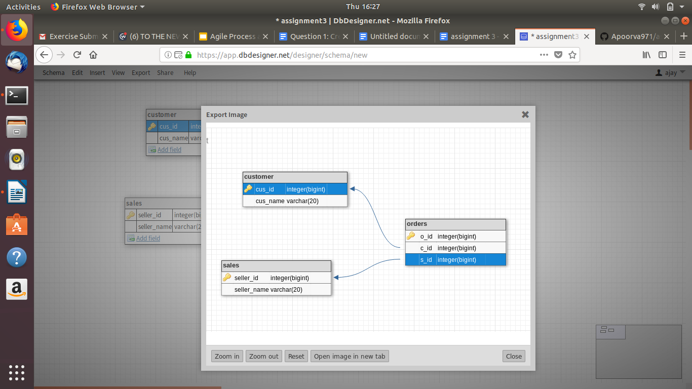

Question 3:Create tables

Answer:

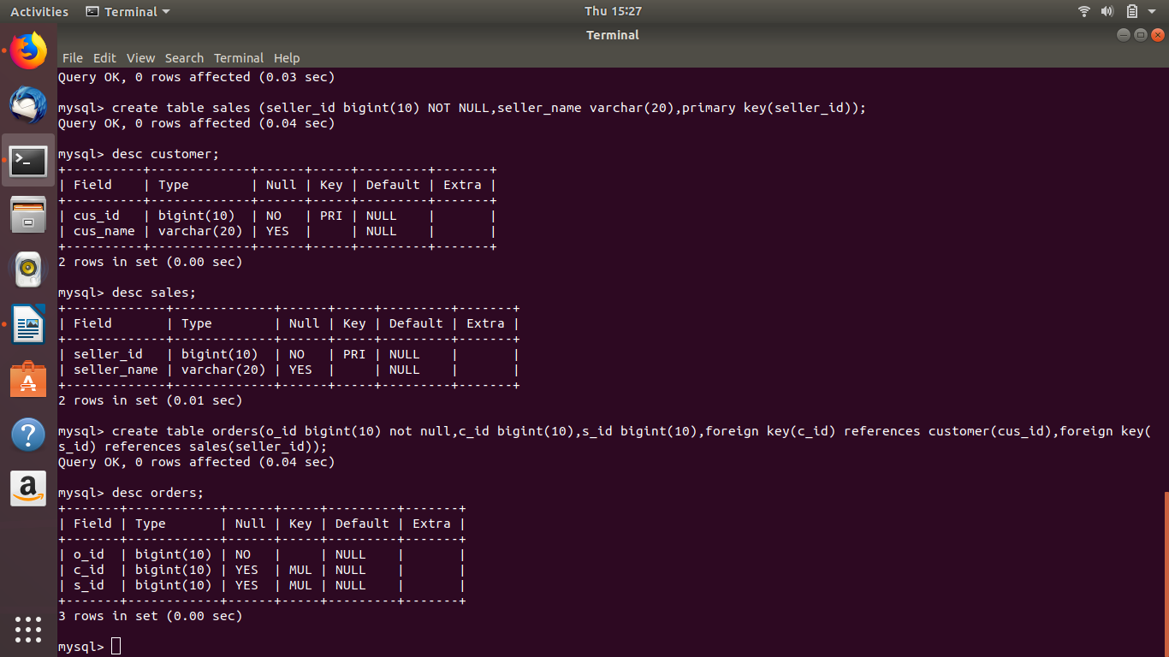

Question 4:Insert sample data

Answer:

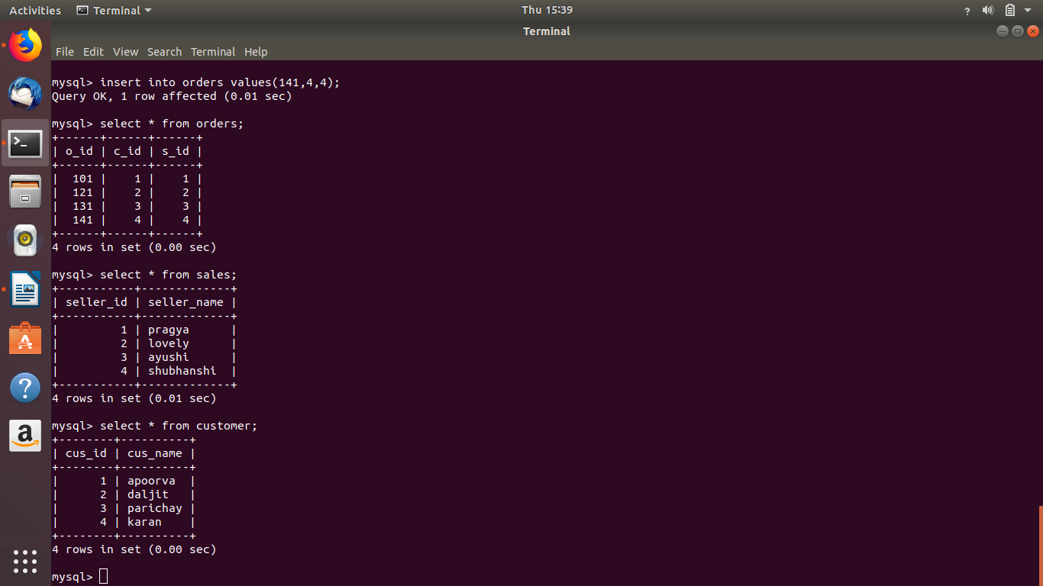

Question 5:Find the sales person have multiple orders.

Answer:

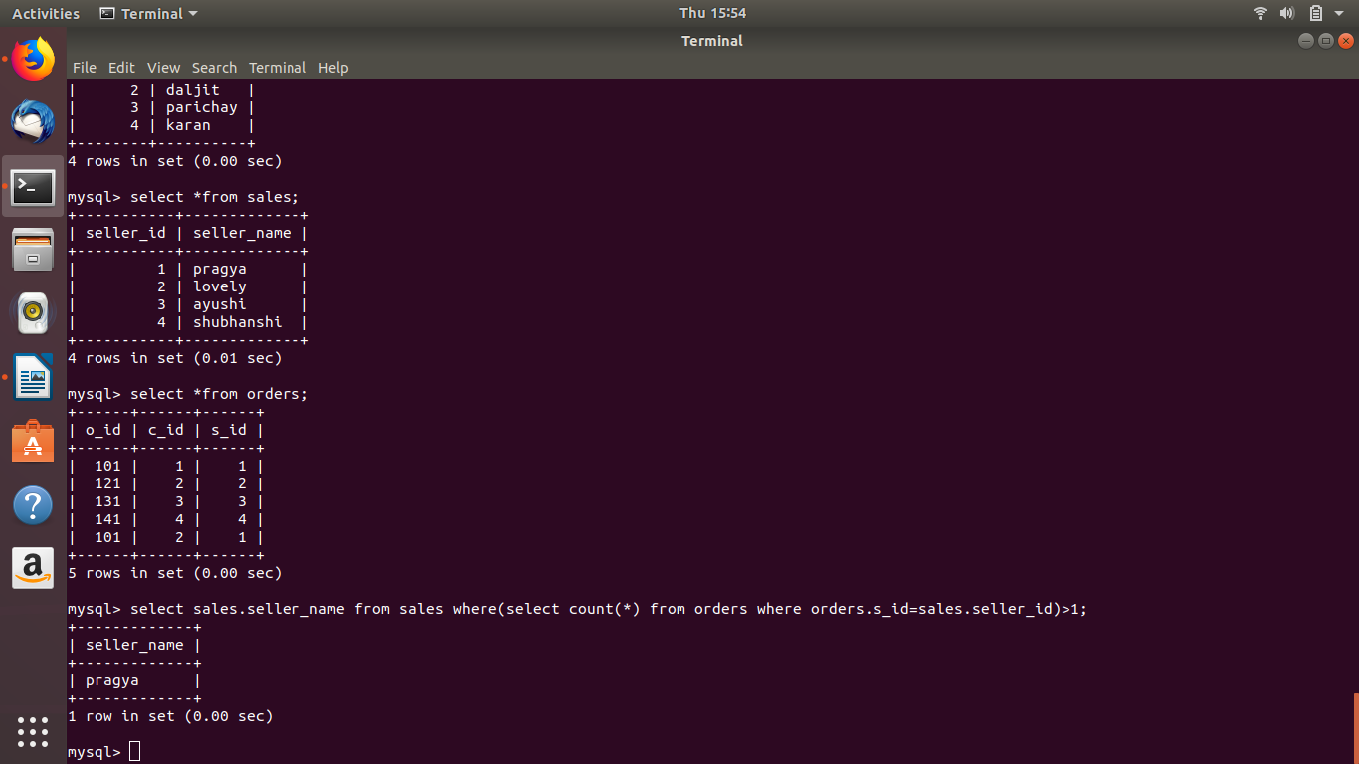

Question 6:Find the all sales person details along with order details

Answer:

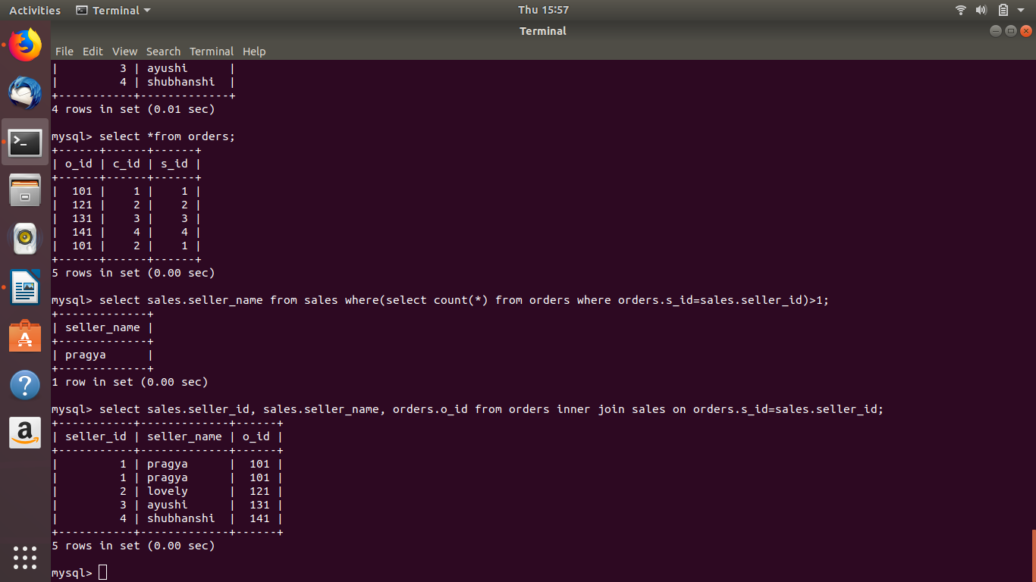

Question 7:Create index

Answer:

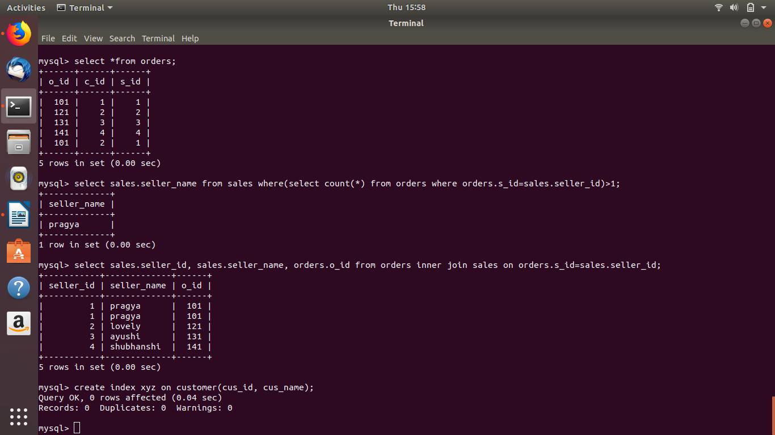

Question 8:How to show index on a table

Answer:

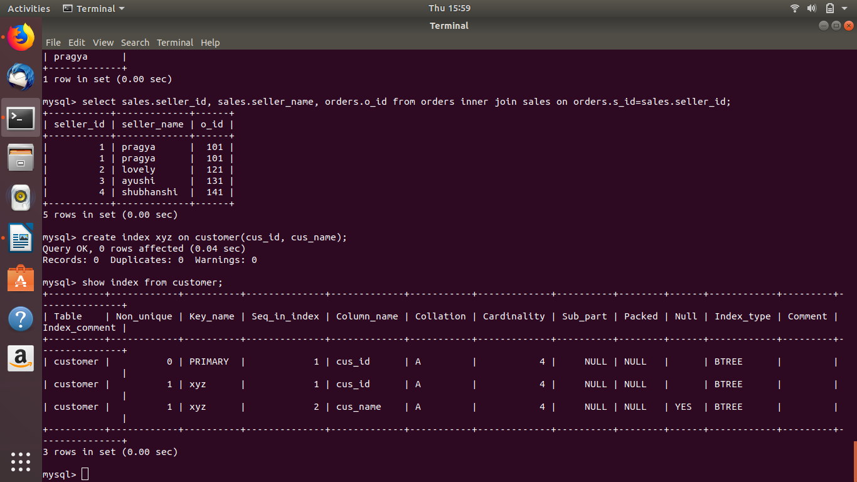

Question 9:Find the order number, sale person name, along with the customer to whom that order belongs to

Answer:

