**Performance Based Incentives Policy: A Geometric Hybrid Model**

Ch. Apoorva, Ch. Sekhar

*Department of CSE*

*Vignan’s Institute of Information Technology (Autonomous)*

*Visakhapatnam, AP, India*

**ABSTRACT:**

Performance based incentives are incentives that are disbursed based on the authentic performance of an employee for a stipulated resulted period. Using a PBI policy is enormously successful in inspiring professors and other stakeholder to focus on core areas of an educational institute. In this article, the author proposed a geometric hybrid model for computing performance based an incentive which helps to tie compensation directly to specific institutional goals and management objectives of an institute. In PBI policy, performance of the faculty is always evaluated based on his or her academic output in terms of result or percentage of marks. However sometimes faculty argues that academic output always depends on the subject toughness rather than the faculty’s performance in terms of results. On the contrary, someone may be argued that the criteria of student feedback system are the best decisive factor to evaluate faculty’s performance. Hence, a traditional PBI policy always consider both the results and student feedback criterion as decisive factor for appraising faculty’s performance but it was failed in considering subject toughness and quality of students input. To overcome this gap, the author proposed a geometric hybrid model of performance based incentive policy which considers a set of notional variable like, subject toughness, subject’s results and average result of all subjects. This geometric hybrid model delivers competitive pay for cutthroat levels of performance and also encourages employees to constantly develop new skills. This model suggests a mathematical proposition for evaluation of professor’s performance through justification proportionate variables in technical educational institutes.

**1. Introduction**

Incentives are instant rewards and they create immediate effect on performance. Some of the researchers portrayed that faculty is always rewarded based on his/her output. Since the quality of output rewarded, most of the eminent faculty can be moved to areas of low socio-economic status due to lack of a fast track mechanism to identify the performance and propose the incentives. Hence, a strong performance appraisal system assists an educational institute to establish potential man force; analysis employee performance is essential to determine if further training is needed or if dismissal is appropriate. Sanction of the incentive is always preceded by appraisal of an employee at various levels. At the same time, it’s also required to consider special incentives for specific individual performances which should be made with orderly paid, in order that the employee gets motivated by the appreciation of his/her contribution and uphold self-esteem. As per the psychometric studies motivation plays a vital role in law of behaviour that higher impetuses will prompt to predominant execution. Hence, a performance based incentive methodology always helps to tie compensation straight to specific organizational goals and management objectives.

**2. Hybrid Model Performance Based Incentive (GHMPBI) Policy**

Educators in many parts of the world are remunerated in view of degrees and experience. In any case, a considerable lot of the analysts came about that the rewards to experience are constrained and that qualifications have minor effect on understudies' execution. By and by, educators' quality is vital. As a result of this distinction between educator remuneration and instructor execution, the possibility of budgetary motivating forces for instructors (regularly called as Performance Based Incentive or Merit Based Incentive) related with occasions of understudy execution has turned out to be increasingly acknowledged and well known. In this way, a generous assemblage of literature argued that the performance based incentive frameworks with the mix of all parameters incorporate in establishing objectives are a change on the productivity of pay scales. Pioneering incentive mechanisms based on loss rather than gain or on relative student performance show promise for high effectiveness but are yet to be rigorously evaluated. With this motivation this paper presented a hybrid model with combination of all parameters of faculty assessment.

Traditional PBI policy determined objectively where as GHMPBI policy provides fair and accurate evaluation both objectively and subjectively. It creates competition among professors in terms of their results, research output correspondingly which uplifts the institute goals. In this GHMPBI policy, higher performer always encourages with higher incentive. A range of perverse outcomes occur because of faculty ‘game playing’ to impress the superior rather than his or her core values. Whereas in case of GHMPBI policy fully automated which creates better opportunities to prove individual by creating competition among them. GHMPBI policy can be implemented easily by adopting a simple data base system with the help of simple software. The details of the model are presented in the Table1 below.

**Table 2.1. Model of Geometric Hybrid Model Performance Based Incentive Policy**

|  |  |  |  |  |
| --- | --- | --- | --- | --- |
| Criteria | Academic results | Student Feedback | Research & Development | Other Contribution |
| Maximum Credits Awarded | 3 | 1 | 3 | 3 |
| Scope of  compensation | All faculty who can achieve maximum academic Results | All faculty who can achieve maximum student feedback score | All faculty who can progress through their research | All professors who can support the students, peers, and institute |
| Areas evaluated | Evaluated on the premise of showed abilities and information which are thought to be connected to expanded staff performance. Regularly comes as Academic outcomes | Assessed on the premise of exhibited aptitudes and learning which are thought to be connected to expanded staff performance. Regularly comes as Students input | Assessed on the basic of output connected to faculty research area. Often comes as quality distributions | Evaluated on the premise of workforce yield as additional commitments for advancement of understudy, self and establishment. Like, student counseling, discipline and Peers feedback often  comes in the form of  other credentials |

**3. Hypothesis & Methodology**

Keeping in view the importance of the study and in light of the above parameters, this study attempts a geometric model of experiments to test the performance appraisal. The main aim of this model is to develop a comprehensive mathematical model which would be suitable to technical institutions to assess an annual academic appraisal of a faculty. The propositions of this model are:

**Step -1**: The growth & development of any technical institute may depends on its overall students results, students feedback on faculty teaching methodology, its research output of institute and other contributions. Hence, the author presumed that there are four basic parameters may influence the institute development and growth like, Student academic results, feedback, Faculty development through research & development. Subject wise toughness plays a vital role in producing good results. Since student result being played a vital role PBI policy, some of the faculty expressed their un-happiness and it is also pointed out that the student result is fortunately depends on students’ intelligence and paper toughness. For this reason, qualitative staff may get disappointed. Therefore, this study considers comparative result score within the same section and results of the other sections.

**Step –2:** The quality of students may differ from section to section. Hence, the author also assumed that number of sections also plays an important role in a technical institute which comprises with many sections and different faculty may teach the same subject for different sections. In light of the above recommendations, the review endeavors to test the accompanying speculations:

H1: It is hypothesized that there is a strong significant association between the result range within the same section and the result of the same subject in other section.

H0: It is estimated that there is no relationship between individual subject result and other subject’s results.

Based on the above hypothesis, the GHMPBI proposes TEN point scales to evaluate a professors’ performance in a technical institute. Mainly the GHMPBI Policy considers all the core areas of a technical institutional objectives like, Academic Result (AR), Academic Feedback (AF), Research & Development (RD) and other contributions (OC) of an employee for his/her improvement as well as institutional growth. The details of the weighted score for the above criteria are given below:

Weighted Academic Result Score (WARS) = 3 Marks

Weighted Academic Feedback Score (WAFS) = 1 Marks

Weighted Research & Development Score (WRDS) = 3 Marks

Weighted other contributions Score (Wocs) = 3 Marks

Mathematically it can be expressed as:

PBI score of an Employee = [(ΣARS. WARS) + (ΣAFS. WAFS) + (ΣRDS.WRDS) + (ΣOCS. Wocs)] (1)

ARS = Academic Result Score;

AFS=Academic Feedback Score;

RDS = Research & Development Score;

OCS = other contributions Score

**Step -3:** **Assessment of “Academic Result Score (ARS)”:** This criterion mainly focuses on the academic performance of an employee which covers the semester results of an employee in an academic year. The author proposes 3 marks in this criterion based on the following propositions:

* It considers Individual Subject Result Analysis within the class/section when compared to other subjects of the same class.
* It also considers the performance of individual subject result when compared to the result of the same subject in all sections of all the branches. Based upon above propositions, the author develops the following Geometric Hybrid Model for computation of Academic Performance Score (APS):

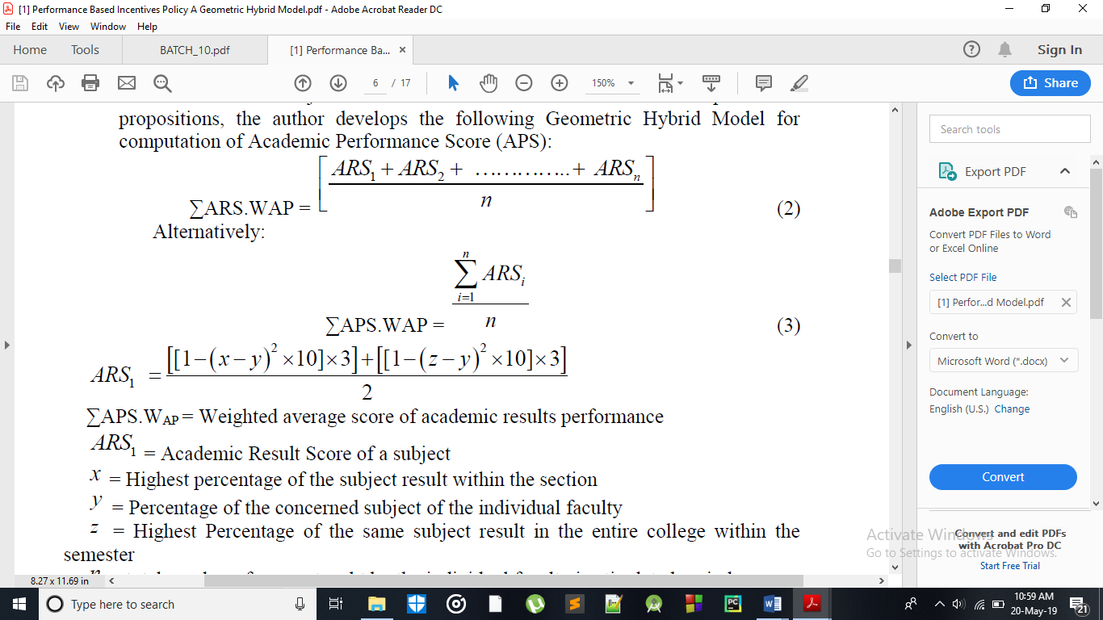





∑APS.WAP = Weighted average score of academic results performance

ARS1 = Academic Result Score of a subject

x = Highest percentage of the subject result within the section

y= Percentage of the concerned subject of the individual faculty

z= Highest Percentage of the same subject result in the entire college within the semester

n = total number of papers taught by the individual faculty in stipulated period

**Step -4**: **Assessment of Academic Feedback Score (AFS)**

This is the second criterion of the GHMPBI policy which proposed the following to assess the student’s feedback. There are nine question put forward to students, for that they will allot 0-10 marks for individual questions on individual subject. Finally the study considers average score of subject feedback for individual subjects and consolidates total subjects feedback score.

**Table 10. The Details of the Questions and their Mathematical Equation**

|  |  |  |  |  |  |
| --- | --- | --- | --- | --- | --- |
| **Criterion** | **Question** | **S1** | **S2** | **S3** | **S4** |
| Q1 | Clarity in Presentation of Topics in the class & Subject knowledge of the faculty | SQ11 | SQ12 | SQ13 | SQ14 |
| Q2 | Courteous and impartial to students | SQ21 | SQ22 | SQ23 | SQ24 |
| Q3 | Coverage of the syllabus as per lecture plan | SQ31 | SQ32 | SQ33 | SQ34 |
| Q4 | Discipline maintenance in the class | SQ41 | SQ42 | SQ43 | SQ44 |
| Q5 | Doubt clearance | SQ51 | SQ52 | SQ53 | SQ54 |
| Q6 | Faculty comes to class on time | SQ61 | SQ62 | SQ63 | SQ64 |
| Q7 | Faculty speaks clearly and audibility | SQ71 | SQ72 | SQ73 | SQ74 |
| Q8 | Faculty writes and draw legibly | SQ81 | SQ82 | SQ83 | SQ84 |
| Q9 | Motivates the students to study | SQ91 | SQ92 | SQ93 | SQ94 |

|  |  |  |  |  |
| --- | --- | --- | --- | --- |
|  | AFS1 | AFS2 | AFS3 | AFS4 |

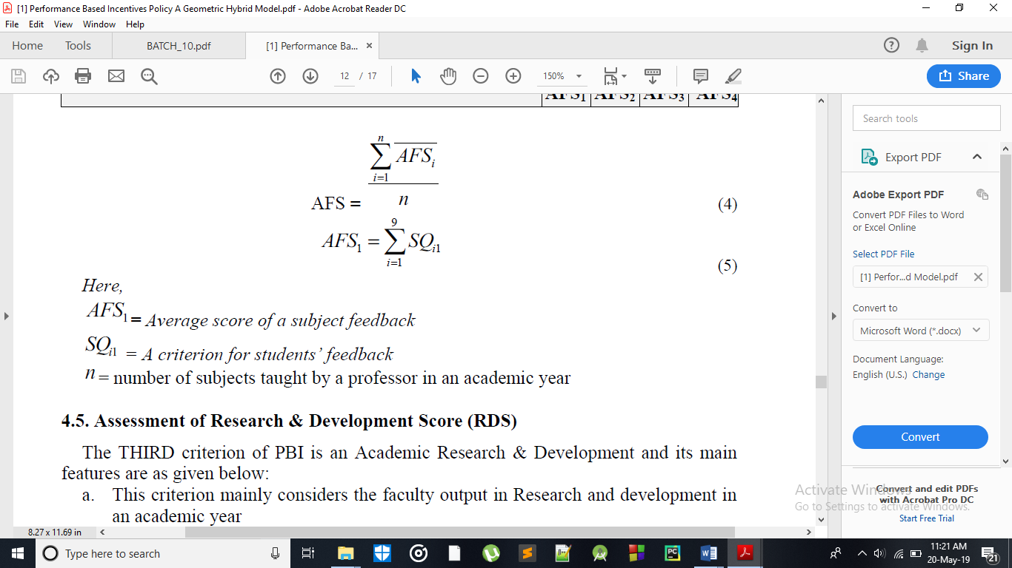

*Here,*

AFS1 ***=*** *Average score of a subject feedback*

SQi1 = A criterion for students’ feedback

N = number of subjects taught by a professor in an academic year

**Step -5: Assessment of Research & Development Score (RDS)**

The THIRD criterion of PBI is an Academic Research & Development and its main features are as given below:

a. This criterion mainly considers the faculty output in Research and development in an academic year

b. Here R&D includes Research article produced in the National and International Journals, Articles presented in the national and International Conferences, Conferences/ Workshops/ Symposium organized and participated.

c. It also consider the quality of research and ARDS score computed based on Global R&D quality indexes like, Citation, impact factor and H-index *etc.*

Statement of Evaluation Score of ARDS is shown as below.

**Table 11. Statement of Evaluation Score of ARDS**

|  |  |  |  |  |  |
| --- | --- | --- | --- | --- | --- |
| **Category(c)** | **Paper with+(p)** | **Index/Citation value (i)** | **Weight (Wpci)** | **Marks**  **(Mpci)** | **Total weighted score**  **(TWS)** |
| **International**  **Journal-Un Paid**  **(with ISSN/ISBN)** | H-Indexed | 10 Above | 1 | 3 | 3 |
| 10-May | 0.7 | 2.1 |
| 0-5 | 0.4 | 1.2 |
| Impact factor | Above 3 | 1 | 2 | 2 |
| 1.00 – 2.99 | 0.7 | 1.4 |
| 0.01-0.99 | 0.4 | 0.8 |
| Other (Indexed) | Peer  Reviewed/  Refereed | 0.5 | 1.5 | 0.75 |
| **International**  **Journal-Paid (JCR Indexed)** | H-Indexed | 10 Above | 1 | 2 | 2 |
| 10-May | 0.7 | 1.4 |
| 0-5 | 0.4 | 0.8 |
| Impact factor | Above 3 | 1 | 1.75 | 1.75 |
| 1.00 – 2.99 | 0.7 | 1.225 |
| 0.01-0.99 | 0.4 | 0.7 |
| Other(Indexed) | Peer  Reviewed/  Refereed | 0.5 | 1.5 | 0.75 |
| **National JournalsUnpaid** | H-Indexed | 10 Above | 1 | 1.5 | 1.5 |
| 10-May | 0.7 | 1.05 |
| 0-5 | 0.4 | 0.6 |
| Impact factor | Above 3 | 1 | 1.2 | 1.2 |
| 1.00 – 2.99 | 0.7 | 0.84 |
| 0.01-0.99 | 0.4 | 0.48 |
| Peer  Reviewed/  Refereed | 0.5 | 0.8 | 0.4 |
| **National JournalsPaid** | H-Indexed | 10 Above | 1 | 1 | 1 |
| 10-May | 0.7 | 0.7 |
| 0-5 | 0.4 | 0.4 |
| Impact factor | Above 3 | 1 | 0.8 | 0.8 |
| 1.00 – 2.99 | 0.7 | 0.56 |
| 0.01-0.99 | 0.4 | 0.32 |
| Peer  Reviewed/  Refereed | 0.5 | 0.6 | 0.3 |
| **International**  **Conference**  **Proceedings**  **(Indexed)** | With ISBN/ISSN | NA | 1 | 0.5 | 0.5 |
| Without  ISBN/ISSN | NA | 0.8 |  | 0.4 |
| **National**  **Conference**  **Proceedings**  **(Indexed)** | With ISBN/ISSN | NA | 1 | 0.5 | 0.5 |
| Without  ISBN/ISSN | NA | 0.8 |  | 0.4 |
| **Workshops/ Symposiums** | With Funding by  other agencies | NA | 1 | 1 | 1 |
| **Organized** | Without funding | NA | 0.5 |  | 0.5 |
| **FDP/Workshops/**  **Symposiums**  **Participated** | International Level | NA | 1 | 0.5 | 0.5 |
| National Level | NA | 0.6 |  | 0.3 |
| Others | NA | 0.4 |  | 0.2 |

Research and development is an integral part of innovation, the study considers that it is very essential for institutions and their staff to upgrade themselves and/or to upkeep the knowledge. Hence, it’s considered to be very important for technical education. At this juncture, the author(s) supposed that there are multiple corners of research & development criterion like, publications, participation in conferences, Workshops, Symposiums and FDP *etc.*

(**Σ**RDS.WRDS = TWS .WRDS (6)

Where TWS = Total weighted score = (Wpci ) . (Mpci);

Wpci = Wight of a paper category index; Mpci = Maximum marks of a paper in given category

**Step -6: Assessment of Other Activities Score**

The FINAL criterion of GHMPBI is Performance Appraisal for Other Activities Score (OAS) done by an employee. The following are the main features of this criterion:

i. OAS of GHMPB mainly considers three core areas of the Institute like, Faculty discipline in-terms of Punctuality, Faculty participation in Student counseling and Feedback of an employee from respective department HOD and Principal.

ii. This study also presumed that there are three additional qualities of faculty influences institutional growth. They are faculty discipline which includes punctuality, passion, innovation, integrity, patience *etc.*

iii. This study also assumed that the role faculty plays a vital role in motivating or encouraging students through proper counseling. Hence, this also given importance for student counseling.

iv. The strong PBI policy should respect Hierarchy and the feedback from peers.

From the view point of the above, the author allotted a thirty percentage of total score for this criterion. The Maximum score of this criterion is 3 Marks which includes:

Faculty Discipline - 1 Mark

Student Counseling - 1 Mark

HOD and Principal feedback - 1 Mark

**4. Conclusion**

Incentives are instant rewards and they create immediate effect on performance. PBI policy always encourages employee competition rather that collaboration among employees. It delivers competitive pay for competitive levels of performance and also encourages employees to constantly develop new skills. With this motivation the author developed a geometric hybrid model for performance appraisal which is highly suitable for technical institutions. Hence, it creates competition among professors in terms of their results, research output correspondingly which uplifts the institute goals. Mainly the GHMPBI Policy considers all the core areas of a technical institutional objectives like, Academic Result (AR), Academic Feedback (AF), Research & Development (RD) and other contributions (OC) of an employee for his/her improvement as well as institutional growth. This study experimented with few practical examples and analysed with the given result. The developed policy considers all the parameters like student’s results & feedback, faculty research output and other contributions. This study may helpful in practical implementation in assessment of faculty appraisal and increments. At the outset it can be conclude that the review has been finished with sentiment happiness and loaded with fulfilment deserting the above proposal that it won't not be comprehensive but rather these would meet the changing desires of the personnel in specialized establishments in the field of technical institutions.