Task 1:
Installation of htop:
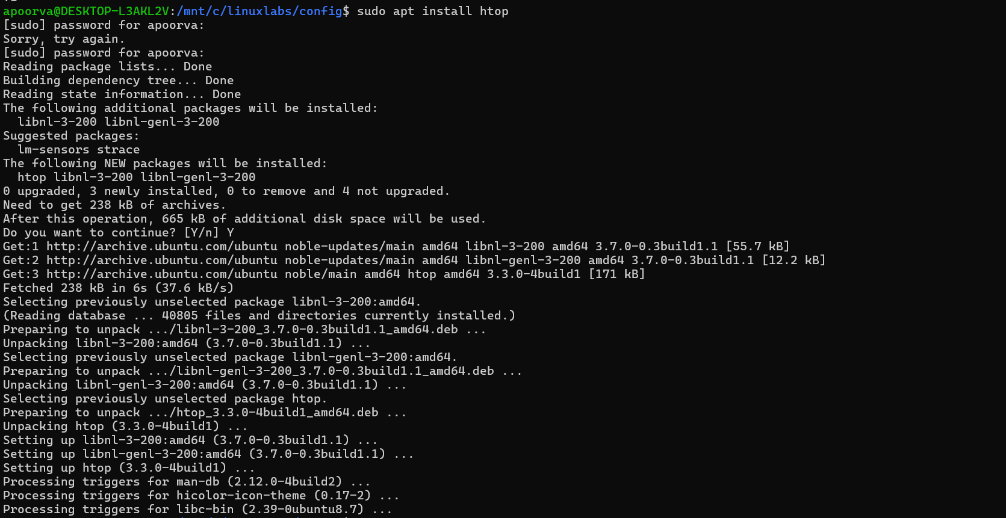

Htop CPU, memory and processes usage:

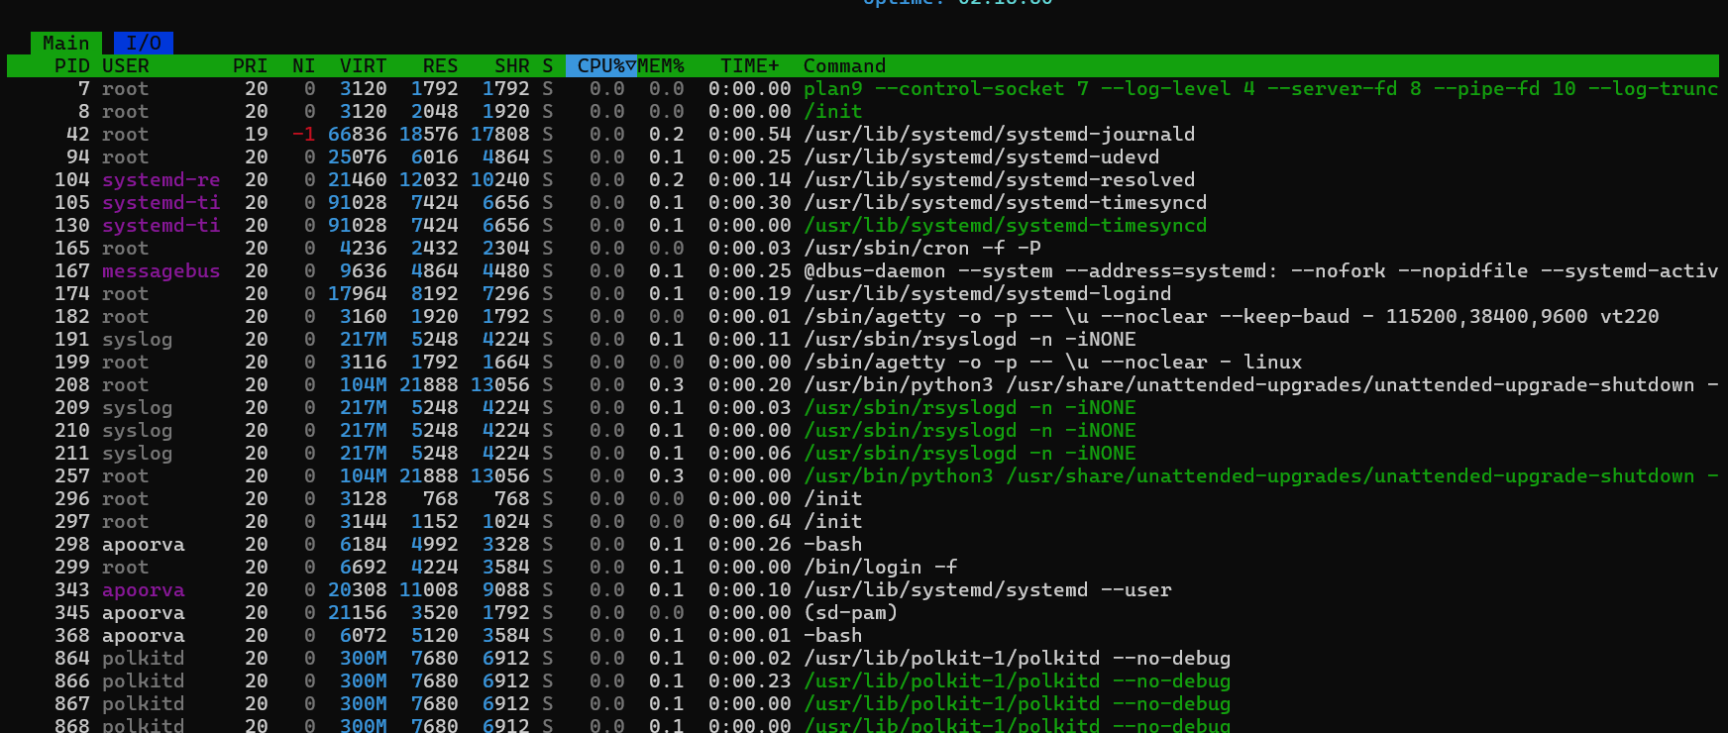

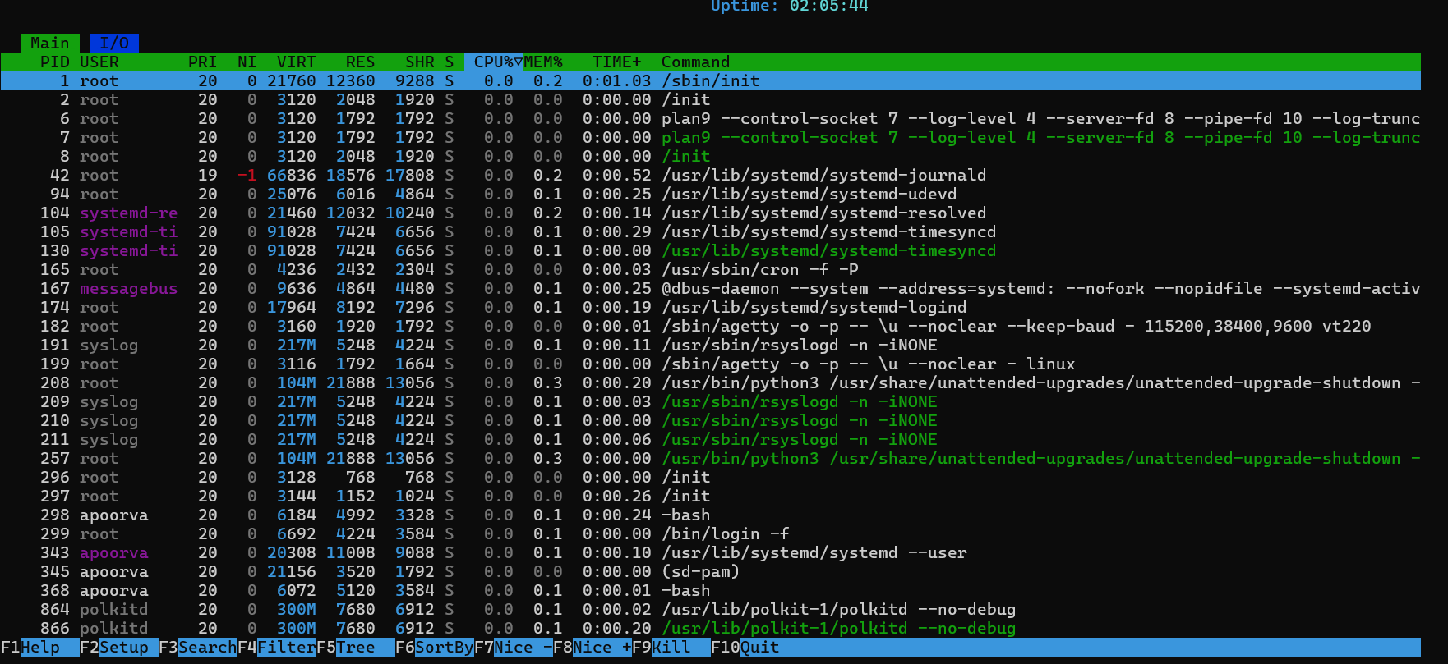

df command :
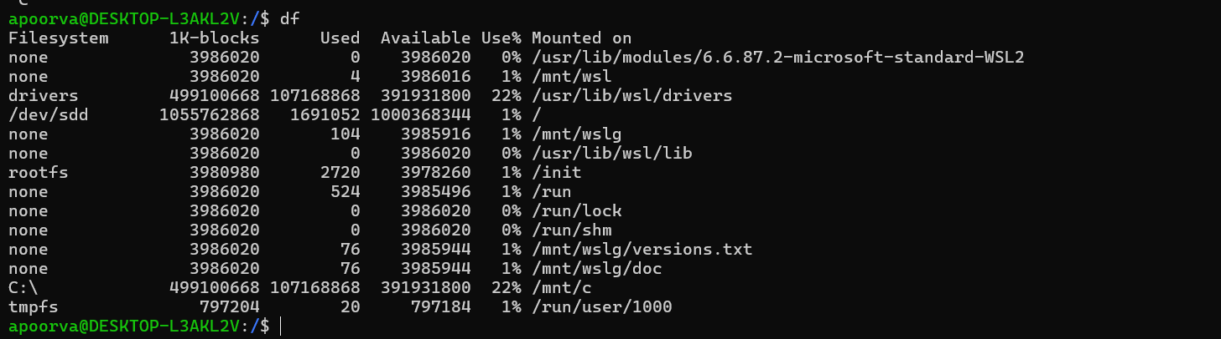
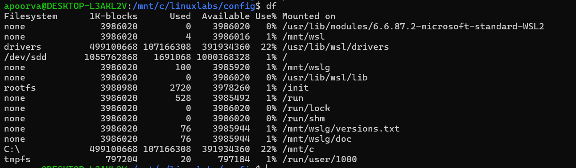

du command:
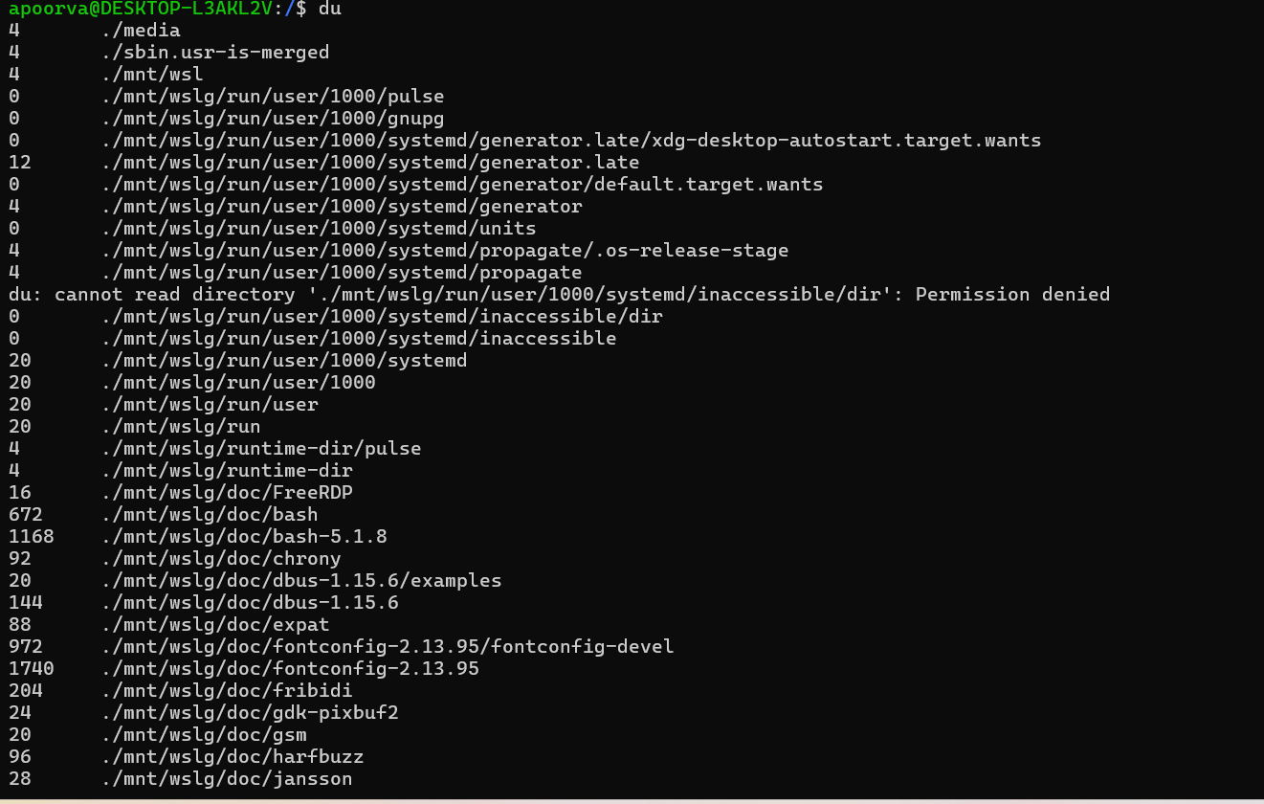
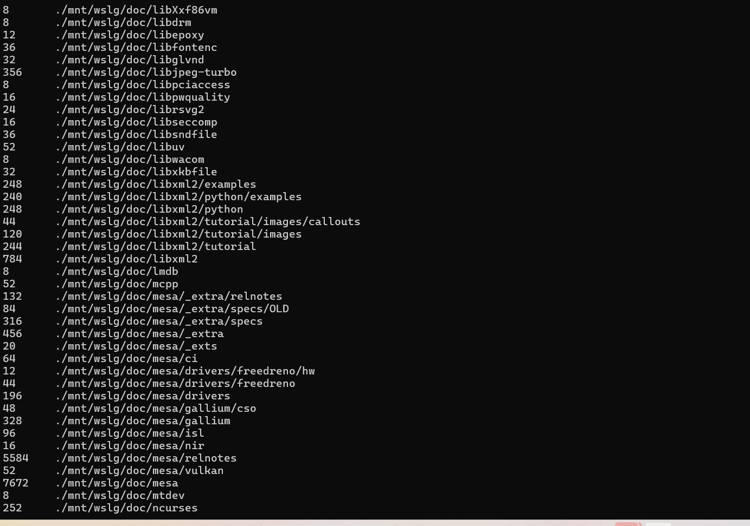

Task 2:
Create a new user sarah with password:
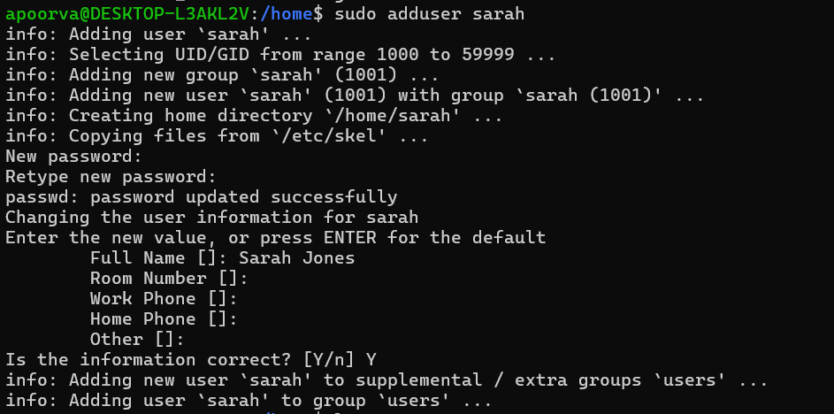
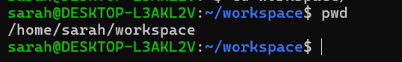

Create a new user Mike:
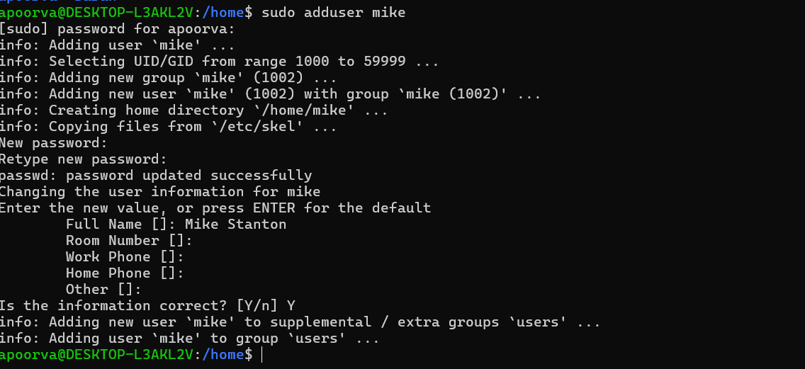
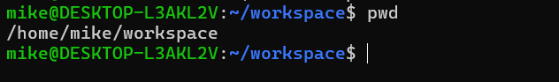
Permission provided for mike:
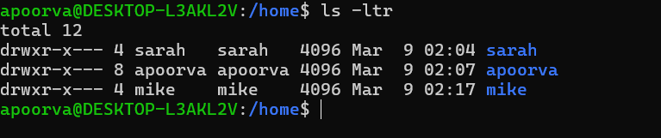
Password policy implemented for Sarah and Mike: Password expires every 30 days:
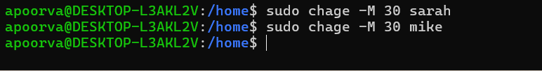
Task 3:

Install Apache for Sarah
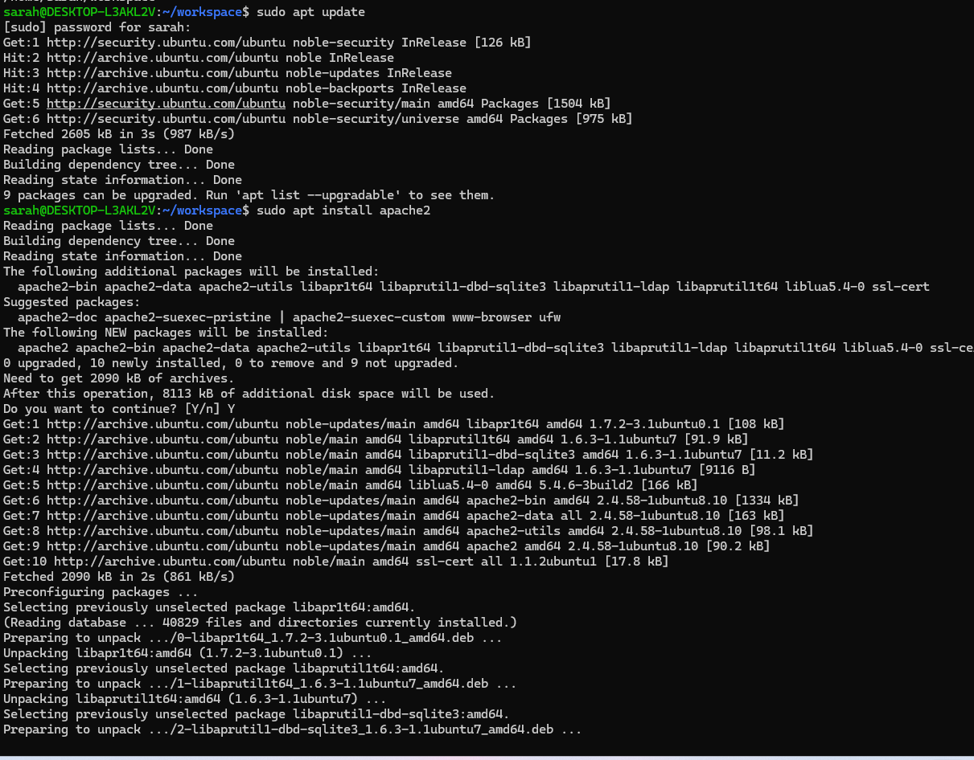
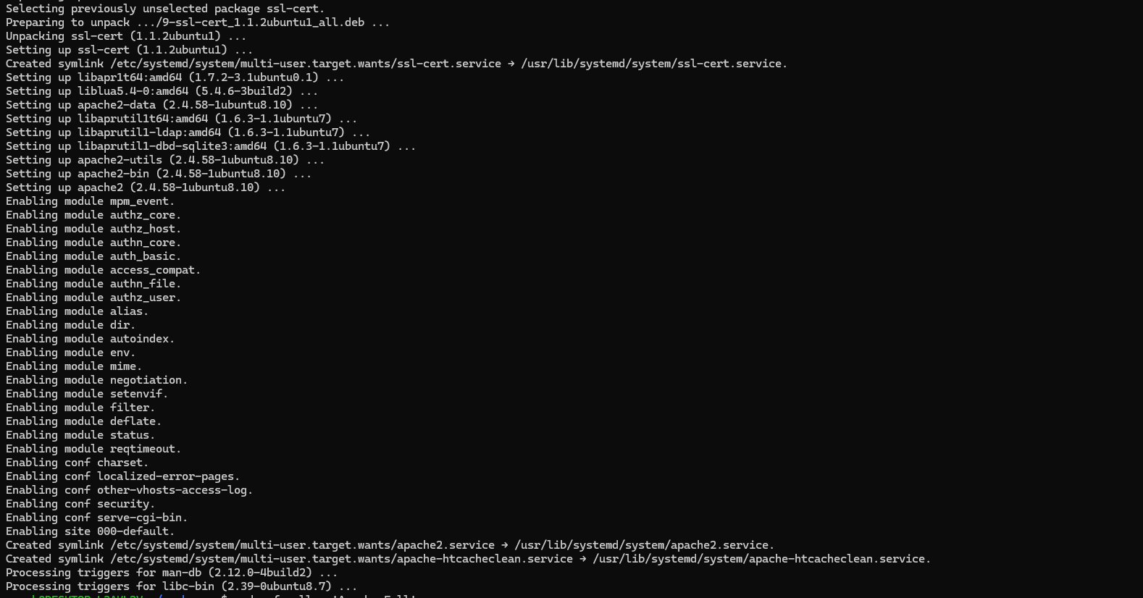
Allow firewall access:
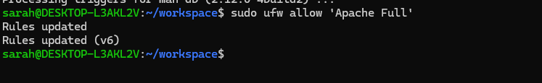

Creating tar file for apache2 folder:
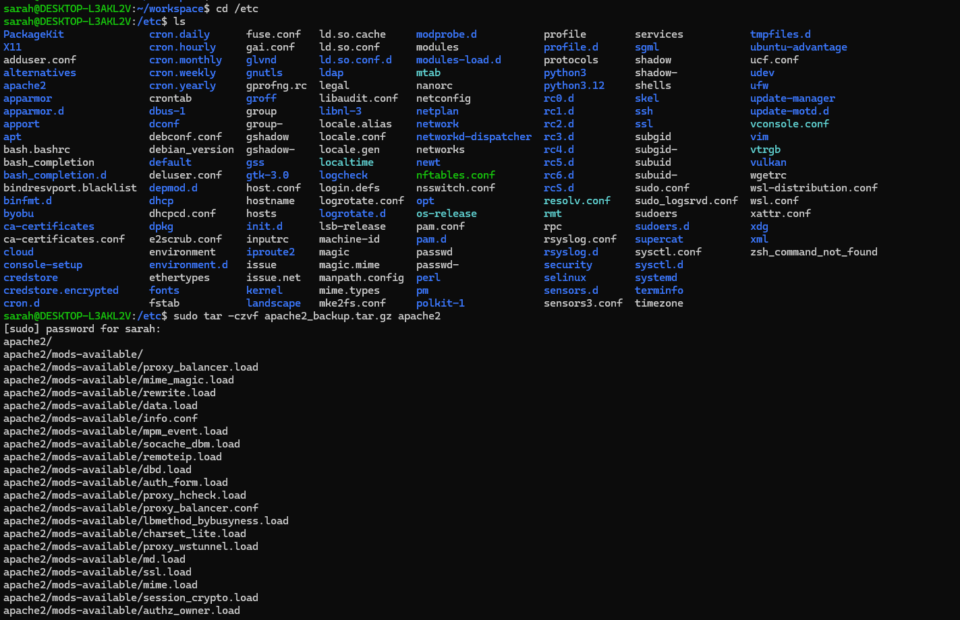
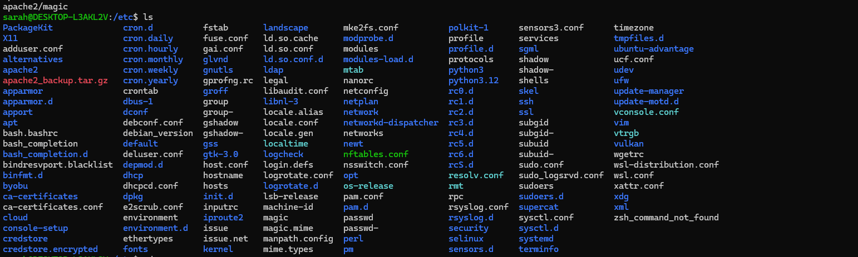
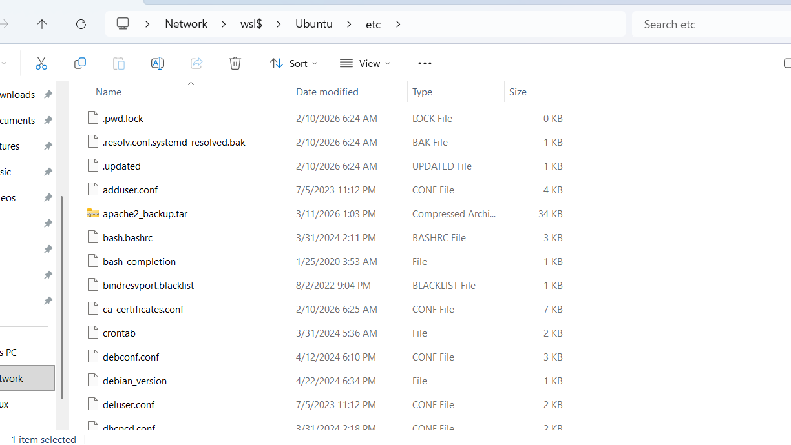
This tar file is also attached to the Git repo
Creating backup of the index.html inside var/www/html:
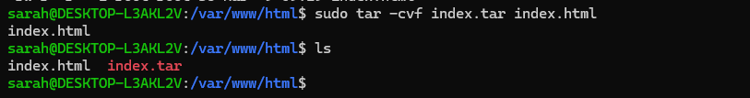
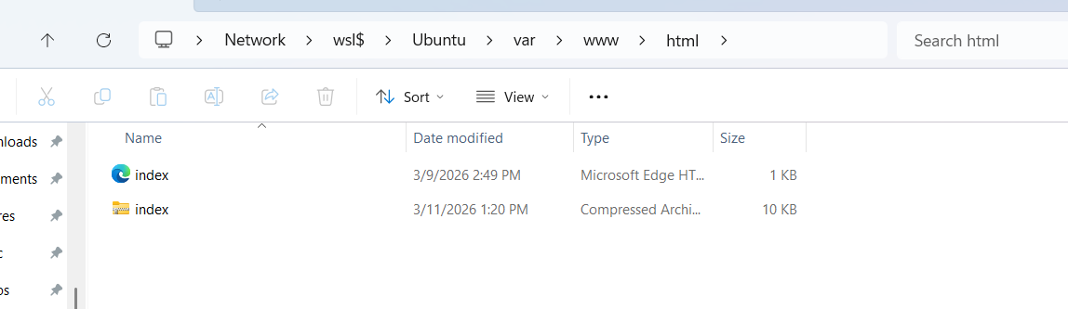

Install nginx for Mike:
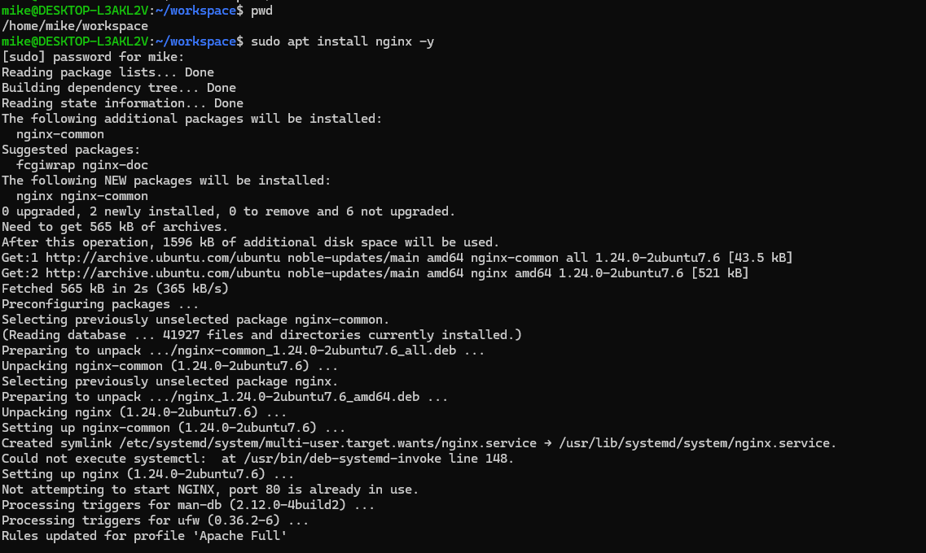

Creating backup for /etc/nginx, named: nginx_backup_2026-03-16
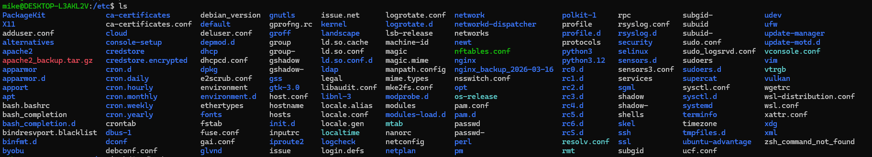
Create tar file of the nginx back
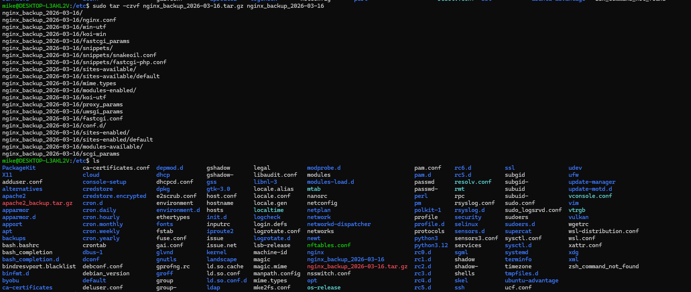
Backup the /usr/share/nginx/html index.html file
Create compressed tar file of the back up file:
Script to backup the apache server:
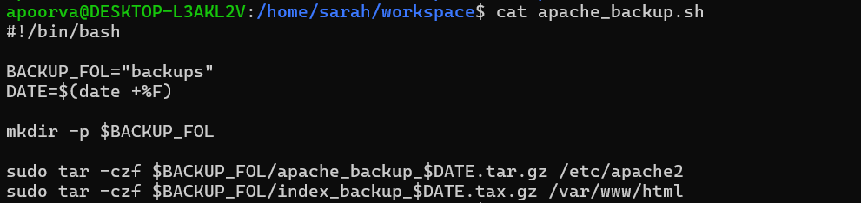
Run the backup script to create tar files for apache2 and document root
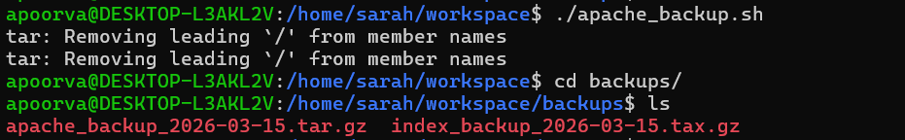
Cron job to run every Tuesday at 12:00 AM to backup the apache server:
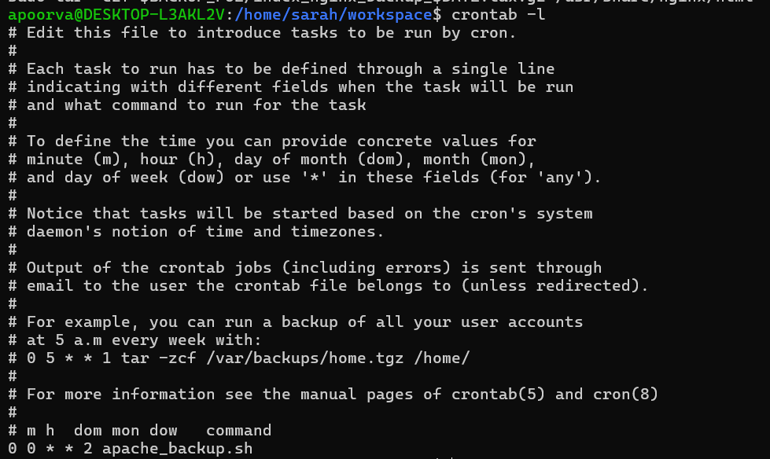
Script to backup the nginx server:
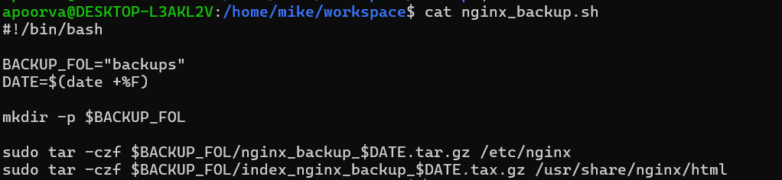
Run the backup script to create tar files for nginx and document root
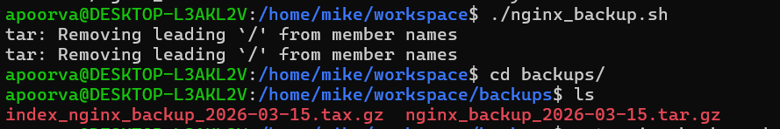
Cron job to run nginx server every Tuesday at 12:00 AM:
