Contents
1. Jenkins CI CD pipeline for flask application 3
1. Setup: 3
- Install Jenkins on a virtual machine or use a cloud-based Jenkins service. 3
- Configure Jenkins with Python and any necessary libraries. 3
2. Source Code: 9
- Fork the provided Python web application repository on GitHub (provide a link to a sample Python web application repository). 9
- Clone the forked repository into your Jenkins server. 9
3. Jenkins Pipeline: 14
- Create a Jenkinsfile in the root of your Python application repository. 14
- Define a pipeline with the following stages: 14
- Build: Install dependencies using pip. 14
- Test: Run unit tests using a testing framework like pytest. 14
- Deploy: If tests pass, deploy the application to a staging environment. 14
GitHub Actions CI/CD Pipeline Flask App 36
1. Setup: 36
- Use a provided Python application repository on GitHub (provide a link to a sample Python application repository). 36
- Ensure the repository has a main branch and a staging branch. 36
2. GitHub Actions Workflow: 37
- Create a .github/workflows directory in your repository. 37
- Inside the directory, create a YAML file to define the workflow. 37
4. Environment Secrets: 41
- Use GitHub Secrets to store sensitive information required for deployments (e.g., deployment keys, API tokens). 41
3. Workflow Steps: 42
- Define a workflow that performs the following jobs: 42
- Install Dependencies: Install all necessary dependencies for the Python application using pip. 42
- Run Tests: Execute the test suite using a framework like pytest. 42
- Build: If tests pass, prepare the application for deployment. 42
- Deploy to Staging: Deploy the application to a staging environment when changes are pushed to the staging branch. 42
- Deploy to Production: Deploy the application to production when a release is tagged. 42

1. Jenkins CI CD pipeline for flask application

1. Setup:

- Install Jenkins on a virtual machine or use a cloud-based Jenkins service.

- Configure Jenkins with Python and any necessary libraries.

Launch an EC2 instance:
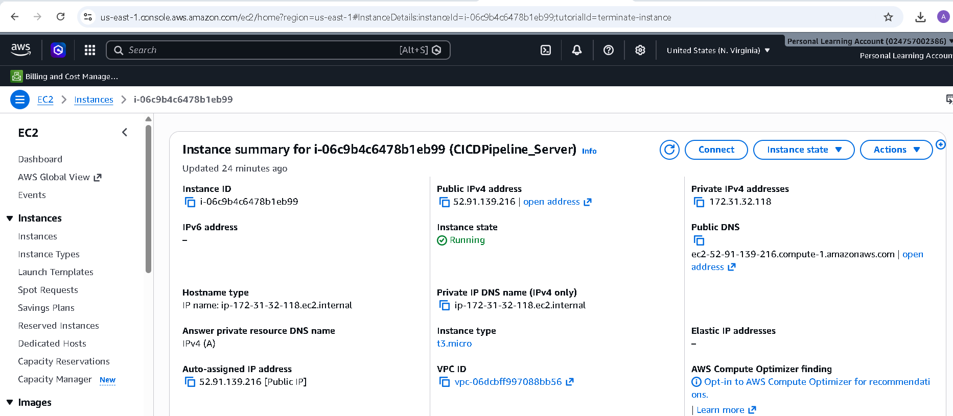

Install Java on EC2 server
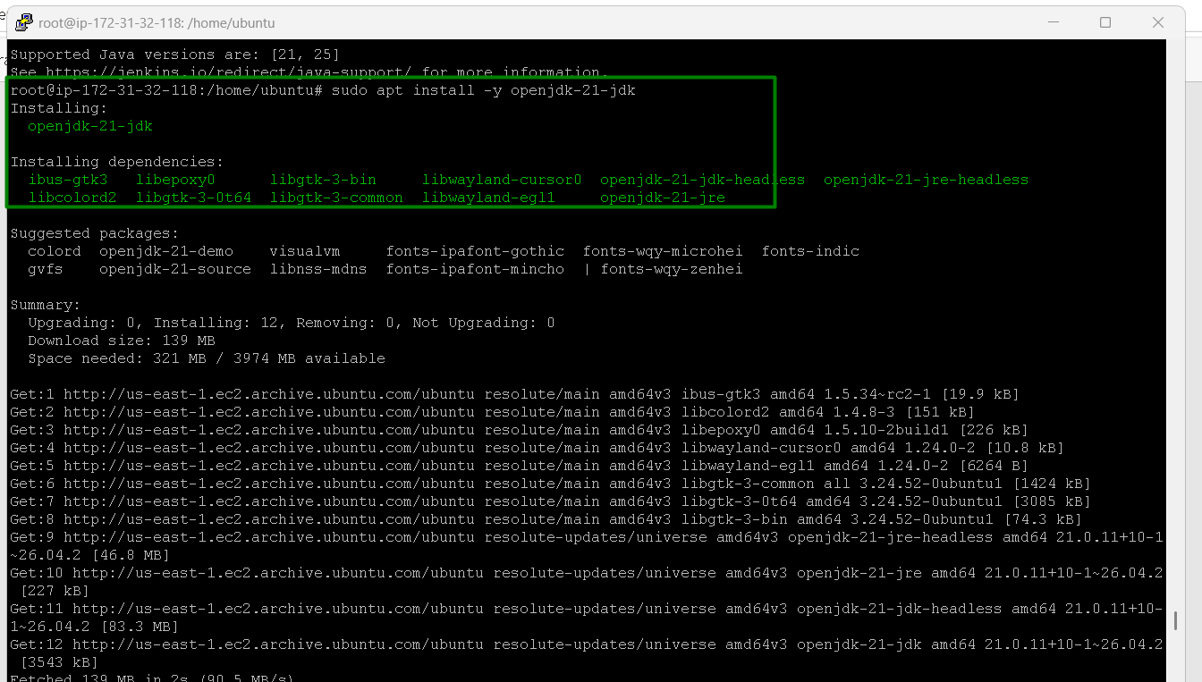
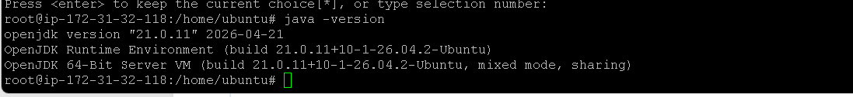

Install Jenkins:
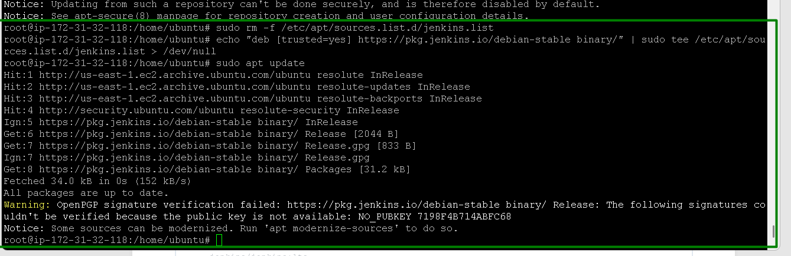
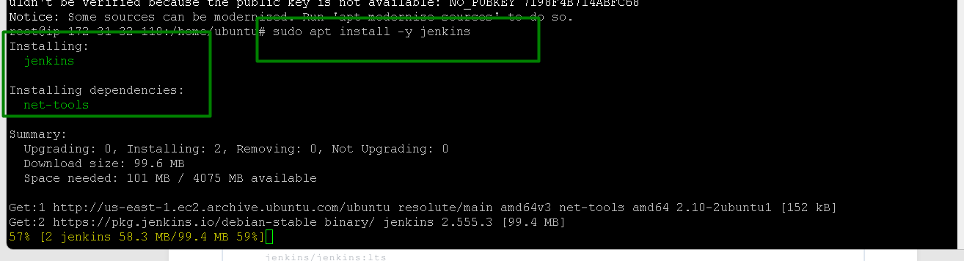
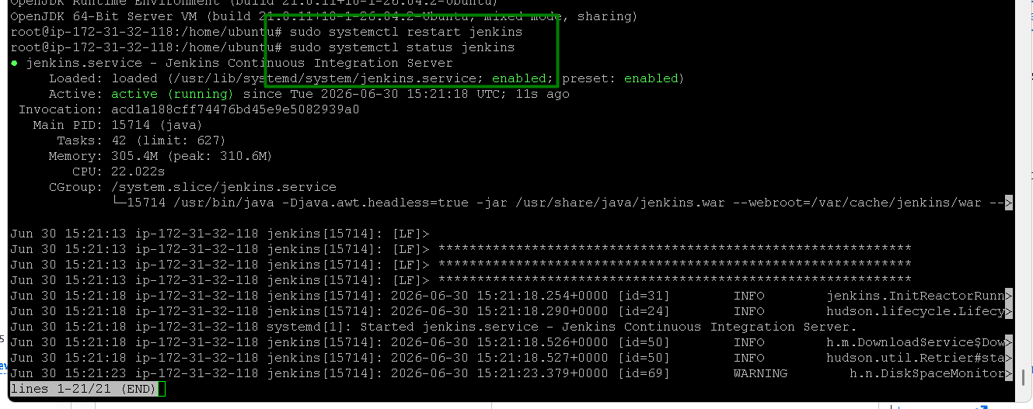
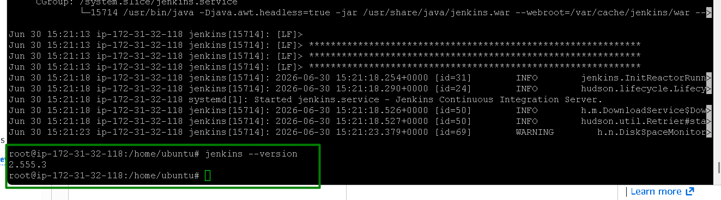

Install Python and Pip:
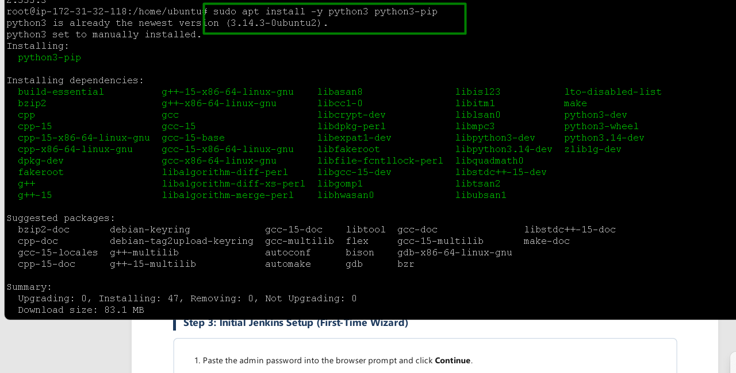
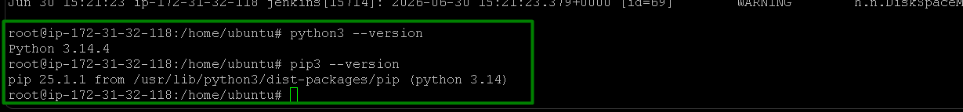

Install python3-venv:
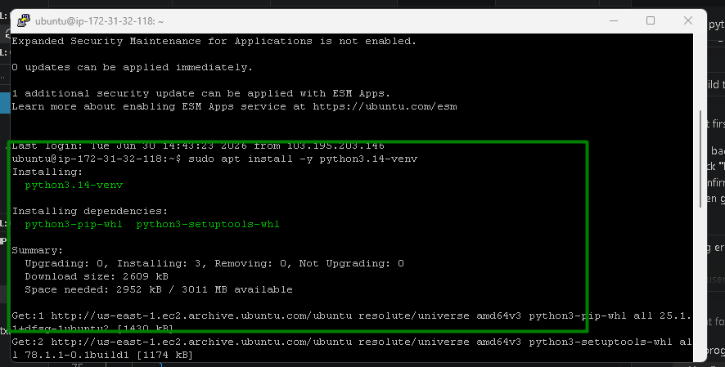

Get Jenkins admin password:
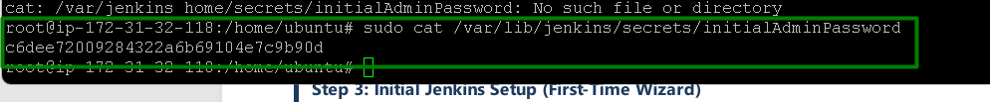

Access Jenkins:
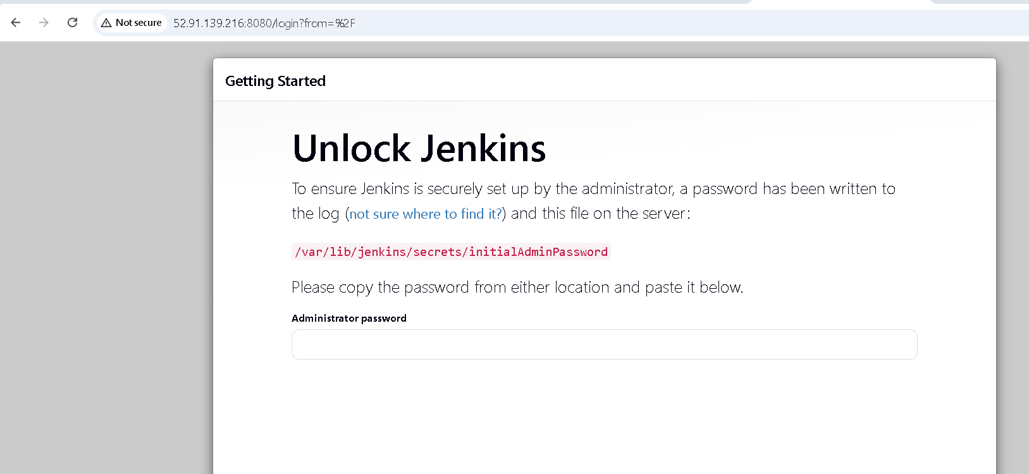

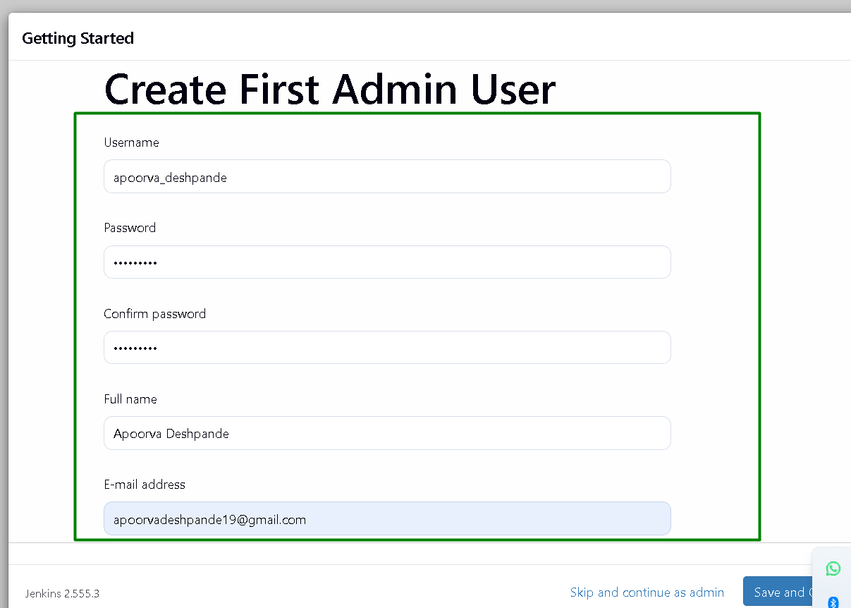

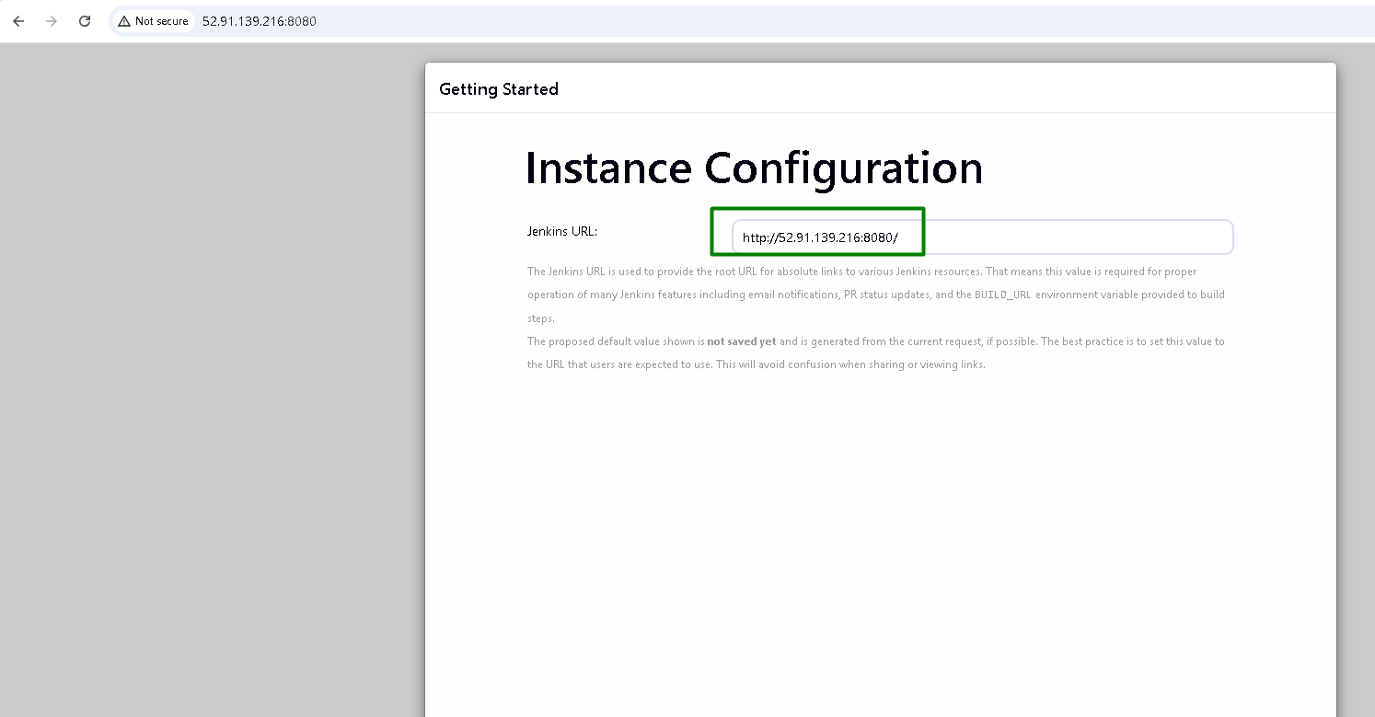

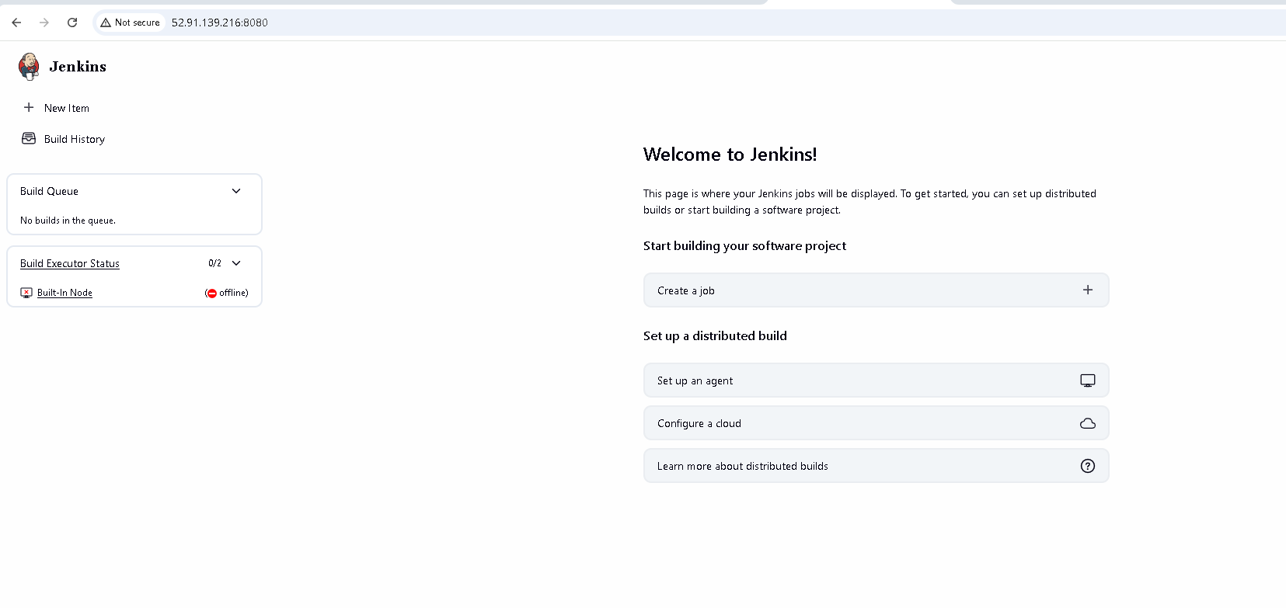

2. Source Code:

- Fork the provided Python web application repository on GitHub (provide a link to a sample Python web application repository).

- Clone the forked repository into your Jenkins server.

Git Repo created for a Flask Web application
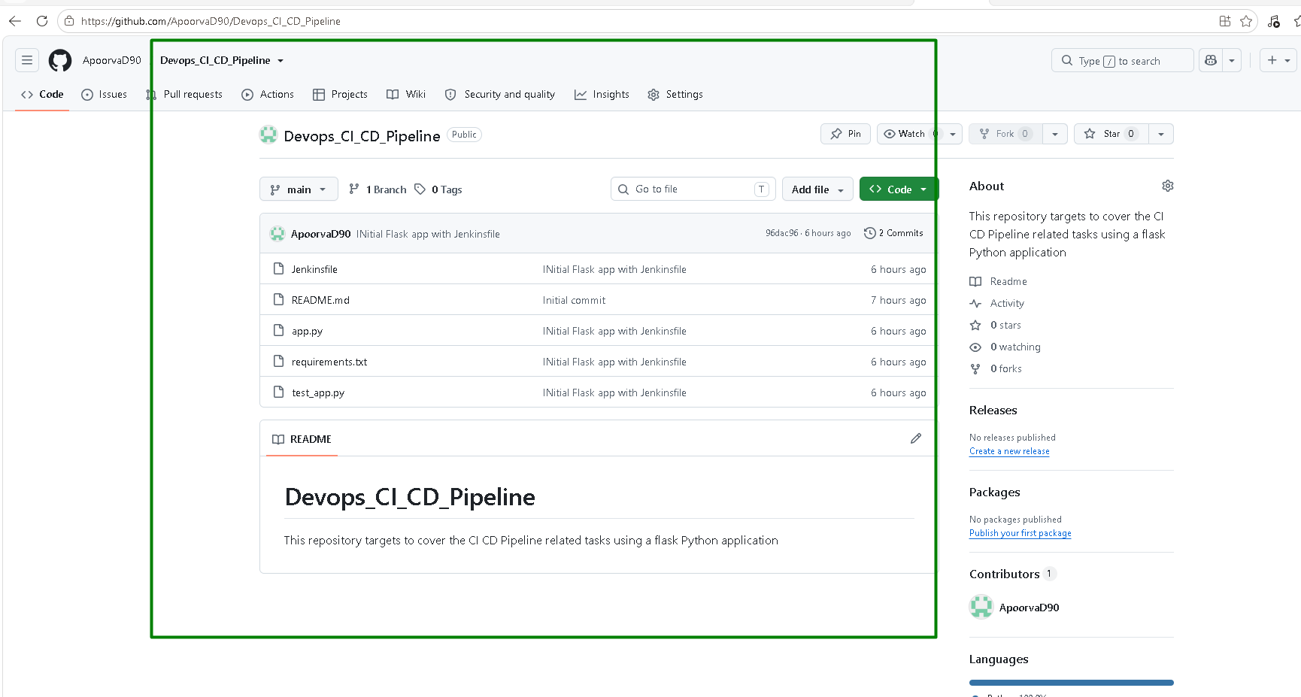

Configure Email notification on Jenkins:
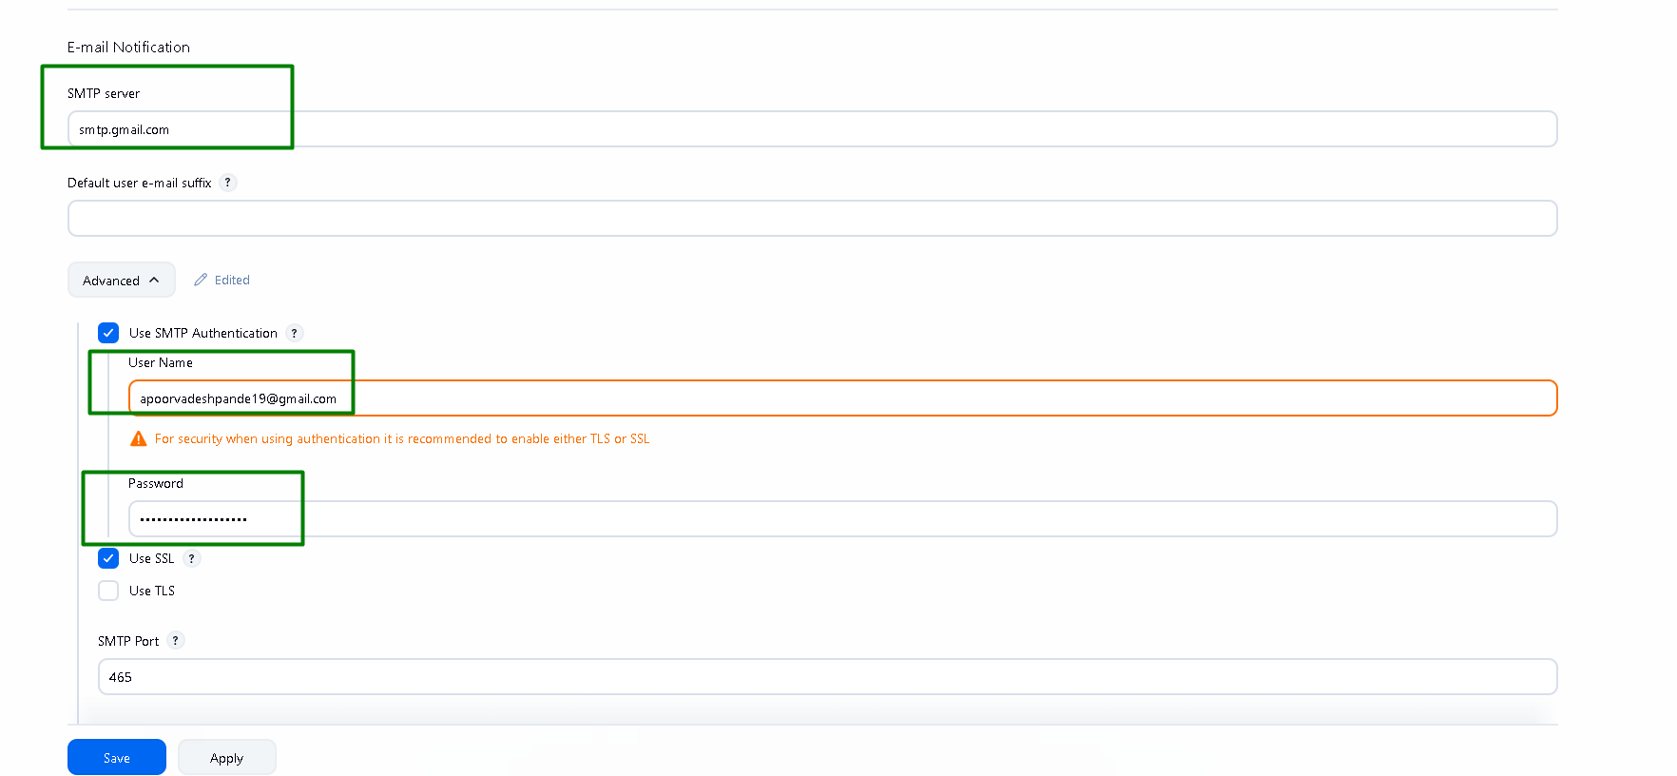

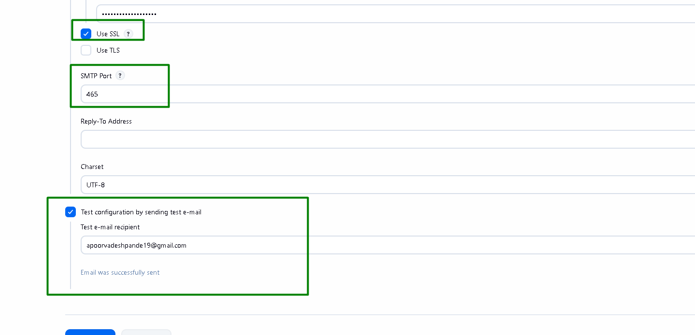

Connect Jenkins to GitHub and generate a GitHub Personal Access Token
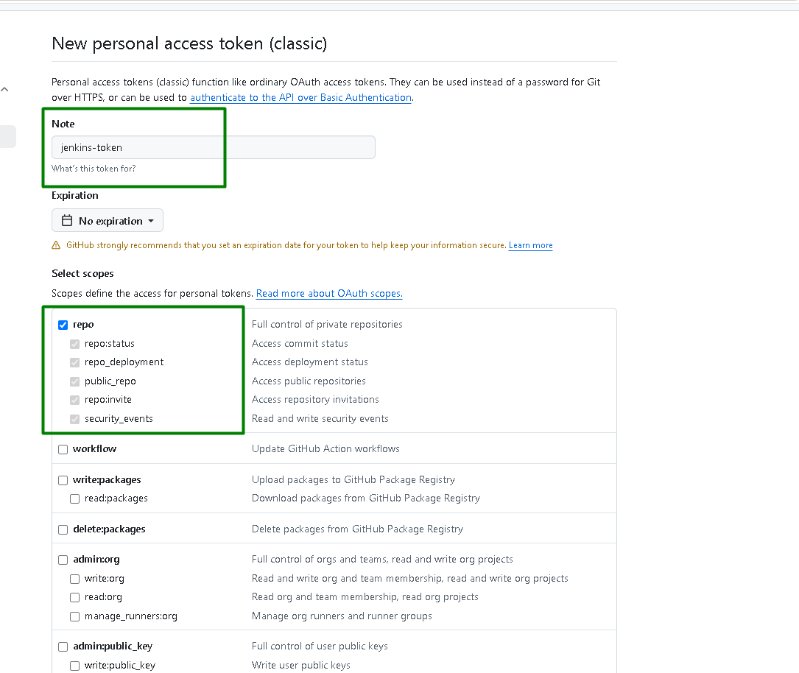
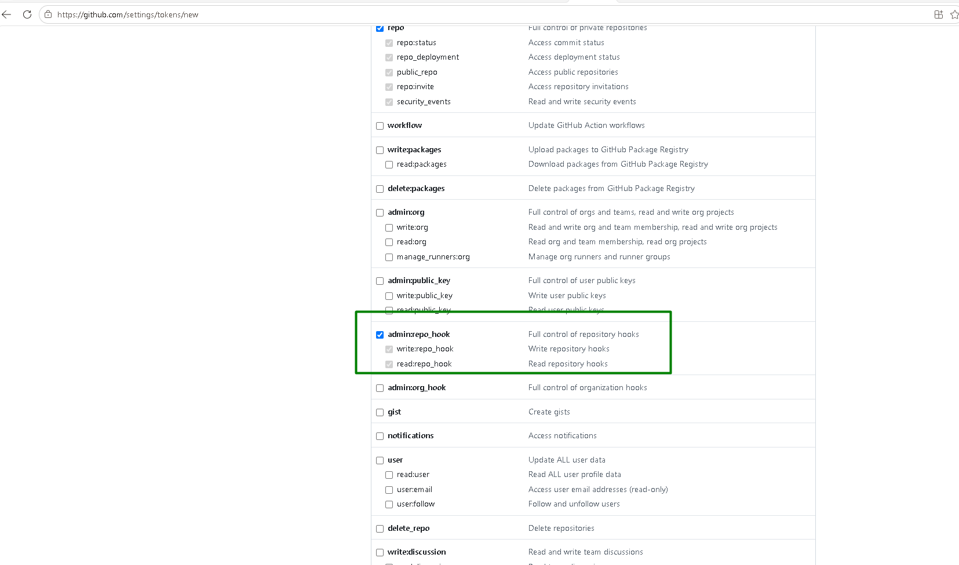

Add Credentials to Jenkins:
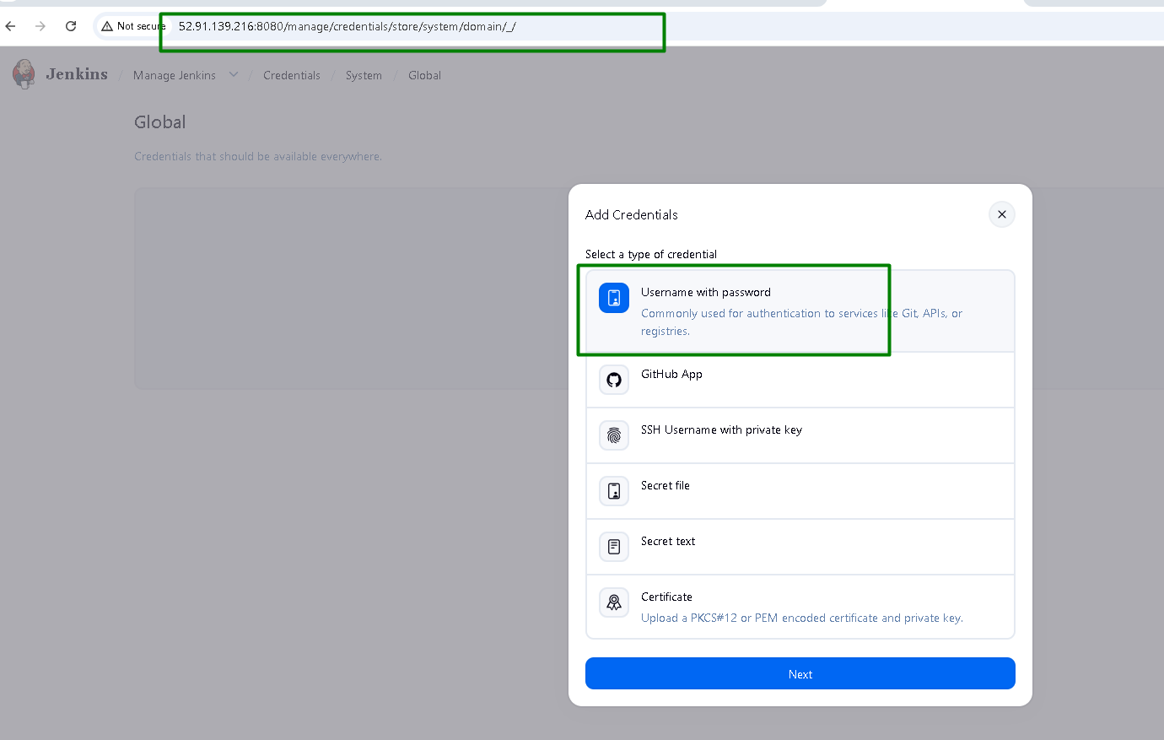
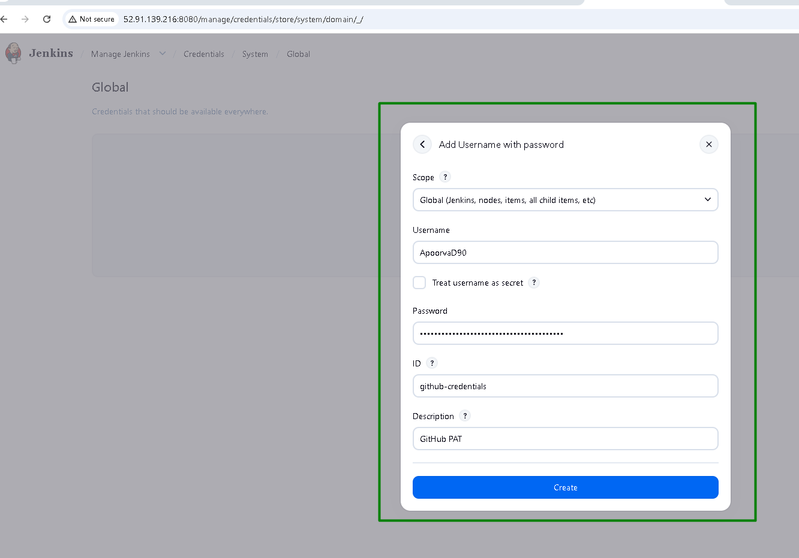
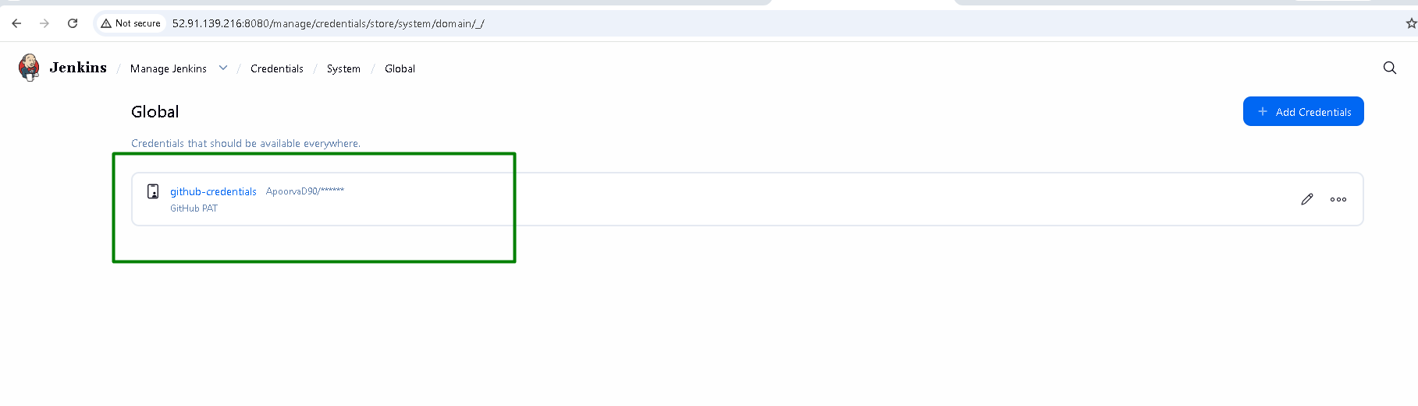

Note: Jenkins automatically clones the repo every time the pipeline runs so we do not manually need to clone the repo

3. Jenkins Pipeline:

- Create a Jenkinsfile in the root of your Python application repository.

- Define a pipeline with the following stages:

- Build: Install dependencies using pip.

- Test: Run unit tests using a testing framework like pytest.

- Deploy: If tests pass, deploy the application to a staging environment.

Jenkinsfile created in the repo
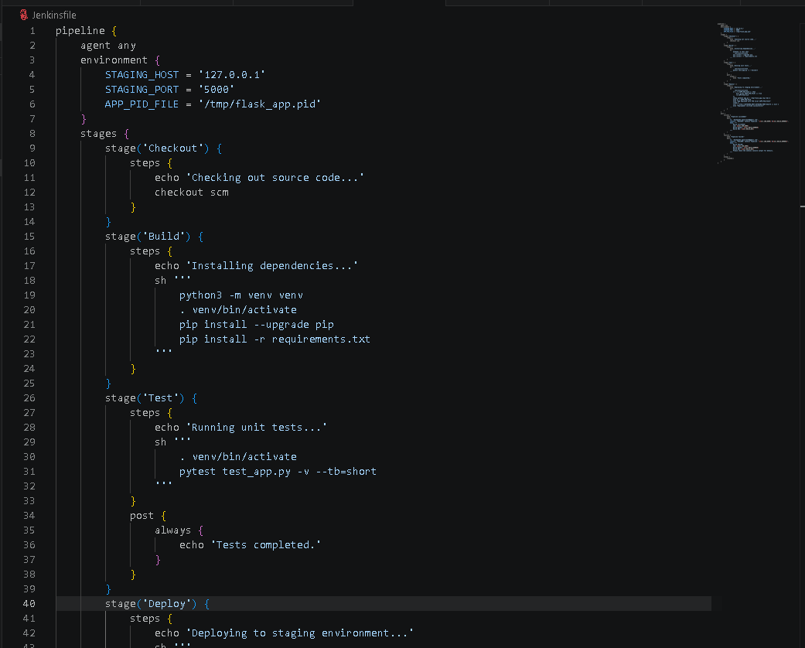

Create a Jenkins Pipeline Job
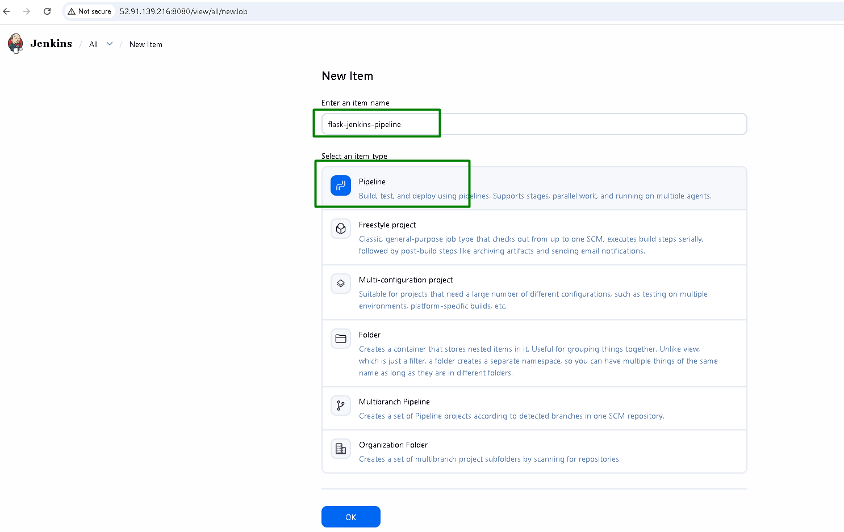
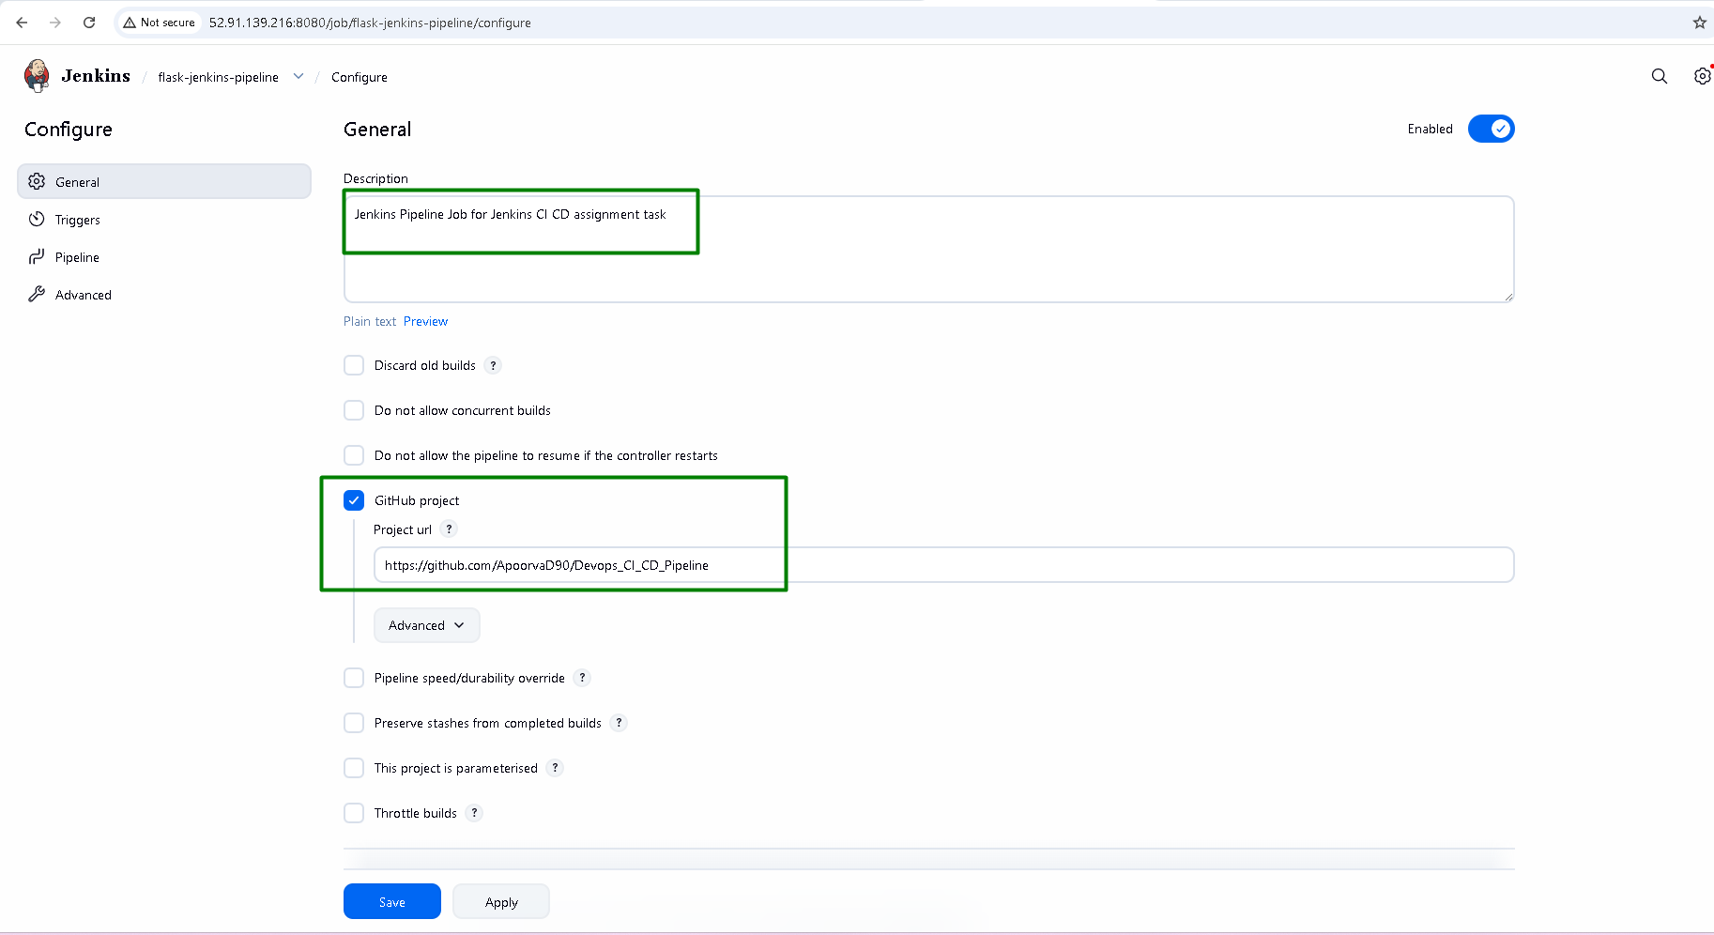
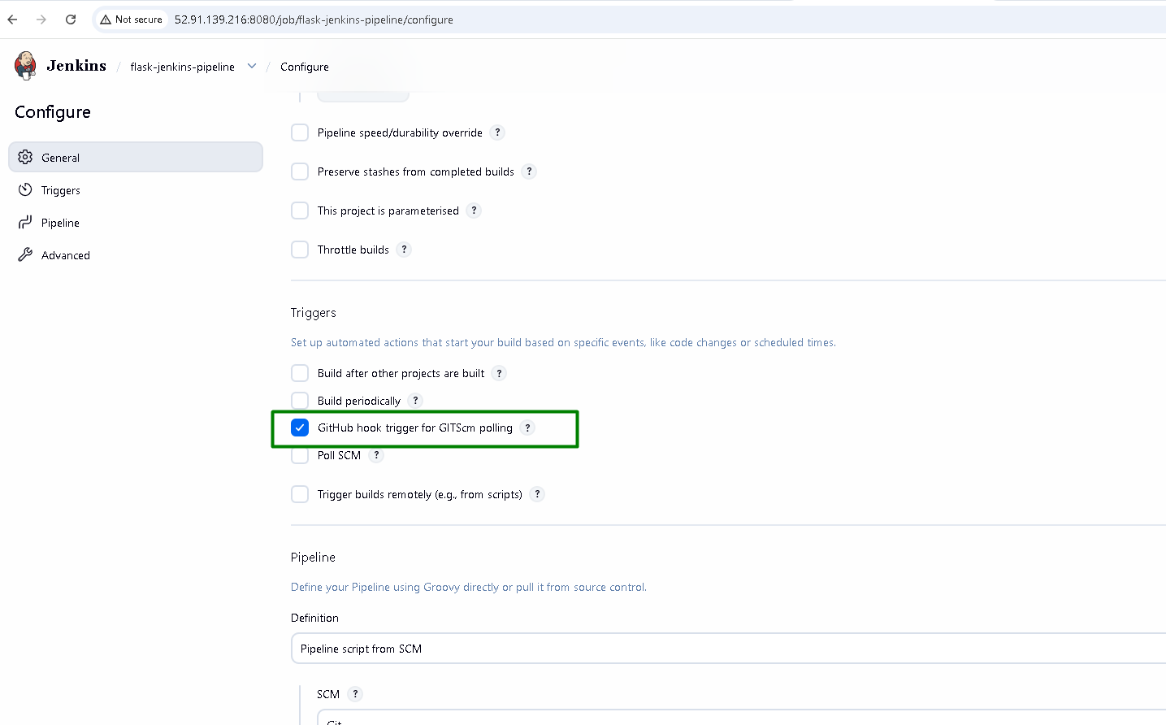
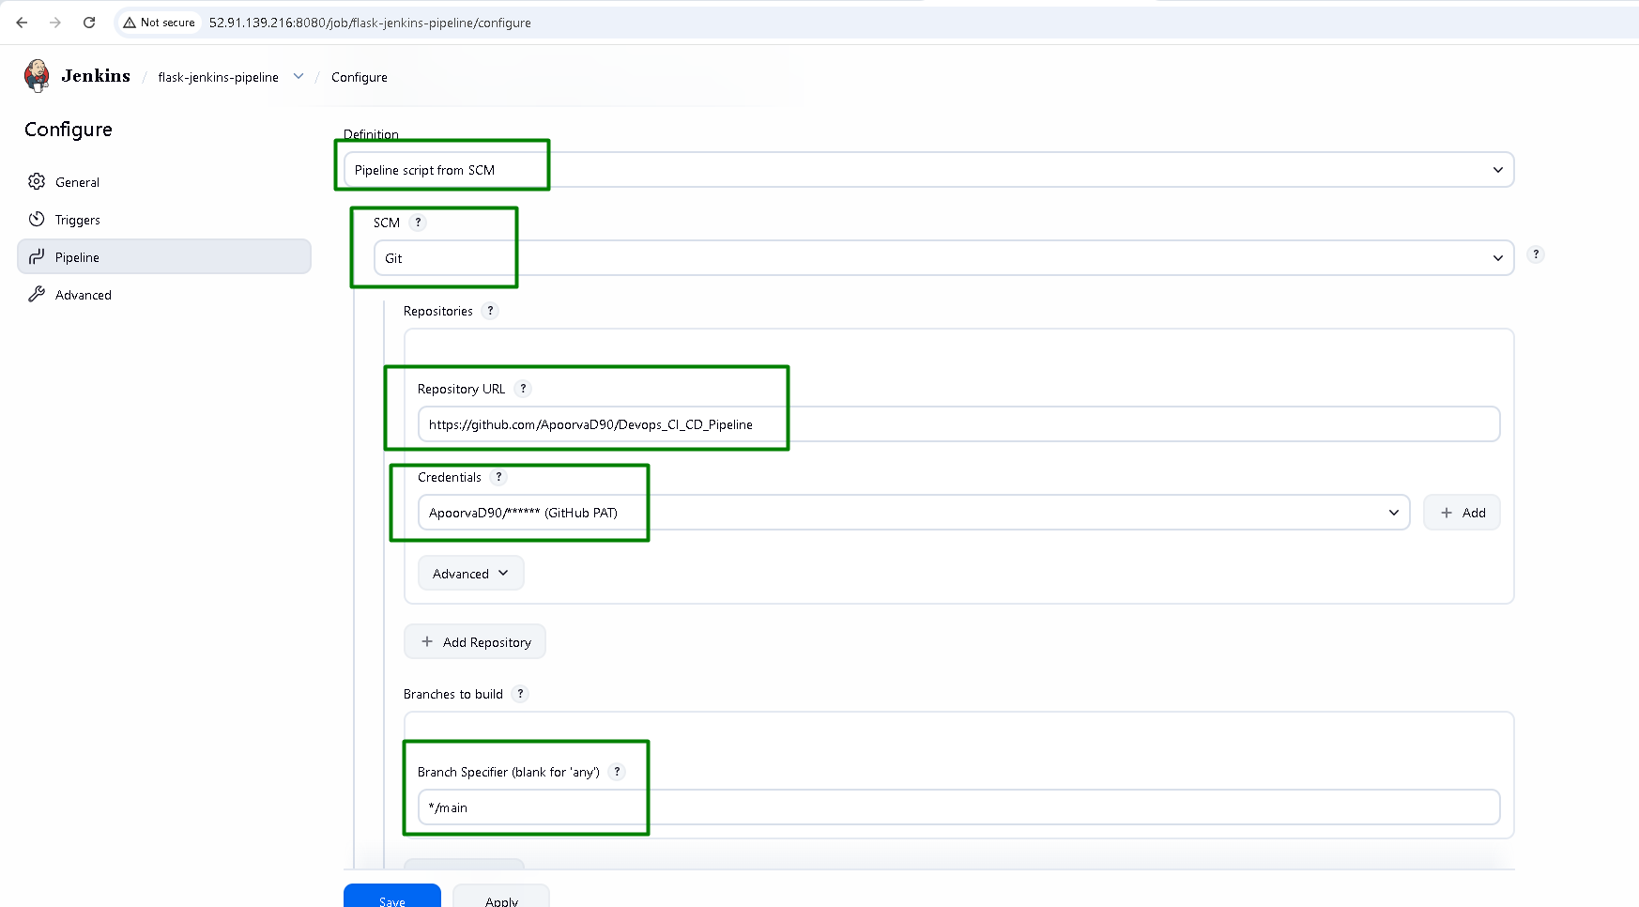
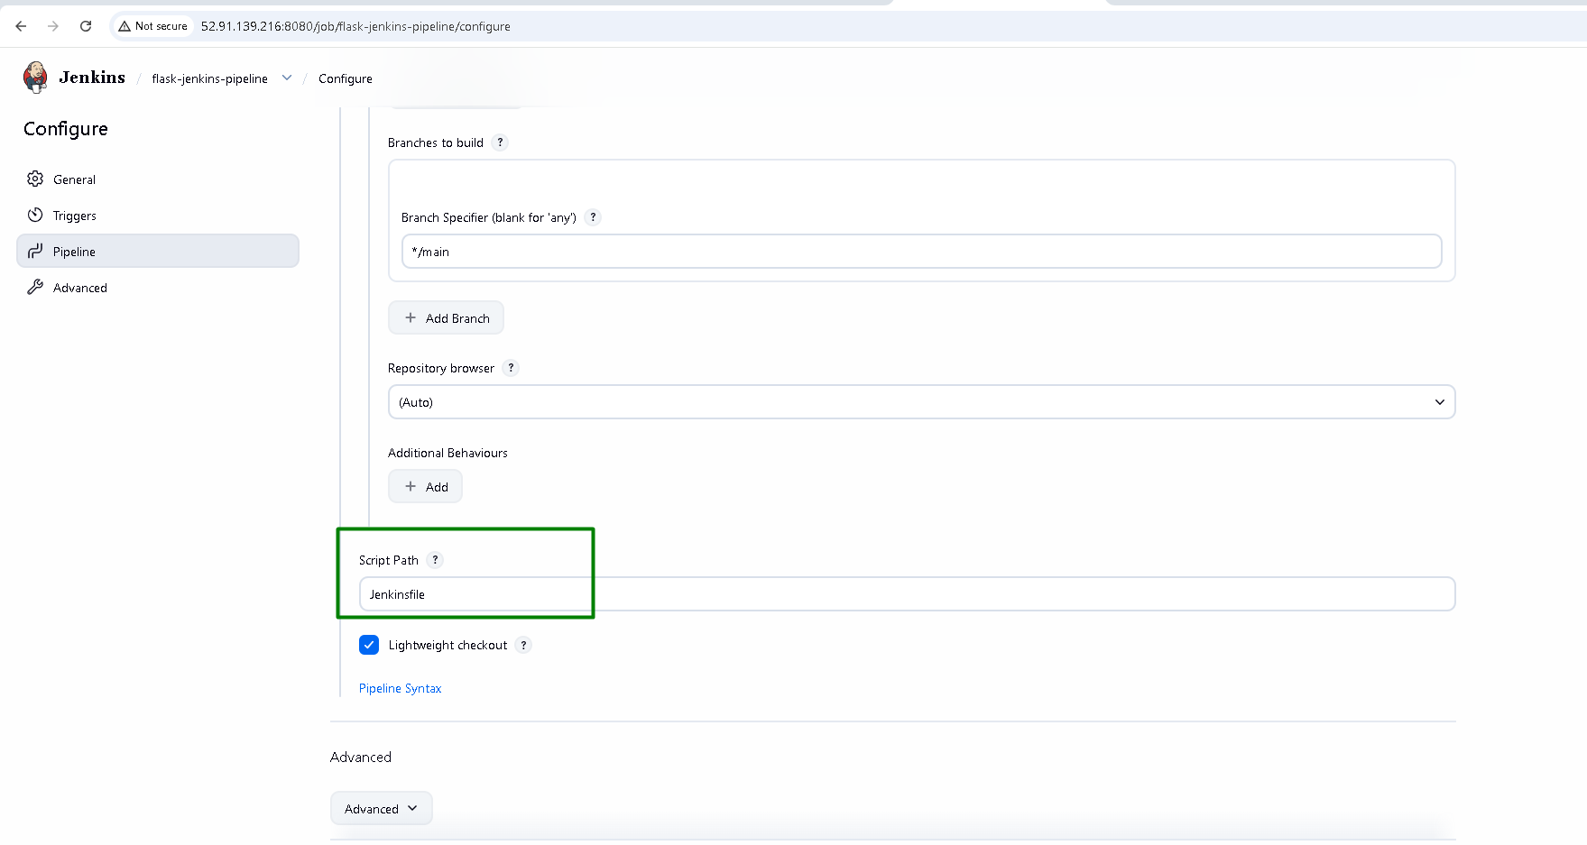

Setup GitHub Webhook (Auto Trigger)
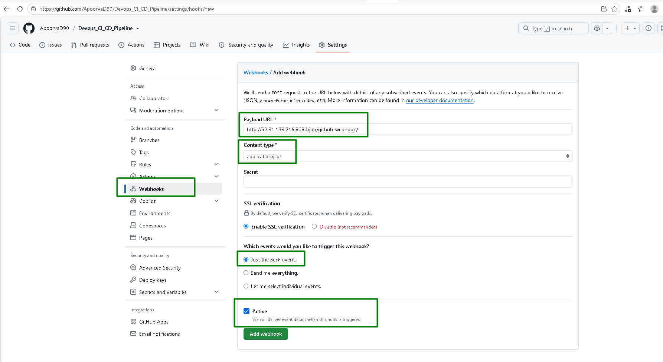

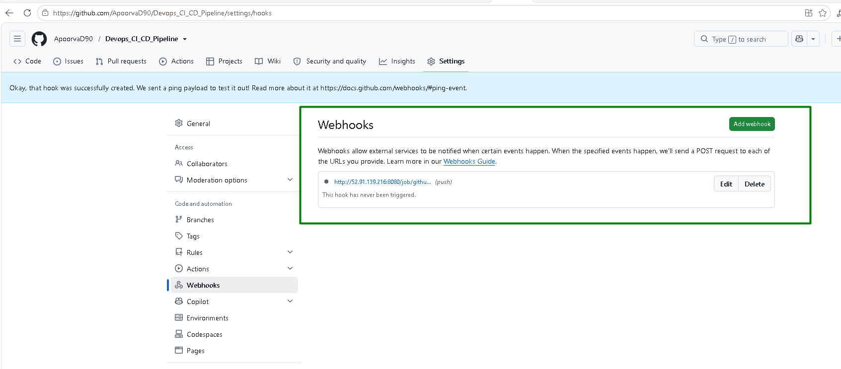

Update the payload URL:
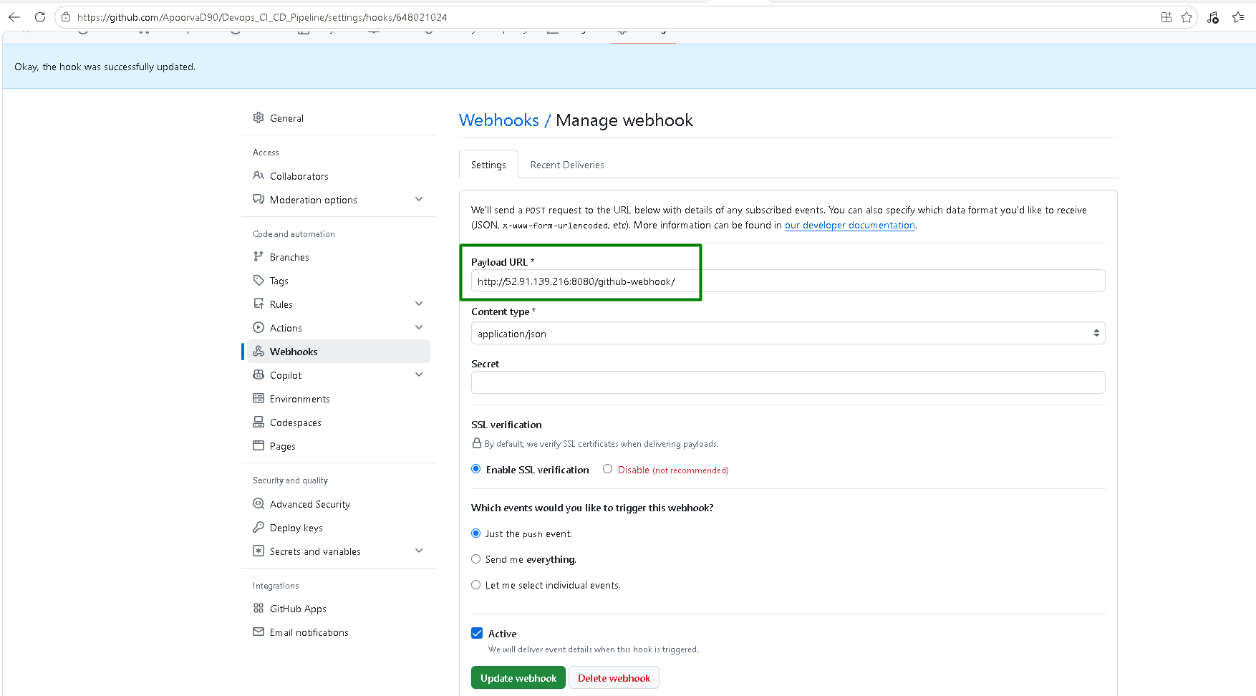

Run the pipeline manually:
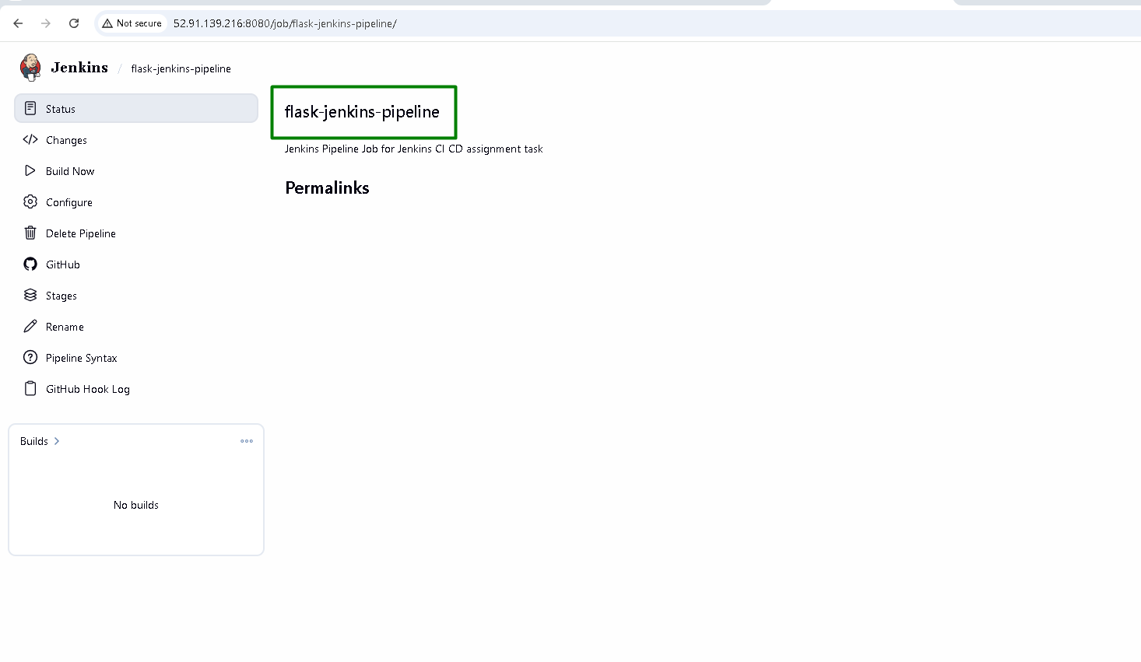
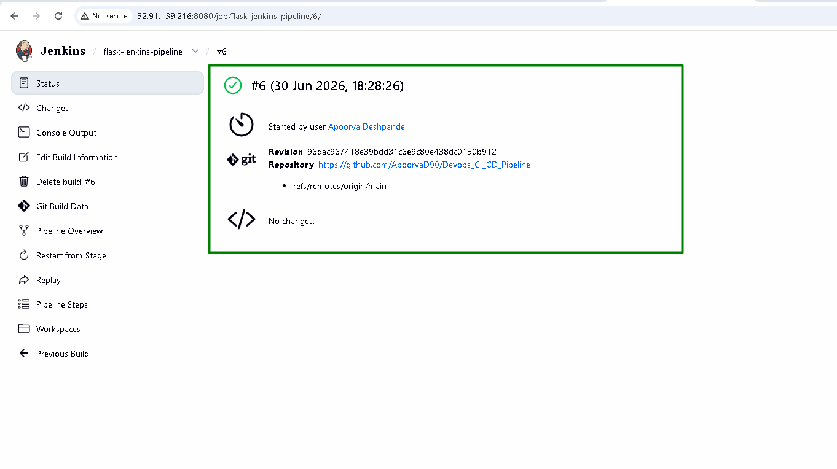
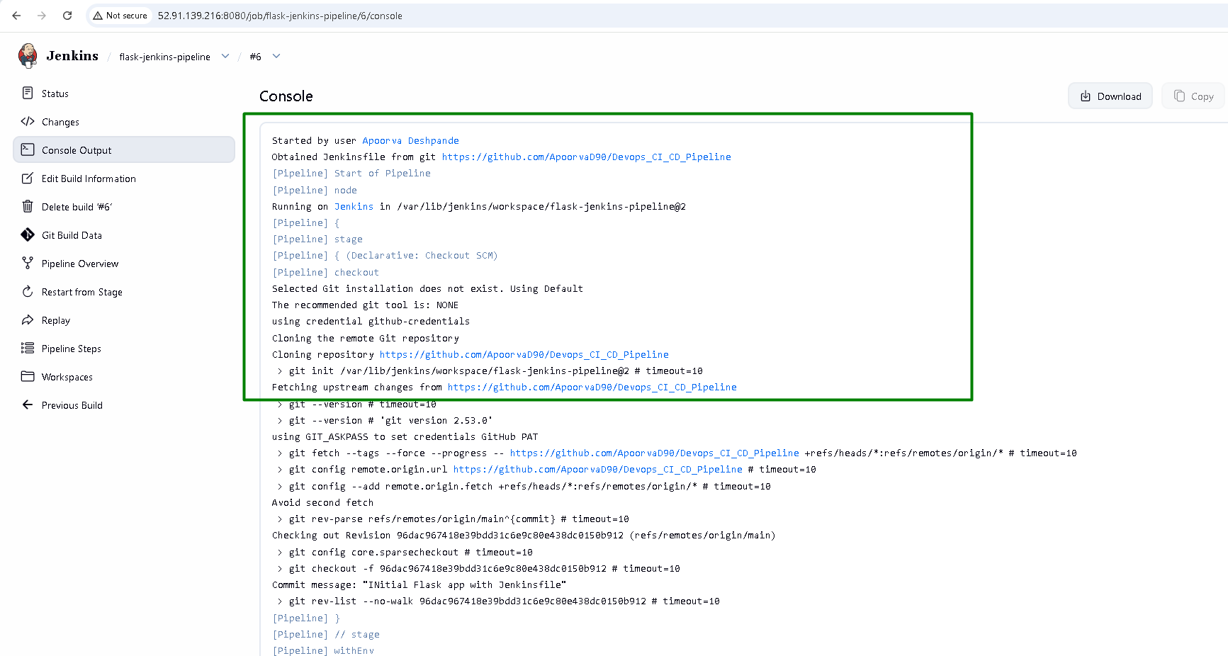

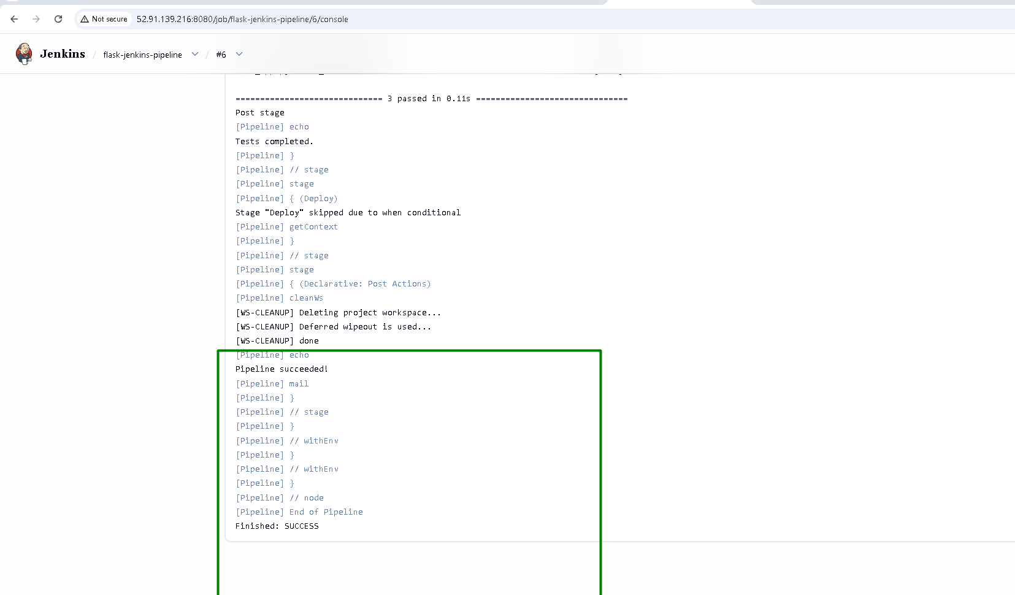

The pipeline is automatically executed when changes are pushed to the main branch:
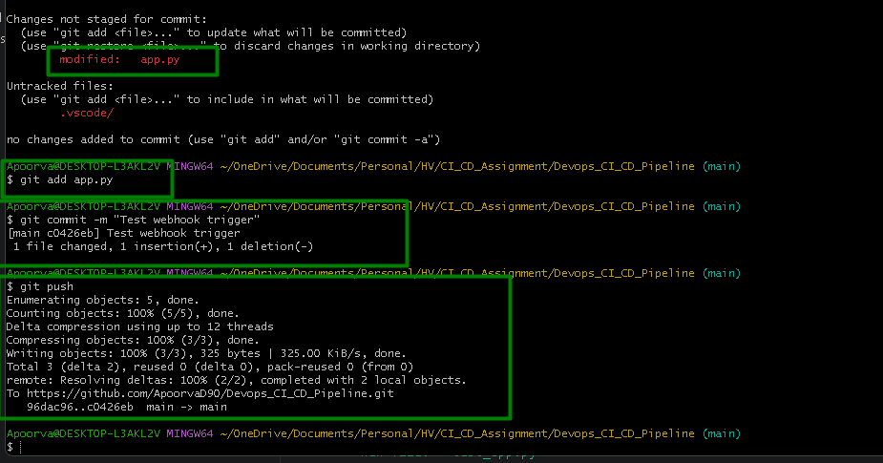

GitHub Webhook recent delivery is successful:
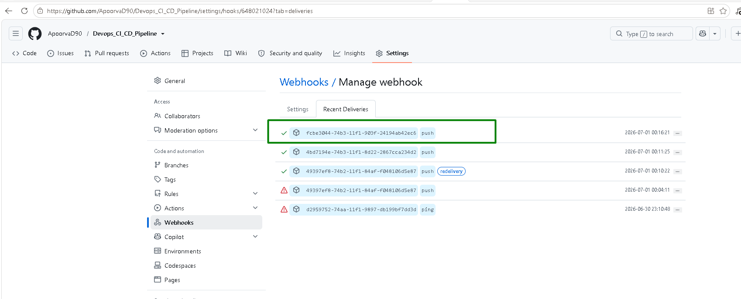
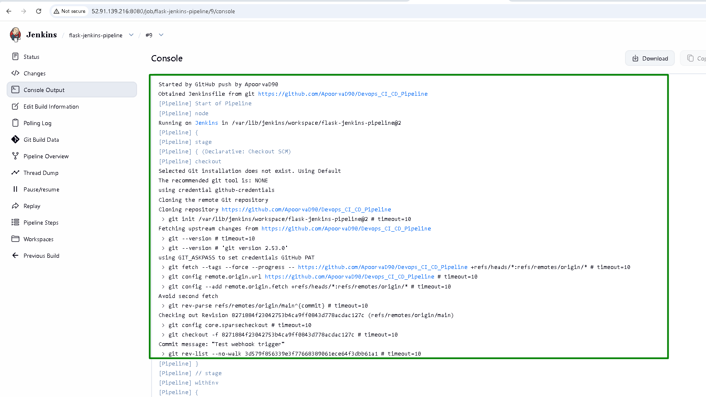
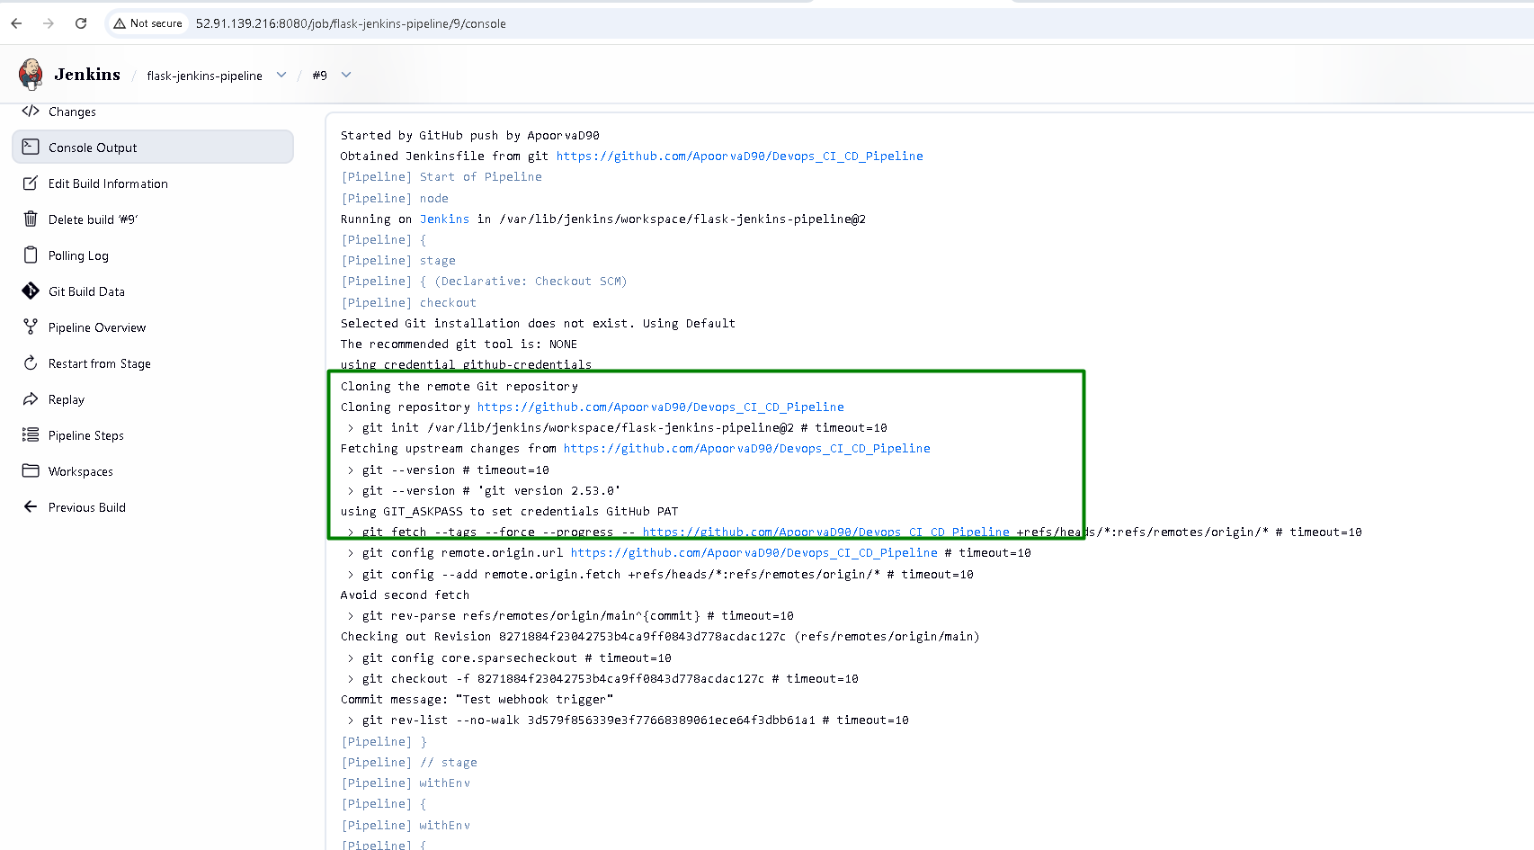

Build Stage displayed in the console output
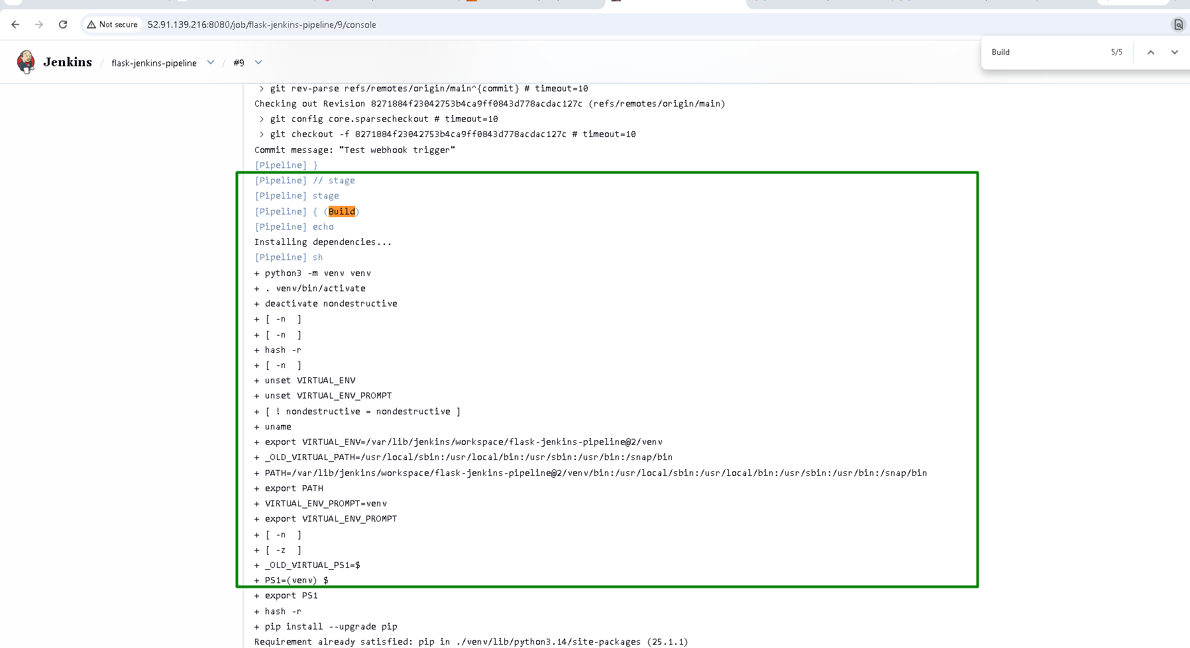

Test stage displayed in the console output
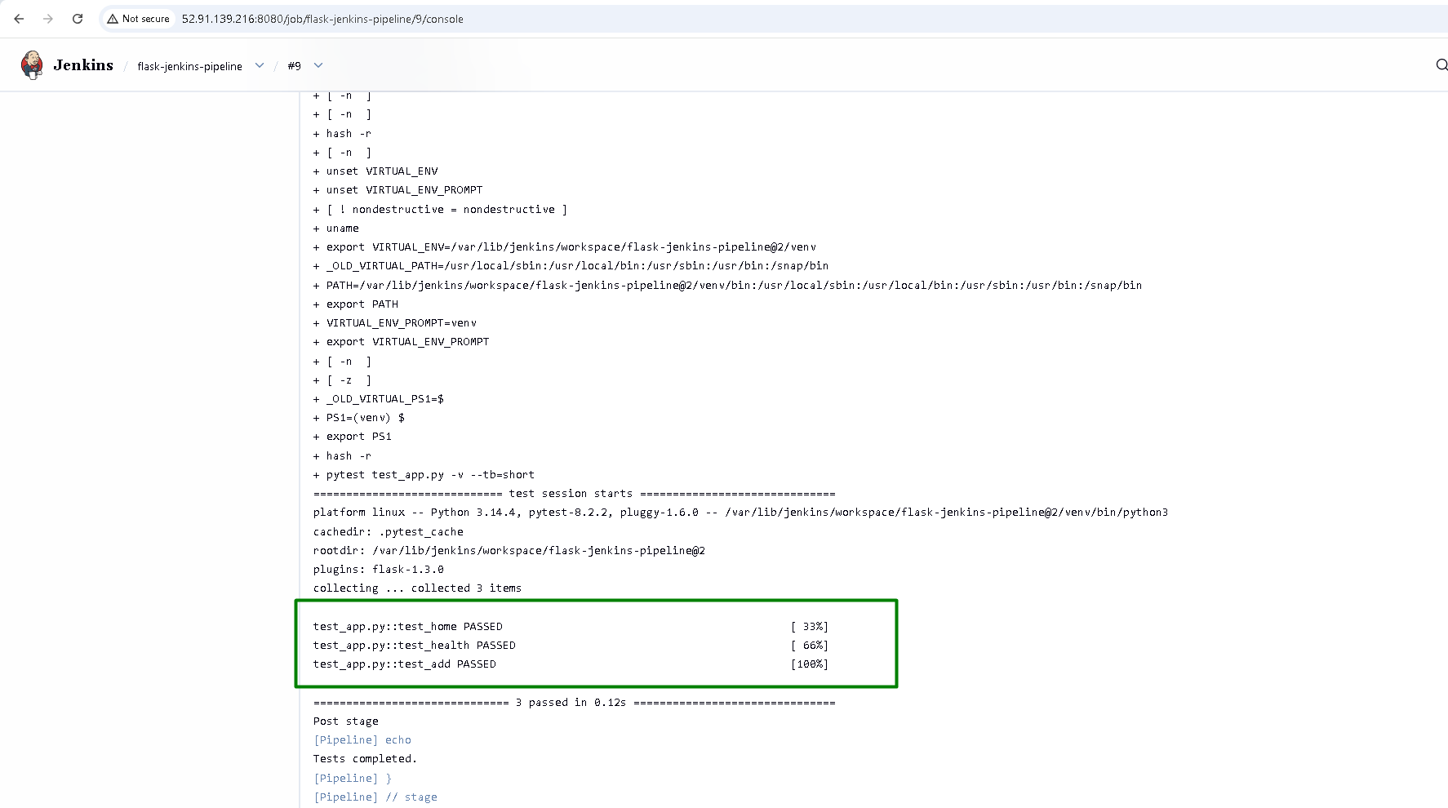

Deploy stage displayed in the console output
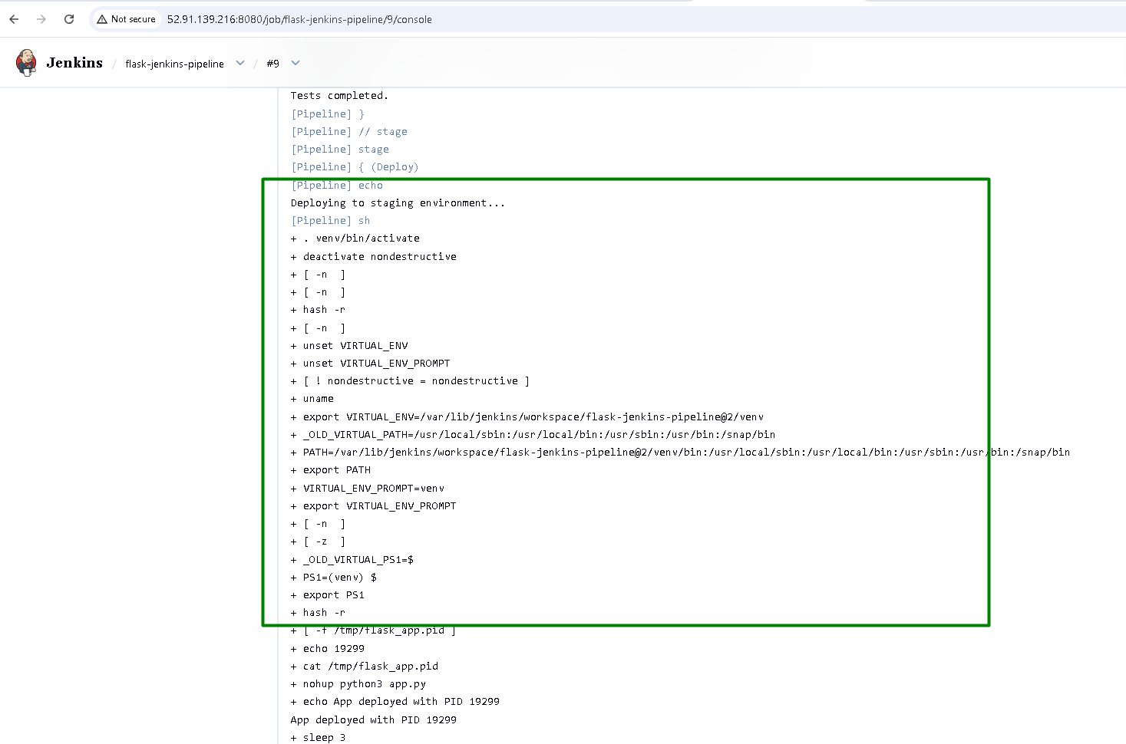

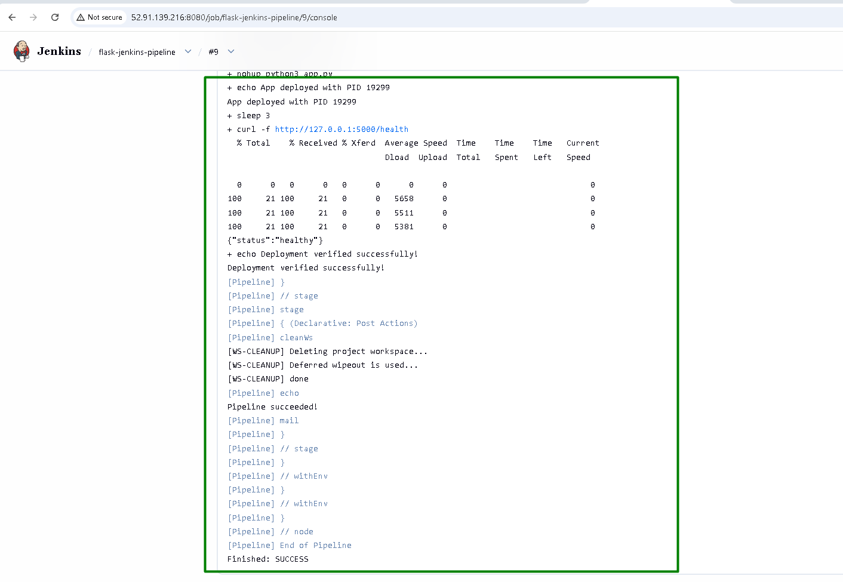
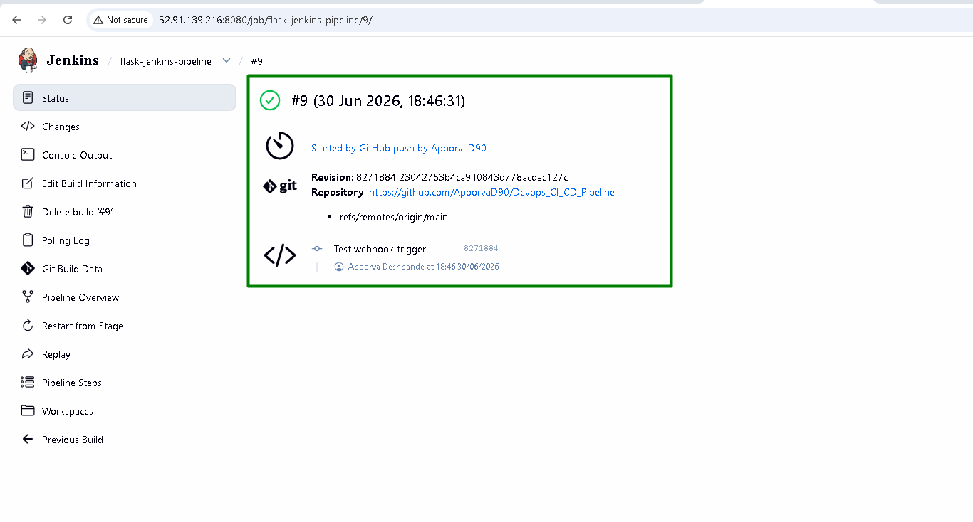

The complete console output is as below:

Started by GitHub push by ApoorvaD90
Obtained Jenkinsfile from git https://github.com/ApoorvaD90/Devops_CI_CD_Pipeline
[Pipeline] Start of Pipeline
[Pipeline] node
Running on Jenkins in /var/lib/jenkins/workspace/flask-jenkins-pipeline@2
[Pipeline] {
[Pipeline] stage
[Pipeline] { (Declarative: Checkout SCM)
[Pipeline] checkout
Selected Git installation does not exist. Using Default
The recommended git tool is: NONE
using credential github-credentials
Cloning the remote Git repository
Cloning repository https://github.com/ApoorvaD90/Devops_CI_CD_Pipeline
> git init /var/lib/jenkins/workspace/flask-jenkins-pipeline@2 # timeout=10
Fetching upstream changes from https://github.com/ApoorvaD90/Devops_CI_CD_Pipeline
> git --version # timeout=10
> git --version # 'git version 2.53.0'
using GIT_ASKPASS to set credentials GitHub PAT
> git fetch --tags --force --progress -- https://github.com/ApoorvaD90/Devops_CI_CD_Pipeline +refs/heads/*:refs/remotes/origin/* # timeout=10
> git config remote.origin.url https://github.com/ApoorvaD90/Devops_CI_CD_Pipeline # timeout=10
> git config --add remote.origin.fetch +refs/heads/*:refs/remotes/origin/* # timeout=10
Avoid second fetch
> git rev-parse refs/remotes/origin/main^{commit} # timeout=10
Checking out Revision 8271884f23042753b4ca9ff0843d778acdac127c (refs/remotes/origin/main)
> git config core.sparsecheckout # timeout=10
> git checkout -f 8271884f23042753b4ca9ff0843d778acdac127c # timeout=10
Commit message: "Test webhook trigger"
> git rev-list --no-walk 3d579f856339e3f77668389061ece64f3dbb61a1 # timeout=10
[Pipeline] }
[Pipeline] // stage
[Pipeline] withEnv
[Pipeline] {
[Pipeline] withEnv
[Pipeline] {
[Pipeline] stage
[Pipeline] { (Checkout)
[Pipeline] echo
Checking out source code...
[Pipeline] checkout
Selected Git installation does not exist. Using Default
The recommended git tool is: NONE
using credential github-credentials
> git rev-parse --resolve-git-dir /var/lib/jenkins/workspace/flask-jenkins-pipeline@2/.git # timeout=10
Fetching changes from the remote Git repository
> git config remote.origin.url https://github.com/ApoorvaD90/Devops_CI_CD_Pipeline # timeout=10
Fetching upstream changes from https://github.com/ApoorvaD90/Devops_CI_CD_Pipeline
> git --version # timeout=10
> git --version # 'git version 2.53.0'
using GIT_ASKPASS to set credentials GitHub PAT
> git fetch --tags --force --progress -- https://github.com/ApoorvaD90/Devops_CI_CD_Pipeline +refs/heads/*:refs/remotes/origin/* # timeout=10
> git rev-parse refs/remotes/origin/main^{commit} # timeout=10
Checking out Revision 8271884f23042753b4ca9ff0843d778acdac127c (refs/remotes/origin/main)
> git config core.sparsecheckout # timeout=10
> git checkout -f 8271884f23042753b4ca9ff0843d778acdac127c # timeout=10
Commit message: "Test webhook trigger"
[Pipeline] }
[Pipeline] // stage
[Pipeline] stage
[Pipeline] { (Build)
[Pipeline] echo
Installing dependencies...
[Pipeline] sh
+ python3 -m venv venv
+ . venv/bin/activate
+ deactivate nondestructive
+ [ -n ]
+ [ -n ]
+ hash -r
+ [ -n ]
+ unset VIRTUAL_ENV
+ unset VIRTUAL_ENV_PROMPT
+ [ ! nondestructive = nondestructive ]
+ uname
+ export VIRTUAL_ENV=/var/lib/jenkins/workspace/flask-jenkins-pipeline@2/venv
+ _OLD_VIRTUAL_PATH=/usr/local/sbin:/usr/local/bin:/usr/sbin:/usr/bin:/snap/bin
+ PATH=/var/lib/jenkins/workspace/flask-jenkins-pipeline@2/venv/bin:/usr/local/sbin:/usr/local/bin:/usr/sbin:/usr/bin:/snap/bin
+ export PATH
+ VIRTUAL_ENV_PROMPT=venv
+ export VIRTUAL_ENV_PROMPT
+ [ -n ]
+ [ -z ]
+ _OLD_VIRTUAL_PS1=$
+ PS1=(venv) $
+ export PS1
+ hash -r
+ pip install --upgrade pip
Requirement already satisfied: pip in ./venv/lib/python3.14/site-packages (25.1.1)
Collecting pip
Using cached pip-26.1.2-py3-none-any.whl.metadata (4.6 kB)
Using cached pip-26.1.2-py3-none-any.whl (1.8 MB)
Installing collected packages: pip
Attempting uninstall: pip
Found existing installation: pip 25.1.1
Uninstalling pip-25.1.1:
Successfully uninstalled pip-25.1.1
Successfully installed pip-26.1.2
+ pip install -r requirements.txt
Collecting flask==3.0.3 (from -r requirements.txt (line 1))
Using cached flask-3.0.3-py3-none-any.whl.metadata (3.2 kB)
Collecting pytest==8.2.2 (from -r requirements.txt (line 2))
Using cached pytest-8.2.2-py3-none-any.whl.metadata (7.6 kB)
Collecting pytest-flask==1.3.0 (from -r requirements.txt (line 3))
Using cached pytest_flask-1.3.0-py3-none-any.whl.metadata (14 kB)
Collecting Werkzeug>=3.0.0 (from flask==3.0.3->-r requirements.txt (line 1))
Using cached werkzeug-3.1.8-py3-none-any.whl.metadata (4.0 kB)
Collecting Jinja2>=3.1.2 (from flask==3.0.3->-r requirements.txt (line 1))
Using cached jinja2-3.1.6-py3-none-any.whl.metadata (2.9 kB)
Collecting itsdangerous>=2.1.2 (from flask==3.0.3->-r requirements.txt (line 1))
Using cached itsdangerous-2.2.0-py3-none-any.whl.metadata (1.9 kB)
Collecting click>=8.1.3 (from flask==3.0.3->-r requirements.txt (line 1))
Using cached click-8.4.2-py3-none-any.whl.metadata (2.6 kB)
Collecting blinker>=1.6.2 (from flask==3.0.3->-r requirements.txt (line 1))
Using cached blinker-1.9.0-py3-none-any.whl.metadata (1.6 kB)
Collecting iniconfig (from pytest==8.2.2->-r requirements.txt (line 2))
Using cached iniconfig-2.3.0-py3-none-any.whl.metadata (2.5 kB)
Collecting packaging (from pytest==8.2.2->-r requirements.txt (line 2))
Using cached packaging-26.2-py3-none-any.whl.metadata (3.5 kB)
Collecting pluggy<2.0,>=1.5 (from pytest==8.2.2->-r requirements.txt (line 2))
Using cached pluggy-1.6.0-py3-none-any.whl.metadata (4.8 kB)
Collecting MarkupSafe>=2.0 (from Jinja2>=3.1.2->flask==3.0.3->-r requirements.txt (line 1))
Using cached markupsafe-3.0.3-cp314-cp314-manylinux2014_x86_64.manylinux_2_17_x86_64.manylinux_2_28_x86_64.whl.metadata (2.7 kB)
Using cached flask-3.0.3-py3-none-any.whl (101 kB)
Using cached pytest-8.2.2-py3-none-any.whl (339 kB)
Using cached pytest_flask-1.3.0-py3-none-any.whl (13 kB)
Using cached pluggy-1.6.0-py3-none-any.whl (20 kB)
Using cached blinker-1.9.0-py3-none-any.whl (8.5 kB)
Using cached click-8.4.2-py3-none-any.whl (119 kB)
Using cached itsdangerous-2.2.0-py3-none-any.whl (16 kB)
Using cached jinja2-3.1.6-py3-none-any.whl (134 kB)
Using cached markupsafe-3.0.3-cp314-cp314-manylinux2014_x86_64.manylinux_2_17_x86_64.manylinux_2_28_x86_64.whl (23 kB)
Using cached werkzeug-3.1.8-py3-none-any.whl (226 kB)
Using cached iniconfig-2.3.0-py3-none-any.whl (7.5 kB)
Using cached packaging-26.2-py3-none-any.whl (100 kB)
Installing collected packages: pluggy, packaging, MarkupSafe, itsdangerous, iniconfig, click, blinker, Werkzeug, pytest, Jinja2, flask, pytest-flask

Successfully installed Jinja2-3.1.6 MarkupSafe-3.0.3 Werkzeug-3.1.8 blinker-1.9.0 click-8.4.2 flask-3.0.3 iniconfig-2.3.0 itsdangerous-2.2.0 packaging-26.2 pluggy-1.6.0 pytest-8.2.2 pytest-flask-1.3.0
[Pipeline] }
[Pipeline] // stage
[Pipeline] stage
[Pipeline] { (Test)
[Pipeline] echo
Running unit tests...
[Pipeline] sh
+ . venv/bin/activate
+ deactivate nondestructive
+ [ -n ]
+ [ -n ]
+ hash -r
+ [ -n ]
+ unset VIRTUAL_ENV
+ unset VIRTUAL_ENV_PROMPT
+ [ ! nondestructive = nondestructive ]
+ uname
+ export VIRTUAL_ENV=/var/lib/jenkins/workspace/flask-jenkins-pipeline@2/venv
+ _OLD_VIRTUAL_PATH=/usr/local/sbin:/usr/local/bin:/usr/sbin:/usr/bin:/snap/bin
+ PATH=/var/lib/jenkins/workspace/flask-jenkins-pipeline@2/venv/bin:/usr/local/sbin:/usr/local/bin:/usr/sbin:/usr/bin:/snap/bin
+ export PATH
+ VIRTUAL_ENV_PROMPT=venv
+ export VIRTUAL_ENV_PROMPT
+ [ -n ]
+ [ -z ]
+ _OLD_VIRTUAL_PS1=$
+ PS1=(venv) $
+ export PS1
+ hash -r
+ pytest test_app.py -v --tb=short
============================= test session starts ==============================
platform linux -- Python 3.14.4, pytest-8.2.2, pluggy-1.6.0 -- /var/lib/jenkins/workspace/flask-jenkins-pipeline@2/venv/bin/python3
cachedir: .pytest_cache
rootdir: /var/lib/jenkins/workspace/flask-jenkins-pipeline@2
plugins: flask-1.3.0
collecting ... collected 3 items

test_app.py::test_home PASSED [ 33%]
test_app.py::test_health PASSED [ 66%]
test_app.py::test_add PASSED [100%]

============================== 3 passed in 0.12s ===============================
Post stage
[Pipeline] echo
Tests completed.
[Pipeline] }
[Pipeline] // stage
[Pipeline] stage
[Pipeline] { (Deploy)
[Pipeline] echo
Deploying to staging environment...
[Pipeline] sh
+ . venv/bin/activate
+ deactivate nondestructive
+ [ -n ]
+ [ -n ]
+ hash -r
+ [ -n ]
+ unset VIRTUAL_ENV
+ unset VIRTUAL_ENV_PROMPT
+ [ ! nondestructive = nondestructive ]
+ uname
+ export VIRTUAL_ENV=/var/lib/jenkins/workspace/flask-jenkins-pipeline@2/venv
+ _OLD_VIRTUAL_PATH=/usr/local/sbin:/usr/local/bin:/usr/sbin:/usr/bin:/snap/bin
+ PATH=/var/lib/jenkins/workspace/flask-jenkins-pipeline@2/venv/bin:/usr/local/sbin:/usr/local/bin:/usr/sbin:/usr/bin:/snap/bin
+ export PATH
+ VIRTUAL_ENV_PROMPT=venv
+ export VIRTUAL_ENV_PROMPT
+ [ -n ]
+ [ -z ]
+ _OLD_VIRTUAL_PS1=$
+ PS1=(venv) $
+ export PS1
+ hash -r
+ [ -f /tmp/flask_app.pid ]
+ echo 19299
+ cat /tmp/flask_app.pid
+ nohup python3 app.py
+ echo App deployed with PID 19299
App deployed with PID 19299
+ sleep 3
+ curl -f http://127.0.0.1:5000/health
% Total % Received % Xferd Average Speed Time Time Time Current
Dload Upload Total Spent Left Speed

0 0 0 0 0 0 0 0 0
100 21 100 21 0 0 5658 0 0
100 21 100 21 0 0 5511 0 0
100 21 100 21 0 0 5381 0 0
{"status":"healthy"}
+ echo Deployment verified successfully!
Deployment verified successfully!
[Pipeline] }
[Pipeline] // stage
[Pipeline] stage
[Pipeline] { (Declarative: Post Actions)
[Pipeline] cleanWs
[WS-CLEANUP] Deleting project workspace...
[WS-CLEANUP] Deferred wipeout is used...
[WS-CLEANUP] done
[Pipeline] echo
Pipeline succeeded!
[Pipeline] mail
[Pipeline] }
[Pipeline] // stage
[Pipeline] }
[Pipeline] // withEnv
[Pipeline] }
[Pipeline] // withEnv
[Pipeline] }
[Pipeline] // node
[Pipeline] End of Pipeline
Finished: SUCCESS

4. Triggers:

- Configure the pipeline to trigger a new build whenever changes are pushed to the main branch of the repository.

This is covered under the 3rd section above

5. Notifications:

- Set up a notification system to alert via email when the build process fails or succeeds.

When the build is triggered, the results is sent to email on Build success:
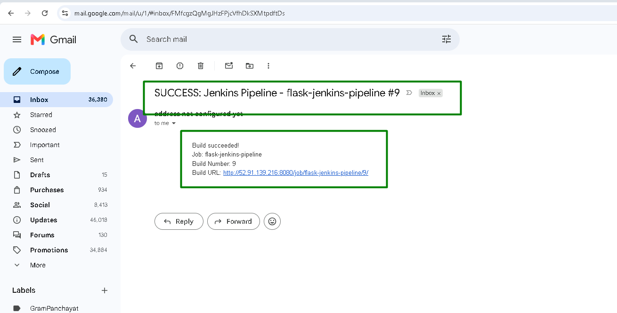

When the build is triggered, the results is sent to email on Build failure:
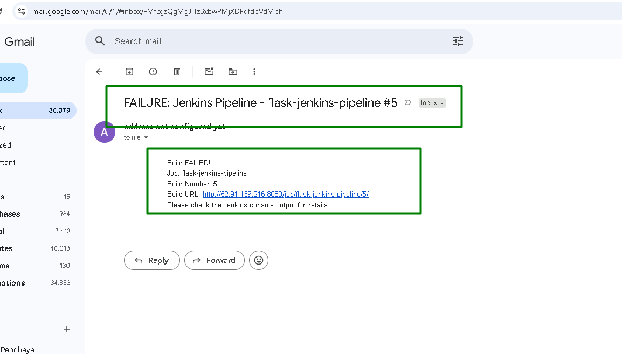

6. Documentation:

- Document the pipeline process and any prerequisites needed for the setup in a README.md file in the repository.

All the details are updated in the read me file in the repo:
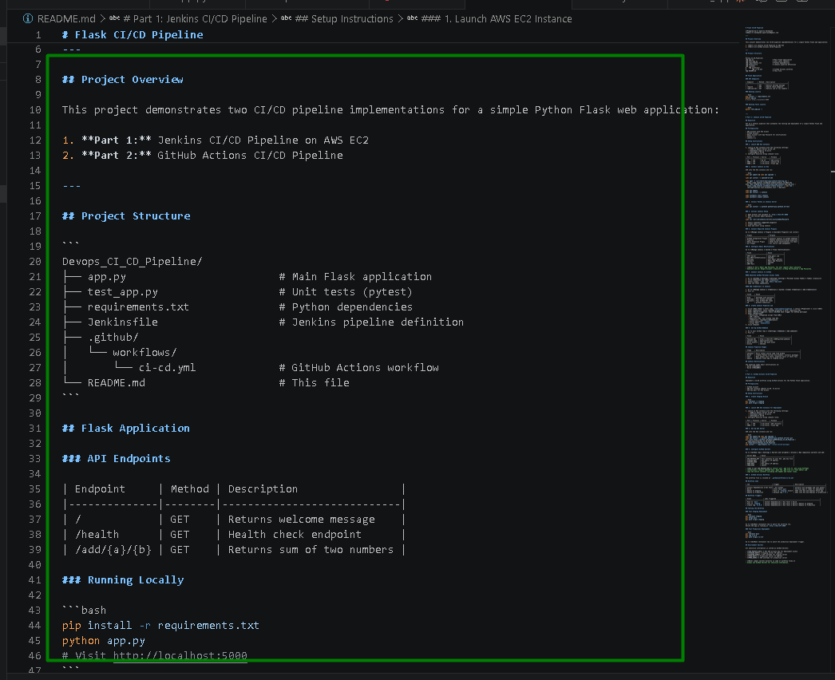

GitHub Actions CI/CD Pipeline Flask App

1. Setup:

- Use a provided Python application repository on GitHub (provide a link to a sample Python application repository).

- Ensure the repository has a main branch and a staging branch.

Using the same repo created earlier

Create a staging branch:
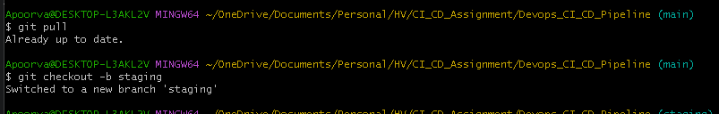
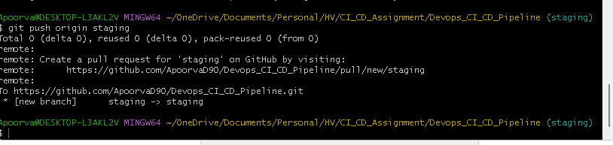
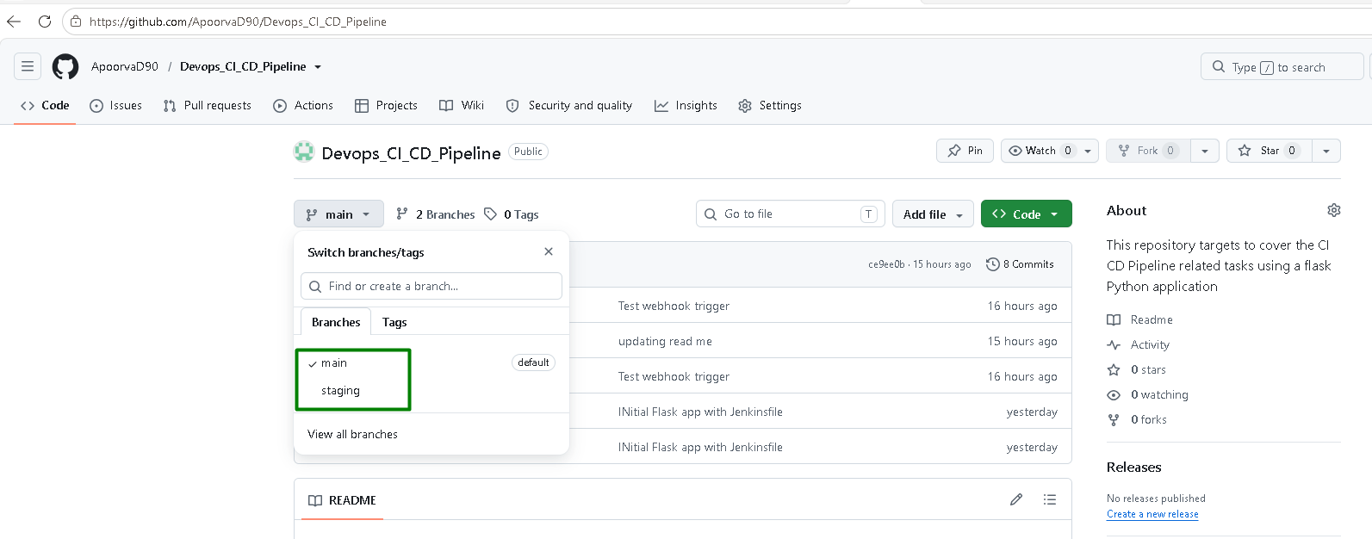

2. GitHub Actions Workflow:

- Create a .github/workflows directory in your repository.

- Inside the directory, create a YAML file to define the workflow.

Create GitHub Actions workflow file along with the directory:
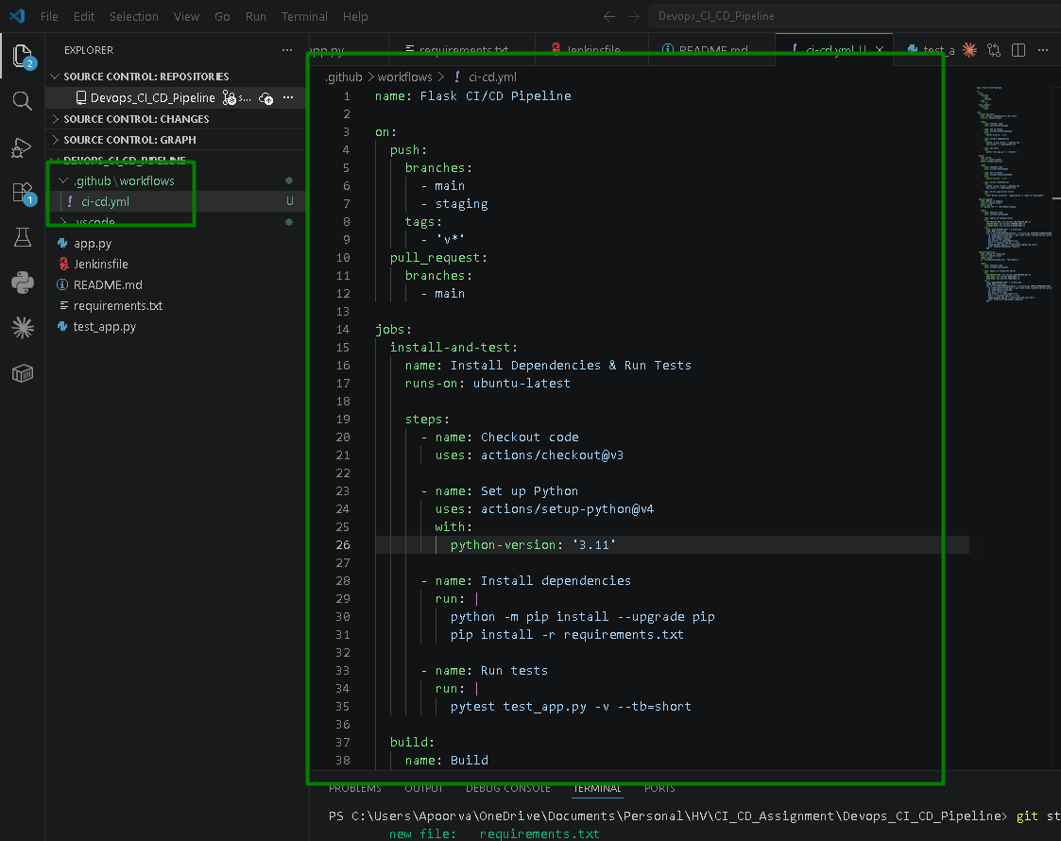

Setup the EC2 server:
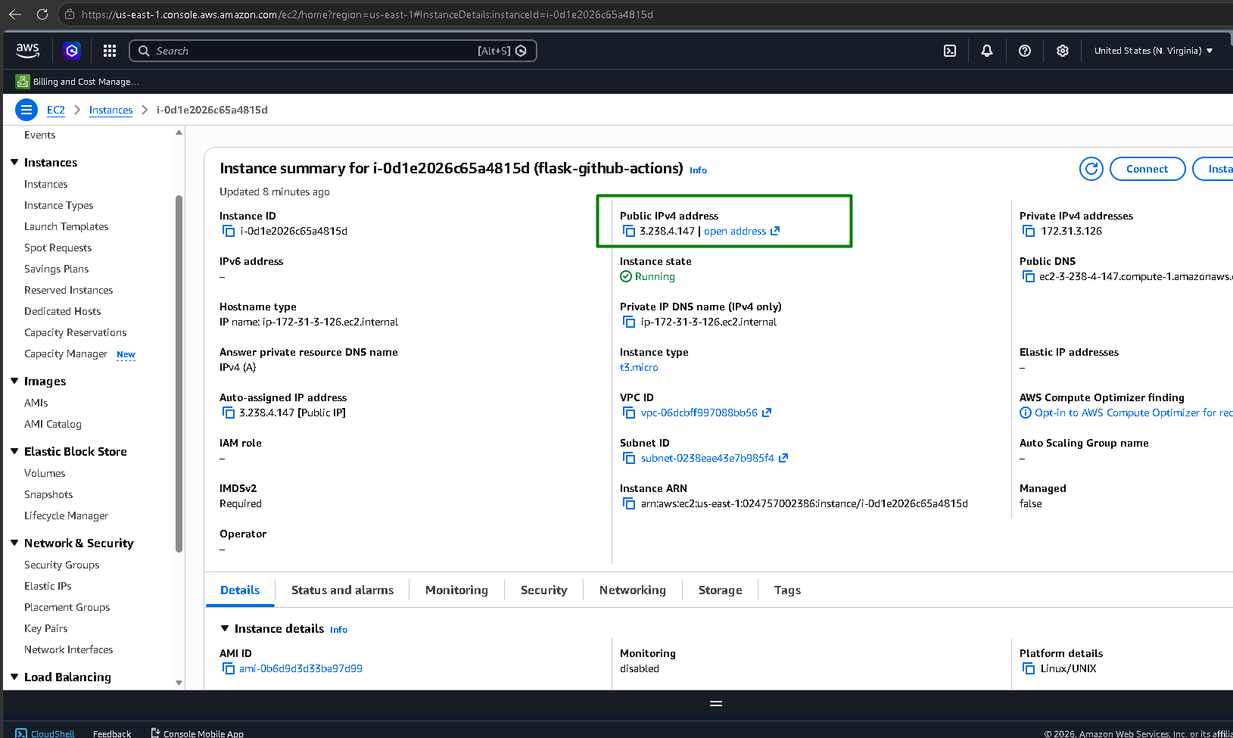
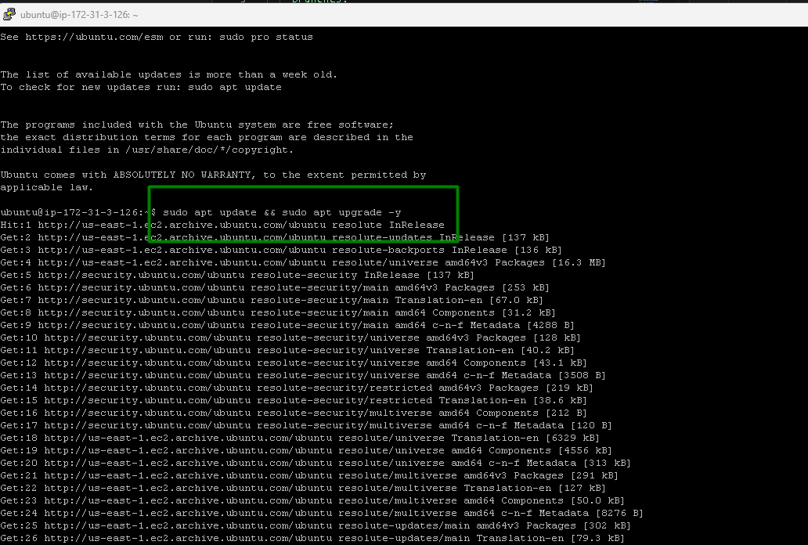
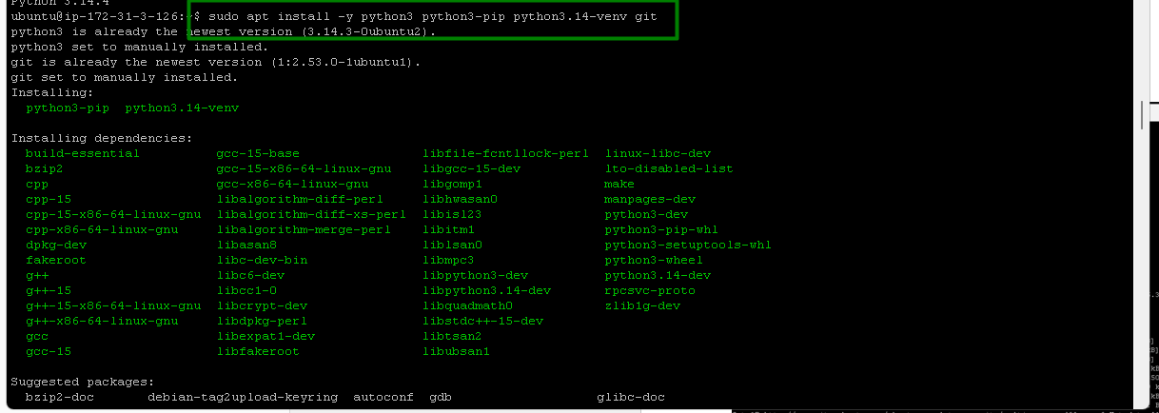
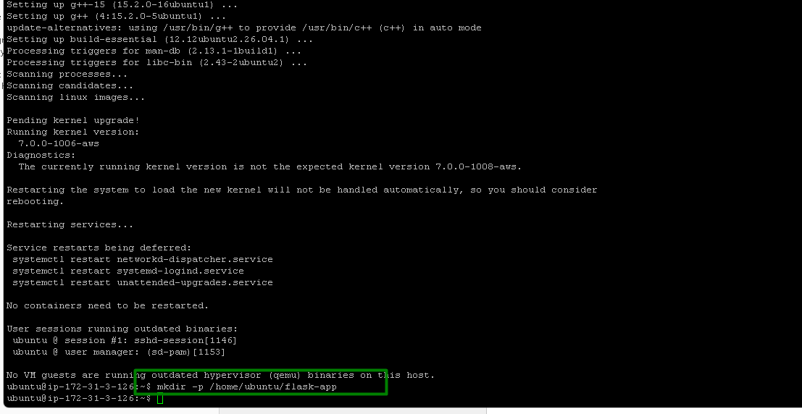

4. Environment Secrets:

- Use GitHub Secrets to store sensitive information required for deployments (e.g., deployment keys, API tokens).

Add GitHub secrets:

SSH_PRIVATE_KEY>> full contents of the .pem file

STAGING_HOST>> EC2 public IP address

STAGING_USER>> ubuntu

PROD_HOST>> EC2 public IP address

PROD_USER>> ubuntu
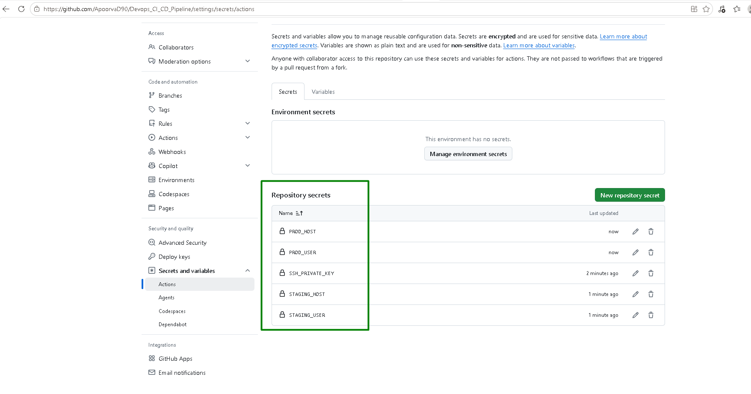

Push workflow file to GitHub:
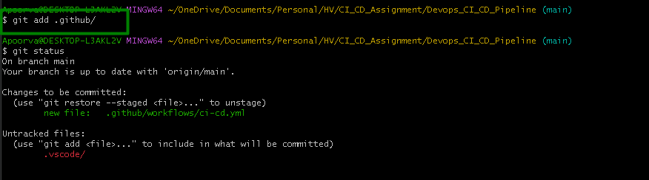
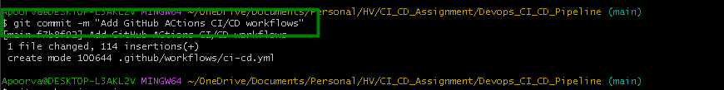
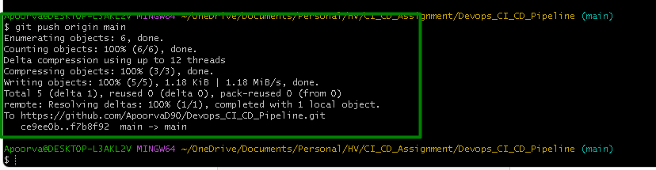

3. Workflow Steps:

- Define a workflow that performs the following jobs:

- Install Dependencies: Install all necessary dependencies for the Python application using pip.

- Run Tests: Execute the test suite using a framework like pytest.

- Build: If tests pass, prepare the application for deployment.

- Deploy to Staging: Deploy the application to a staging environment when changes are pushed to the staging branch.

- Deploy to Production: Deploy the application to production when a release is tagged.

Test Staging Deployment
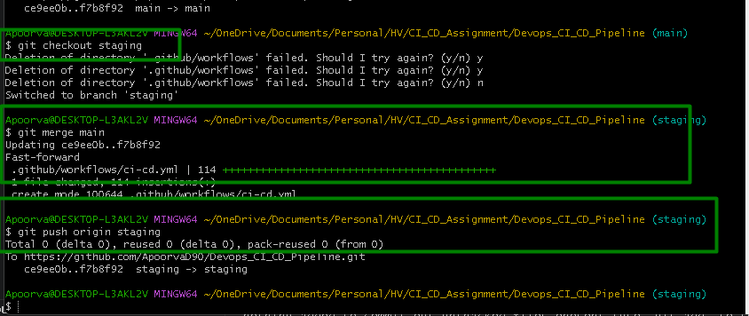
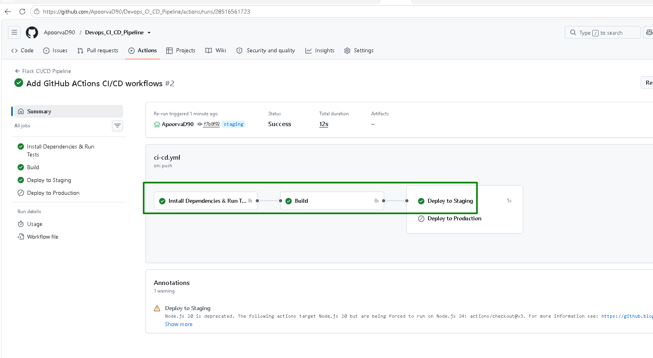

Install Dependencies and Run tests stage
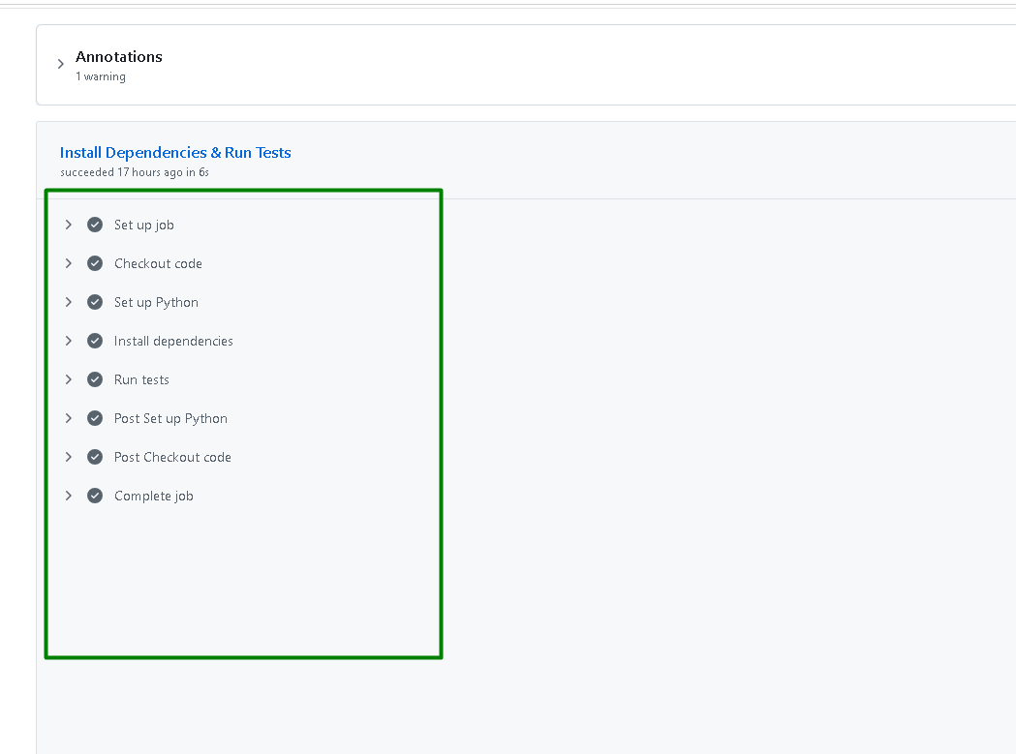

Each job in GitHub Actions runs in a completely fresh, isolated virtual machine. Hence the dependencies step is added in Build stage as well
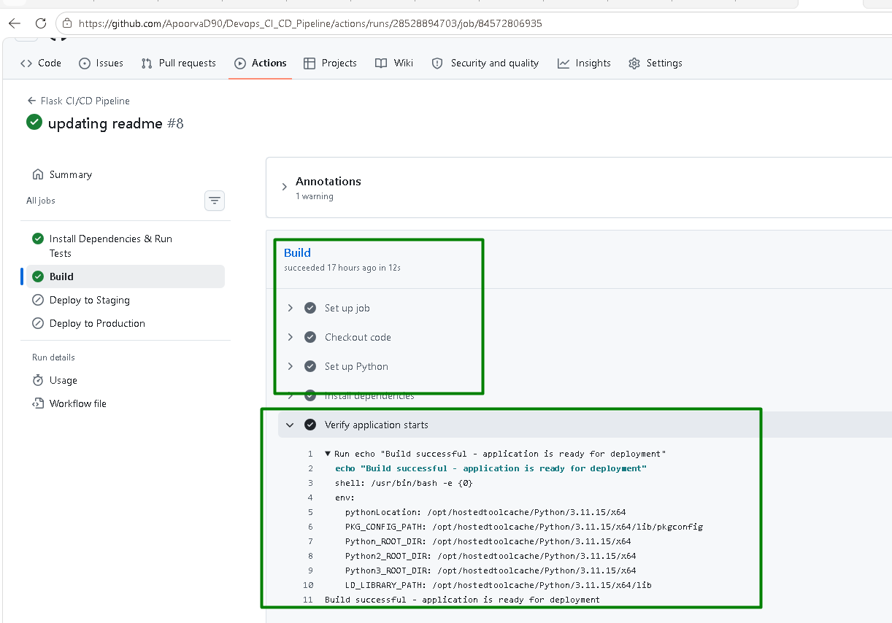

Deploy to Staging step
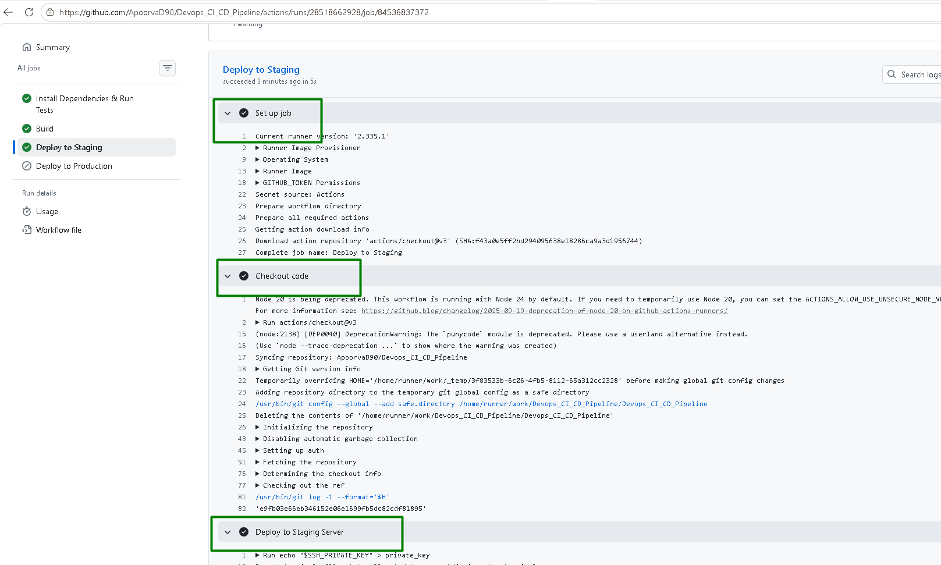
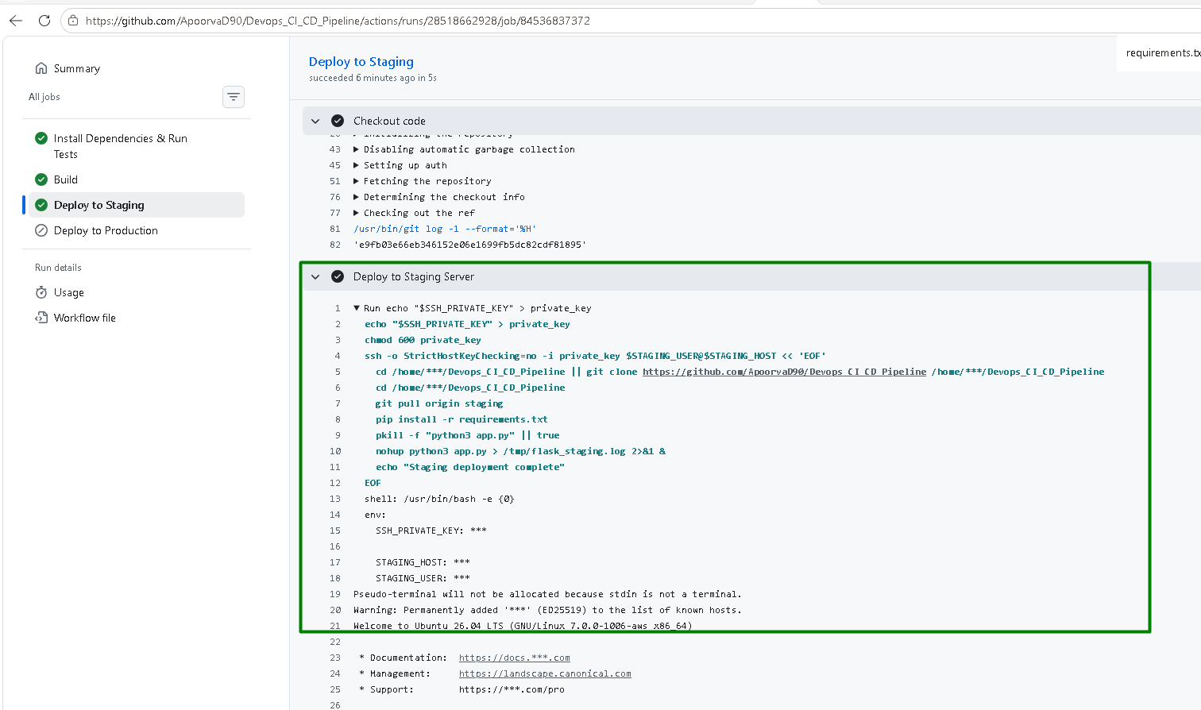
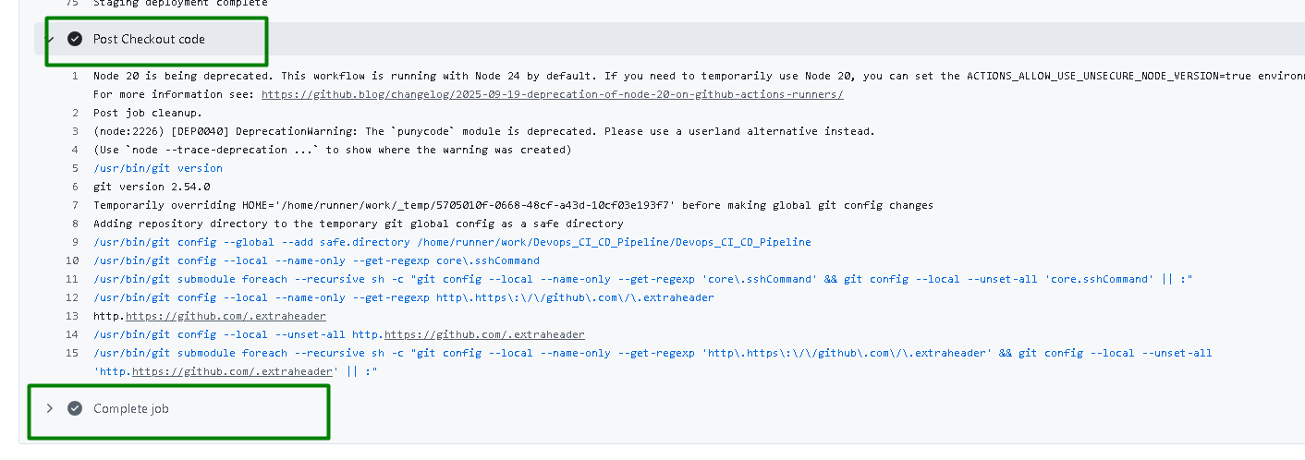

The flask App is accessible on the EC2 server:
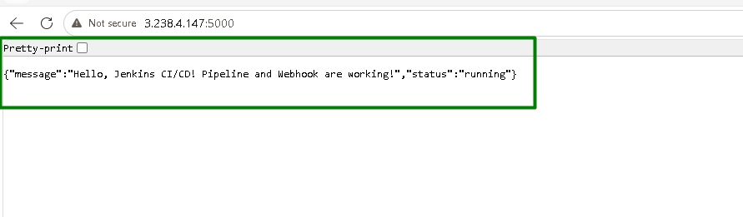

Test Production Deployment:
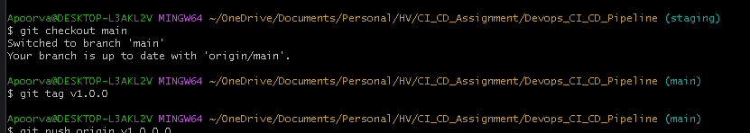
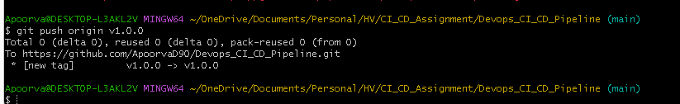

Deploy to Production is triggered:
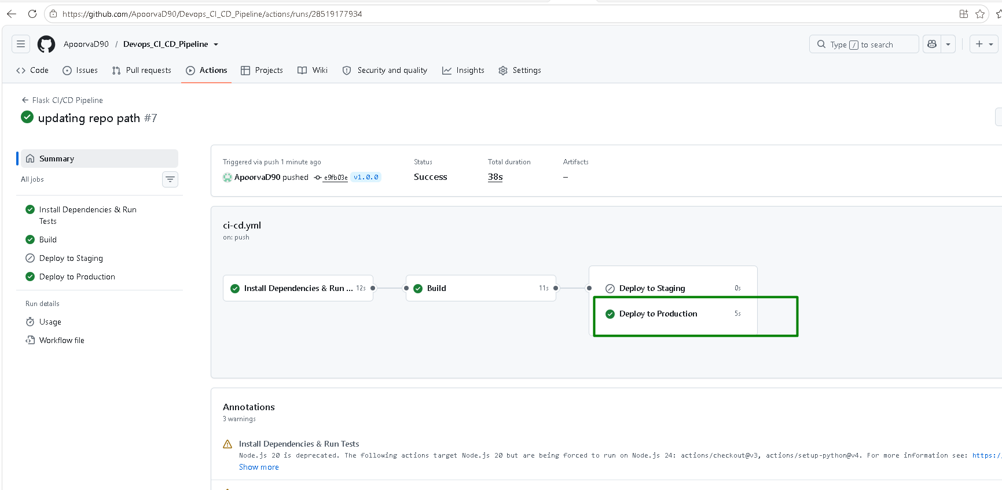
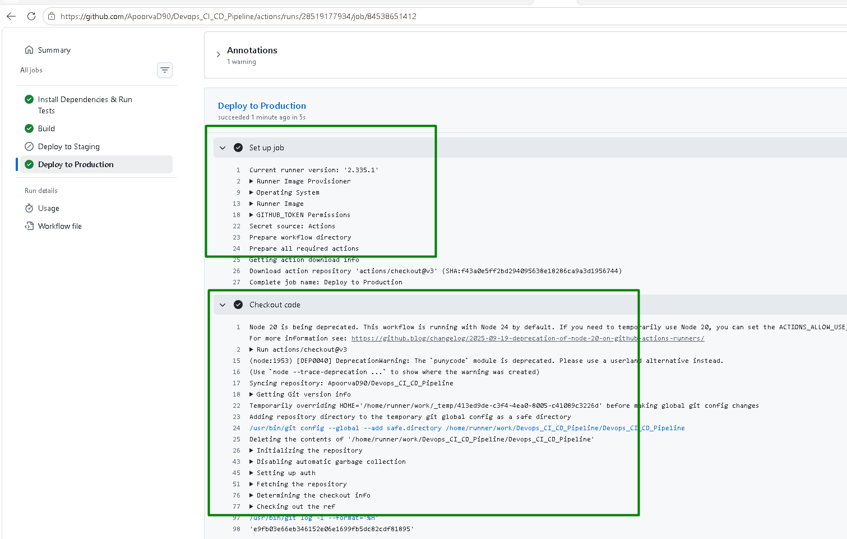
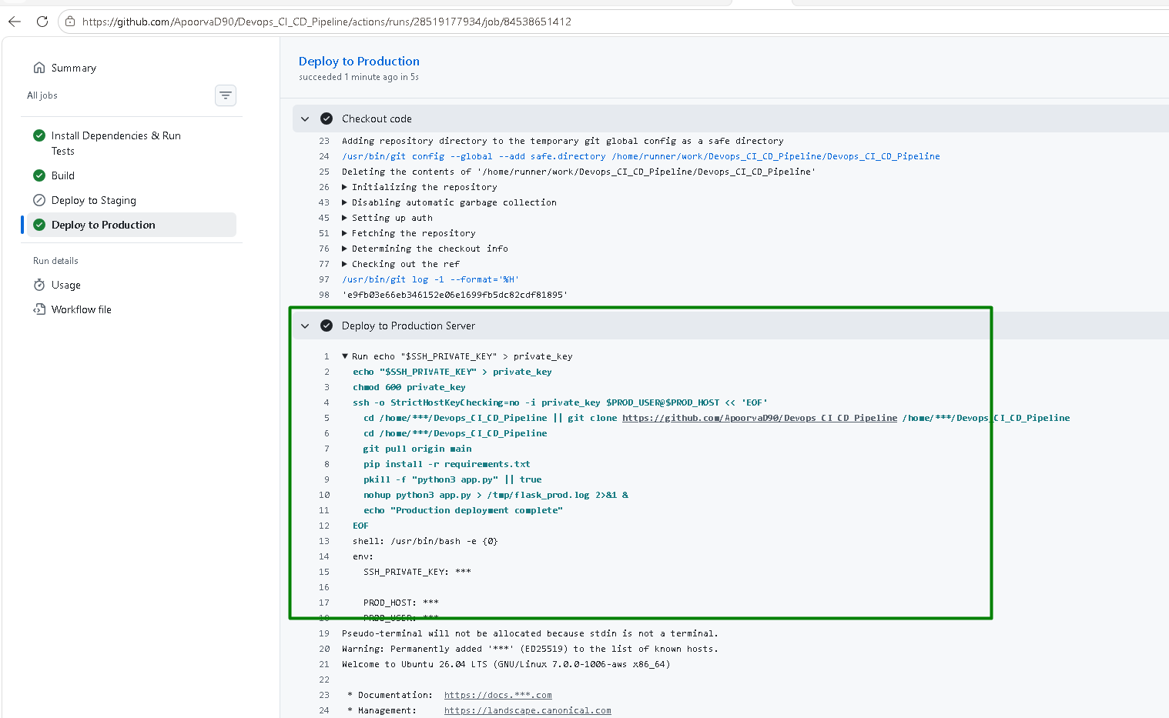
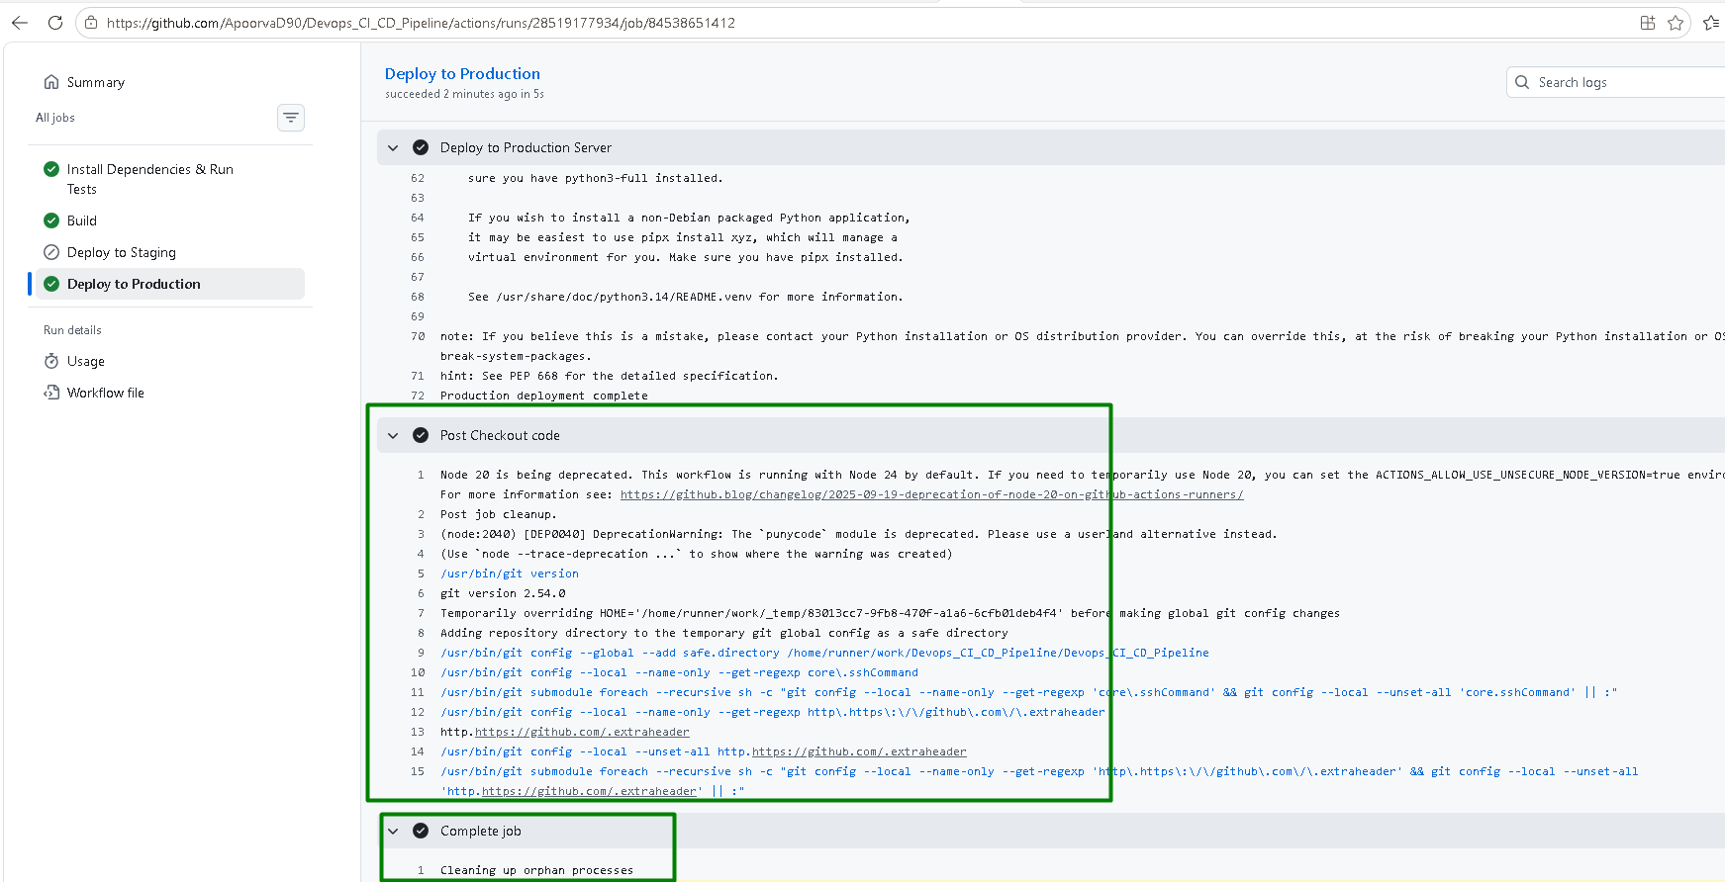

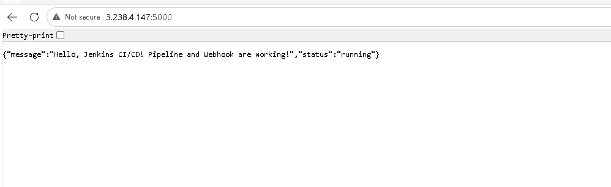

5. Documentation:

- Update the README.md file with instructions on how the GitHub Actions workflow works and how to configure the necessary secrets.

All the instructions are stored in the Readme file:
