Devops: Containerization and Container Orchestration

Git Repo: https://github.com/ApoorvaD90/SampleMERNwithMicroservices

Step 1: Version Control with Git

Fork the main repository into your GitHub account.

Maintain your version by syncing updates from the main repository as needed.

Forked the main repo to personal GitHub Account:
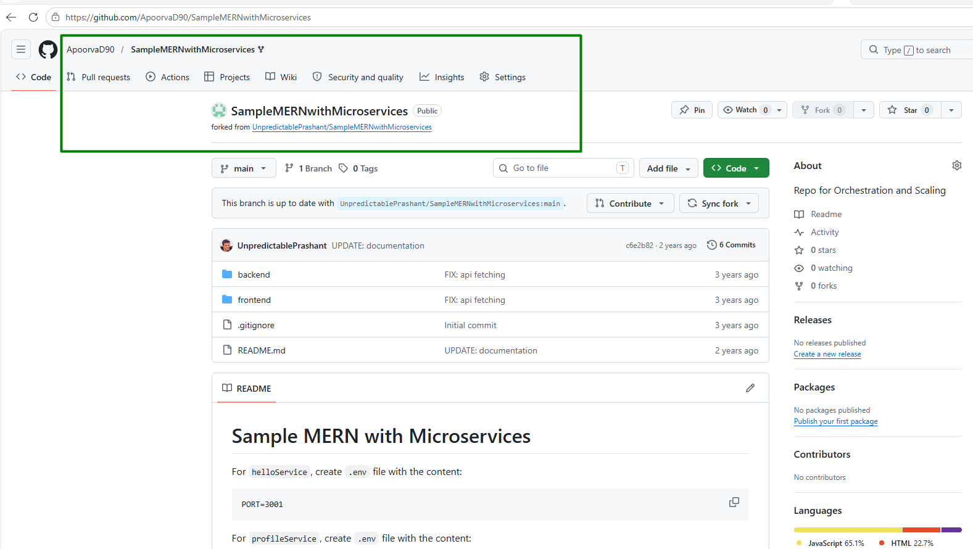

Add upstream remote to sync future updates
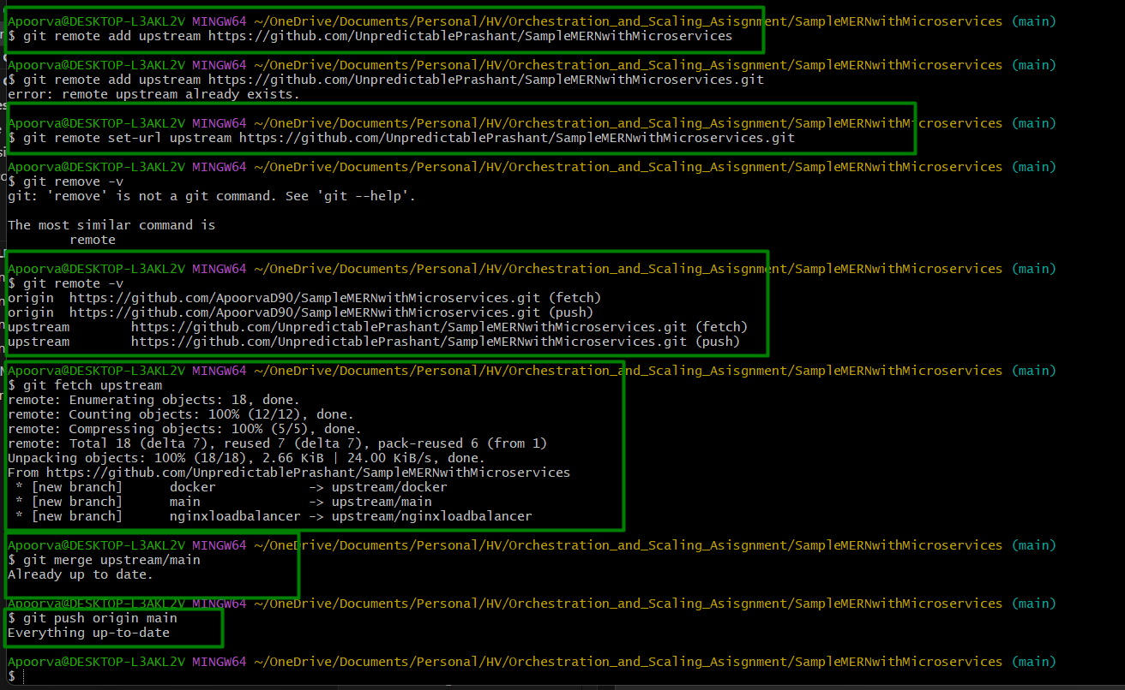

Step 2: Prepare the MERN Application

Containerize the Application

Create Dockerfiles for each component (Frontend and Backend).

Backend> helloService>Dockerfile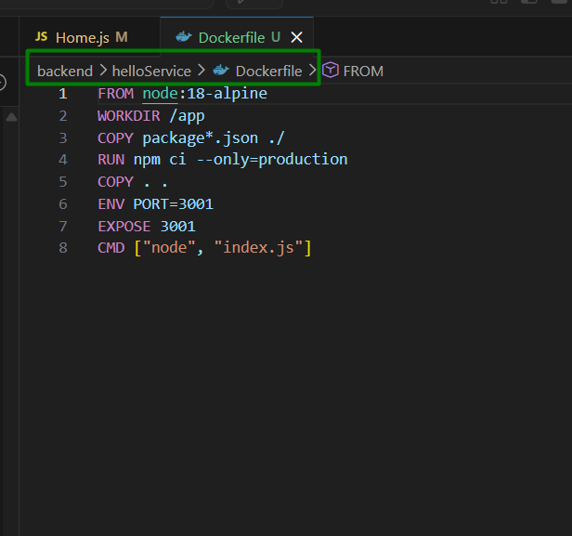

Create Backend > helloService>.dockerignore: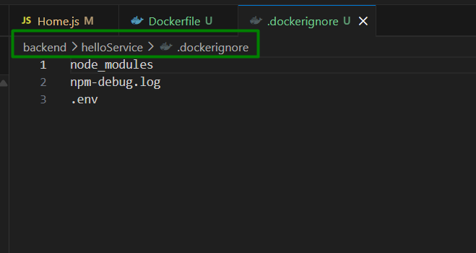

Create Backend> profileService>Dockerfile: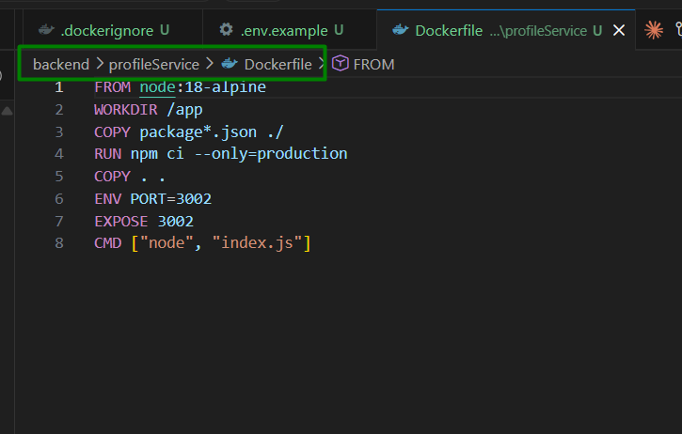

Create Backend> profileService>.dockerignore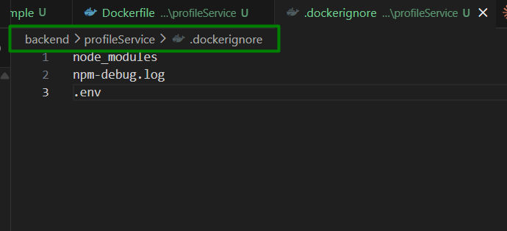

Create frontend>nginx.conf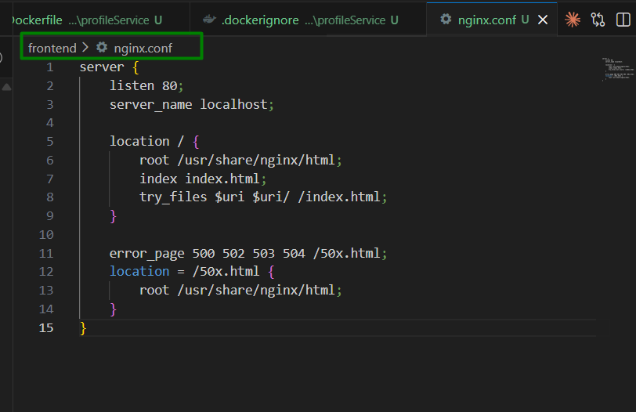

Create frontend>Dockerfile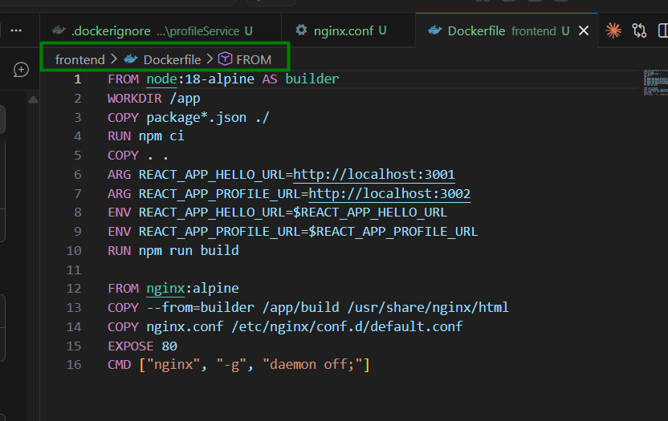

Create frontend>.dockerignore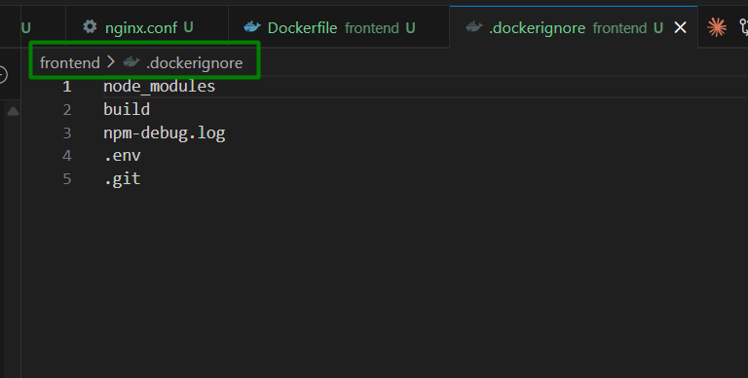

Create docker-compose.yml for local testing
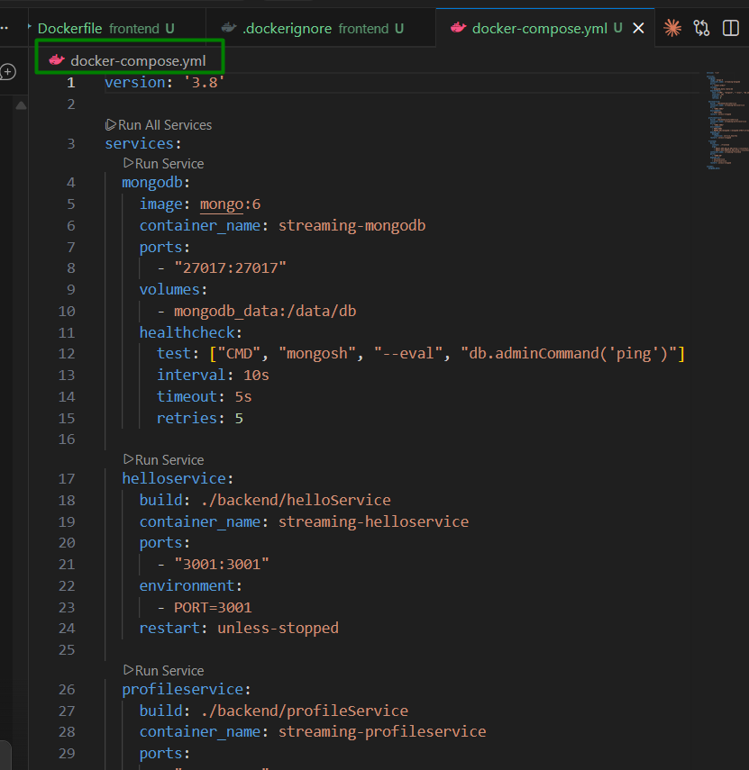

Docker-compose.yml data :
version: '3.8'

services:
mongodb:
image: mongo:6
container_name: streaming-mongodb
ports:
- "27017:27017"
volumes:
- mongodb_data:/data/db
healthcheck:
test: ["CMD", "mongosh", "--eval", "db.adminCommand('ping')"]
interval: 10s
timeout: 5s
retries: 5

helloservice:
build: ./backend/helloService
container_name: streaming-helloservice
ports:
- "3001:3001"
environment:
- PORT=3001
restart: unless-stopped

profileservice:
build: ./backend/profileService
container_name: streaming-profileservice
ports:
- "3002:3002"
environment:
- PORT=3002
- MONGO_URL=mongodb://mongodb:27017/streaming_app
depends_on:
mongodb:
condition: service_healthy
restart: unless-stopped

frontend:
build:
context: ./frontend
args:
- REACT_APP_HELLO_URL=http://localhost:3001
- REACT_APP_PROFILE_URL=http://localhost:3002
container_name: streaming-frontend
ports:
- "3000:80"
depends_on:
- helloservice
- profileservice
restart: unless-stopped

volumes:
mongodb_data:

Updating “frontend/src/components/Home.js” to use environment variables instead of hardcoded localhost URLs

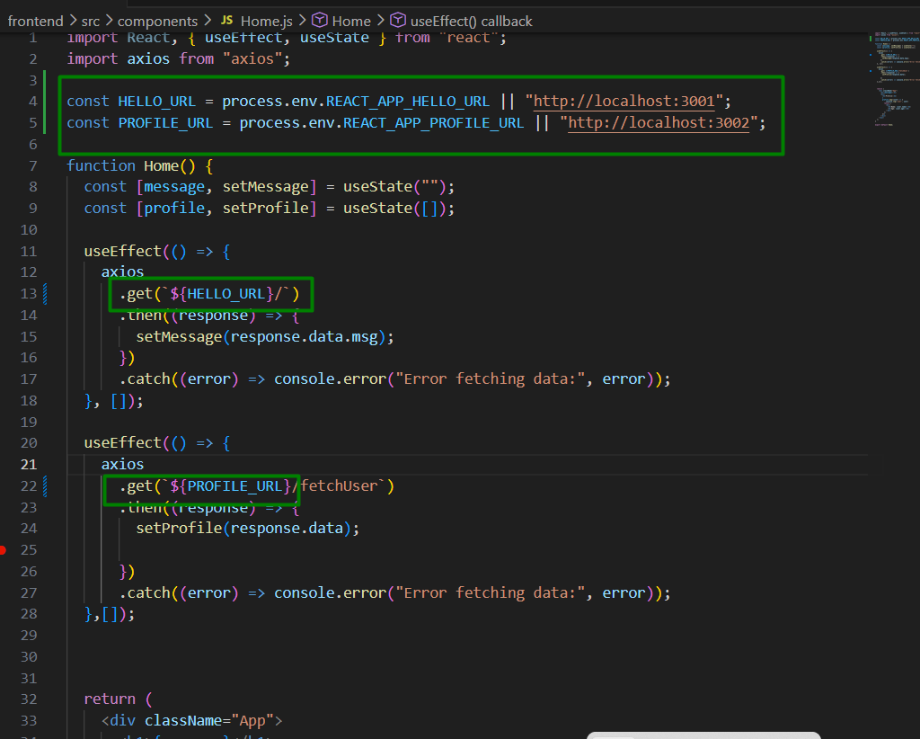

Testing the changes locally with command “docker-compose up --build”:
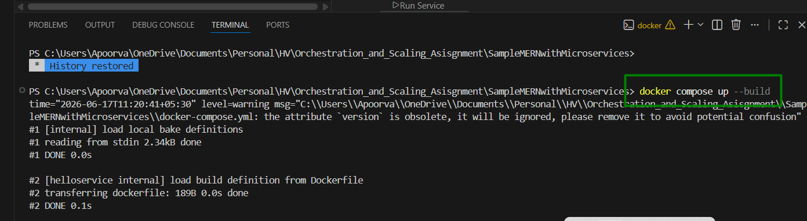
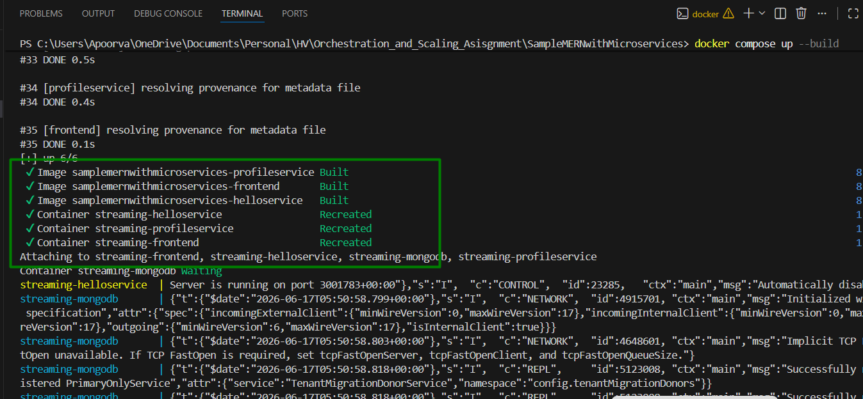

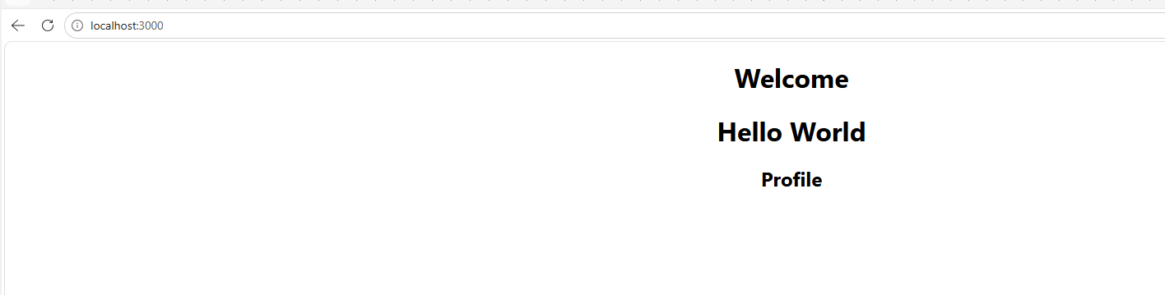

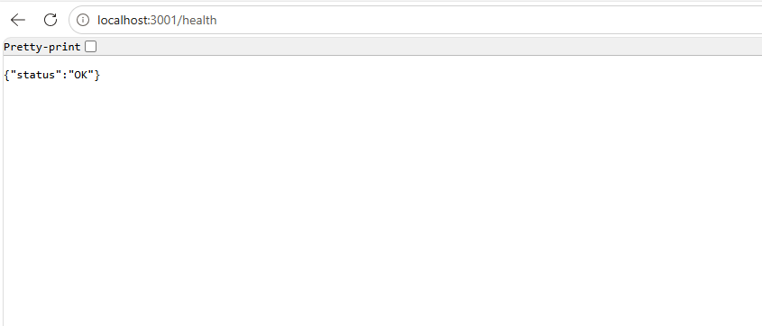
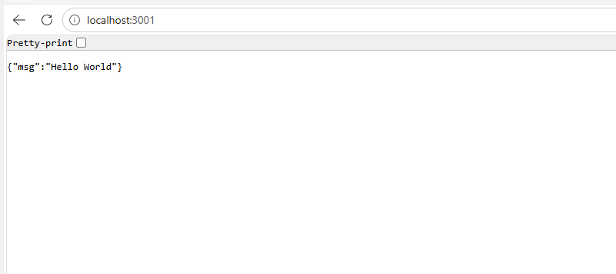

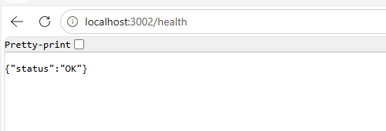

Push Docker Images to Amazon ECR

Create IAM user: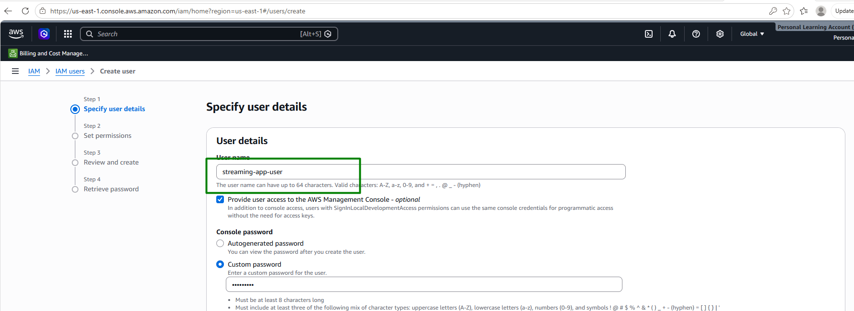

Attach policies: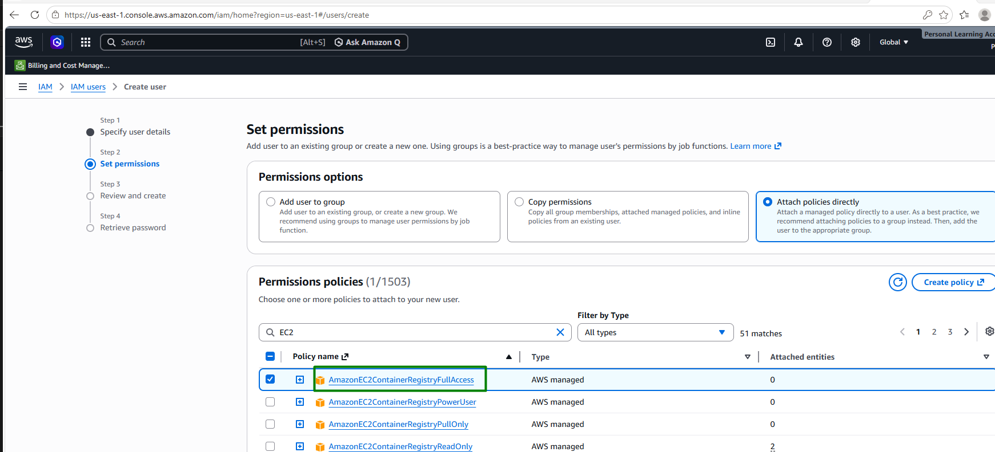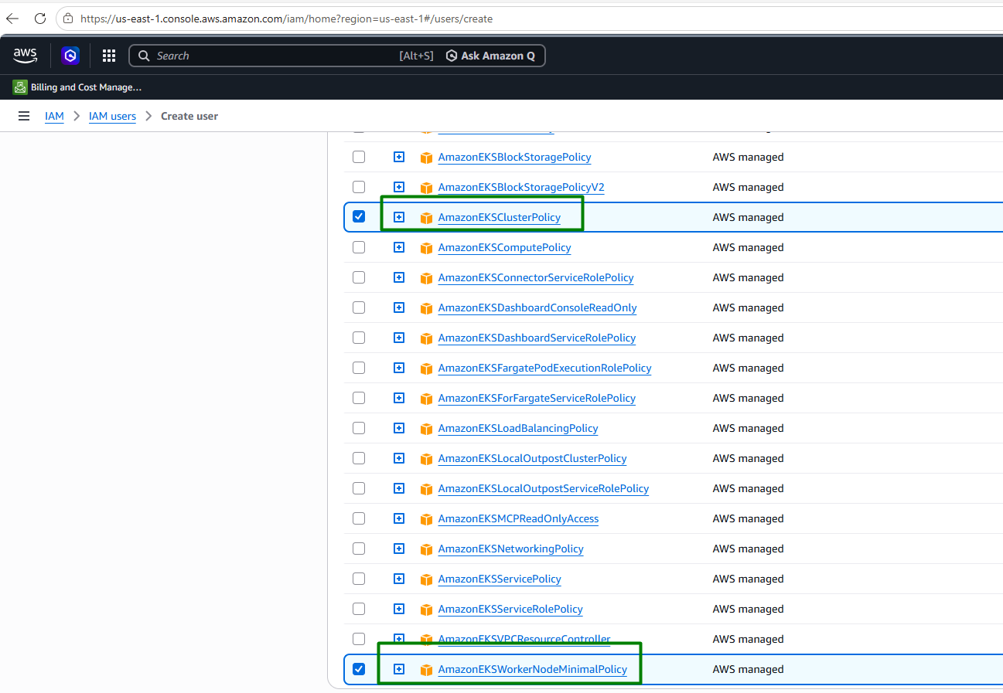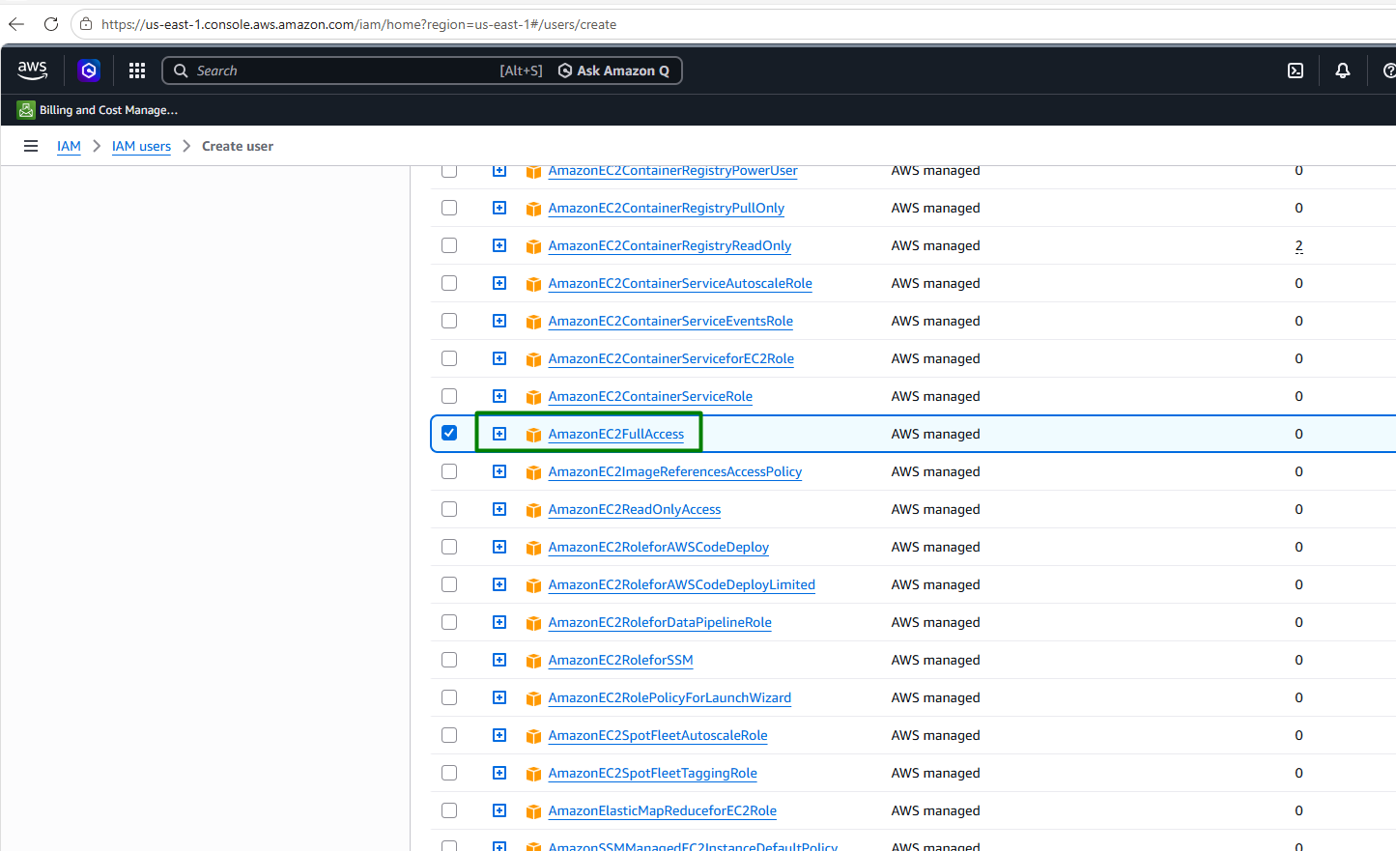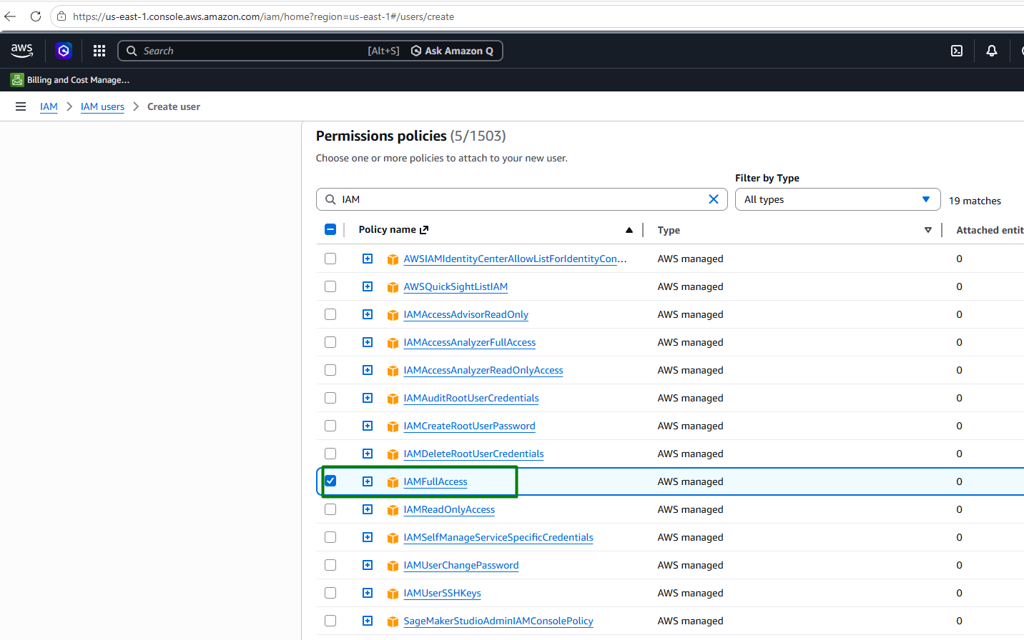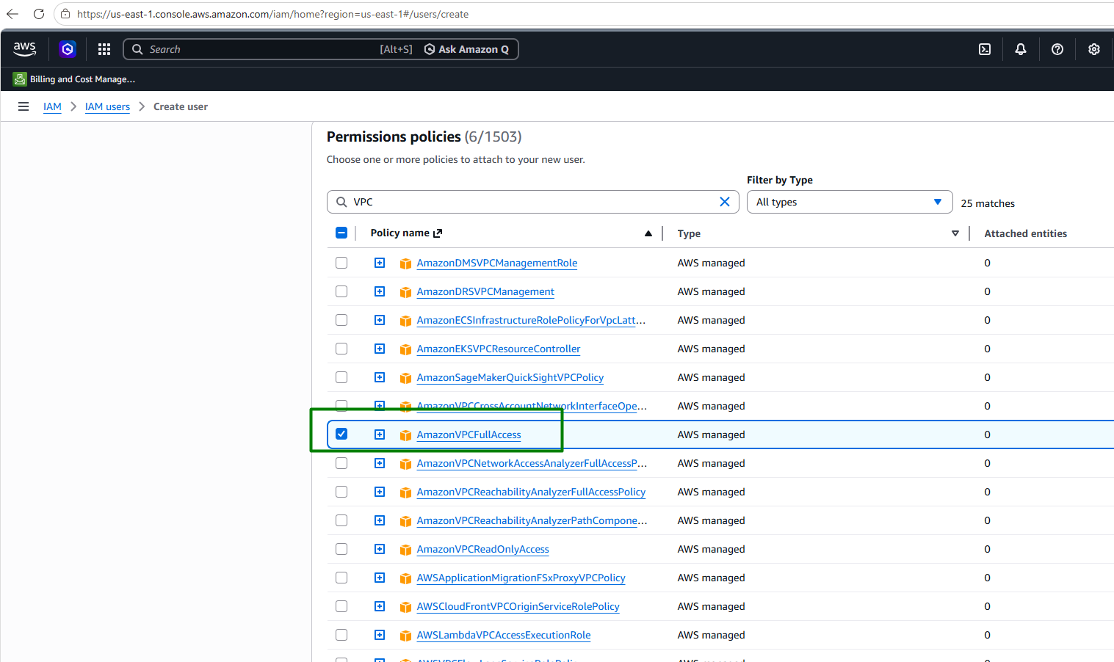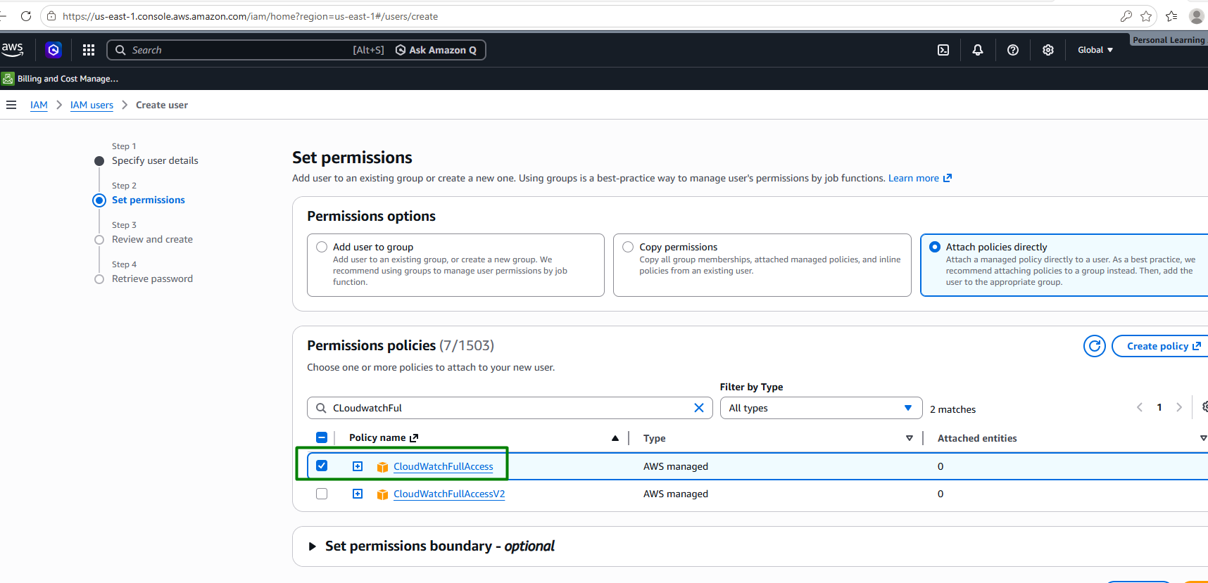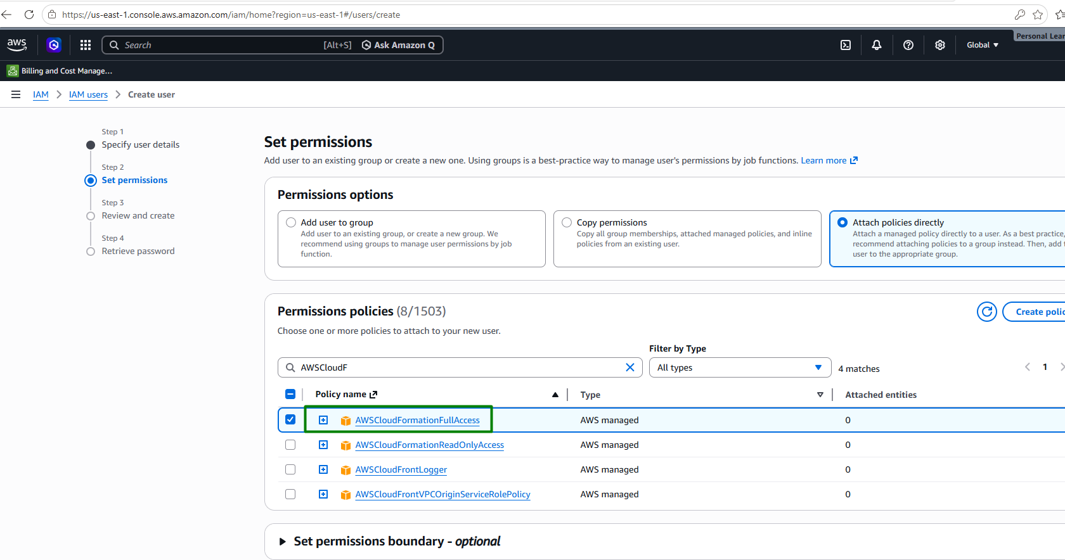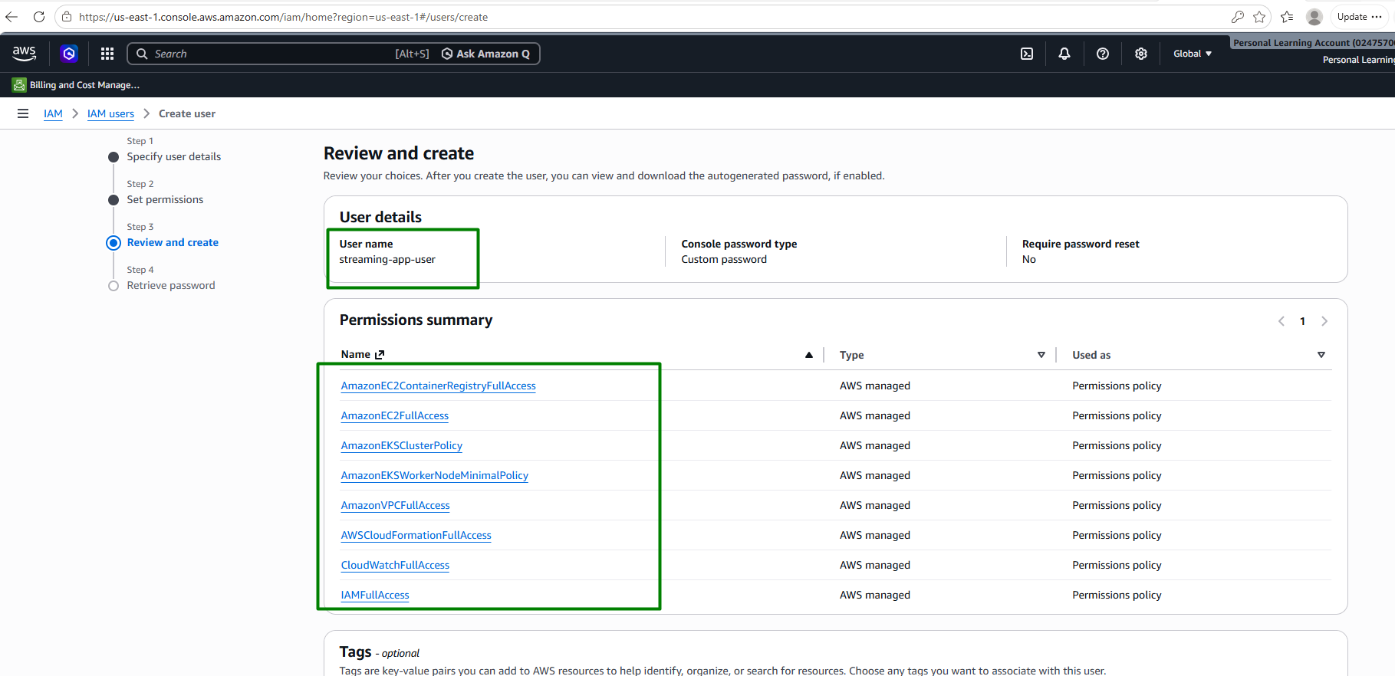

Adding admin access to be able to create EKS through AWS CLI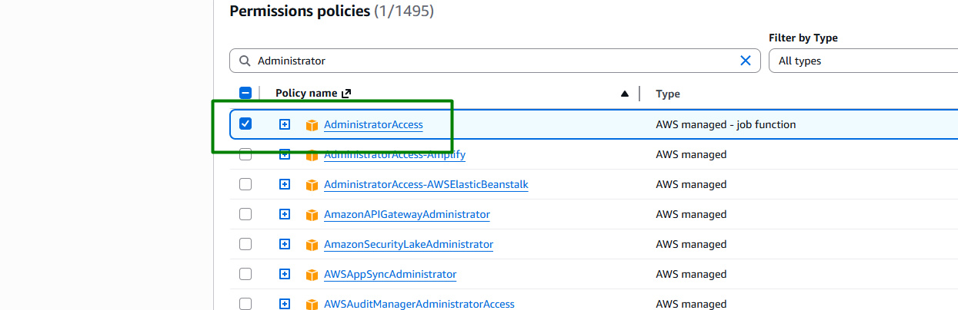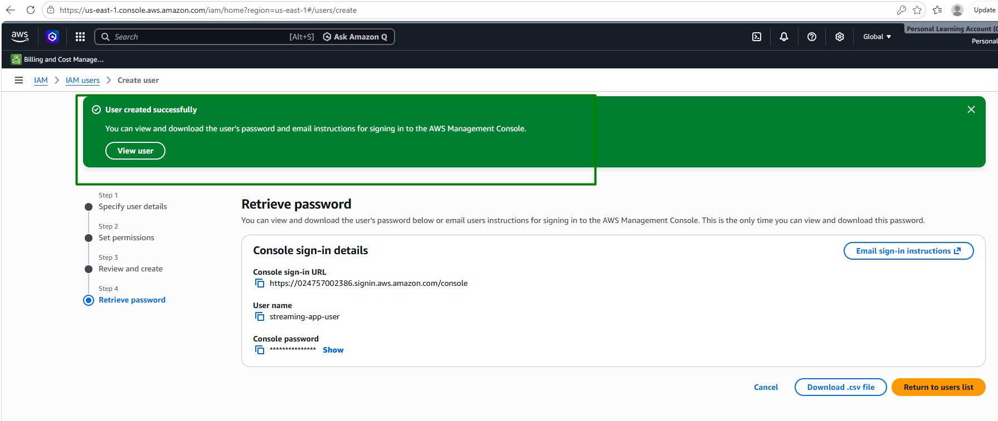

Create Access Key:
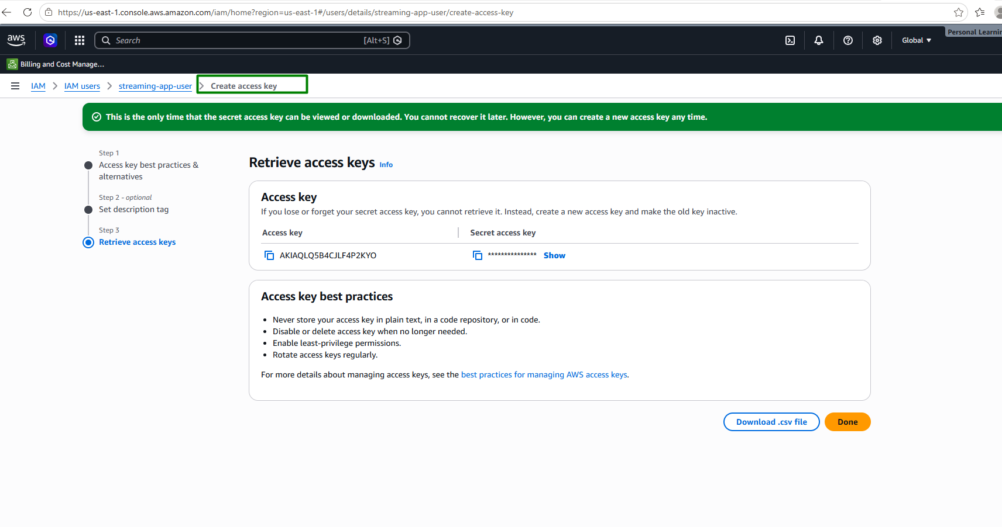

Configure AWS CLI
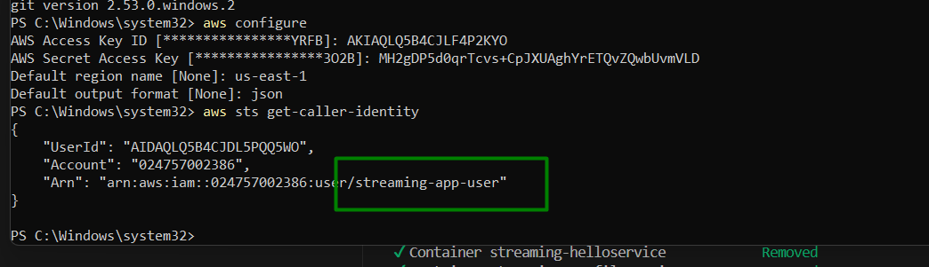

Create individual ECR repositories:

Create ECR repository for helloService:
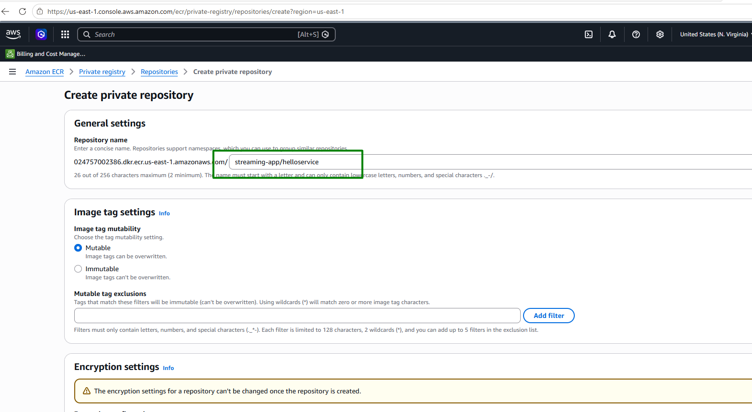

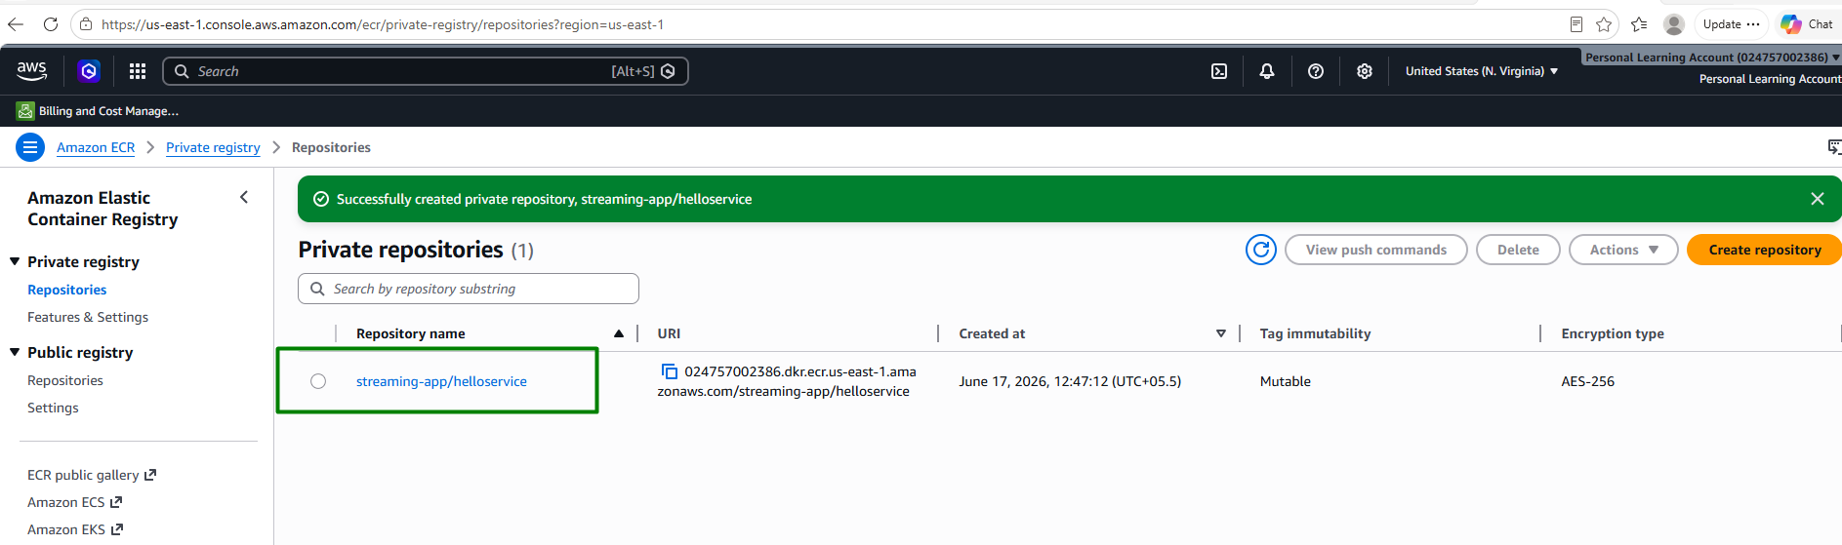

Create ECR repository for profileService:
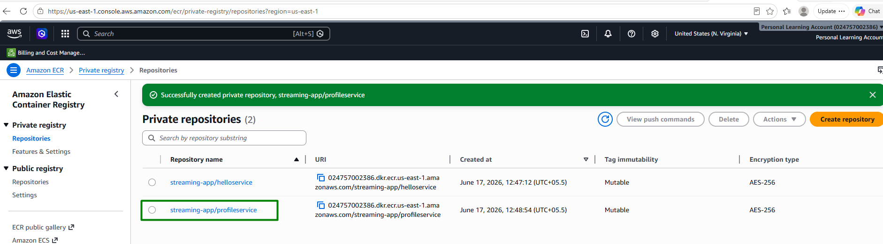

Create ECR repository for frontend:
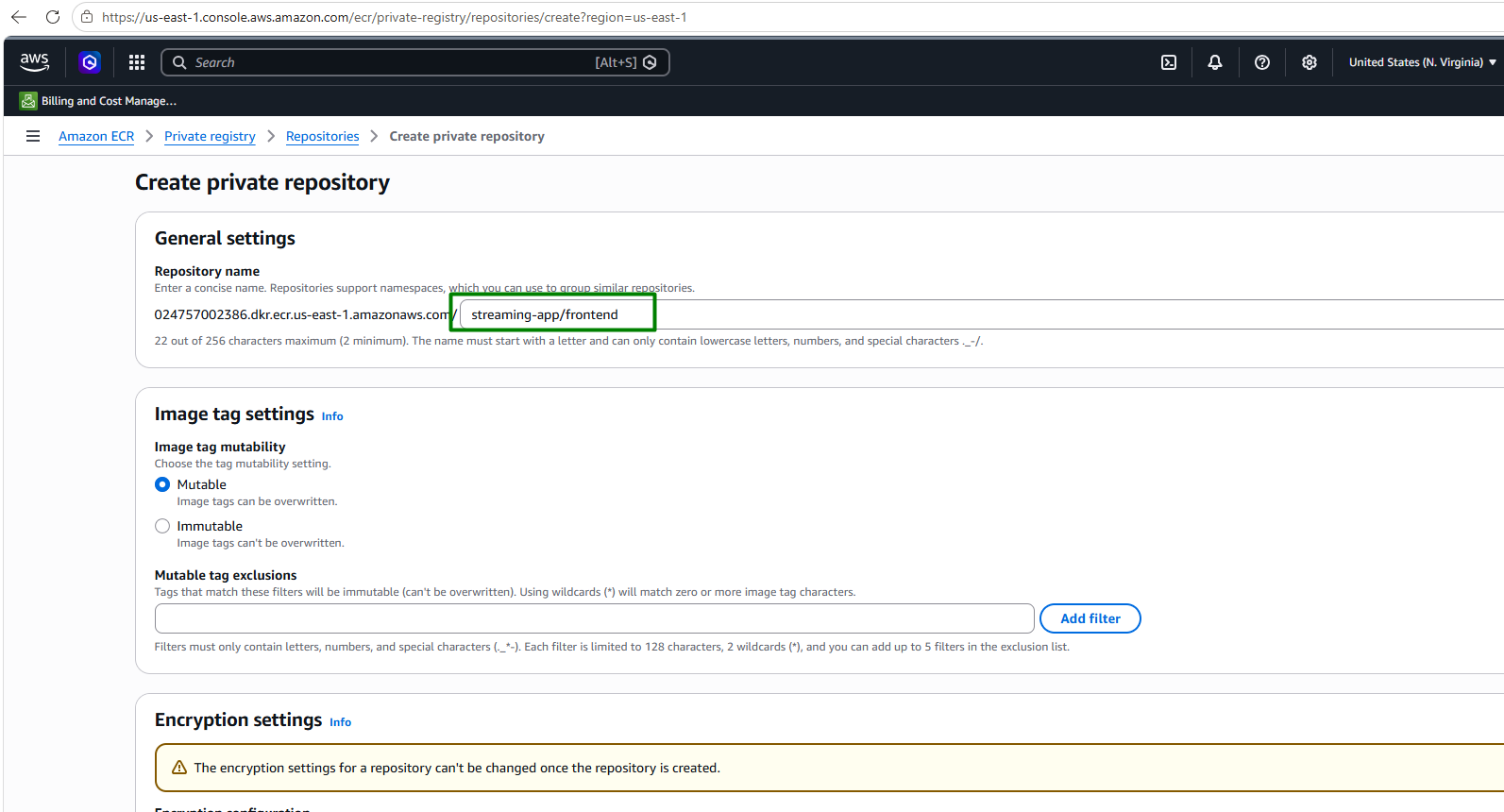
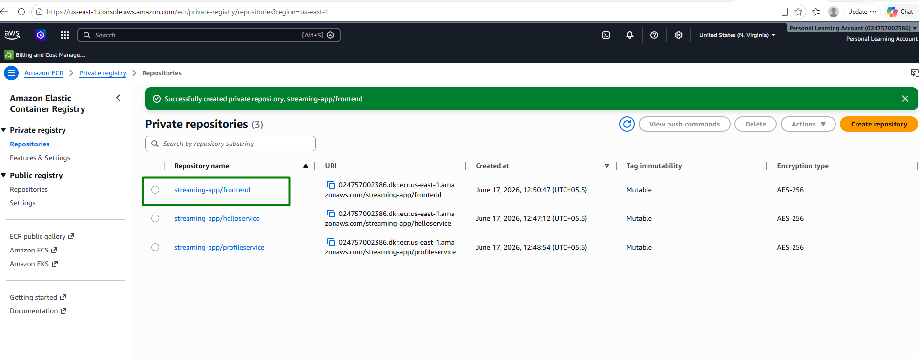

Set variables in powershell terminal:
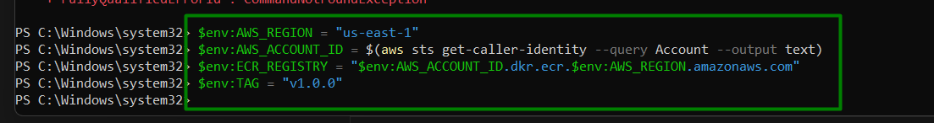

Authenticate Docker to ECR:
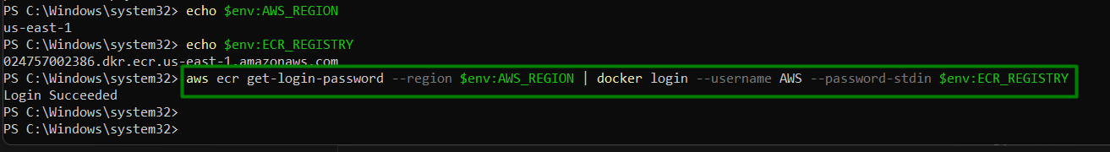

Build Docker images for both components.

Create individual ECR repositories.

Push the images to their respective ECR repositories.

Build and push helloService:
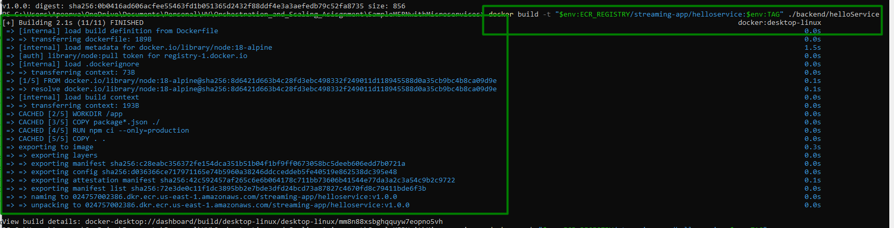
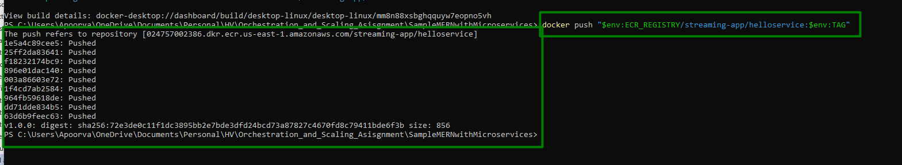

Build and push profileService:
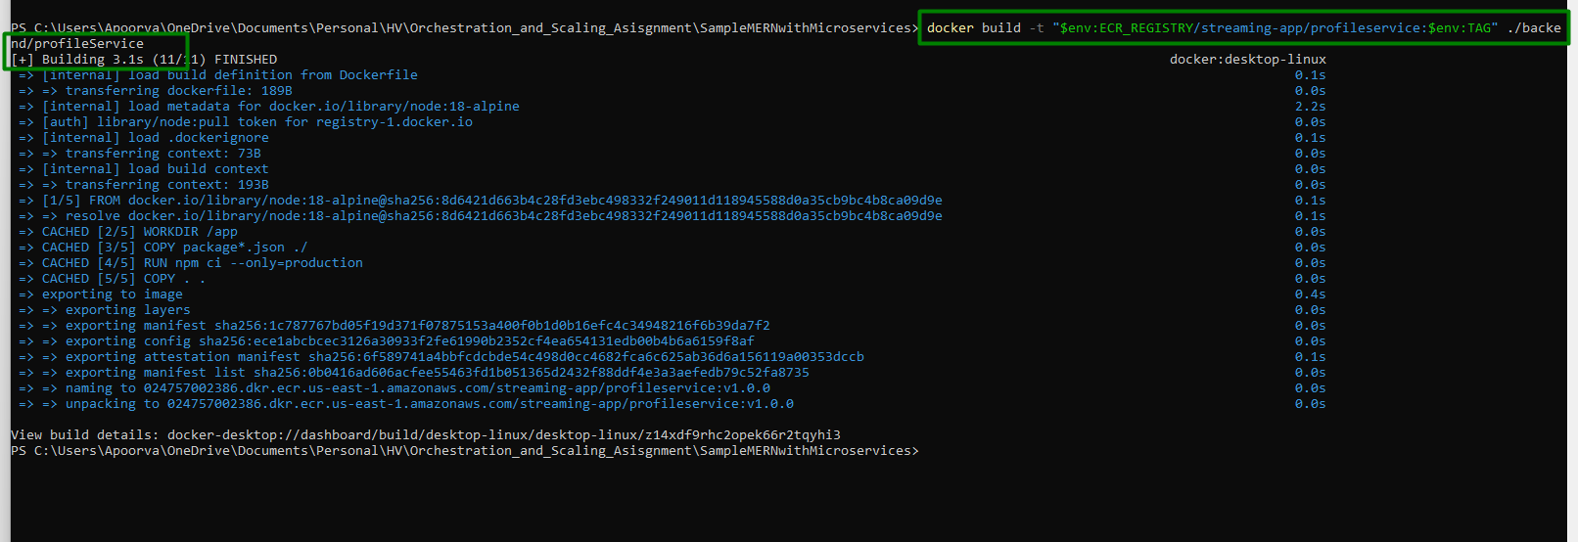
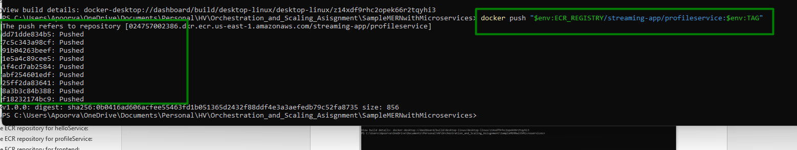

Build and push frontend (Adding placeholders for now, will be building frontend again with EKS ingress hostname)
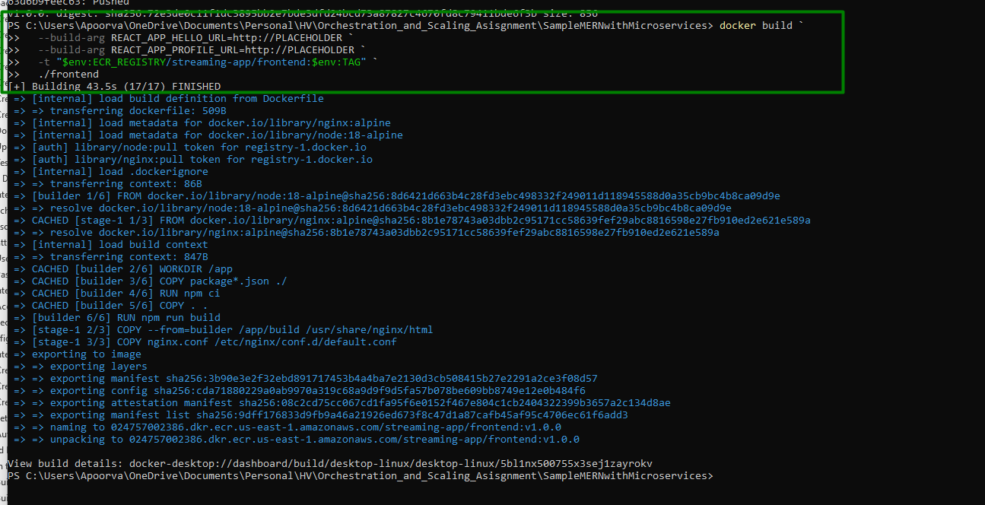
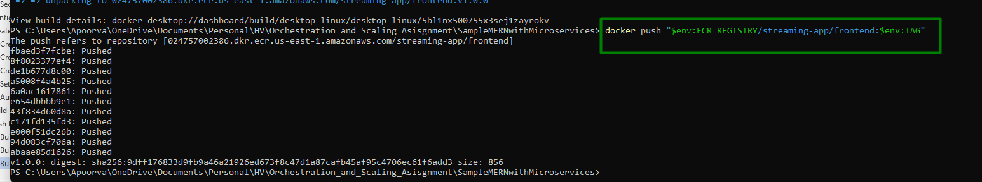

helloService image is pushed and tag is created:
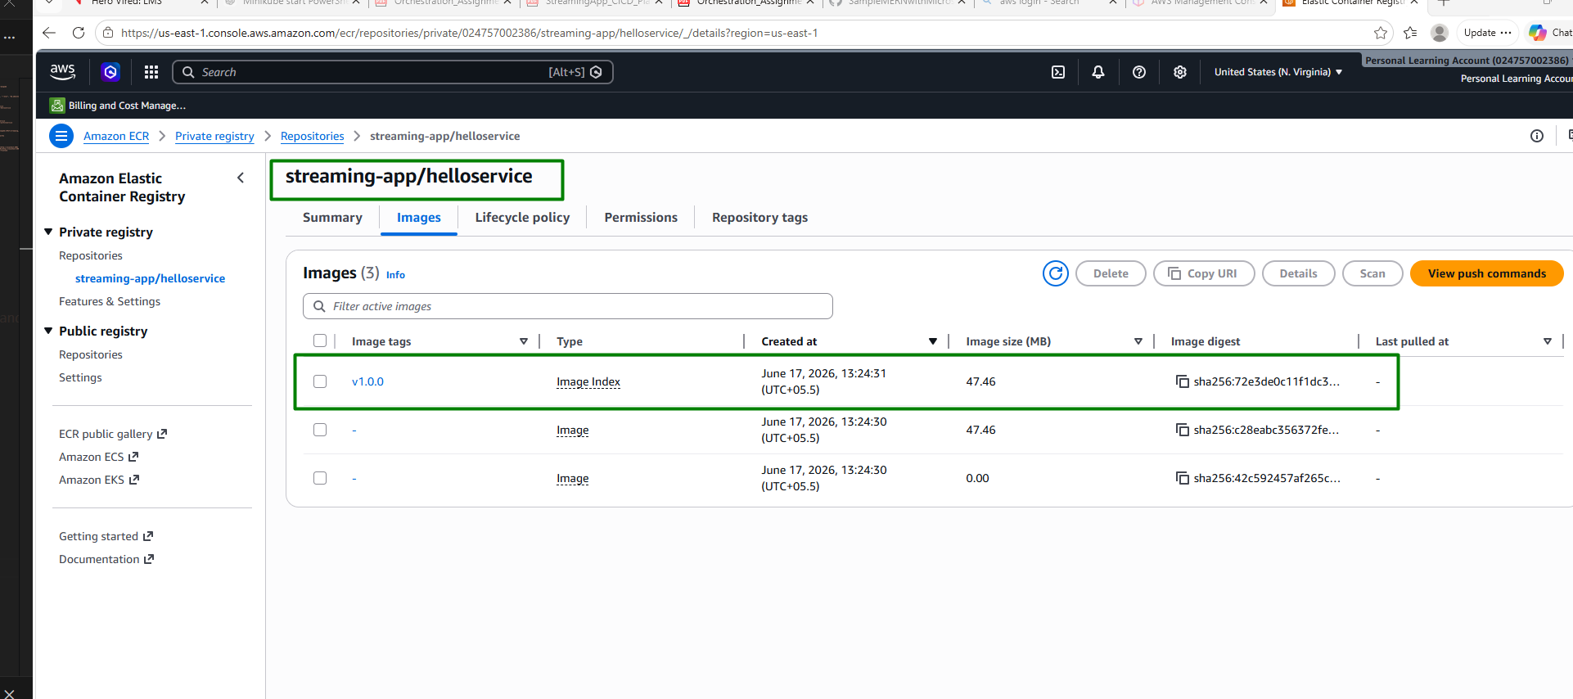

profileService image is pushed and tag is created:
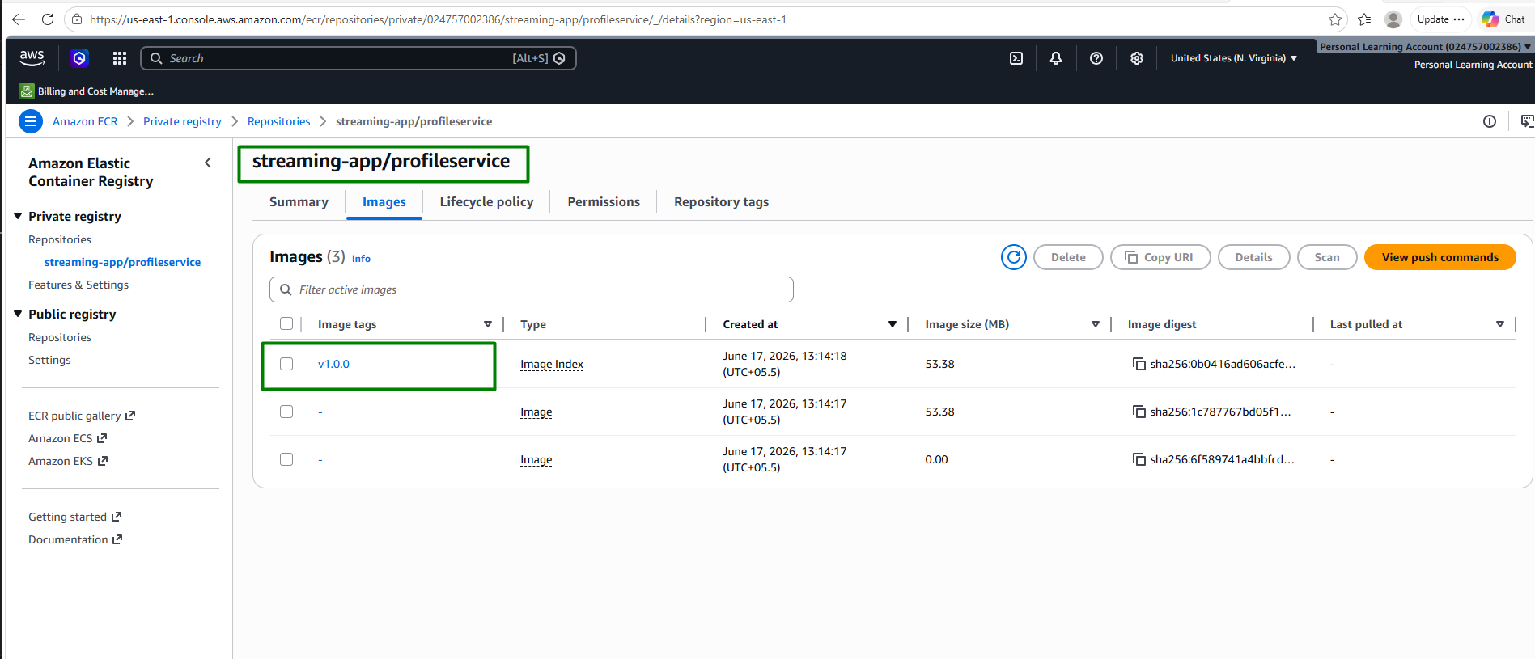

frontend image is pushed and tag is created:
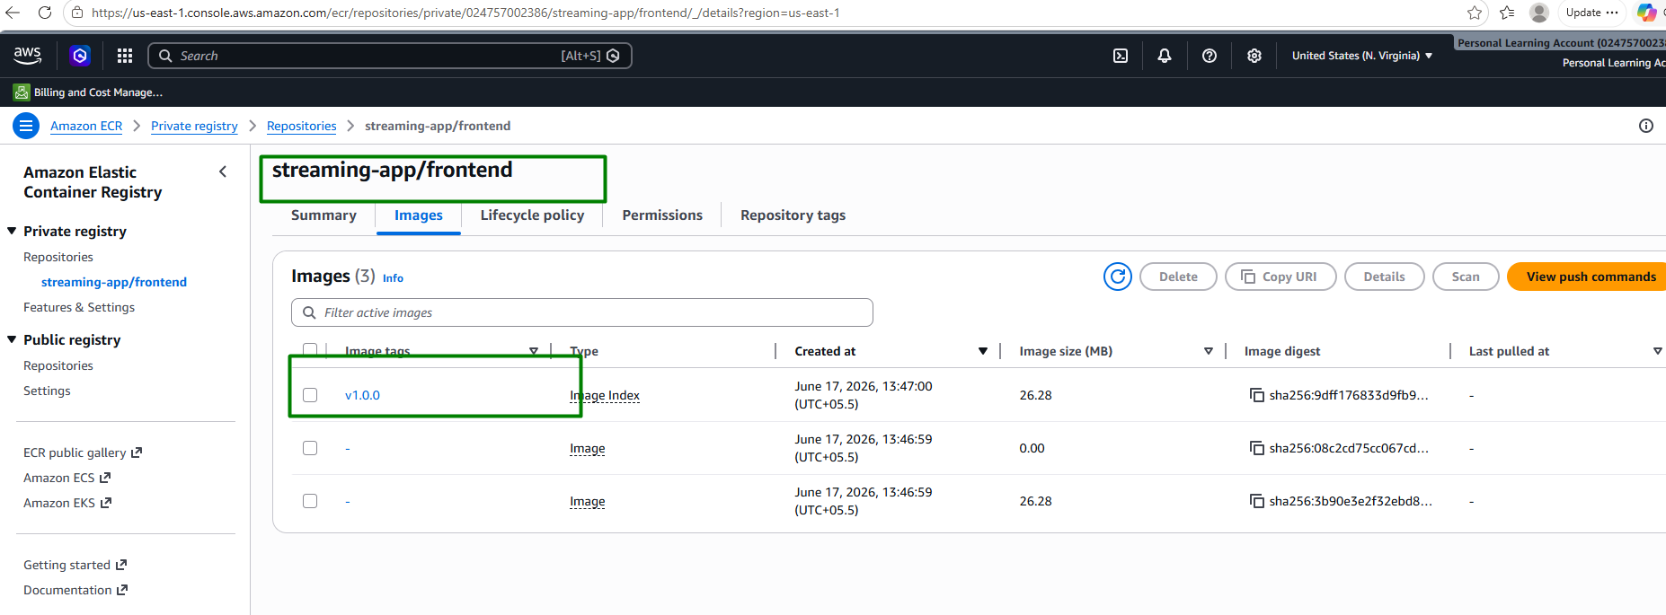

Step 3: AWS Environment Setup

Install and Configure AWS CLI

Set up AWS CLI with your access credentials.

This is covered under Step 2 after creating IAM user and creating access key

Step 4: Continuous Integration (CI) using Jenkins

Set Up Jenkins

Install Jenkins on an AWS EC2 instance.
Since the Jenkins URL is shared by herovired that we need to use, hence I have not installed Jenkins on EC2 instance here

Configure necessary plugins and credentials.
All the required plugins are installed on the Hero Vired Jenkins server. Below are the plugins required:
  - Pipeline
  - Docker Pipeline
  - Amazon ECR
  - AWS Credentials
  - Git
  - GitHub Integration Plugin

Add AWS credentials:
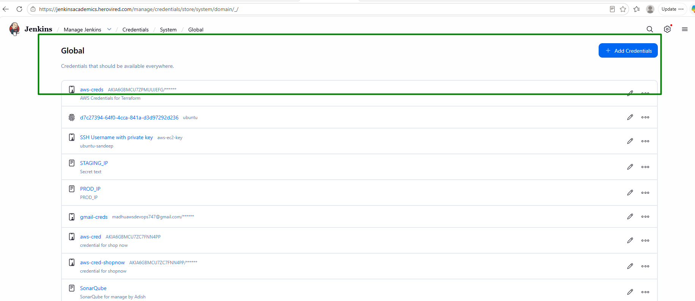
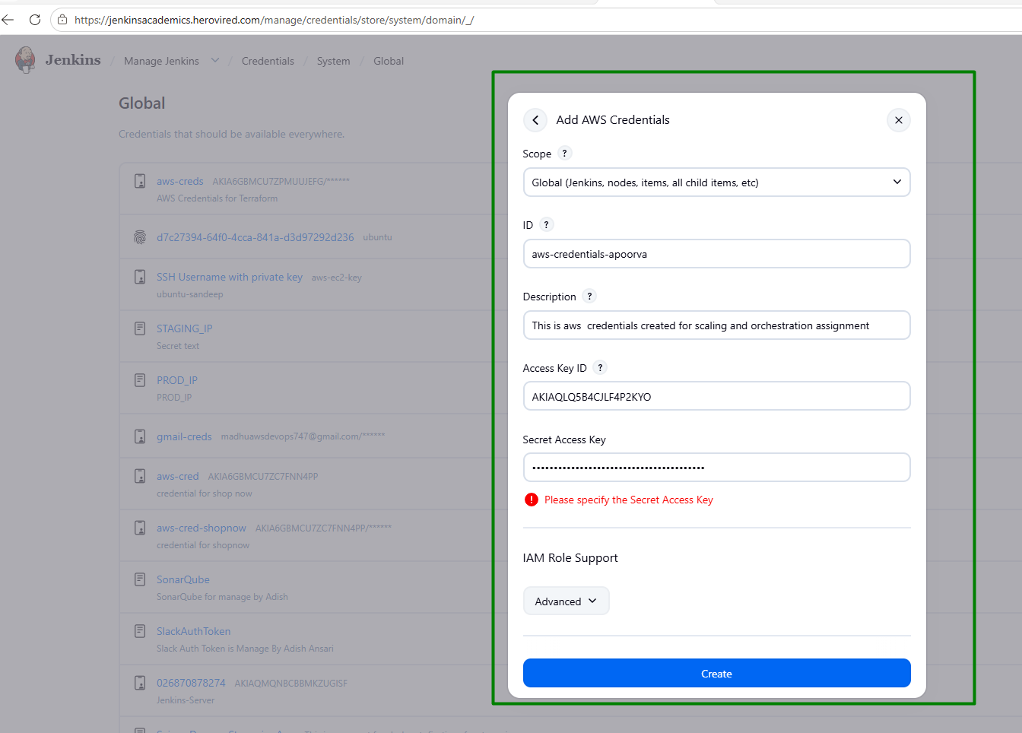
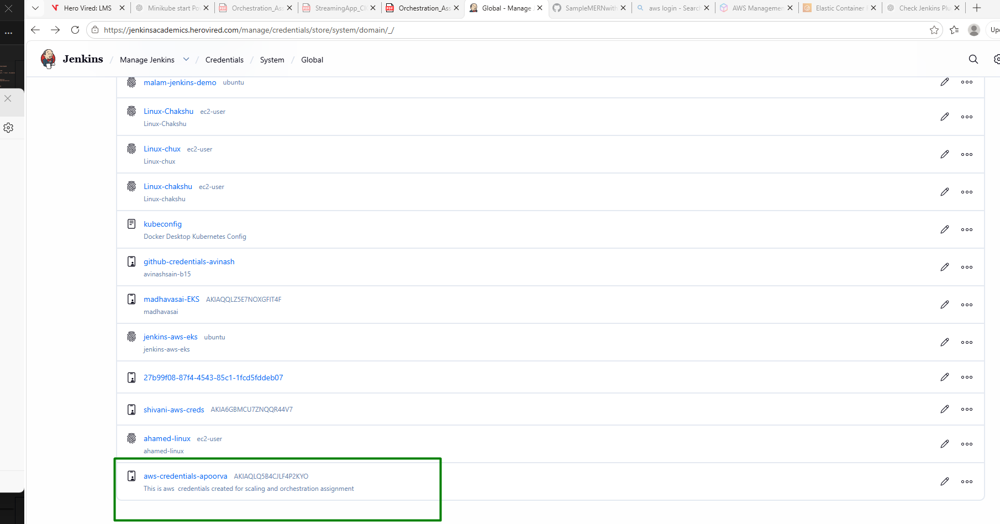

Add AWS account ID as secret text: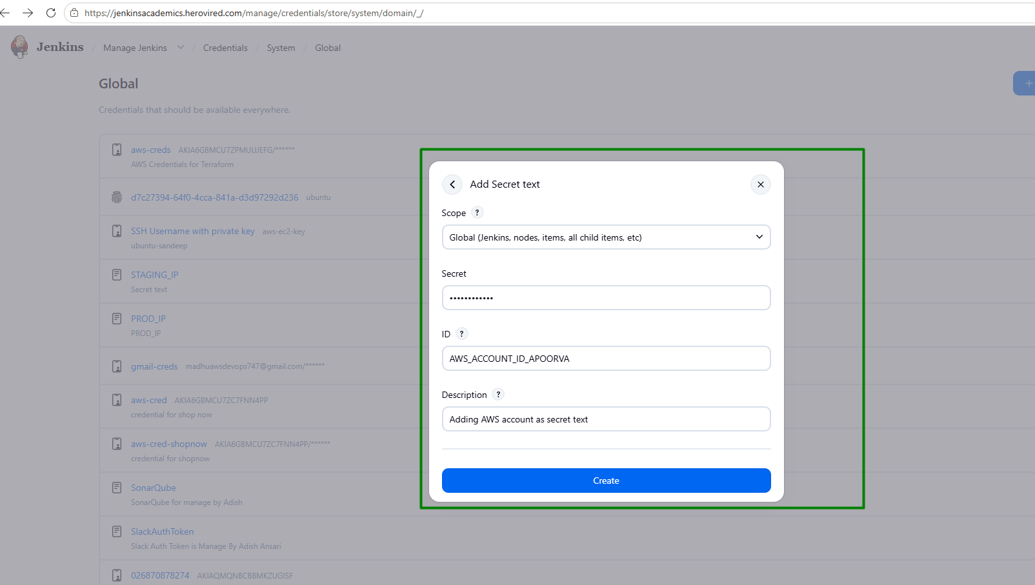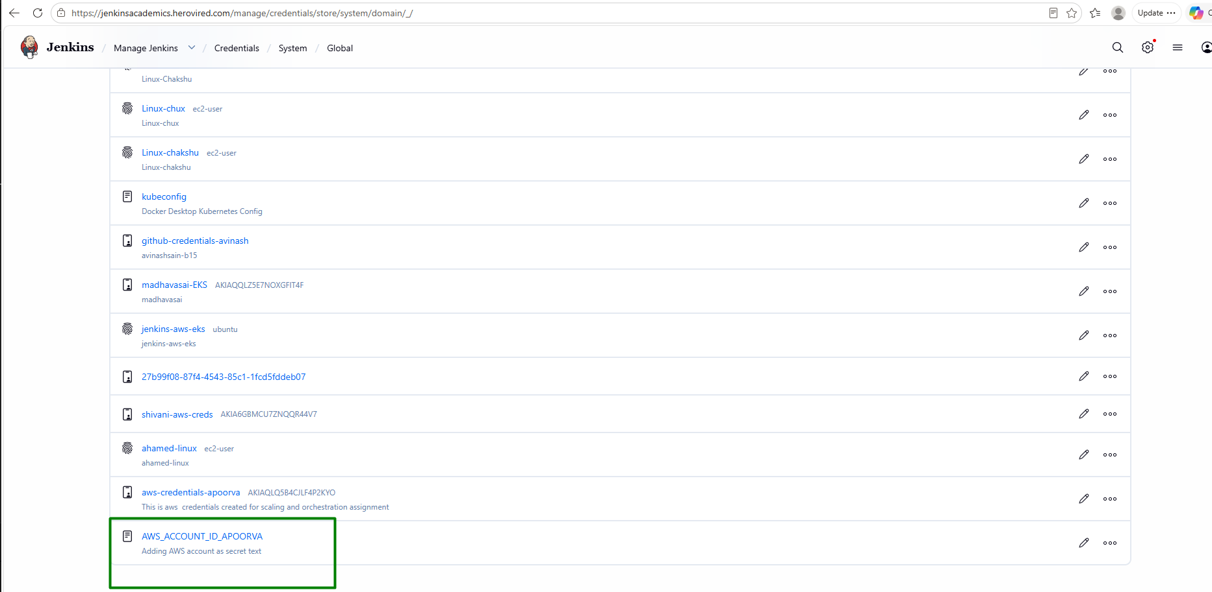

Add Ingress host as secret text (The secret will be added after implementing ingress):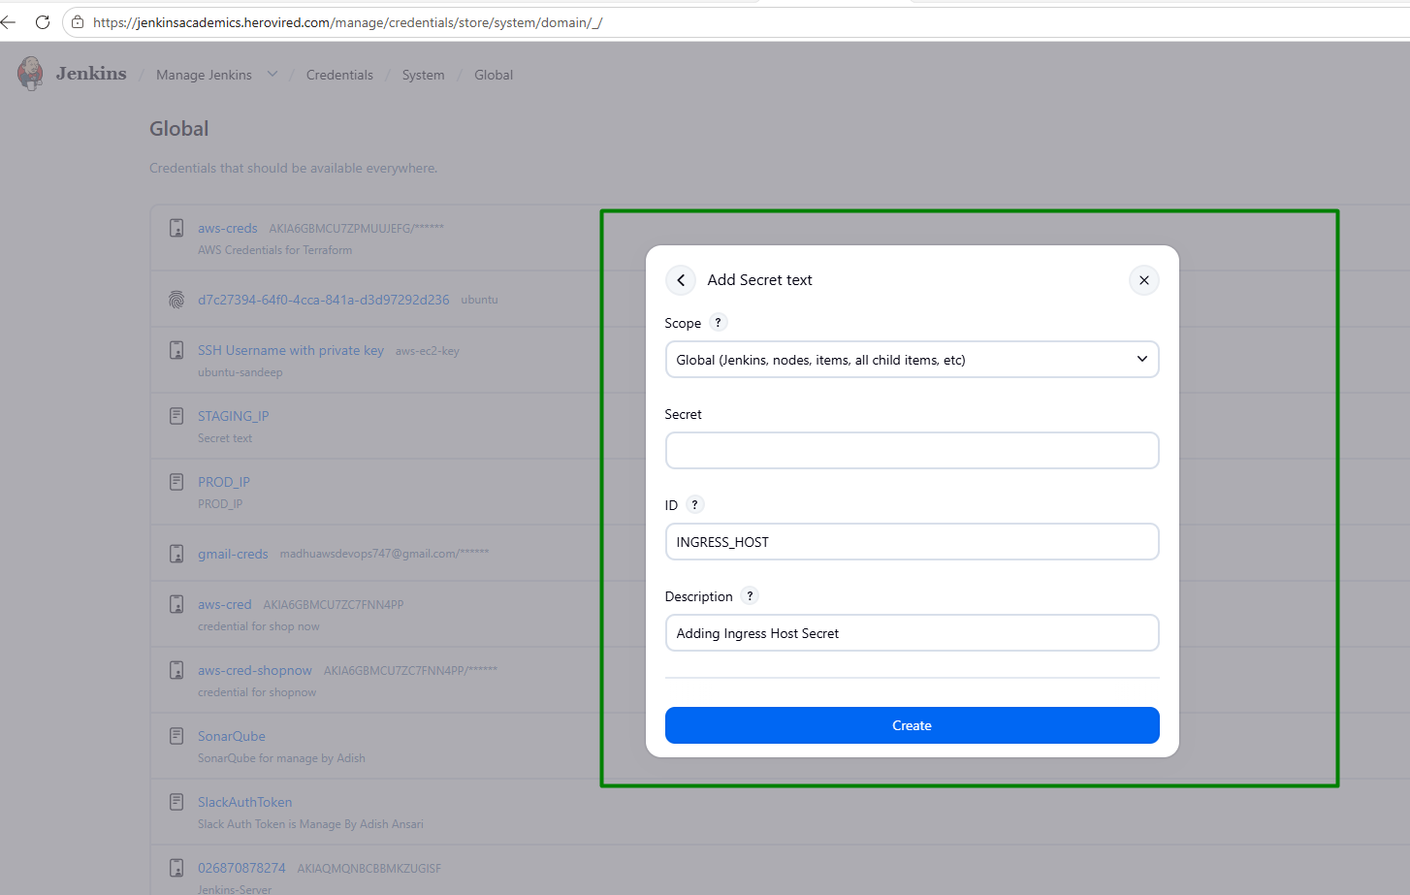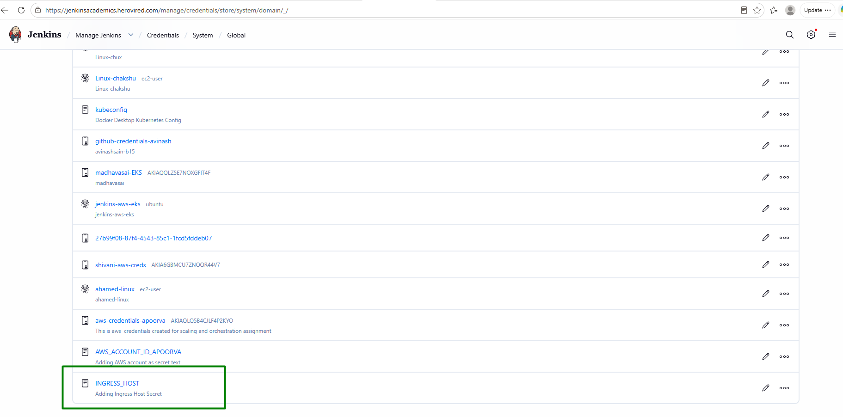

Add ECR Registry as a credential in Jenkins to use it instead of hardcoding in the code
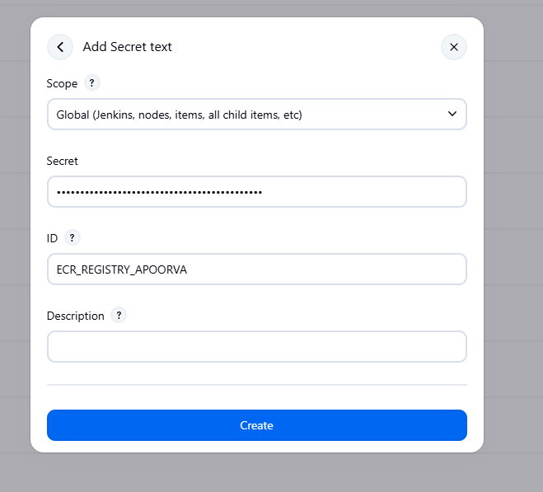
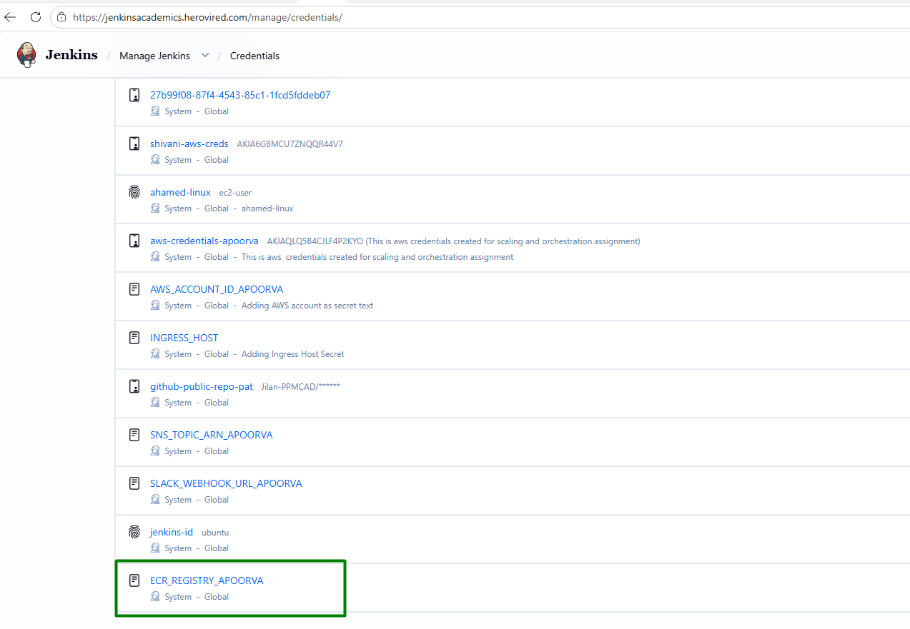

Add EKS Cluster Name as a credential in Jenkins to use it instead of hardcoding in the code
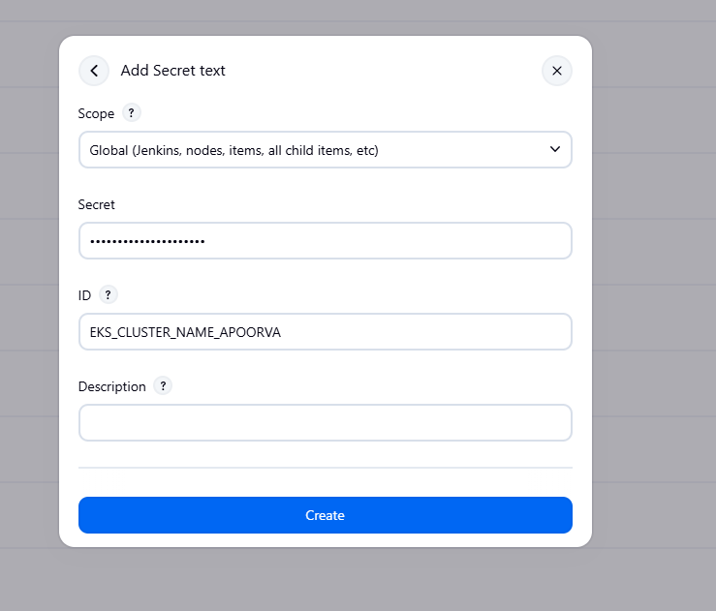
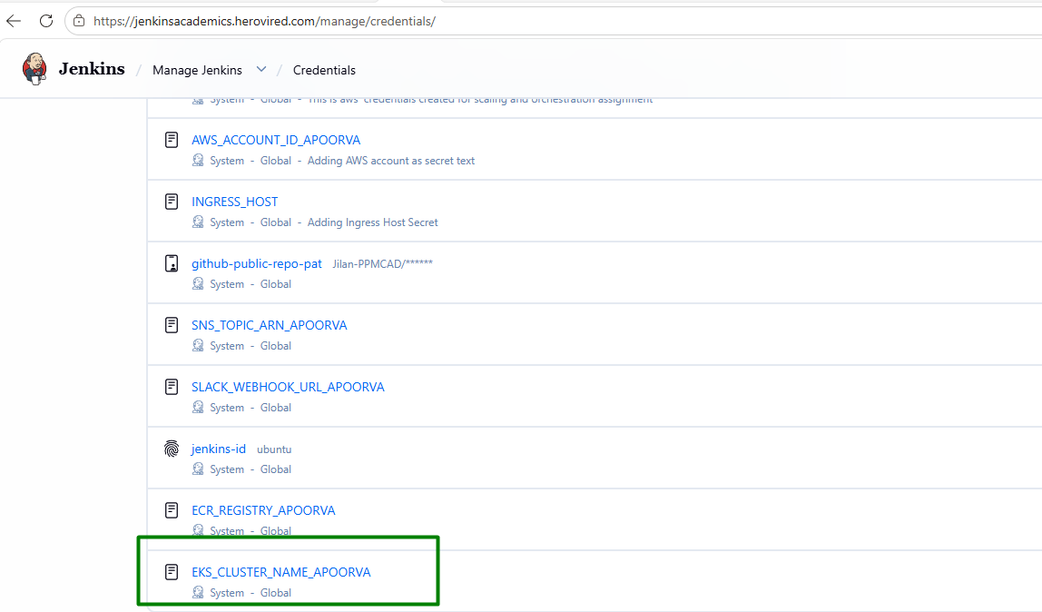

Create Jenkinsfile in project root:
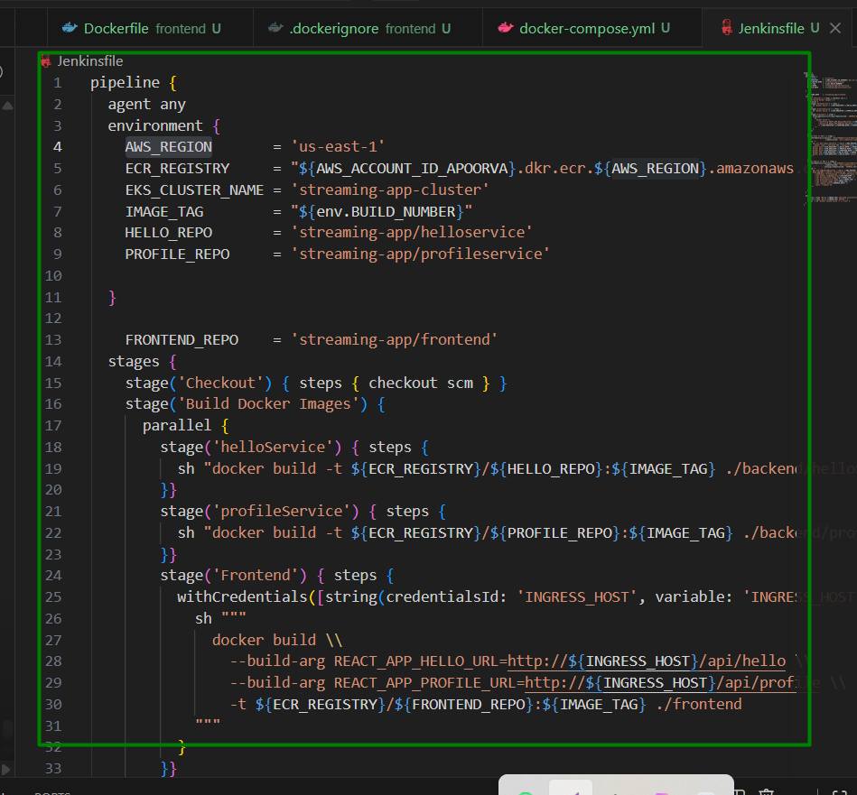

Jenkins file content:

pipeline {

agent any

environment {

AWS_REGION = 'us-east-1'

ECR_REGISTRY = "${AWS_ACCOUNT_ID_APOORVA}.dkr.ecr.${AWS_REGION}.amazonaws.com"

EKS_CLUSTER_NAME = 'streaming-app-cluster'

IMAGE_TAG = "${env.BUILD_NUMBER}"

HELLO_REPO = 'streaming-app/helloservice'

PROFILE_REPO = 'streaming-app/profileservice'

}

FRONTEND_REPO = 'streaming-app/frontend'

stages {

stage('Checkout') { steps { checkout scm } }

stage('Build Docker Images') {

parallel {

stage('helloService') { steps {

sh "docker build -t ${ECR_REGISTRY}/${HELLO_REPO}:${IMAGE_TAG} ./backend/helloService"

}}

stage('profileService') { steps {

sh "docker build -t ${ECR_REGISTRY}/${PROFILE_REPO}:${IMAGE_TAG} ./backend/profileService"

}}

stage('Frontend') { steps {

withCredentials([string(credentialsId: 'INGRESS_HOST', variable: 'INGRESS_HOST')]) {

sh """

docker build \\

--build-arg REACT_APP_HELLO_URL=http://${INGRESS_HOST}/api/hello \\

--build-arg REACT_APP_PROFILE_URL=http://${INGRESS_HOST}/api/profile \\

-t ${ECR_REGISTRY}/${FRONTEND_REPO}:${IMAGE_TAG} ./frontend

"""

}

}}

}

}

stage('Push to ECR') { steps {

withCredentials([[$class: 'AmazonWebServicesCredentialsBinding',

credentialsId: 'aws-credentials-apoorva']]) {

sh """

aws ecr get-login-password --region ${AWS_REGION} | \\

docker login --username AWS --password-stdin ${ECR_REGISTRY}

docker push ${ECR_REGISTRY}/${HELLO_REPO}:${IMAGE_TAG}

docker push ${ECR_REGISTRY}/${PROFILE_REPO}:${IMAGE_TAG}

docker push ${ECR_REGISTRY}/${FRONTEND_REPO}:${IMAGE_TAG}

docker tag ${ECR_REGISTRY}/${HELLO_REPO}:${IMAGE_TAG} ${ECR_REGISTRY}/${HELLO_REPO}:latest

docker push ${ECR_REGISTRY}/${HELLO_REPO}:latest

"""

}

}}

stage('Deploy to EKS') { steps {

withCredentials([[$class: 'AmazonWebServicesCredentialsBinding',

credentialsId: 'aws-credentials'],

[string(credentialsId: 'INGRESS_HOST', variable: 'INGRESS_HOST')]]) {

sh """

aws eks update-kubeconfig --region ${AWS_REGION} --name ${EKS_CLUSTER_NAME}

helm upgrade --install streaming-app ./helm/streaming-app \\

--namespace streaming-app --create-namespace \\

--set global.imageRegistry=${ECR_REGISTRY} \\

--set helloService.image.tag=${IMAGE_TAG} \\

--set profileService.image.tag=${IMAGE_TAG} \\

--set frontend.image.tag=${IMAGE_TAG} \\

--set ingress.host=${INGRESS_HOST} \\

--wait --timeout 5m

"""

}

}}

}

post {

success { echo "Build ${IMAGE_TAG} deployed successfully." }

failure { echo "Build ${IMAGE_TAG} FAILED." }

always { sh "docker system prune -f || true" }

}

}

Create Jenkins Pipelines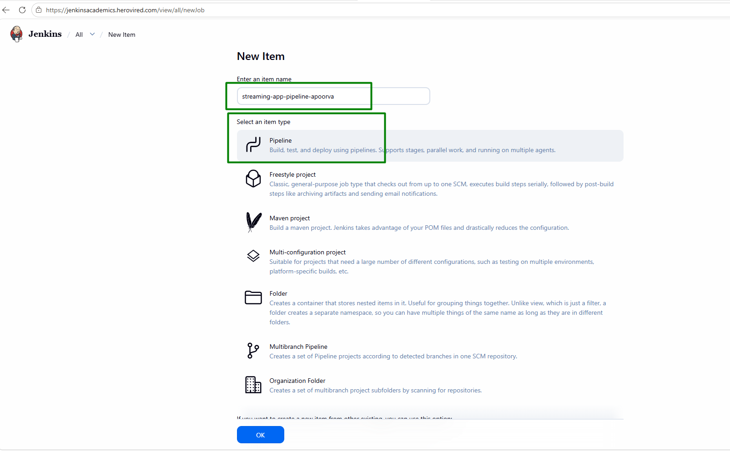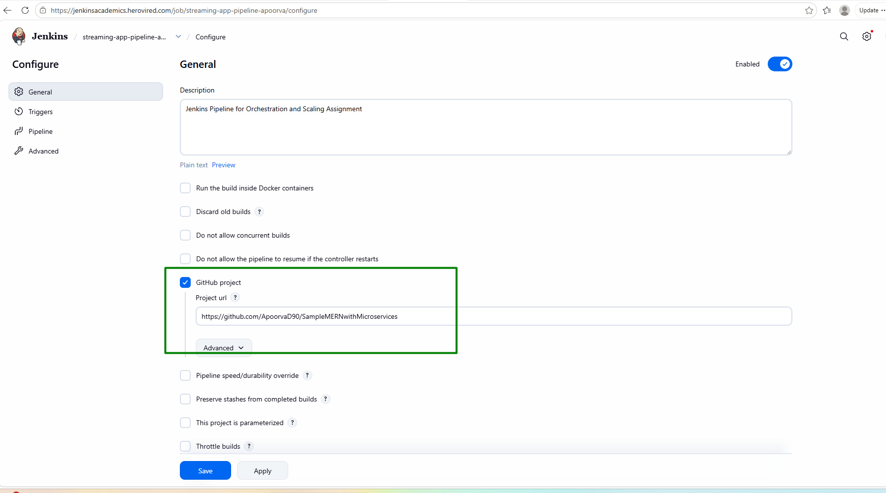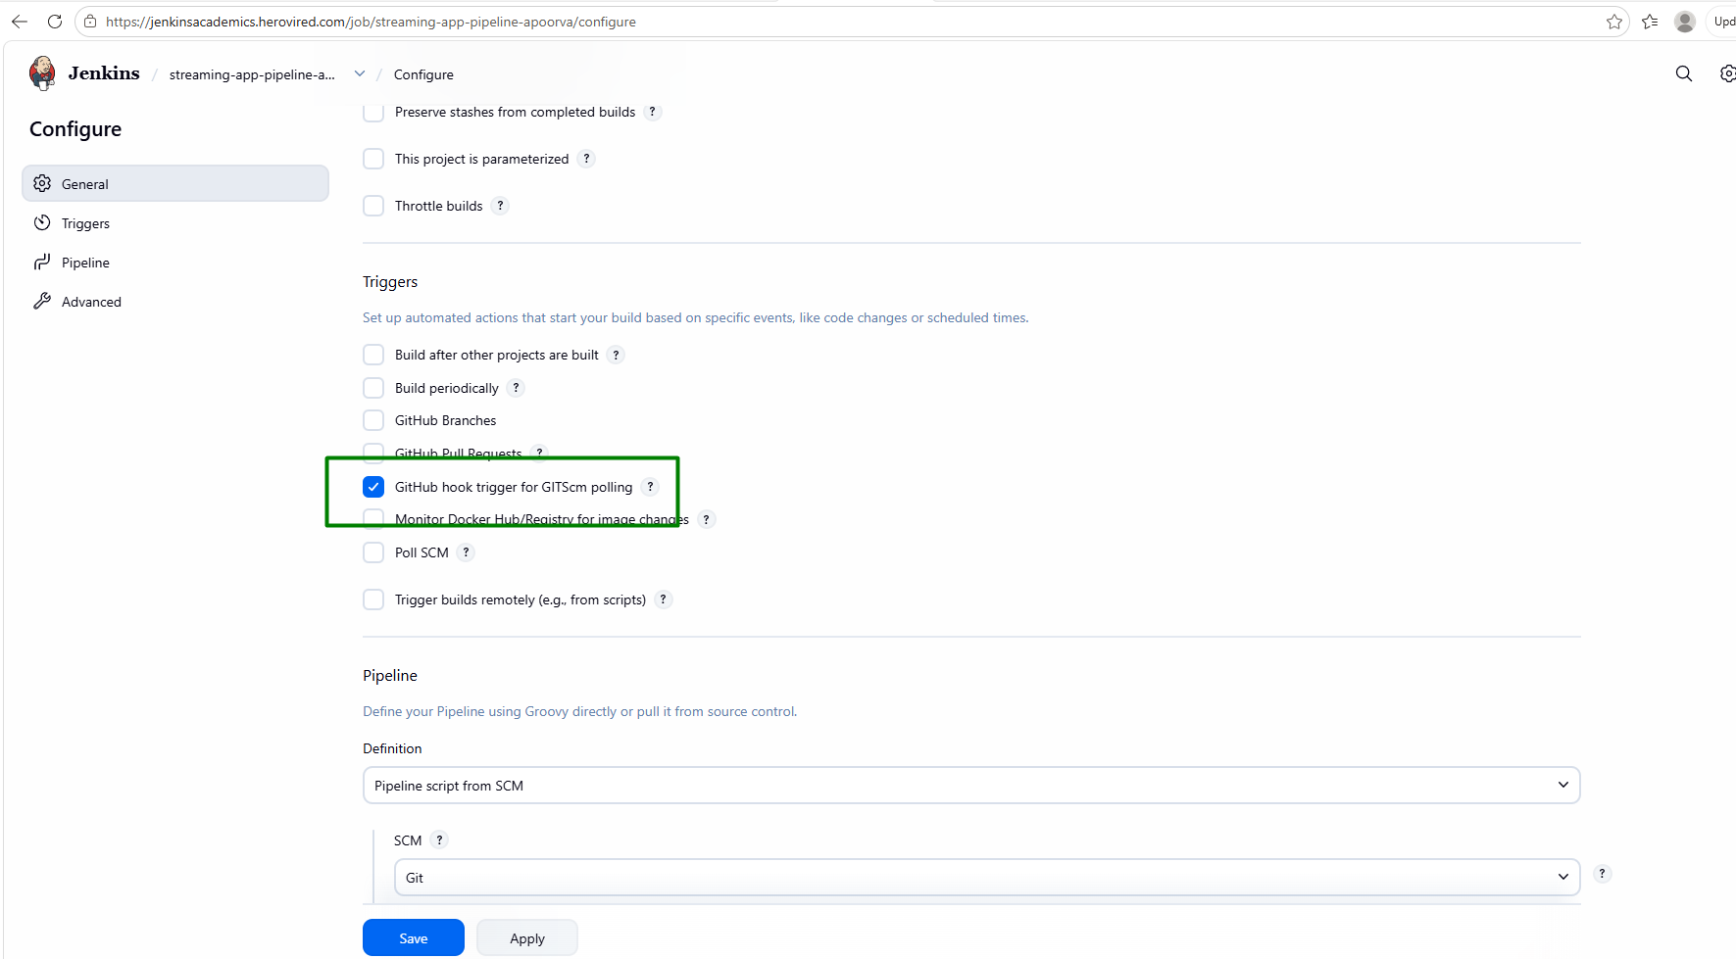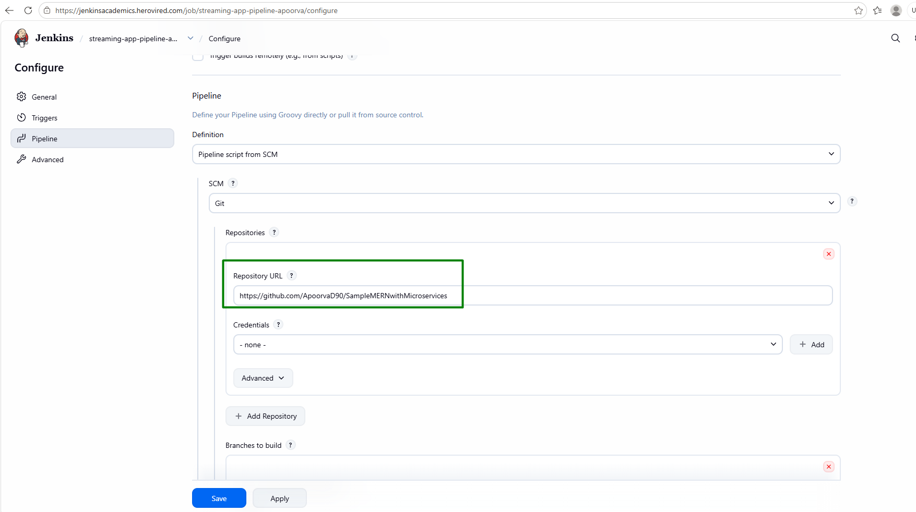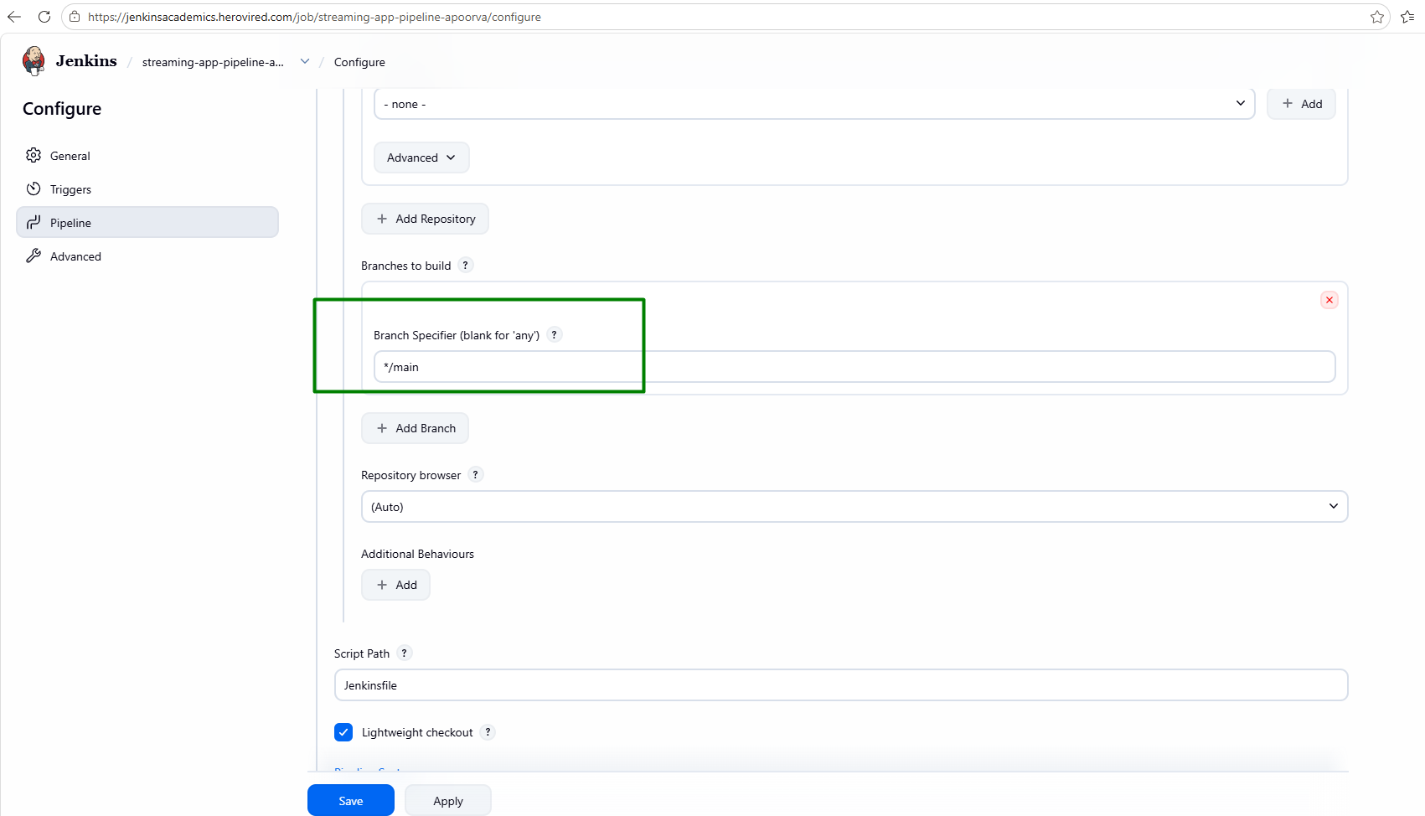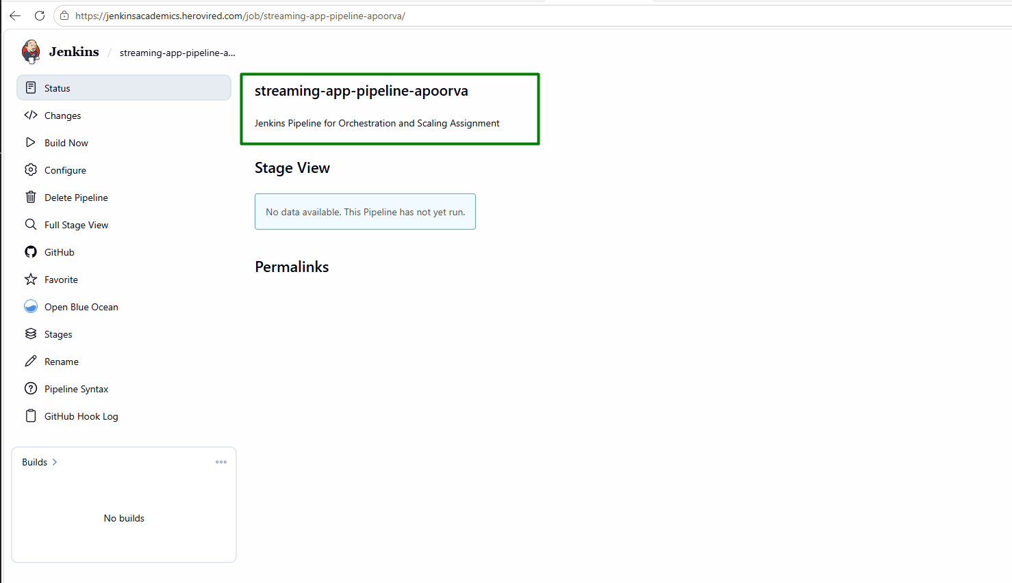

Add GitHub Webhook
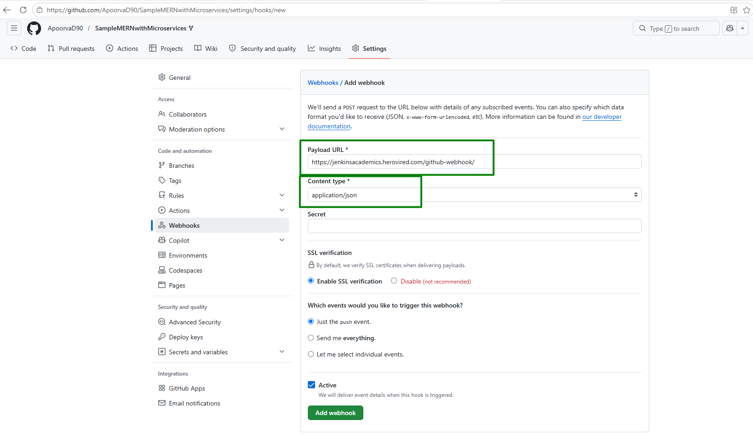
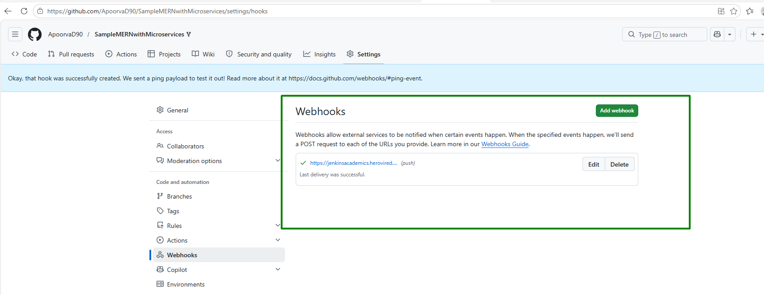

Build and push Docker images to ECR using Jenkins jobs.

Trigger builds automatically on new commits from the Git repository.
Above 2 steps are covered under Step 8: Final Validation. Screenshots are attached that shows, after changes to GIT repo, Jenkins build is automatically started on recent build with recent docker images to ECR pushed

Step 5: Kubernetes Deployment (EKS)

Create an EKS Cluster

Use eksctl or similar tools to set up Amazon EKS.

Creating EKS Cluster below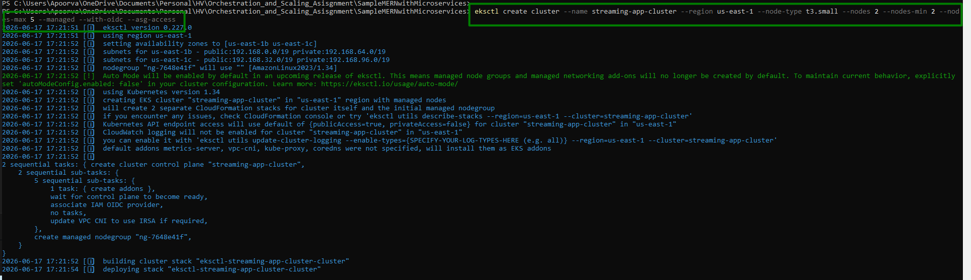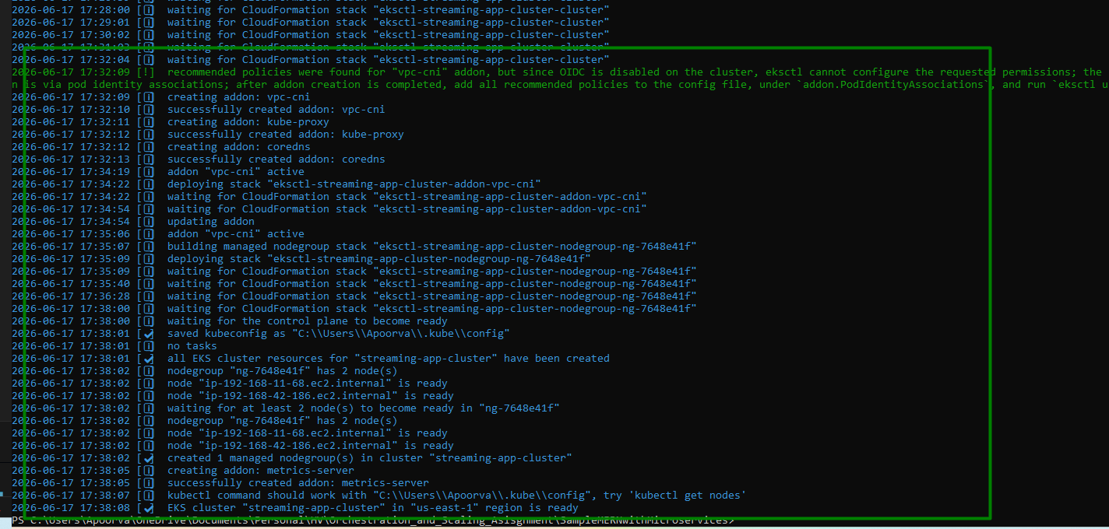
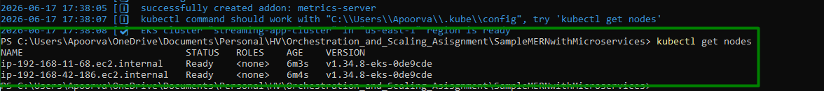

Install nginx Ingress Controller
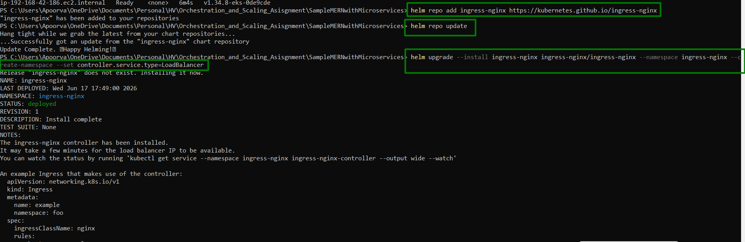

Get Ingress Hostname:
ab848443a5b3a452aba8765e31e8bb37-1377079175.us-east-1.elb.amazonaws.com

Install Metrics Server:
kubectl apply -f https://github.com/kubernetes-sigs/metrics-server/releases/latest/download/components.yaml

Deploy via Helm

Package and deploy the MERN stack using Helm charts.

Create the Helm chart file structure
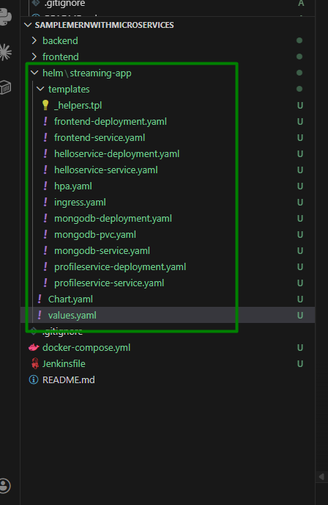

Helm/streaming-app/Chart.yaml:
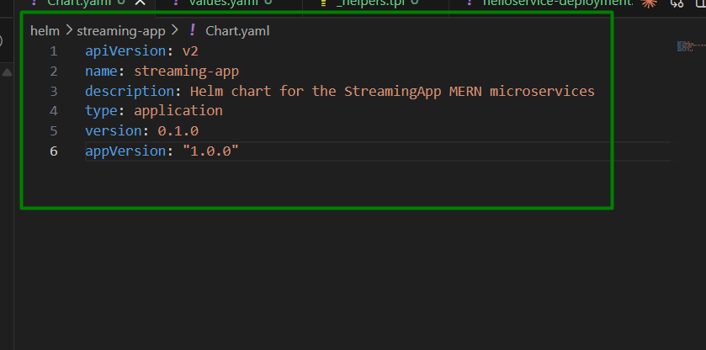

Helm/streaming-app/values.yaml:
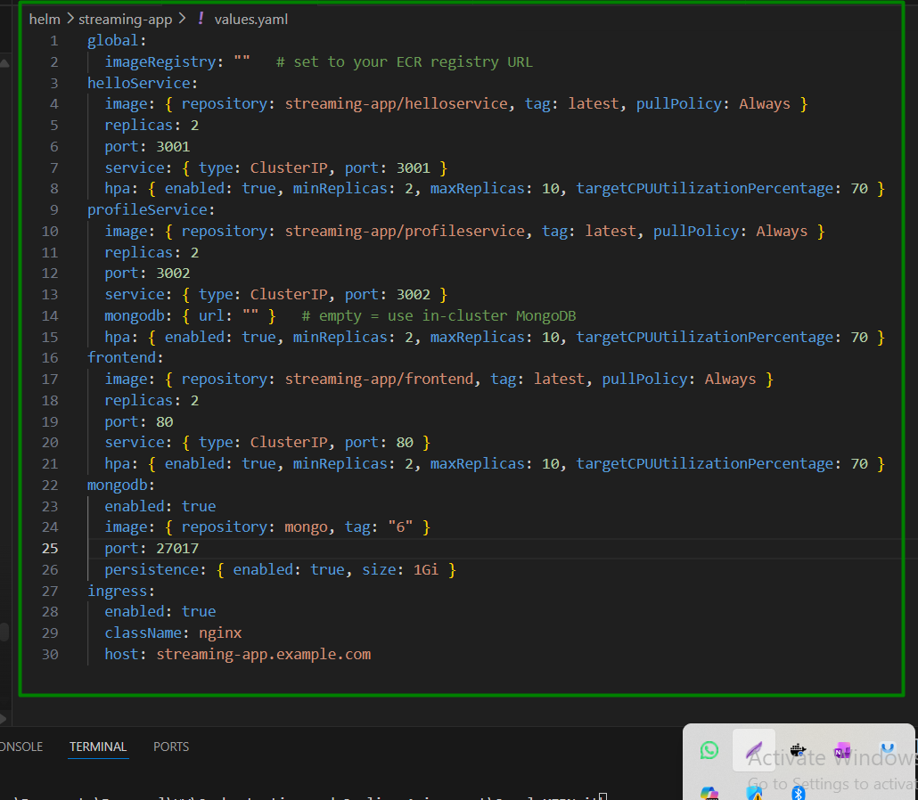

Helm/streaming-app/templates/_helpers.tpl> This will define reusable template functions
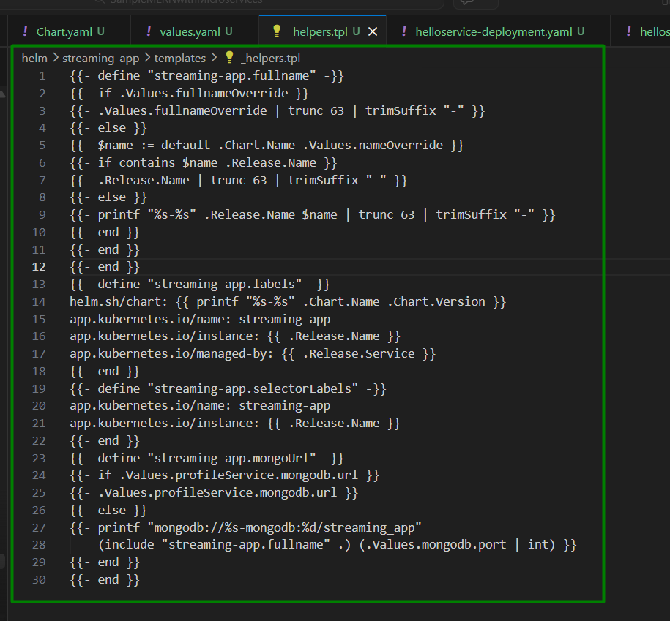

helm/streaming-app/templates/helloservice-deployment.yaml
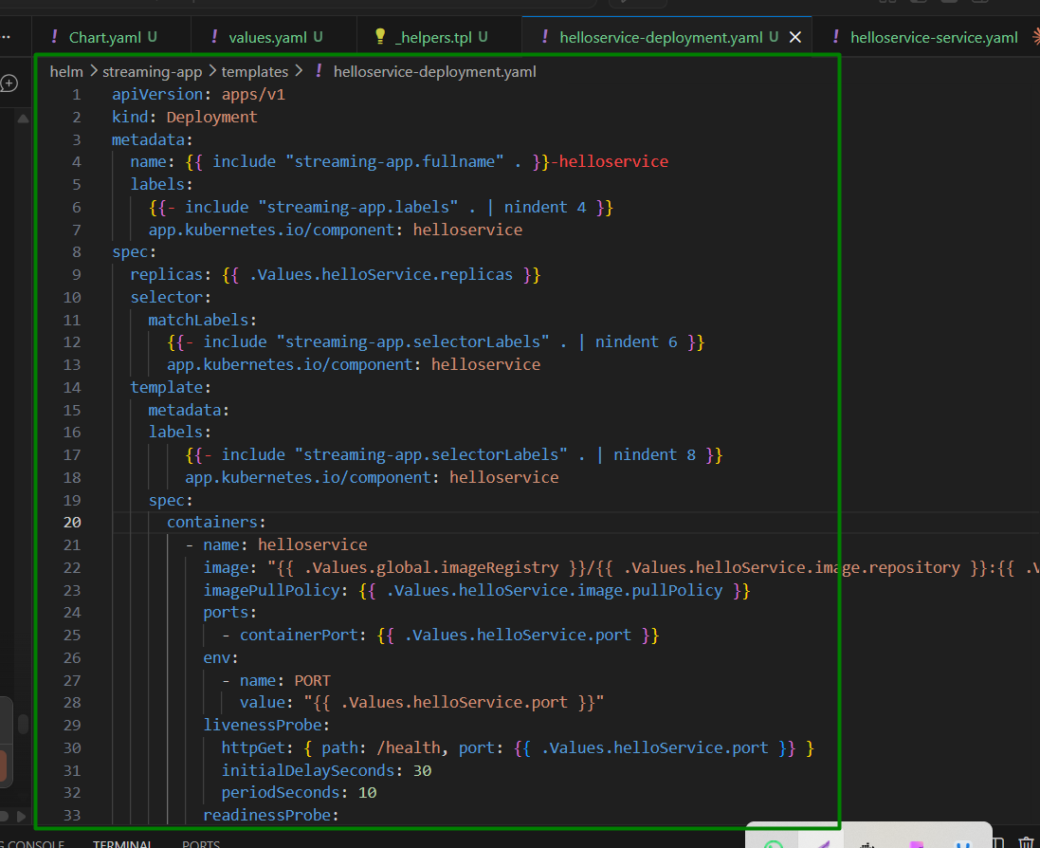

helm/streaming-app/templates/helloservice-service.yaml
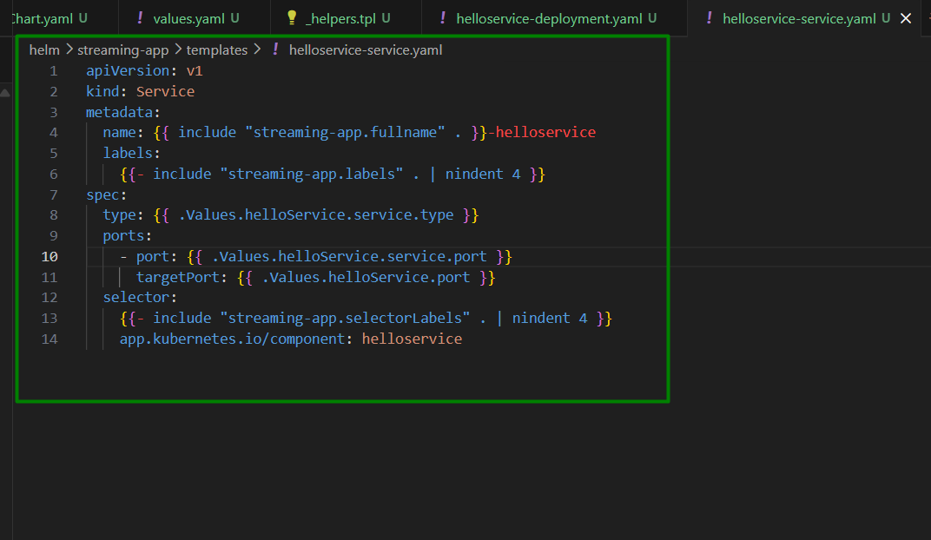

helm/streaming-app/templates/profileservice-deployment.yaml
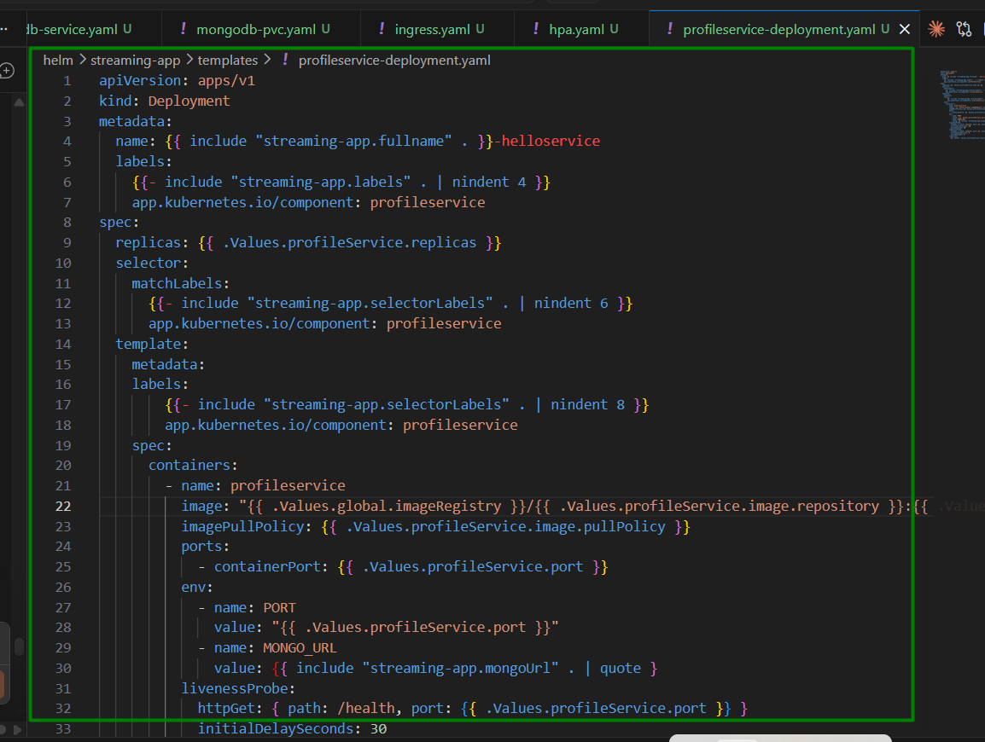
apiVersion: apps/v1
kind: Deployment
metadata:
name: {{ include "streaming-app.fullname" . }}-helloservice
labels:
{{- include "streaming-app.labels" . | nindent 4 }}
app.kubernetes.io/component: profileservice
spec:
replicas: {{ .Values.profileService.replicas }}
selector:
matchLabels:
{{- include "streaming-app.selectorLabels" . | nindent 6 }}
app.kubernetes.io/component: profileservice
template:
metadata:
labels:
{{- include "streaming-app.selectorLabels" . | nindent 8 }}
app.kubernetes.io/component: profileservice
spec:
containers:
- name: profileservice
image: "{{ .Values.global.imageRegistry }}/{{ .Values.profileService.image.repository }}:{{ .Values.profileService.image.tag }}"
imagePullPolicy: {{ .Values.profileService.image.pullPolicy }}
ports:
- containerPort: {{ .Values.profileService.port }}
env:
- name: PORT
value: "{{ .Values.profileService.port }}"
- name: MONGO_URL
value: {{ include "streaming-app.mongoUrl" . | quote }
livenessProbe:
httpGet: { path: /health, port: {{ .Values.profileService.port }} }
initialDelaySeconds: 30
periodSeconds: 10
readinessProbe:
httpGet: { path: /health, port: {{ .Values.profileService.port }} }
initialDelaySeconds: 5
periodSeconds: 5
resources:
{{- toYaml .Values.profileService.resources | nindent 12 }}

helm/streaming-app/templates/profileservice-service.yaml
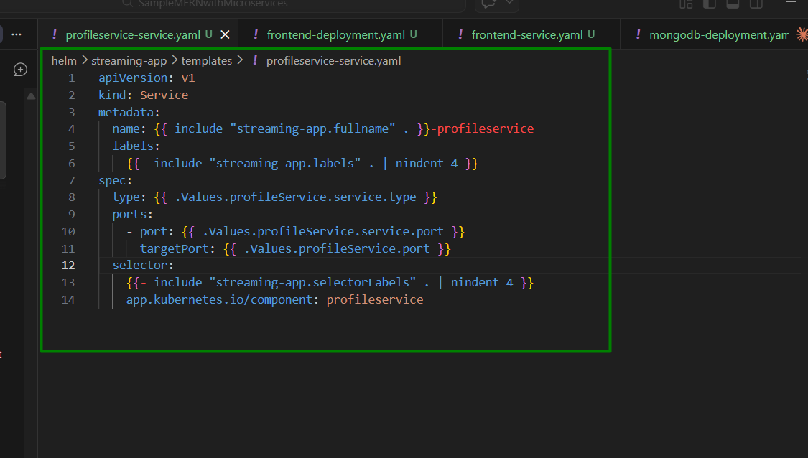

Helm/streaming-app/templates/frontend-deployment.yaml:
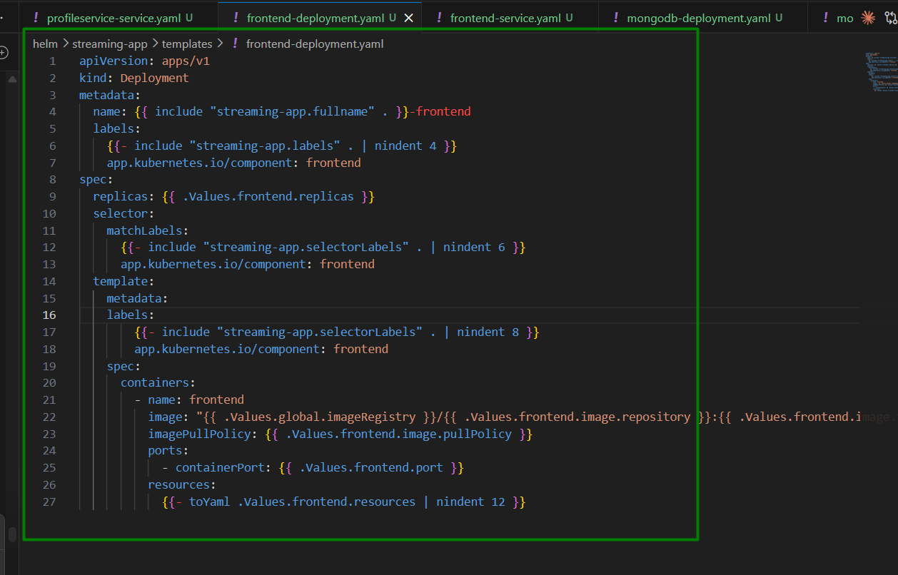

Helm/streaming-app/templates/frontend-service.yaml:
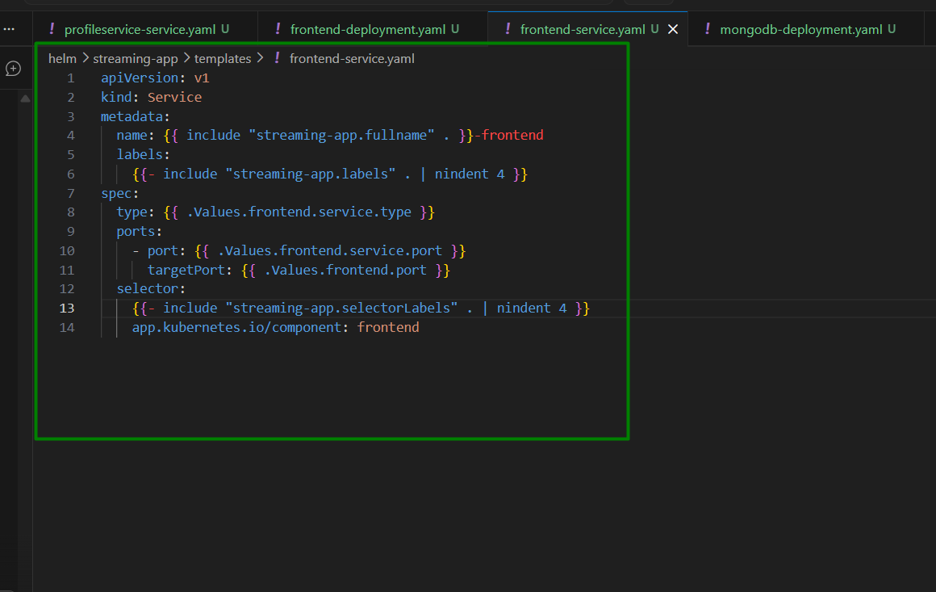

helm/streaming-app/templates/mongodb-deployment.yaml:
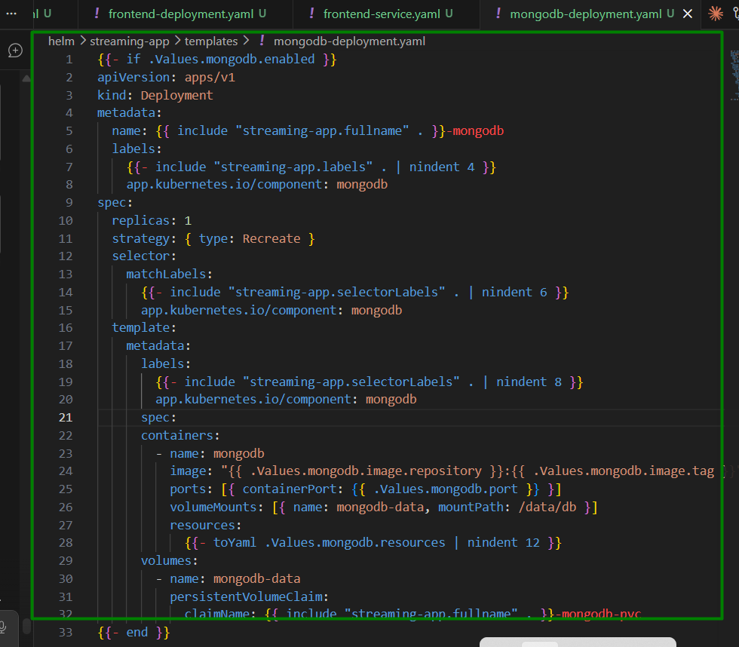

helm/streaming-app/templates/mongodb-service.yaml:
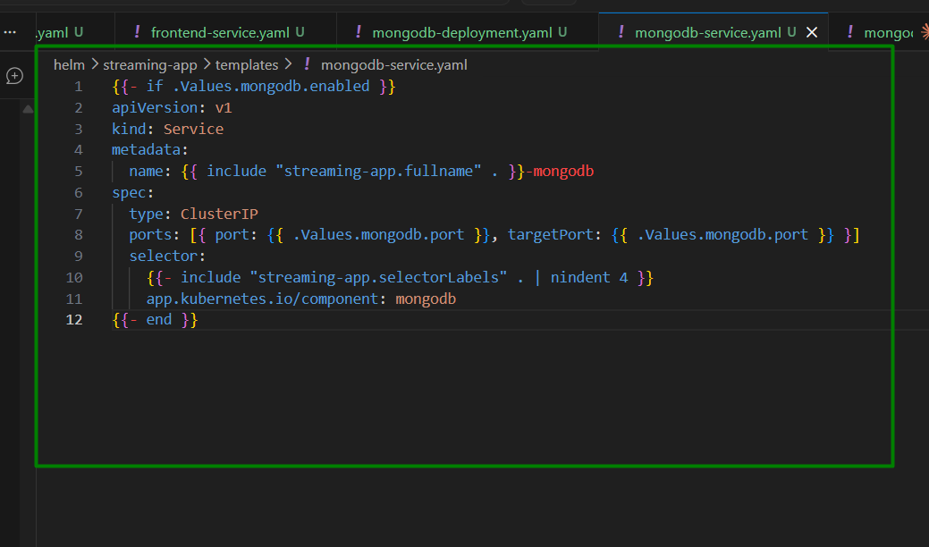

Helm/streaming-app/templates/mongodb-pvc.yaml
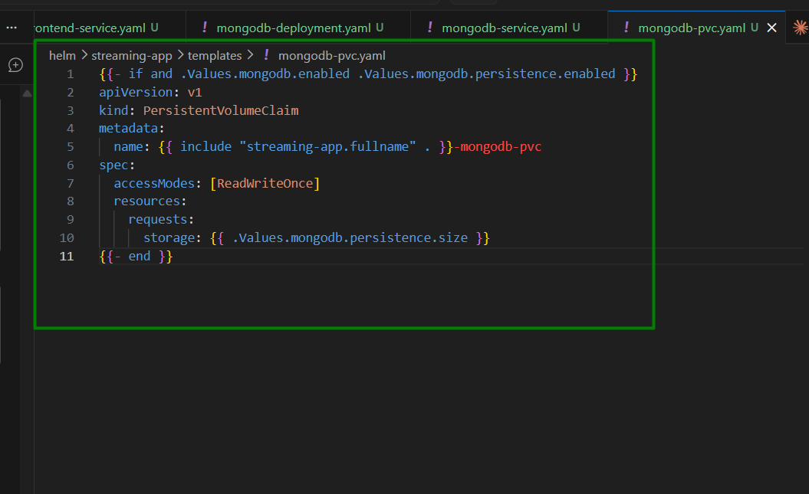

Helm/streaming-app/templates/ingress.yaml:
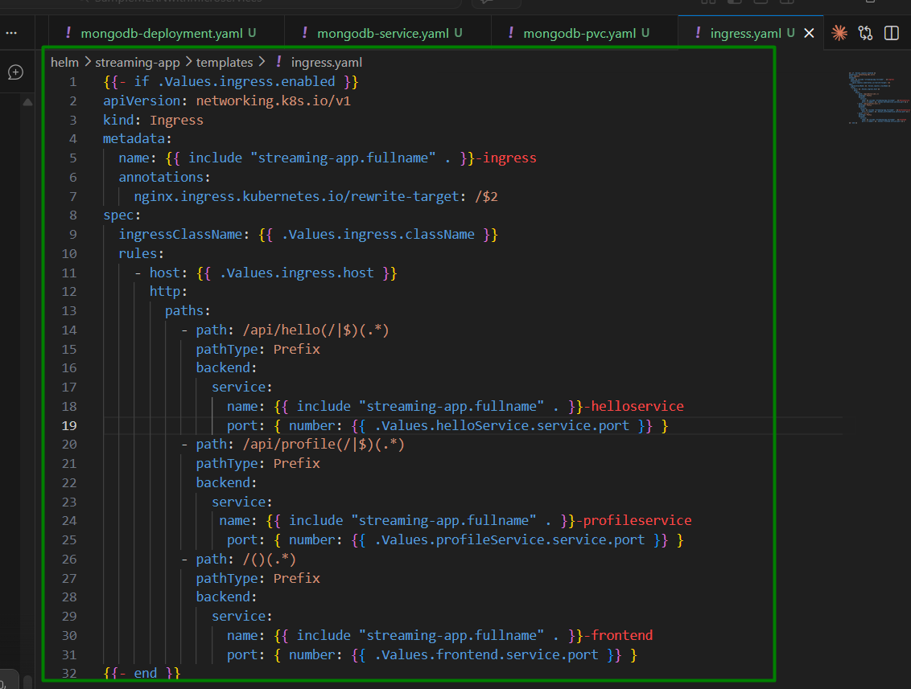

Helm/streaming-app/templates/hpa.yaml: Horizontal Pod Autoscaler
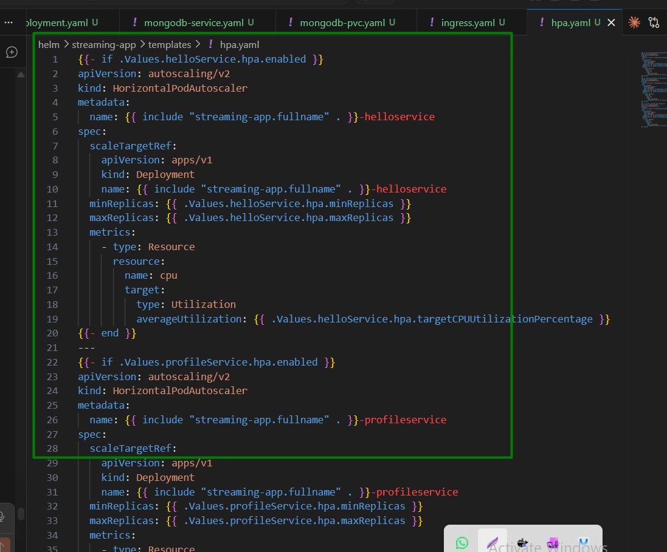

Rebuild frontend with real Ingress Host
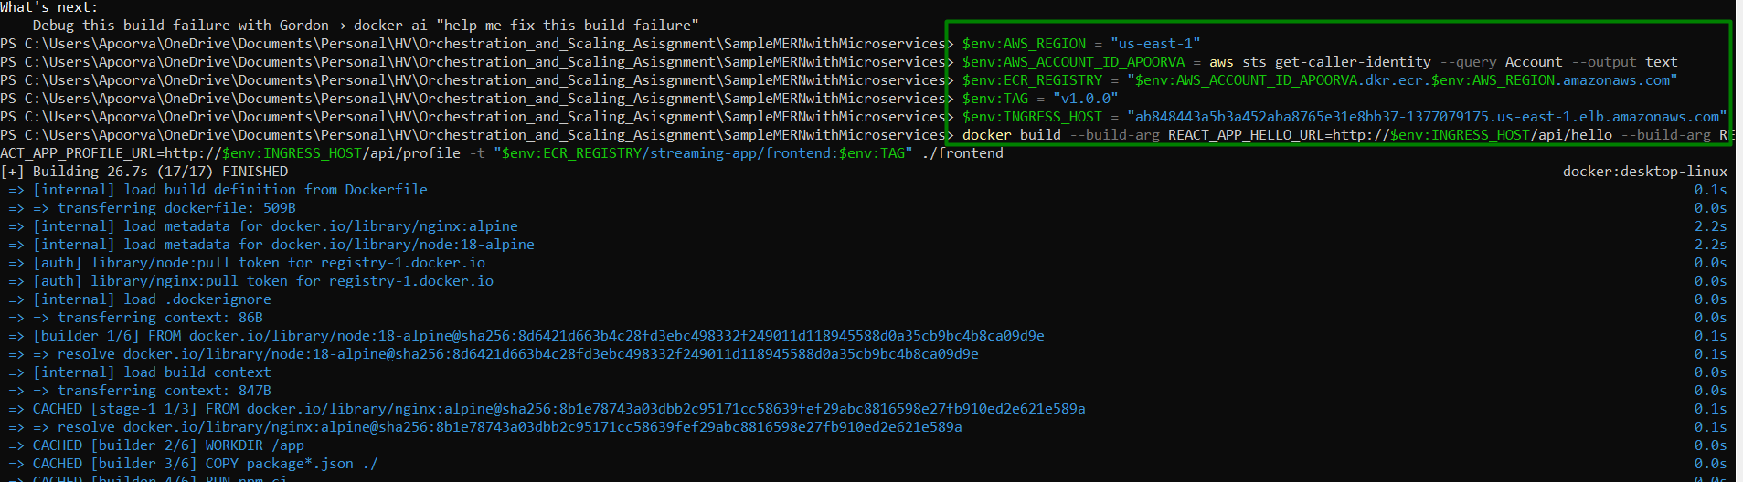
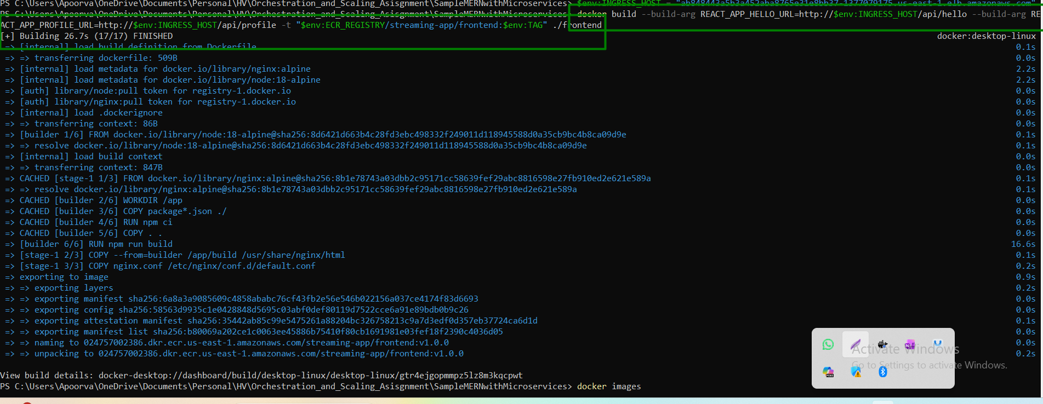

Deploy with Helm and verify with commands:
kubectl get pods -n streaming-app
kubectl get ingress -n streaming-app
curl http://$INGRESS_HOST/api/hello/
curl http://$INGRESS_HOST/api/profile/health
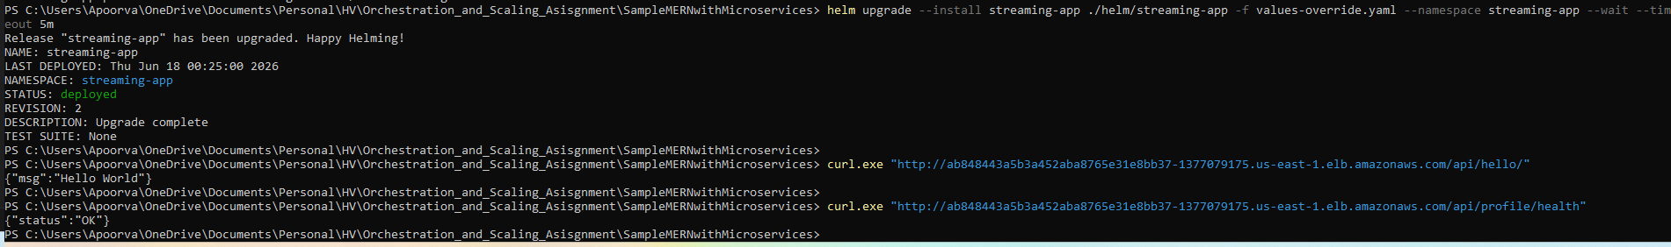
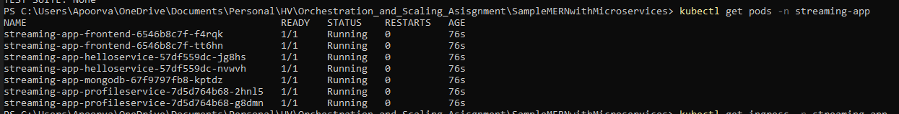
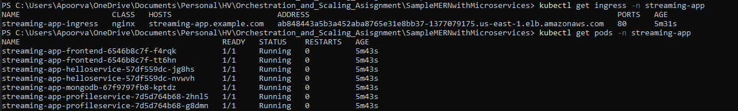

Step 6: Monitoring and Logging

Set Up Monitoring

Use Amazon CloudWatch for metrics and alarms.

Attach cloudwatch policy to EKS nodes

Deploy Cloudwatch container insights
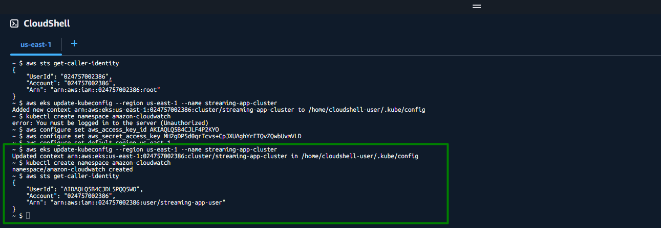

Configure Logging

Centralize application logs using CloudWatch Logs or similar tools.
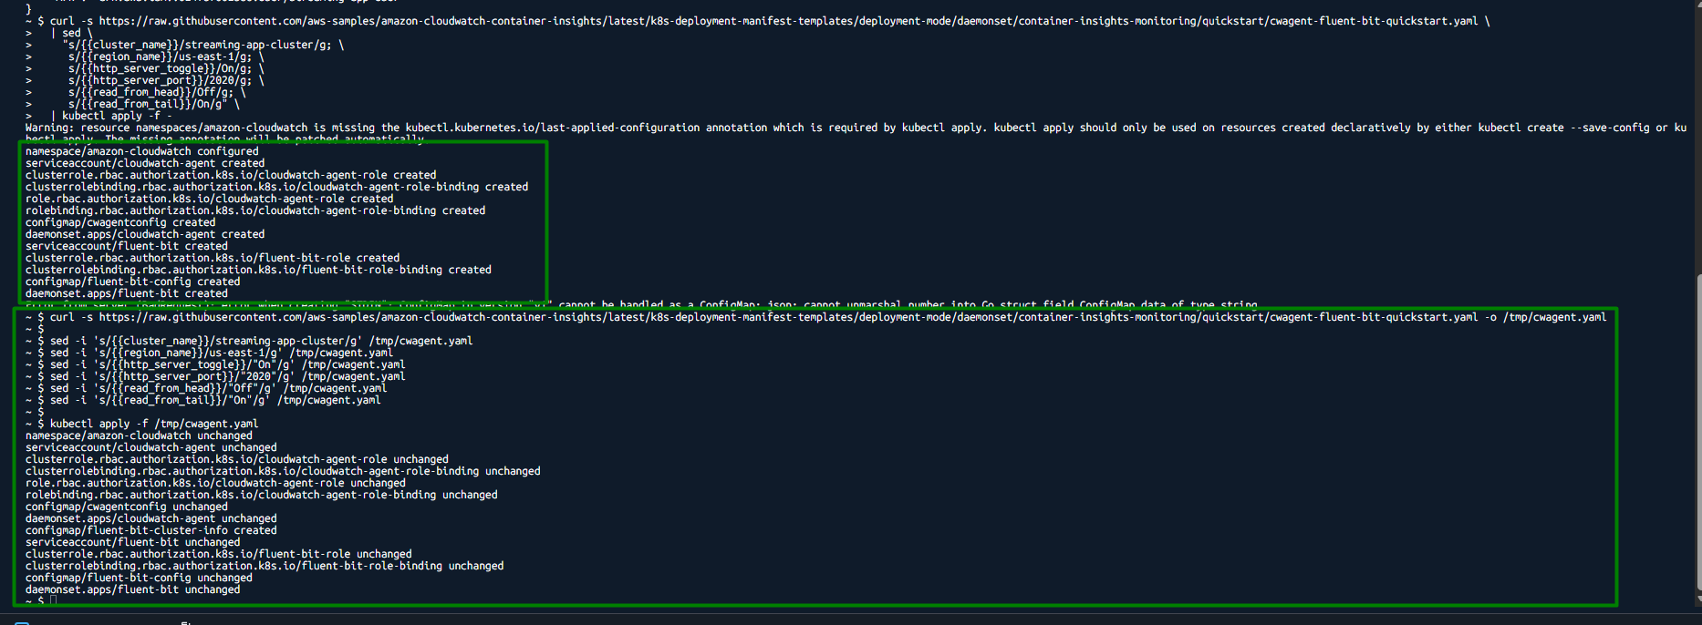

Create a CPU alarm via AWS console
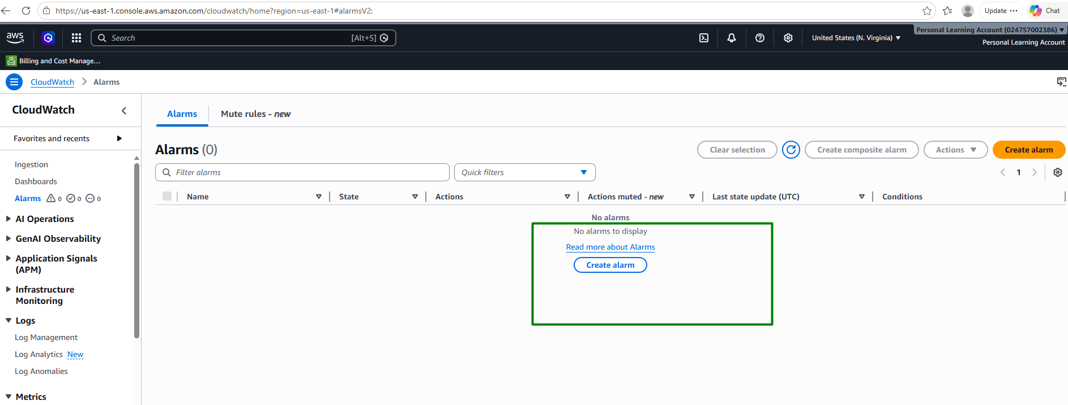
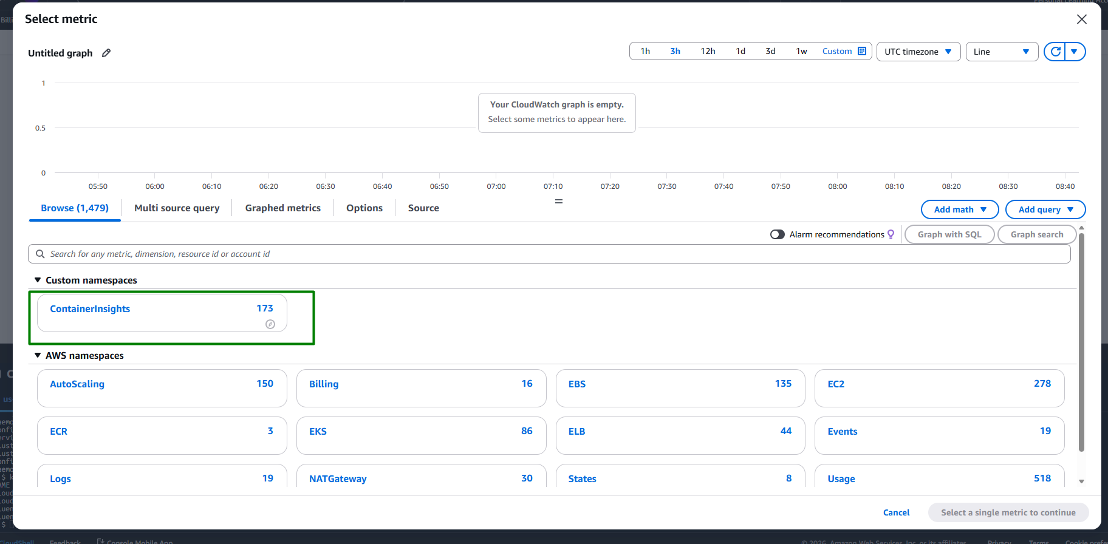
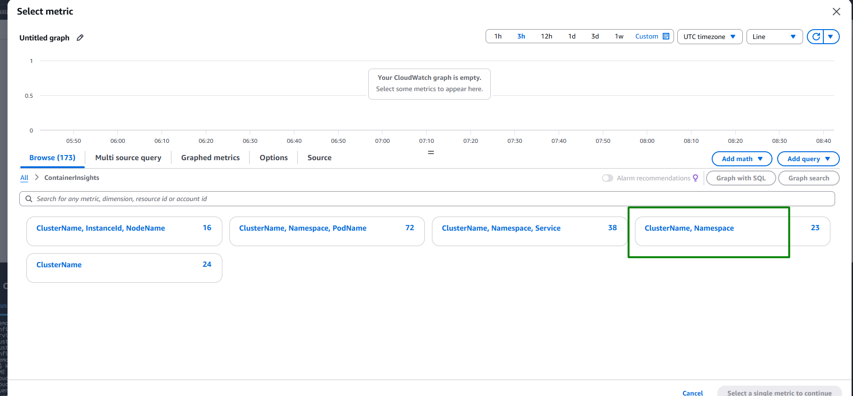
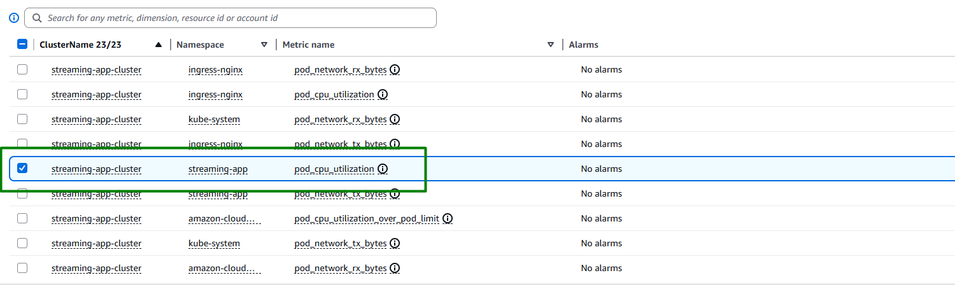
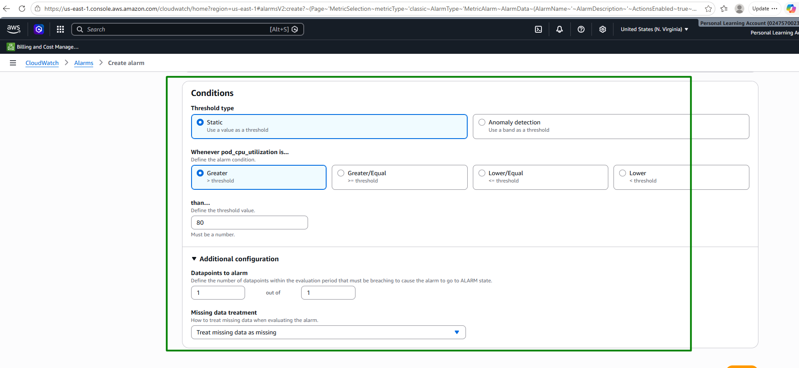
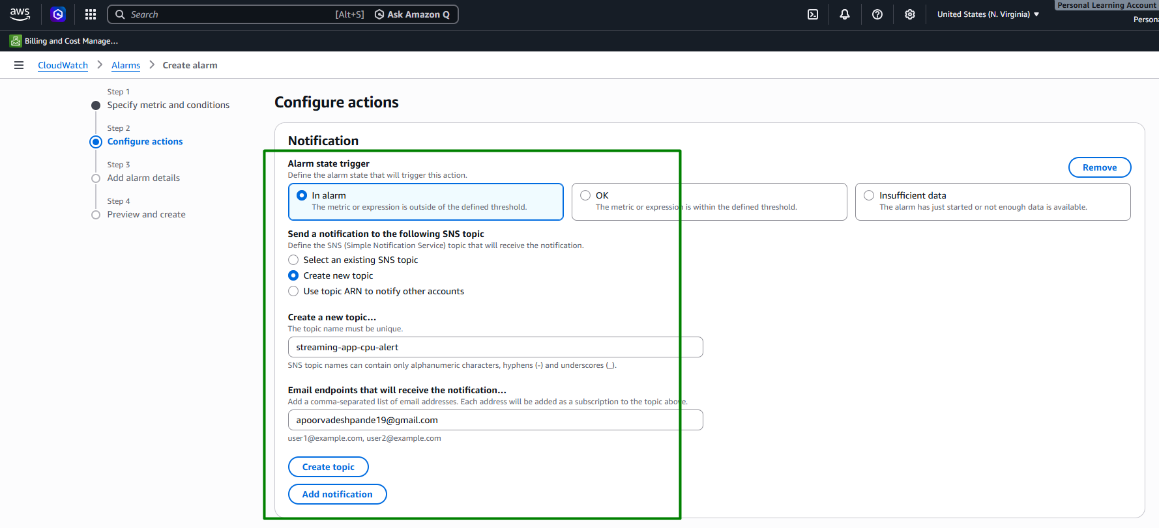
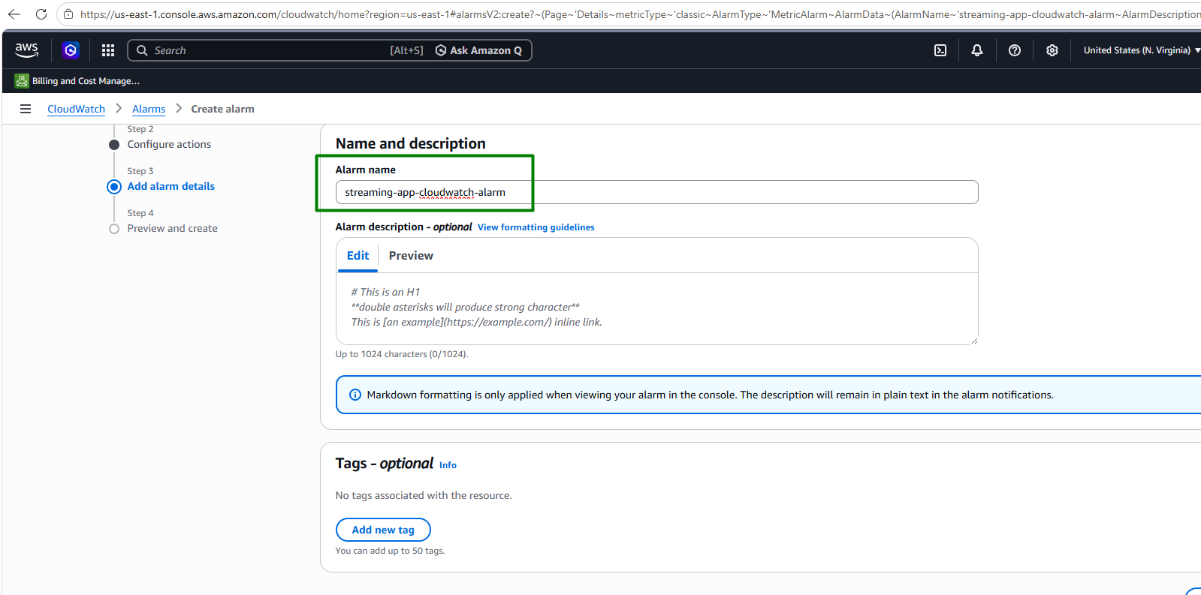
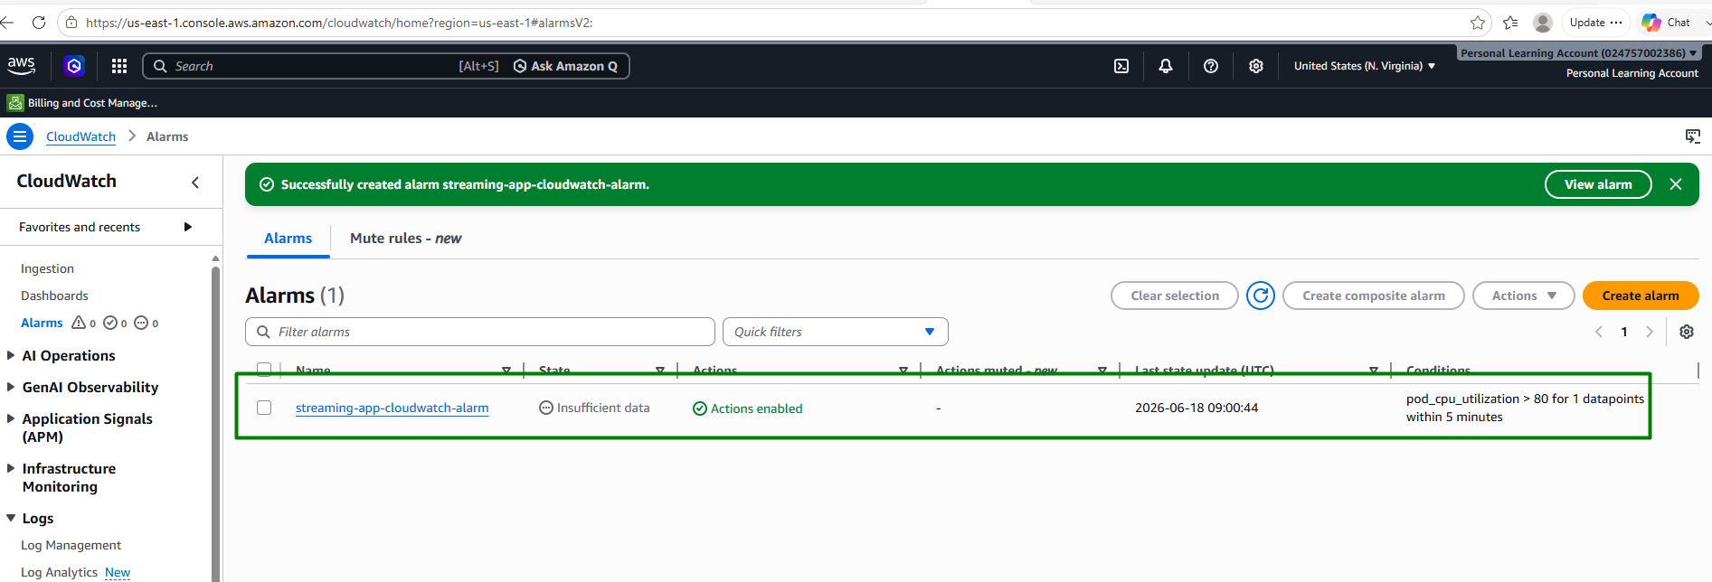

Verify monitoring:
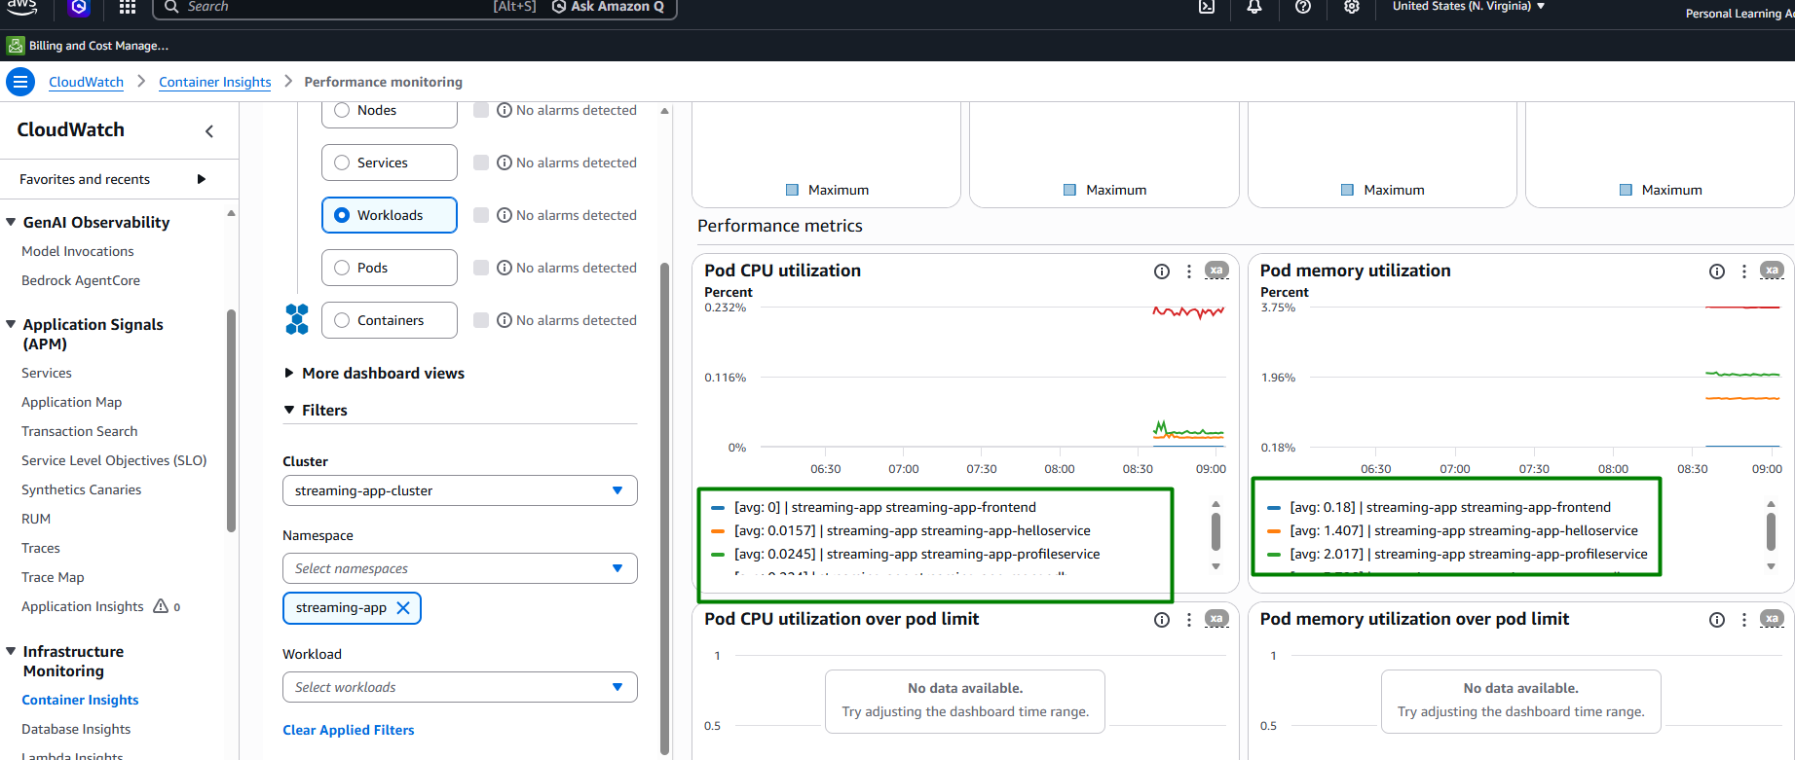

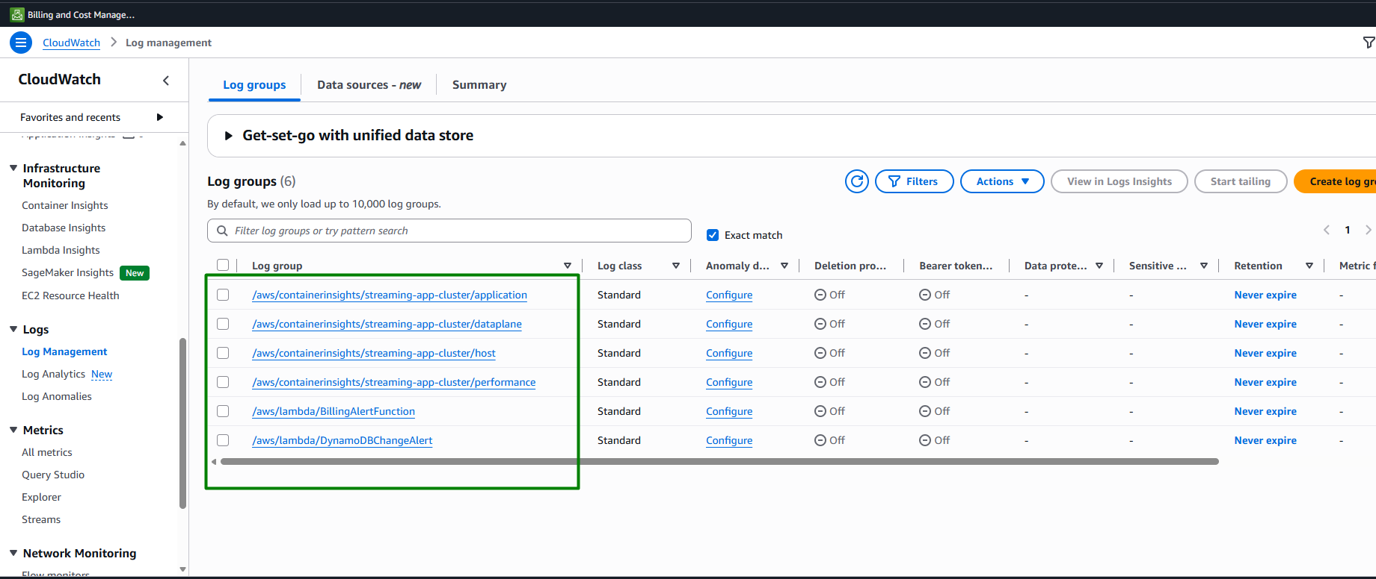

Automatic build triggered by Jenkins after pushing changes to GIT:
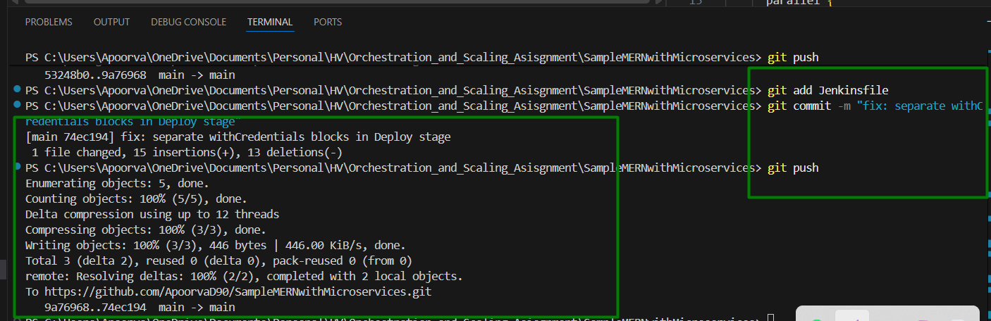
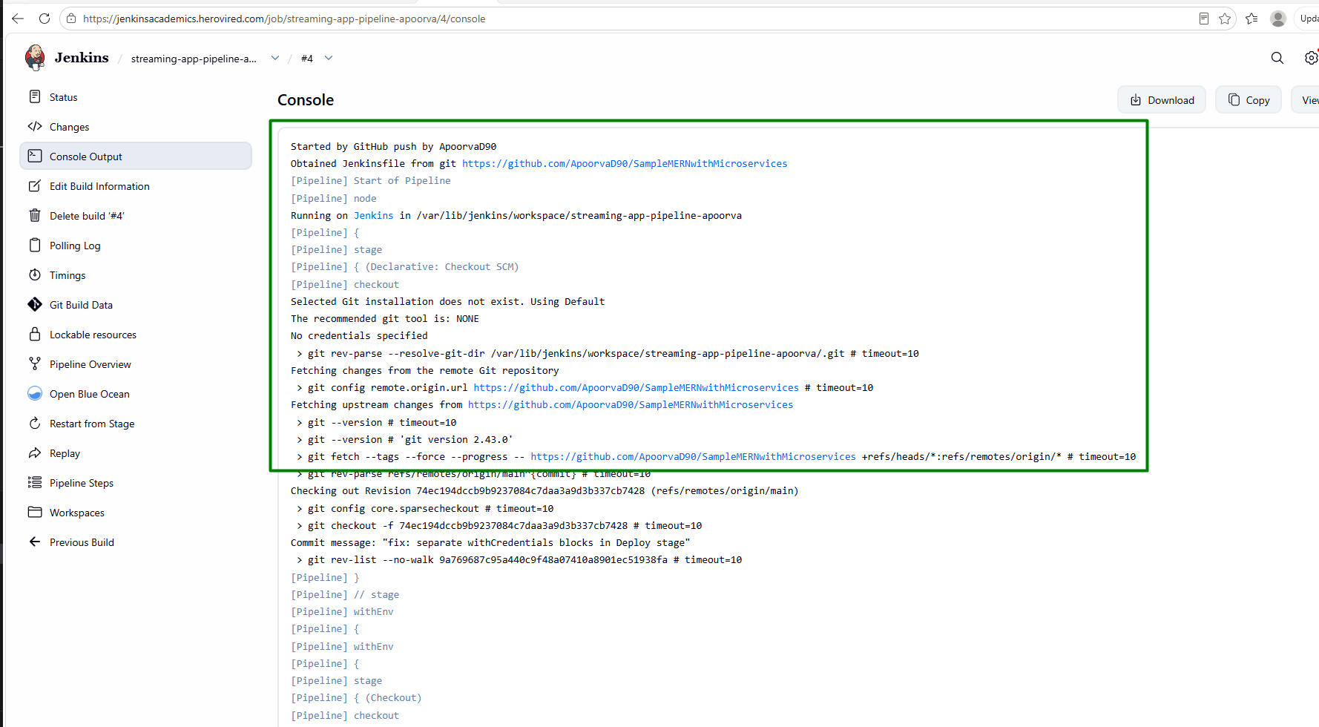
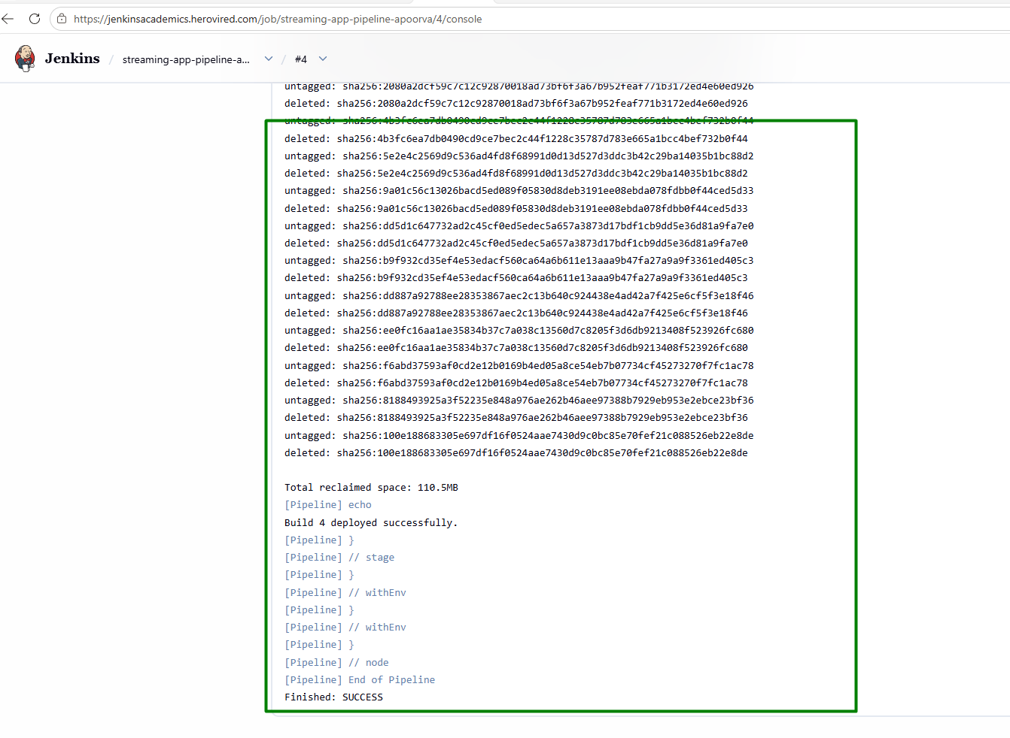
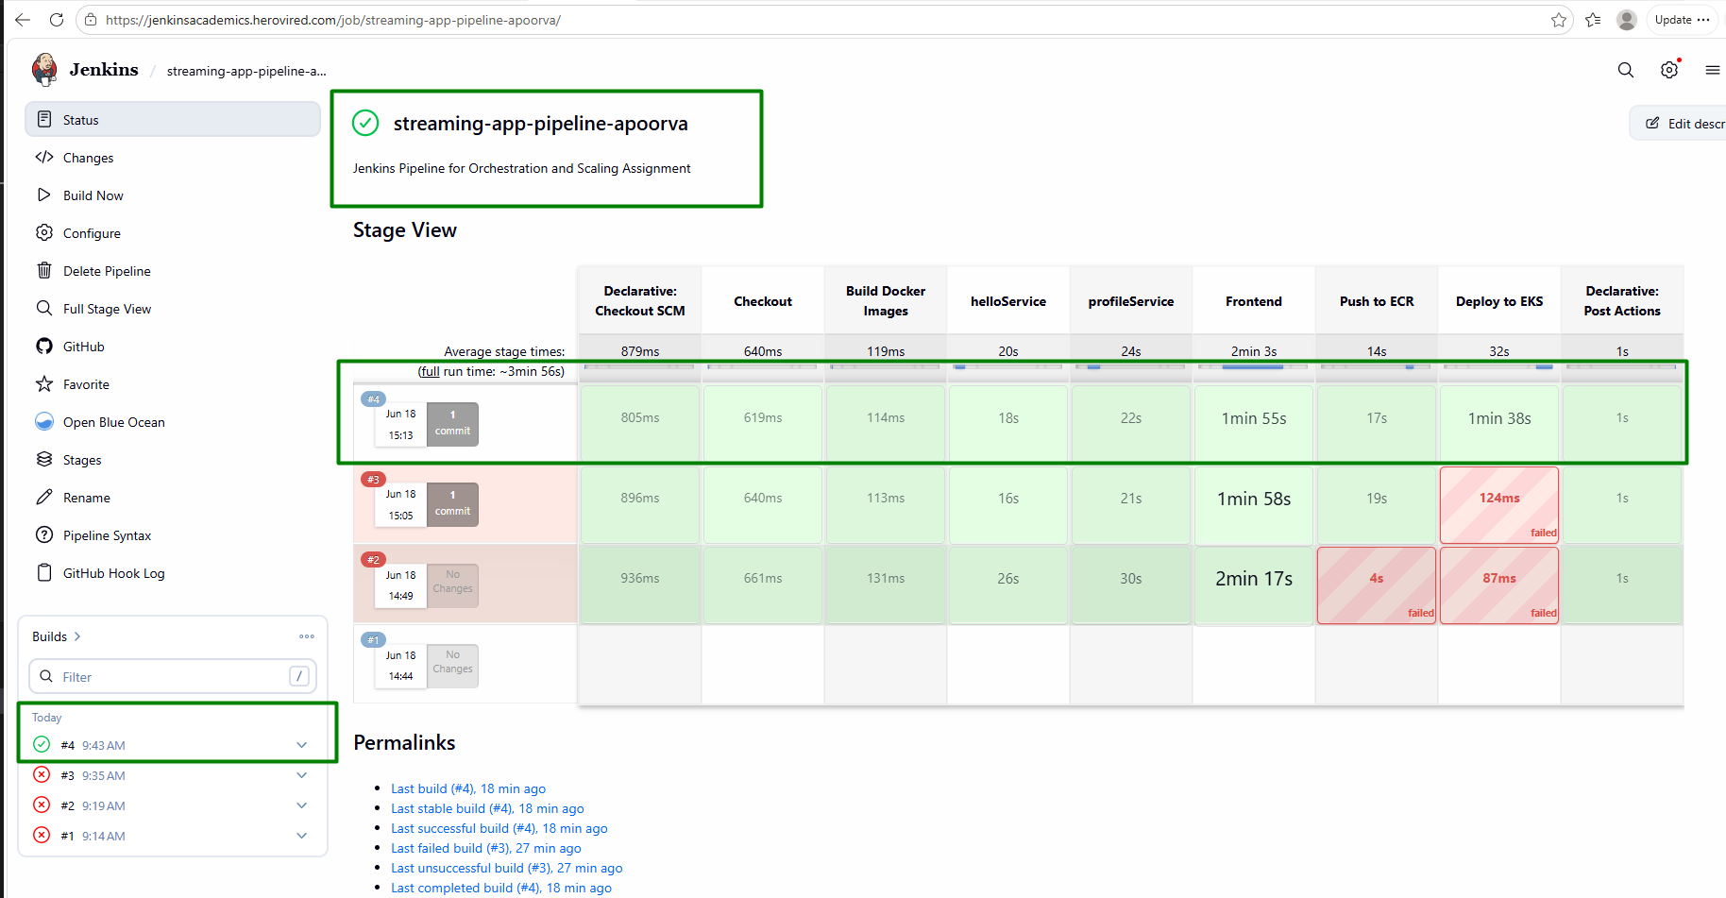

Step 8: Final Validation

Verify that both frontend and backend are functional and accessible.

Ensure the application meets deployment and scaling requirements.

Docker compose up –build> localhost:3000 should show Hello world
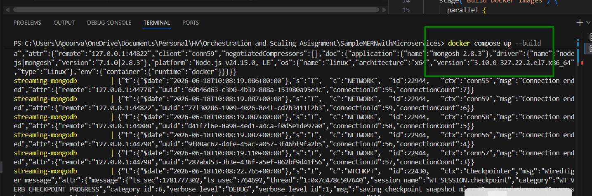
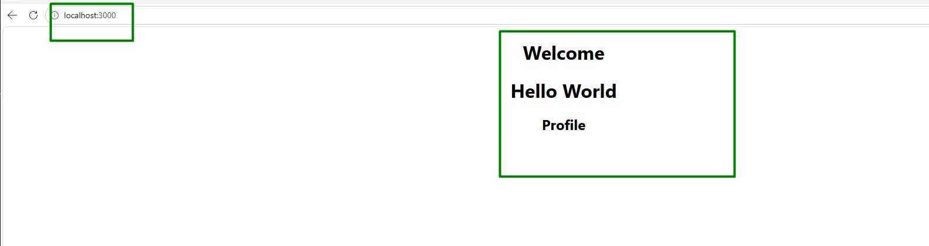

ECR> All 3 repositories have images in AWS console:
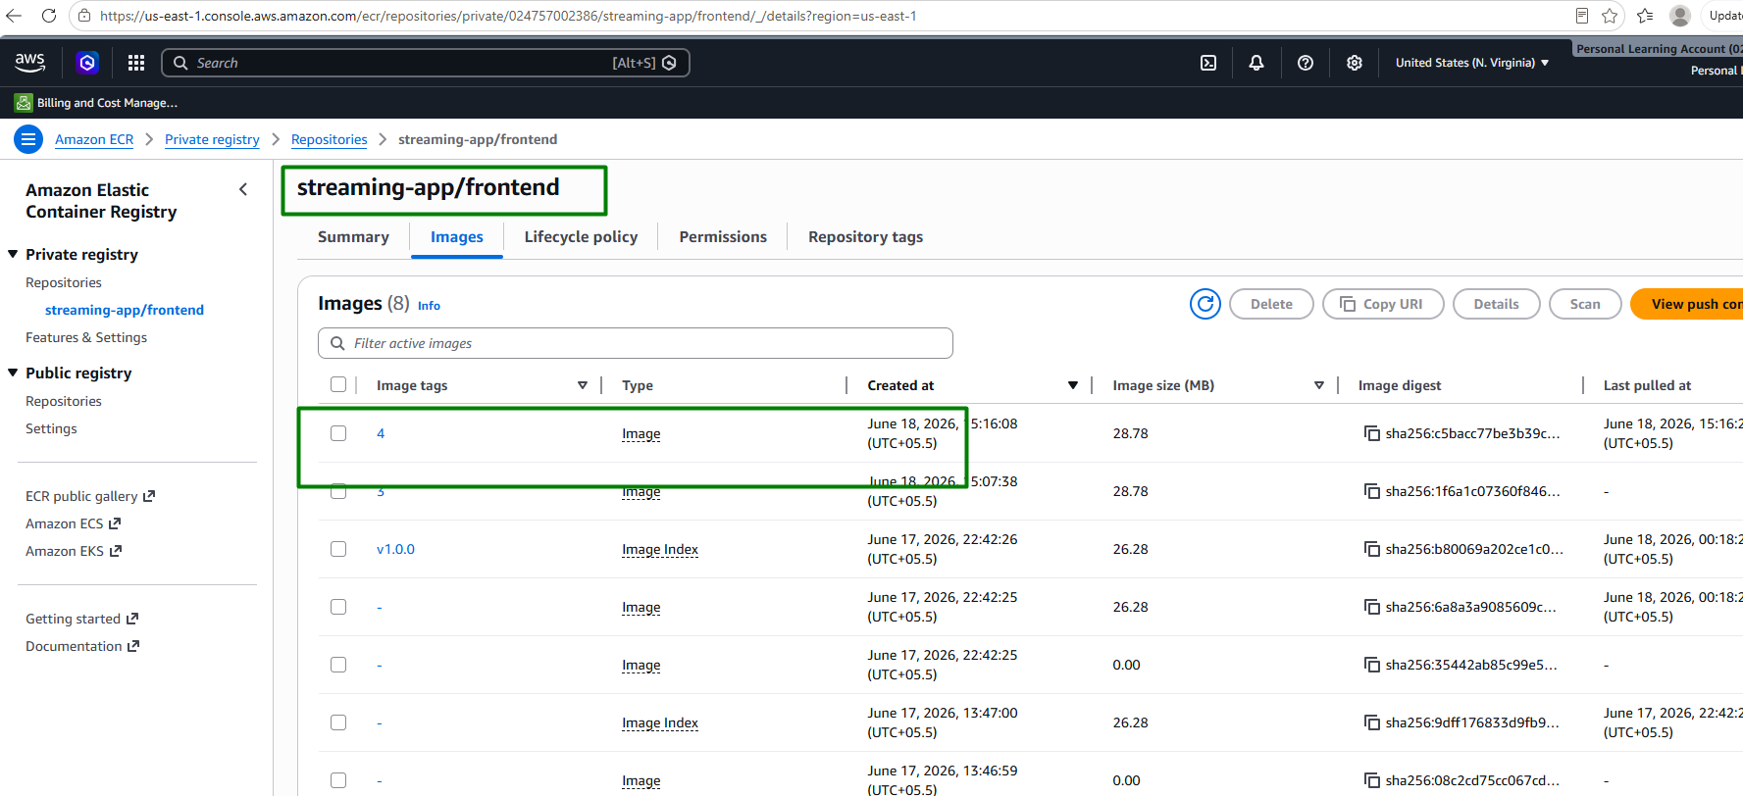
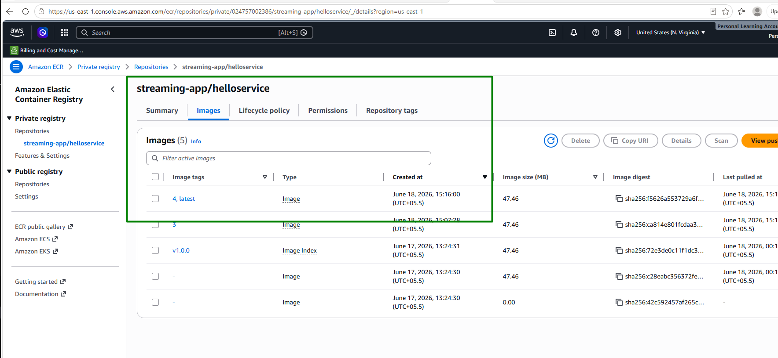
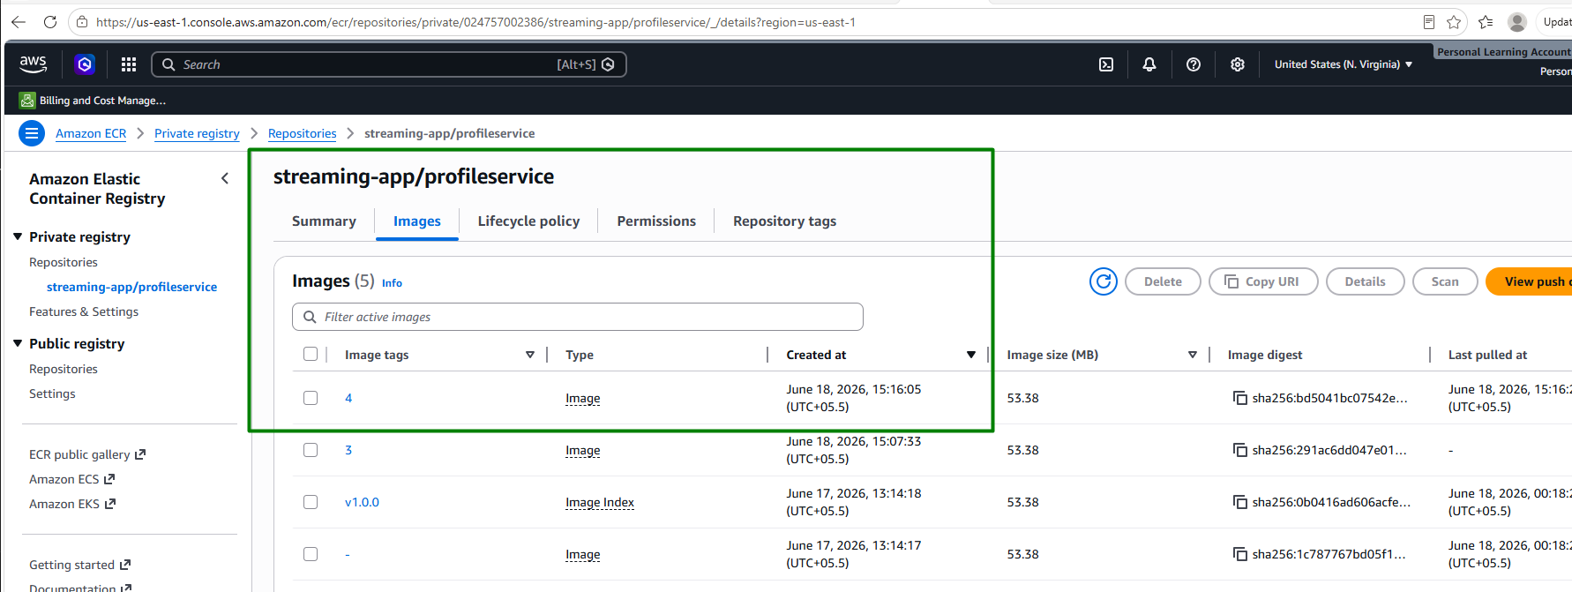

Jenkins pipeline runs green:
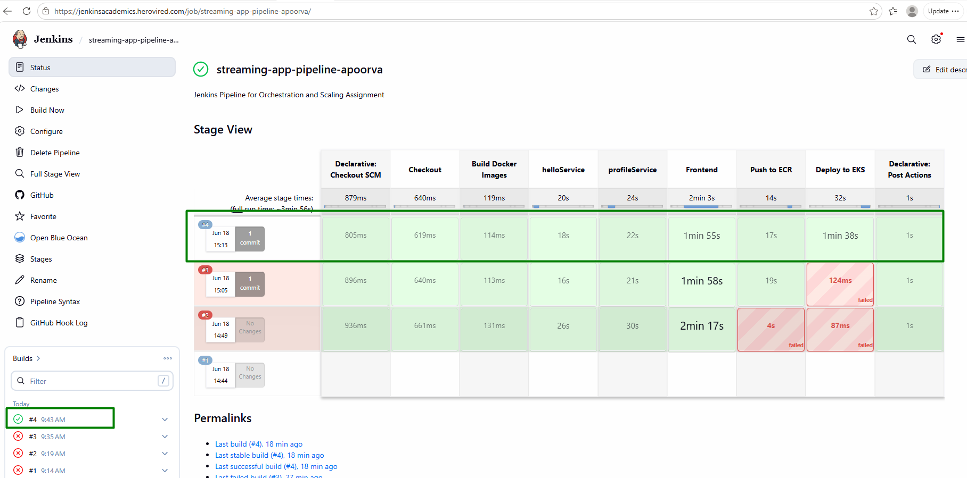

All pods show running:
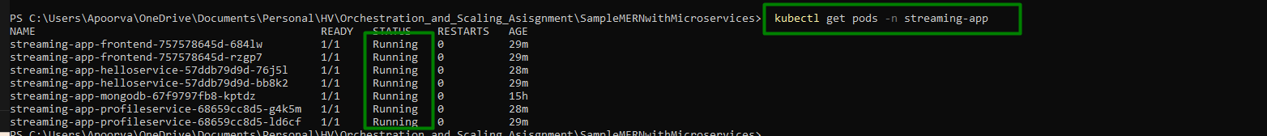

curl http://$INGRESS_HOST/api/hello/ -> {"msg":"Hello World"}

curl http://$INGRESS_HOST/api/profile/health -> {"status":"OK"}

Browser at http://$INGRESS_HOST -> React UI loads and displays 'Hello World'
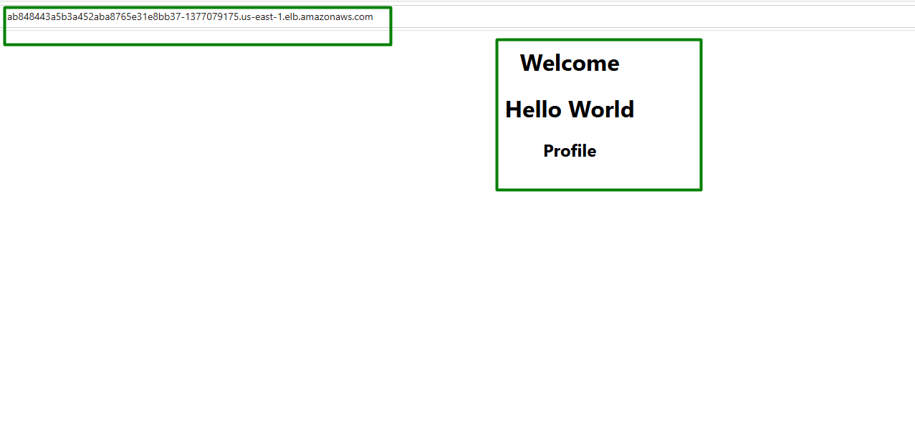

CPU/memory metrics for the cluster is being generated:
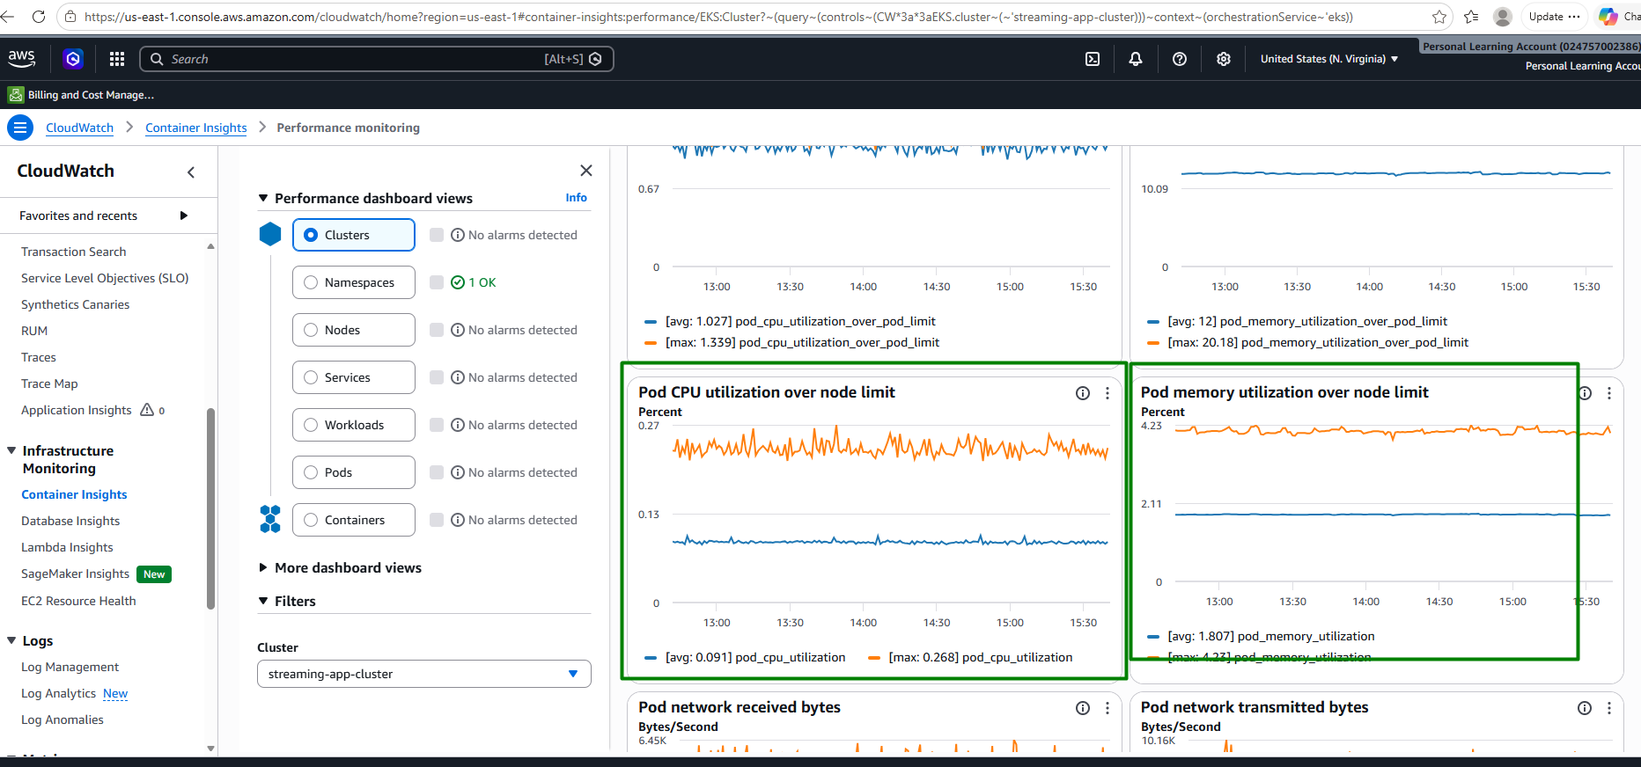

kubectl get hpa -n streaming-app
Shows pod auto scalers for all three services frontend, helloservice, profileservice

Bonus: Step 9 — ChatOps Integration

Create SNS Topics

Use SNS topics for various events (e.g., deployment success/failure).
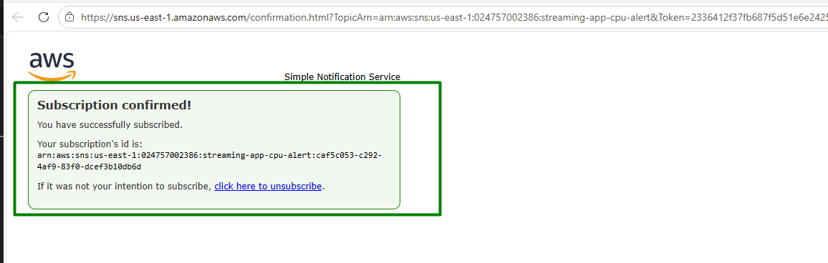
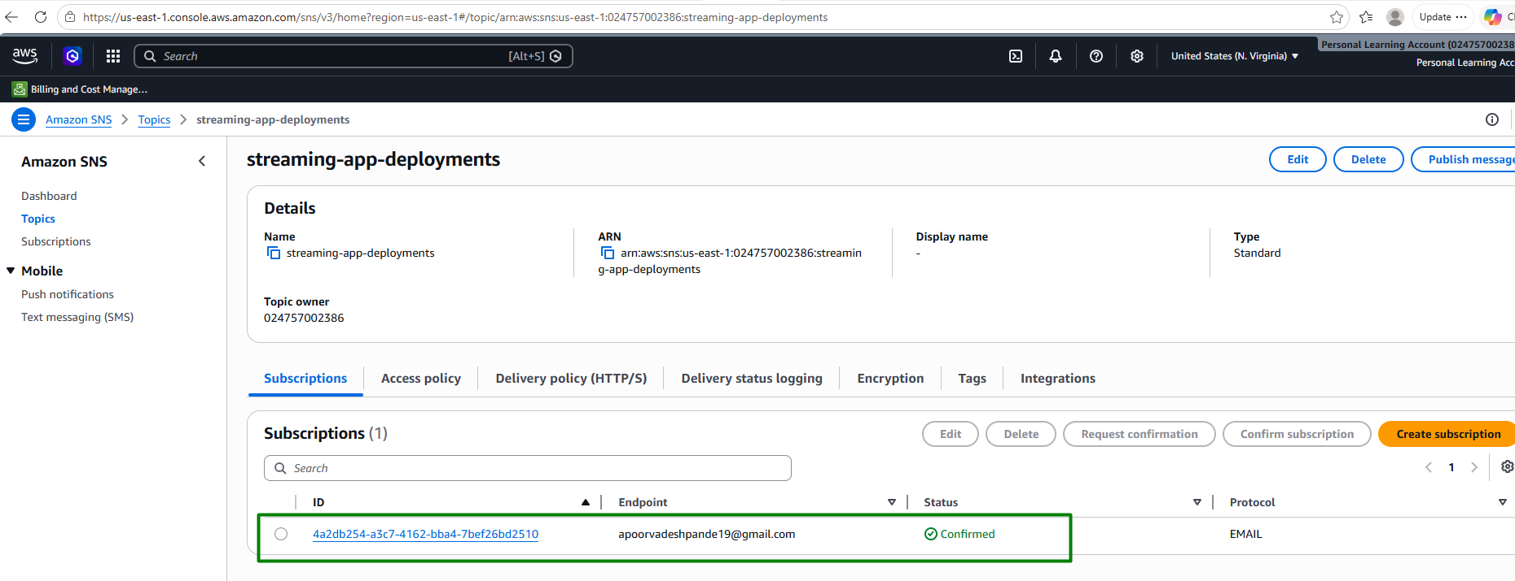

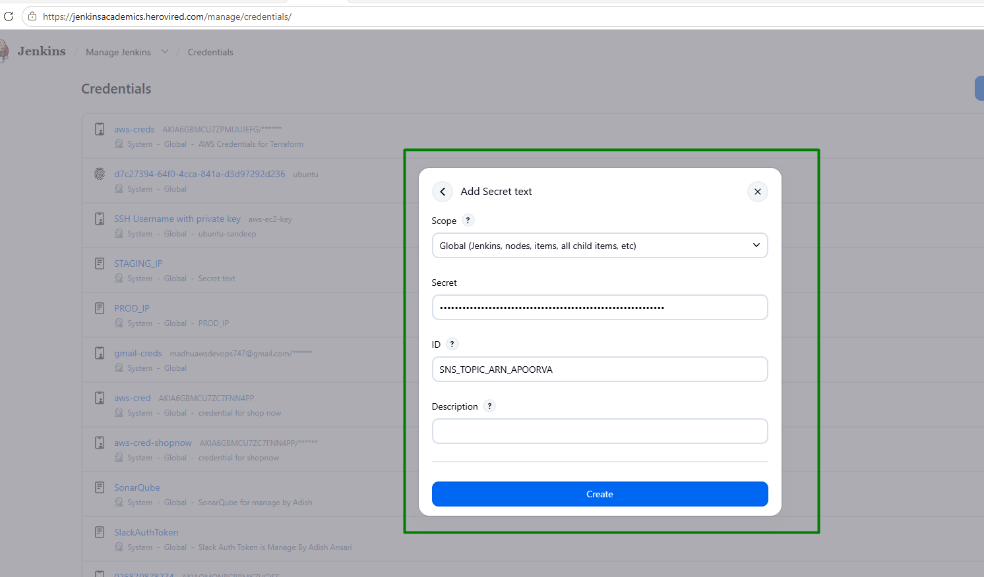
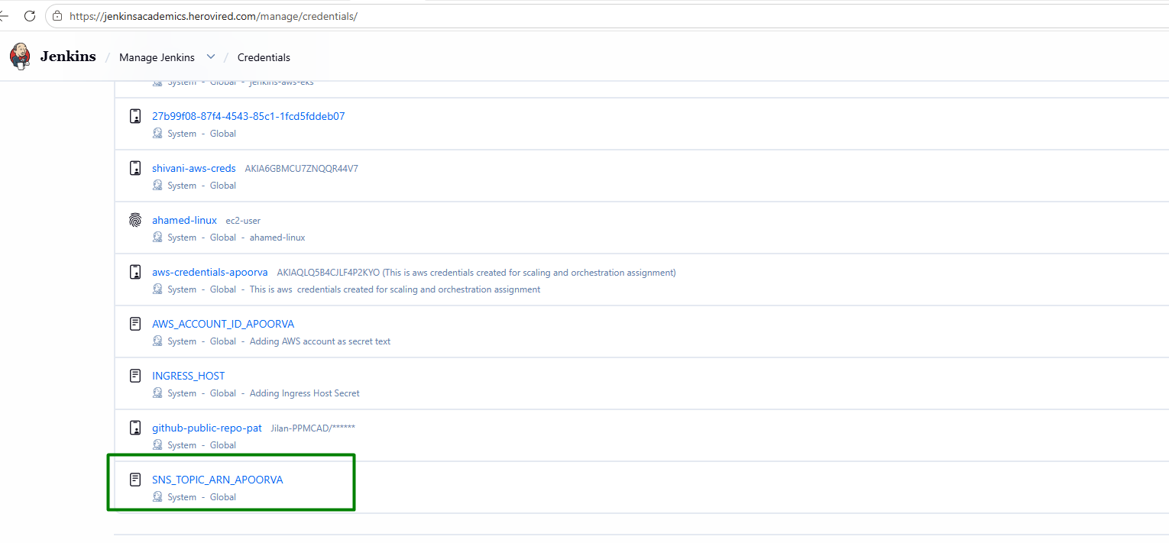
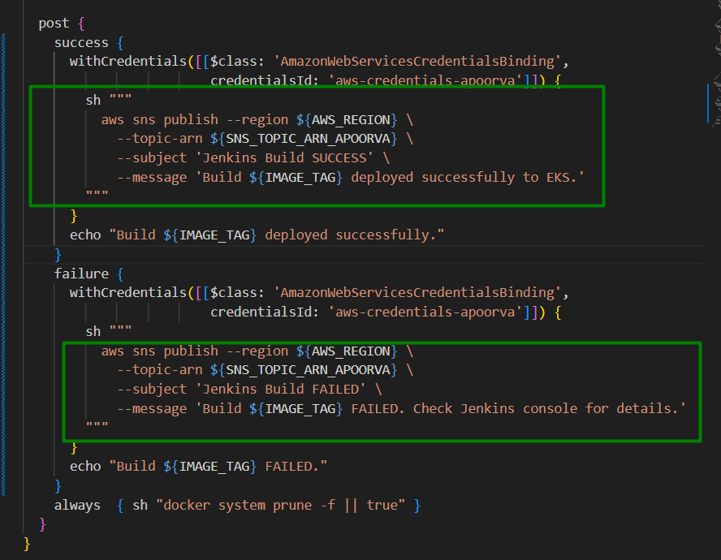

Jenkins build triggered automatically after pushing changes:
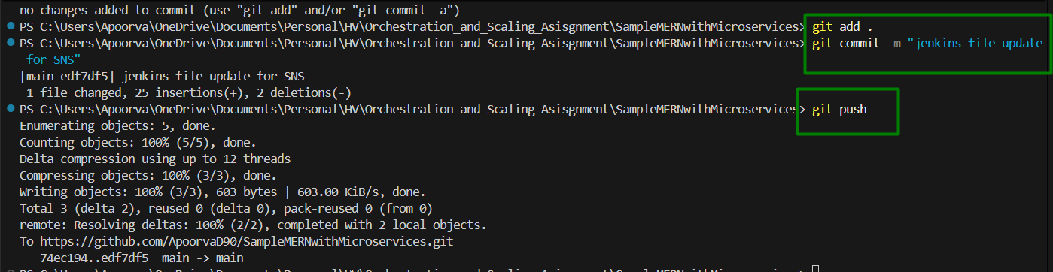
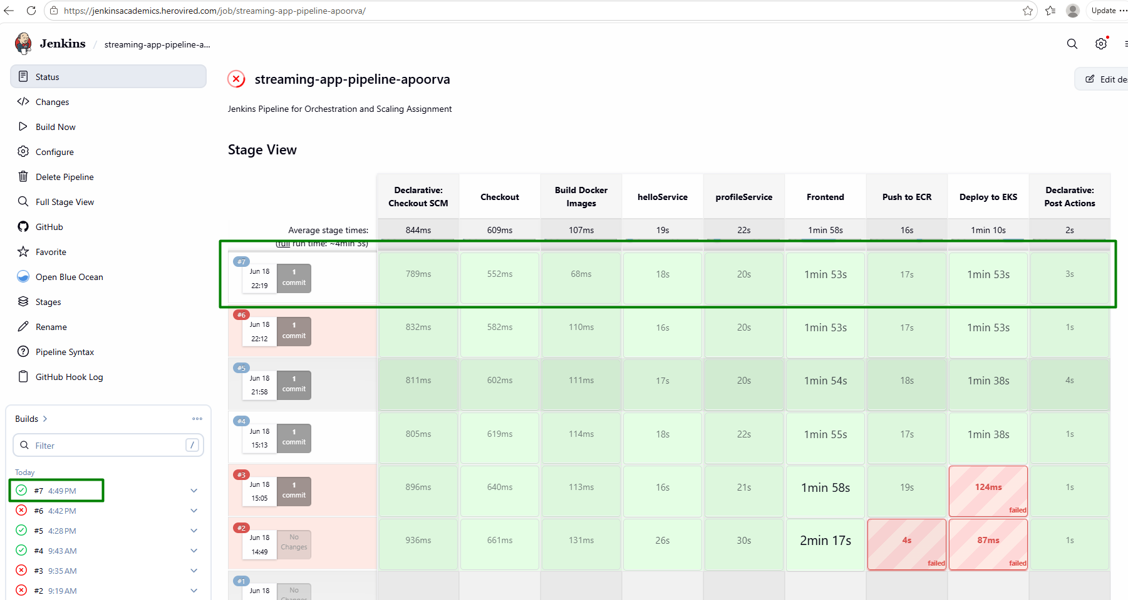

Notification received on email:
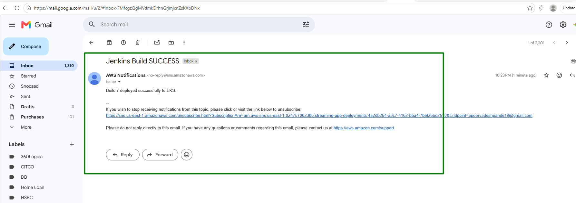

Integrate with Messaging Platform

Connect SNS with Slack, Microsoft Teams, or Telegram for real-time alerts.
New workspace created and channel Jenkins-notification is added on same:
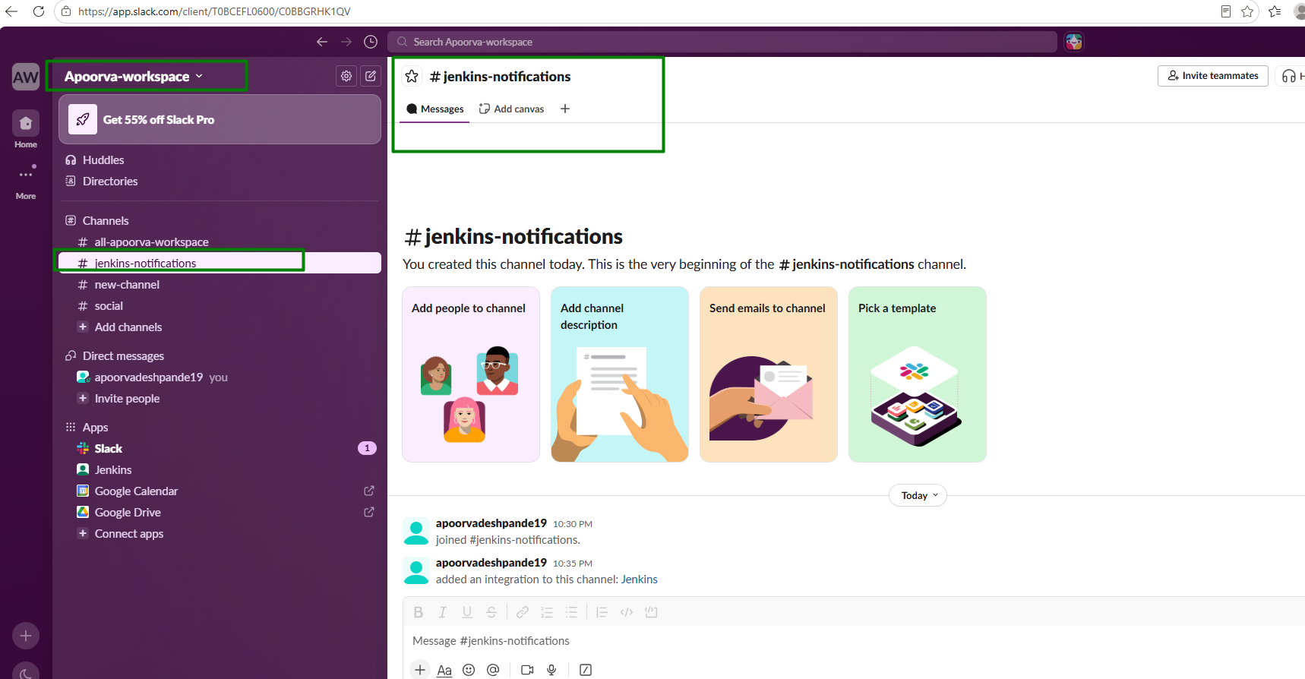
Incoming webhook allowed on Slack. New app Jenkins is created. Incoming Webhooks is enabled on the app. New webhook is added on channel jenkins-notification:
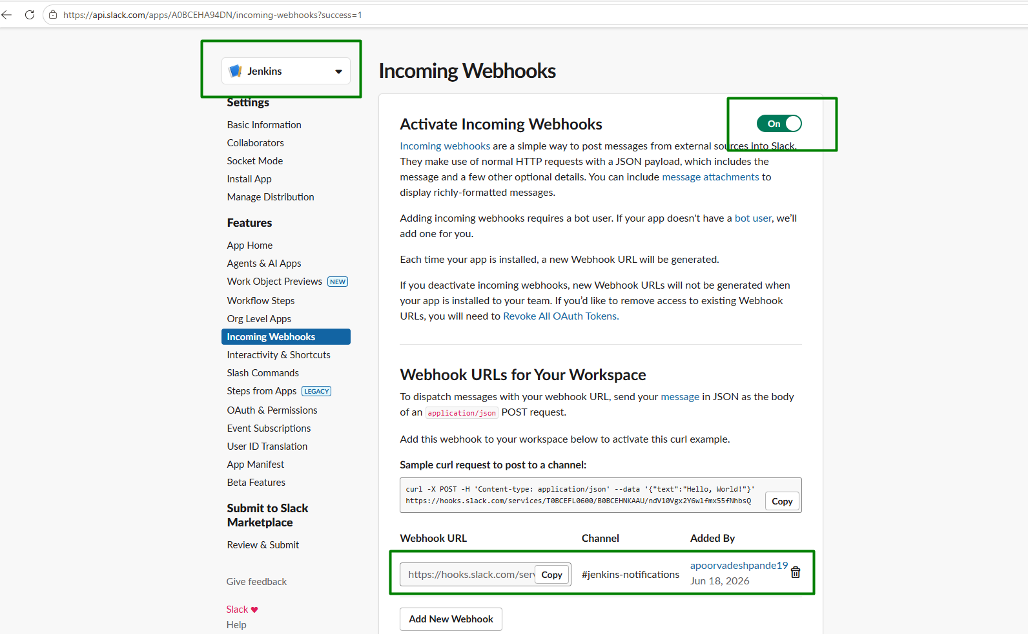

Adding credentials in Jenkins:
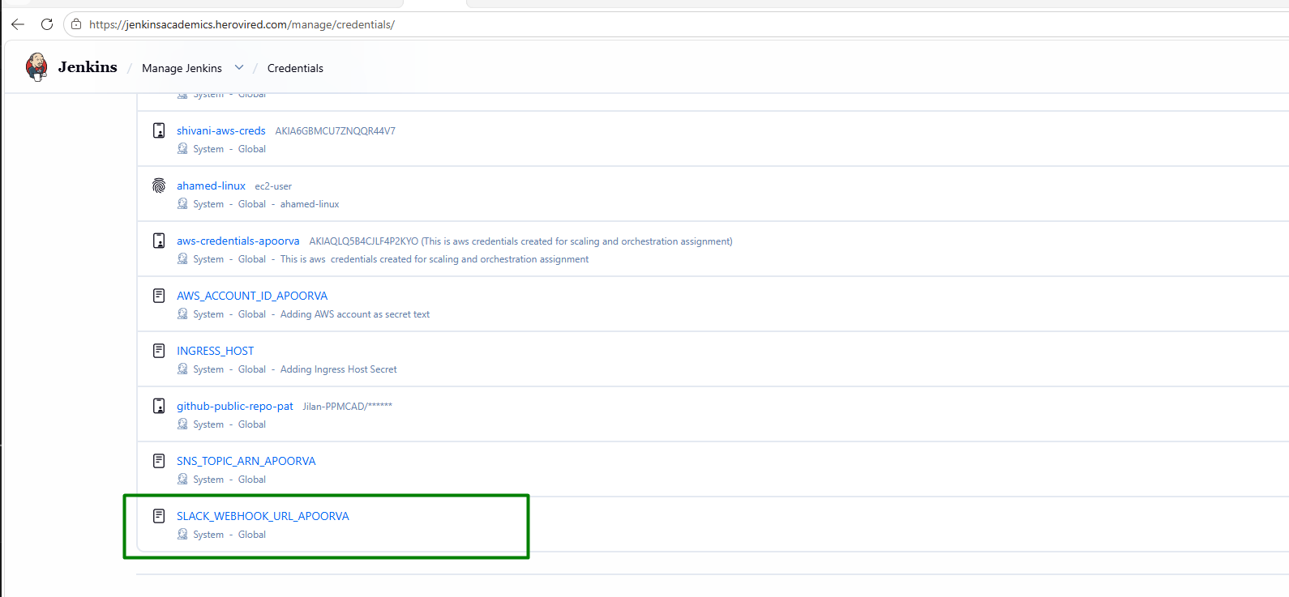

Pushed changes to GIT for slack integration
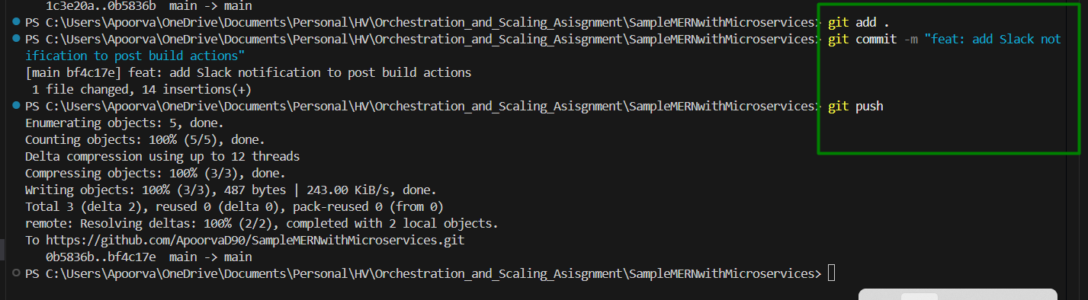

Jenkins build is successful after recent push to GIT
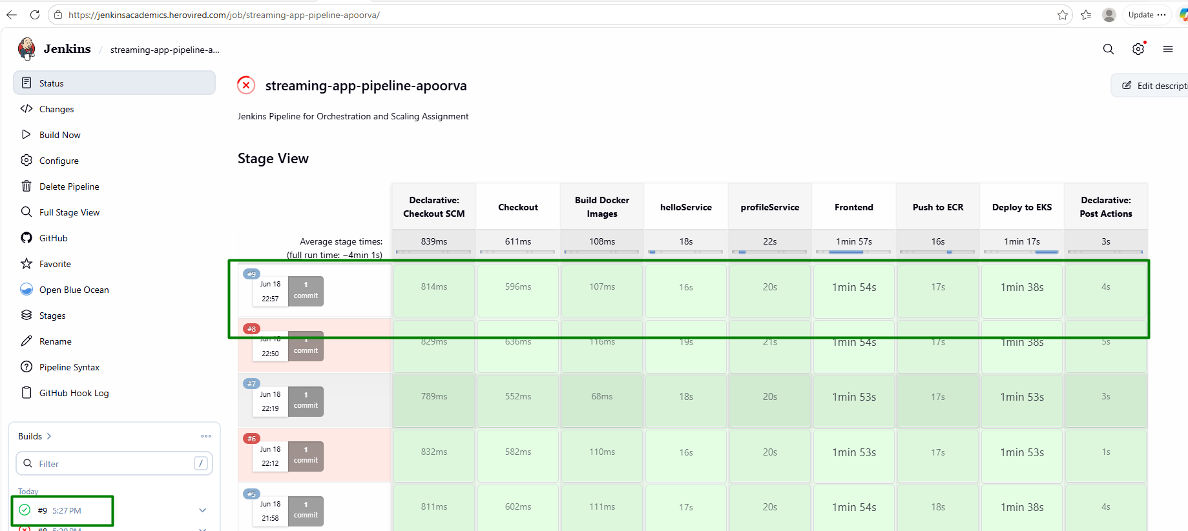

Email on successful deployment:
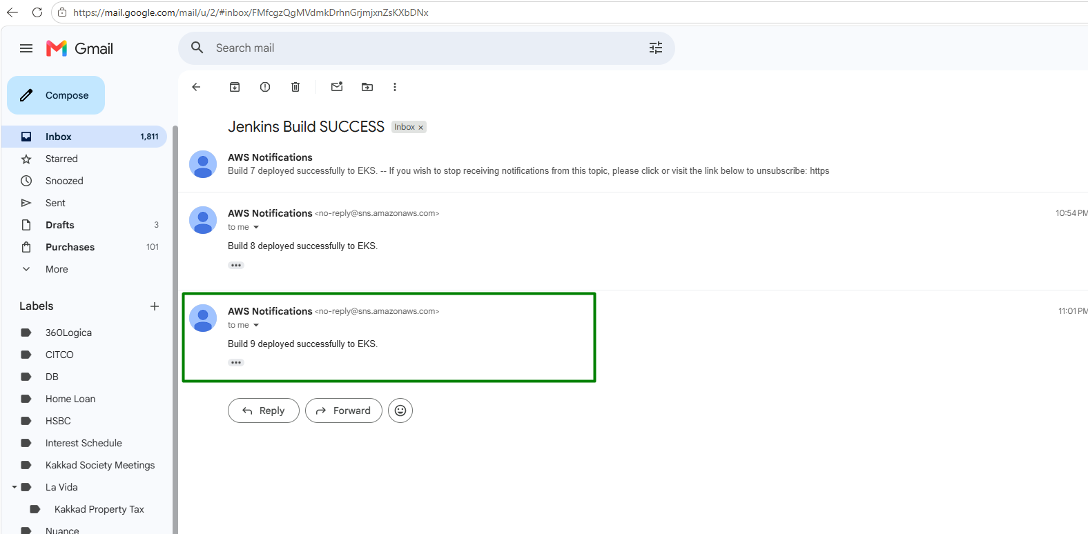

Slack notification for successful build:
