Travel Memory Application

Set up the backend running on Node.js

Steps:
- Create an EC2 instance from AWS
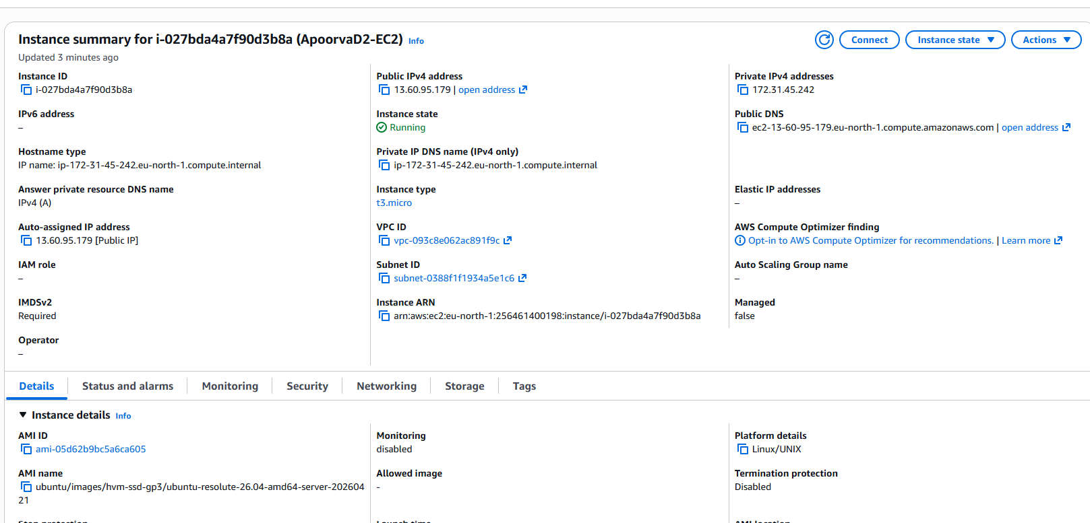

- Update latest versions and install nginx on the server using below commands:
sudo apt update
sudo apt install nginx -y
sudo systemctl start nginx
sudo systemctl enable nginx
After installation below nginx folder structure should be automatically created:

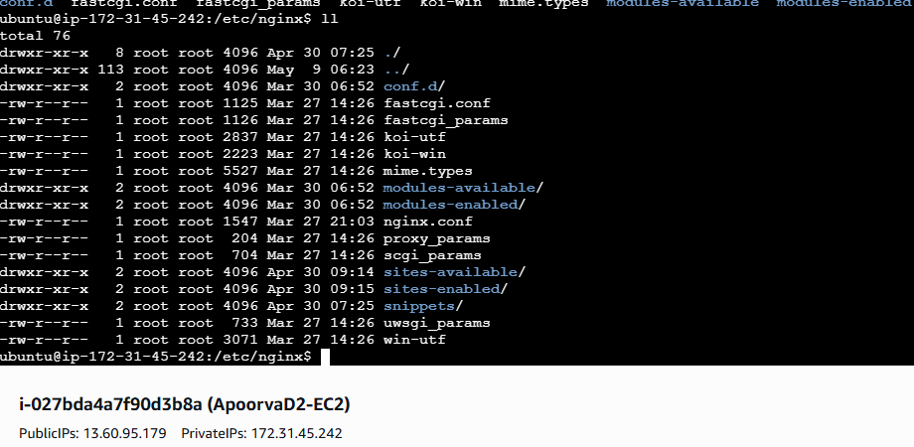

- Nginx sites-available folder should have reverse proxy created:
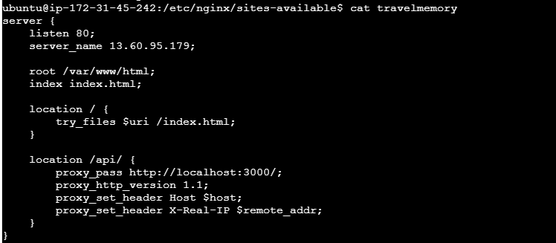
Verify nginx config is successful using commands:
Sudo nginx -t
Sudo systemctl reload nginx
- Clone the Travelmemory repository and navigate to the backend folder:
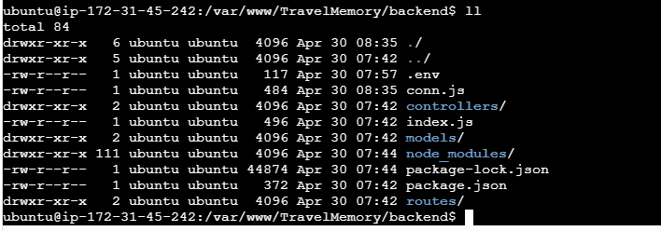

- Create a Mongo Database and add the connection string and Port details to the .env file in backend folder of the repo:
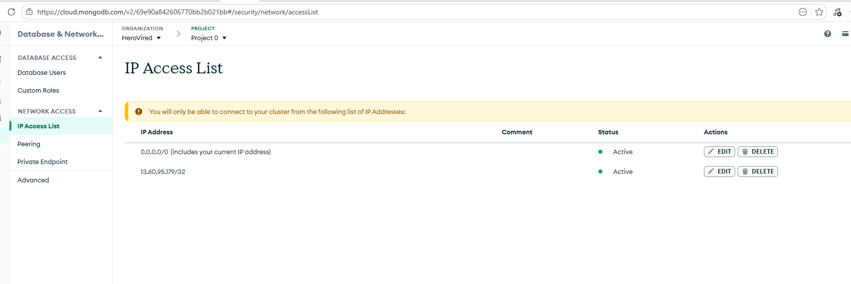

- Start backend by running command:
sudo node index.js
node should start on port 3000
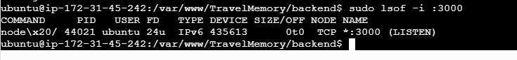
- The BE server should be up and running
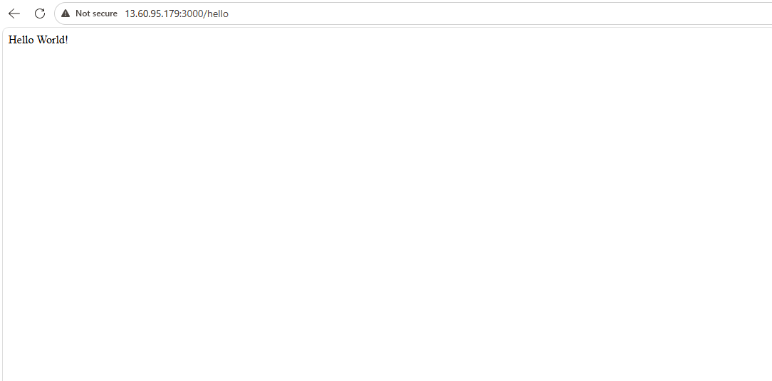

Frontend and Backend Connection
- Create another EC2 instance for frontend setup:
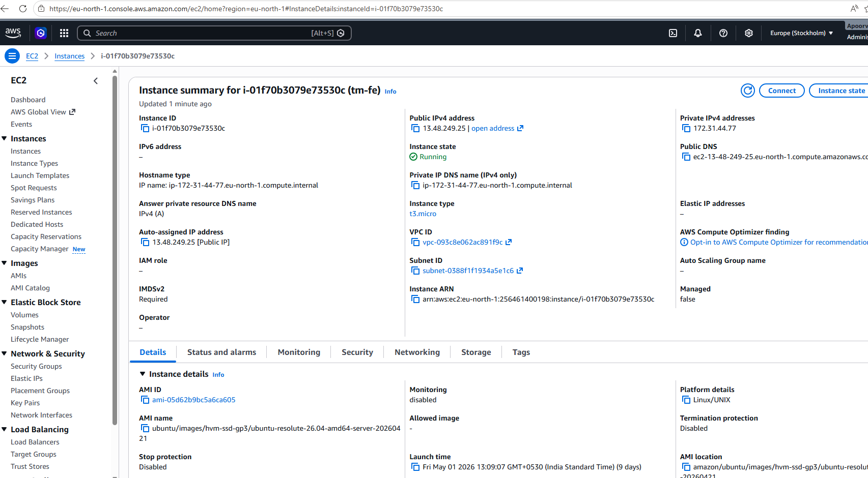
- On the server, in the frontend folder update url.js with backend IP to enable communication with backend

- Update .env file in the frontend folder:
- Run sudo npm start command to start the frontend instance
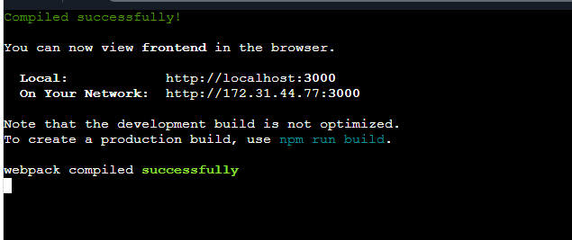

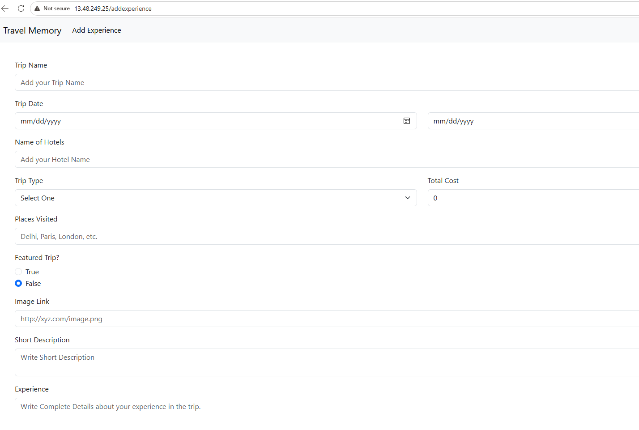

Scaling application
- Create an image of the backend instance
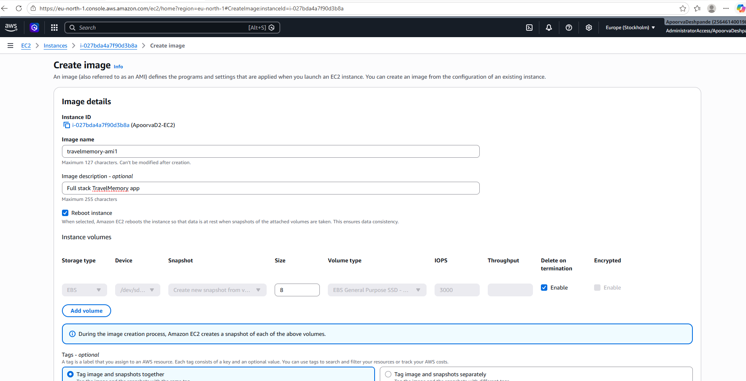

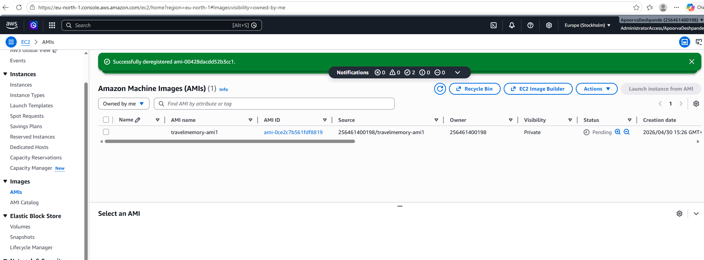

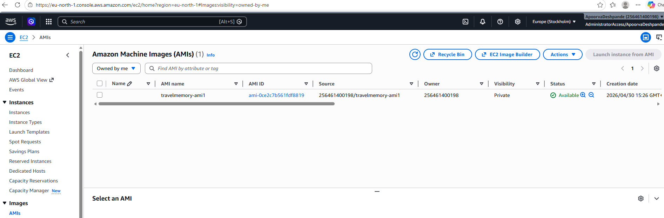

- Use this image to create multiple backend instances
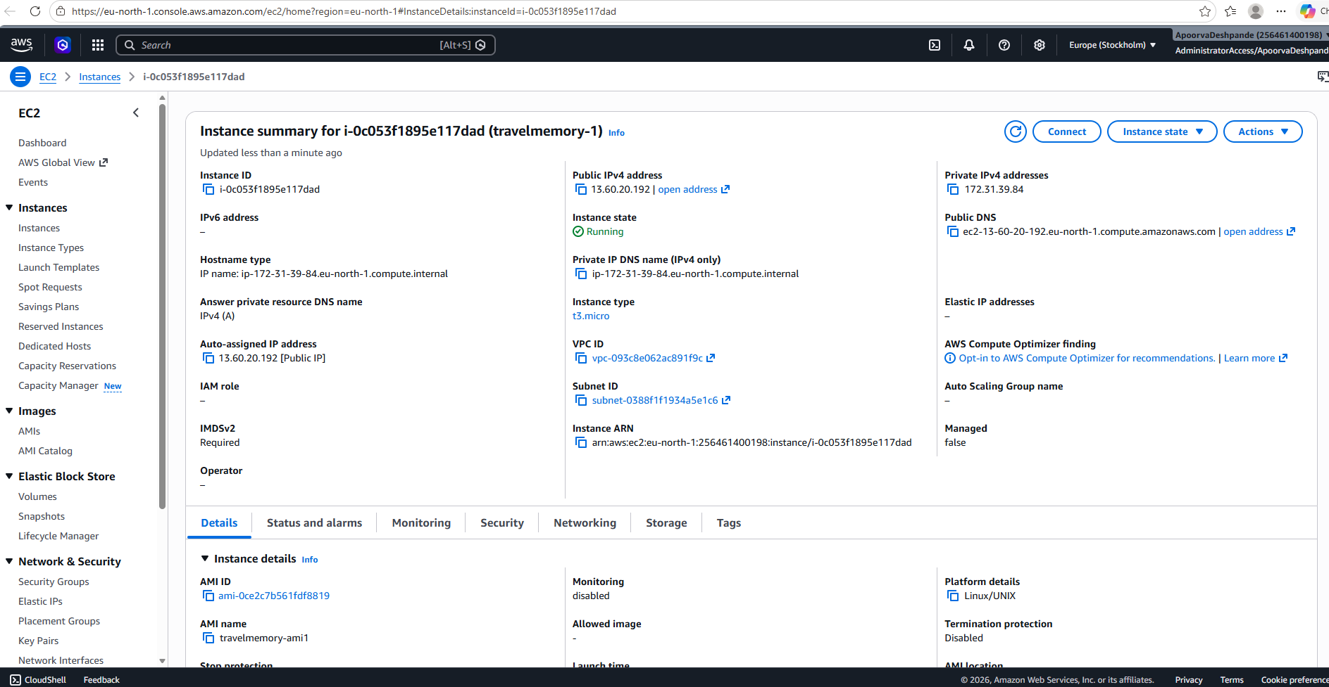
Instance has node, nginx and code present:
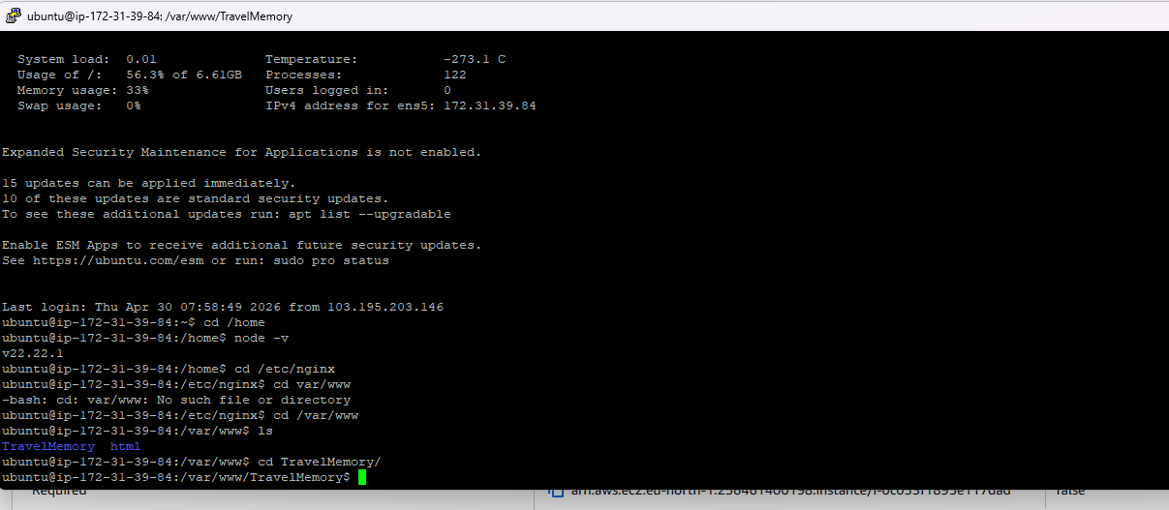
Created another instance:
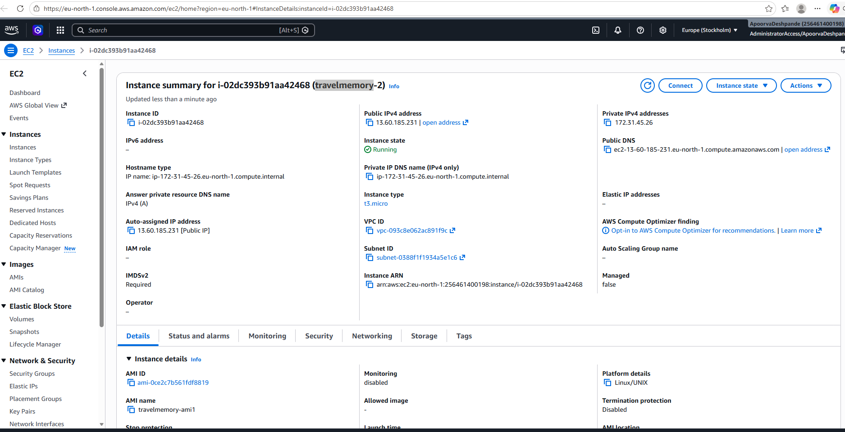
Also, node, nginx, code installed in second instance:
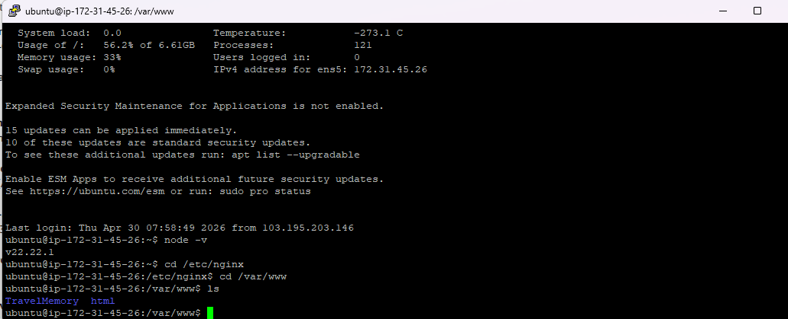
- Similarly create multiple instances of frontend
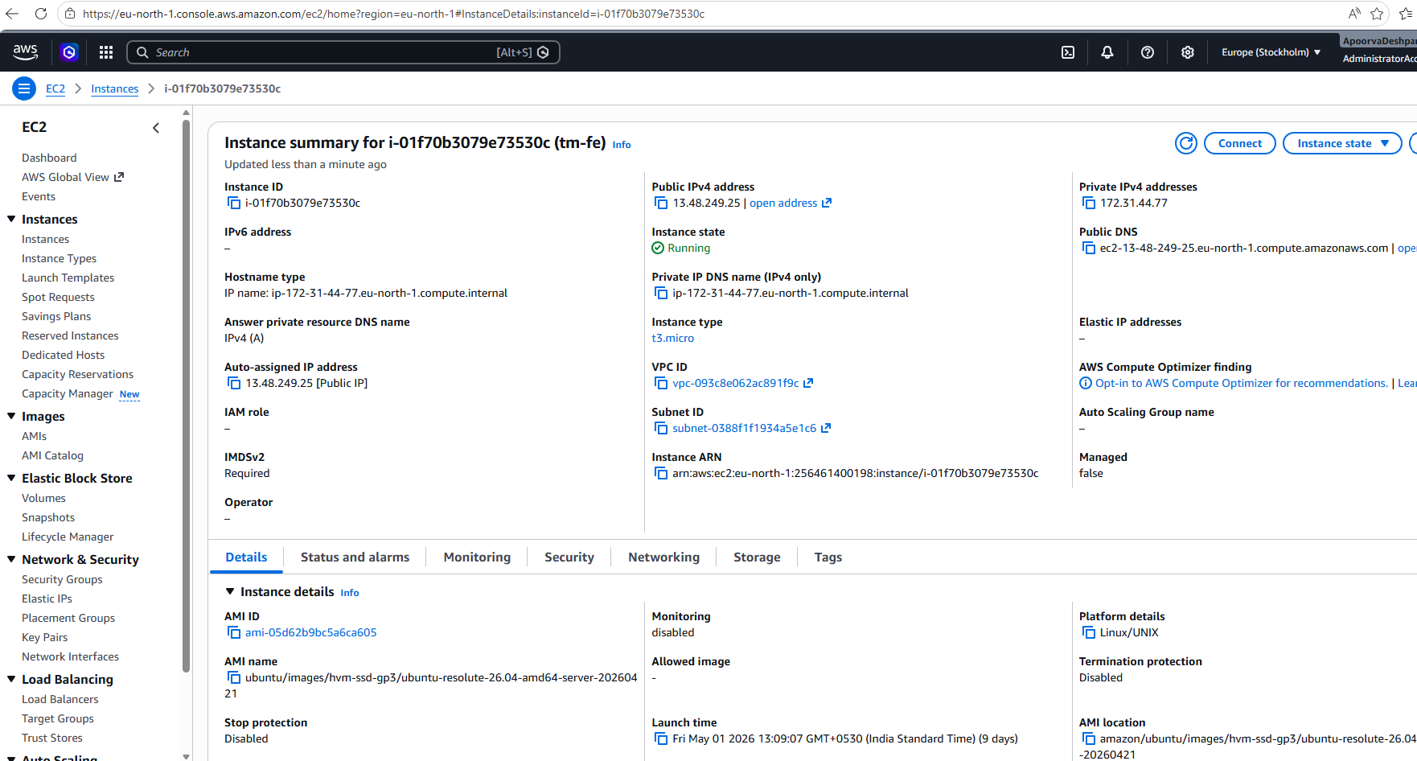

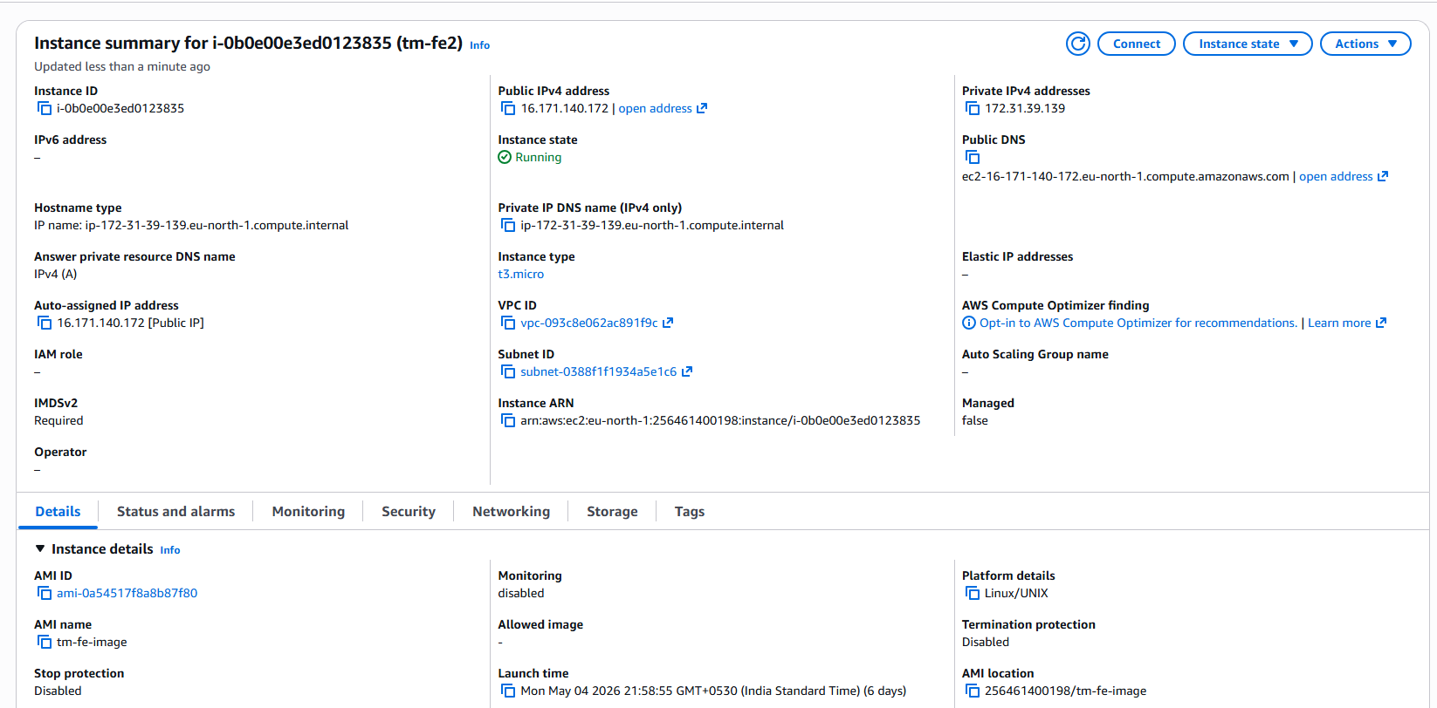

- Now create a target group for the 2 backend instances created above:
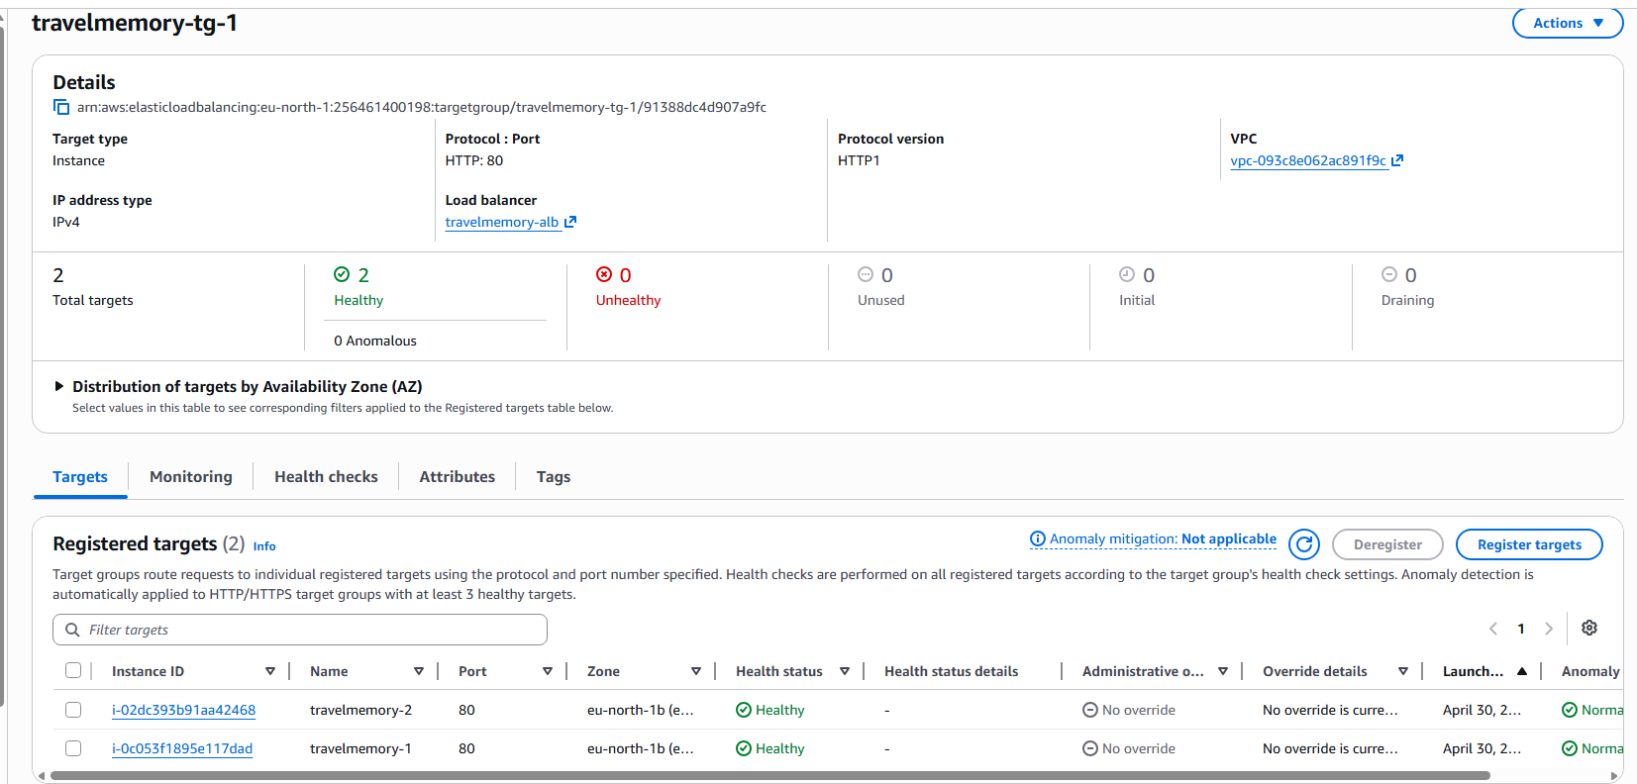
Similarly create a target group for frontend instances
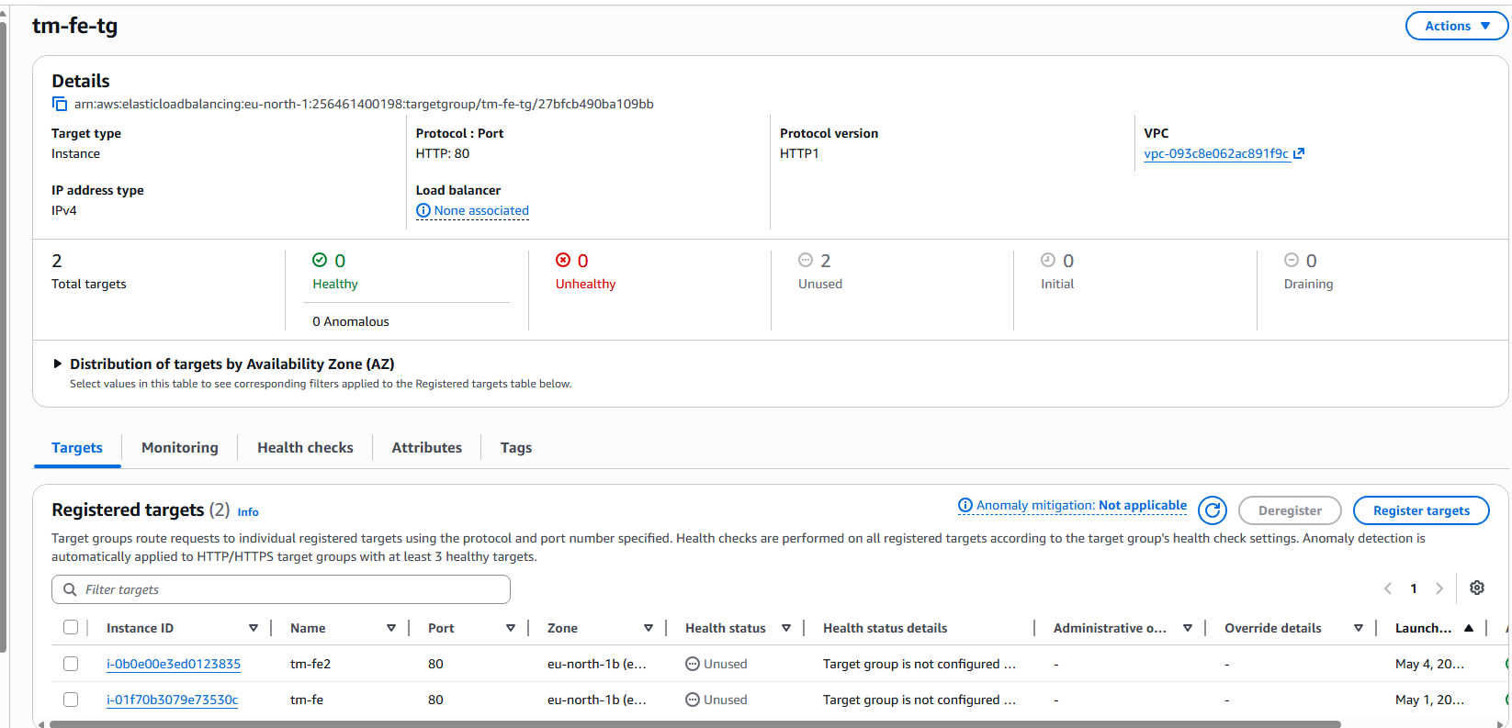
- Now create 1 load balancer for the backend instances and 1 load balancer for FE instances:
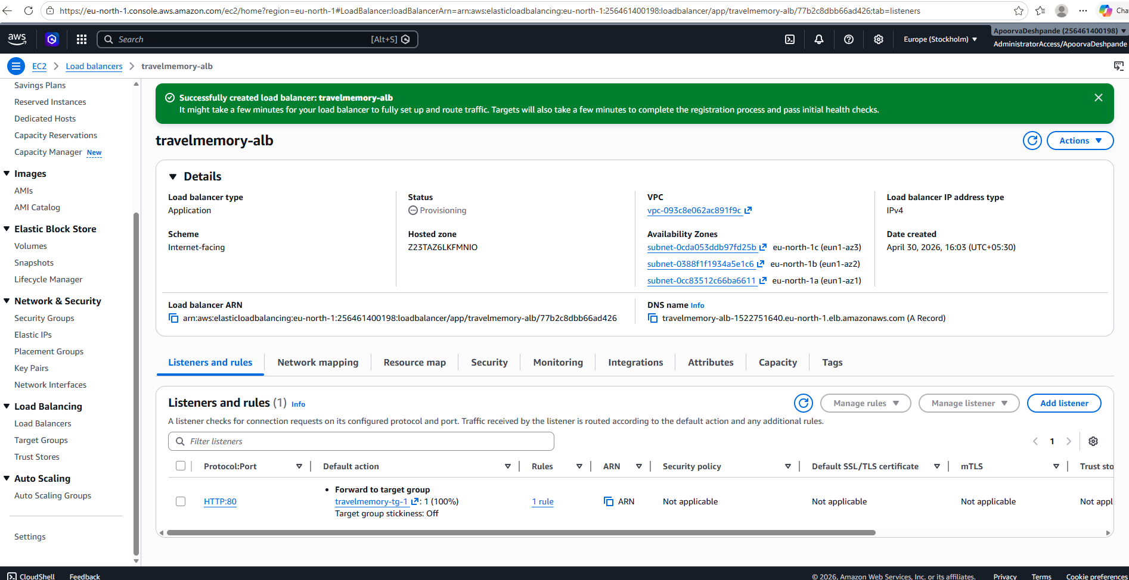
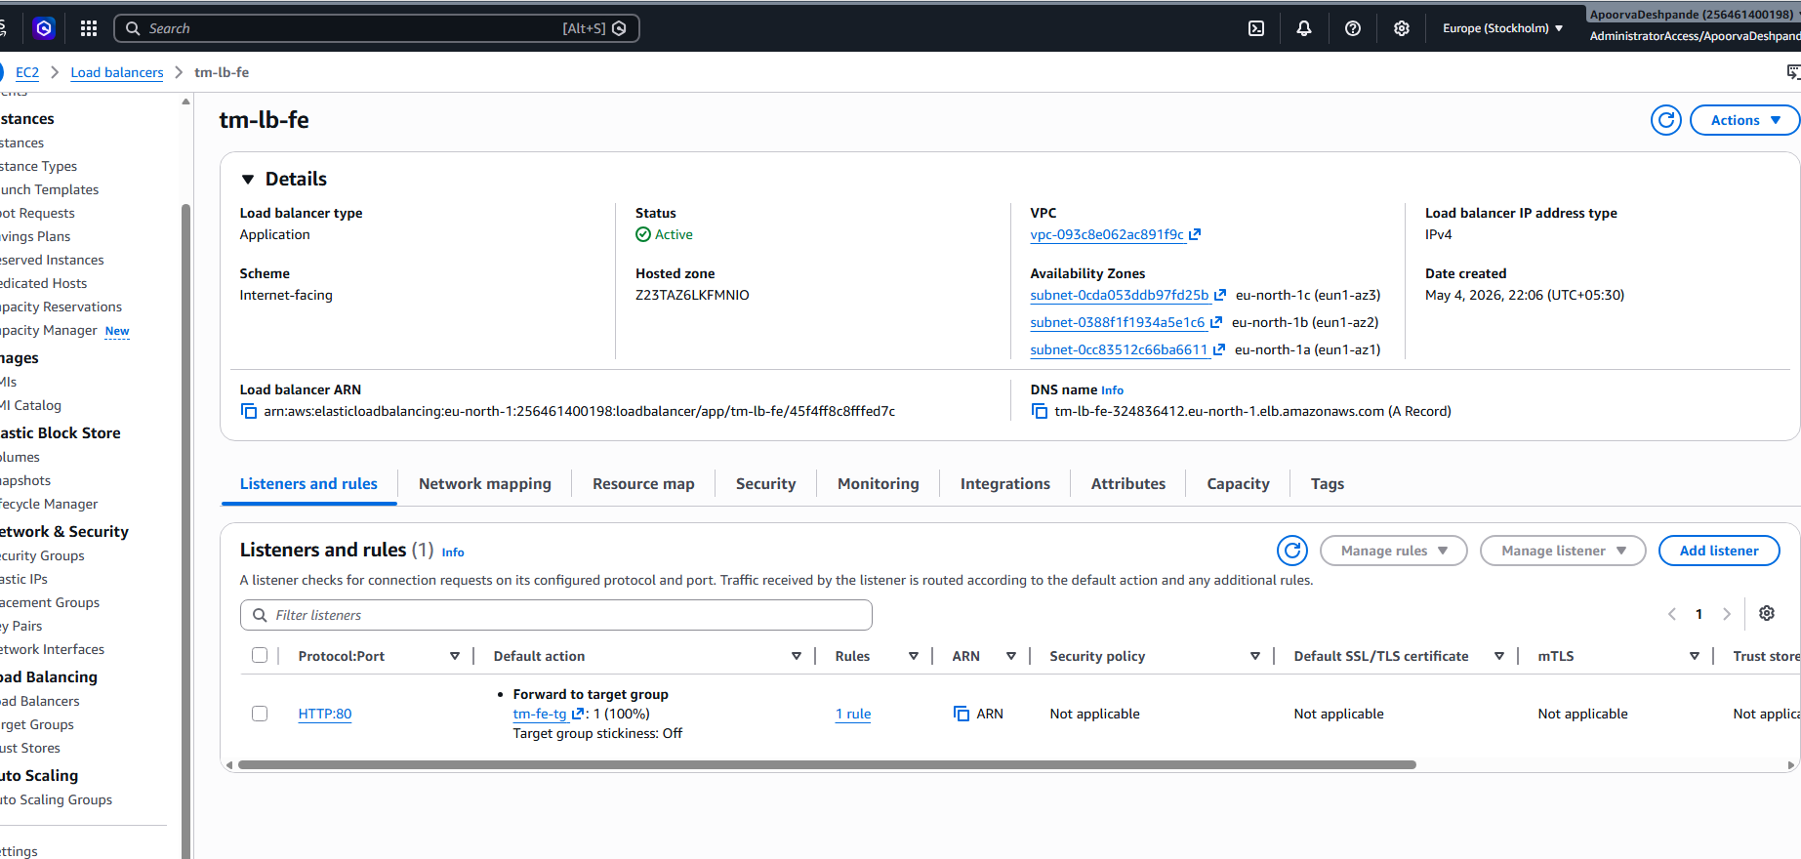

Both the load balancers are active:
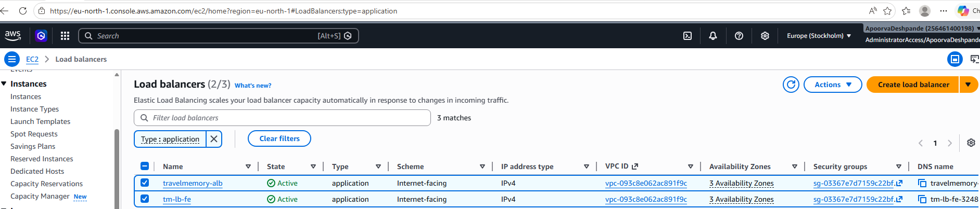
- Update the Load balancer DNS name in the url.js on the FE EC2 instances
- Start both BE and FE instances and then hit the load balancer DNS name and expect the Travel memory app to be up and running
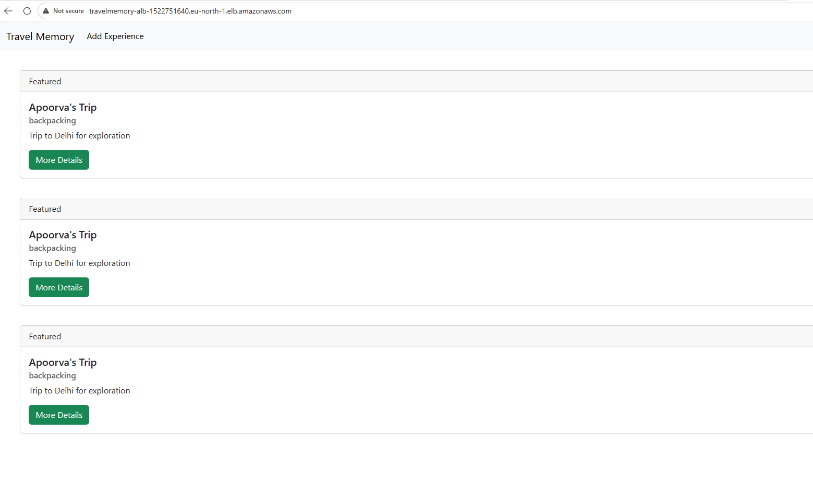
Domain Setup with Cloudflare
- Create a custom domain using GoDaddy:
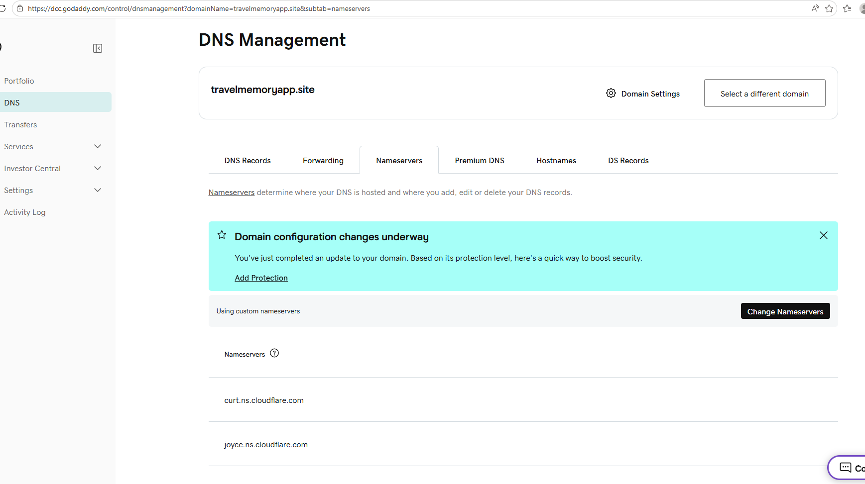
- Create a CName record on Cloudflare pointing to ALB endpoint:
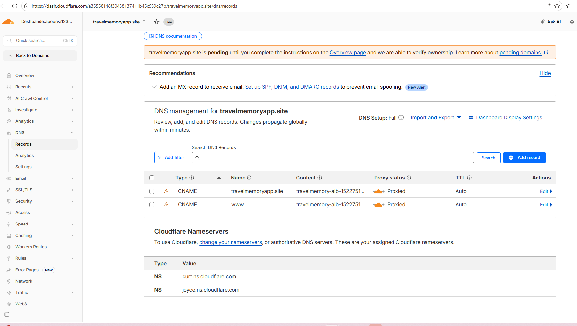
- Hit the domain and expect the site to be hosted on the domain:
