KLE Society's

KLE Technological University



Open Ended Experiment Report

AMAZECART

**Team No: A14**

|  |  |
| --- | --- |
| **Name** | **USN** |
| Anusha Raikar | 01FE18BCS043 |
| Apoorva Jinde | 01FE18BCS044 |
| Archana Badagi | 01FE18BCS045 |
| Arpitha Kademani | 01FE18BCS049 |

# PROBLEM STATEMENT

We have been assigned to develop an application that serves the purpose of an **e-commerce** site for electronic products. We have selected followings services: Buying Products, Adding to Cart, Placing Order

**Objectives of our Project:**

* Creating the product catalog models, adding them to the administration site, and building the basic views to display the catalog
* Building a shopping cart system using Django sessions to allow users to keep selected products while they browse the site.
* Creating the form and functionality to place orders on the site.

# APPROACH

The whole project was divided into set of modules and the modules were built independently and then clubbed to form a complete webapp.

The modules were:

* **Frontend HTML pages**: Basic HTML pages of the complete project were created.
* **Dynamic URL linking of the pages**: All the pages created for the frontend were dynamically linked to each other, using links we passed the required data for the next page to render.
* **Creating views and models**: Views contain the functions which will fetch the data from database and will pass this data to the HTML pages to render the data; models are used to create tables for the database.
* **Adding CSS to the frontend:** The basic HTML pages which were created in the first module were given styling’s and work on aesthetics of the pages was done.

Each team member worked on one module and then all the modules were clubbed to complete the project.

# DESIGN

# 

**Overview Design of our Application**

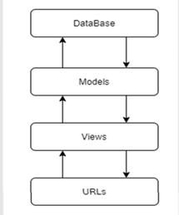

1. **FEATURES**

## USER

* + User can register to Amazecart.
  + User can login into his account.
  + User can view different categories of Products and the quantity of that particular product.
  + User can add products in cart.
  + User can enter address for delivery.

## ADMIN

* + Admin can login using his credentials.
  + Admin can perform CRUD operations on users.
  + Admin can perform CRUD operations on products.

# IMPLEMENTATION DETAILS

# Home Page:

# 

**Login Page:** From this page the user as well as the admin can login using his credentials. If the user is new to this portal, he/she can register to Amazecart using Signup option..

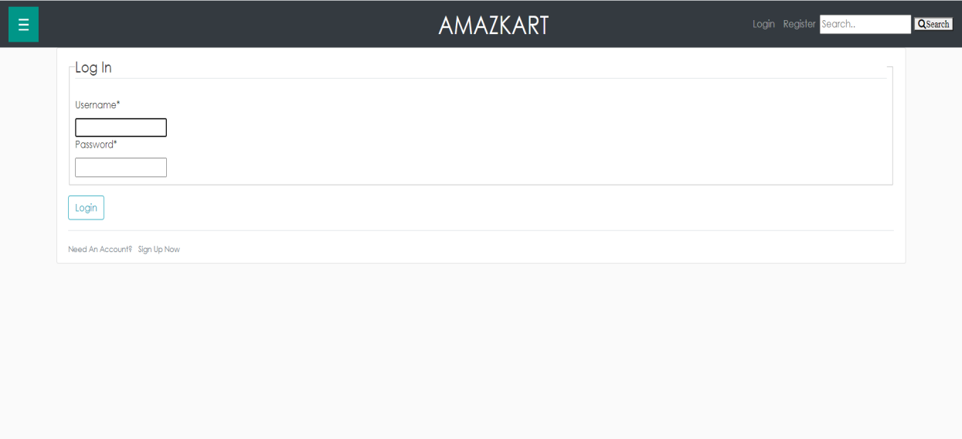

**Signup Page:** From this page the fresher user can create his account into Amazecart by providing the details asked.

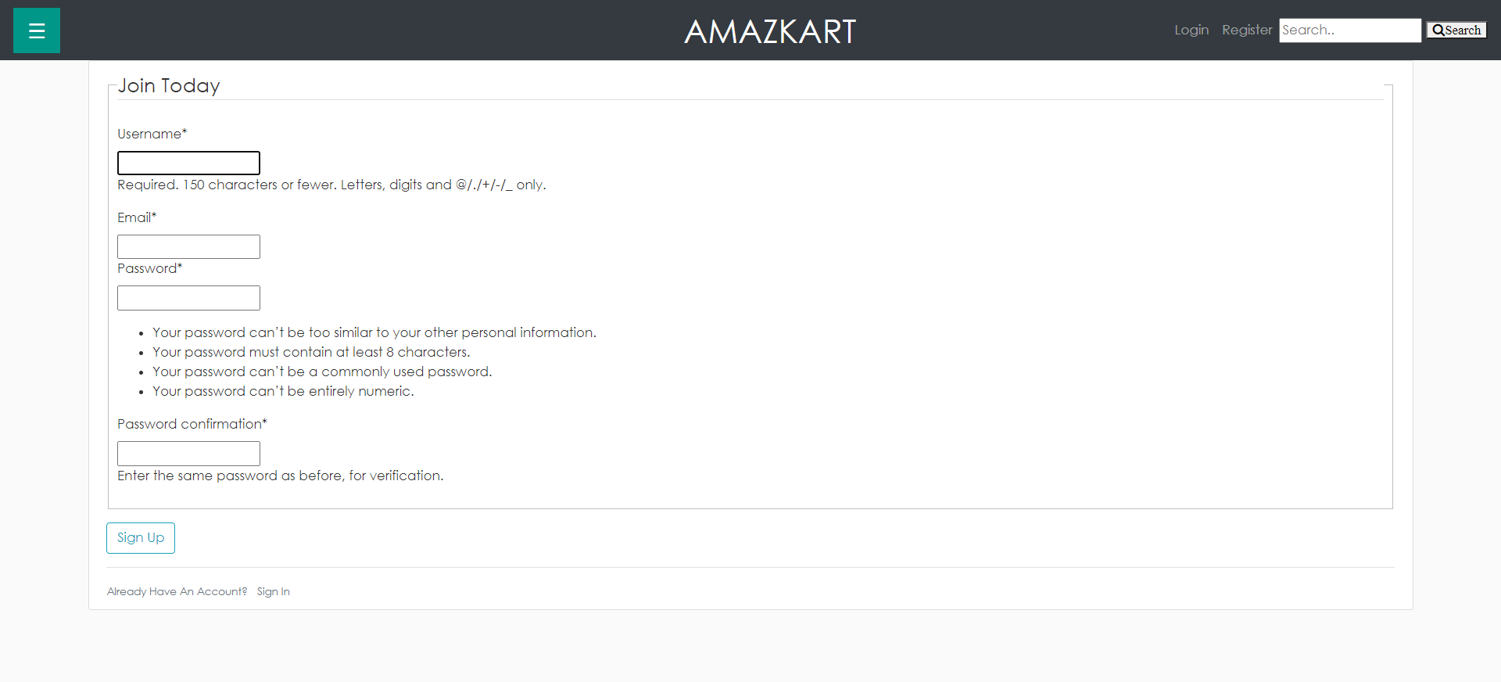

**Products Page:** From this page the user visiting Amazecart can know about the different categories of products like camera , mobile phones etc. From this page the user can select the product for knowing the detailed specification of that particular product.



**Cart Page:** From this page the user will get the list of products selected. If required the user can change the quantity attribute in the cart also directly from this page. The Price of a product * quantity is calculated and summed for all the products and displayed in the cart.

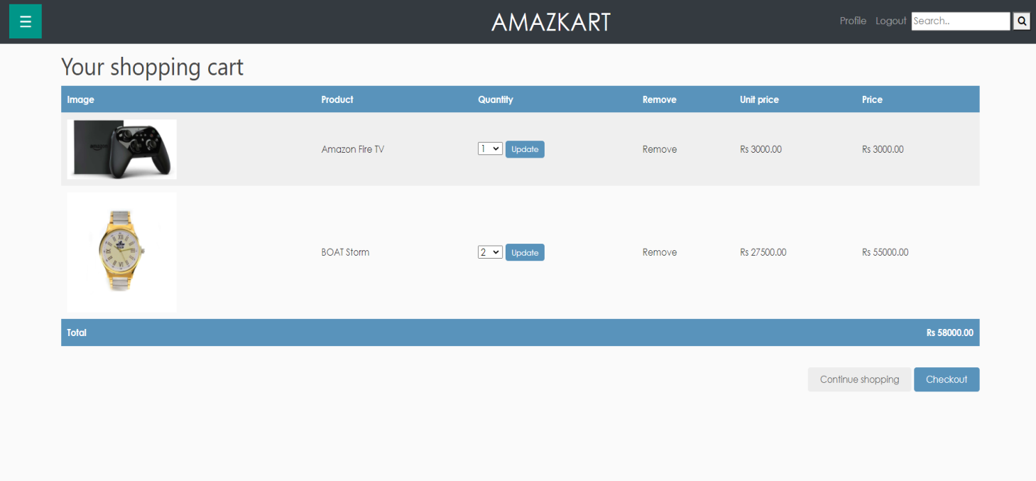

**Checkout Page:** From this page the user can enter the details like name, address, mail ID as the details are essential for delivering the products.

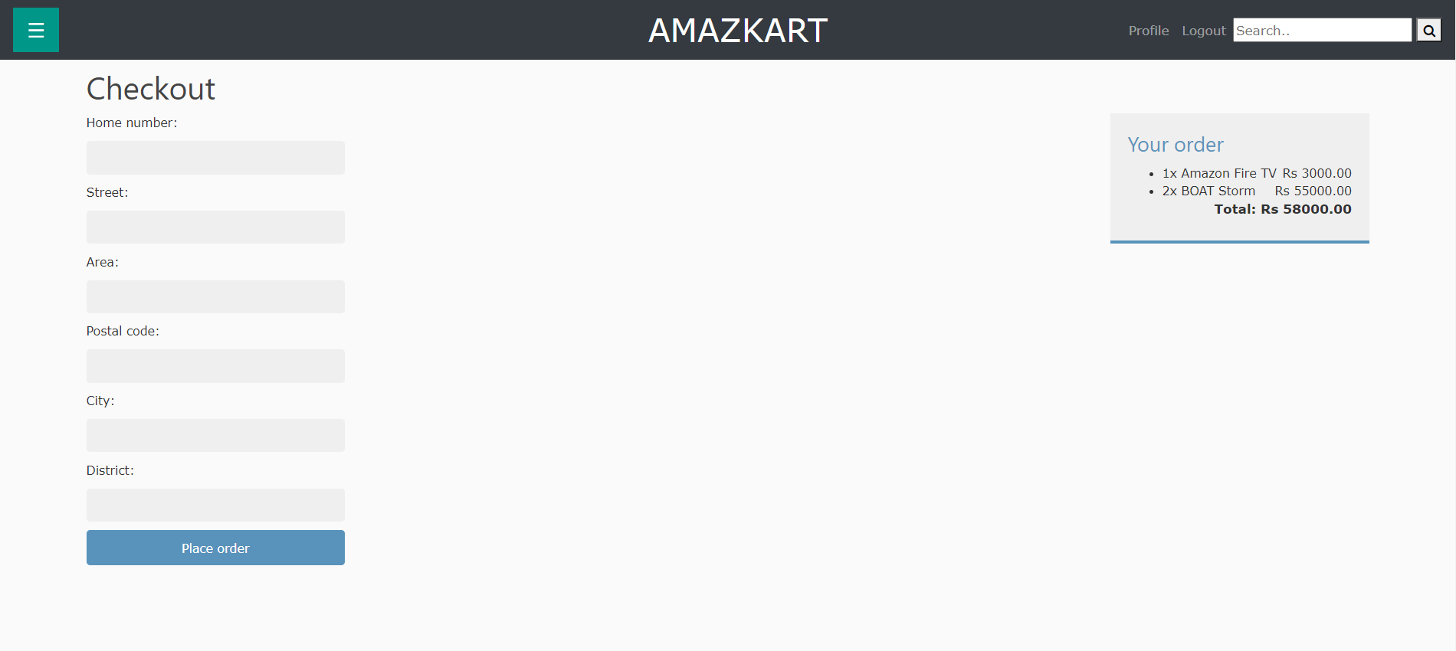

**Product’s Detail Page:** The user can view the product details and enter the quantity and click on add to cart. This will add the product and the quantity selected into the car

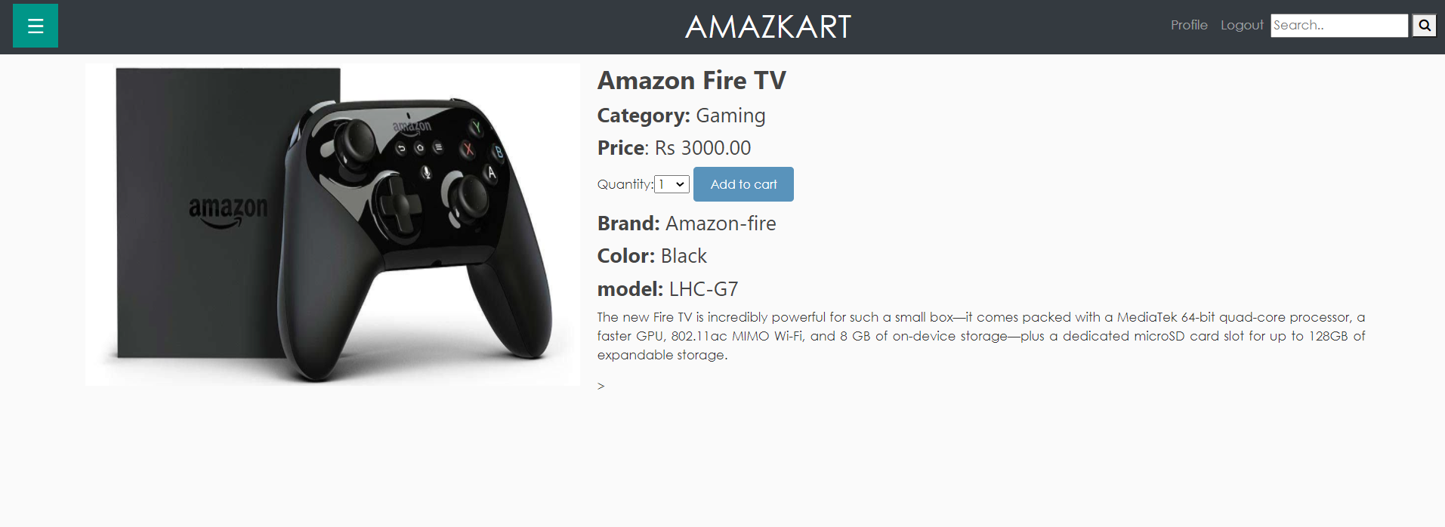

**Admin Panel**: Using the admin panel the admin can perform the CRUD operations on the user details and also on the Products

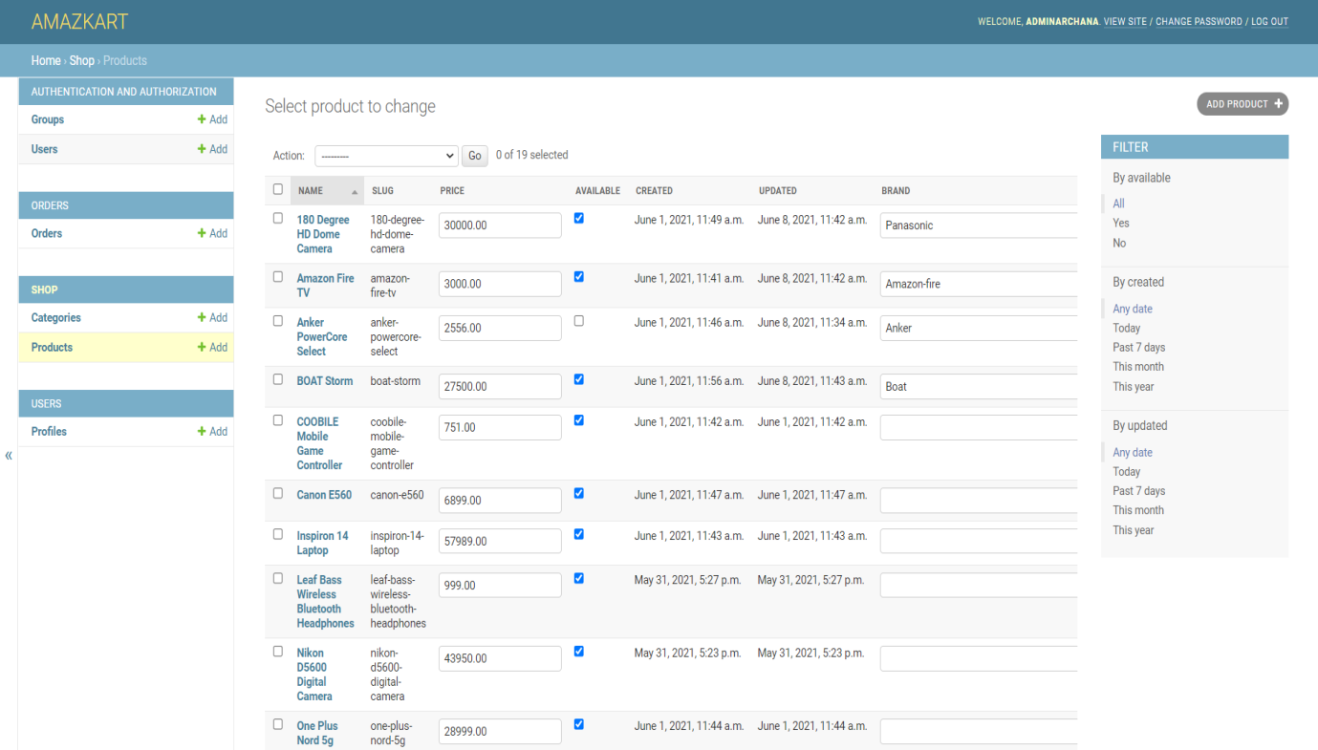

# ADVANTAGES OF THE FRAMEWORK

* Django is a free open-source web application framework written in python.
* Django offers a big collection of modules which we can use in our projects.
* Django is scalable in nature and has ability to quickly and flexible to switch from small to large scale application.
* A Django admin panel is generated automatically from Python code.
* Django is compatible with major operating systems and databases.
* Django provides robust security features.
* As an open source and available for free online, Django is supported by active volunteers who constantly provide updates and resources on djangoproject.com and on GitHub.
* One of the nicest advantages of Django is that it can handle traffic and mobile app API usage of more than 400 million+ users helping maximize scalability and minimize web hosting costs

# CONCLUSION AND FUTURE SCOPE

It was a great opportunity to work on such a project, where we got to learn and know more about some good technologies such as Django, node, Bootstrap, java script, html and CSS.

About Amazecart, it is an application helpful for users to view and order the different digital products , the demand of such applications always remain high as we all have experienced in this pandemic that the online shopping has proved to be much safer than offline shopping.

With this mode of shopping we get the provision of receiving the products to our door steps unlike the offline mode where we need to wander different shops to purchase our required products.

Thus, adapting to application such Amazecart will be more beneficial for users who can access the products anywhere and anytime.