Store Address Speculation and Mis-speculation Recovery Mechanism Study
by Apoorva Karnik, Sourabh Dugar
{apkarnik, sdugar}@ncsu.edu

Abstract
In always stall policy when a load encounters unresolved stores, processor always speculates loads to be dependent on unresolved stores. We propose to modify this behavior. To begin with we would modify the simulator to always predict no-dependence. We would also attempt to add more intelligence to disambiguation at a later stage so that a dynamic prediction can be made. We will compare two hybrid prediction schemes, the first uses associative load store pairs and the second will use store distance as a parameter for prediction. We have used these schemes with two recovery approaches, complete squash and complete re-execution. Further we have performed several sensitivity studies and analysis. Details of the schemes used will be described in this paper.
We will add a replay buffer structure to the simulator to re-inject violating load and its dependent instructions into the issue queue.

Related Work
In our study we reference a lot of work in the field of speculative execution of loads, recovery mechanisms and Memory Dependence Predictor schemes.
In Akkary et al[1], a memory dependence predictor is suggested based on storing the SQ distance of the conflicting store entry from the store queue index that a load takes when dispatched. They propose caching multiple such forwarding distances. This was a fairly simple scheme that we decided to explore. We will compare the results of this approach with our approach.
Moshovos et al[2], is an early paper which creates explicit synchronization signals for loads and stores. This scheme is very similar to the store load forwarding architecture already available in current super scalar processors based on the LSQ (Load Store Queue).
In Chrysos et al[3], a Memory Dependence prediction scheme is described using store-sets. In this whenever a violation occurs the load and a store are given an SSID (Store Set ID) in a table indexed by load PC. Whenever this store arrives it checks the SSID table and deposits its inum(unique identifier) in a LFST (Last Fetched Store Table)table. When a load is fetched the processor creates a dependence based on the stores in the LFST. As multiple stores can be present in the LFST to simplify implementation they suggest making the load dependent on the next youngest store, and each store depend on the younger store to create an in-order chain of instructions. In our work we remove some of the limitations imposed by [3] for the purpose of study. We leave the effective implementation of the scheme in hardware as future work.

Introduction
In this paper we explore the performance obtained by speculatively executing loads in the presence of unresolved store addresses in Load/Store queue (LSQ). We also add various types of Memory Dependence Predictors (MDP) and two recovery schemes – complete-squash and complete re-execution.
We start with the simplest kind of prediction where we always predict that the load is not dependent on any previous unresolved stall. Then we begin with the more sophisticated techniques where we use hybrid schemes for prediction using some confidence mechanism. To associate a confidence mechanism with loads when there are unresolved stores older than the loads, we use two different prediction schemes. This allows us to speculatively obtain the value from D-Cache/previous store for a high confidence load or stall a low confidence one. This was done by using two techniques, 1) associating store distance[1] with the load PC in an address indexed table, 2) caching frequently violating load/store pairs[2].
Since speculation will involve a recovery approach we have used two approaches along with the speculations schemes as described earlier. Our first approach is to squash all instructions after a violating load (including the load) from all stages of the pipeline whereas the second approach will be to do a complete re-execution instead of a complete squash, i.e. we will squash all the instructions after the violating load from the backend of the processor pipeline. For this we could treat the load as an exception and wait for it to reach the head of the active list to flush the pipeline and start re-fetching from load PC( in case of complete squash). We do not trap into the exception handler for this. In the second approach we cache all the instructions at dispatch in a replay buffer (in program order). When a violation is detected at the head of the active list, instructions are re-inserted from this buffer into the issue queue one by one. By doing this we attempt to avoid re-decoding and re-renaming instructions. We compare the two approaches and then used the best one for all the sensitivity tests.

Organization
The rest of the paper is organized into the following sections:

Experimental Setup

Technical Details
- Blind speculation
- Memory Dependence Predictors
  - Store distances.
  - Counter based
  - Hybrid (Counter + Store distances).
  - Store sets.
- Recovery Mechanisms
  - Complete squash
  - Complete re-execution

Experiments

Analysis

Key outcomes and Learning

Future Work

References

Appendix

Experimental Setup
For our study we utilize the ECE721 simulator designed at North Carolina State University by Dr. Eric Rotenberg and his students. The simulator has modeled all the components of a modern superscalar processor with 8 canonical pipeline stages namely Fetch, Decode, Rename, Dispatch, Schedule, Register-read, Writeback and Retire. In additions it has a LSU (Load Store Unit) which is our main interest in this study. The LSU in the current implementation always stalls in the presence of unresolved store entries, we chang this behavior and add MDP’s to the simulator.

Technical Details

i) Blind Speculation
The first approach we studied was the always speculate mechanism. In this scheme a load is never stalled. Whenever we encounter an unresolved store in the LSQ we determine that the store will not conflict with the load and speculatively execute the load. To support this, the following changes were made to the simulator structures –
- Active list – Active list was augmented with a violation bit which is set by a store when it detects a mis-speculation.
- Renamer – The renamer commit was modified to treat violating loads as an exception and signal the same to retire stage.
- LSQ – Load store queue had no mechanism for executing loads to check younger loads for a mis-speculation. We added this support. When a store executes in the execute stage in the LSQ it checks the younger loads to see if they are speculative. If they are speculative and have their value available they are marked as violating, i.e. the active list violation bit is raised.
- Retire stage – When a load mis-speculation is signaled we take the appropriate steps for recovery. Our recovery approaches will be described in the next sections.
Although this scheme gave an improvement over the stall approach and reduced stalls to almost zero (the few remaining stalls were due to split instructions), the scheme was not very good in that it caused a lot of memory violations. Also the total number of loads executed was increased.

ii) Memory Dependence Predictors
When we used the blind speculation approach although we found an improvement over the always stall approach we found that the performance was much inferior to that obtained with oracle disambiguation as may be expected. To address this we decided to study the effect of various memory dependence predictors.

Counter Based Mechanism
The motivation behind using this approach is that some loads get frequently mis-predicted and it is difficult to ascertain a prediction scheme based on load-store pairs. Such loads when mis-predicted, cause violations and hence expensive recovery approaches have to be used. In this approach we implement a naive scheme based on 2 bit counters for every occurring load. The policy used here is as follows:
When a load appears for the first time, it is always predicted to conflict and hence it is made to stall. Also the counter associated with this load is initialized to 1, indicating weak confidence. (0 indicates good confidence)
The same load when appears for the next time we predict 'stall' since we had weak confidence on this load. If a violation is detected later, we increment the counter. Similarly for loads which get predicted correctly, counter is decremented. Only loads which have a counter value of 0 are predicted not to conflict and hence they do not stall.
It is important to note here that any load to be marked as non-colliding it should have enough hysteresis i.e it should have been correctly predicted before.

Store Distances
In this approach we use the store distance to predict the memory dependence for a store. The store distance (in terms of number of stores) is defined as the distance between the forwarding store and the load [4]. In this approach we maintained a prediction table where we store the store distances for each load. For loads that did not get value from forwarding we stored a '-1' for simulation purposes. The proposed scheme works as follows:
When a value is forwarded to a load, an entry is made in the prediction table corresponding to the load and the 'store distance', i.e. the number of stores in between load and forwarding store is stored in it.
When the same load appears for the next time, we check if there is any previous unresolved store at the same distance as the distance value stored in the prediction table. If we find a match then it indicates that the unresolved store could resolve to the same address and hence we make the load stall. If no match is found then we predict that the store will not collide and hence do not make load stall for it.

Hybrid Scheme (Counter + Store Distance)
We found that a hybrid approach using both the counter approach and the store distance approach yielded better performance than each of the policies described above, used individually. In the hybrid scheme we used the counter scheme with an added parameter that if there is a store distance match we will over-ride the counter and stall. This can help in cases when a program stores a value which is then loaded. The stall distance retains this information and can correct the counter quickly. The advantage of keeping the counter is to reduce the number of store distances that are stored in cases when more than one store is alternately forwarding to a load. In such cases since we maintain only one store distance our store distance will never indicate a stall, however the counter will correct our behavior and indicate a stall.

Store sets
The motivation behind store set based approach is that a load pc tends to conflict with or obtain values from another load in a predictable manner that depends on the program. Therefore caching this conflicting store PC’s in a table indexed by load pc will give us a fairly good idea of when to stall and when to speculate. There will be initial memory violations (much like the compulsory cache-mis) when the table has not learned (or created entries for the load). Once the table has learnt it will be able to make fairly good prediction. The load may depend on only one store or may depend on multiple stores. Therefore the store set we suggest and implement has a variable associativity. Where associativity refers to number of store PC’s, deemed to conflict with this load, stored against a load pc.
In the store set based approach we have a pc tagged table of loads. Initially the table is empty. An entry is allocated and updated in the following manner:
- When a store detects a violation on the load, the load is given an entry in the table. The store is added to the store-set of this load. An LRU counter is associated with each store and this is updated when the store is added.
- If an entry for the load is already present in the table, the store is added to the store set at a position with the highest LRU counter. (LRU counter for least recently conflicting store is always set to 0).
In contrast with [3], we do not give a store an SSID, this is because the store is deposited in the LSQ anyway and will be checked by a load when deciding whether to speculate or stall. Also the architectural limitation that was imposed in the paper where a store cannot be in multiple store-sets has not been imposed because of the reason explained above.
Also after a certain number of cycles we squash the table completely, similar to that in the paper. The motivation behind this is that as the code executes the load pc’s will no longer match/conflict with the same store pc’s as in older sequence of instructions. Therefore it is necessary to unlearn to prevent false stalls (prevent being too conservative). This also helps in reducing the effective size of the store table.

iii) Recovery Mechanisms
With load speculation, it is essential to have some mechanism to recover in case of incorrect execution.
In our study we explored to different approaches. The first one was complete squash which is simplest to implement and the second one is complete re-execution from a replay buffer.

Full Squash
In the full squash approach we have a modified active list with a violation bit for every entry. This bit is set when a store detects a mis-speculation. When the active lists commit an instruction at the head, it examines this bit to check if there is a mis-speculation. If that happens recovery process is initiated by squashing the entire pipeline, resetting the active list, LSQ and issue queues, the BP is also flushed. Re-fetching begins from the violating load instruction and the violating load instruction is also executed again.
The LSQ is modified so that every time a store executes it examines the load queue to determine if there are younger loads that match the address of the store which already have a value. If that happens, the store sets the violation bit of the load in the active list.

Complete Re-execution
In complete re-execution we attempt to save on re-decoding and re-renaming the instructions. For this we insert all the instructions in a replay buffer at dispatch. The replay buffer is maintained much like the active list except that it has no RMT, AMT and no architectural registers. It has enough information about the instruction to be able to re-inject it into issue-queue.
We still follow the same approach of marking a violating load in the active list as described in the complete squash section. We also squash the backend and the issue-queues. When a violating load is detected at the head of the active list we send a replay signal to the dispatch stage of the processor, setting a replay bit. When this bit is set, the dispatch stops consuming instructions from the replay stage (effectively stalling the entire front-end) and start consuming instructions from the replay buffer till its empty. We dispatch instructions equal to dispatch-width at the maximum from the replay buffer every cycle till its empty.
Checkpoint recovery of branches poses significant difficulty in this case. As the branches can depend on a load which can potentially re-execute due to a memory violations we cannot be sure if the branch has executed correctly till all the loads it depends on retire. As the branches can re-execute multiple times we cannot free the check-point bit in the GBM (Global Branch Mask) till all the instructions that a branch depends on retire. To overcome this we delayed the finalizing of recovery to the retire stage. This was however a simple approach and more aggressive approaches such as recovering but not releasing checkpoint and recovering early when all the producer instructions that can go wrong have retired are worth trying to give the full benefit of complete re-execution, however they are not explored in our study. Due to our approach we recover later and cause the entire pipeline to be idle for longer. This causes its performance to be in inferior to the complete squash and hence we will be considering complete squash with store sets for further studies.

Comparison of speculation techniques & recovery schemes
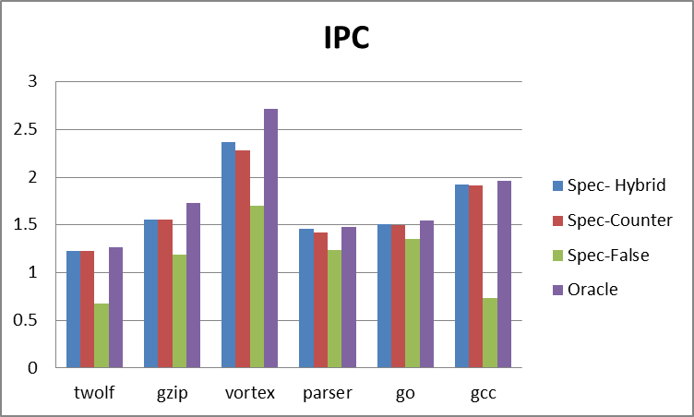
Fig. 0.1 IPC for various speculation techniques
We observed that out of the three speculation techniques, out of counter based mechanism, hybrid and store distance, hybrid performs the best. However on analyzing its performance in comparison to the oracle disambiguation scheme, we found that the store sets scheme is even better than the hybrid scheme. The comparison of oracle disambiguation and store sets based scheme is given in the following graph. We observed that stores sets technique was very close in performance to oracle disambiguation.
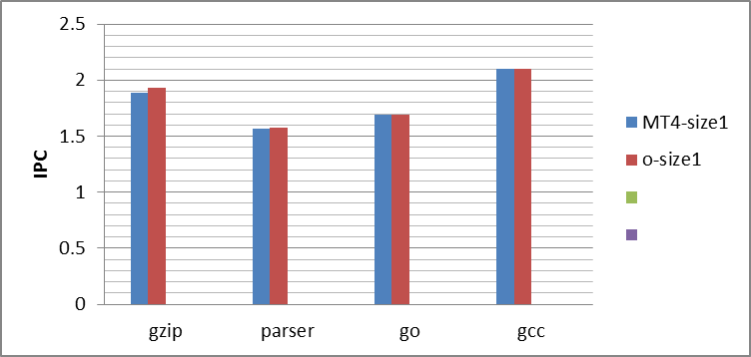
Fig. 0.2 IPC for store sets technique in comparison with oracle disambiguation.
The better performance could also be attributed to the fact that the store-set method used an associativity of 2 (i.e. 2 store pc’s are stored against a load pc) in the above plot. We have not explored the associativity for other prediction methods and leave it for future work.
We also analysed the two recovery mechanisms and in almost all of our runs, we found that the complete squash yielded better performance than complete re-execution. And therefore we will only present results using complete squash recovery.

Experiments & Graphs
We study the effect of speculative load execution on the following parameters:
- Disambiguation stalls
- Forwards
- Number of loads executed
- IPC
- Squash count.
Disambiguation stall – Counts all cases when load is stalled. This also includes the false stalls when an incorrect store may signal a stall.
Forwards – The total cases when a store forwards to a load. This can include incorrect cases when an incorrect store signals a forward.
Number of loads – The total number of loads during the simulation. This includes the re-executed loads in case of recovery.
IPC – Instructions Per Cycle.
Squash count – total number of times the entire pipeline is squashed in case of squash based recovery.
Blind Speculation, Oracle Disambiguation and Speculation with Store-set based MDP
In this section we present the experimental results comparing the performance of blind speculation, store-set based speculation. We also compare the results with oracle disambiguation to show how our modified store-sets help approach an IPC comparable to that of oracle disambiguation. The reason why these parameters are selected is explained in the analysis section.
In the experimental graphs below the following key is used
o –Oracle disambiguation
Basic speculation – Blind speculation with no MDP turned on.
MTx – Store sets based MDP with x associativity
In the experiments below the configuration was the following.
Issue-width - 8
Dispatch-width – 4
Fetch-width-4
Retire-width-4
Active-list size - 128
Size of the predictor – 1000 x associativity
We have used an unbounded size predictor in our simulation which is squashed every 400000 cycles. And we observe that for most benchmarks the size is under 100 entries.
For go and gcc the size goes to 600 entries.
However we have included a size of 1000 entries as the maximum upper bound.

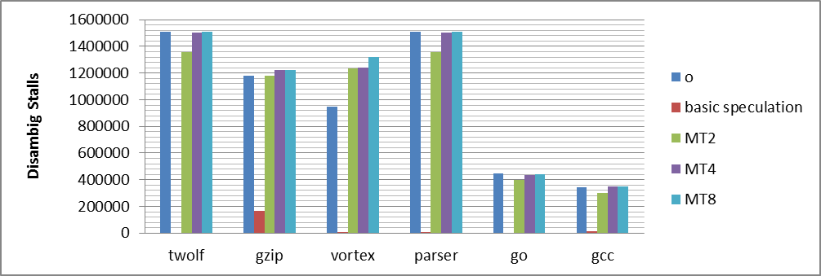

Fig. 1 Disambiguation stalls with various speculation techniques and oracle disambiguation

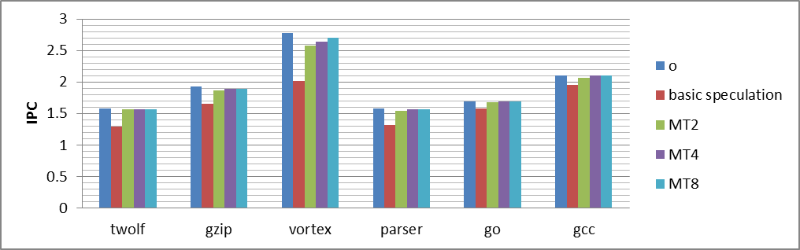

Fig. 2 IPC with various speculation techniques and oracle disambiguation

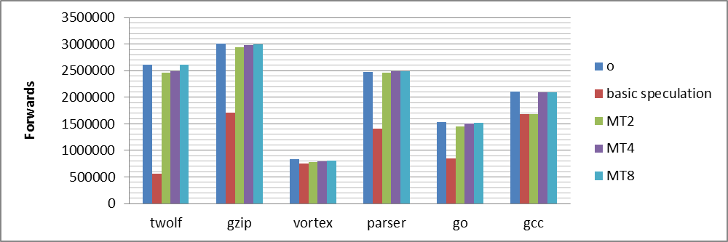

Fig. 3 Forwards with various speculation techniques and oracle disambiguation

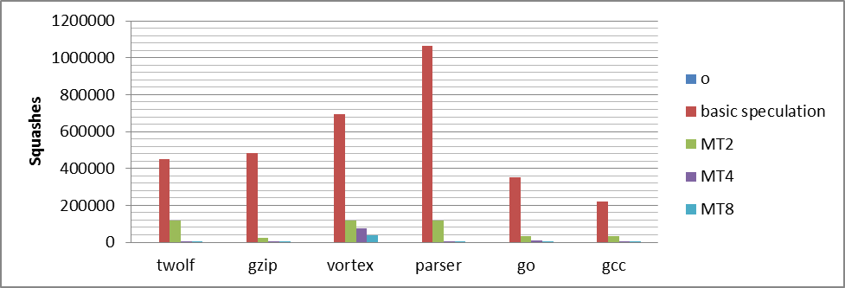

Fig. 4 Squashes with various speculation techniques and oracle disambiguation

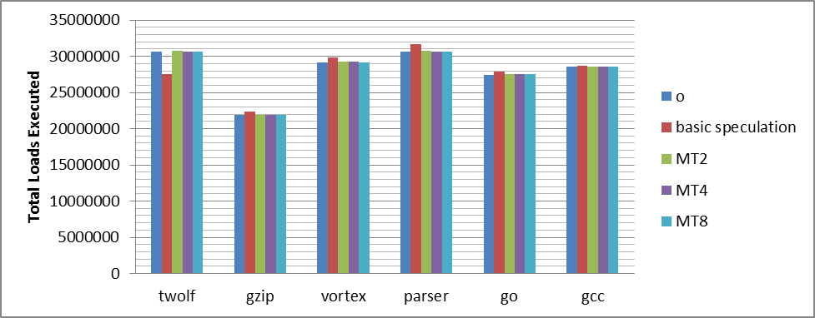

Fig. 5 Total Loads Executed. This is an interesting parameter to consider as the number of violations increase the total number of loads that execute.

Sensitivity of dispatch width MDP prediction
In this section we explore the effect of increasing the dispatch width on our MDP. We use MDP with an associativity of 4 in this section. This is because we see that there is not performance gain in switching from an associativity of 4 – 8.
We present the total number of squashes an indicator of memory violations and the IPC achieved by the simulator.
Key to Fig 6. and Fig 7.
o, MTx – stand for same thing as above
size1 – same size as above
size2 – 2 x size1
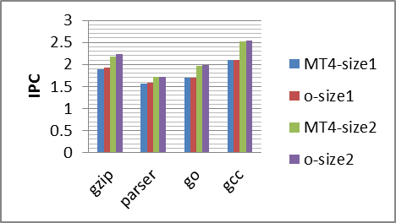
Fig. 6 IPC observed when doubling superscalar width.
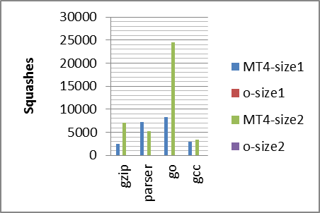
Fig. 7 Squashes observed due to doubling super-scalar width.

Analysis
Pure speculation is better than the stall approach, but does not fare well as compared to oracle disambiguation based runs. Speculation with store sets based MDP lead to IPC results that are comparable to oracle disambiguation. Speculation with moderately sized MDP is much better than blind speculation. We observed an overall decrease in memory violation of 10 fold or more when moving from blind speculation to 1 entry store set. Yet another 10 fold reduction was seen when moving from 1 entry to 2 entry(LRU based replacement). The reduction in memory violations when moving from 2 to 4 entries wasn’t very large and hence later experiments with the Store-set MDP were restricted to an MDP with 2 entries.
General trends when moving from blind speculation to increasingly associative Store-set MDP were the following:
- Decrease in total number of loads executed. (The number came closer and closer to loads executed with oracle disambiguation).
- Increase in number of stores forwarded (Again number coming closer and closer to number with oracle disambiguation).
- We observed a slight increase in number of disambiguation stalls when increasing MDP associativity. (The number with blind speculation was close to zero). The number was however less than the oracle disambiguation case in most benchmarks.
- An increase in IPC. (This number again approached the IPC with oracle disambiguation).
The IPC improved with Store-set MDP due to an increase in forwards and decrease in number of overall loads executed. With blind speculation the total number of loads increases combined with a decrease in forwarding percent leads to a degraded IPC. We observe that with increased associativity we close the gap in terms of stalls, forwards, IPC and total loads executed with the oracle disambiguation simulator.
All these are important indicators as more loads executed and less store-forwards degrade IPC.
In case of increased width of the processor we see that although the squashes increase the performance of our simulator remains very close to the oracle disambiguation.

Key outcomes and Learning
The following were the key outcomes of the project
- Enhancement in IPC due to speculation over stalling. Conclusively proving that stalling is in general a better approach
- MDP based speculation performs better than blind speculation.
- Performance remains comparable to oracle disambiguation when increasing processor width.
- Comparison between complete-re-execution and squash based recovery.
- Early branch recovery is a key to performance. Delaying recovery led to inferior performance in a what should have been a superior approach in the case of complete re-execution.

Future Work
We believe that complete re-execution should yield a better IPC than squash based approach. However, in our runs there is performance degradation due to forcibly delaying recovery. We would like to extend this work to observe the effect of complete re-execution on IPC once this limitation is removed.
We would also like to implement selective re-execution of instructions to see the performance gain that can be achieved.
We would also like to improve the Store-set MDP to prevent caching of incorrect violations. This will help reduce both the size and accuracy of predictions. This we believe could be achieved with the help of dependence vectors that would likely be needed for selective re-execution.
We would also like to explore our other prediction methods with an increased associativity.

Refrences:
[1] H. Akkary, R. Rajwar, and S. Srinivasan. “Checkpoint Processing and Recovery: Towards Scalable Large Instruction Window Processors.” 36th International Symposium on Microarchitecture (MICRO-36), 2003.
[2] A. Moshovos, S. Breach, T. Vijaykumar and G. Sohi. “Dynamic Speculation and Synchronization of Data Dependences”. In Int’l Symp. on Computer Architecture, 1997, pp. 181-193.
[3] G. Chrysos and J. Emer. “Memory Dependence Prediction using Store Sets”. In Int’l Symp. on Computer Architecture, 1998, pp. 142-153.
[4] C. Fang, S. Carr, S. Onder, and Z. Wang. “Feedback-Directed Memory Dismabiguation Throuh Store Distance Analysys.” In International Conference on Supercomputing, June 2006.
[5] E. Rotenberg. “Lecture notes on value prediction”. ECE 721, 2012.
[6] E. Rotenberg. “Lecture notes on load store queue”. ECE 721, 2012.

Appendix
We added the following support to the simulator.
- Speculation for loads
- Modifying LSU such that stores can mark violations when the execute.
- Modified renamer and retire stage to treat mis-speculated loads as violations and initiate recovery.
- Added MDP to the simulator to improve performance over the blind speculation case. For this we explored a modified form of store-sets, store-distances and counter based confidence.
- Complete re-executions based recovery required a replay_buffer class implementation.
- Changes throughout processor stages to integrate the replay buffer class.
- Experiment design and data collection.
For the above work there were following contributions.
Apoorva Karnik = 1
Sourabh Dugar = 1
This included reading various papers, design discussions and actual coding.

