- Apoorva Pote

1. **Retrieve the full name of artists along with the names of the museums where their works are displayed.**



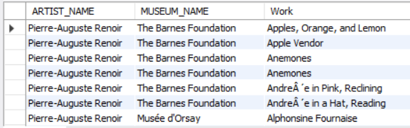

**2. How many works does each artist have in the database? Display the artist's full name along with the count of their works, ordered by the count in descending order.**



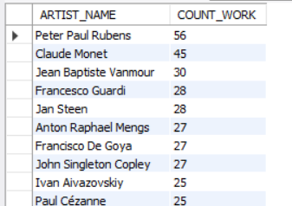

**3. List the top 5 museums with the highest number of works displayed in the database, along with their respective counts.**

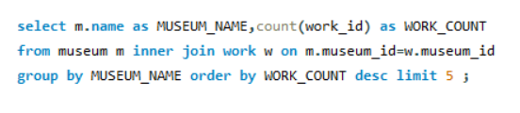

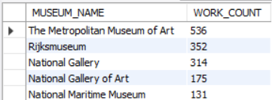

**4. Display the names and styles of the works along with the corresponding museum names, ordered by the museum name in ascending order. Limit the results to 10.**

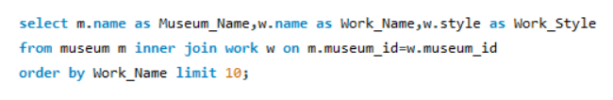

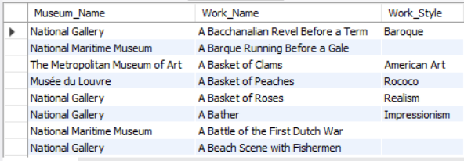

**5.Show the total sale price for each artist's works. Display the artist's full name along with the total sale price, ordered by the total sale price in descending order.**

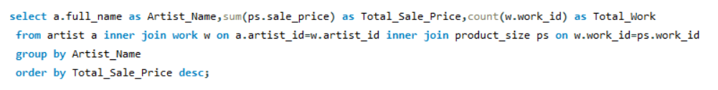

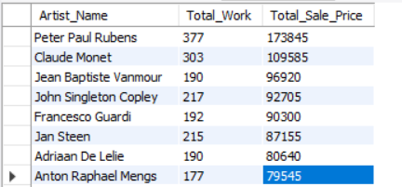

**6. List artists who have more than 3 works in the database, along with the count of their works.**

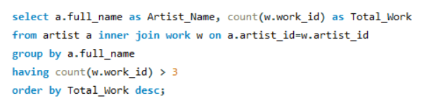

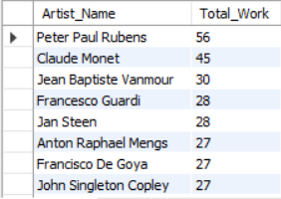

**7. Retrieve the names of works and their corresponding artists' full names for works that have a sale price smaller than their regular price.**

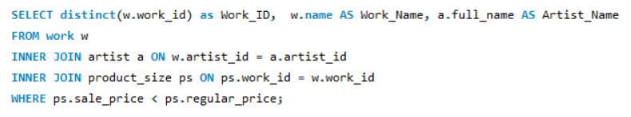

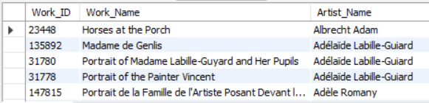

**8. Calculate the average height and width of the artworks in the database. Display the average height and width.**

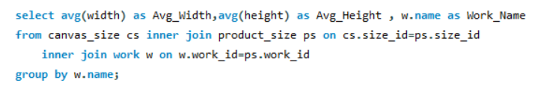

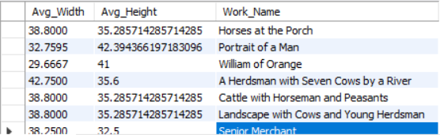

**9 Find the maximum sale price among all the works in each museum. Display the museum name along with the maximum sale price.**

