IMPACT ATTENUATOR DESIGN REPORT
FORMULA BHARAT 2021

This form must be completed and submitted by all teams no later than the date specified on www.formulabharat.com/deadlines. Click here for FAQs. The Rules Committee will review all submissions which deviate from the rules governing the competition and reply with a decision about the requested deviation. All requests and queries on the same must be directed to formulabharat-rules@googlegroups.com.

If the Rules Committee requests for additional information or calculations, the team has one week from the date of the request to submit the requested information or ask for a deadline extension.

CAR # | N/A | TEAM NAME | Manab Racing
 |  | SCHOOL NAME | Haldia Institute Of Technology

CONTACT NAME | Aman Sagar
CONTACT EMAIL | manabracing.hit@gmail.com

Material(s) Used | Dow Impaxx™ 700 energy absorbing foam
Description of form/shape | Trapezoidal Shape
IA to Anti-Intrusion Plate mounting method | Loctite Adhesive
Anti-Intrusion Plate to Front Bulkhead mounting method | Welded
Peak deceleration (<= 40 g's)
Average deceleration (<= 20 g's)

Length (fore/aft direction) (mm) | 304.8 | Width (lateral direction) (mm) | 355.6 | Height (vertical direction) (mm) | 254
(>=200mm) (>=200mm) (>=100mm)
Confirm that the attenuator contains the minimum volume 200mm long x 200mm wide x 100mm high

Insert force-displacement curve
(If not using standard IA)
Figure 1: Force-Displacement Curve (dynamic tests must show displacement during collision and after the point v=0 and until force becomes = 0)

ATTACH PROOF OF EQUIVALENCY

TECHNICAL COMMITTEE DECISION/COMMENTS

APPROVED BY: |  | DATE:

NOTE: THIS REPORT AND THE APPROVED COPY OF THE SUBMISSION MUST BE PRESENTED AT TECHNICAL INSPECTION AT COMPETITION

Insert energy-displacement curve
(If not using standard IA)
Figure 2: Energy-Displacement Curve (dynamic tests must show displacement during collision and after v=0)

Insert Picture of IA, Anti-Intrusion Plate which also shows the method of spacing it at least 50mm from any rigid structure  (If not using standard IA) |  | Insert Picture of IA, Anti-Intrusion Plate which shows the deflection was less than 25.4mm  (If not using standard IA)
Figure 3: Attenuator as Constructed |  | Figure 4: Attenuator after Impact

Energy Absorbed (J):  Must be >= 7350 J |  | Vehicle includes front wing in front of front bulkhead? | Yes/No
IA Max. Crushed Displacement (mm): |  | Wing structure included in test? | Yes/No
IA Post Crush Displacement - demonstrating any return (mm): |  | Test Type: (e.g. barrier test, drop test, quasi-static crush)
Anti-Intrusion Plate Deformation (mm) |  | Test Site: (must be from approved test site list on website for dynamic tests)

IN THE FOLLOWING PAGES, INCLUDE (NOT LIMITED TO) THE FOLLOWING INFORMATION:

- CALCULATIONS (If not using standard IA)
- TECHNICAL DRAWINGS
- TEST SCHEMATIC(S) (If not using standard IA)
- TEST PHOTOS (If not using standard IA)
- REASONS FOR SELECTION, ADVANTAGES / DISADVANTAGES ETC (optional)
- RECEIPTS / PACKING SLIP (If using standard IA)
- DATA SHEETS (optional)

Technical Drawings

1. Impact Attenuator
- Isometric View

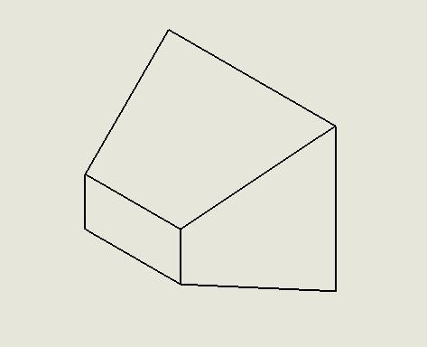
Isometric view of IA

- Front View

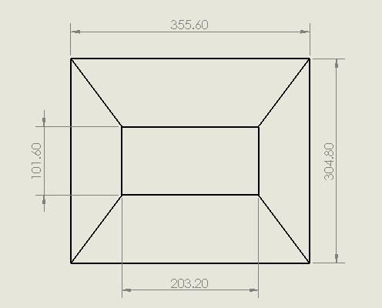
Front view of IA
All dimensions are in mm
Scale 1:1
- Top View

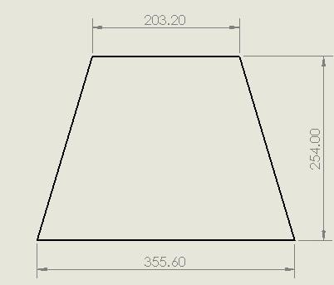
Top view of IA

- Side View

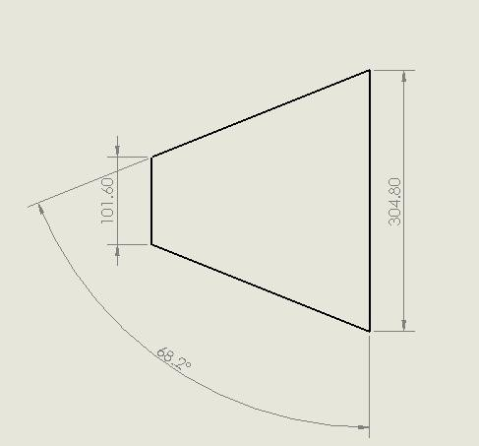
Side View of IA

All dimensions are in mm
Scale 1:1

2. Anti Intrusion Plate

Material Used

Solid Steel

Thickness

1.5
mm

- Isometric View

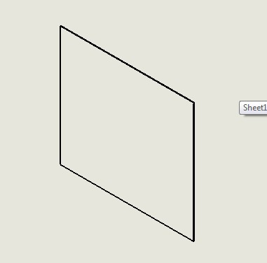
Isometric View of AIP

- Front View
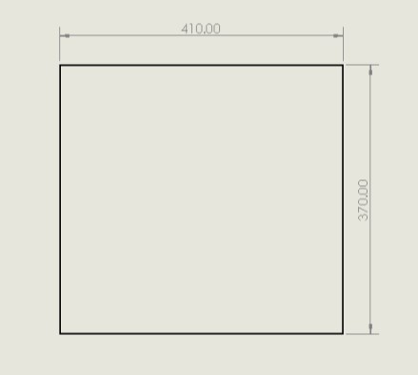
Front View of AIP

All Dimensions are in mm Scale 1:1.

- Top View

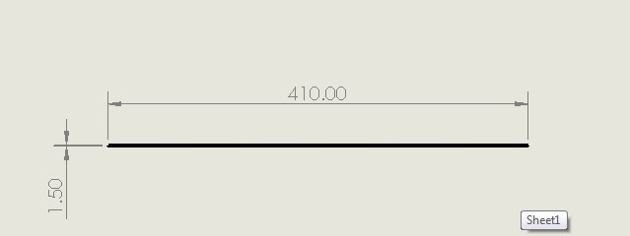

- Side View

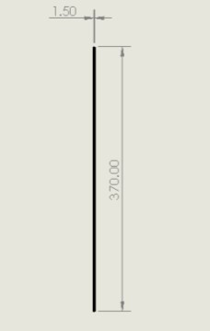
Side View of AIP

All dimensions are in mm
Scale 1:1.

3. IA and AIP Assembly

- Isometric View

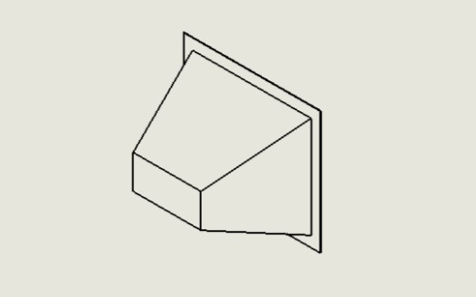
Isometric View of IA and AIP Assembly

- Front View

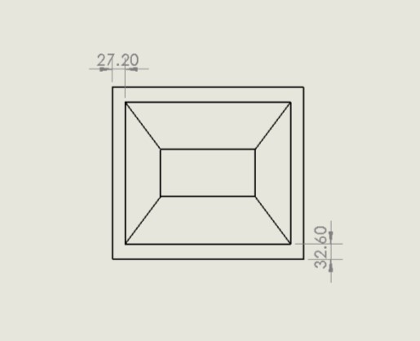
Front View of IA and AIP Assembly

All dimensions are in mm
Scale 1:1
- Top View

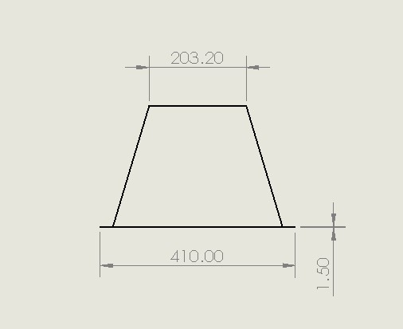
Top View of IA and AIP Assembly

- Side View

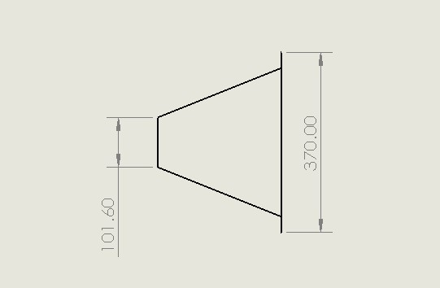
Side View of IA and AIP Assembly

All dimensions are in mm
Scale 1:1.

