**Phase2:** **Org Setup & Configuration**

**Salesforce Edition & Company Profile:**

Setup → Company Settings → Company Information → Edit Organization Name → Update Default Locale, Default Time Zone, Currency Locale.

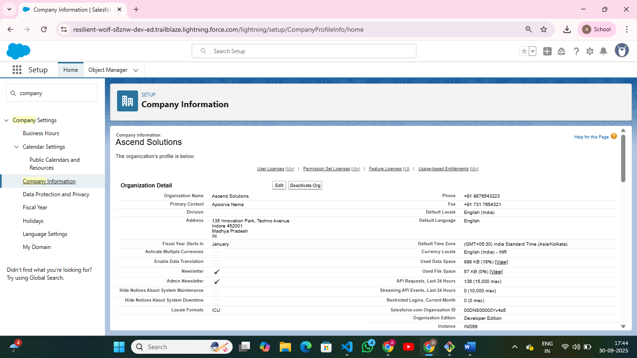

**Business Hours & Holidays:**

Setup → Company Settings → Business Hours → New Business Hours → Enter Name, Time Zone, Start & End Time.  
Setup → Company Settings → Holidays → New Holiday → Enter Holiday Name, Date, Time Zone.

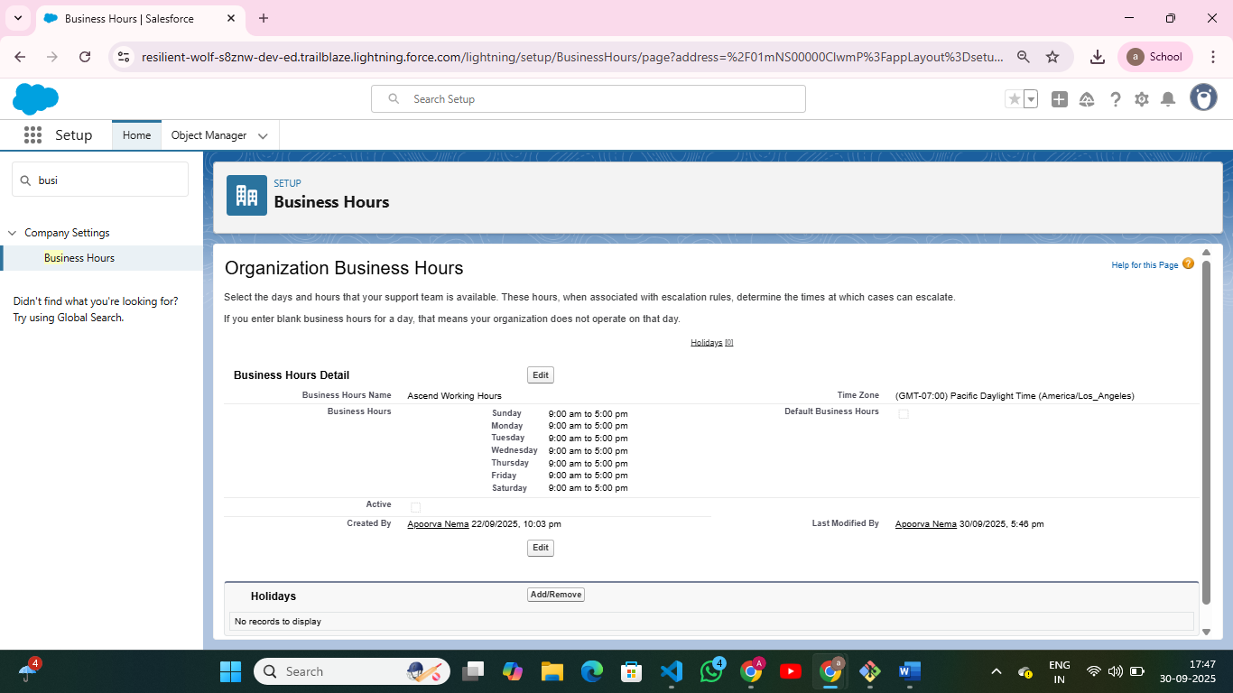

**Fiscal Year Settings**

Setup ----> Fiscal Year ----> Edit Standard Fiscal year

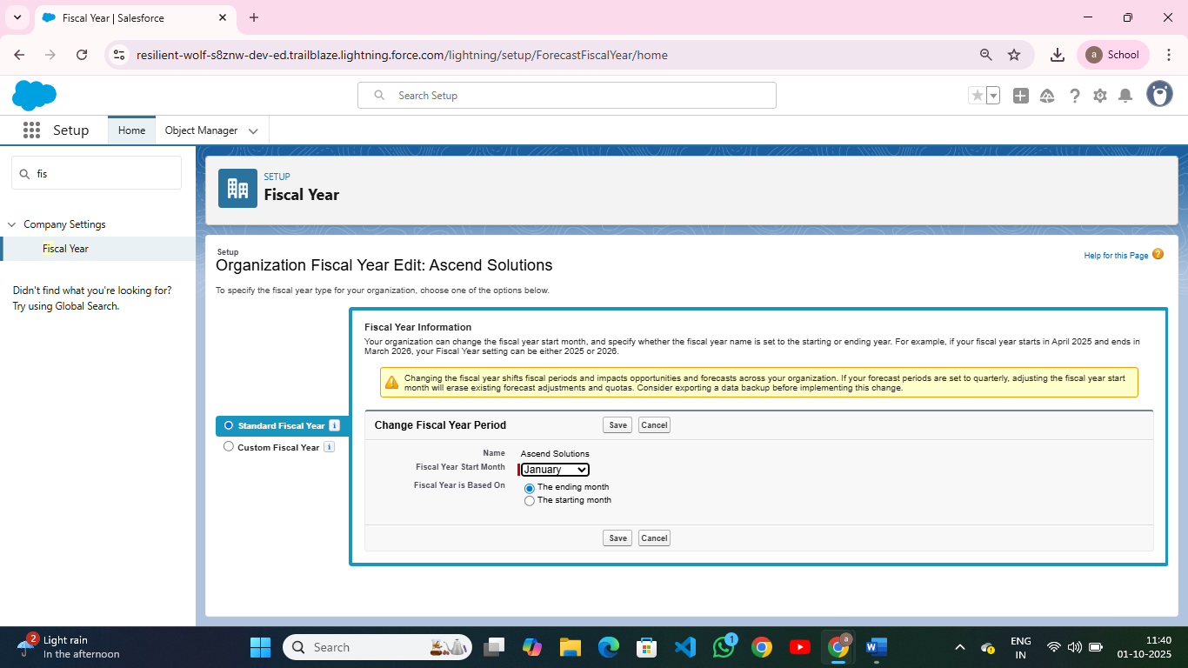

**Users & Licenses:**

Setup → Users → New User → Fill Name, Email, Alias, User License, Profile.  
Setup → Company Information → Check Available User Licenses.

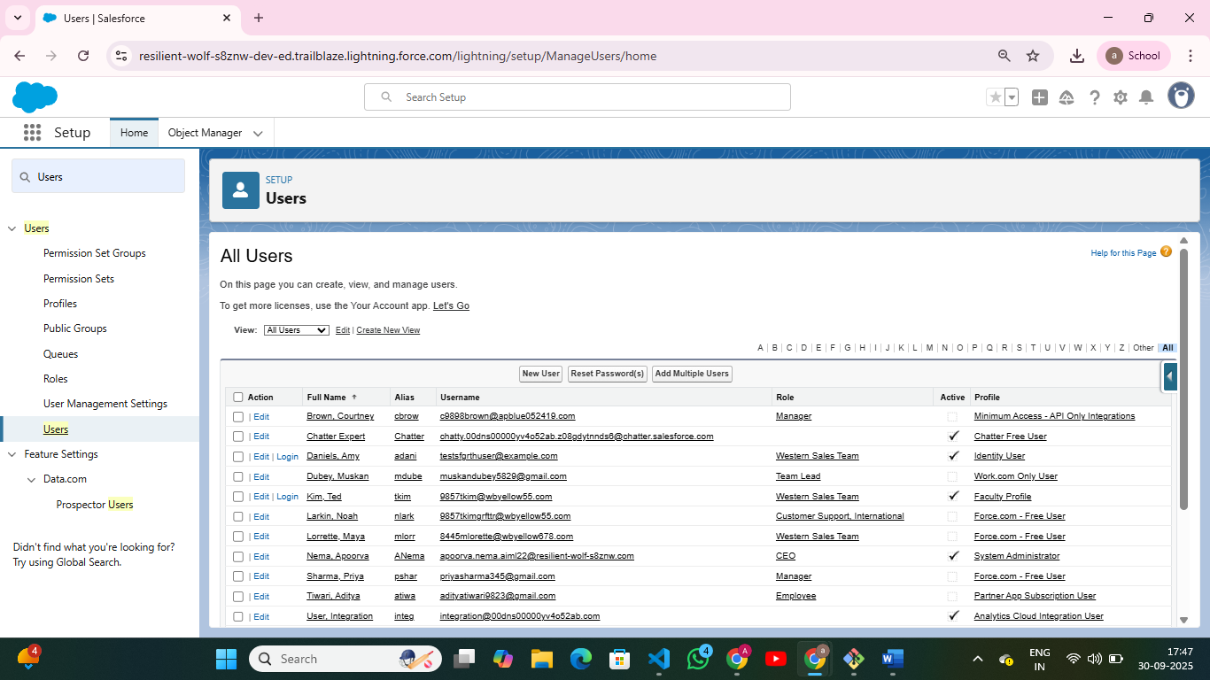

**Profiles:**

Setup → Profiles → Clone Standard User Profile → Faculty Profile.  
Assign Object Permissions (Read/Write)

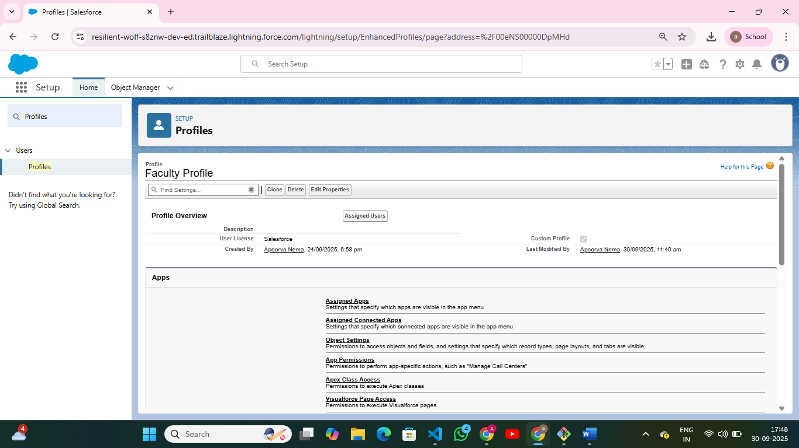

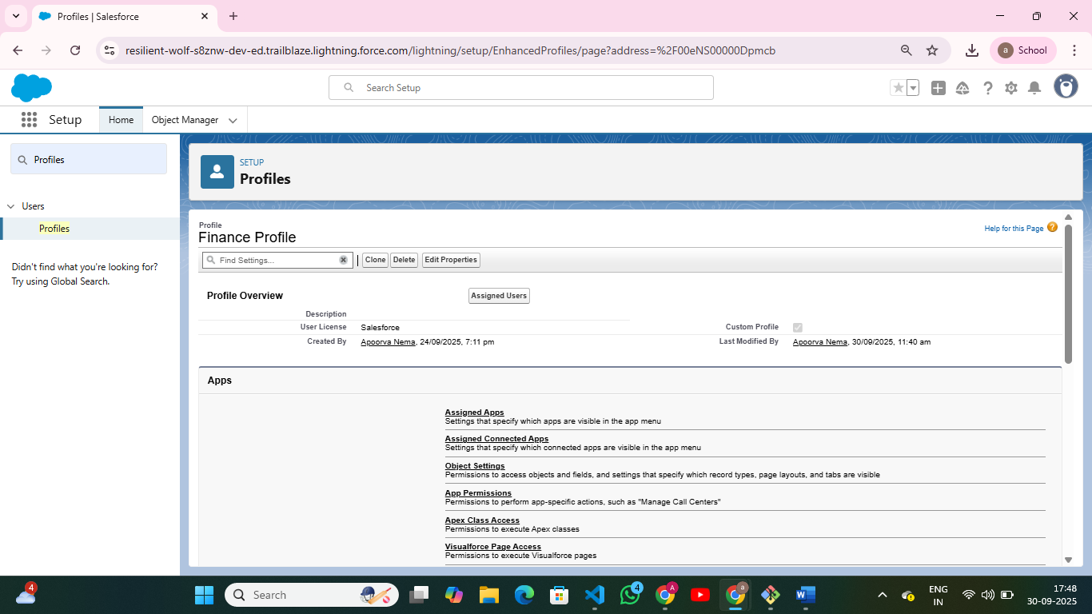

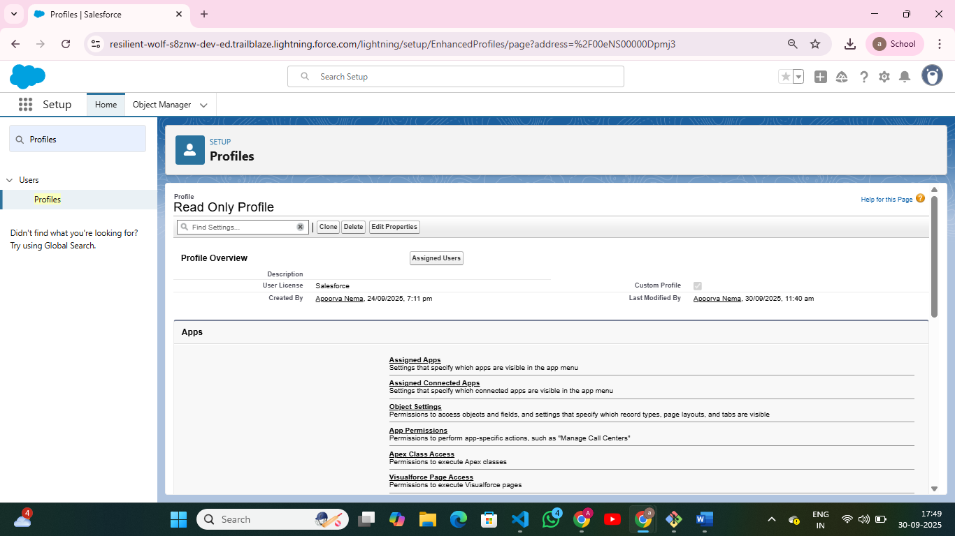

**Roles:**

Setup → Roles → Set Up Roles → Create New Role → Define Role Hierarchy.

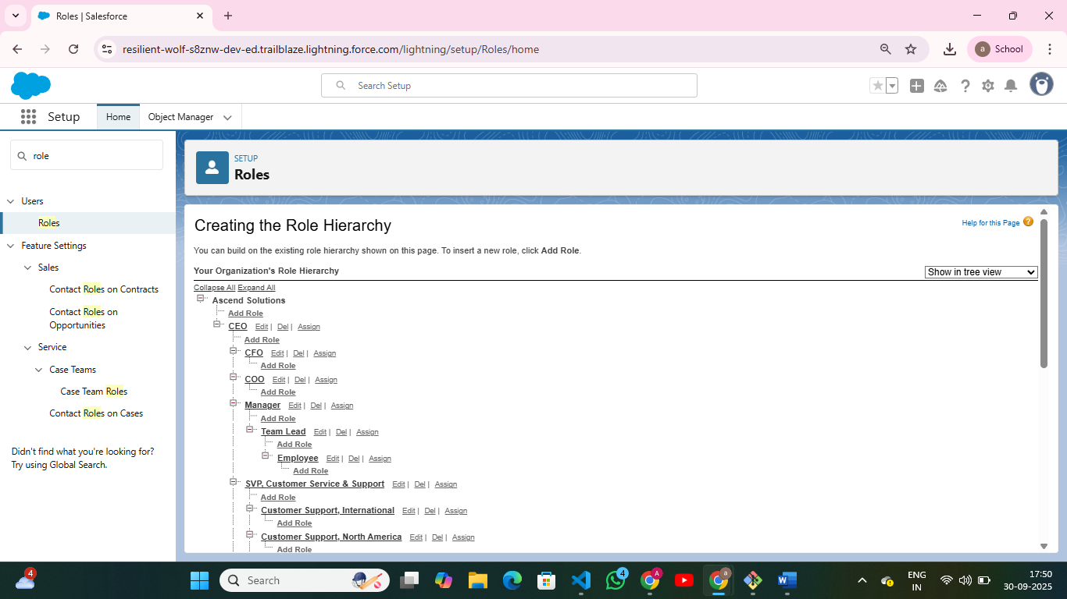

**Permission Sets & Sharing Rules**

Setup → Permission Sets → New → Assign Custom Permissions (e.g., FeePayment Access).  
Assign Permission Set to specific Users.

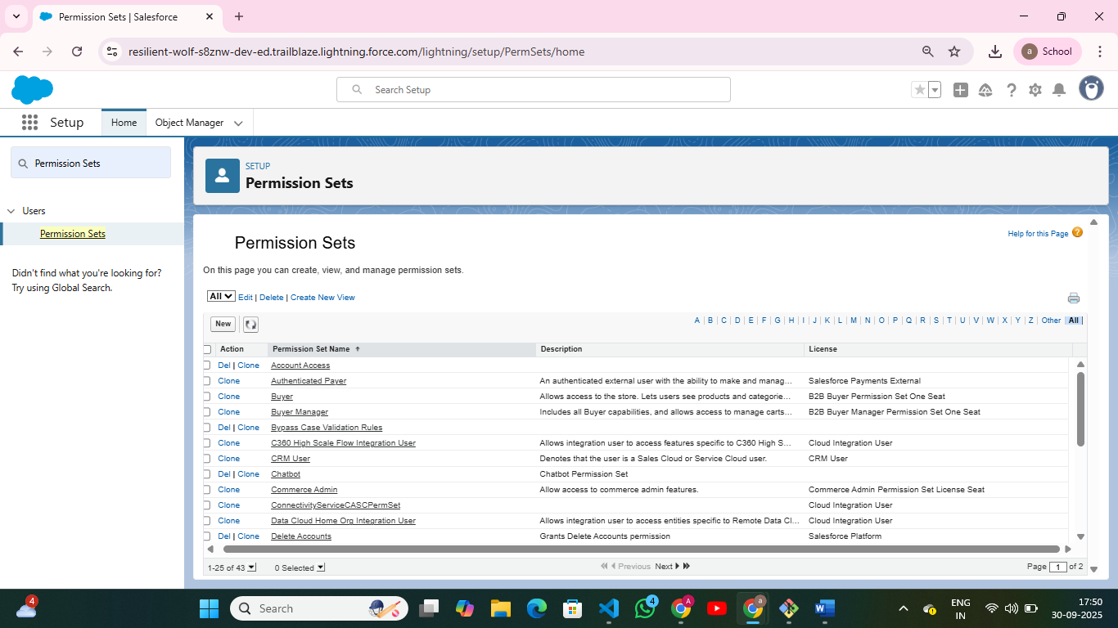

**Organization-Wide Defaults (OWD)**  
Setup → Sharing Settings → Edit → Set *Default Internal Access* (Private, Public Read Only, Public Read/Write) for each Object.

**Login Access Policies:**

Setup → Permission Sets → New → Assign *Custom Permissions (e.g., FeePayment Access)*.  
Assign Permission Set to specific Users.

