Caesar cipher shift technique
#include<stdio.h>
int main(){
int n,i;
printf("Enter the length of the string: ");
scanf("%d",&n);
char str[n];
printf("Enter the string: ");
scanf(" %s",str);
printf("Enter the shift value: ");
int k;
scanf("%d",&k);
for(i=0;i<n;i++){
if(str[i]>=65 && str[i]<=95){
str[i]=((str[i]+k-65)%26)+65;
}
else{
str[i]=((str[i]+k-97)%26)+97;
}
}
printf("Encryption Shift Cipher: %s\n",str);
for(i=0;i<n;i++){
if(str[i]>=65 && str[i]<=95){
str[i]=((str[i]-k-65)%26)+65;
}
else{
str[i]=((str[i]-k-97)%26)+97;
}
}
printf("Decryption Shift Cipher: %s",str);
}
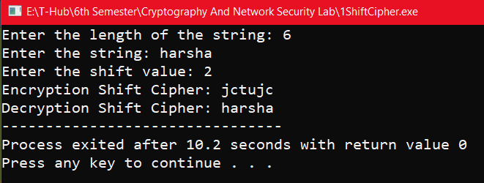

Mono alphabetic shift
#include<stdio.h>
#include<string.h>
int main(){
char ptu[26]={'A','B','C','D','E','F','G','H','I','J','K','L','M','N','O','P','Q','R','S','T','U','V','W','X','Y','Z'};
char ctu[26]={'Z','Y','X','W','V','U','T','S','R','Q','P','O','N','M','L','K','J','I','H','G','F','E','D','C','B','A'};
char ptl[26]={'a','b','c','d','e','f','g','h','i','j','k','l','m','n','o','p','q','r','s','t','u','v','w','x','y','z'};
char ctl[26]={'z','y','x','w','v','u','t','s','r','q','p','o','n','m','l','k','j','i','h','g','f','e','d','c','b','a'};
char p[20]={'\0'},c[20]={'\0'},r[20]={'\0'};
int i,j;
printf("Enter the plain text: ");
scanf("%s",p);
// Encryption
for(i=0;i<strlen(p);i++){
for(j=0;j<26;j++){
if((p[i]>=65&&p[i]<=90) && ptu[j]==p[i]){
c[i]=ctu[j];
break;
}
else if((p[i]>=97&&p[i]<=122) && ptl[j]==p[i]){
c[i]=ctl[j];
break;
}
}
}
printf("Cipher Encryption text is: %s\n",c);
// Decryption
for(i=0;i<strlen(c);i++){
for(j=0;j<26;j++){
if(ctu[j]==c[i]){
r[i]=ptu[j];
break;
}
else if(ctl[j]==c[i]){
r[i]=ptl[j];
break;
}
}
}
printf("Cipher Decryption text is: %s",r);
}

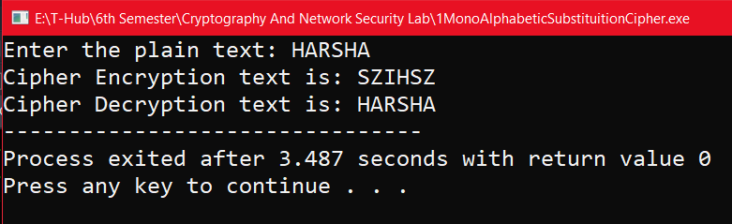

One time pad cipher
#include <stdio.h>
int main() {
int n;
printf("Enter Length: ");
scanf("%d", &n);

char plain[n + 1], key[n + 1], cipher[n + 1];
printf("Enter plain text: ");
scanf("%s", plain);
printf("Enter key: ");
scanf("%s", key);

printf("Cipher: ");
for (int i = 0; i < n; i++) {
char base = (plain[i] >= 'A' && plain[i] <= 'Z') ? 'A' : 'a';
cipher[i] = ((plain[i] - base) + (key[i] - base)) % 26 + base;
printf("%c", cipher[i]);
}
cipher[n] = '\0';
printf("\nAfter Decryption: ");
for (int i = 0; i < n; i++) {
char base = (key[i] >= 'A' && key[i] <= 'Z') ? 'A' : 'a';
int val = ((cipher[i] - base) - (key[i] - base) + 26) % 26;
printf("%c", val + base);
}
return 0;
}
Output:
Enter Length: 5
Enter plain text: Hello
Enter key: World
Cipher: Dscwr
After Decryption: Hello

Vernam cipher
#include<stdio.h>
int main(){
int n;
printf("Enter length: ");
scanf("%d",&n);
printf("Enter both plain text and key in the same case (upper/lower)\n");
char plain[n],key[n];
printf("Enter plain text: ");
scanf("%s",plain);
printf("Enter key: ");
scanf(" %s",key);
printf("Cipher: ");
char cipher[n+1];
for(int i=0;i<n;i++){
cipher[i]=(char)(plain[i]^key[i]);
if(plain[i]>=65 && plain[i]<=90)
printf("%c",(cipher[i]%26)+65);
else
printf("%c",(cipher[i]%26)+97);
}
printf("\n");
cipher[n]='\0';
char deplain[n+1];
for(int i=0;i<n;i++){
deplain[i]=(char)(cipher[i]^key[i]);
}
deplain[n]='\0';
printf("After decryption, plain text is: %s\n",deplain);
}
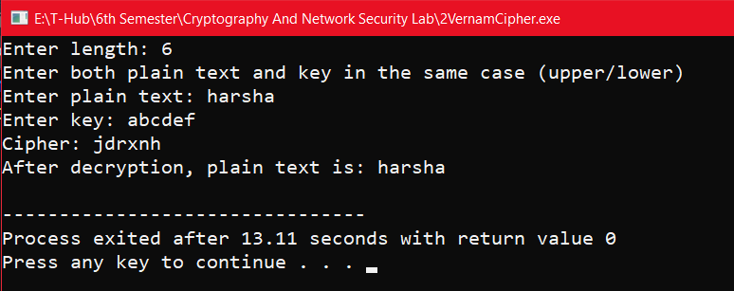

RSA algorithm
#include<stdio.h>
#include<math.h>
int gcd(int a, int h){
int temp;
while(1){
temp=a%h;
if(temp==0) return h;
a = h;
h = temp;
}
}
int main(){
double p = 3,q = 7;
double n=p*q,count,totient = (p-1)*(q-1),e=2;
while(e<totient){
if(gcd(e,totient)==1) break;
else e++;
}
double d,k = 2;
d = (1 + (k*totient))/e;
double msg = 12,c = pow(msg,e);
double m = pow(c,d);
c=fmod(c,n);
m=fmod(m,n);
printf("Message data = %lf",msg);
printf("\np = %lf",p);
printf("\nq = %lf",q);
printf("\nn = pq = %lf",n);
printf("\ntotient = %lf",totient);
printf("\ne = %lf",e);
printf("\nd = %lf",d);
printf("\nEncrypted data = %lf",c);
printf("\nOriginal Message Sent = %lf",m);
}

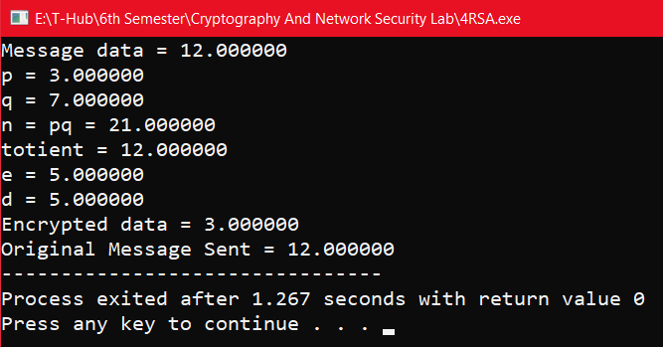

Diffie hellman key exchange
#include<stdio.h>
#include<math.h>
long long int power(long long int a, long long int b, long long int P){
if(b == 1) return a;
else return (((long long int)pow(a, b)) % P);
}
int main(){
long long int P, G, x, a, y, b, ka, kb;
// Both the persons will be agreed upon the
// public keys G and P
P = 23;
// A prime number P is taken
printf("The value of P : %lld\n", P);
G = 9;
// A primitive root for P, G is taken
printf("The value of G : %lld\n\n", G);
// Alice will choose the private key a
a = 4;
// a is the chosen private key
printf("The private key a for Alice : %lld\n", a);
x = power(G, a, P);
// gets the generated key
// Bob will choose the private key b
b = 3;
// b is the chosen private key
printf("The private key b for Bob : %lld\n\n", b);
y = power(G, b, P);
// gets the generated key
// Generating the secret key after the exchange of keys
ka = power(y, a, P);
// Secret key for Alice
kb = power(x, b, P);
// Secret key for Bob
printf("Secret key for the Alice is : %lld\n", ka);
printf("Secret Key for the Bob is : %lld\n", kb);
return 0;
}

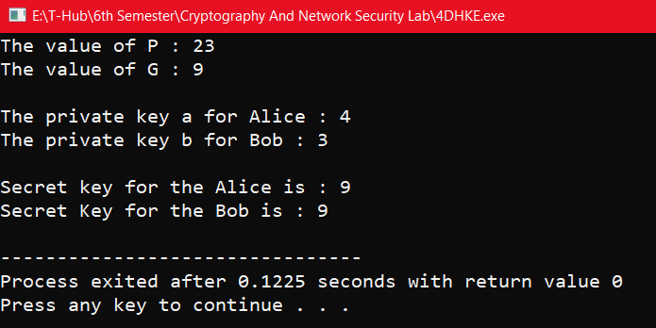

Elgamal cryptographic system
#include<stdio.h>
#include<math.h>
int main(){
int p,d,e1,e2,c1,c2,m,r;
printf("Enter Prime Number: ");
scanf("%d",&p);
printf("Enter private (or) Decryption key: ");
scanf("%d",&d);
printf("Enter public (or) Encryption key: ");
scanf("%d",&e1);
e2=pow(e1,d);
e2%=p;
printf("Value of e2: %d\n",e2);
printf("Enter random value for r: ");
scanf("%d",&r);
c1=pow(e1,r);
c1%=p;
printf("Enter m value: ");
scanf("%d",&m);
c2=m*(pow(e2,r));
c2%=p;
printf("Encryption:\n");
printf("Final ciphers are %d and %d\n",c1,c2);
printf("Decryption:\n");
m=(c2*(pow(c1,d)-1));
m%=p;
printf("m value is: %d\n",m);
}

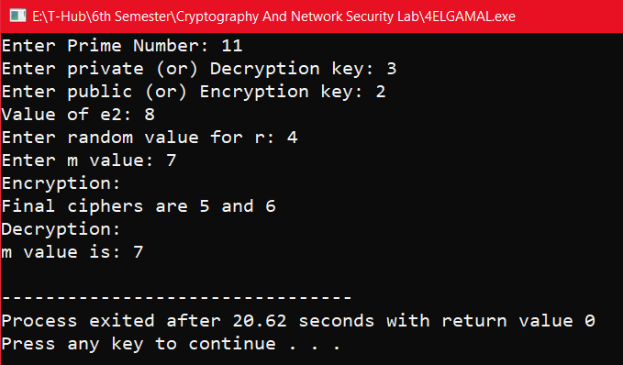

RPC to add and subtract

CalculatorService.java
import java.rmi.Remote;
import java.rmi.RemoteException;

public interface CalculatorService extends Remote {
int add(int a, int b) throws RemoteException;
int subtract(int a, int b) throws RemoteException;
}

CalculatorServer.java
import java.rmi.registry.LocateRegistry;
import java.rmi.registry.Registry;
import java.rmi.server.UnicastRemoteObject;

public class CalculatorServer implements CalculatorService {

public int add(int a, int b) {
return a + b;
}

public int subtract(int a, int b) {
return a - b;
}

public static void main(String[] args) {
try {
CalculatorServer obj = new CalculatorServer();
CalculatorService stub = (CalculatorService) UnicastRemoteObject.exportObject(obj, 0);

Registry registry = LocateRegistry.createRegistry(1099); // RMI default port
registry.rebind("CalculatorService", stub);

System.out.println("Calculator Server is ready.");
} catch (Exception e) {
e.printStackTrace();
}
}
}

CalculatorClient.java
import java.rmi.registry.LocateRegistry;
import java.rmi.registry.Registry;

public class CalculatorClient {
public static void main(String[] args) {
if (args.length != 3) {
System.out.println("Usage: java CalculatorClient <server_ip> <a> <b>");
return;
}

String host = args[0];
int a = Integer.parseInt(args[1]);
int b = Integer.parseInt(args[2]);

try {
Registry registry = LocateRegistry.getRegistry(host);
CalculatorService stub = (CalculatorService) registry.lookup("CalculatorService");

int sum = stub.add(a, b);
int diff = stub.subtract(a, b);

System.out.println("Addition Result: " + sum);
System.out.println("Subtraction Result: " + diff);
} catch (Exception e) {
e.printStackTrace();
}
}
}

Sample Output
Addition Result: 25
Subtraction Result: 5

- File transfer tcp using ipc in java

FileReceiver.java
import java.io.*;
import java.net.*;

public class FileReceiver {
public static void main(String[] args) throws Exception {
ServerSocket serverSocket = new ServerSocket(9999);
System.out.println("Waiting for file...");

Socket socket = serverSocket.accept();
BufferedReader in = new BufferedReader(new InputStreamReader(socket.getInputStream()));
PrintWriter fileOut = new PrintWriter("received.txt");

String line;
while (!(line = in.readLine()).equals("EOF")) {
fileOut.println(line);
}

System.out.println("File received successfully.");
fileOut.close();
in.close();
socket.close();
serverSocket.close();
}
}

FileSender.java (client)
import java.io.*;
import java.net.*;

public class FileSender {
public static void main(String[] args) throws Exception {
Socket socket = new Socket("localhost", 9999);
PrintWriter out = new PrintWriter(socket.getOutputStream(), true);
BufferedReader fileIn = new BufferedReader(new FileReader("input.txt"));

String line;
while ((line = fileIn.readLine()) != null) {
out.println(line);
}

out.println("EOF"); // end of file marker

System.out.println("File sent successfully.");
fileIn.close();
out.close();
socket.close();
}
}

input.txt
Hello from the client.
This is a test file.
Sending via Java Sockets. Same we get in the output txt file.

implementation of IPC using Pipes and FIFO in java.
import java.io.*;

public class exp10FIFO{

public static void main(String[] args) throws IOException {

// Create piped input and output streams
final PipedOutputStream output = new PipedOutputStream();
final PipedInputStream input = new PipedInputStream(output);

// Writer thread (acts like sender)
Thread writer = new Thread(() -> {
try {
String message = "Hello from Writer (FIFO style)";
output.write(message.getBytes());
output.close();
} catch (IOException e) {
e.printStackTrace();
}
});

// Reader thread (acts like receiver)
Thread reader = new Thread(() -> {
try {
int data;
System.out.print("Reader received: ");
while ((data = input.read()) != -1) {
System.out.print((char) data);
}
System.out.println(); // for newline
input.close();
} catch (IOException e) {
e.printStackTrace();
}
});

// Start both threads
reader.start();
writer.start();
}
}
Input:
Hello from Writer (FIFO style)
Output:
Reader received: Hello from Writer (FIFO style)

- Code to send udp file transfer

UDPFileSender.java
java
CopyEdit
import java.net.*;
import java.io.*;

public class UDPFileSender {
public static void main(String[] args) throws Exception {
DatagramSocket socket = new DatagramSocket();
InetAddress ip = InetAddress.getByName("localhost");

BufferedReader file = new BufferedReader(new FileReader("input.txt"));
String line;
while ((line = file.readLine()) != null) {
byte[] data = line.getBytes();
DatagramPacket packet = new DatagramPacket(data, data.length, ip, 9999);
socket.send(packet);
Thread.sleep(100); // to avoid packet flooding
}

// Send end message
byte[] end = "EOF".getBytes();
socket.send(new DatagramPacket(end, end.length, ip, 9999));

file.close();
socket.close();
System.out.println("File sent successfully.");
}
}

UDPFileReceiver.java
java
CopyEdit
import java.net.*;
import java.io.*;

public class UDPFileReceiver {
public static void main(String[] args) throws Exception {
DatagramSocket socket = new DatagramSocket(9999);
FileWriter file = new FileWriter("received.txt");

byte[] buffer = new byte[1024];
while (true) {
DatagramPacket packet = new DatagramPacket(buffer, buffer.length);
socket.receive(packet);

String msg = new String(packet.getData(), 0, packet.getLength());
if (msg.equals("EOF")) break;

file.write(msg + "\n");
}

file.close();
socket.close();
System.out.println("File received successfully.");
}
}

Sample i/p and o/p:
This is a test file.
Sent via UDP.
Line 3 here.

Design a TCP concurrent server to echo given set of sentences using poll functions.

EchoServer.java
java
CopyEdit
import java.io.IOException;
import java.net.InetSocketAddress;
import java.nio.ByteBuffer;
import java.nio.channels.*;
import java.util.Iterator;

public class EchoServer {
public static void main(String[] args) throws IOException {
Selector selector = Selector.open();
ServerSocketChannel server = ServerSocketChannel.open();
server.bind(new InetSocketAddress(12345));
server.configureBlocking(false);
server.register(selector, SelectionKey.OP_ACCEPT);

System.out.println("Echo server started on port 12345...");

while (true) {
selector.select(); // Wait for events
Iterator<SelectionKey> keys = selector.selectedKeys().iterator();

while (keys.hasNext()) {
SelectionKey key = keys.next();
keys.remove();

if (key.isAcceptable()) {
SocketChannel client = server.accept();
client.configureBlocking(false);
client.register(selector, SelectionKey.OP_READ);
System.out.println("Client connected: " + client.getRemoteAddress());
}

if (key.isReadable()) {
SocketChannel client = (SocketChannel) key.channel();
ByteBuffer buffer = ByteBuffer.allocate(1024);
int read = client.read(buffer);

if (read == -1) {
client.close();
System.out.println("Client disconnected");
} else {
buffer.flip();
client.write(buffer); // Echo back
buffer.clear();
}
}
}
}
}
}

EchoClient.java
java
CopyEdit
import java.io.*;
import java.net.Socket;

public class EchoClient {
public static void main(String[] args) throws IOException {
Socket socket = new Socket("localhost", 12345);
BufferedReader userInput = new BufferedReader(new InputStreamReader(System.in));
PrintWriter out = new PrintWriter(socket.getOutputStream(), true);
BufferedReader in = new BufferedReader(new InputStreamReader(socket.getInputStream()));

System.out.println("Connected to echo server. Type sentences:");

String line;
while (!(line = userInput.readLine()).equalsIgnoreCase("exit")) {
out.println(line);
System.out.println("Echoed: " + in.readLine());
}

socket.close();
}
}
Run server
o/p in client console:
Connected to echo server. Type sentences:
Hi Server!
Echoed: Hi Server!
How are you?
Echoed: How are you?
Exit

Java UDP Client-Server application that reverses an input sentence.

📥 1. UDP Server – UDPReverseServer.java
import java.net.*;

public class UDPReverseServer {
public static void main(String[] args) throws Exception {
DatagramSocket socket = new DatagramSocket(9876);
byte[] recv = new byte[1024];

System.out.println("UDP Server is running...");

while (true) {
DatagramPacket receivePacket = new DatagramPacket(recv, recv.length);
socket.receive(receivePacket);

String input = new String(receivePacket.getData(), 0, receivePacket.getLength());
System.out.println("Received: " + input);

String reversed = new StringBuilder(input).reverse().toString();
byte[] sendData = reversed.getBytes();

InetAddress clientAddress = receivePacket.getAddress();
int clientPort = receivePacket.getPort();

DatagramPacket sendPacket = new DatagramPacket(sendData, sendData.length, clientAddress, clientPort);
socket.send(sendPacket);
}
}
}

2. UDP Client – UDPReverseClient.java
import java.net.*;
import java.util.Scanner;

public class UDPReverseClient {
public static void main(String[] args) throws Exception {
DatagramSocket socket = new DatagramSocket();
InetAddress serverIP = InetAddress.getByName("localhost");

Scanner sc = new Scanner(System.in);
System.out.print("Enter a sentence: ");
String input = sc.nextLine();

byte[] sendData = input.getBytes();
DatagramPacket sendPacket = new DatagramPacket(sendData, sendData.length, serverIP, 9876);
socket.send(sendPacket);

byte[] recv = new byte[1024];
DatagramPacket receivePacket = new DatagramPacket(recv, recv.length);
socket.receive(receivePacket);

String reversed = new String(receivePacket.getData(), 0, receivePacket.getLength());
System.out.println("Reversed sentence: " + reversed);

socket.close();
}
}

🔌 Server Output:
UDP Server is running...
Received: Hello UDP

💻 Client Output:
Enter a sentence: Hello UDP
Reversed sentence: PDU olleH

Message queue form of ipc
import java.io.*;
import java.util.concurrent.*;

public class exp11MessageQueue {

public static void main(String[] args) {

// Create a message queue
BlockingQueue<String> messageQueue = new ArrayBlockingQueue<>(10);

// Sender thread: reads from file and puts into queue
Thread sender = new Thread(() -> {
try (BufferedReader reader = new BufferedReader(new FileReader("input.txt"))) {
String line;
while ((line = reader.readLine()) != null) {
messageQueue.put(line); // Send line to queue
}
messageQueue.put("END"); // Special message to indicate finish
} catch (IOException | InterruptedException e) {
e.printStackTrace();
}
});

// Receiver thread: takes from queue and writes to new file
Thread receiver = new Thread(() -> {
try (BufferedWriter writer = new BufferedWriter(new FileWriter("output.txt"))) {
String message;
while (!(message = messageQueue.take()).equals("END")) {
writer.write(message);
writer.newLine();
}
} catch (IOException | InterruptedException e) {
e.printStackTrace();
}
});

// Start both threads
sender.start();
receiver.start();
}
}

Input.txt
Java is fun.
Message queues help with thread communication.
This is a test message.

Same output txt will be generated

Here's a clean and simple TCP server in Java using Selector, just like the select()-based TCP server you had in C.

✅ Java TCP Server using Selector (TCPServer.java)
import java.io.*;
import java.net.*;
import java.nio.*;
import java.nio.channels.*;
import java.util.*;

public class TCPServer {
public static void main(String[] args) throws IOException {
Selector selector = Selector.open();

// Create TCP server channel
ServerSocketChannel serverChannel = ServerSocketChannel.open();
serverChannel.bind(new InetSocketAddress(5000));
serverChannel.configureBlocking(false);
serverChannel.register(selector, SelectionKey.OP_ACCEPT);

System.out.println("TCP Server is running...");

while (true) {
selector.select(); // Wait for ready events
Iterator<SelectionKey> keys = selector.selectedKeys().iterator();

while (keys.hasNext()) {
SelectionKey key = keys.next();
keys.remove();

if (key.isAcceptable()) {
SocketChannel clientChannel = serverChannel.accept();
clientChannel.configureBlocking(true); // Blocking for I/O simplicity

BufferedReader in = new BufferedReader(
new InputStreamReader(clientChannel.socket().getInputStream())
);
PrintWriter out = new PrintWriter(clientChannel.socket().getOutputStream(), true);

String clientMessage = in.readLine();
System.out.println("Message from TCP client: " + clientMessage);

out.println("Hello Client");

clientChannel.close();
}
}
}
}
}

✅ Matching TCP Client (TCPClient.java)
import java.io.*;
import java.net.*;

public class TCPClient {
public static void main(String[] args) throws IOException {
Socket socket = new Socket("127.0.0.1", 5000);

PrintWriter out = new PrintWriter(socket.getOutputStream(), true);
BufferedReader in = new BufferedReader(new InputStreamReader(socket.getInputStream()));

out.println("Hello Server via TCP");
System.out.println("Message from server: " + in.readLine());

socket.close();
}
}

🧾 Input & Output

Client sends:
Hello Server via TCP

Server prints:
TCP Server is running...
Message from TCP client: Hello Server via TCP

Client prints:
Message from server: Hello Client

Sure! Here's a TCP-based iterative client-server Java application that performs the same task: it reverses a sentence sent by the client.

📥 1. TCP Server – TCPReverseServer.java
(This is an iterative server – handles one client at a time)
import java.io.*;
import java.net.*;

public class TCPReverseServer {
public static void main(String[] args) throws Exception {
ServerSocket serverSocket = new ServerSocket(9999);
System.out.println("TCP Server is running...");

while (true) {
Socket socket = serverSocket.accept();
System.out.println("Client connected.");

BufferedReader in = new BufferedReader(new InputStreamReader(socket.getInputStream()));
PrintWriter out = new PrintWriter(socket.getOutputStream(), true);

String input = in.readLine();
System.out.println("Received: " + input);

String reversed = new StringBuilder(input).reverse().toString();
out.println(reversed);

socket.close(); // iterative: handle one client, then accept the next
}
}
}

🖥️ 2. TCP Client – TCPReverseClient.java
import java.io.*;
import java.net.*;
import java.util.Scanner;

public class TCPReverseClient {
public static void main(String[] args) throws Exception {
Socket socket = new Socket("localhost", 9999);

BufferedReader in = new BufferedReader(new InputStreamReader(socket.getInputStream()));
PrintWriter out = new PrintWriter(socket.getOutputStream(), true);

Scanner sc = new Scanner(System.in);
System.out.print("Enter a sentence: ");
String input = sc.nextLine();

out.println(input); // send to server
String reversed = in.readLine(); // receive reversed

System.out.println("Reversed sentence: " + reversed);

socket.close();
}
}

🧪 Sample Run:

🔌 Server Output:
TCP Server is running...
Client connected.
Received: Hello TCP

💻 Client Output:
Enter a sentence: Hello TCP
Reversed sentence: PCT olleH

Let me know if you’d like the concurrent version (multi-client using threads) too.

