View this with all mark-up on in Word

Sketches – 2 points = 2/2
- Did you post at least 12 hand sketches and variations of your logo AND your mind map to the discussion board and to the submissions folder? (1-point)
- Did your sketches represent a good amount of exploration (meaning 12 distinct ideas) indicating creative brainstorming?(1-point)
Words – style related – post modern, curious, trustworthy
I really felt that these two stood out and reflected your words -
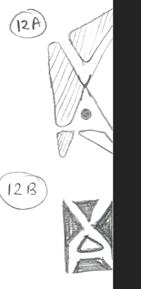
I would work with refining one of those

