tessera
User Guide
Tessera POS for wines & spirits shops
Prepared for Spanish Wines & Spirits, Kobil Imara Daima
Version 1.0 · 20 October 2026

Contents
Right-click here and choose Update Field to show the contents.

1. Getting started
Tessera POS runs in a web browser. There is nothing to install on the office computer: open the address Tessera gave you (for example https://pos.yourshop.co.ke) in Google Chrome or Microsoft Edge. The till runs in the same browser, full screen, on the computer or tablet at the counter.
There are two ways in:
Who | Where they sign in | How
Owner, admin, branch manager, storekeeper, accountant | The back office | Email or phone number, and a password
Cashier | The till | Tap their name and enter a four-digit PIN

The examples in this guide use Spanish Wines & Spirits at Kobil Imara Daima, with a second branch in Westlands. The people, phone numbers and KRA PINs in the pictures are made up.

Signing in to the back office
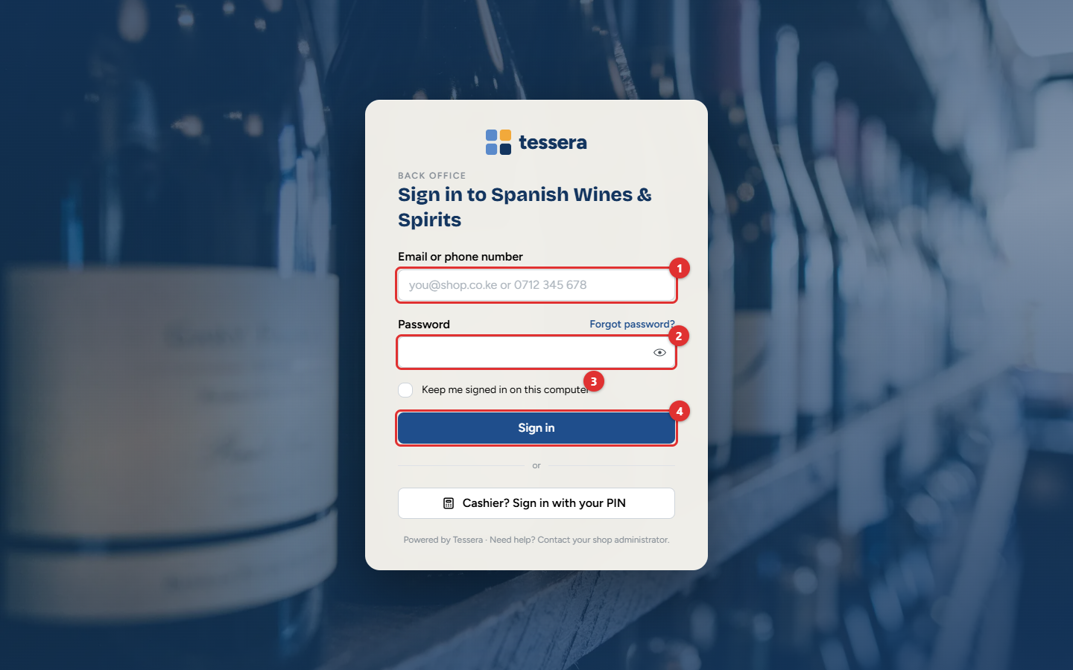
Figure 1.1: The sign-in page
1. Type your email address or phone number (1).
2. Type your password (2). Passwords are case-sensitive.
3. Tick Keep me signed in on this computer (3) only on a computer nobody else uses.
4. Click Sign in (4).
The first time you sign in, or when your password has expired, you are asked to choose a new one. Owners and admins may also be asked for a six-digit code from an authenticator app on their phone (two-step login). This protects the accounts that can change prices and see the money.
Tip: Forgot your password? The owner or an administrator sets a new one for you under Administration → Users & roles. There is no reset by email.
Important: The back office signs you out after 30 minutes without use, so an unattended computer is not left open.

The screen
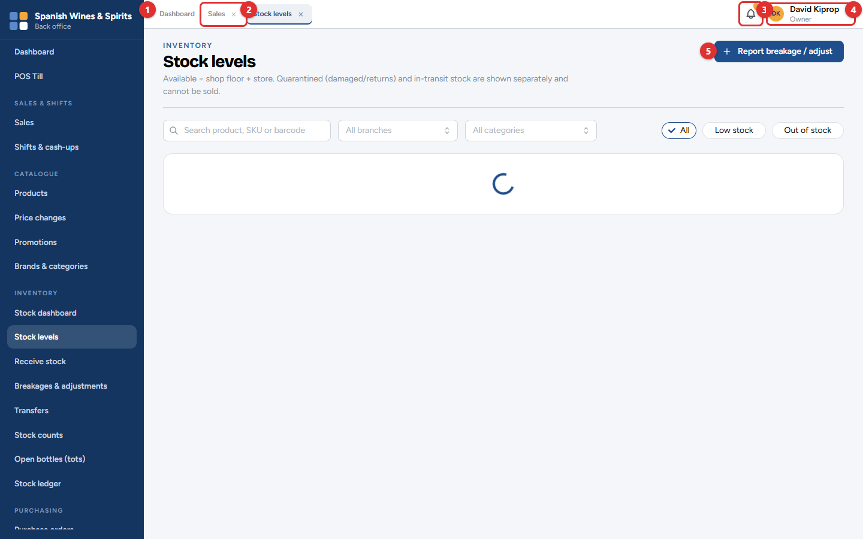
Figure 1.2: The back office, with two screens open as tabs
Part | What it does
Menu (1) | The navy bar on the left, with the shop name at the top. It lists only what your role allows you to use. Click an item to open it.
Tabs (2) | Each screen you open gets a tab at the top, like a web browser. Click a tab to go back to that screen; it is exactly as you left it, filters and all.
Notifications (3) | The bell shows alerts: low stock, cash shortages, licences about to expire, eTIMS problems. The number is how many you have not read.
Account menu (4) | Your name. Opens the till, changes your password or two-step login, and signs you out.
The screen itself | Its title and a short explanation on the left, and its own buttons at the top right (5).

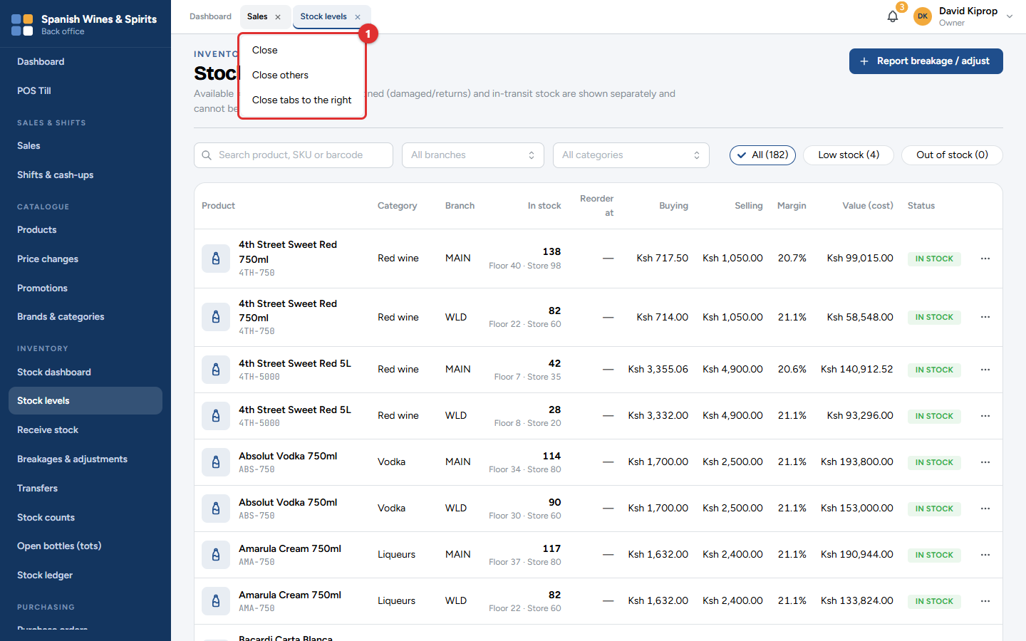
Figure 1.3: Right-click a tab to close it or the others
Right-click a tab (1) to close it, close the others, or close the tabs to its right. You can also click the small × on the tab.
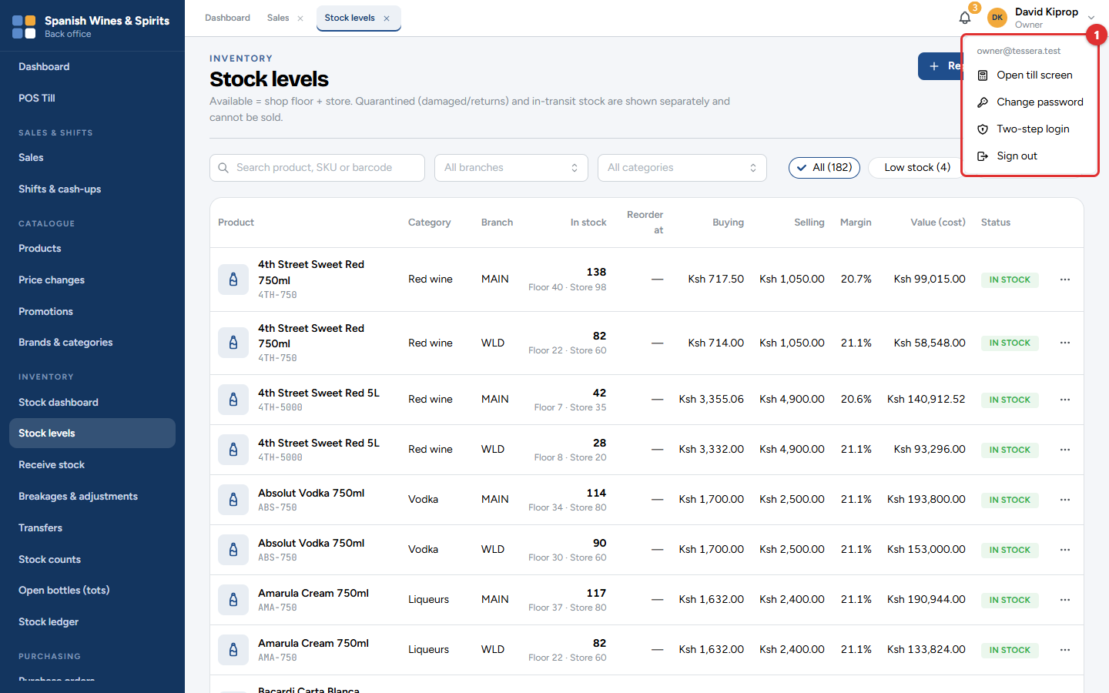
Figure 1.4: The account menu
The account menu (1) has:
• Open till screen: turns this computer into the till (only if it has been set up as one; see chapter 3).
• Change password and Two-step login.
• Sign out. Always sign out on a shared computer.

Who can do what
Each person has one role. The role decides which menu items they see and what they may do. A few actions always need a second person (for example, approving a purchase order or a price change), so that no one can both make and approve a change.
Role | Typical person | Main jobs
Owner | The business owner | Everything, and approves prices, promotions and large changes
Admin | Office manager | Set-up, products, staff and purchasing
Branch Manager | Shop manager | Runs a branch: approves discounts, refunds, adjustments and cash-ups
Cashier | Counter staff | Sells at the till only
Storekeeper | Stock clerk | Receives deliveries, counts stock, records breakages and transfers
Accountant | Bookkeeper | Purchase orders, supplier bills and payments, expenses, reports

Common mistake: Sharing a sign-in or a PIN. Everything is recorded against the person who is signed in, including refunds and cash counts. Give everyone their own account.

Getting help
• Each screen has a short explanation under its title.
• Hover over a small ⓘ or More button to read what a setting does.
• For anything else, contact Tessera support with the screen name and, if possible, a photo of the screen.

2. How everything connects
Tessera POS is one system, not a set of separate programs. When a cashier sells a bottle, the stock goes down, the tax invoice goes to KRA, the money shows in the day's takings and the owner's dashboard updates, all at once. You do not copy anything from one screen to another.
This chapter follows one ordinary day at Spanish Wines & Spirits, a shop with two branches in Nairobi (Kobil Imara Daima and Westlands). It shows which part of the system is used at each step, who uses it, and what changes elsewhere as a result. Later chapters explain each part in detail.

The big picture
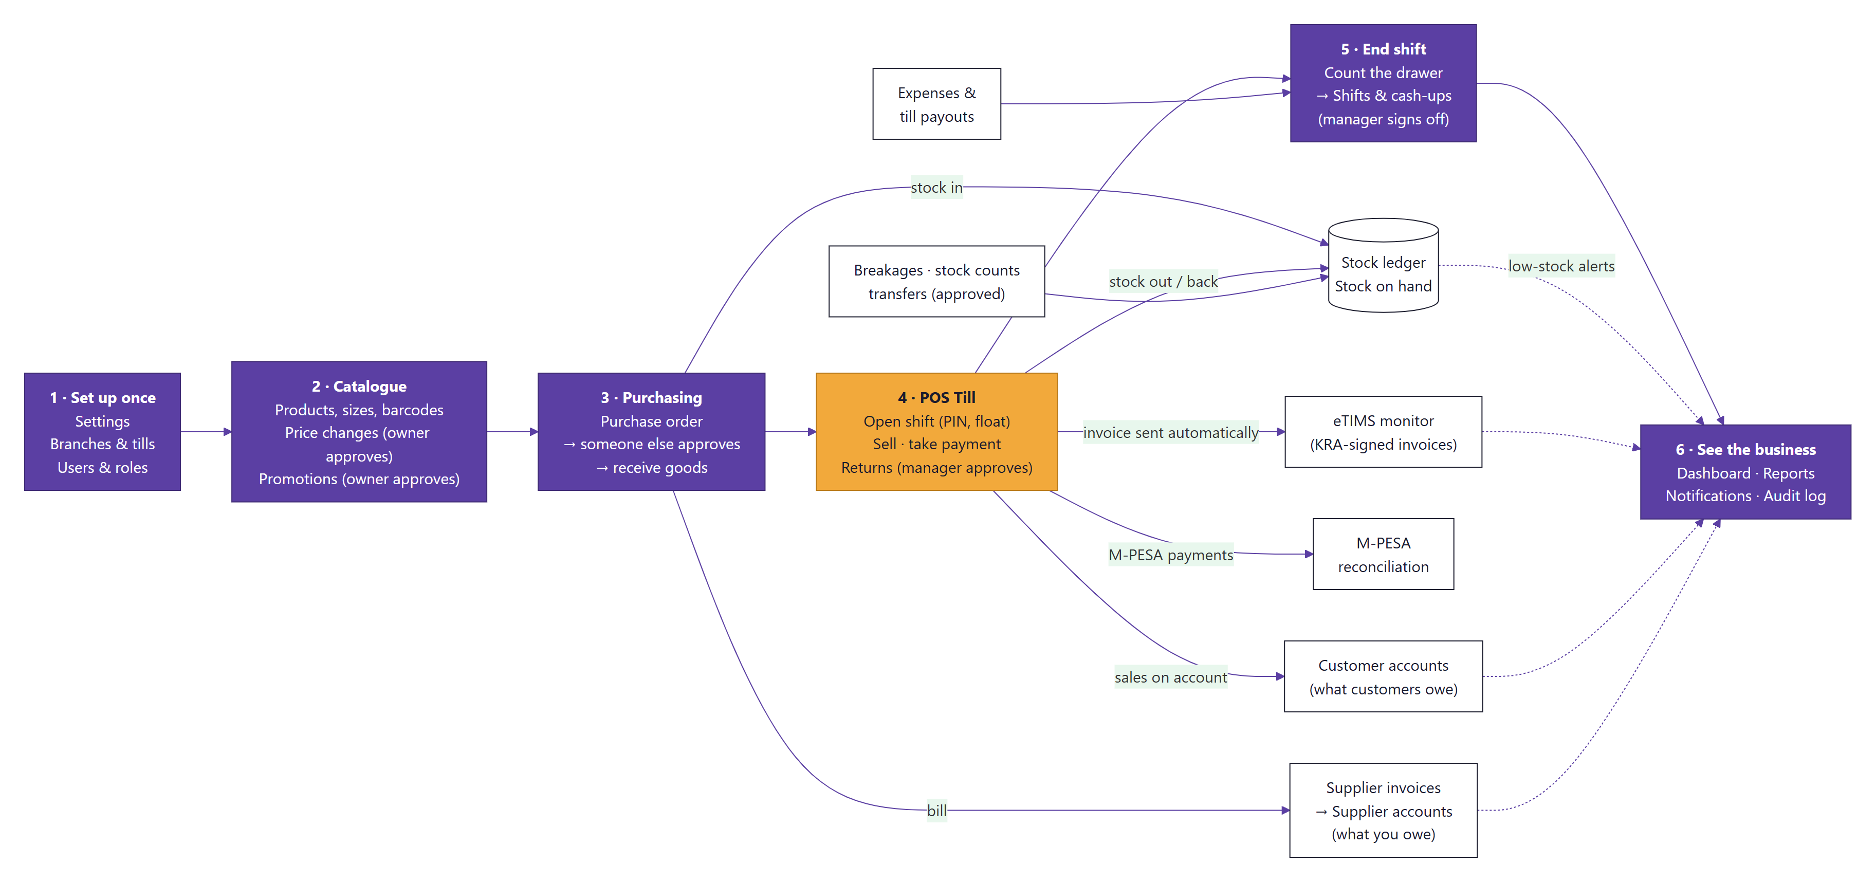
Figure 2.1: How the parts of Tessera POS feed each other, in the order of a business day
Read the chart from left to right. The purple boxes are the main steps of a day, and the amber box is the till. The white boxes are the records that each step updates for you. The dotted arrows show what feeds the dashboard, the reports and the alerts.
A few words you will meet in this chapter:
Word | What it means
Till | A computer or tablet at the counter, set up to sell. Each till belongs to one branch.
Shift | The time one cashier works on one till, from signing in to counting the cash at the end.
Float | The cash put in the drawer at the start of a shift so the cashier can give change (for example KSh 5,000).
Cash-up | Counting the cash in the drawer at the end of a shift and comparing it with what the system expected.
Variance | The difference between the cash counted and the cash expected. Zero is perfect.
eTIMS | Electronic Tax Invoice Management System: KRA's system that signs every sales invoice.
M-PESA payment request | A prompt sent to the customer's phone asking them to approve the payment with their M-PESA PIN (also called STK Push).

The day, step by step

Step 1: The owner sets up the business (once)
Who: the owner (David Kiprop). Where: Administration → Settings, Branches, and Users & roles.
Before the first sale, the owner fills in the business details that print on every receipt and tax invoice, adds the branches and their tills, and creates an account for each member of staff with the right role.
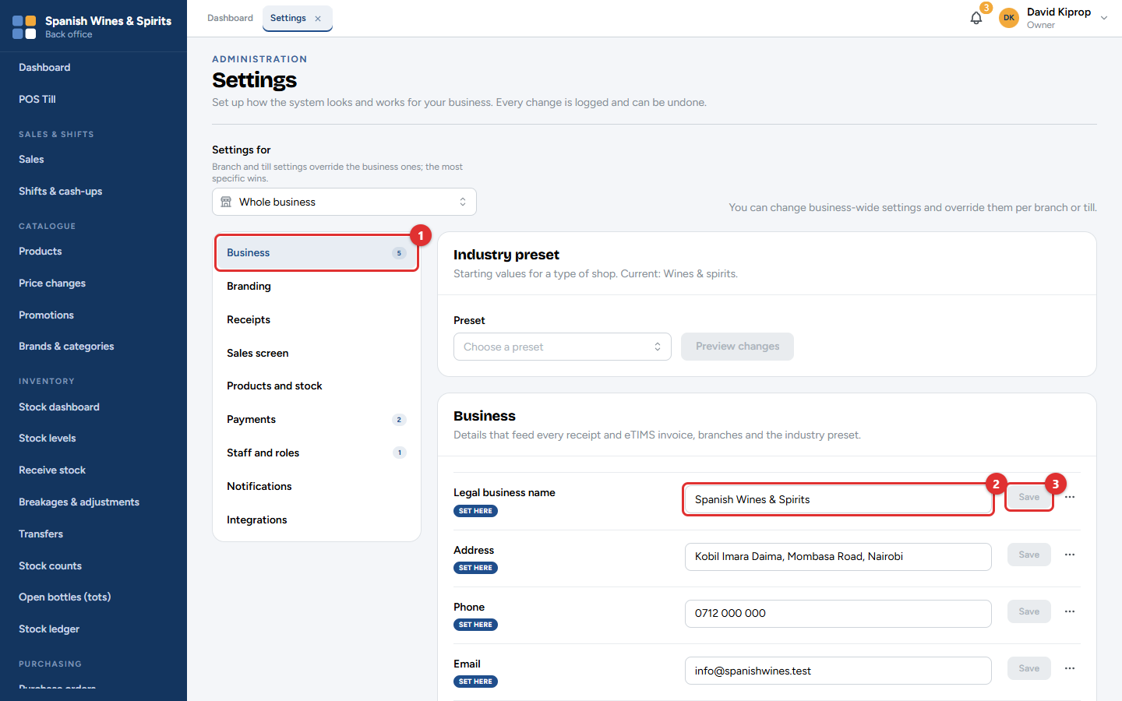
Figure 2.2: Settings → Business: the name, address and phone printed on receipts
1. Open Administration → Settings and choose Business (1).
2. Type the business name (2) and click Save (3) next to it. Do the same for the address, phone and email.
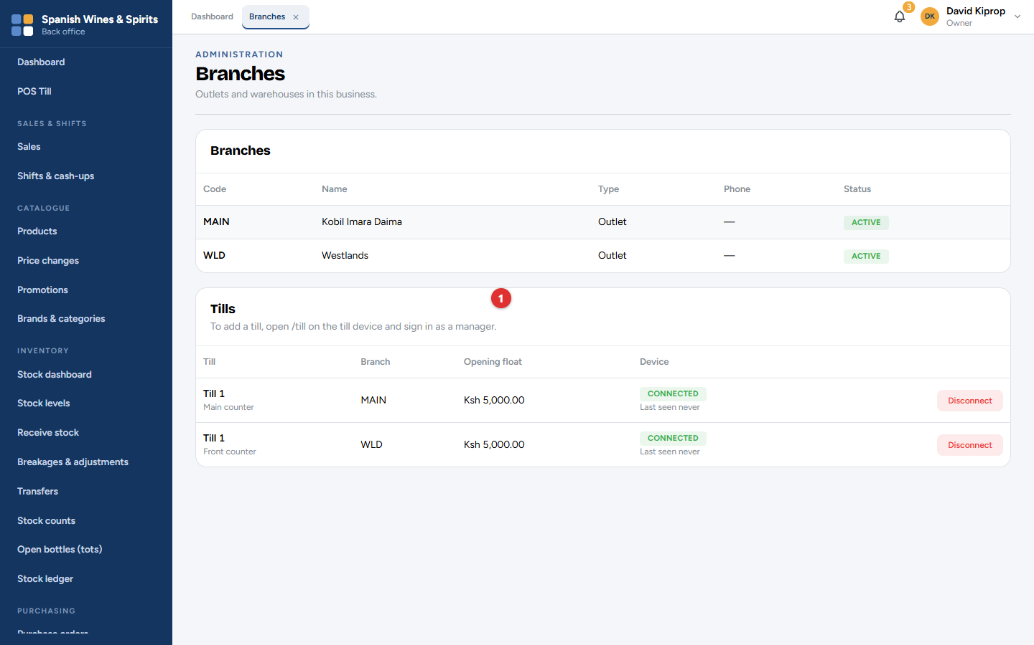
Figure 2.3: Administration → Branches, with each branch's tills
The Tills (1) list shows every till and which branch it belongs to. A till is added from the till computer itself (see Step 3).
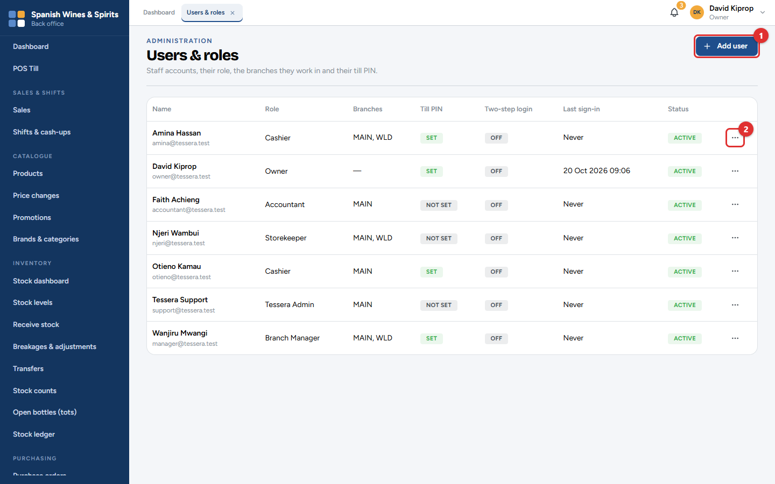
Figure 2.4: Administration → Users & roles
Click Add user (1) to create staff accounts. Each person gets a role, such as Cashier or Branch Manager, which decides what they can see and do. Use the Actions (2) button to set a cashier's four-digit till PIN.
What changes elsewhere: the business name and address appear on every receipt and eTIMS invoice. New staff appear on the till's sign-in screen.
Important: The KRA PIN and eTIMS details are set up by Tessera support after they have been checked, because a mistake there stops invoices from being signed.

Step 2: Products are added and stock is received
Who: the owner or admin adds products. The owner, an admin or the accountant orders stock, and a different person approves the order. The storekeeper receives the delivery. Where: Catalogue → Products, Purchasing → Purchase orders, and Inventory → Stock levels.
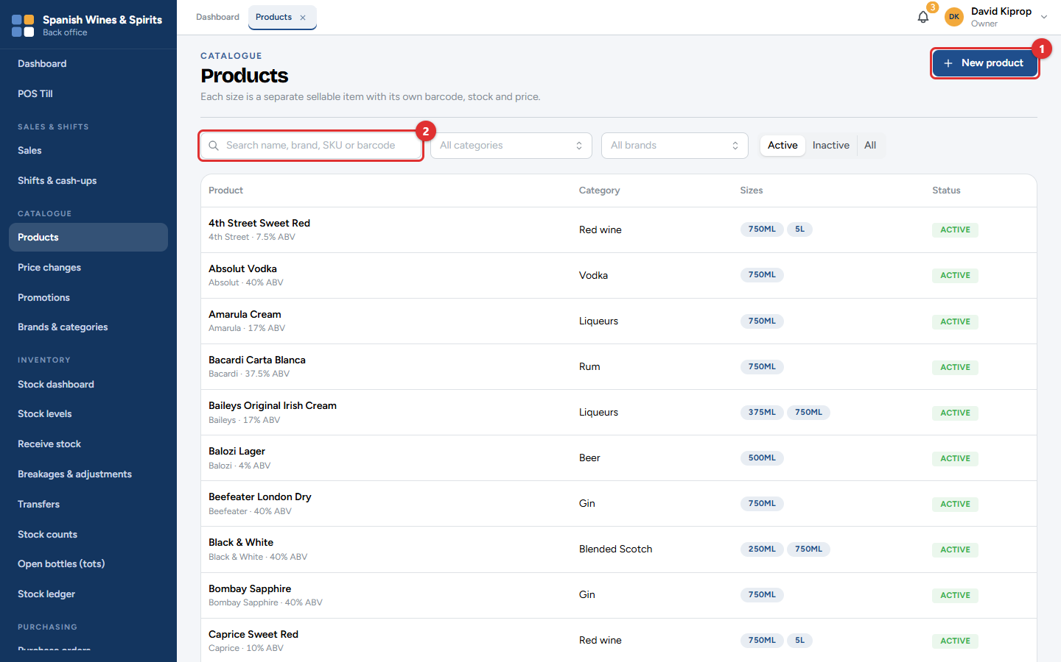
Figure 2.5: Catalogue → Products
Every item the shop sells is a product with one or more sizes (for example Johnnie Walker Black Label 200 ml, 375 ml, 750 ml and 1 L). Click New product (1) to add one, or search the list (2).
Stock comes in through a purchase order: a list of what you are ordering from a supplier. Someone other than the person who raised it must approve it. When the delivery arrives, the storekeeper records what was received, and the stock goes up.
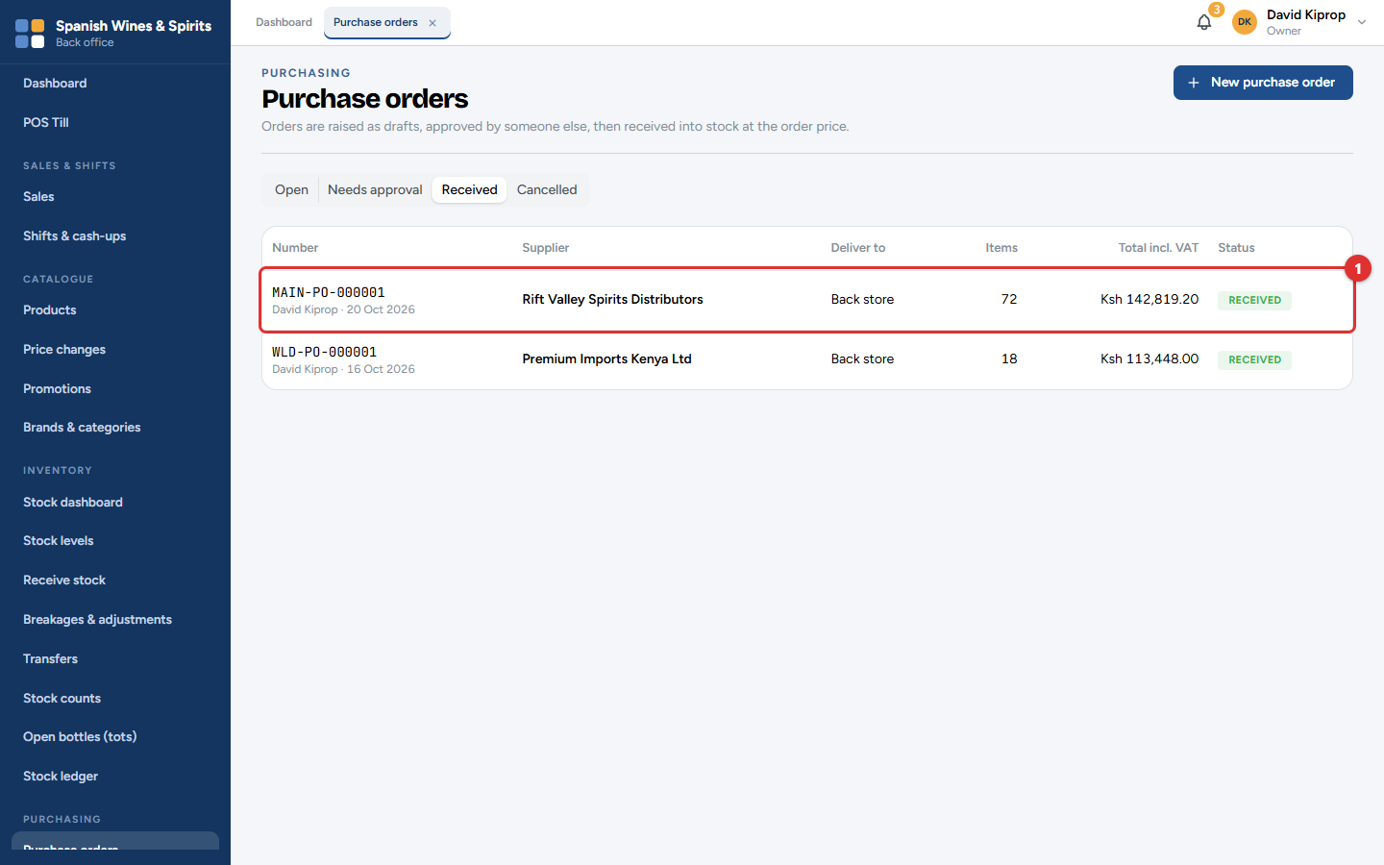
Figure 2.6: Purchase orders → Received: an order from Rift Valley Spirits Distributors that has been delivered
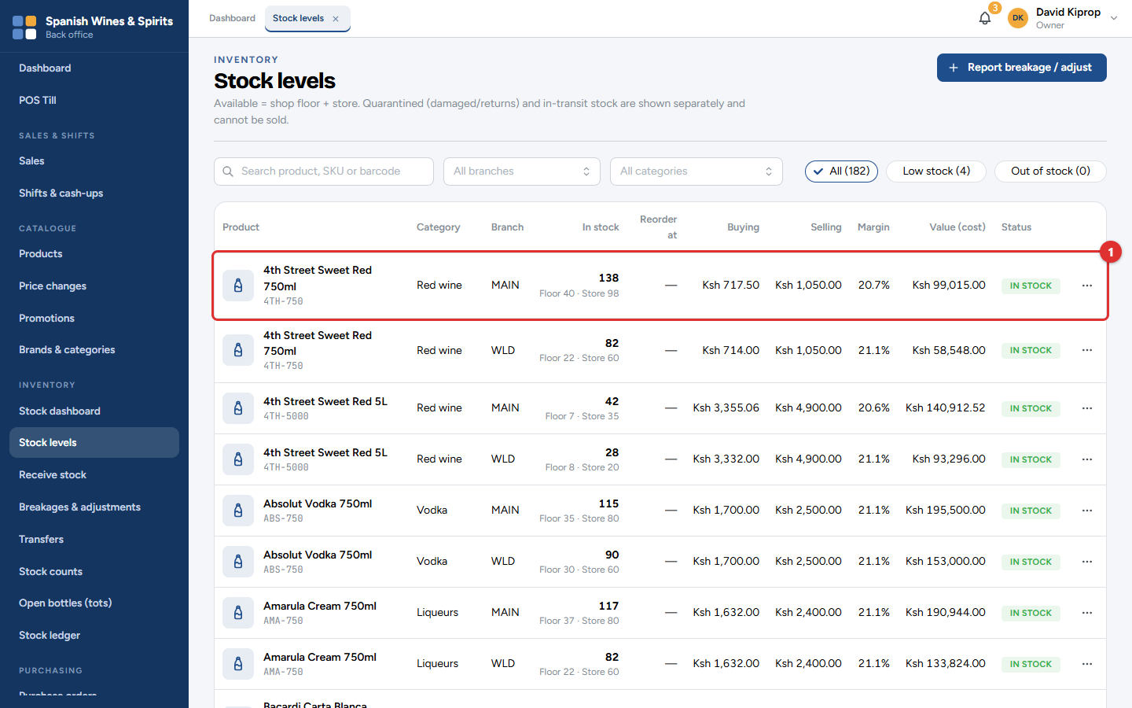
Figure 2.7: Inventory → Stock levels, per item and branch
What changes elsewhere: receiving goods adds stock to the stock ledger (the full history of every bottle in and out) and to Stock levels. When the supplier's invoice is recorded, the amount appears under Supplier accounts as money you owe.
Tip: Prices are set centrally by the owner or admin, and a new price waits for the owner's approval. This keeps both branches charging the same and keeps tax invoices correct.

Step 3: The cashier signs in and the shift starts
Who: the cashier (Amina Hassan, Westlands). Where: the till.
A till is set up once: a manager signs in on the till computer, names the till and sets its opening float. After that, cashiers sign in with their PIN. Signing in starts the shift with that float.
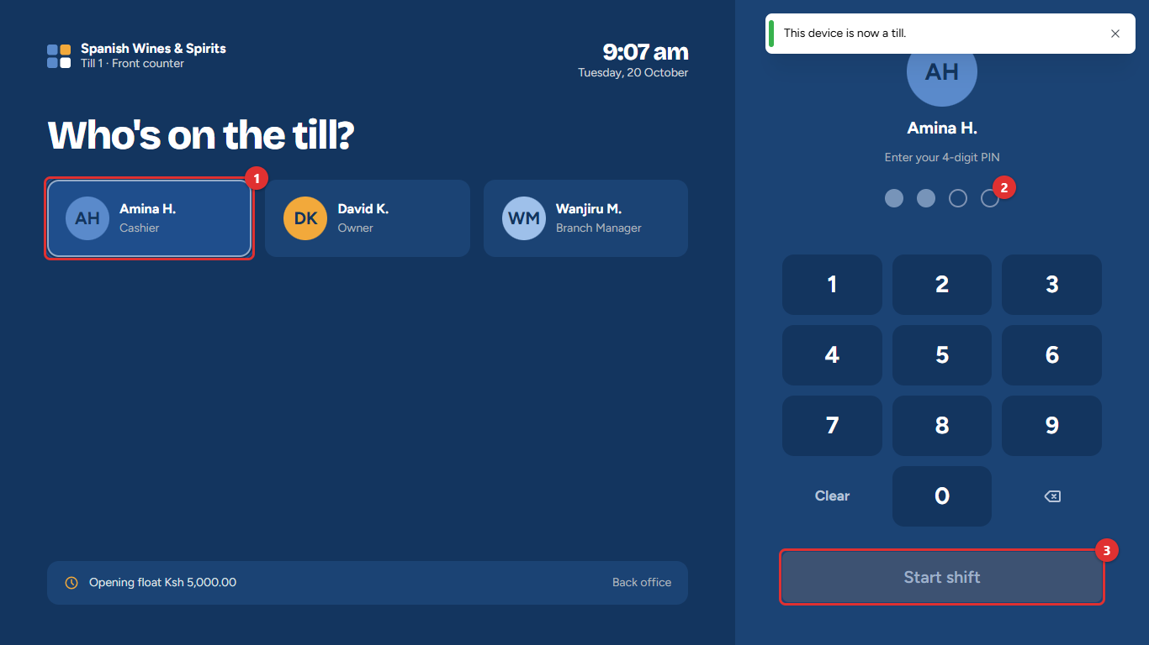
Figure 2.8: "Who's on the till?": the cashier picks her name and enters her PIN
1. Tap your name (1).
2. Enter your four-digit PIN on the keypad. The dots (2) fill in as you type.
3. Tap Start shift (3).
What changes elsewhere: the shift appears as open on the owner's dashboard (Shifts open now) with its float.
Common mistake: Using another person's PIN. Every sale, refund and cash-up is recorded against the person who signed in, so never share PINs.

Step 4: The cashier sells, and the customer pays
Who: the cashier. Where: the till.
A customer buys two bottles of Nederburg Cabernet Sauvignon and a Coca-Cola and pays by M-PESA.
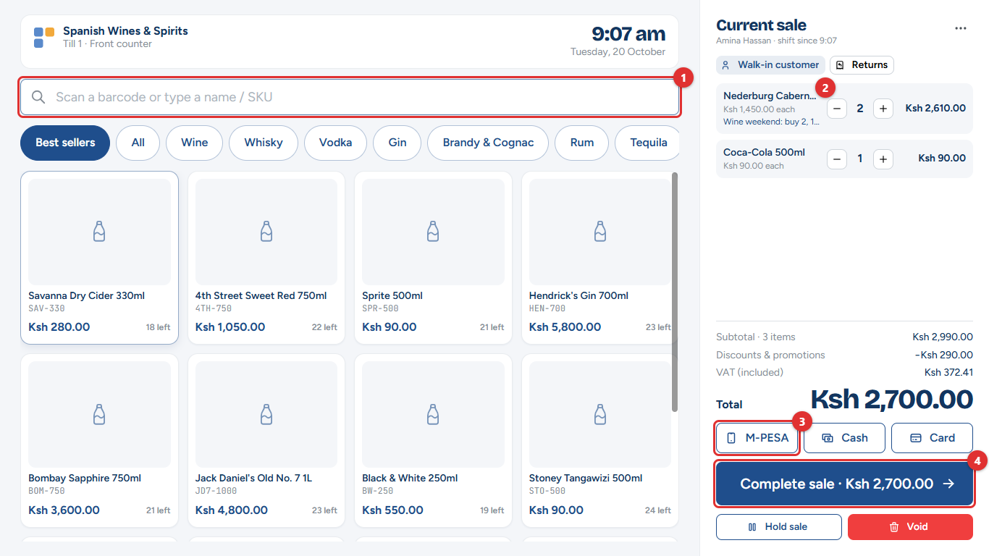
Figure 2.9: The selling screen. The wine promotion is taken off automatically
1. Scan the barcode or type part of the name in the search box (1), then tap the item.
2. Check the items in the sale (2). Two bottles of wine qualify for the Wine weekend: buy 2, 10% off promotion, so KSh 290 is taken off by itself.
3. Under the total, tap how the customer pays, here M-PESA (3), then tap Complete sale (4). The total is KSh 2,700.
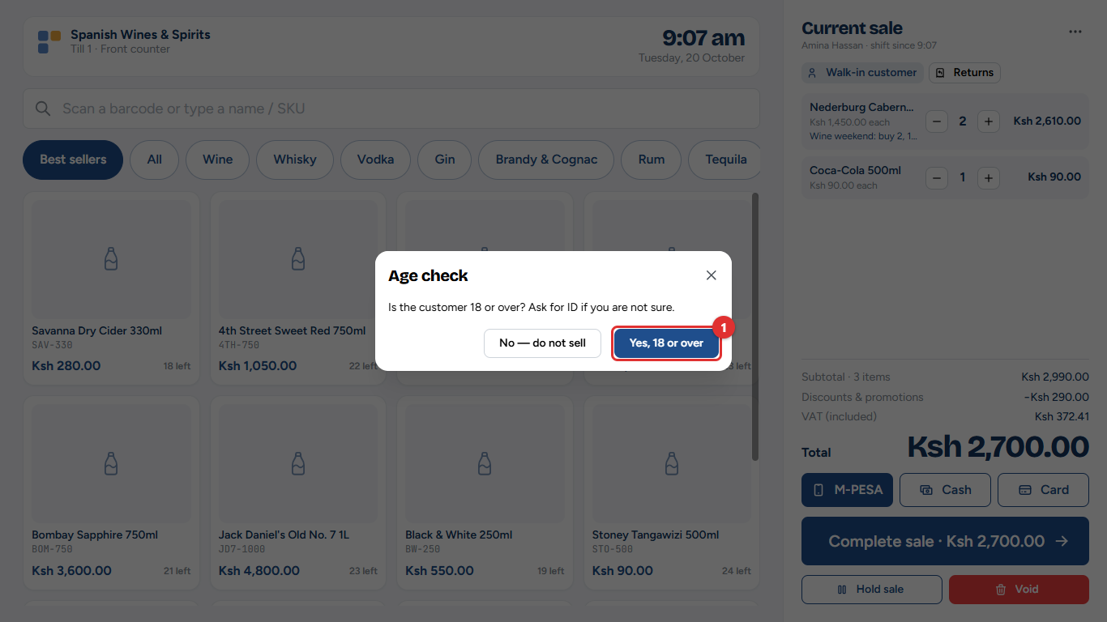
Figure 2.10: The age check before payment
4. Because the sale includes alcohol, the till asks whether the customer is 18 or over. Ask for ID if you are not sure, then tap Yes, 18 or over (1).
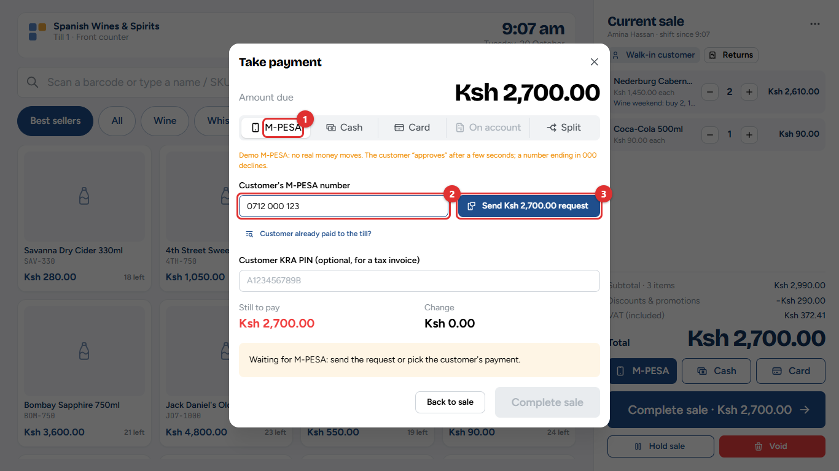
Figure 2.11: Take payment: M-PESA
5. M-PESA (1) is selected. Type the customer's phone number (2) and tap Send request (3). The customer approves the payment on their phone.
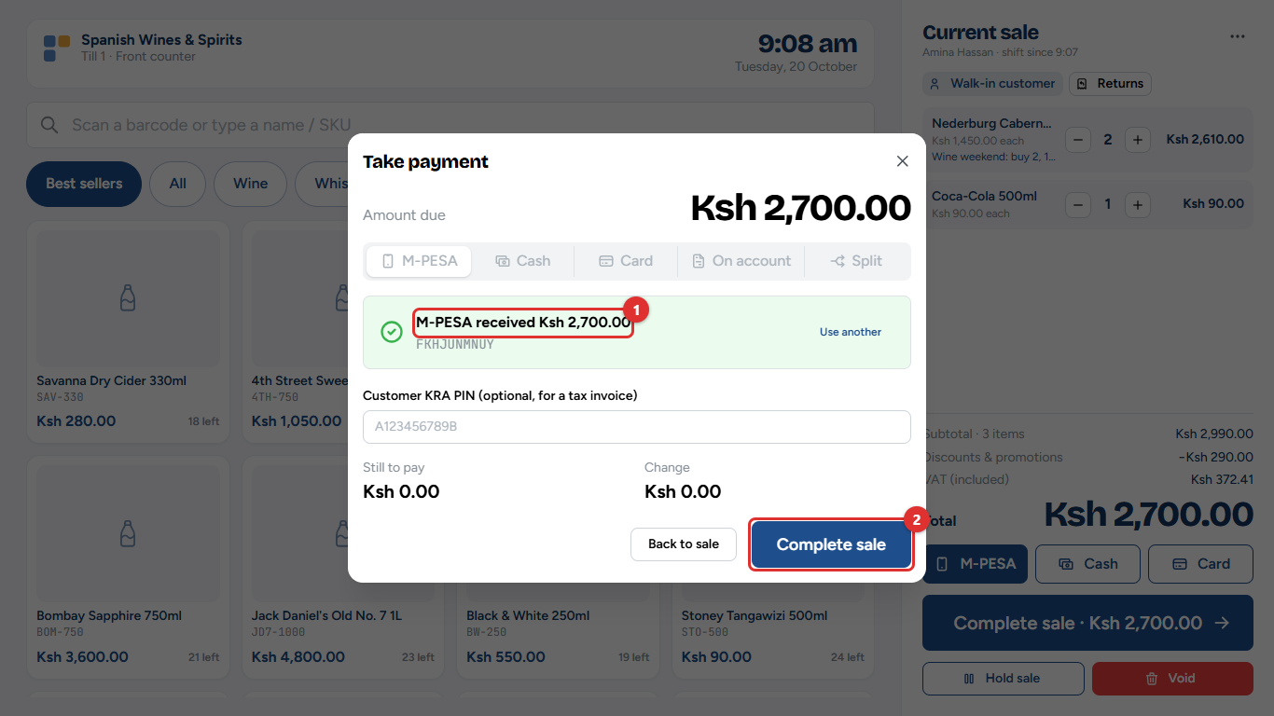
Figure 2.12: The M-PESA payment is confirmed
6. When the confirmation (1) appears, tap Complete sale (2).
For cash, choose Cash and type the amount the customer hands over; the till shows the change to give. Card payments and sales on a customer's account work the same way (see chapter 3).
What changes elsewhere: the moment the sale completes, the two bottles and the Coca-Cola leave the stock, the M-PESA payment is matched to the sale, and the day's sales on the dashboard go up.

Step 5: The tax invoice goes to KRA, and the receipt prints
Who: nobody has to do anything. Where: the receipt, and Compliance → eTIMS monitor.
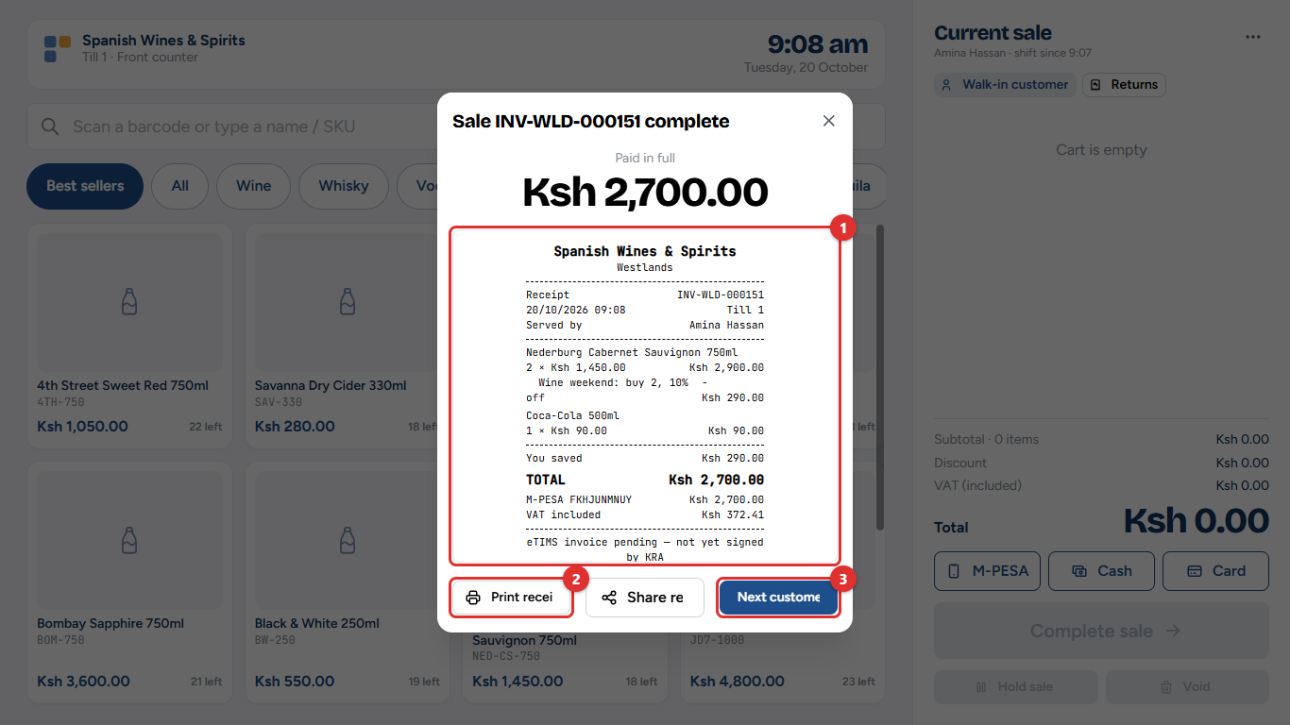
Figure 2.13: Sale complete, with the receipt
The receipt (1) shows the items, the promotion, the M-PESA code and the VAT included. Tap Print receipt (2), then Next customer (3).
Tessera sends every sale to KRA's eTIMS automatically, straight after the sale. The first receipt may say eTIMS invoice pending: KRA's signature arrives a few seconds later, and a reprint shows it.
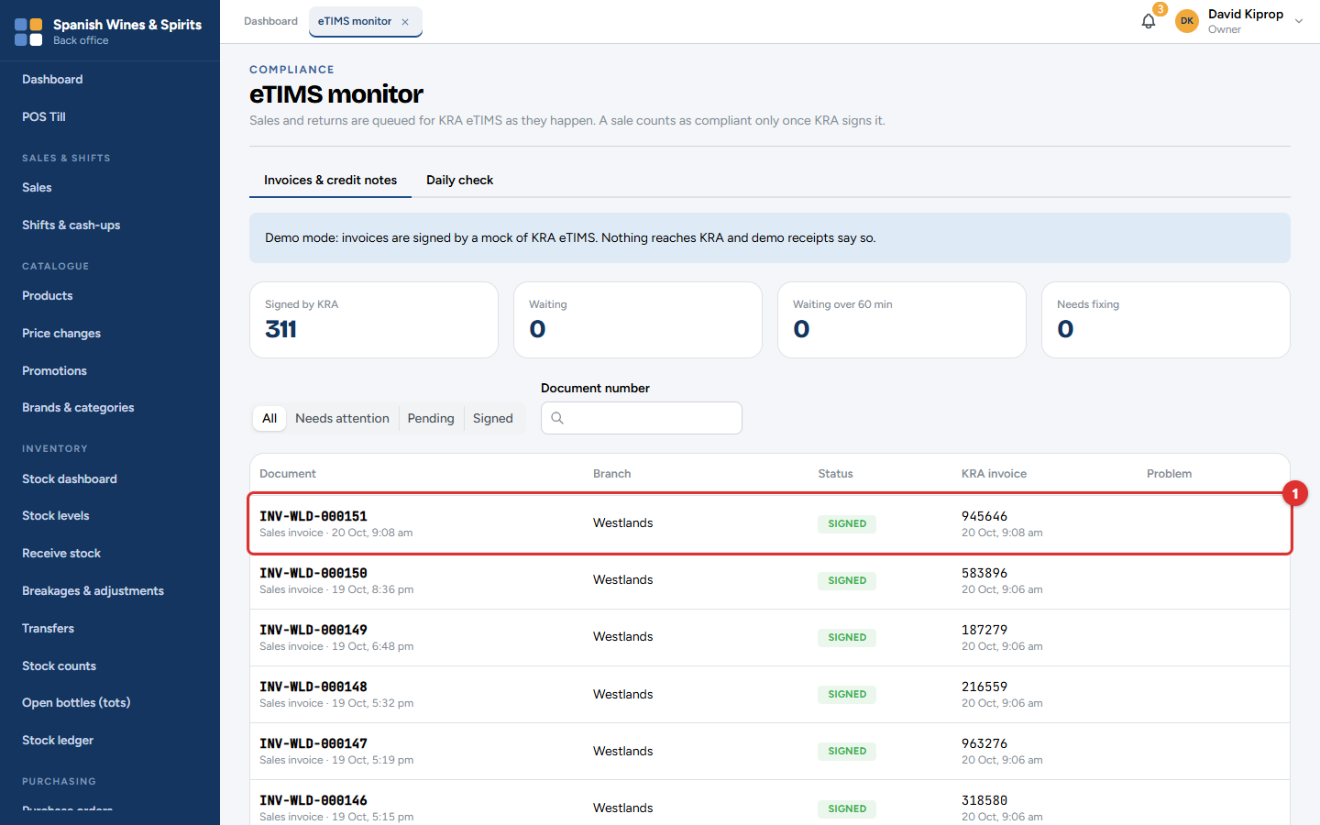
Figure 2.14: Compliance → eTIMS monitor: the sale has been signed by KRA
The owner or manager can check that every sale was signed (1). Anything that needs attention is counted in the boxes at the top.
Important: While the system runs on its demonstration connection, invoices are signed by a practice copy of eTIMS and nothing reaches KRA. The screens say so. The live connection is switched on when your business goes live.

Step 6: Stock goes down, and low stock is flagged
Who: nobody has to do anything. Where: Inventory → Stock ledger, and the notifications bell.
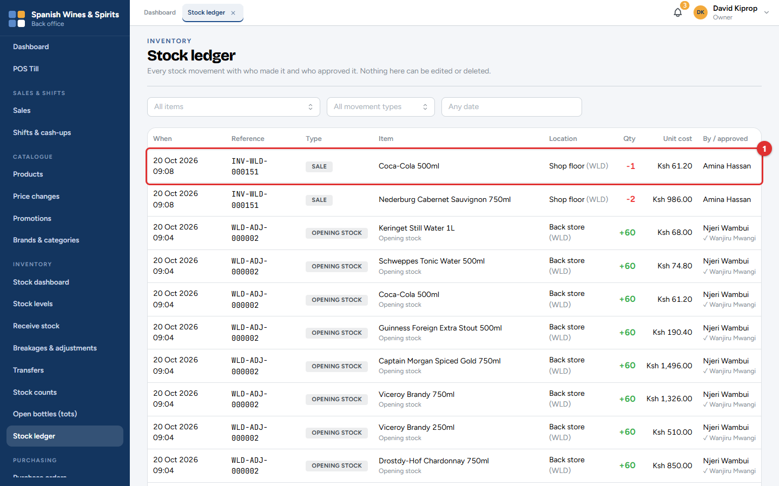
Figure 2.15: Inventory → Stock ledger: the sale took the bottles off the Westlands shop floor
Every movement of stock (sales, deliveries, returns, breakages, transfers) is recorded in the stock ledger (1), with who did it and when. Nobody can edit or delete it.
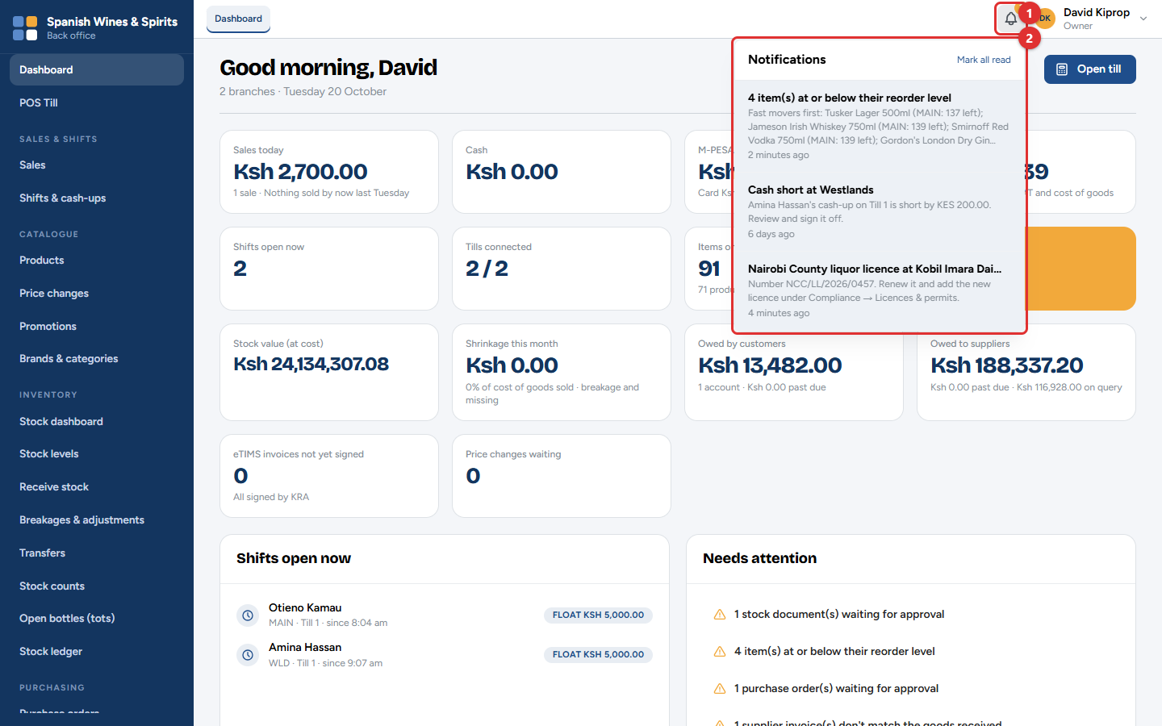
Figure 2.16: The notifications bell: low stock, cash shortages and licence reminders
When an item drops to its reorder level (the stock level at which you should order more), the owner and managers are told. Click the bell (1) to see the alerts (2).

Step 7: A return needs a manager's approval
Who: the cashier starts it, and a manager approves it with their PIN. Where: the till → till menu → Return / reprint.
The customer comes back with one sealed bottle: they bought the wrong wine.
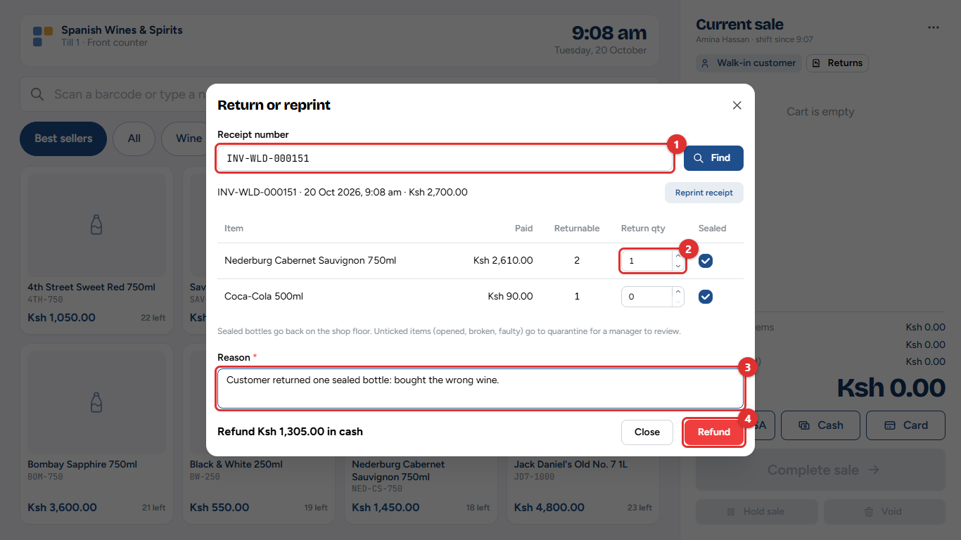
Figure 2.17: Finding the sale and choosing what comes back
1. Type the receipt number (1) and tap Find.
2. Enter how many of each item come back (2). A sealed bottle goes back on the shelf; an opened or broken one goes to a separate area for the manager to check.
3. Type the reason (3), then tap Refund (4). Here the refund is KSh 1,305, the bottle's price after the promotion.
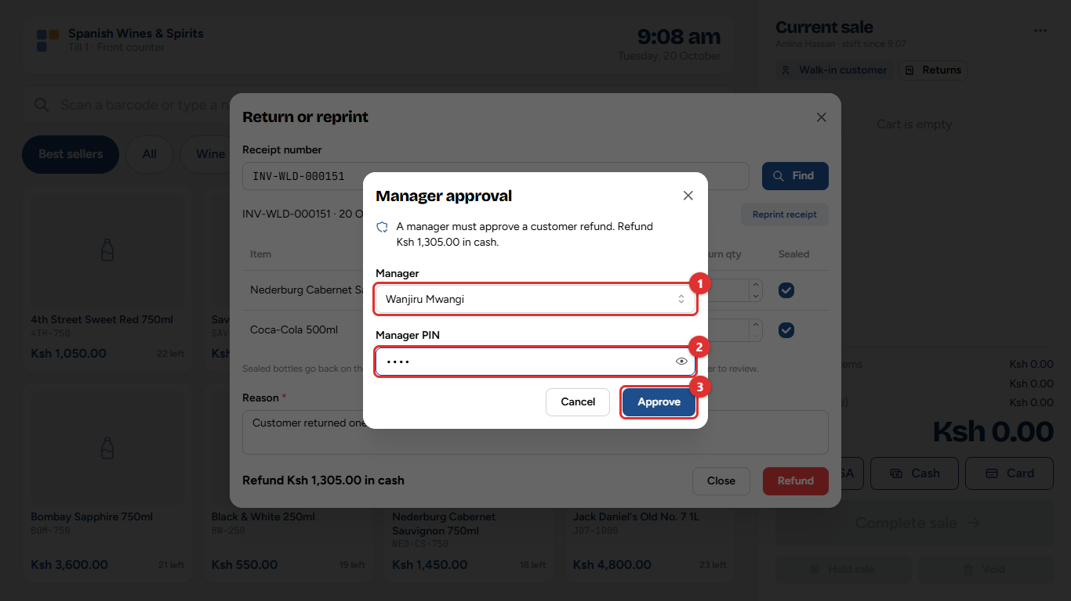
Figure 2.18: The manager approves the refund with their PIN
4. The manager chooses their name (1), enters their PIN (2) and taps Approve (3).
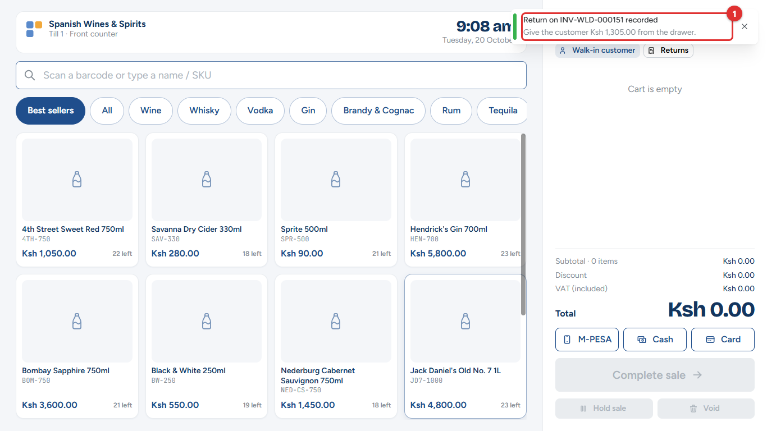
Figure 2.19: The return is recorded
5. The till confirms the return (1) and says how much to give back from the drawer.
What changes elsewhere: the bottle goes back into stock, a credit note is sent to eTIMS, and the refund is recorded against the shift, so the expected cash in the drawer goes down.
Tip: Refunds are paid in cash from the drawer, even when the customer first paid by M-PESA.

Step 8: The cashier ends the shift and counts the cash
Who: the cashier counts, and a manager signs off. Where: till menu → End shift, then Sales & Shifts → Shifts & cash-ups.
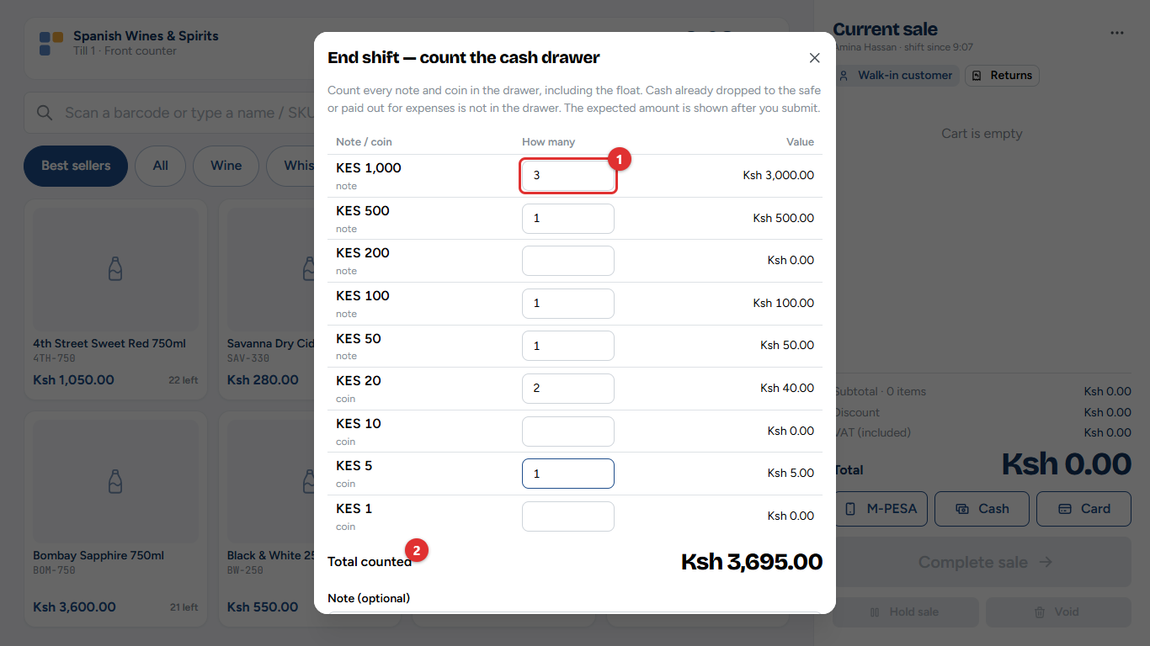
Figure 2.20: Counting the drawer, note by note
1. Enter how many of each note and coin are in the drawer (1). The total (2) adds up as you type.
2. Tap Submit count (3). The cashier does not see the expected amount until after submitting, so the count is honest.
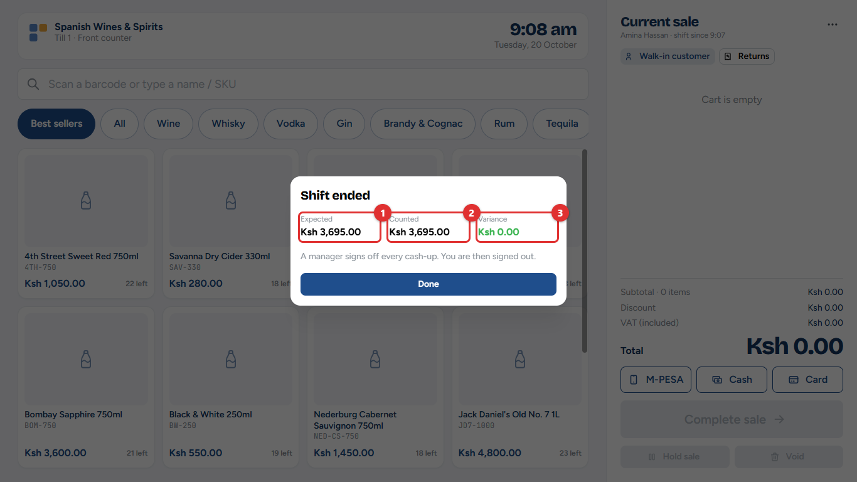
Figure 2.21: The result: expected, counted and the difference
The till shows the cash it expected (1), what was counted (2) and the variance (3). Here Amina started with KSh 5,000, refunded KSh 1,305 and took no other cash, so KSh 3,695 was expected, and the drawer balances. If there is a difference, the cashier is asked to explain it.
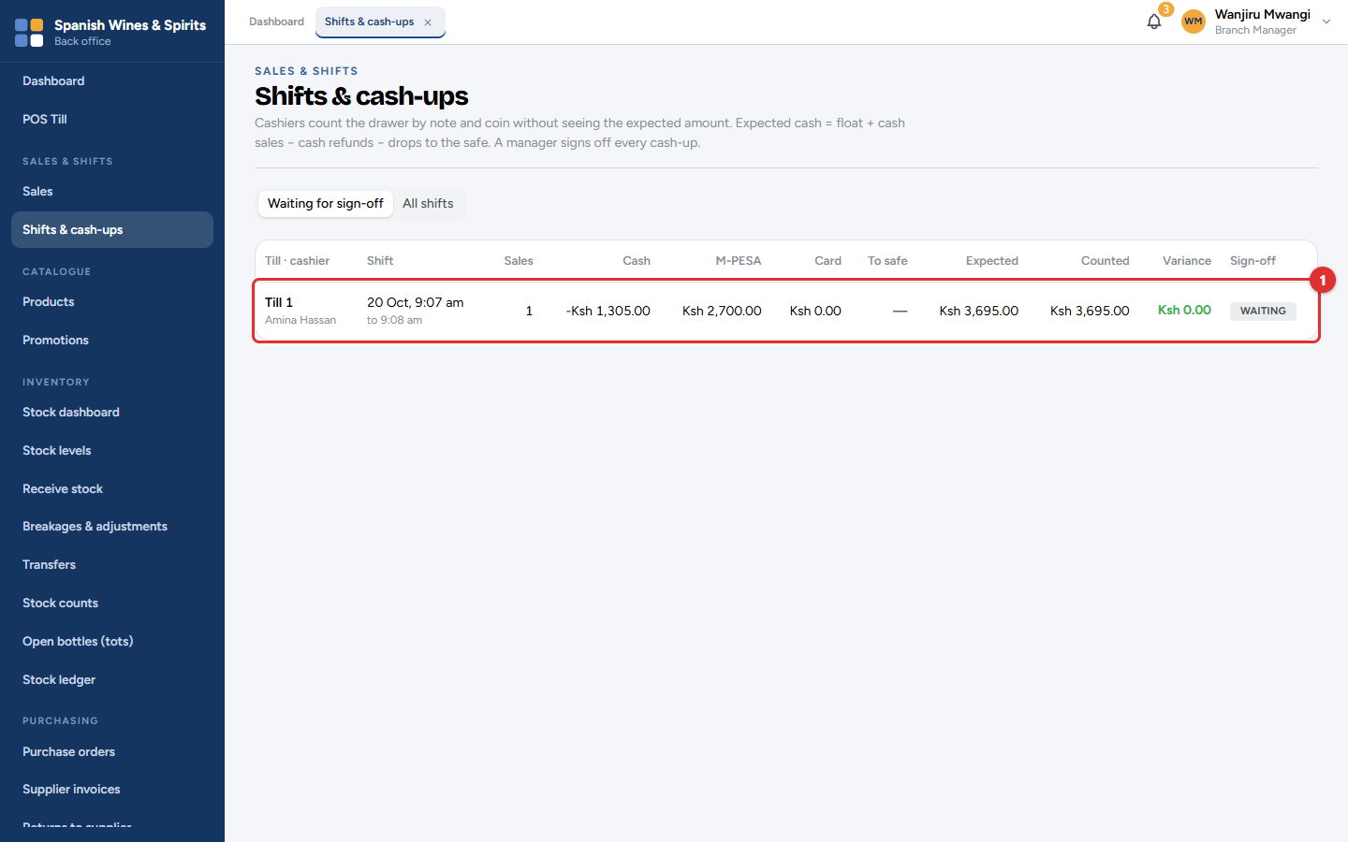
Figure 2.22: The manager's list of cash-ups waiting for sign-off
The branch manager checks each cash-up (1) and signs it off.
What changes elsewhere: the cash-up appears in the Shift cash-up & variance report, and any shortage is shown on the dashboard and sent as an alert.

Step 9: The owner checks the business and reorders
Who: the owner. Where: Dashboard, Reports, Purchasing.
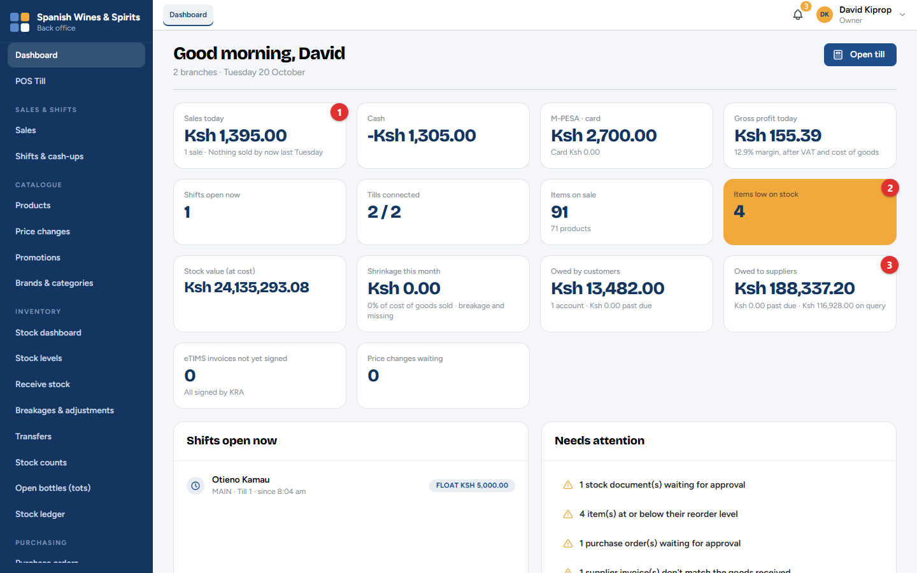
Figure 2.23: The owner's dashboard
The dashboard shows today's sales (1), how many items are low on stock (2) and what is owed to suppliers (3), for both branches together. Open Reports for the detail behind each figure.
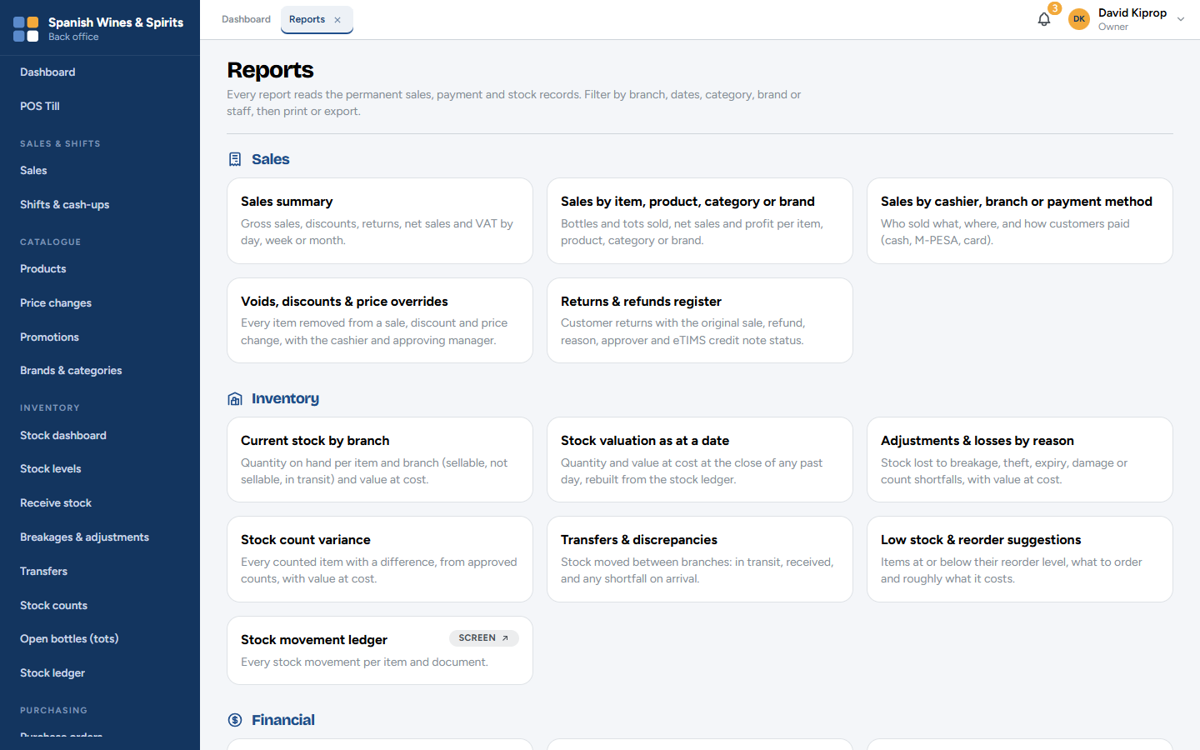
Figure 2.24: Reports: every report in one place
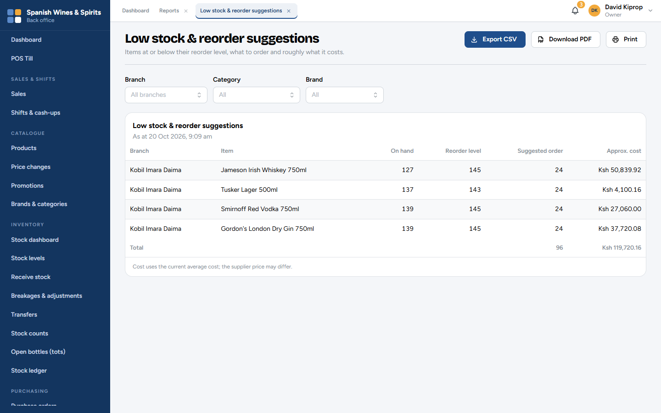
Figure 2.25: The Low stock & reorder suggestions report
This report lists what to order and roughly what it will cost. To order, open Purchasing → Purchase orders and click New purchase order:
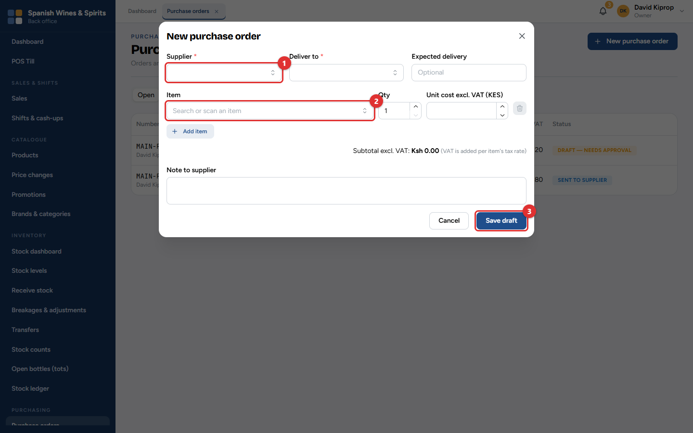
Figure 2.26: A new purchase order
1. Choose the supplier (1).
2. Add each item (2) with its quantity and cost.
3. Click Save draft (3). The order then waits for someone else to approve it before it is sent.

Step 10: Month end: reports for the accountant and VAT
Who: the owner or the accountant. Where: Reports.
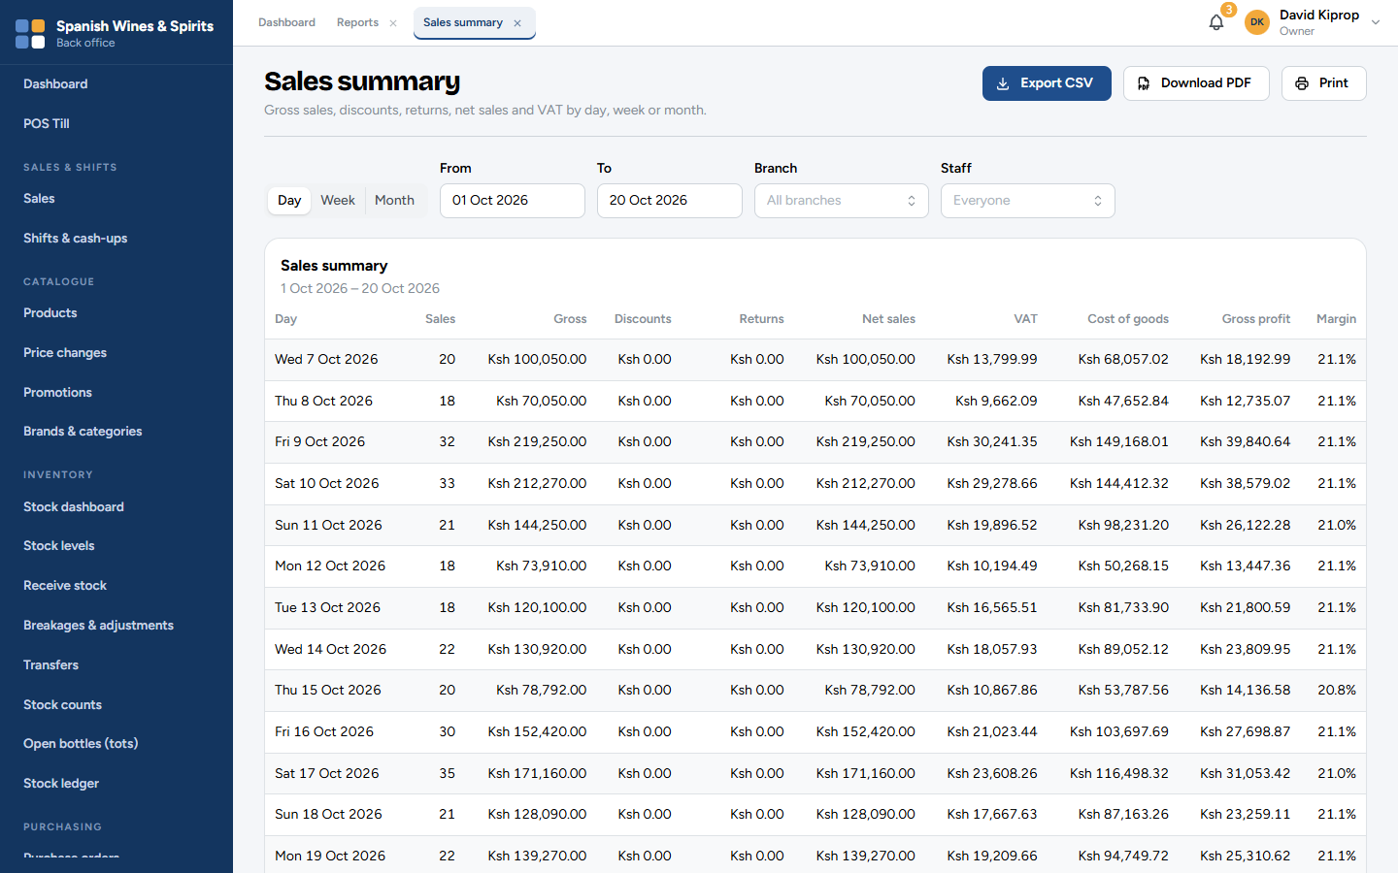
Figure 2.27: The Sales summary report, with VAT, ready to export
The Sales summary shows gross sales, discounts, returns, net sales and VAT (Value Added Tax) for any period, by day, week or month. Click Export CSV to open it in Excel, Download PDF for a branded copy, or Print. The accountant also uses Revenue, cost of goods & gross profit, Expenses, Receivables aging and Payables aging. Because every sale was signed on eTIMS as it happened, the VAT figures match what KRA has on record.

Who does what: summary
Step | Part of the system | Who | What else changes
1. Set up | Settings, Branches, Users & roles | Owner | Receipts, invoices and the till sign-in screen use these details
2. Products and stock in | Catalogue, Purchasing, Inventory | Owner/admin/accountant order, another person approves, storekeeper receives | Stock goes up; the supplier's bill goes to Supplier accounts
3. Shift starts | Till | Cashier | Shift shows as open on the dashboard
4. Sale and payment | Till | Cashier | Stock goes down; M-PESA matched; sales totals update
5. Tax invoice and receipt | eTIMS (automatic) | Nobody | eTIMS monitor shows the signed invoice
6. Stock and alerts | Stock ledger, notifications | Nobody | Low-stock alerts to owner and managers
7. Return | Till, manager approval | Cashier and manager | Stock back; credit note to eTIMS; expected cash goes down
8. Cash-up | Till, Shifts & cash-ups | Cashier and manager | Cash-up report; alert if short
9. Check and reorder | Dashboard, Reports, Purchasing | Owner | A new purchase order starts step 2 again
10. Month end | Reports | Owner or accountant | Exports for the accountant and VAT filing

Frequently asked questions
Do I need to send invoices to KRA myself? No. Every sale and return is sent to eTIMS automatically. Check Compliance → eTIMS monitor now and then; it shows anything that still needs attention.
What happens if the internet goes down during the day? The till keeps selling for cash and card, and for M-PESA by typing the code from the customer's message. It sends the sales when the connection comes back. M-PESA payment requests, returns and manager approvals need the connection. See chapter 3.
Can a cashier see how much money should be in the drawer? Not before counting. The expected amount is shown only after the count is submitted, so the count is honest.
Why can't my branch manager change prices? Prices are set centrally by the owner or admin and approved by the owner. This stops unapproved price changes, keeps every branch charging the same, and keeps tax invoices correct. Managers can still approve discounts at the till, up to their limit.

3. Selling at the till
The till is the screen at the counter. It fills the whole screen and is made for touch, a mouse or a barcode scanner. This chapter covers setting a computer up as a till, signing in, and making a sale from start to finish.
Who: cashiers, and anyone else with a till PIN (managers and the owner). Where: the till computer.

Setting up a computer as a till (once)
A computer or tablet becomes a till once. After that it opens straight to the cashier sign-in.
1. On the till computer, open the Tessera address and add /till at the end (or choose Open till screen from the account menu).
2. Click Manager sign in and sign in as the owner or an admin.
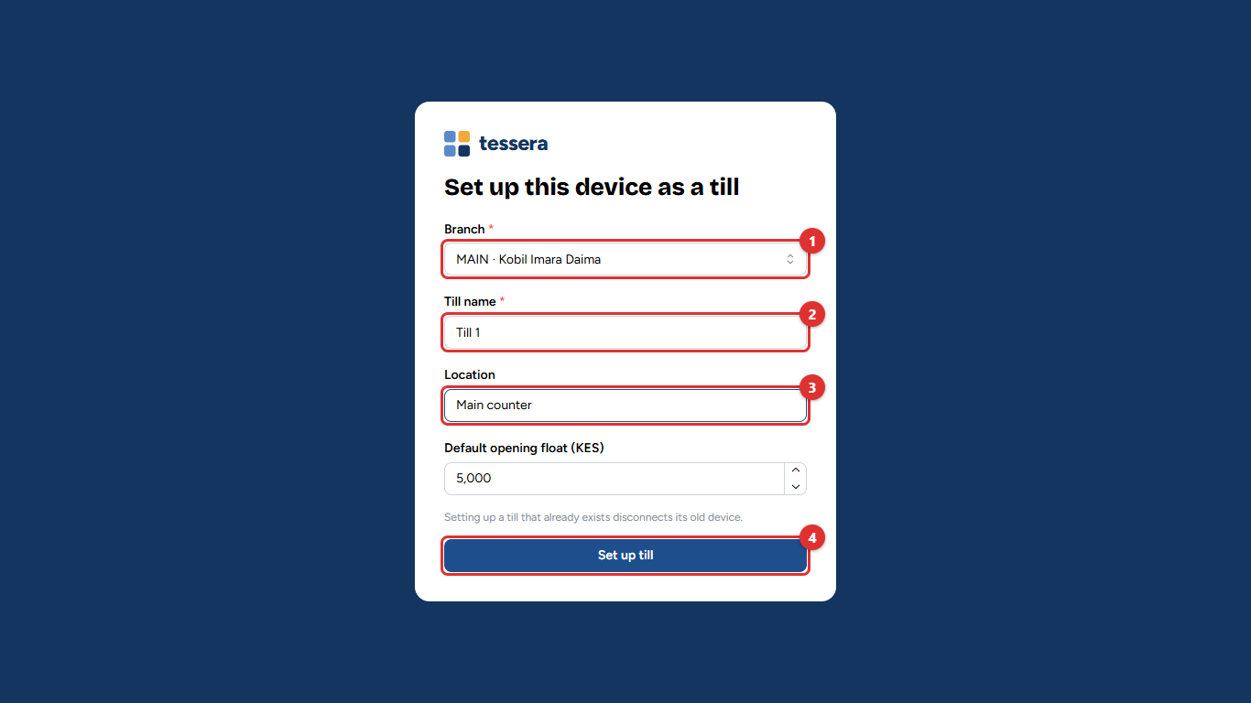
Figure 3.1: Setting up this computer as a till
3. Choose the Branch (1) the till belongs to.
4. Give it a Till name (2), such as Till 1, and say where it is (3), such as Main counter.
5. Check the opening float, then click Set up till (4).
Tip: If a computer breaks, set up the new one with the same till name. The old computer stops working as that till straight away.
To stop a lost or stolen computer from selling, the owner clicks Disconnect next to the till under Administration → Branches (chapter 12).

Signing in and starting the shift
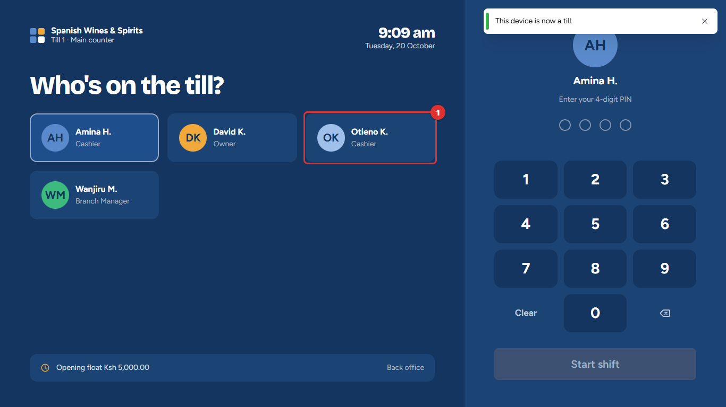
Figure 3.2: "Who's on the till?"
1. Tap your name (1).
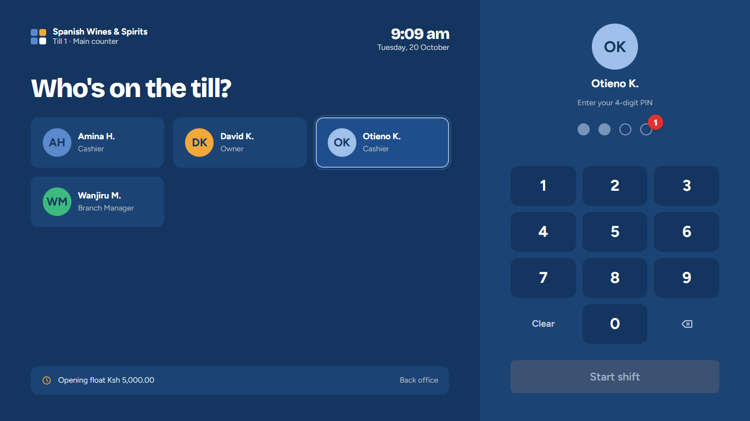
Figure 3.3: Entering the PIN
2. Type your four-digit PIN on the keypad or the keyboard. A dot fills in for each digit (1).
3. Tap Start shift. If you already have a shift open on this till, you carry on where you left off.
Common mistake: A cashier can have only one shift open at a time. If the till says You still have an open shift on Till 1, go back to that till, or end that shift first.

The selling screen
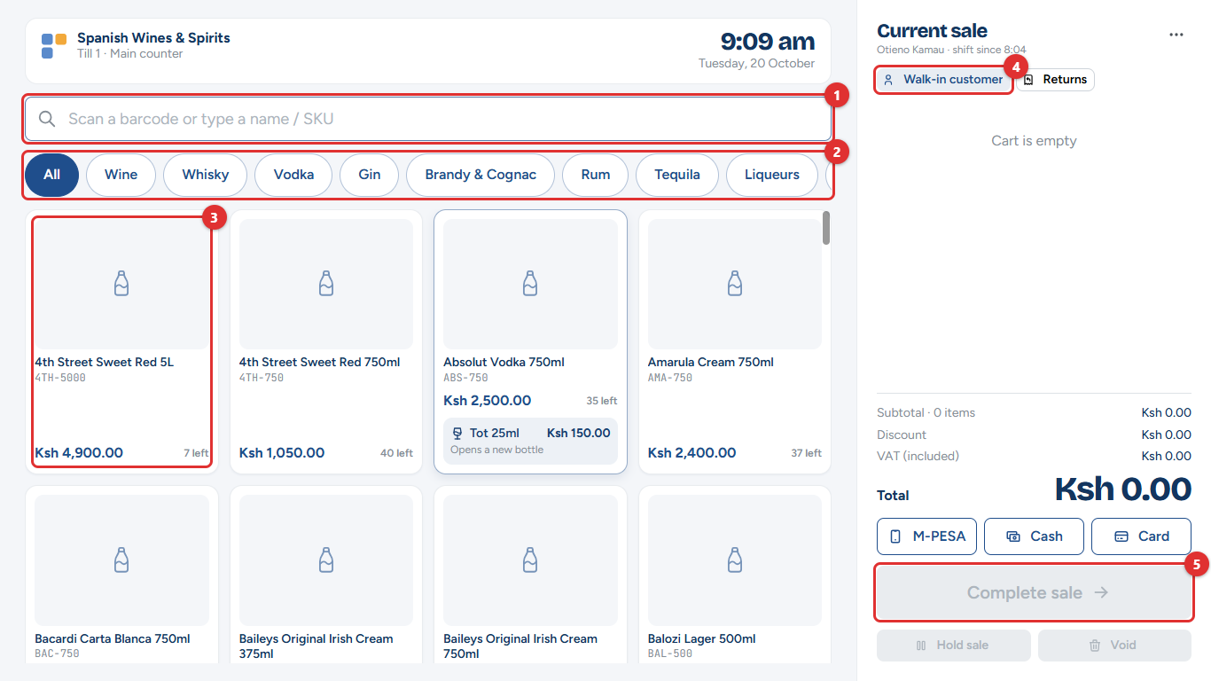
Figure 3.4: The selling screen
Part | What it does
Search box (1) | Scan a barcode, or type part of a name or the product code (SKU).
Categories (2) | Best sellers shows this week's most sold items. Tap a category (Wine, Whisky, Vodka…) or All to browse.
Product cards (3) | Tap a card to add one to the sale. Each card shows the price and how many are left on the shop floor. Out of stock is shown in red.
Customer (4) | Walk-in customer unless you choose a registered customer.
Complete sale (5) | Takes the payment. It is greyed out until the sale has an item.

At the top, the till shows the shop, the till's name and the time. On the right, the current sale lists every item with the total, the discount and the VAT included.
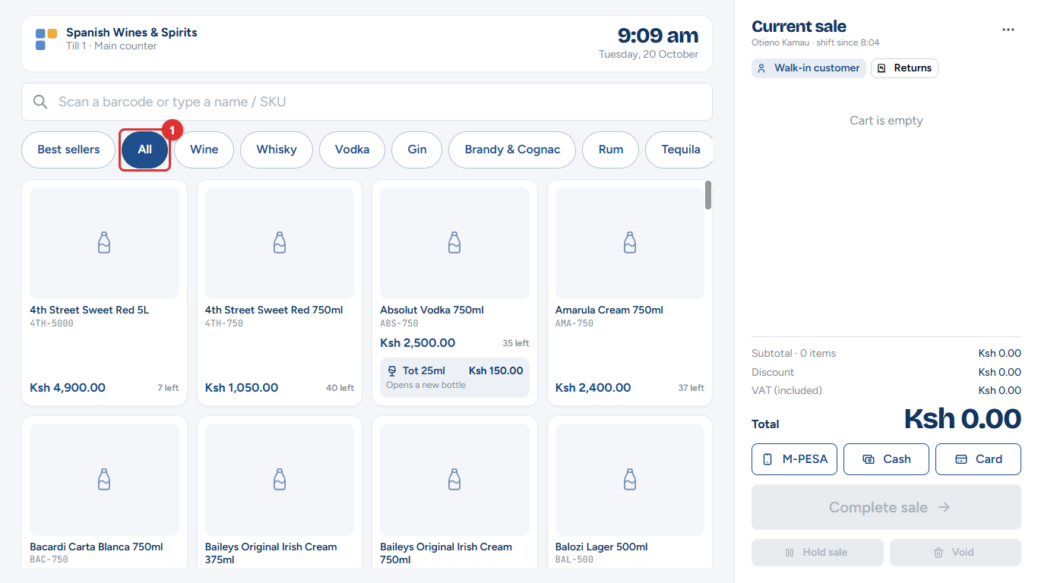
Figure 3.5: Browsing all items

Adding items
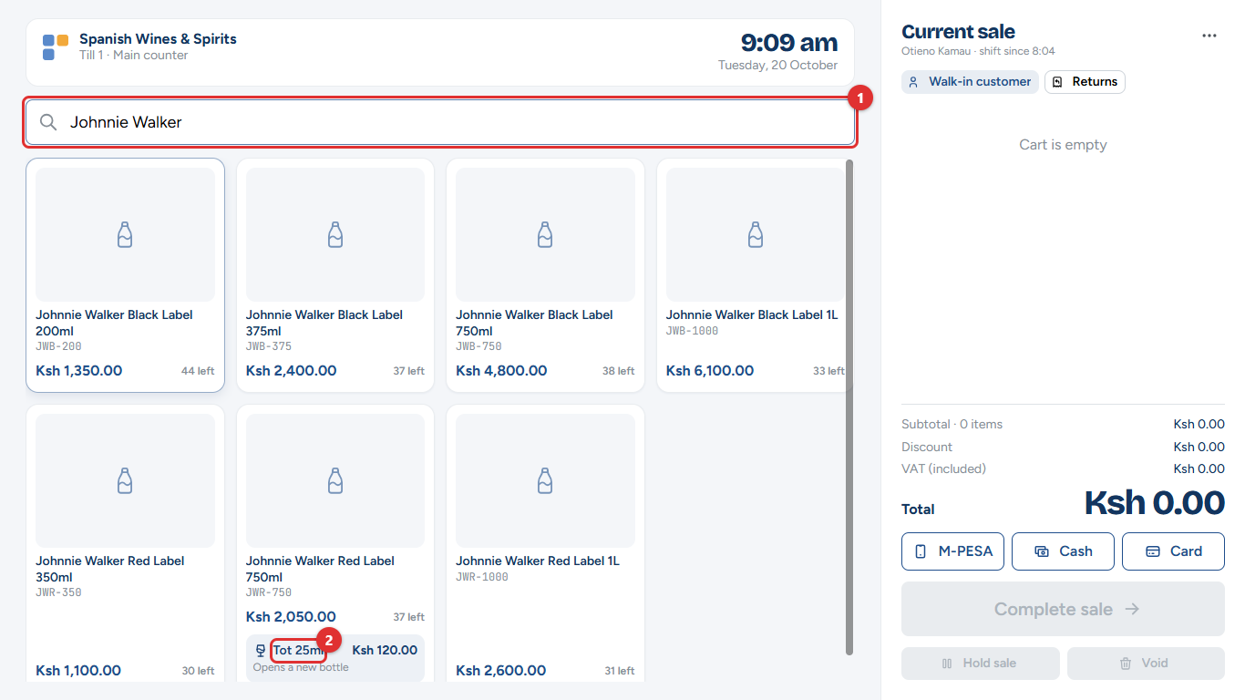
Figure 3.6: Searching by name. Some spirits can also be sold by the tot
1. Scan the barcode, or type part of the name in the search box (1). Only matching items are shown.
2. Tap the item you want.
3. To sell a tot (a measure poured from an open bottle), tap the tot button on the card (2). The first tot opens a new bottle; the system keeps track of how much is left (chapter 7, Open bottles).
Scanning the same barcode again adds one more.
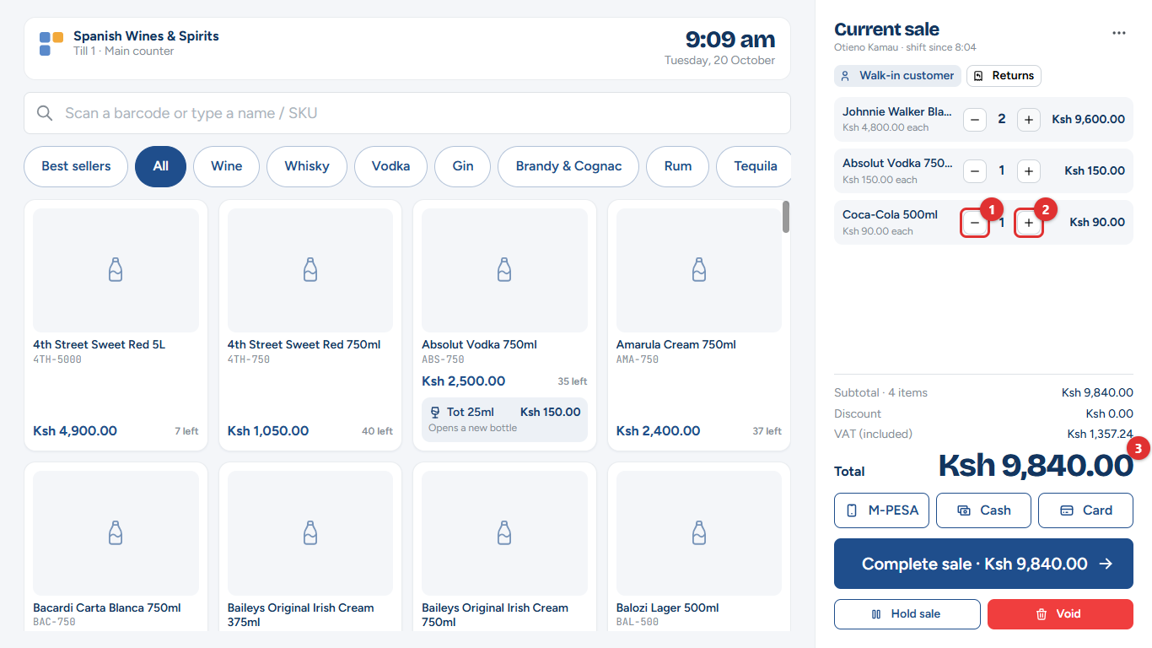
Figure 3.7: The sale, with one more and one less buttons
• Tap − (1) or + (2) to change how many.
• The total (3) updates straight away. Promotions are taken off by themselves, with their name under the item.

Changing an item, giving a discount
Tap an item's name in the sale to change it.
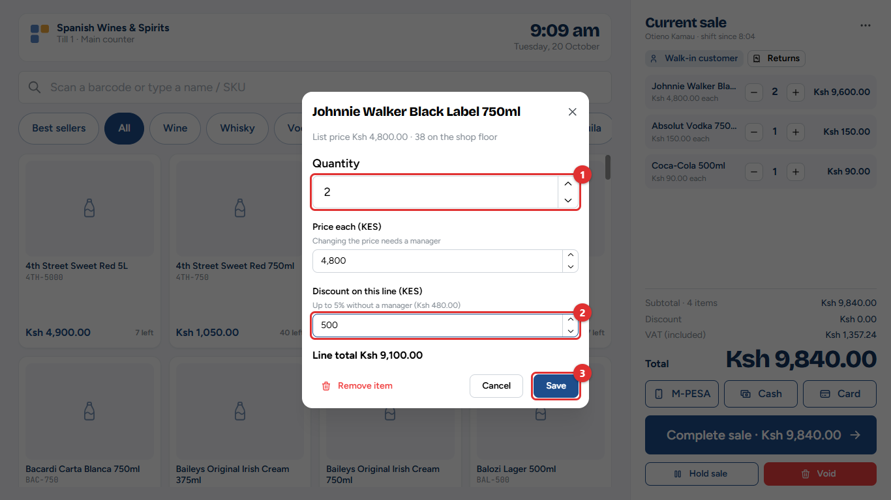
Figure 3.8: Changing an item
1. Change the Quantity (1).
2. Type a Discount (2) in shillings. The note under the box shows how much you may give without a manager (here up to 5%).
3. Tap Save (3). Remove item takes it off the sale.
Changing the Price each always needs a manager.
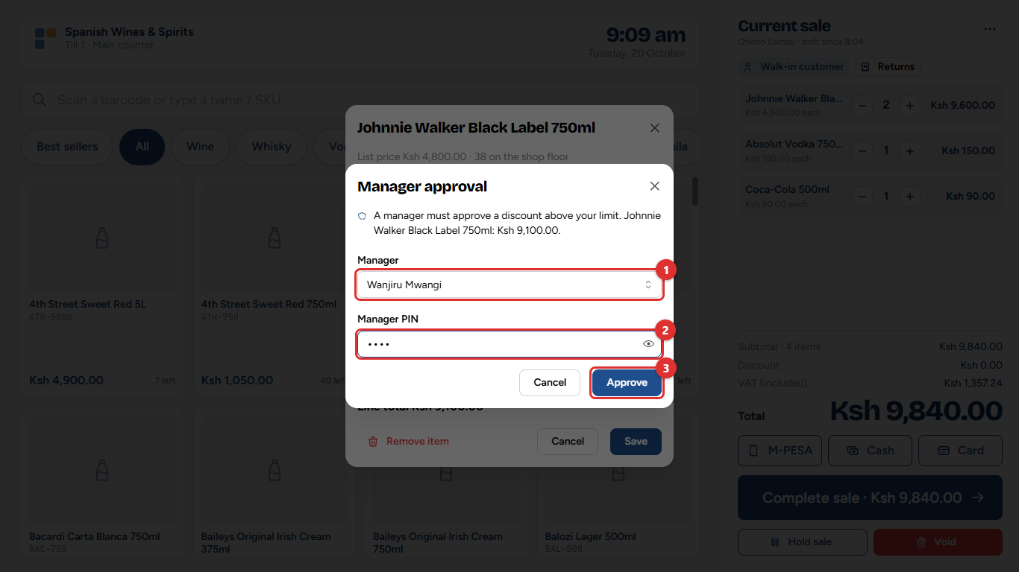
Figure 3.9: A manager approves the discount with their PIN
When a discount or price change is over your limit, a manager comes to the till, chooses their name (1), types their PIN (2) and taps Approve (3). The sale then shows who approved it.
Important: The manager types the PIN, not the cashier. Every approval is recorded with the manager's name and appears in the Voids, discounts & price overrides report.

Choosing a customer
Most sales are to walk-in customers. Choose a registered customer when:
• the customer is a wholesale buyer (they get wholesale prices);
• the sale goes on account (the customer pays later);
• the customer wants a tax invoice with their KRA PIN.
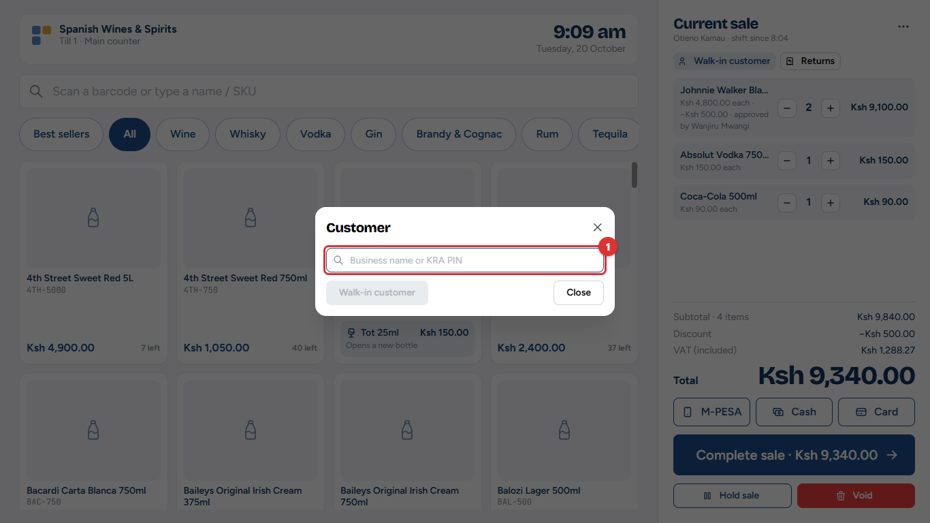
Figure 3.10: Finding a registered customer
Tap Walk-in customer, then type the business name or KRA PIN (1) and tap the customer. Customers are registered in the back office (chapter 9).

The till menu
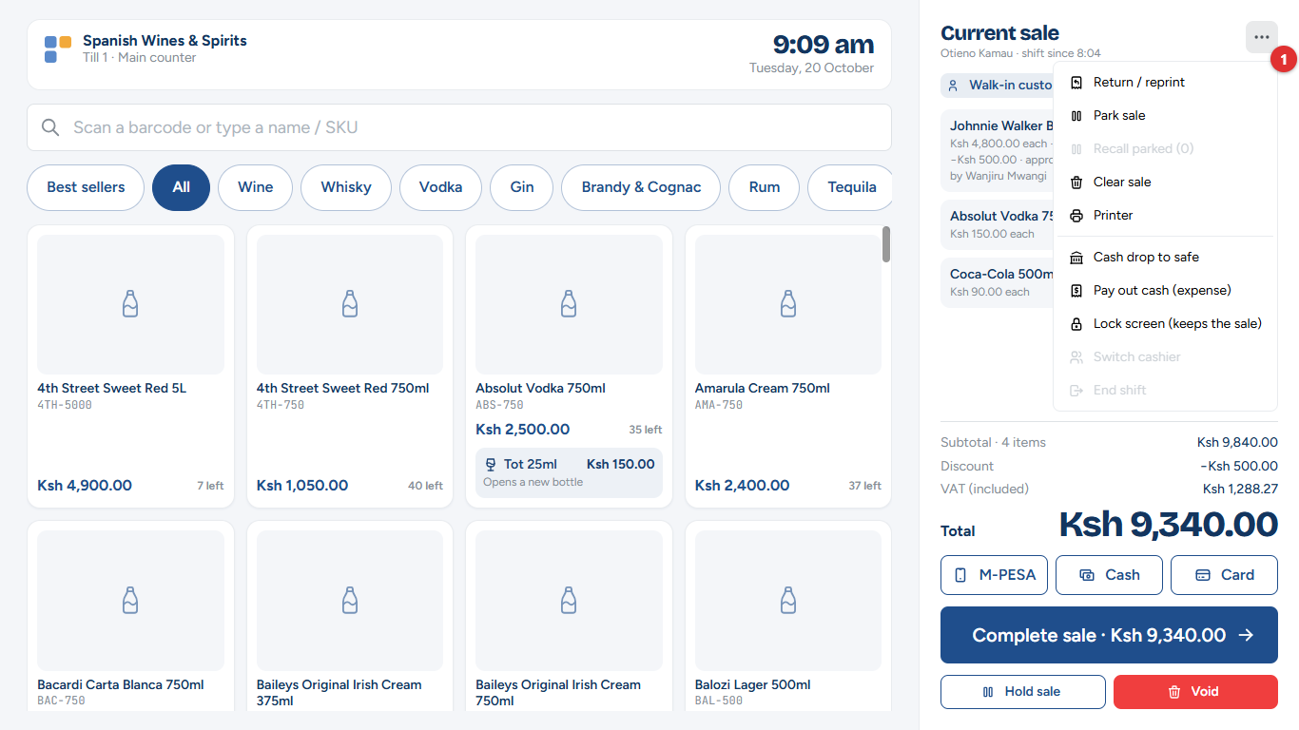
Figure 3.11: The till menu (the ⋯ button next to "Current sale")
The ⋯ button next to Current sale opens the till menu (1). Return / reprint, Cash drop, Pay out, Lock screen, Switch cashier and End shift are covered in chapter 4. Here:
• Park sale: put the sale on hold (see below).
• Recall parked: bring a held sale back.
• Clear sale: empty the sale and start again.
• Printer: check the receipt printer.

Taking payment
1. Under the total, tap how the customer pays (M-PESA, Cash or Card). You can also leave it and choose on the next screen.
2. Tap Complete sale.
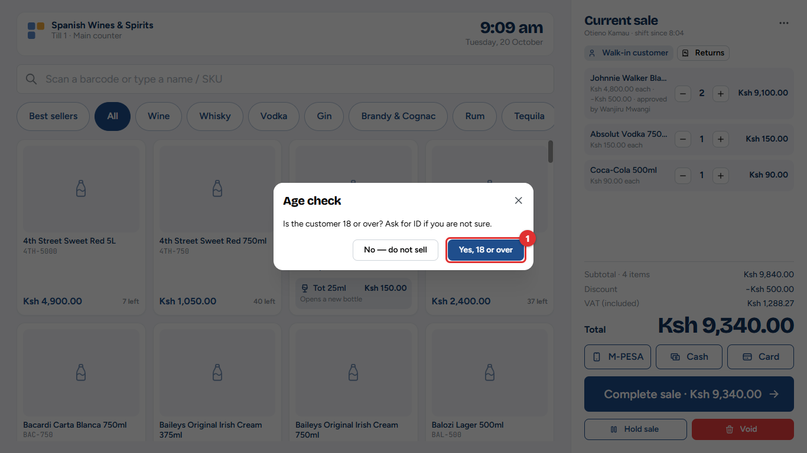
Figure 3.12: The age check
3. If the sale includes alcohol, the till asks whether the customer is 18 or over. Ask for ID if you are not sure, then tap Yes, 18 or over (1). If they are not, tap No — do not sell.

Cash
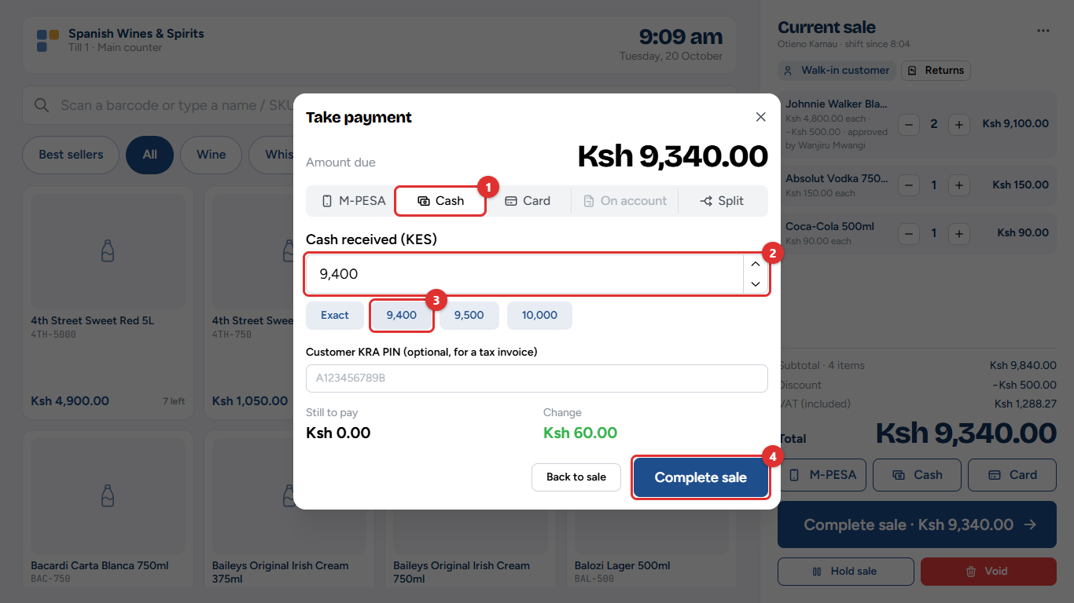
Figure 3.13: Take payment: cash
1. Cash (1) is selected.
2. Type what the customer gives you (2), or tap a quick amount (3): Exact or the next round notes.
3. The till shows the Change to give. Tap Complete sale (4).
If the shop rounds cash to the nearest shilling amount, the till shows the rounded amount to collect.

M-PESA
Choose M-PESA, type the customer's phone number and tap Send request. The customer approves the payment on their phone with their M-PESA PIN. When M-PESA received appears, tap Complete sale. Chapter 2 (Step 4) shows each screen.
If the customer has already paid to the till number, choose the payment from the list of payments received instead of sending a request.

Card
Choose Card, take the payment on the card machine, then type the machine's approval code (and, if you like, the last four digits of the card) and tap Complete sale.

On account
Only for a registered customer with a credit account. The till shows how much credit is available. The amount is added to what the customer owes (chapter 9).

Split payment
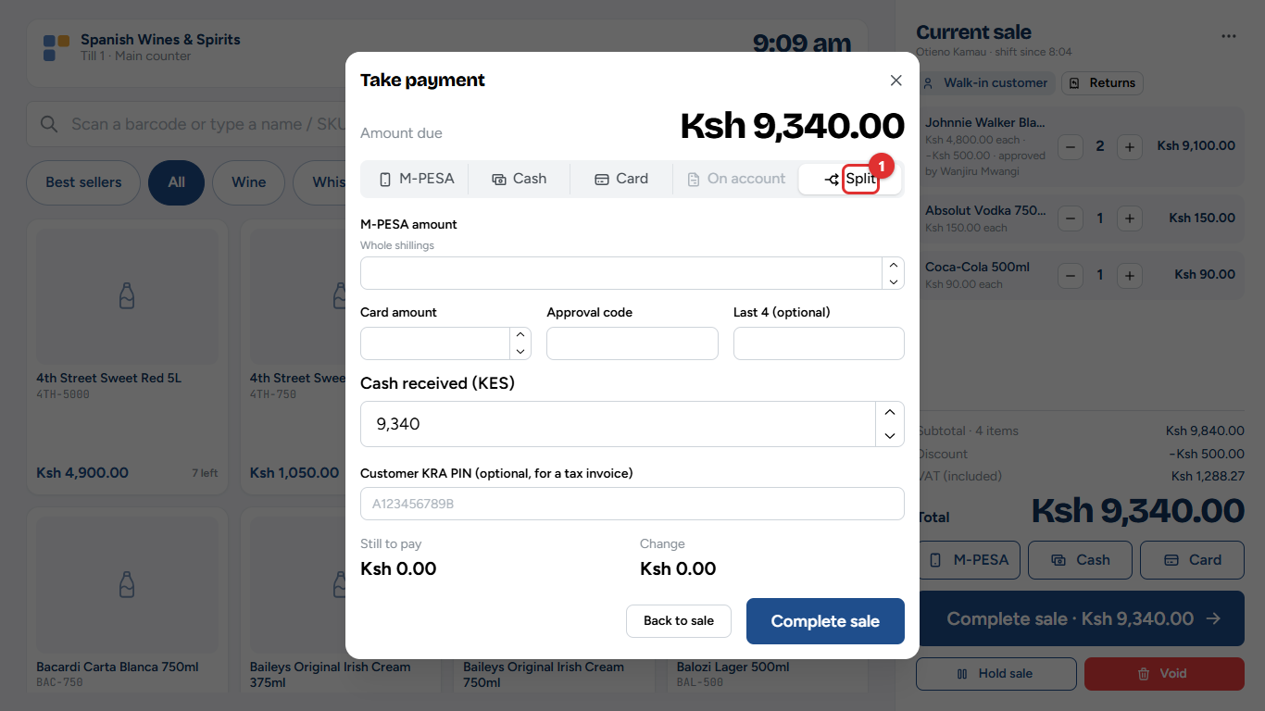
Figure 3.14: Split: part cash, part M-PESA or card
Choose Split (1) when the customer pays part in cash and part by M-PESA or card. Enter each amount; Still to pay must reach zero.

A tax invoice for a business
Type the customer's KRA PIN in Customer KRA PIN on the payment screen. The eTIMS invoice then carries the PIN, so the business can claim the VAT.

Sale complete: the receipt
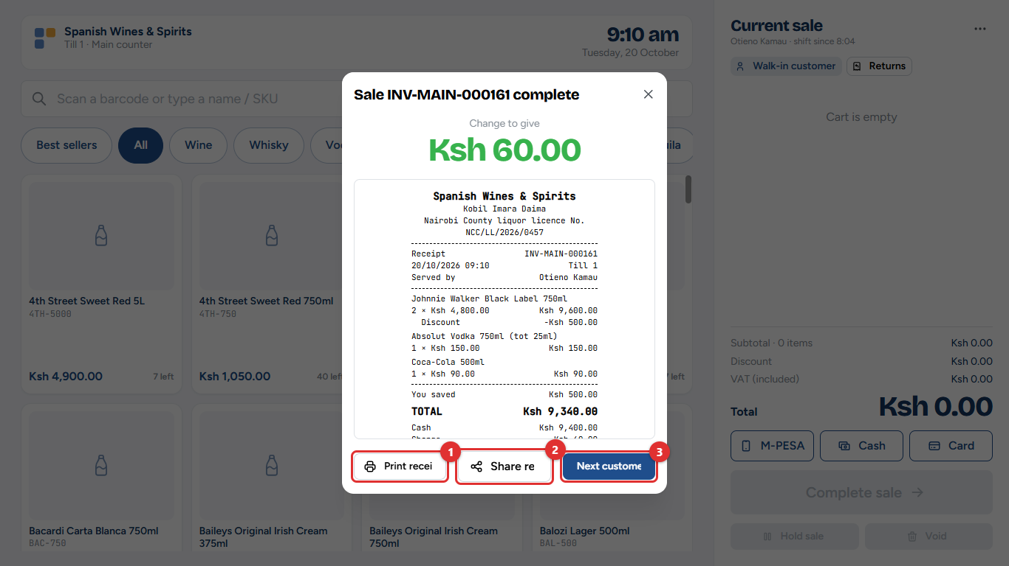
Figure 3.15: Sale complete
The till shows the change to give in large figures, and the receipt.
• Print receipt (1) prints it on the receipt printer.
• Share receipt (2) gives the customer a link instead of paper.
• Next customer (3) clears the screen for the next sale.
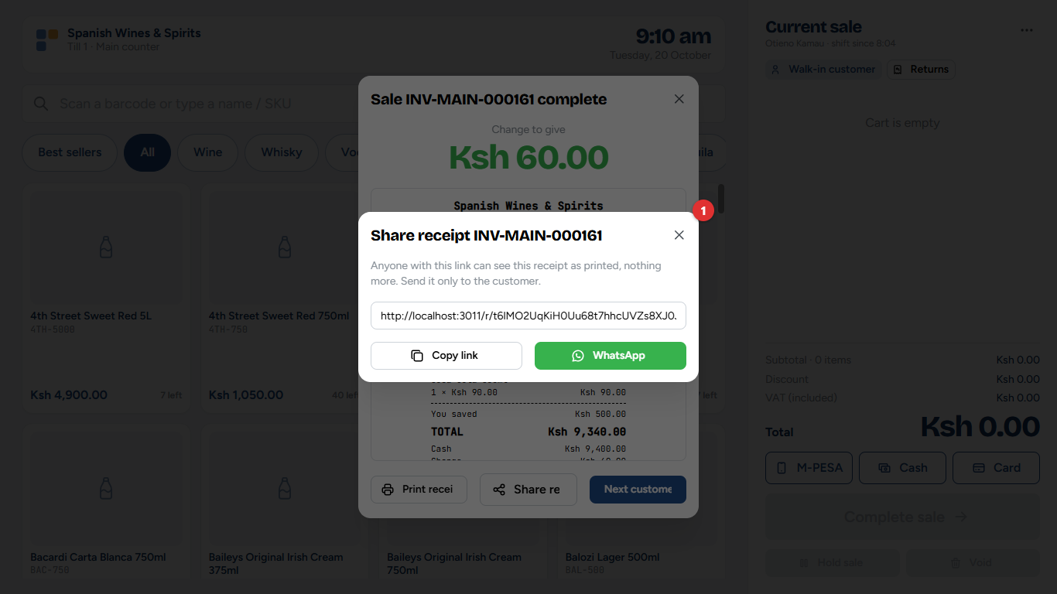
Figure 3.16: Sharing a receipt link
The link (1) opens the receipt on the customer's phone, exactly as printed. Tap Copy link, or WhatsApp to send it in a WhatsApp message. Send it only to the customer.
The tax invoice is sent to KRA's eTIMS automatically. If the receipt says eTIMS invoice pending, KRA's signature follows a few seconds later; reprint the receipt if the customer needs it.

Holding a sale (park and recall)
When a customer goes back to fetch something, park their sale and serve the next person.
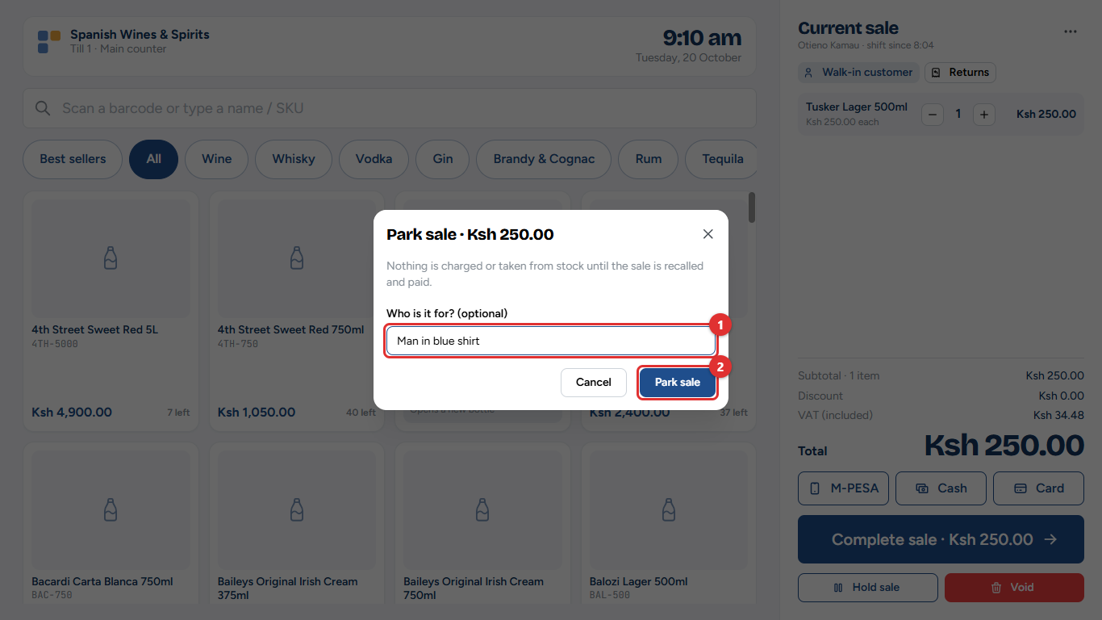
Figure 3.17: Parking a sale
1. Tap Hold sale (under Complete sale), or Park sale in the till menu.
2. Type a note so you can find it again (1), for example Man in blue shirt.
3. Tap Park sale (2).
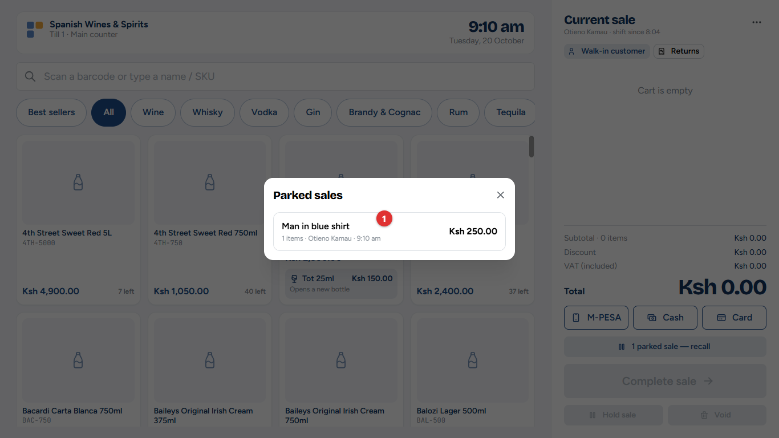
Figure 3.18: Recalling a parked sale
To bring it back, tap 1 parked sale — recall above Complete sale, or Recall parked in the till menu, and tap the sale (1).

Removing everything: Void
Void (next to Hold sale) clears the whole sale. A manager's PIN is needed when the sale is above the amount set by the owner. Every void is recorded in the Voids, discounts & price overrides report.

When the internet is down
The till keeps selling. A yellow banner says Offline — still selling.
• Cash and card work as usual.
• M-PESA: ask the customer to pay to the till number, check the amount on their message, and type the M-PESA code from it. The code is checked with Safaricom when the connection is back; a manager is told if it cannot be confirmed.
• Returns, M-PESA payment requests, manager approvals and ending the shift wait for the connection.
Offline sales are saved on the till and sent by themselves when the connection is back. Do not close the browser or switch the computer off until the banner says they have been sent.
Common mistake: Clearing the browser's history or data on the till while it has offline sales waiting. Those sales would be lost. Wait until they have been sent.

Outside licensed hours
If the owner has switched on the licensed-hours lock, the till shows Outside licensed hours: alcohol cannot be sold and refuses alcohol until the licensed hours start again. Soft drinks, water and other items can still be sold.

4. During and after a shift
This chapter covers everything at the till that is not a sale: returns and reprints, the receipt printer, moving cash to the safe, paying for small expenses from the drawer, leaving the till, handing over to another cashier, and counting the cash at the end of the shift.
Who: cashiers, with a manager for the steps that need a witness. Where: the till menu (the ⋯ button next to Current sale).

Returns and reprints
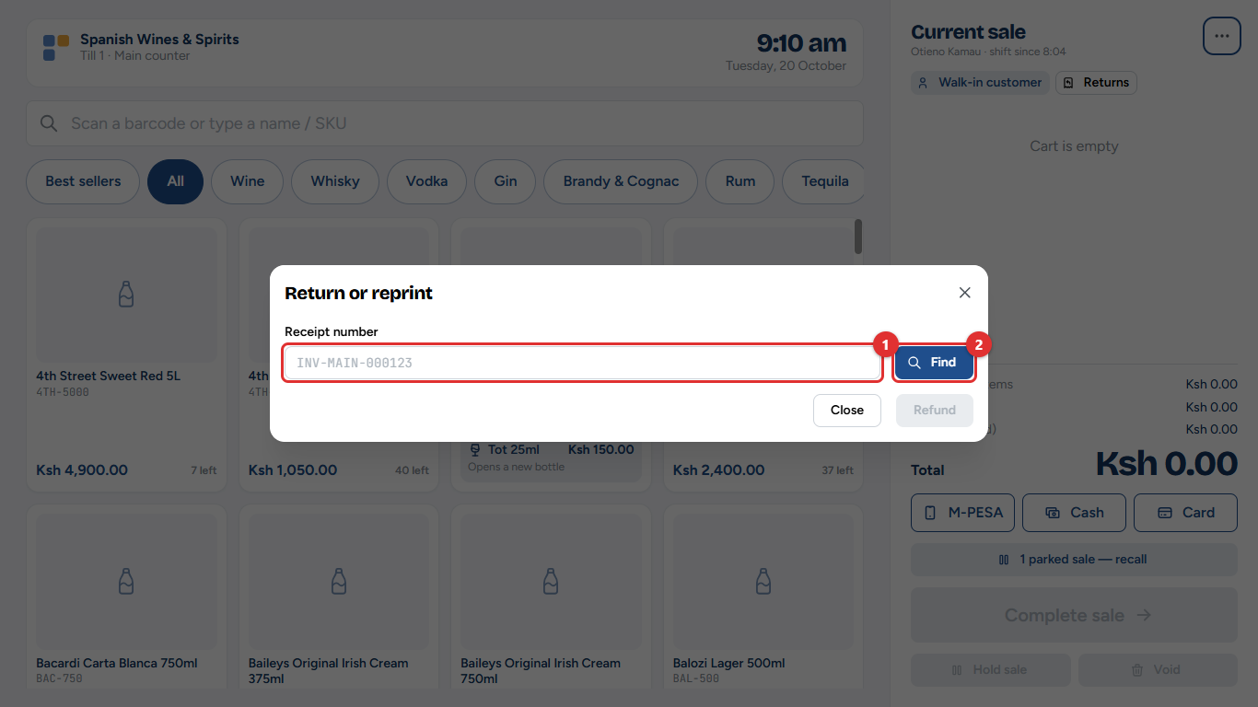
Figure 4.1: Return or reprint
Open the till menu and choose Return / reprint (or tap Returns under Current sale).
1. Type the receipt number (1) from the customer's receipt, for example INV-MAIN-000161, and tap Find (2).
2. To print another copy, tap Reprint receipt. You can stop here.
3. For a return, enter how many of each item come back.
4. Tick Sealed for a bottle that is unopened and can go back on the shelf. Leave it unticked for an opened, broken or faulty item: it goes to a separate quarantine area for the manager to check, and is not sold again by mistake.
5. Type the Reason, then tap Refund.
6. If the shop's settings ask for it, a manager approves the refund with their PIN.
The refund is paid in cash from the drawer, even when the customer paid by M-PESA or card. The till says how much to give back. Chapter 2 (Step 7) shows each screen of a return.
What changes elsewhere: the stock goes back, a credit note is sent to eTIMS, and the expected cash for the shift goes down by the refund.
Important: Returns are accepted only for a set number of days after the sale (the owner sets this). After that, the till says returns are closed for that sale.

The receipt printer
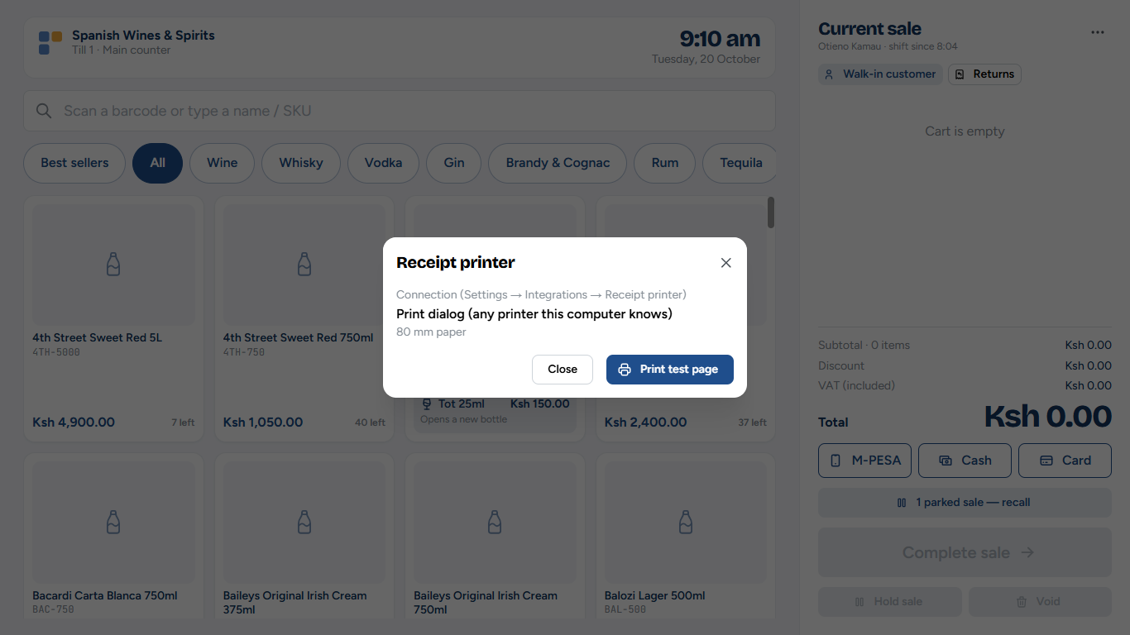
Figure 4.2: Checking the receipt printer
Till menu → Printer shows how this till prints and lets you Print test page. If the printer is connected directly (USB or serial), the window also has buttons to connect it and to test the cash drawer.
How each till prints is chosen by the owner under Administration → Settings → Integrations → Receipt printer (chapter 12).
Tip: If nothing prints, check that the printer is on, has paper and is plugged in, then print a test page. Receipts can always be reprinted from Return / reprint.

Cash drop to the safe
Too much cash in the drawer is a risk. During the shift, move some to the safe.
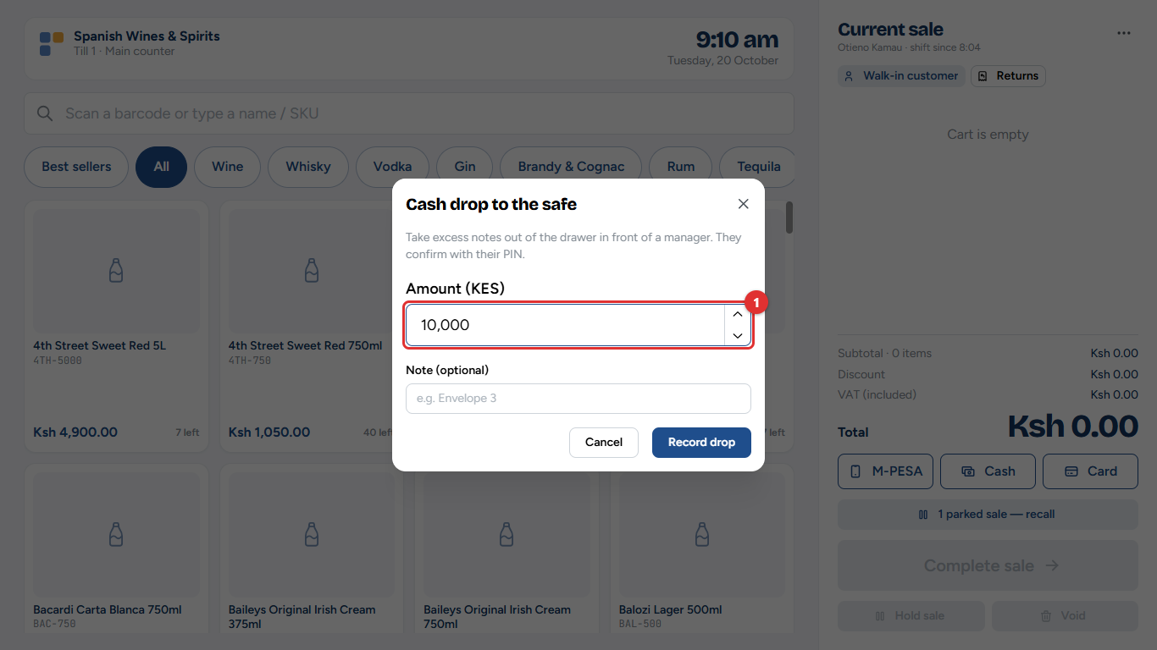
Figure 4.3: Cash drop to the safe
1. Till menu → Cash drop to safe.
2. Type the Amount (1) and, if you like, a note such as the envelope number.
3. A manager witnesses the drop with their PIN.
The drop is taken off the cash expected in the drawer at the end of the shift.

Paying out cash for an expense
For a small expense paid from the drawer, such as a boda rider for a delivery:
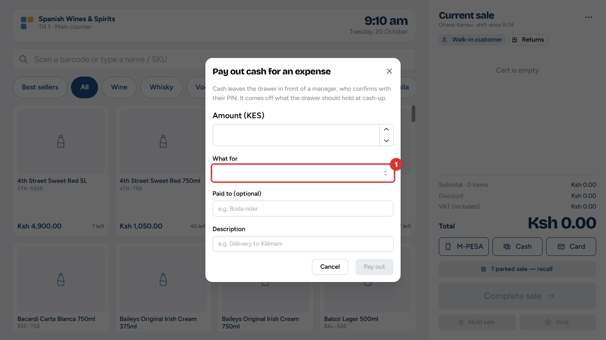
Figure 4.4: Pay out cash for an expense
1. Till menu → Pay out cash (expense).
2. Type the amount, choose What for (1) (the expense category), who was paid, and a short description.
3. A manager witnesses the payout with their PIN.
The payout is recorded as an expense (chapter 10) and taken off the cash expected in the drawer.

Leaving the till: lock screen
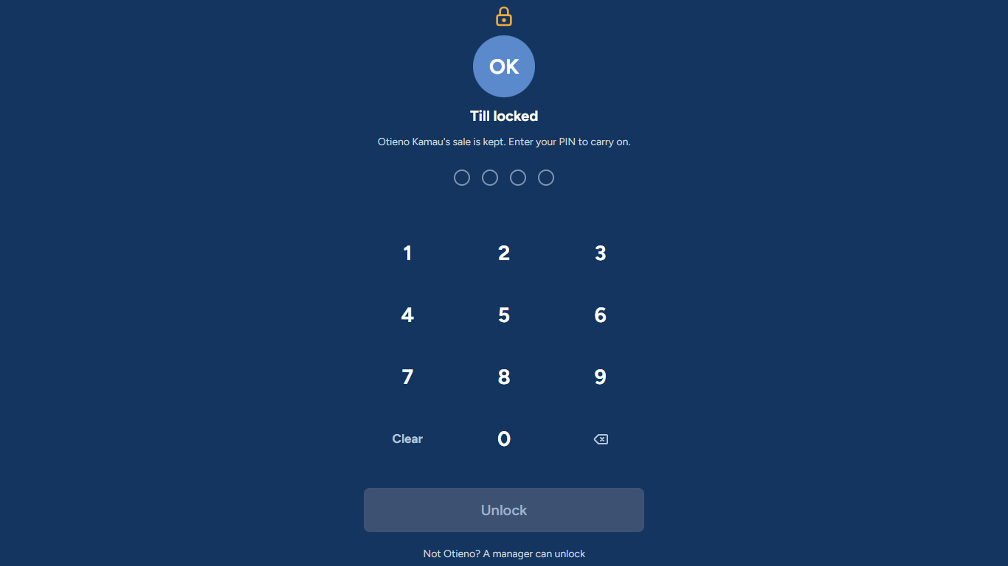
Figure 4.5: The till is locked; the sale is kept
Till menu → Lock screen (keeps the sale) locks the till while you step away. The till also locks itself after a short time without use.
• To carry on, type your PIN and tap Unlock. The sale is exactly as you left it.
• If you cannot come back, a manager taps *Not (name)? A manager can unlock*, chooses their name and types their PIN.

Handing over: switch cashier
Till menu → Switch cashier goes back to Who's on the till? without ending your shift, so another cashier can sign in with their own PIN. The sale must be empty first (complete, park or clear it).
Common mistake: Selling on someone else's shift. Each sale and every shilling in the drawer belongs to the cashier who is signed in. Always switch cashier, never "just use" the open screen.

Ending the shift: counting the cash
At the end of the shift, the cashier counts the drawer. The sale must be empty, and any offline sales must have been sent.
Figure 4.6: Counting the drawer, note by note
1. Till menu → End shift.
2. Enter how many of each note and coin are in the drawer (1). The total (2) adds up as you type.
3. Add a note if something needs explaining, and tap Submit count (3).
The till does not show how much it expected until the count is submitted, so the count is honest.
Figure 4.7: The result: expected, counted and the difference
The till then shows:
Line | Meaning
Expected (1) | Opening float + cash sales − cash refunds − cash drops − payouts
Counted (2) | What you counted
Variance / Short / Over (3) | The difference. Zero means the drawer balances.

If the drawer is short or over, the cashier must type why before finishing (for example Gave KES 100 too much change to a customer). Tap Done. The till goes back to Who's on the till?.
What changes elsewhere: the cash-up waits for a manager's sign-off under Sales & Shifts → Shifts & cash-ups (chapter 5). A shortage is shown on the dashboard and sent as an alert.

At a glance
Task | Where | Needs a manager?
Reprint a receipt | Till menu → Return / reprint | No
Return or refund | Till menu → Return / reprint | Yes, if the shop's settings say so
Test the printer | Till menu → Printer | No
Cash to the safe | Till menu → Cash drop to safe | Yes (witness)
Small expense from the drawer | Till menu → Pay out cash (expense) | Yes (witness)
Step away | Till menu → Lock screen | Only if you cannot unlock it yourself
Hand over | Till menu → Switch cashier | No
End of shift | Till menu → End shift | Signs off the cash-up afterwards

5. Sales and cash-ups
Every sale made at any till, and every shift's cash count, can be looked at from the back office. This is where a manager finds a receipt, checks a refund and signs off the cash-ups.
Who: owner, admin, branch managers and the accountant (managers see only their own branches). Where: Sales & Shifts → Sales and Shifts & cash-ups.

Finding a sale
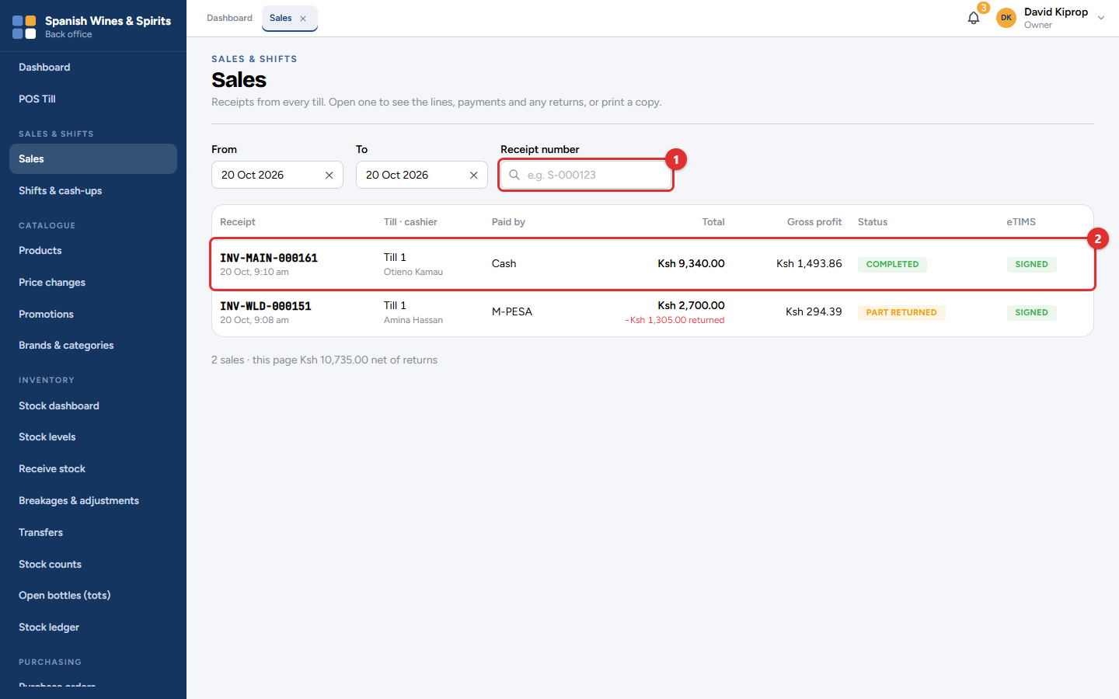
Figure 5.1: Sales & Shifts → Sales
The list opens on today's sales. Change the From and To dates to look further back, or type a Receipt number (1) to go straight to one sale.
Each row (2) shows:
Column | Meaning
Receipt | The receipt number and time. The middle part is the branch (for example MAIN or WLD).
Till · cashier | Which till, and who was signed in.
Paid by | Cash, M-PESA, card, on account, or split.
Total | What the customer paid. Any amount returned later is shown in red underneath.
Gross profit | The total less VAT and the cost of the goods (shown only to people allowed to see profit).
Status | Completed, Part returned or Returned.
eTIMS | Signed when KRA has signed the invoice; Pending for a few seconds after the sale.

Under the list, the number of sales and their total, net of returns.
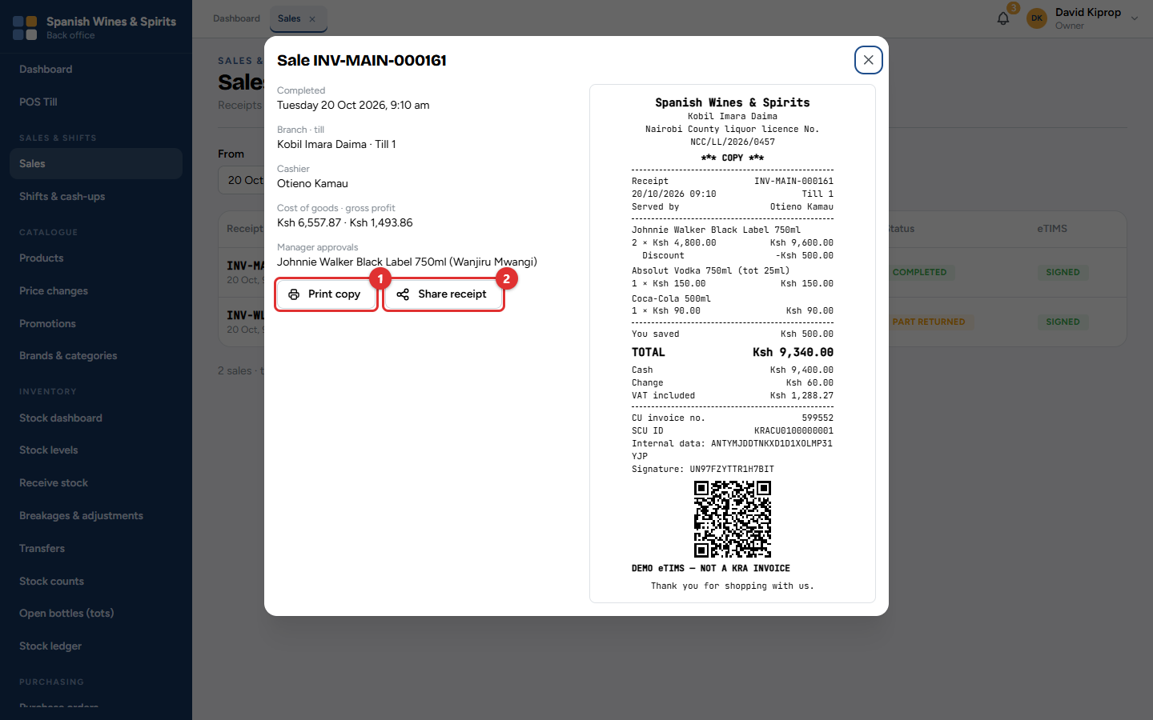
Figure 5.2: A sale's details
Click a sale to see its items, payments, VAT, any returns and the eTIMS invoice number. From here:
• Print copy (1) prints the receipt again.
• Share receipt (2) creates a link to send to the customer (see chapter 3).
Important: A completed sale can never be edited or deleted. A mistake is corrected with a return at the till, which keeps a full record of what happened.

Checking and signing off cash-ups
At the end of every shift, the cashier counts the drawer (chapter 4). A manager then checks the count and signs it off.
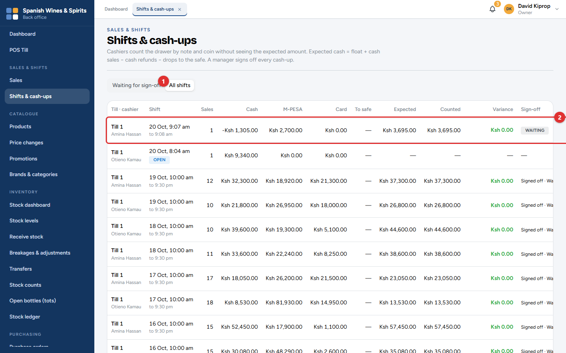
Figure 5.3: Sales & Shifts → Shifts & cash-ups
The screen opens on Waiting for sign-off (1). Choose All shifts to see every shift, including the ones still open.
Each row (2) shows the till, the cashier, when the shift ran, the number of sales, the takings by cash, M-PESA and card, the cash moved to the safe, and:
Column | Meaning
Expected | Opening float + cash sales − cash refunds − cash drops − payouts.
Counted | What the cashier counted.
Variance | Counted − expected. Green when the drawer balances.
Sign-off | Waiting, or who signed it off and when.

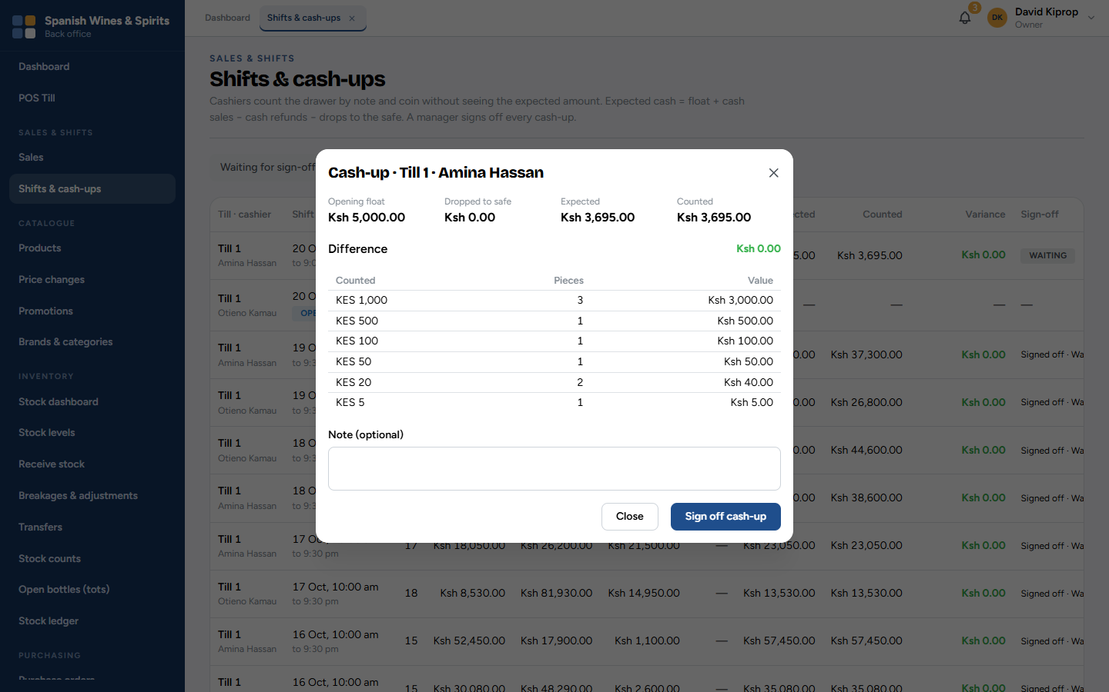
Figure 5.4: One cash-up, note by note
1. Click a row to open the cash-up. It shows the float, cash to the safe, expected and counted, and every note and coin counted.
2. If the cashier gave a reason for a difference, it is shown here.
3. Add a note if needed, then click Sign off cash-up.
Tip: Sign off cash-ups every day. A shortage is easier to explain the same evening than a week later.
Common mistake: Treating a small overage as good news. Cash over usually means a sale was not rung up, or the wrong change was given. Ask the cashier.
What changes elsewhere: signed-off cash-ups appear in the Shift cash-up & variance report (chapter 11). A shortage also raises an alert for the owner and managers.

6. Products, prices and promotions
The catalogue is the list of everything the shop sells: each product, its sizes, barcodes and prices, and the promotions that take money off automatically at the till.
Who: the owner and admin manage the catalogue. Branch managers, storekeepers and the accountant can look. New prices and promotions are approved by the owner. Where: the Catalogue menu.

Products and sizes
A product is a drink, such as Johnnie Walker Black Label. Each size of it (200 ml, 375 ml, 750 ml, 1 L) is a separate item with its own product code (SKU), barcode, price and stock. A pack (for example a crate of 24 beers) is a way of selling or receiving several of one size at once.
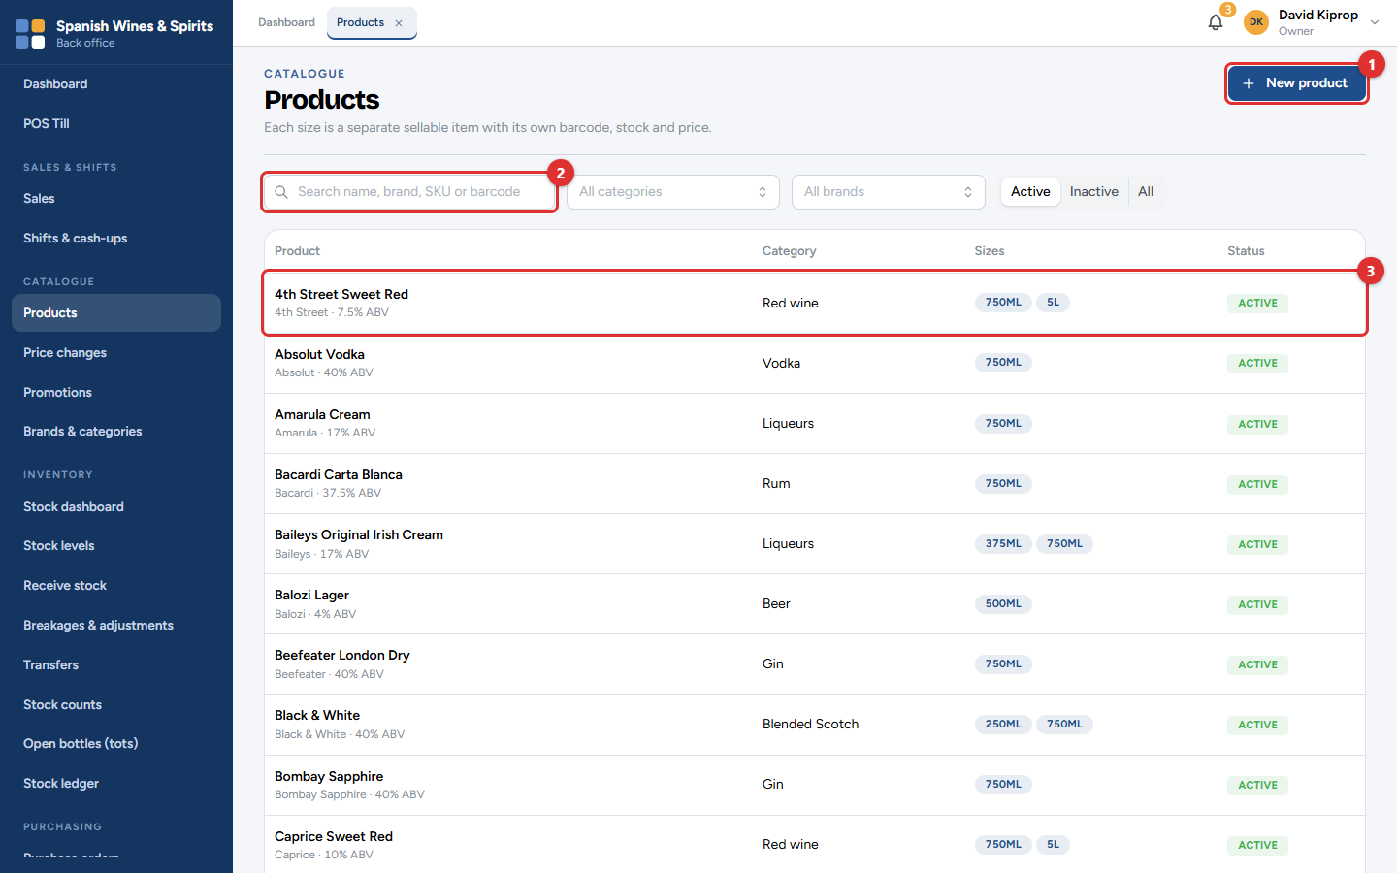
Figure 6.1: Catalogue → Products
• New product (1) adds a product.
• Search by name, brand, SKU or barcode (2), or filter by category and brand.
• Each row (3) shows the product, its category and its sizes. Click it for the details.
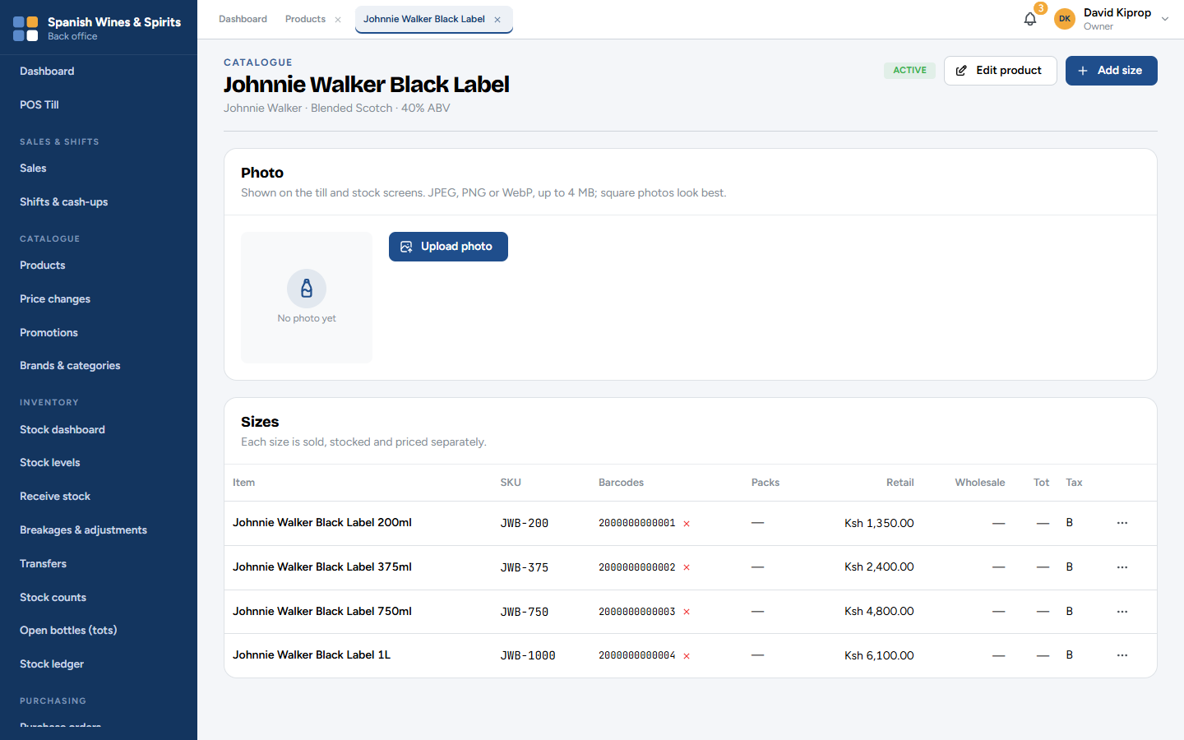
Figure 6.2: A product and its sizes
On a product:
• Upload photo adds a picture, shown on the till and stock screens. Use a clear photo of the bottle, square if possible.
• Edit product changes the name, brand, category or description.
• Add size adds another size.
• The ⋯ button on each size has: Edit size, Add barcode, Add pack, Change price, Price history and Set reorder level.
The Tot column shows the tot price for sizes that can be poured by the tot. The Tax column shows the VAT class used on the eTIMS invoice.

Adding a product
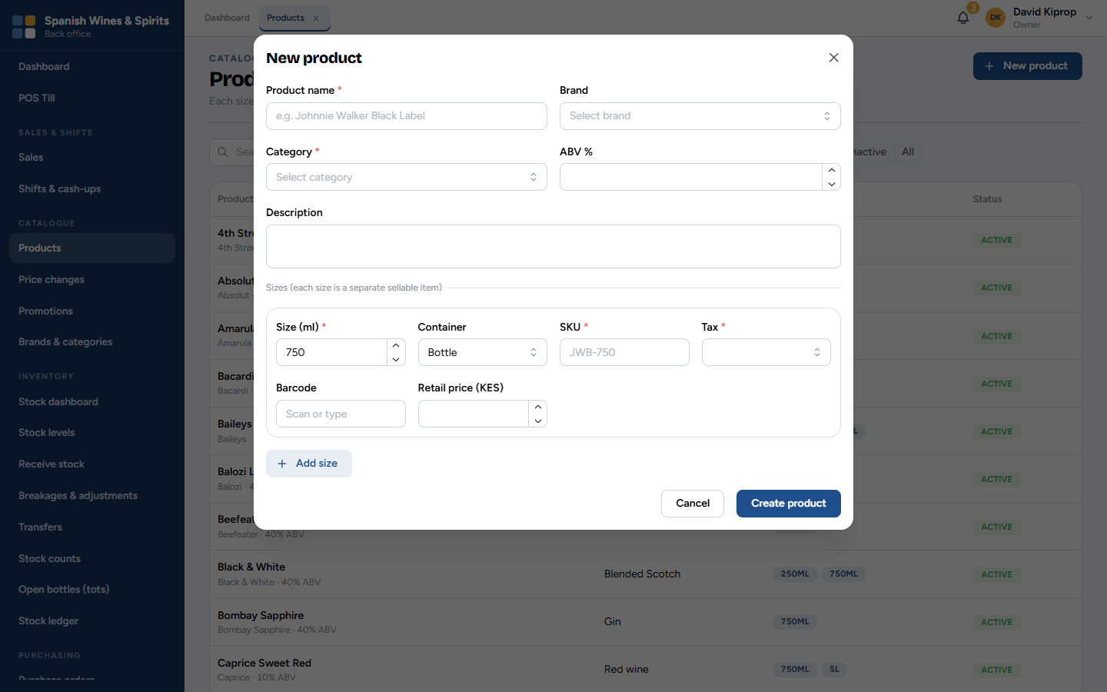
Figure 6.3: New product
1. Type the Product name, and choose the Brand and Category. The ABV % (alcohol strength) is optional.
2. For each size, enter the Size (ml), the Container (bottle, can, box…), a short SKU, the Tax class, the Barcode (scan it) and the Retail price.
3. Click Add size for each extra size, then Create product.
Important: Choose the tax class carefully. It decides the VAT on the eTIMS invoice. Ask your accountant if you are not sure. Most alcoholic drinks are standard-rated (16%).
Common mistake: Typing a barcode by hand. Scan it from the bottle: one wrong digit means the till cannot find the item.

Prices
Prices are set centrally for every branch, so all branches charge the same and tax invoices stay correct. Each size can have:
• a retail price (walk-in customers);
• a wholesale price (registered wholesale customers);
• a tot price, if it is sold by the tot.
To change a price, open the product, click ⋯ on the size, then Change price. Choose the price type, type the New price, the date it starts (Effective from, or leave empty for straight away) and a Reason.
A price change by anyone other than the owner waits for the owner's approval.
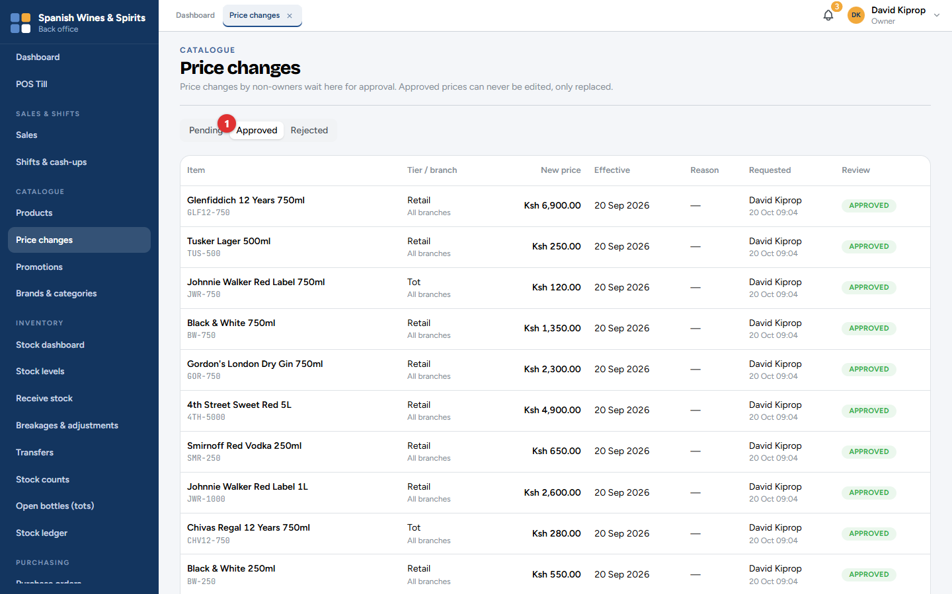
Figure 6.4: Catalogue → Price changes
Pending (1) lists the changes waiting. The owner clicks Approve or Reject. Approved and Rejected keep the history. An approved price is never edited: a new change replaces it, so you can always see what was charged when.
Tip: Branch managers cannot change prices. At the till they can still approve a discount on a sale, up to their limit.

Promotions
A promotion takes money off automatically at the till when the sale qualifies. Nobody needs to remember it.
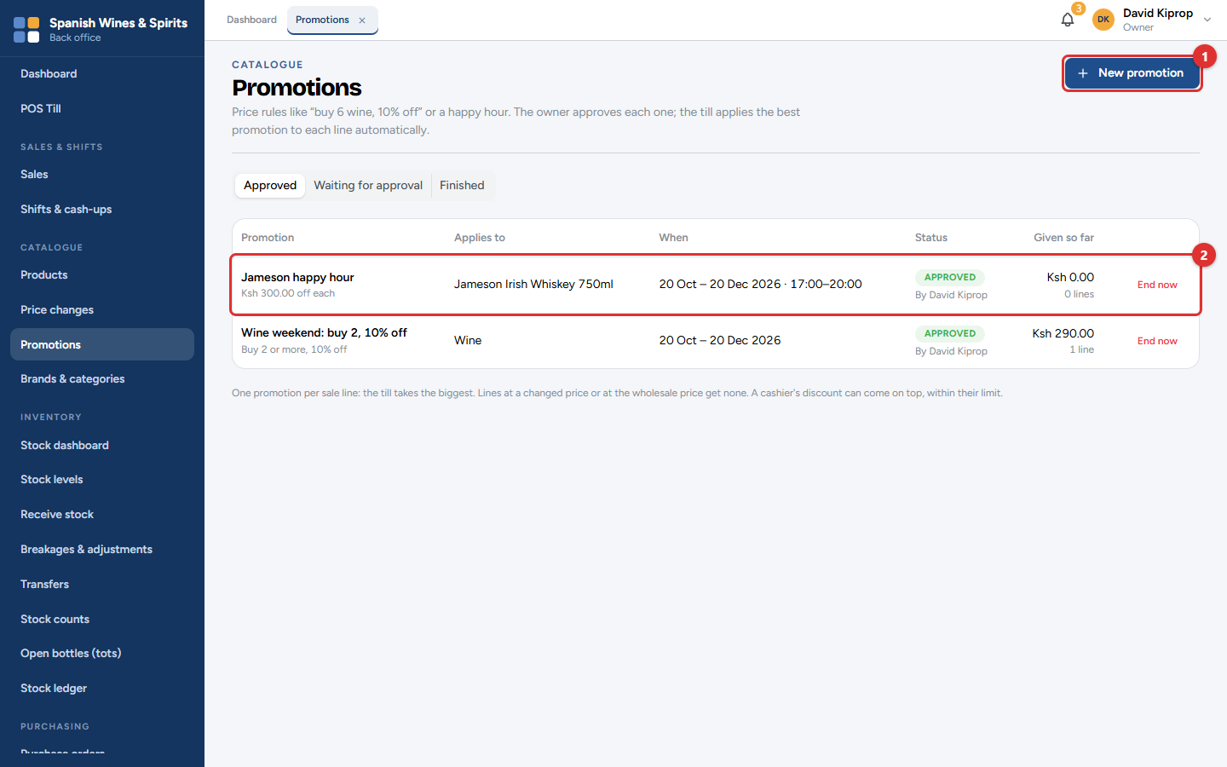
Figure 6.5: Catalogue → Promotions
• New promotion (1) creates one.
• The list (2) shows each promotion, its status and how much discount it has given so far. End now stops one early.
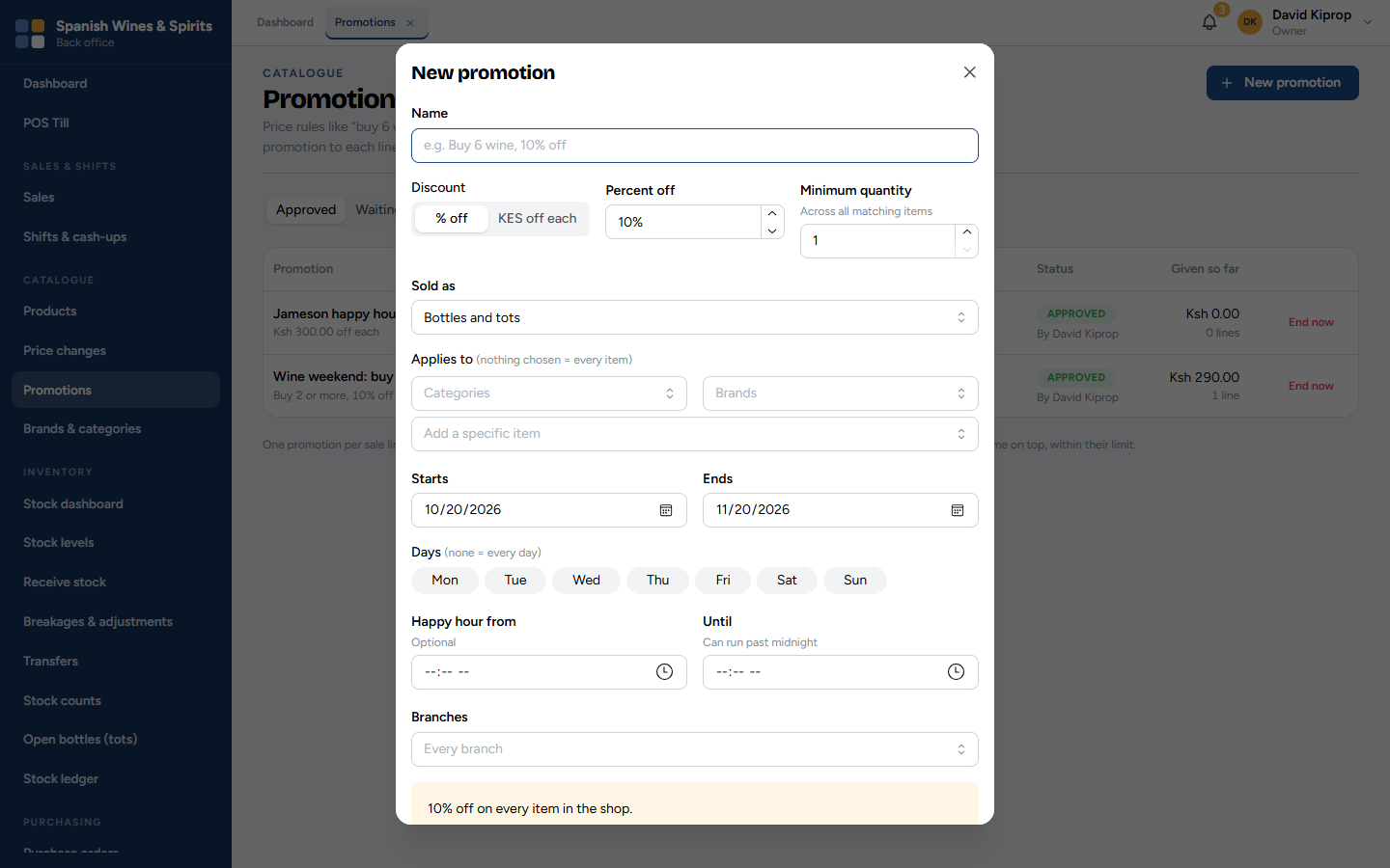
Figure 6.6: A new promotion
1. Give it a Name the customer will understand, such as Wine weekend: buy 2, 10% off. It is printed on the receipt.
2. Choose % off or KES off each, and the amount.
3. Minimum quantity: how many matching items must be in the sale (across all matching items).
4. Sold as: bottles, tots, or both.
5. Applies to: categories, brands or particular items. Leave it empty for every item.
6. Starts and Ends; optionally the Days of the week and Happy hour times (which can run past midnight).
7. Branches: leave empty for every branch.
8. The yellow box at the bottom repeats the promotion in plain words. Check it, then save.
A new promotion waits for the owner's approval (Waiting for approval) and starts only when approved.
Important: Only one promotion applies to each item in a sale: the best one for the customer. A manager's discount at the till can still be added on top, within their limit.

Brands and categories
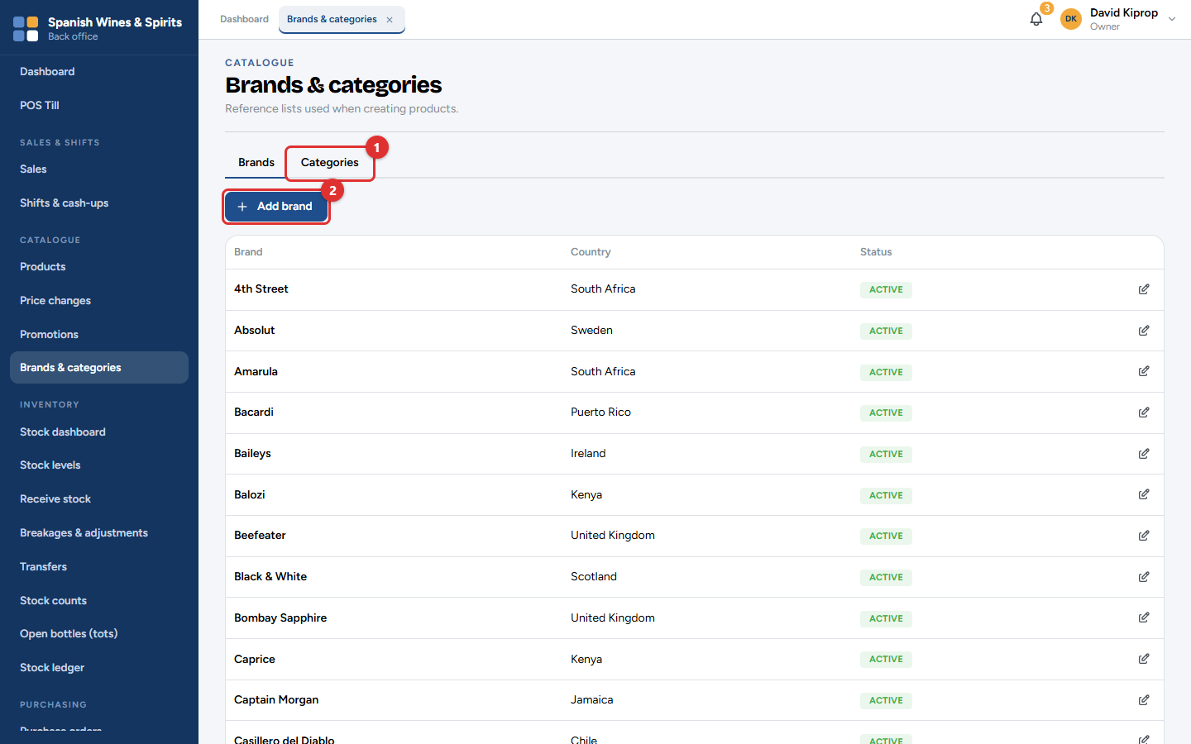
Figure 6.7: Catalogue → Brands & categories
Use the Brands and Categories (1) tabs to keep the lists tidy. Add brand (2) (or Add category) adds one; the pencil button edits one. Categories are the chips across the top of the till (Wine, Whisky, Vodka…), so keep them short.

7. Stock
Tessera keeps track of every bottle at every branch. Stock is never typed in directly: it goes up when a delivery is received or a customer returns something, and down when something is sold, broken or moved. Each of those is a record in the stock ledger, so the stock figure can always be explained.
Each branch has three places for stock:
Place | What is there
Shop floor | On the shelves, for sale. The till sells from here.
Back store | Stored stock, not yet on the shelves.
Quarantine | Damaged items, and opened or faulty returns, waiting for a manager. They cannot be sold.

Who: storekeepers do most of the work; branch managers approve; the owner, admin and accountant can look at everything. Where: the Inventory menu.

Stock dashboard
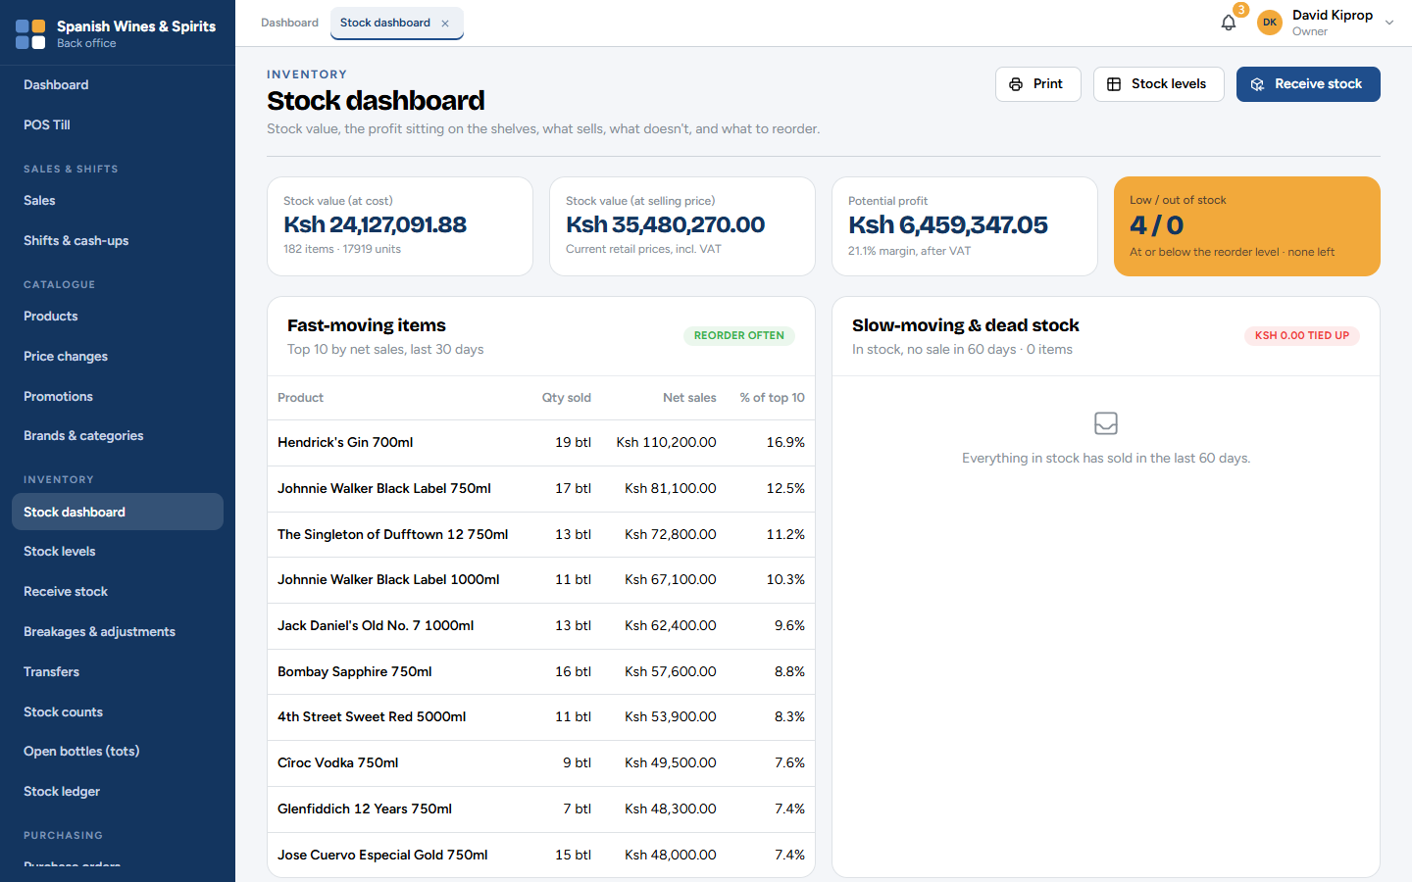
Figure 7.1: Inventory → Stock dashboard
The stock dashboard shows, for the branches you can see:
• Stock value at cost and at selling price, and the potential profit between them;
• Low / out of stock (amber when something needs attention);
• Fast-moving items (order these often) and slow-moving & dead stock (money tied up on the shelf).
Receive stock, Stock levels and Print are at the top right.

Stock levels
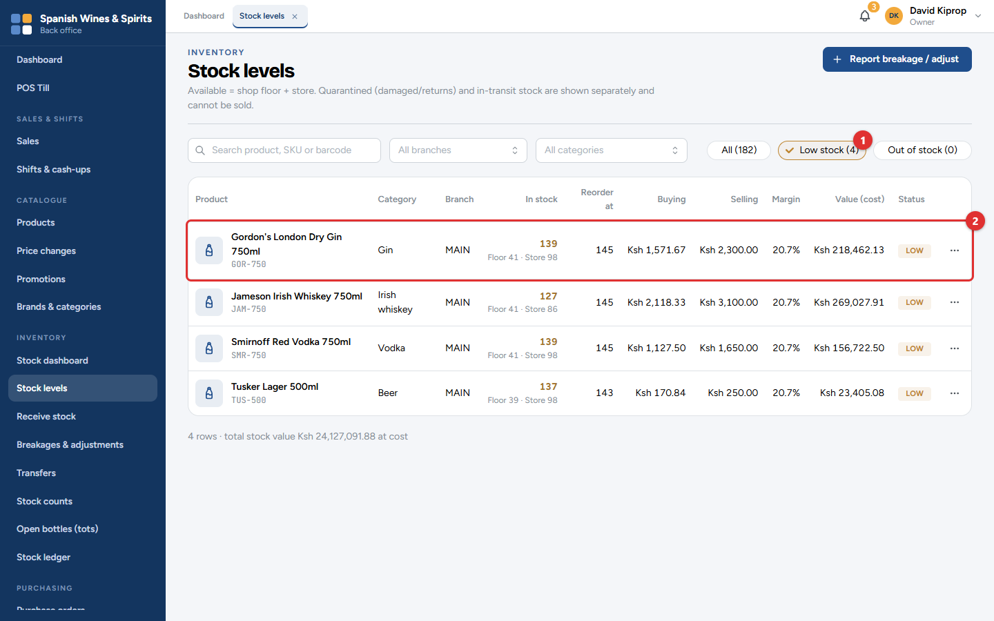
Figure 7.2: Inventory → Stock levels, showing only the items running low
Search by product, SKU or barcode, or filter by branch and category. Low stock (1) and Out of stock show only the items that need ordering.
Each row (2) shows the stock in hand (split into shop floor and store), the reorder level, the buying and selling price, the margin, the stock value and a status badge: In stock, Low or Out.
The ⋯ button on a row sets that item's reorder level: when stock falls to this number, the item counts as low, and the owner and managers get an alert.
Tip: Set reorder levels on your best sellers first. Start with about two weeks of sales and adjust over time.

Receiving a delivery
Deliveries are received against an approved purchase order (chapter 8).
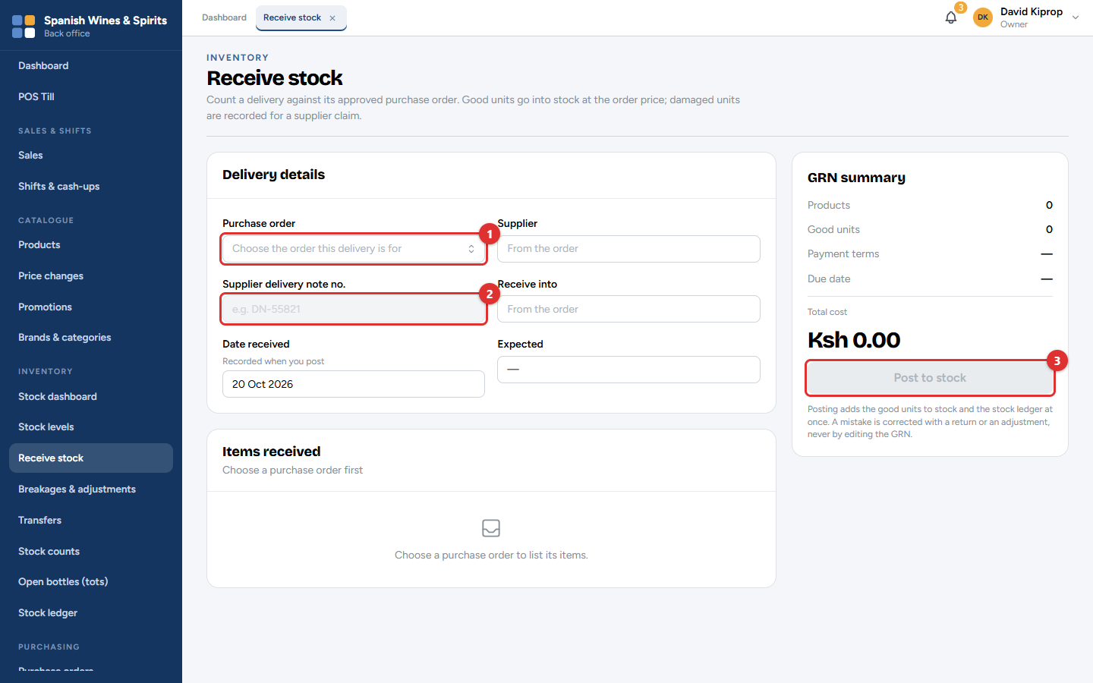
Figure 7.3: Inventory → Receive stock
1. Choose the Purchase order (1) the delivery is for. The supplier, the branch and what is expected fill in by themselves.
2. Type the Supplier delivery note no. (2) from the driver's paperwork.
3. For each item, count what has arrived and enter the good quantity, and any damaged units separately.
4. Check the summary on the right, then click Post to stock (3).
Good units go onto the stock straight away at the order's price. Damaged units are recorded for a claim against the supplier (Returns to supplier, chapter 8). The record of the delivery is the GRN (goods-received note).
Important: Count before you post. A posted delivery cannot be edited: a mistake is corrected with a return to the supplier or a stock adjustment.

Breakages and adjustments
Any stock lost or found outside a sale, delivery or transfer is an adjustment: breakage, theft, spoilage, expired goods, a correction after a count.
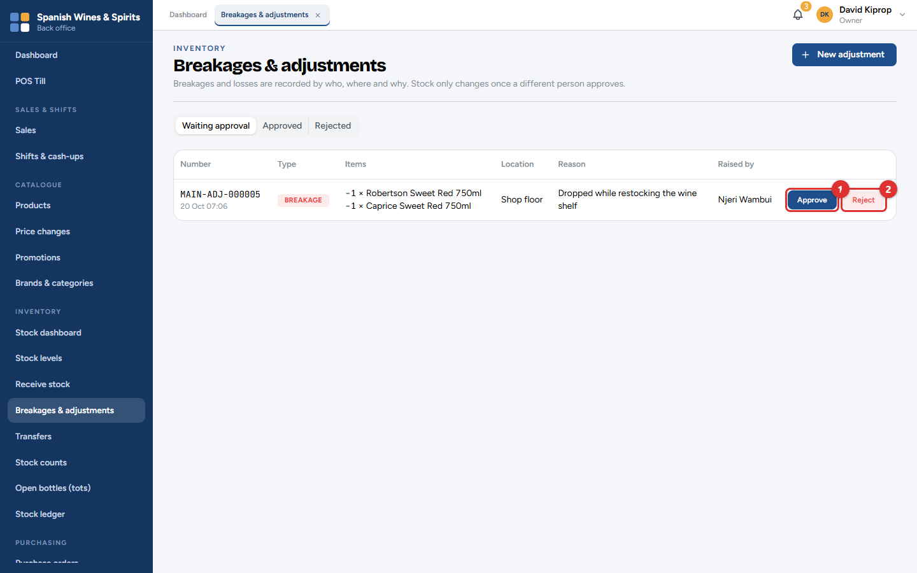
Figure 7.4: Inventory → Breakages & adjustments, with one waiting for approval
Adjustments waiting for a manager are listed first. The manager checks each one and clicks Approve (1) or Reject (2).
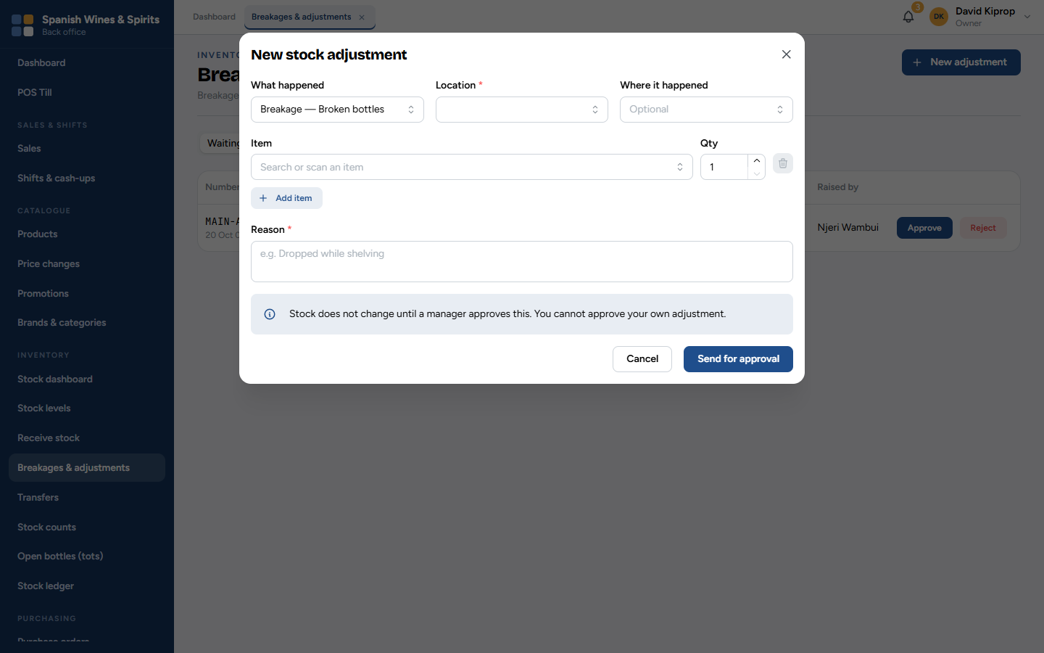
Figure 7.5: A new stock adjustment
1. Click New adjustment (or Report breakage / adjust on Stock levels).
2. Choose What happened, the Location (shop floor, store or quarantine) and, if you like, where it happened.
3. Add each Item and Qty.
4. Type the Reason, for example Dropped while shelving, and click Send for approval.
The stock does not change until a manager approves it, and nobody can approve their own adjustment.

Transfers
A transfer moves stock between branches, or from the back store to the shop floor.
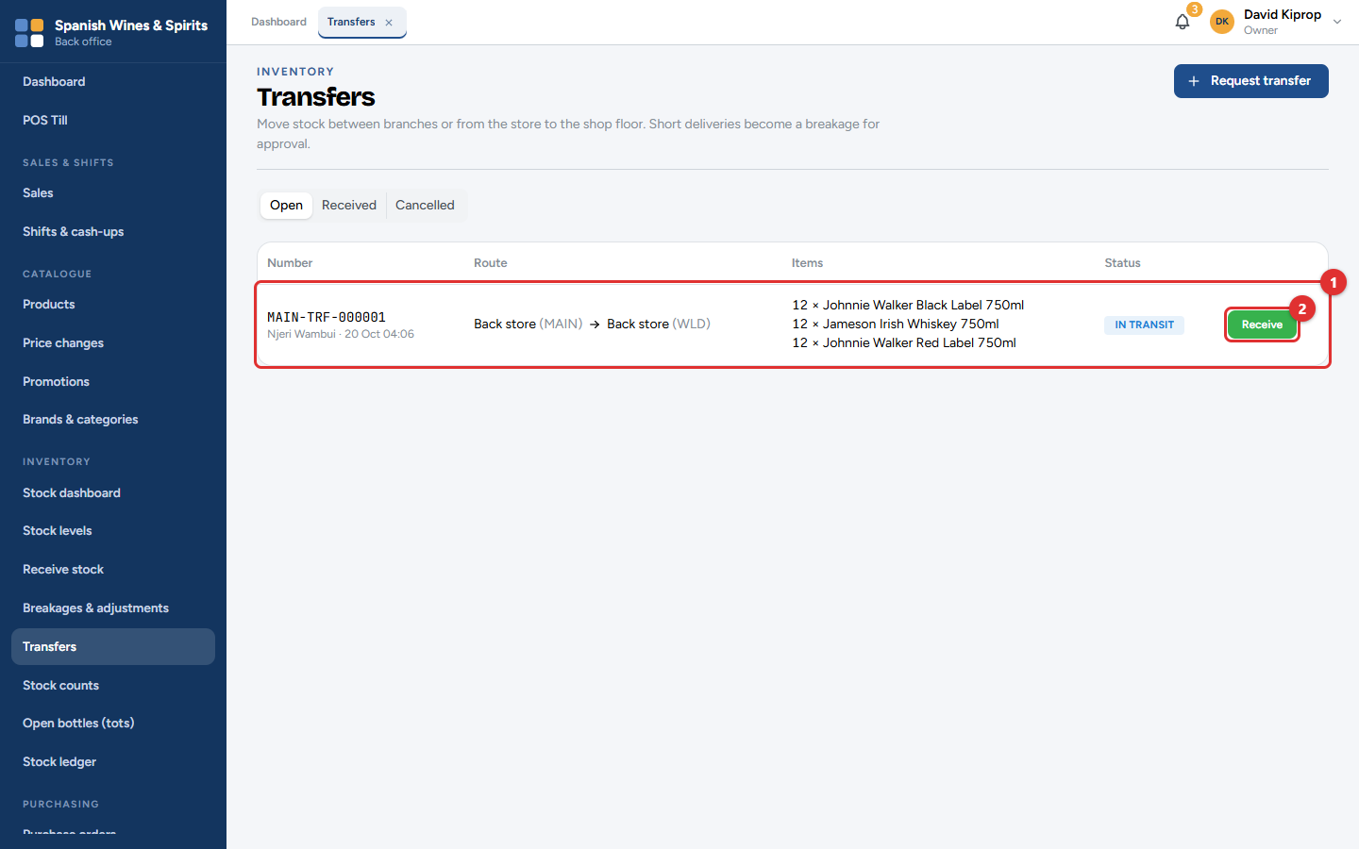
Figure 7.6: Inventory → Transfers: a transfer on its way
1. Request transfer: choose where from, where to, and the items. A manager approves it.
2. The sending branch dispatches it. It is now In transit (1): it has left one branch but not reached the other.
3. The receiving branch clicks Receive (2) and enters what actually arrived.
If less arrives than was sent, the difference becomes a breakage for a manager to approve.

Stock counts
A stock count (stock-take) checks what is really on the shelves against the system.
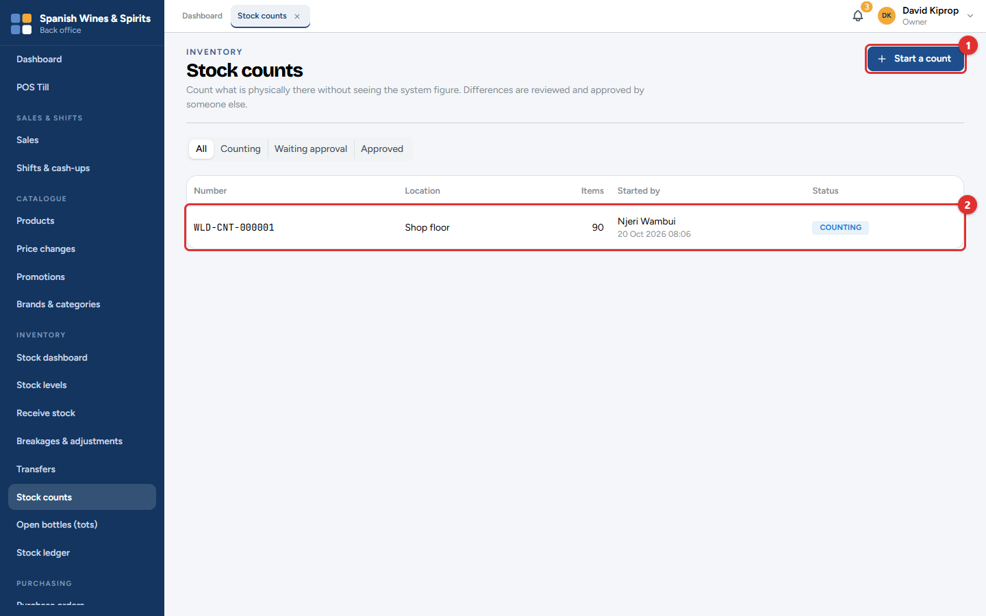
Figure 7.7: Inventory → Stock counts
Click Start a count (1), choose the branch and location, and whether it is a blind count. The count then appears in the list (2).
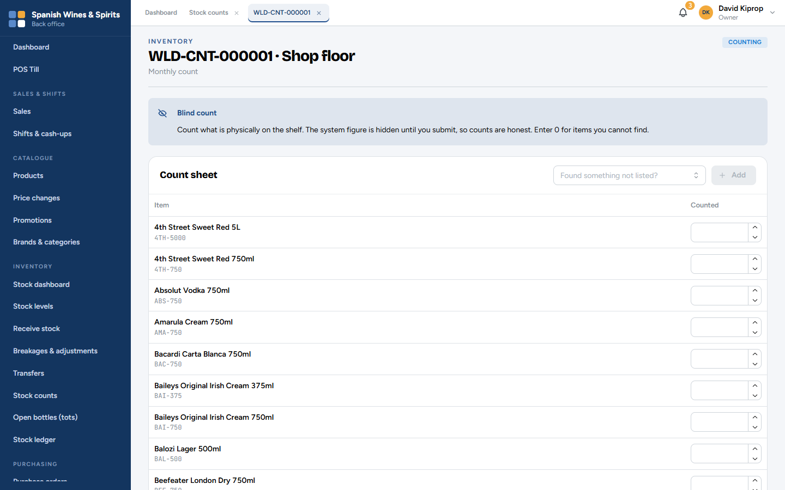
Figure 7.8: The count sheet (blind count)
1. Open the count and enter the number counted for each item. Enter 0 for an item you cannot find.
2. Found something not on the sheet? Add it with Found something not listed?.
3. Submit the count. With a blind count, the system's figure is shown only now, so the count is honest.
4. A manager reviews the differences and approves the count. The stock is then corrected, and the differences appear in the Stock count variance report.
Tip: Count one area at a time (for example the whisky shelf) at a quiet hour, and keep selling from the other shelves.

Open bottles (tots)
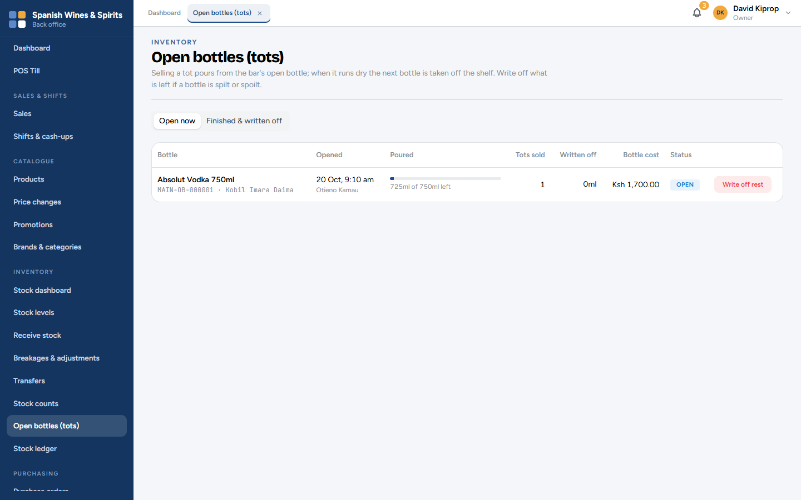
Figure 7.9: Inventory → Open bottles (tots)
When the till sells a tot, it pours from the open bottle of that spirit. When the bottle runs dry, the next one is taken off the shelf. This screen shows each open bottle and how much is left. Write off what is left if a bottle is spilt or spoilt; Finished & written off keeps the history.

Stock ledger
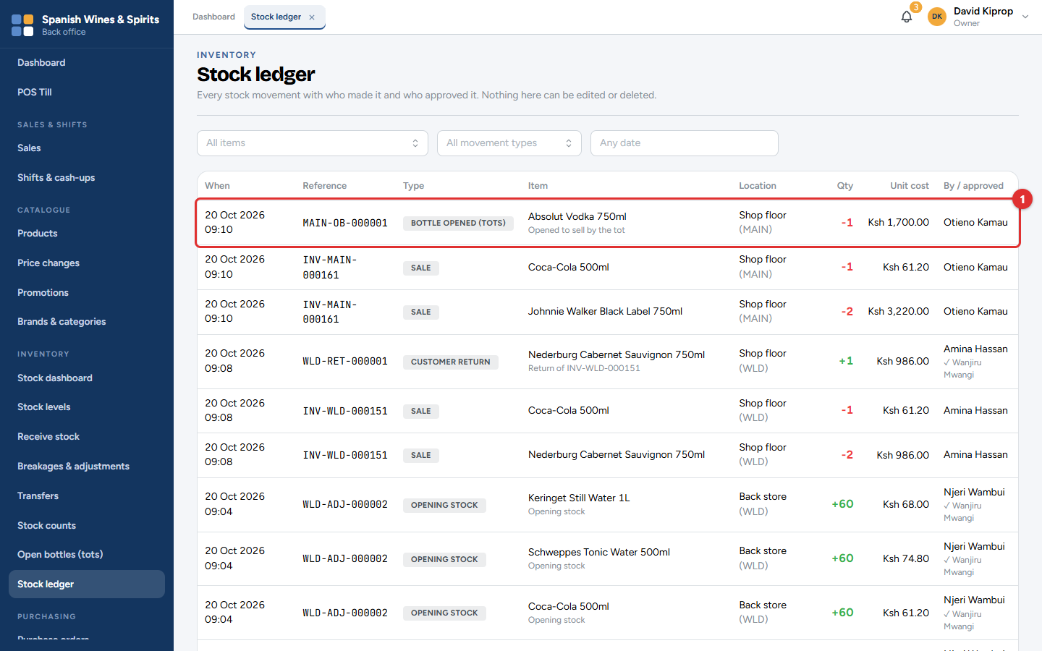
Figure 7.10: Inventory → Stock ledger
The ledger lists every movement of stock (1): sales, returns, deliveries, returns to suppliers, adjustments, transfers, counts and tots. Filter by item, movement type and dates. Each line shows who did it, when, and the document it came from.
Nobody can edit or delete the ledger. Every night, Tessera also checks that the stock figures agree with the ledger, and tells the owner if anything does not match.

8. Purchasing and suppliers
Buying stock follows the same path every time:
1. A purchase order says what you are ordering from a supplier.
2. Someone else approves it, and it is sent to the supplier.
3. The delivery is received against the order (chapter 7), and the stock goes up.
4. The supplier's invoice is recorded and compared with what was received.
5. The supplier is paid.
Each step is done by the right person, and nobody approves their own order.
Who: the owner, admin or accountant raise orders; a branch manager, the owner or an admin approves them (never their own); storekeepers and managers receive; the owner, admin or accountant record invoices and payments. Where: the Purchasing menu.

Purchase orders
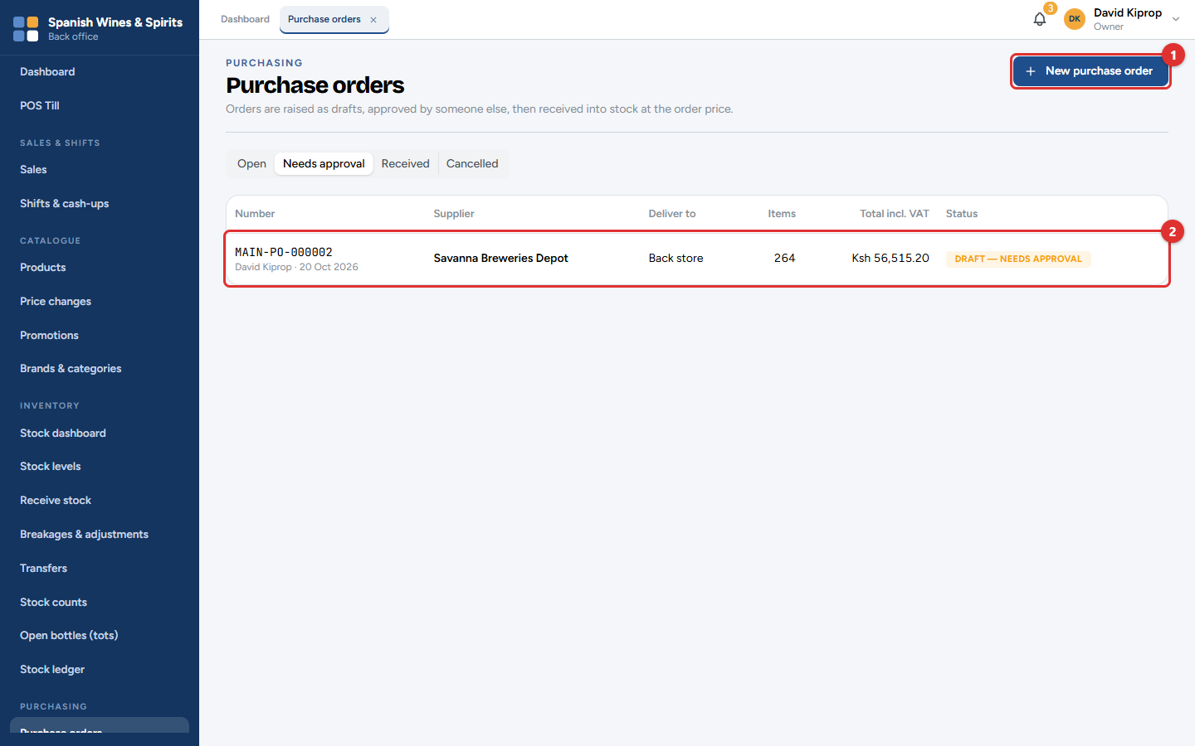
Figure 8.1: Purchasing → Purchase orders → Needs approval
The tabs show Open orders, those that Need approval, Received and Cancelled ones. Click New purchase order (1) to start one, or a row (2) to open it.

Raising an order
1. Click New purchase order.
2. Choose the Supplier and the branch it is for.
3. Search or scan each item and enter the quantity and the unit cost. The VAT and total are worked out for you.
4. Click Save draft. The order now waits for approval.
Chapter 2 (Step 9) shows the new-order screen. The Low stock & reorder suggestions report (chapter 11) is a good starting list.

Approving an order
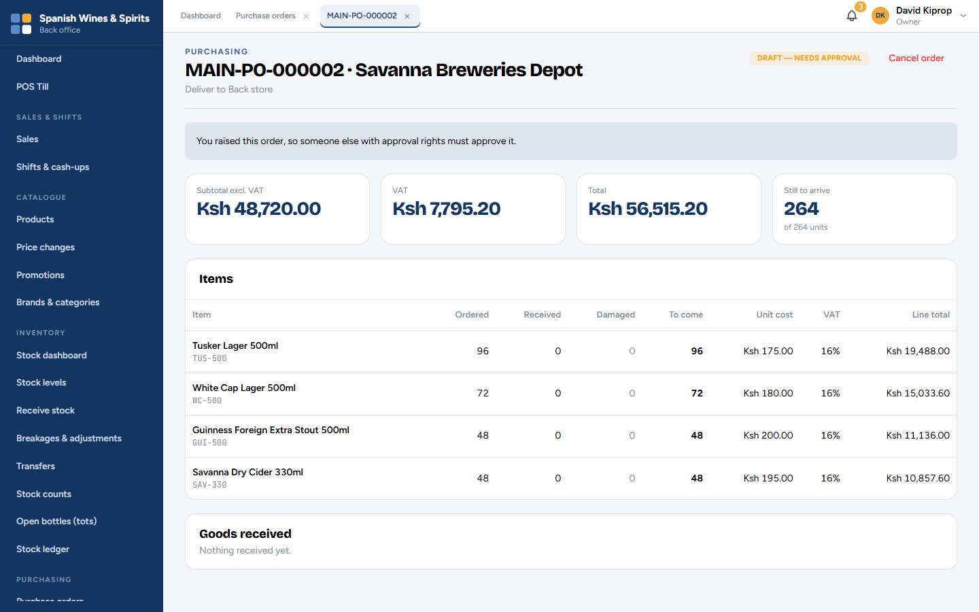
Figure 8.2: A purchase order waiting for approval
The order shows the supplier, where it will be delivered, the subtotal, VAT and total, and each item with the quantity ordered, received, damaged and still to come.
The person approving checks the items and prices, then clicks Approve (or Reject with a reason). The person who raised it sees You raised this order, so someone else with approval rights must approve it. Cancel order stops an order that is no longer needed.
Common mistake: Receiving goods that were not ordered. Only approved orders can be received. If the supplier brings extra, raise and approve an order for it first, or send it back.

Supplier invoices
When the supplier's invoice arrives, record it so you know what you owe.
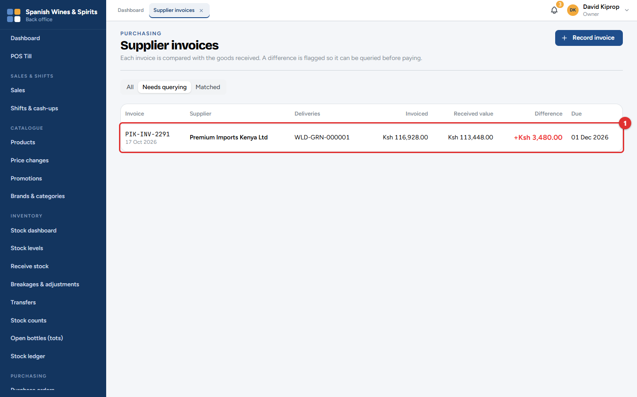
Figure 8.3: Purchasing → Supplier invoices → Needs querying
1. Click Record invoice, choose the supplier and the deliveries the invoice is for, and type the invoice number, date and amount.
2. Tessera compares the invoice with the value of the goods received. If they match, the invoice is Matched. If not, it goes to Needs querying (1) with the Difference in red.
Settle a difference with the supplier (a credit note, or the missing goods) before paying.

Returns to supplier
Damaged, wrong or expired goods go back to the supplier with a return.
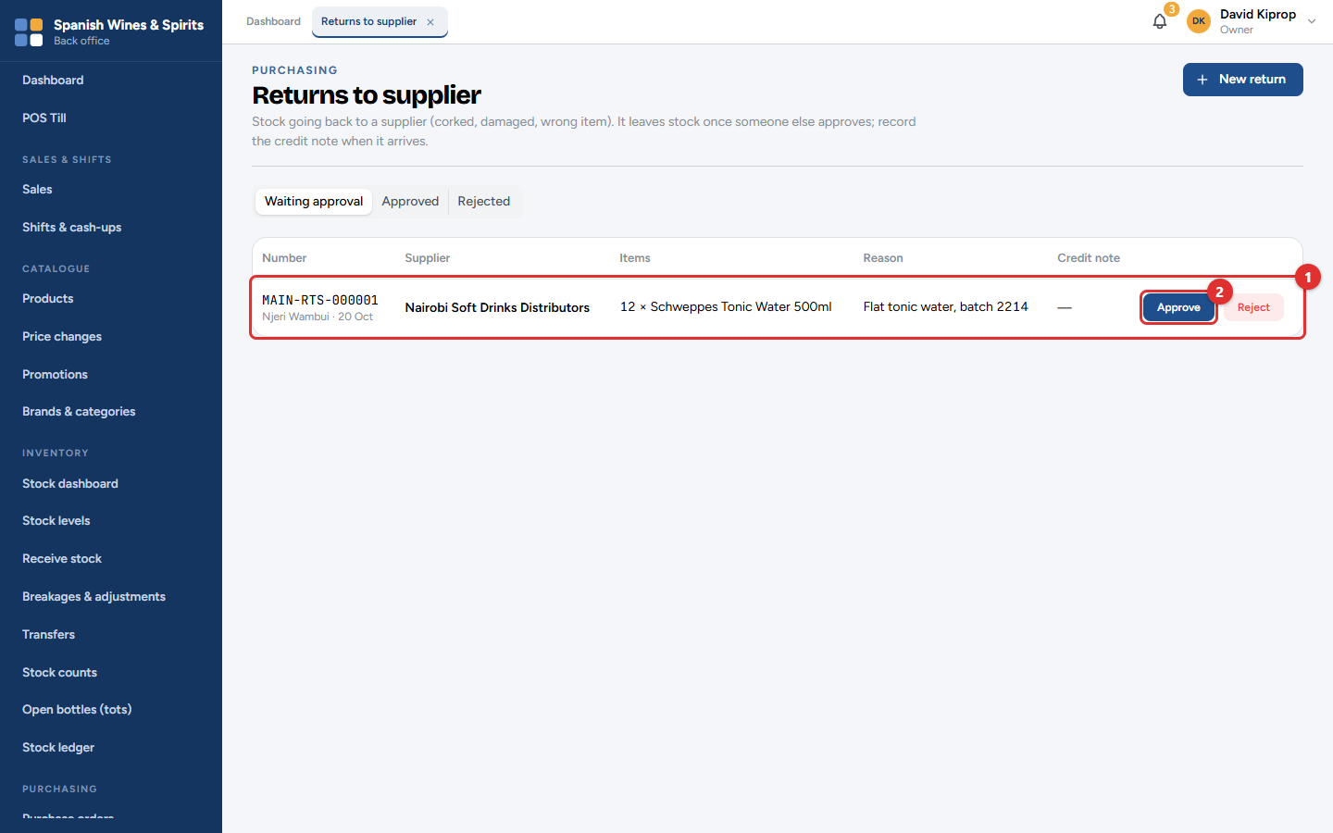
Figure 8.4: Purchasing → Returns to supplier
1. Click New return, choose the supplier and the items, and give a reason.
2. A manager approves it (2). The stock leaves your books when it is approved.
3. Record the supplier's credit note when it comes; it reduces what you owe.
Returns waiting for approval are listed first (1).

Suppliers
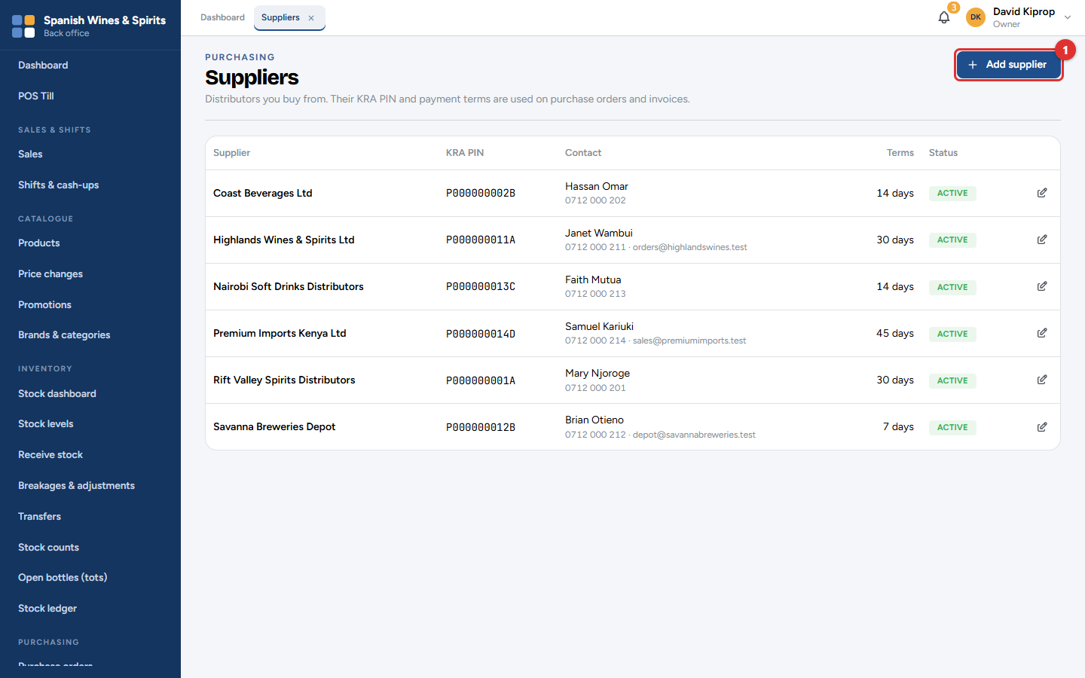
Figure 8.5: Purchasing → Suppliers
Each supplier has a name, contact person, phone, email, KRA PIN and payment terms (for example 30 days). Add supplier (1) adds one; click a supplier to edit it. The terms decide when each invoice is due.

Supplier accounts: what you owe
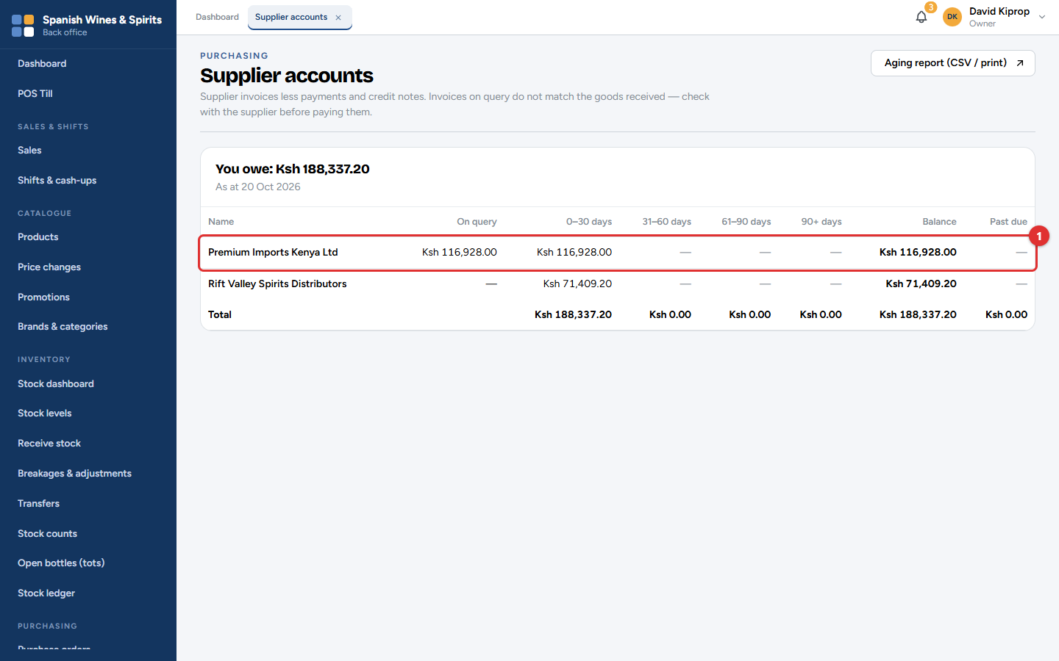
Figure 8.6: Purchasing → Supplier accounts
This screen lists what you owe each supplier (1), split by age: current, 31–60, 61–90 and over 90 days, with what is past due. Aging report (CSV / print) gives the same list for the accountant.
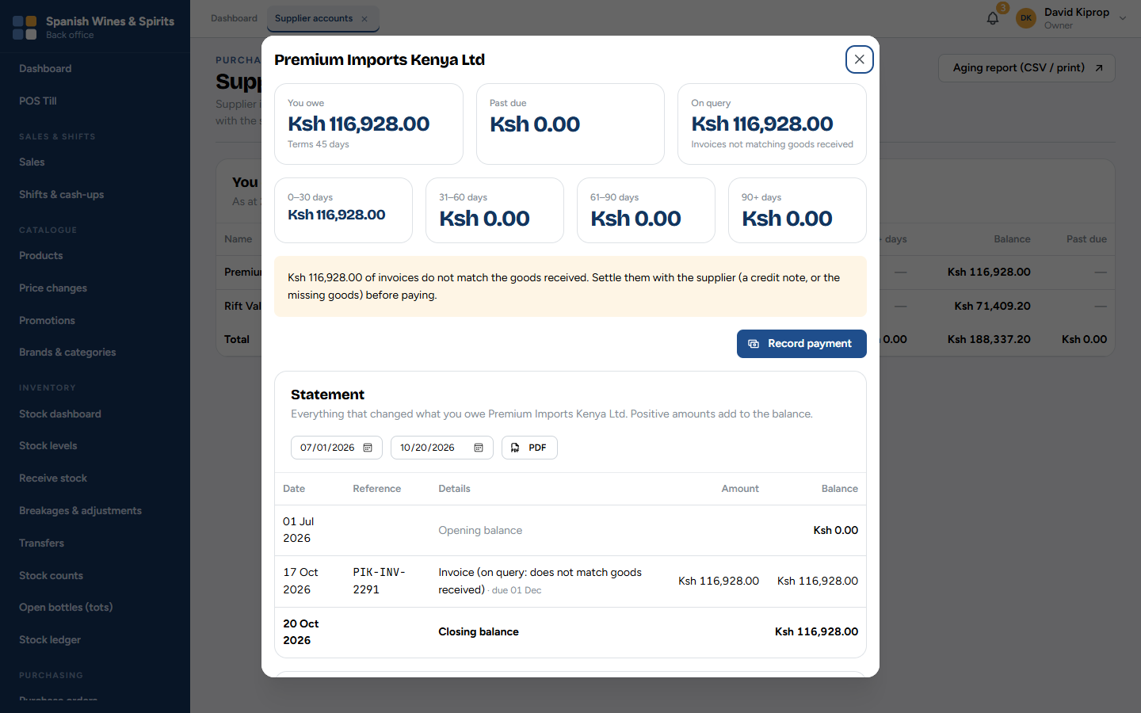
Figure 8.7: One supplier's account and statement
Click a supplier to see:
• You owe, Past due and On query (invoices that do not match the goods received);
• the amounts by age;
• Record payment to record a payment you have made (bank, M-PESA or cash, with its reference);
• the Statement: every invoice, payment, credit note and return between two dates. Click PDF to download it, for example to agree balances with the supplier.
Important: A payment is never edited or deleted. If one was recorded by mistake, reverse it; both lines stay on the statement.

9. Customers and credit
Walk-in customers need no record. Register a customer when they are:
• a wholesale buyer, such as a bar, hotel or restaurant, who pays wholesale prices;
• a business that needs its KRA PIN on the tax invoice;
• a customer who buys on account (pays later).
Who: the owner, admin and branch managers register and edit customers; the owner, admin and accountant manage credit; cashiers can only find and choose a customer at the till. Where: Customers → Customers and Customer accounts.

The customer list
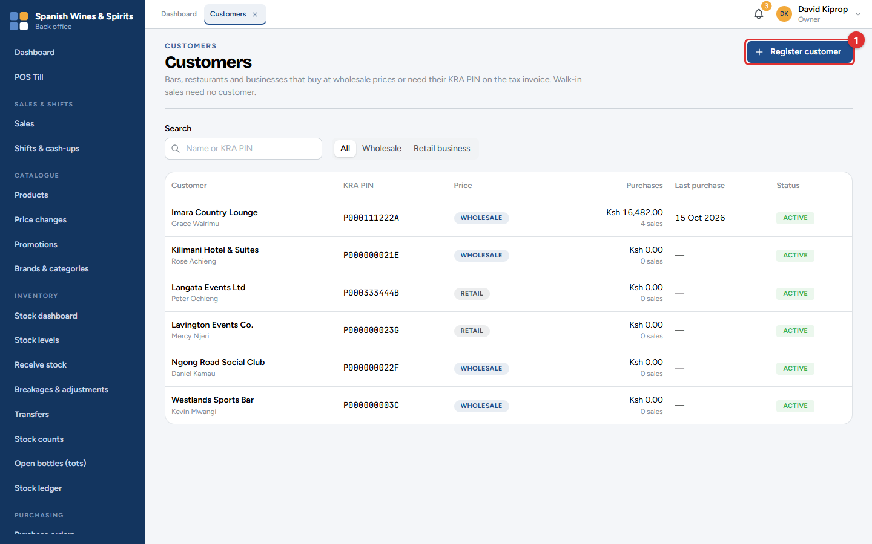
Figure 9.1: Customers → Customers
Search by name or KRA PIN, or show only Wholesale or Retail business customers. Each row shows the customer, their KRA PIN, which prices they pay, their purchases and the date of their last purchase.

Registering a customer
1. Click Register customer (1).
2. Type the Business name and KRA PIN. The PIN is printed on their tax invoices.
3. Tick Wholesale customer — pays wholesale prices at the till if they buy at wholesale prices.
4. Add a contact person, phone, email and address, then save.
Important: Customer contact details are personal data. Only managers can see them, and every time someone opens a customer's record it is logged. Collect only what you need.

A customer's record and credit account
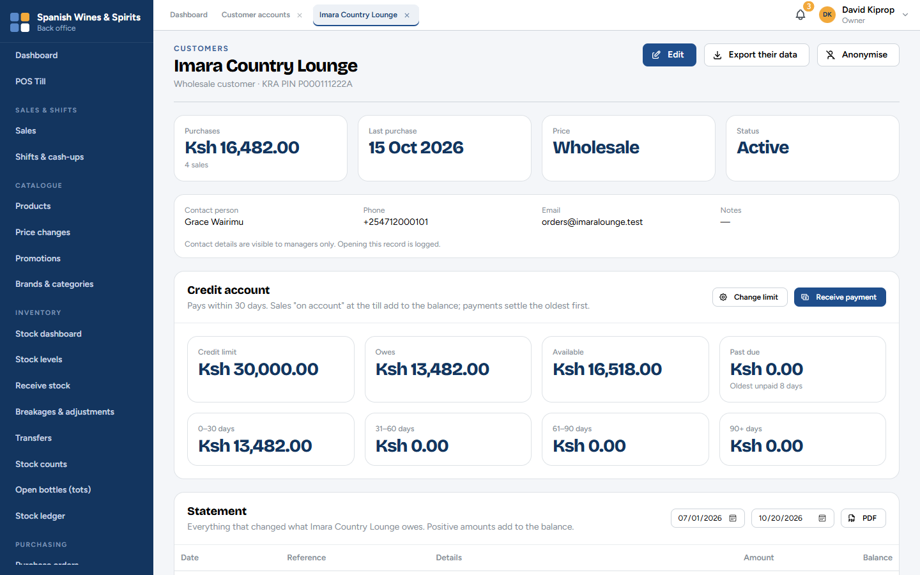
Figure 9.2: A customer with a credit account
At the top: their purchases, last purchase, price level (retail or wholesale) and status. Edit changes their details.
Under Credit account:
Figure | Meaning
Credit limit | The most they may owe at any time.
Owes | What they owe now.
Available | Limit − owes: how much more they can buy on account. The till checks this.
Past due | Unpaid past their payment terms, with the age of the oldest unpaid sale.
0–30, 31–60, 61–90, 90+ days | What they owe, by age.

• Change limit sets the credit limit and the payment terms (for example 30 days), or switches buying on account on or off.
• Receive payment records money they have paid you: the amount, how it was paid and its reference. A payment settles the oldest sales first.
• The Statement lists every sale on account, payment and return between two dates. Click PDF to download it and send it to the customer.
Common mistake: Giving credit without a limit. Set a limit for every account customer and check Past due each week.

Other buttons
• Export their data: downloads everything held about the customer, if they ask for it (Data Protection Act).
• Anonymise: if the customer asks to be forgotten, removes their name and contact details while keeping the sales for the tax records. You must give a reason, and it cannot be undone. Only the owner or an admin can export or anonymise.

Customer accounts: who owes you
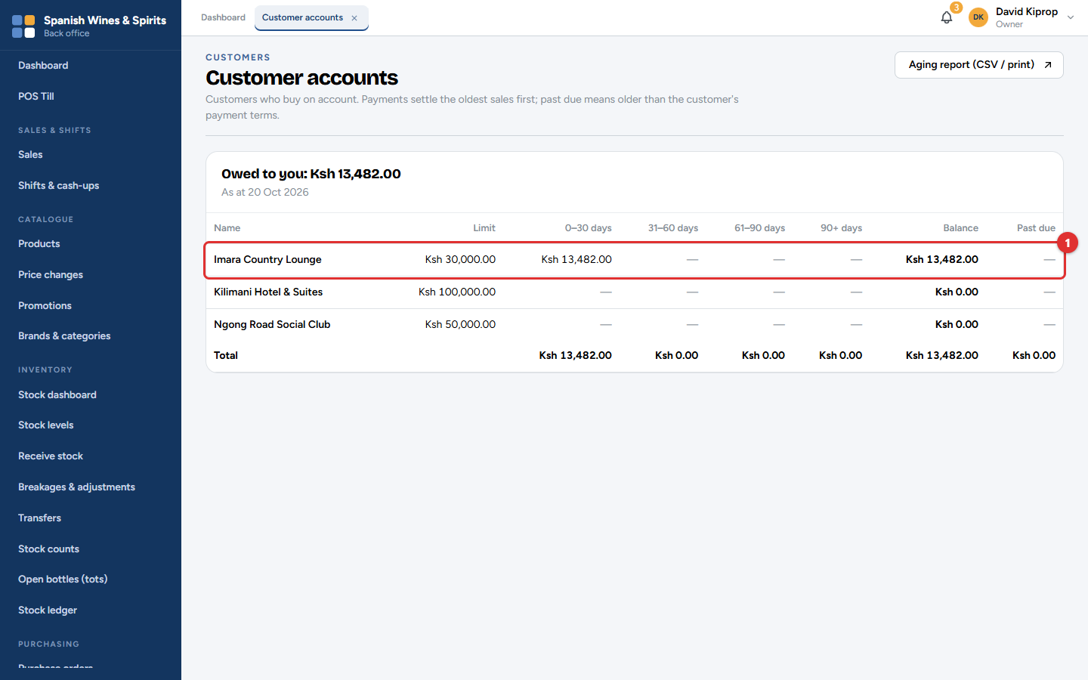
Figure 9.3: Customers → Customer accounts
All account customers in one list (1): what each owes, split by age, and what is past due. Click a customer to open their account. Aging report (CSV / print) gives the list for the accountant.

Selling on account at the till
1. At the till, tap Walk-in customer and choose the customer.
2. Tap Complete sale, then On account. The till shows how much credit is available.
3. The amount goes onto the customer's account; nothing is paid at the till.
A sale over the available credit is refused. Part of the sale can be paid now and the rest put on account with Split.

10. Money: M-PESA, expenses, licences and eTIMS
This chapter covers the screens that keep the money and the paperwork straight: checking every M-PESA payment, recording what the shop spends, keeping licences valid, and making sure every invoice reached KRA.
Who: the owner, admin, branch managers and the accountant. Where: Payments, Expenses and Compliance.

M-PESA reconciliation
An M-PESA payment counts as paid only when Safaricom confirms it. This screen matches every M-PESA payment received with a sale, so nothing is missed or counted twice.
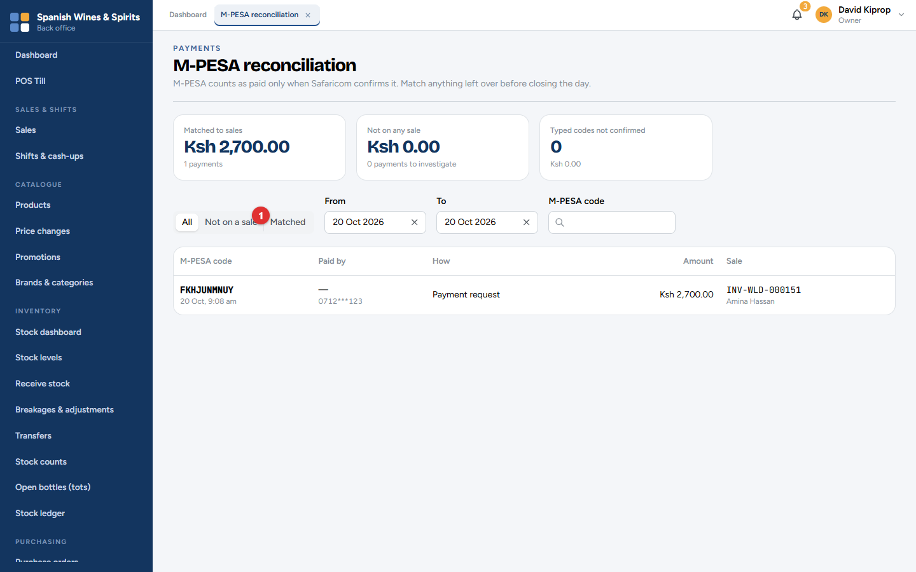
Figure 10.1: Payments → M-PESA reconciliation
The boxes at the top show:
Box | Meaning
Matched to sales | Payments that belong to a sale. All is well.
Not on any sale | Money received with no sale. Investigate each one.
Typed codes not confirmed | M-PESA codes typed at the till while it was offline that Safaricom has not confirmed.

Choose Not on a sale (1) to see only the payments to investigate. Each row shows the M-PESA code, who paid, how (Payment request from the till, or Paid to till), the amount and the sale. Search by M-PESA code to find one payment.
A payment with no sale usually means a customer paid to the till number but the cashier did not choose the payment at the till. Find the sale and match it, or refund the customer.
Tip: Check Not on a sale before closing each day. It should be empty.
Important: While the system runs on its demonstration connection, payments come from a practice copy of M-PESA and no real money moves. The screens say so. The live connection is switched on when your business goes live.

Expenses
Every shilling spent running the shop is an expense: rent, electricity, transport, cleaning, generator fuel. Recording them gives the true profit and keeps the petty cash honest.
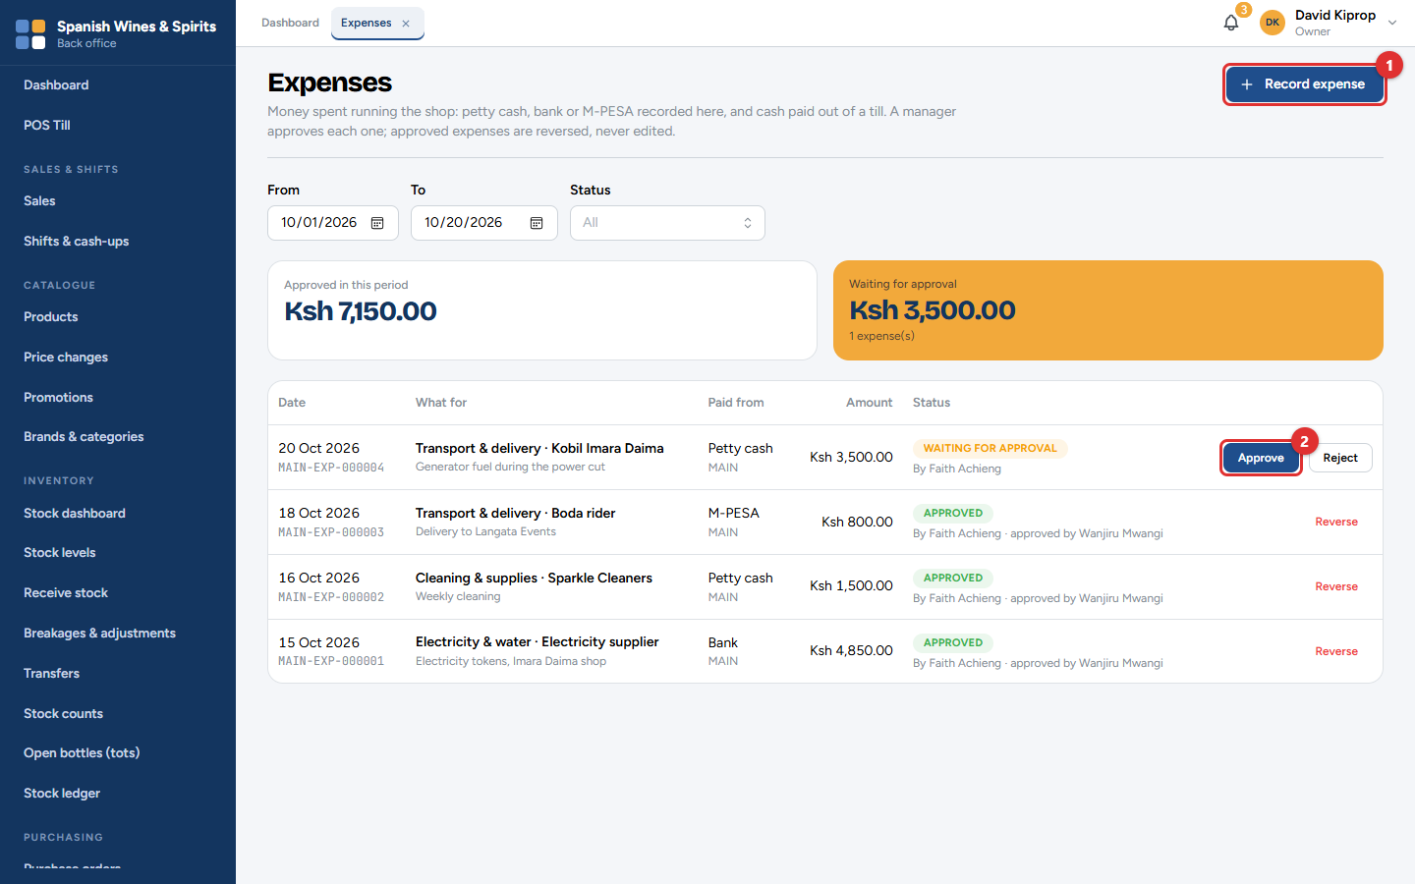
Figure 10.2: Expenses
The screen shows the total approved in the period and what is waiting for approval. A manager checks each new expense and clicks Approve (2) or Reject. Nobody approves their own expense.
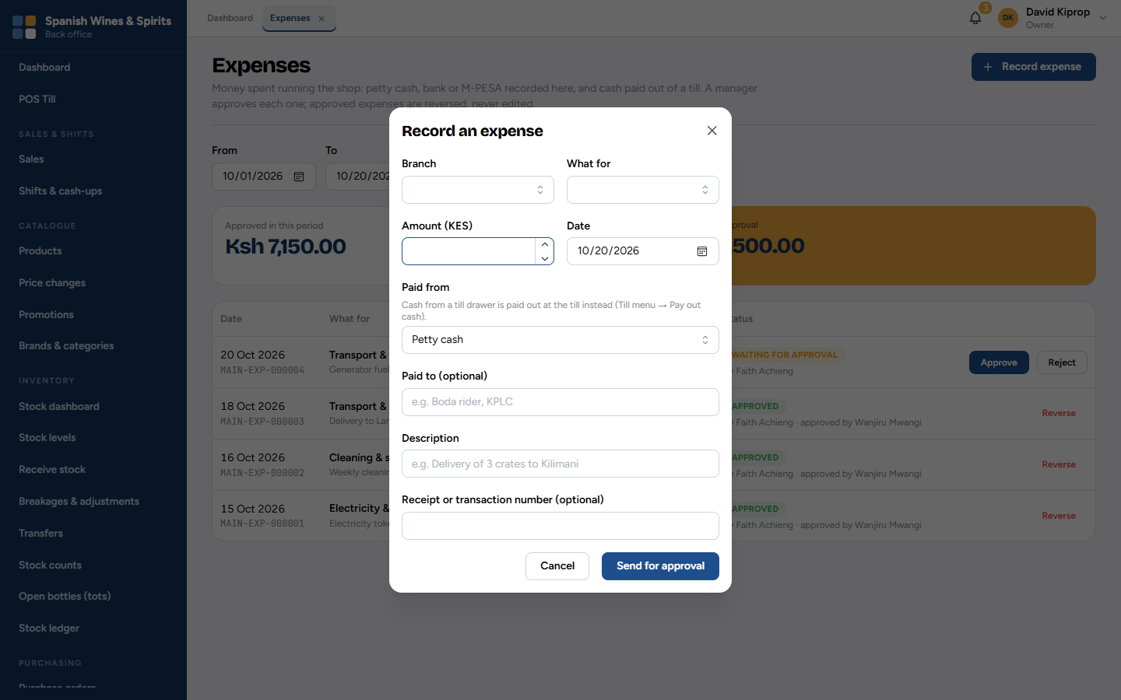
Figure 10.3: Recording an expense
1. Click Record expense (1).
2. Choose the Branch and What for (the expense category).
3. Type the Amount and the Date.
4. Choose where the money came from (Paid from: petty cash, bank or M-PESA). Cash taken from a till drawer is recorded at the till instead (Pay out cash, chapter 4).
5. Add who was paid, a description and the receipt or transaction number.
6. Click Send for approval.
An approved expense is never edited. If it was wrong, click Reverse and record it again correctly.

Licences and permits
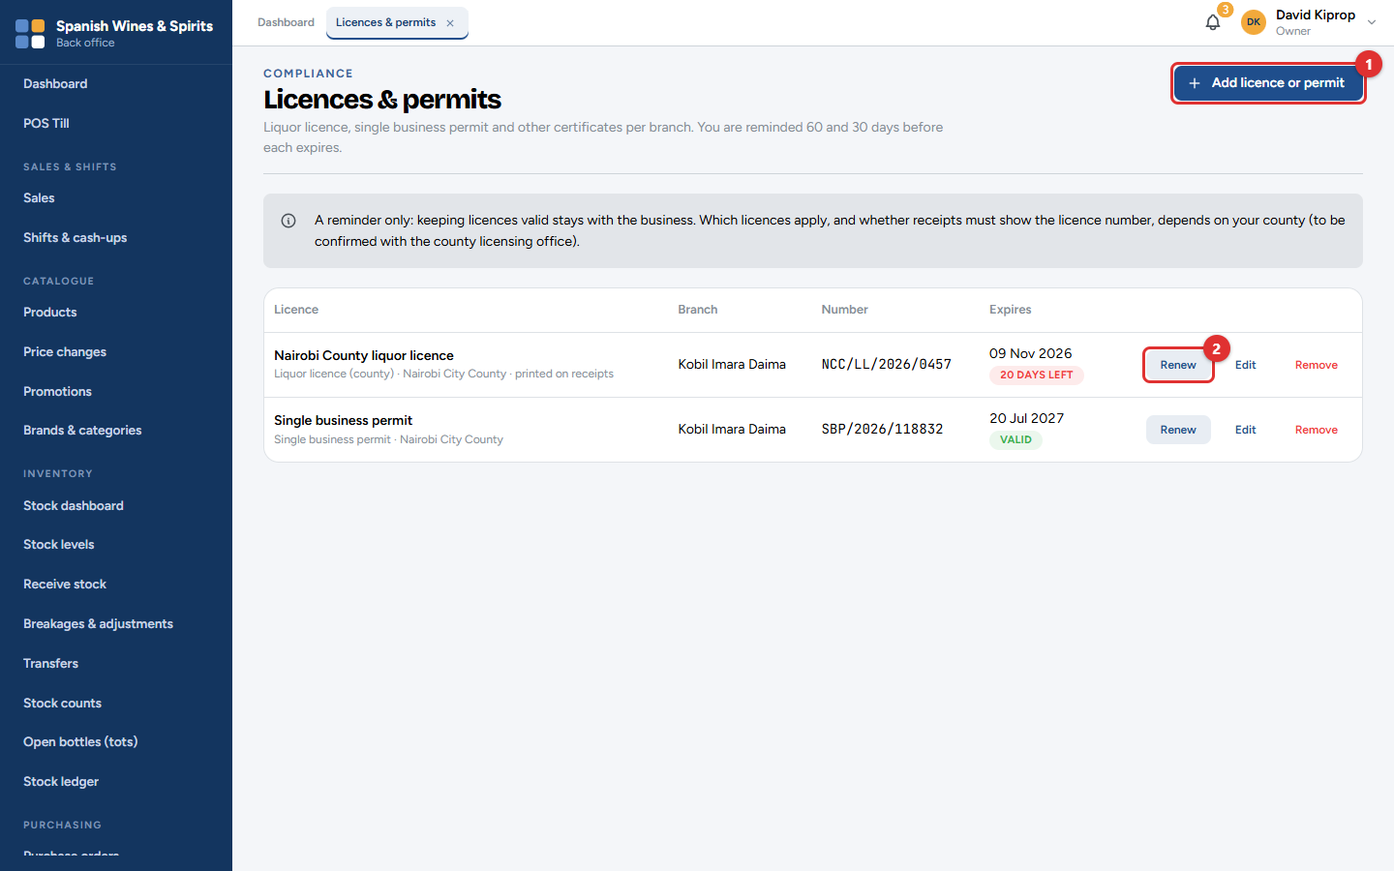
Figure 10.4: Compliance → Licences & permits
Keep your liquor licence, single business permit and other certificates here, for each branch. Tessera reminds the owner and managers 60 and 30 days before each one expires.
• Add licence or permit (1): the type, the issuing county, the branch, the number and the expiry date. Tick Print this number on receipts for a licence that must appear on receipts.
• Renew (2): enter the new number and expiry date when you have renewed it.
• Edit corrects a mistake; Remove takes off one you no longer hold.
The badge shows how many days are left, in red when it is close.
Important: Tessera only reminds you. Keeping licences valid stays with the business, and which licences apply depends on your county.

eTIMS monitor
Every sale and every return is sent to KRA's eTIMS automatically, straight after it is made. This screen shows that each one was signed.
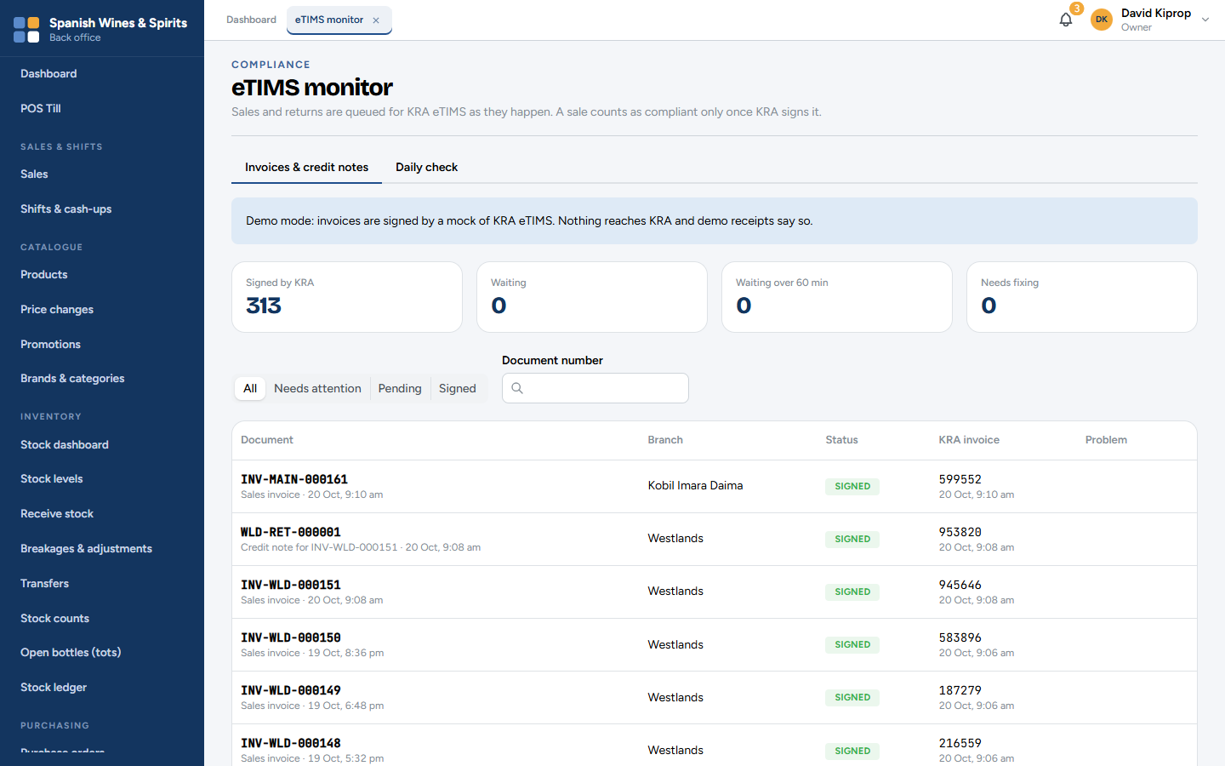
Figure 10.5: Compliance → eTIMS monitor
The boxes at the top count invoices Signed by KRA, Waiting, Waiting over 60 min and Needs fixing. The list shows each document (sales invoices and credit notes for returns), its branch, its status and KRA's invoice number.
• Needs attention shows only the invoices with a problem, and what the problem is.
• Daily check compares each day's sales with what KRA has signed.
A short wait is normal. If invoices stay Waiting for over an hour, or any Need fixing, contact Tessera support.
Important: While the system runs on its demonstration connection, invoices are signed by a practice copy of eTIMS and nothing reaches KRA. The screen says so at the top. The live connection is switched on when your business goes live.

11. Dashboard and reports
The dashboard shows how the business is doing today, at a glance. The reports give the detail behind every figure, for any period, ready for Excel, PDF or paper.
Who: the owner, admin, branch managers and the accountant (reports with profit or money owed need the financial permission). Storekeepers have a stock-only dashboard. Where: Dashboard and Reports.

The dashboard
Figure 11.1: The owner's dashboard
The tiles at the top show the figures for the branches you can see, for example:
• Sales today (1), split into cash and M-PESA · card, and the gross profit today;
• Items low on stock (2) and the stock value (at cost);
• Owed to suppliers (3) and owed by customers;
• Shifts open now, tills connected, price changes waiting, eTIMS invoices not yet signed and shrinkage this month (stock lost).
A tile turns amber when something needs your attention.
Below the tiles: Needs attention, Shifts open now, Low stock — reorder first, Best sellers and slow movers, Branches this month, Cash variance by cashier and Discounts, voids and refunds today. What you see depends on your role: a branch manager sees only their branches, and a storekeeper sees only stock.
Tip: Make the dashboard your first stop every morning, and the notifications bell your second.

Reports
Figure 11.2: Reports
The reports are grouped by Sales, Inventory, Financial and Compliance. Click one to open it. Reports marked Screen open the screen where the same information already lives (for example the stock ledger or the audit log).
Group | Reports
Sales | Sales summary · Sales by item, product, category or brand · Sales by cashier, branch or payment method · Voids, discounts & price overrides · Returns & refunds register
Inventory | Current stock by branch · Stock valuation as at a date · Adjustments & losses by reason · Stock count variance · Transfers & discrepancies · Low stock & reorder suggestions · Stock movement ledger
Financial | Revenue, cost of goods & gross profit · Shift cash-up & variance · Purchases by supplier · Receivables aging · Payables aging · Expenses (petty cash) · M-PESA reconciliation
Compliance | eTIMS status, failures & daily check · Licence & permit expiry list · Audit trail

Using a report
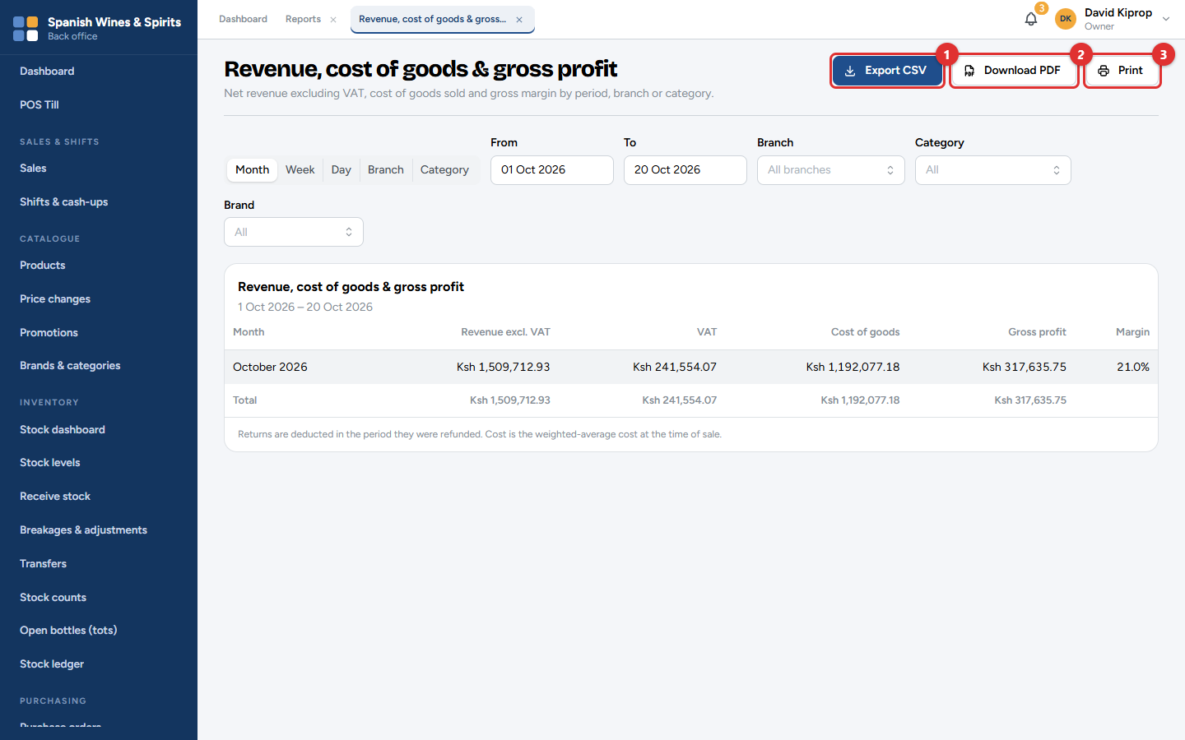
Figure 11.3: A report: revenue, cost of goods and gross profit
1. Choose how to group the figures (for example by Month, Week, Day, Branch or Category).
2. Set the From and To dates and any filters (branch, category, brand…). The report updates as you go.
3. Take it away:
• Export CSV (1) opens in Excel or Google Sheets;
• Download PDF (2) gives a branded A4 document, for example for the accountant or the bank;
• Print (3) prints it.
Each report says how its figures are worked out at the bottom. For example, profit uses the average cost of the goods at the time of the sale, and returns are taken off in the period they were refunded.

Which report for which question?
Question | Report
How much did we sell, and how much VAT is in it? | Sales summary
What sells best? What doesn't? | Sales by item, product, category or brand
Who gave discounts, voided items or changed prices? | Voids, discounts & price overrides
What is our stock worth? | Stock valuation as at a date
What did we lose to breakages and theft? | Adjustments & losses by reason
What should we order? | Low stock & reorder suggestions
Are we making money? | Revenue, cost of goods & gross profit
Which cashiers are short? | Shift cash-up & variance
Who owes us, and whom do we owe? | Receivables aging, Payables aging
Has every invoice reached KRA? | eTIMS status, failures & daily check

Month end
Figure 11.4: The Sales summary, ready to export for the accountant
At the end of each month, send the accountant:
1. Sales summary for the month, grouped by day (gross sales, discounts, returns, net sales and VAT);
2. Revenue, cost of goods & gross profit;
3. Expenses (petty cash);
4. Receivables aging and Payables aging as at the last day of the month;
5. Stock valuation as at the last day of the month.
Because every sale was signed on eTIMS as it happened, the VAT figures match what KRA has on record.

12. Administration
Administration covers the branches and tills, the staff and what each may do, the settings that decide how the system works, and the audit log.
Who: the owner and admin. Branch managers can change some settings for their own branch. Where: the Administration menu.

Branches and tills
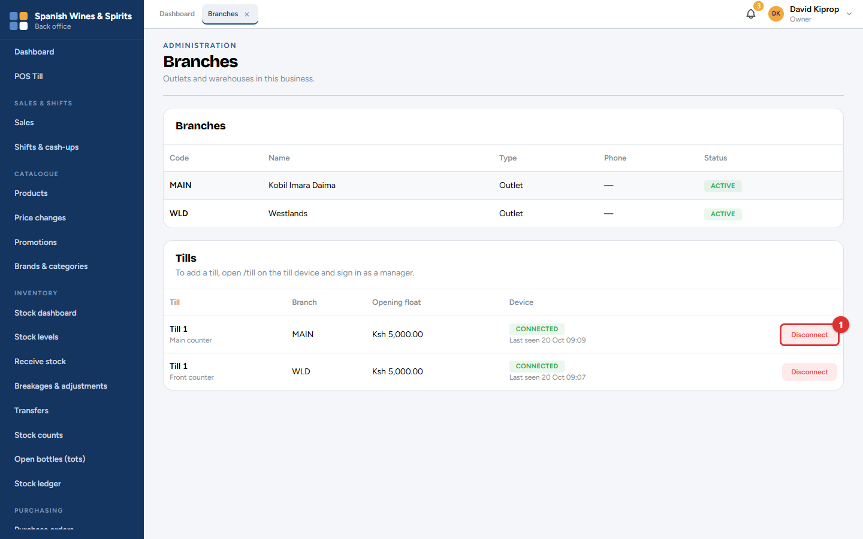
Figure 12.1: Administration → Branches
Branches lists each shop (or warehouse) with its code, name and status. The code is part of every document number, for example INV-MAIN-000161.
Tills lists every till, its branch, its opening float and whether its computer is connected (Last seen tells you when it was last used).
• To add a till, set it up from the till computer itself (chapter 3).
• To stop a computer from selling (lost, stolen or replaced), click Disconnect (1). Setting up a new computer with the same till name also disconnects the old one.

Users and roles
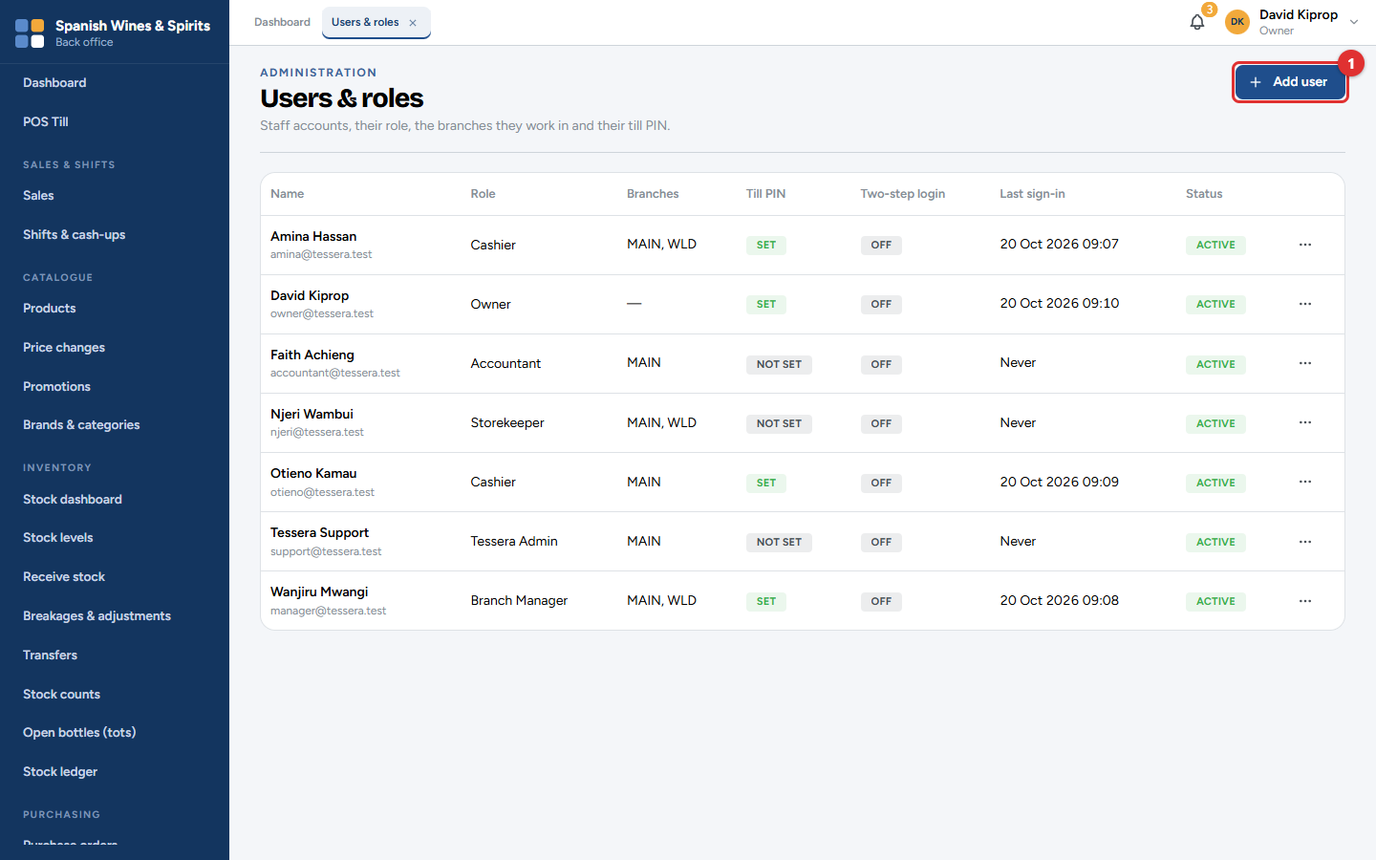
Figure 12.2: Administration → Users & roles
Every person gets their own account. The list shows each person's role, branches, whether they have a till PIN and two-step login, when they last signed in, and whether the account is active.

Adding a user
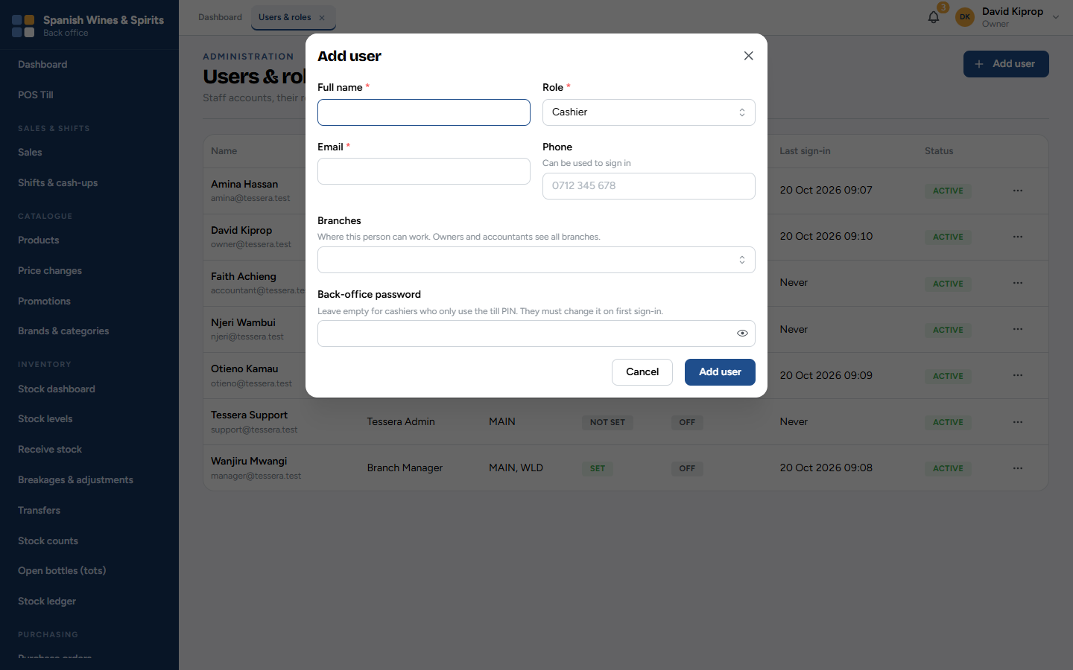
Figure 12.3: Add user
1. Click Add user (1).
2. Type the Full name and choose the Role (chapter 1 explains each role).
3. Type their Email, and optionally their Phone, which they can also use to sign in.
4. Choose the Branches where they work. Owners and accountants see all branches.
5. For anyone who uses the back office, type a first Back-office password. They must change it the first time they sign in. Leave it empty for cashiers who only use the till.
6. Click Add user.
The ⋯ button on each person has:
• Edit: change the name, role, branches, or untick Account active when someone leaves. Their history is kept.
• Set till PIN / Change till PIN: a four-digit PIN for signing in at the till. Type it twice.
• Reset two-step login: if someone has lost their phone.
Important: When someone leaves, make the account inactive the same day. Never share an account.
Tip: To reset a forgotten password, click Edit and type a new one. The person must change it when they next sign in.

Settings
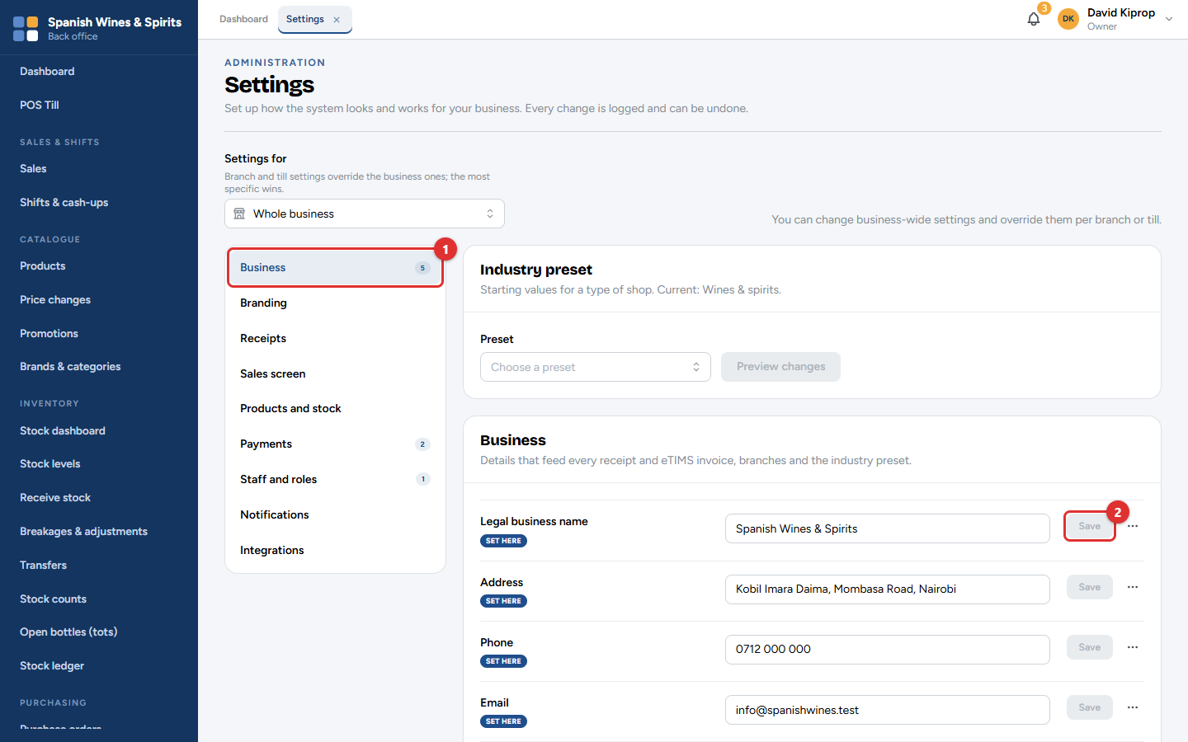
Figure 12.4: Administration → Settings
Settings are grouped in sections on the left: Business (1), Branding, Receipts, Sales screen, Products and stock, Payments, Staff and roles, Notifications and Integrations. A number next to a section shows how many settings are set at this level.
To change a setting, edit it and click its Save (2) button. Every change is logged and can be undone: the ⋯ button next to a setting shows its history.
Settings for (at the top) chooses where the setting applies: the whole business, one branch, or one till. A branch or till setting overrides the business one; the most specific wins. Each setting shows a badge: Default, Set here, or where its value comes from.
Some settings show a lock: they are set up by Tessera support (for example eTIMS), or locked after the first sale so numbers stay in sequence (for example the invoice number prefix). Settings marked Coming later cannot be used yet.
The Industry preset fills in sensible starting values for a type of shop (here Wines & spirits). Click Preview changes to see what it would change before applying it.

The main sections
Section | What you set there
Business | Legal name, address, phone, email, KRA PIN, VAT registration, financial year, currency. Printed on receipts and invoices.
Branding | The shop name shown in the system, logo, colours, and the sign-in page's picture and welcome text.
Receipts | Header and footer lines, what is shown (logo, cashier's name…), paper size, when to print, the invoice number prefix.
Sales screen | How the till looks and works: product tiles, favourites on the first screen, quick buttons, payment buttons and their order, the age check, licensed hours.
Products and stock | Selling by the tot, the licensed-hours lock, the default low-stock level, whether stock may go below zero.
Payments | Which payment methods are accepted, cash rounding, sales on account, the M-PESA till or paybill number.
Staff and roles | Discount limits, which actions need a manager's PIN, opening float and cash-up rules, password rules, idle sign-out and till lock, two-step login.
Notifications | Which alerts are raised, what counts as a "large" refund, the time of the end-of-day summary, which dashboard tiles each role sees.
Integrations | eTIMS (set up by Tessera), accounting export, the receipt printer, cash drawer and scanner.

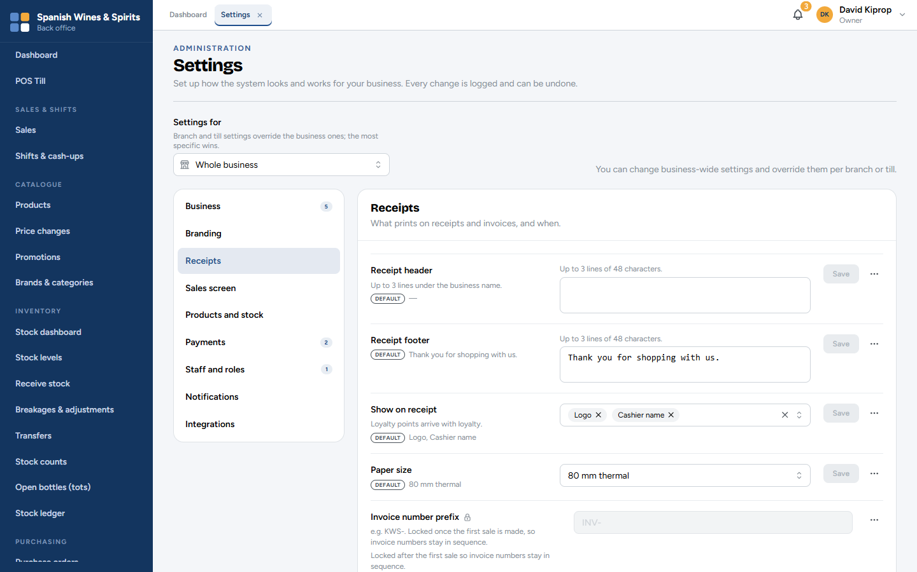
Figure 12.5: Settings → Receipts
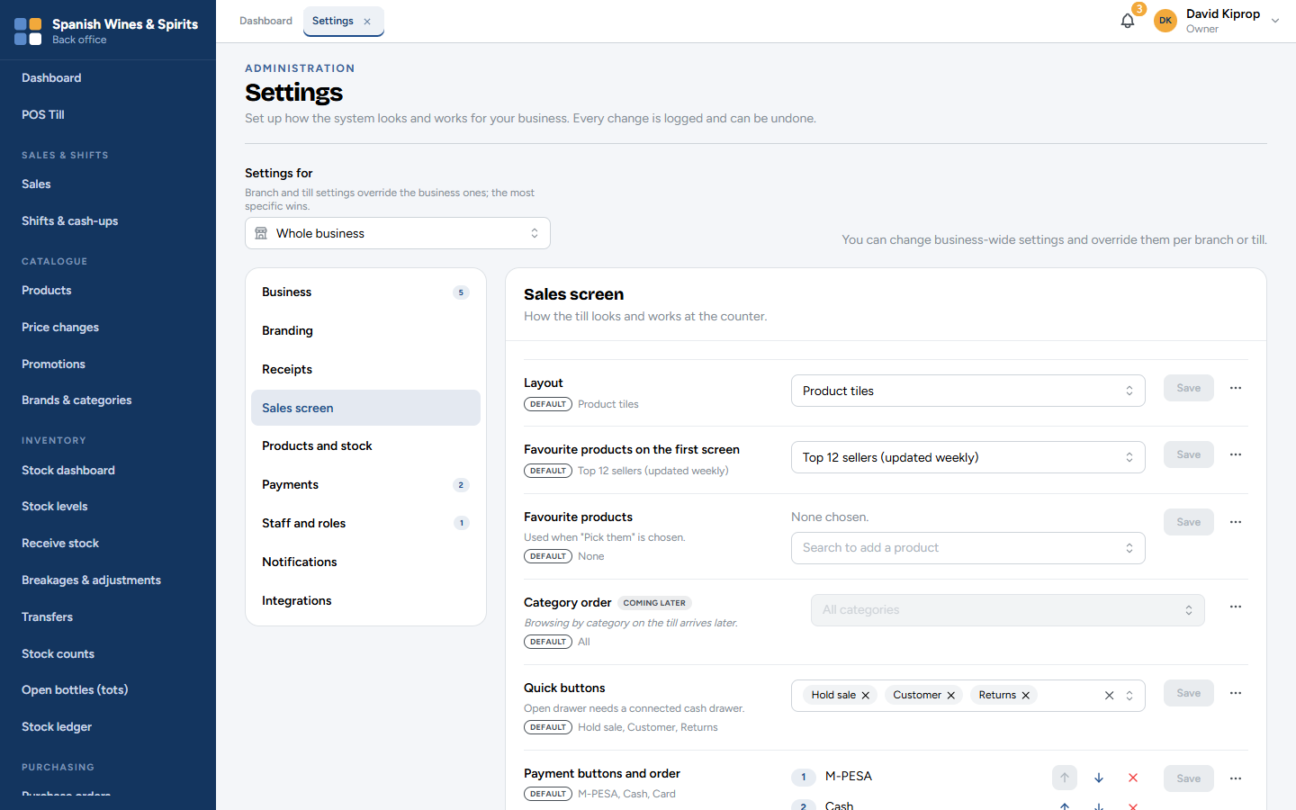
Figure 12.6: Settings → Sales screen
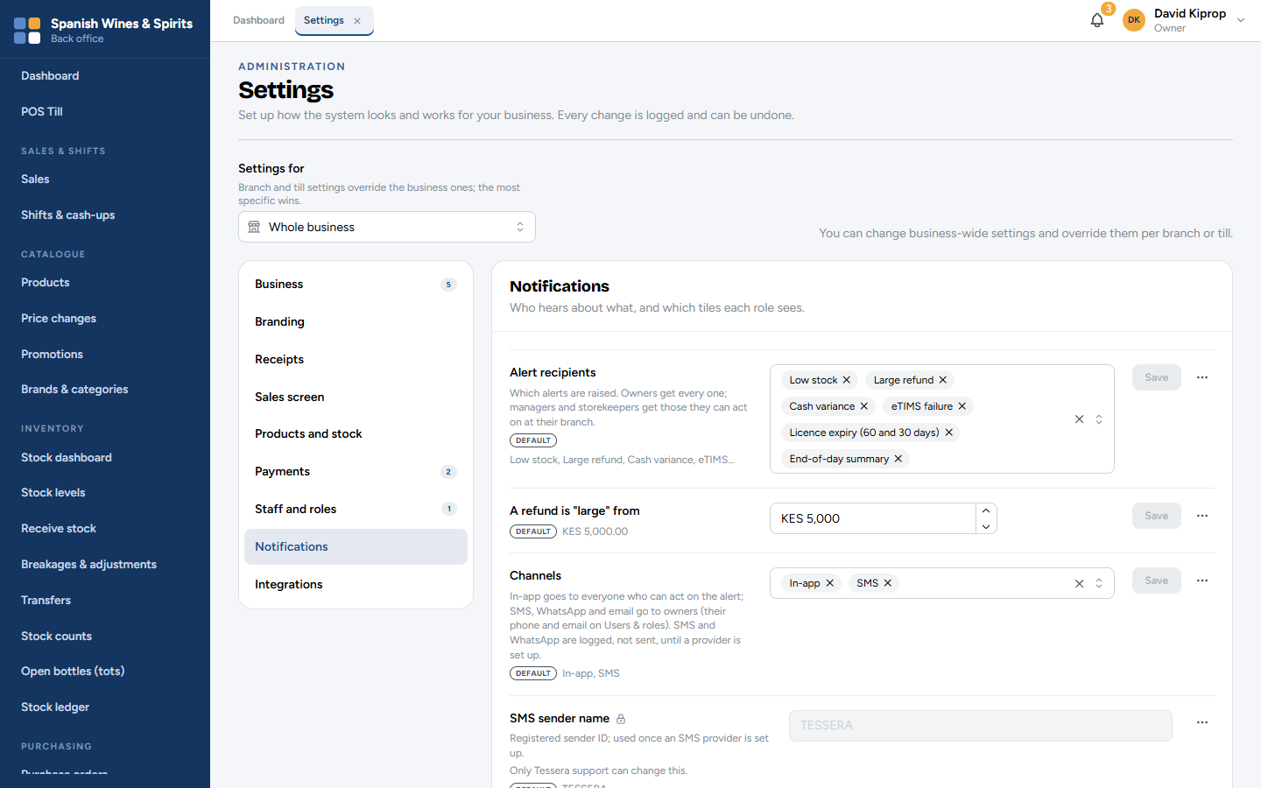
Figure 12.7: Settings → Notifications: which alerts are raised
Alerts appear under the notifications bell for everyone who can act on them: owners get every alert; managers and storekeepers get the ones for their branch.

Receipt printer and cash drawer
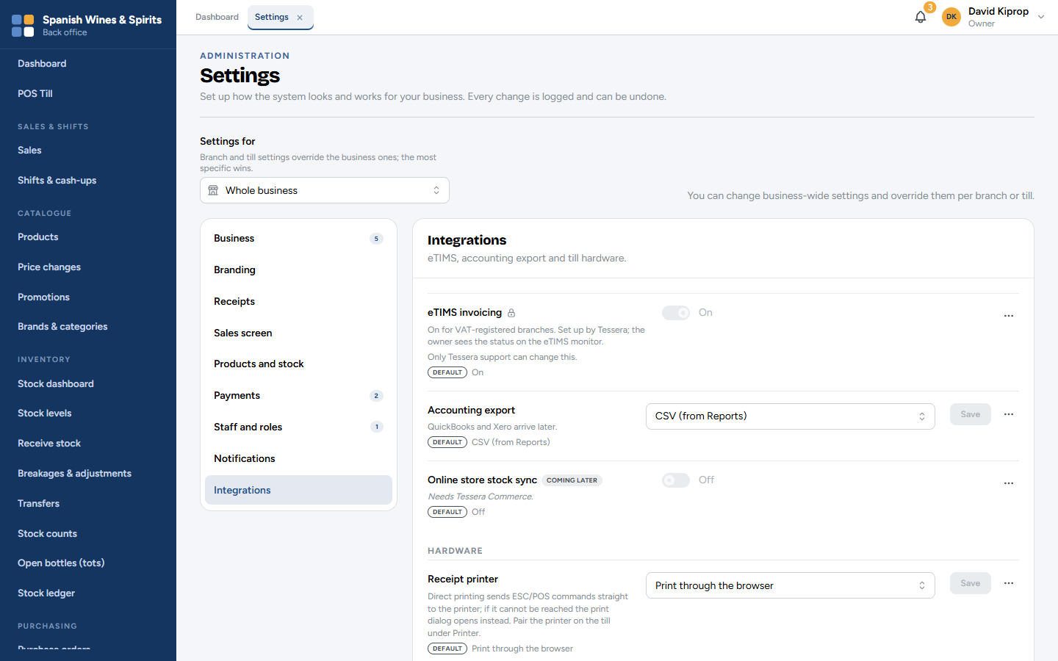
Figure 12.8: Settings → Integrations, with the receipt printer
Under Integrations → Receipt printer, choose how the tills print:
• Print through the browser: works with any printer the computer knows; the print window opens for each receipt.
• Direct printing to a receipt printer connected by USB or a serial cable: faster, and it can open the cash drawer when a cash sale is completed. Connect the printer once on each till (till menu → Printer). If the printer cannot be reached, the print window opens instead.
Set this for the whole business, or per till under Settings for.
Common mistake: Changing a setting for the whole business when you meant one branch. Check Settings for before you save.

Audit log
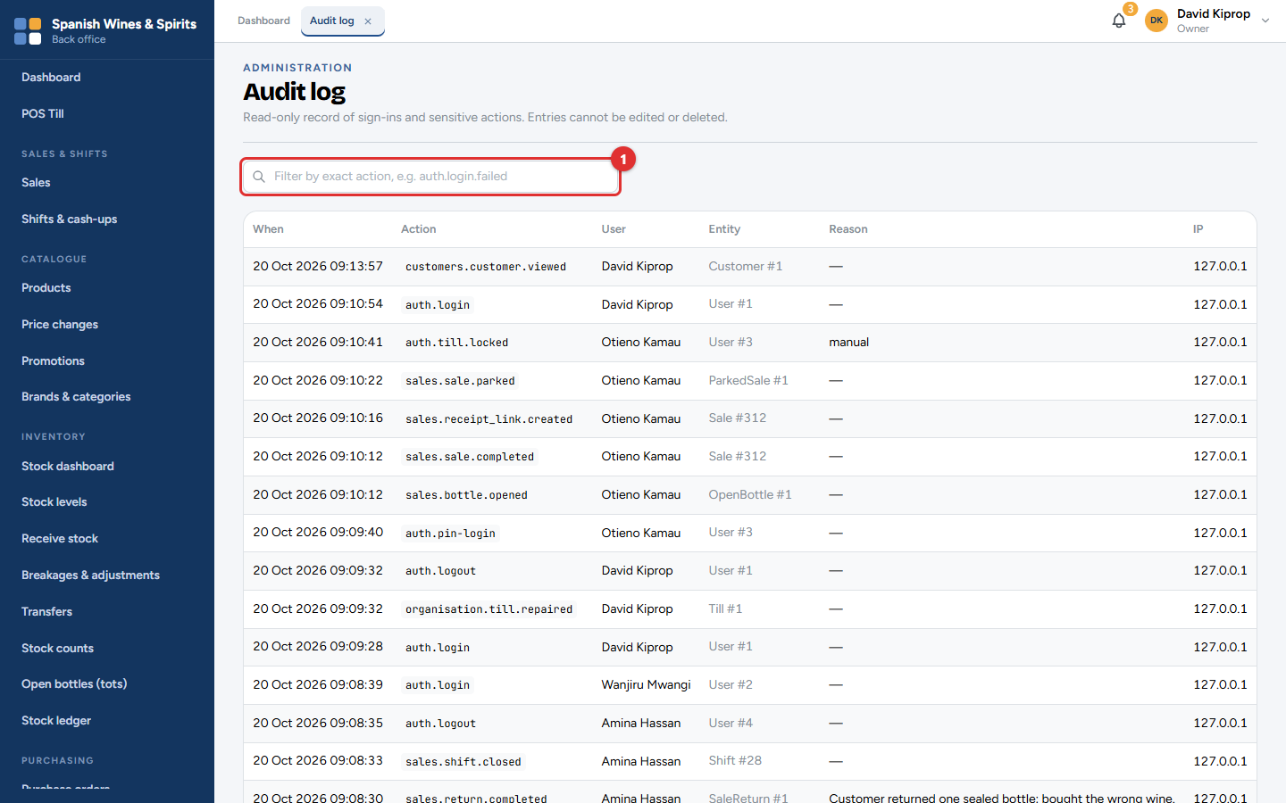
Figure 12.9: Administration → Audit log
The audit log records who did what, and when: sign-ins (including failed ones), sales, refunds, approvals, price changes, settings changes, stock movements, payments and more. Filter by user, date or action (1). Nobody can edit or delete it.
Use it to answer questions such as who changed this price? or who approved this refund?.

Quick reference and glossary

Where to find things
I want to… | Go to | Chapter
Sell | The till (account menu → Open till screen, or /till) | 3
Give a discount | Till: tap the item in the sale | 3
Refund or reprint a receipt | Till menu → Return / reprint | 4
Put cash in the safe | Till menu → Cash drop to safe | 4
Pay a small expense from the drawer | Till menu → Pay out cash (expense) | 4
End my shift | Till menu → End shift | 4
Find a sale | Sales & Shifts → Sales | 5
Sign off a cash-up | Sales & Shifts → Shifts & cash-ups | 5
Add a product or size | Catalogue → Products | 6
Change a price | Catalogue → Products → the item → ⋯ → Change price | 6
Approve a price change | Catalogue → Price changes | 6
Set up a promotion | Catalogue → Promotions | 6
See what is in stock | Inventory → Stock levels | 7
Receive a delivery | Inventory → Receive stock | 7
Record a breakage | Inventory → Breakages & adjustments | 7
Move stock to another branch | Inventory → Transfers | 7
Count stock | Inventory → Stock counts | 7
Order from a supplier | Purchasing → Purchase orders | 8
Record a supplier's invoice | Purchasing → Supplier invoices | 8
Pay a supplier | Purchasing → Supplier accounts | 8
Register a business customer | Customers → Customers | 9
Record a customer's payment | Customers → Customer accounts | 9
Check M-PESA payments | Payments → M-PESA reconciliation | 10
Record an expense | Expenses | 10
Renew a licence | Compliance → Licences & permits | 10
Check invoices reached KRA | Compliance → eTIMS monitor | 10
Run a report | Reports | 11
Add a member of staff or a till PIN | Administration → Users & roles | 12
Change how the system works | Administration → Settings | 12
See who did what | Administration → Audit log | 12

Things that need a second person
Action | Who starts it | Who approves it
Discount over the cashier's limit, price change at the till | Cashier | Manager, with their PIN at the till
Refund (if the shop's settings say so) | Cashier | Manager, with their PIN
Cash drop, payout from the drawer | Cashier | Manager, as witness, with their PIN
Cash-up | Cashier counts | Manager signs off
New price | Admin | Owner
Promotion | Owner, admin or manager | Owner
Purchase order | Owner, admin or accountant | Manager, owner or admin (not the same person)
Stock adjustment, transfer, stock count | Storekeeper | Manager (not the same person)
Return to supplier | Purchasing staff | Manager
Expense (office) | Owner, admin, manager or accountant | Manager, owner or admin (not the same person)

Daily checklist
Opening: sign in at the till and check the float. Look at the dashboard and the notifications bell.
During the day: drop excess cash to the safe. Record every payout at the till.
Closing: every cashier ends their shift and counts the drawer. The manager signs off the cash-ups, checks M-PESA reconciliation → Not on a sale, and checks the eTIMS monitor for anything that needs attention.
Weekly: check low stock and raise purchase orders; check Past due in Customer accounts; count one or two shelves.
Monthly: a full stock count; send the month-end reports to the accountant (chapter 11); check licences.

Glossary
Word | Meaning
Adjustment | A change to stock outside a sale, delivery or transfer, such as a breakage. Needs a manager's approval.
Aging | What is owed, split by how long it has been owed (0–30, 31–60, 61–90, 90+ days).
Audit log | The record of who did what, and when. Nobody can change it.
Back office | The part of Tessera used on an office computer: everything except the till.
Blind count | A stock count or cash count where the expected figure is hidden until the count is submitted.
Cash drop | Moving cash from the till drawer to the safe during a shift.
Cash-up | Counting the drawer at the end of a shift and comparing it with what was expected.
Credit note | The opposite of an invoice: it records money given back, for example for a return.
eTIMS | KRA's Electronic Tax Invoice Management System. Tessera sends it every sale and return.
Float | The cash in the drawer at the start of a shift, for giving change.
GRN | Goods-received note: the record of a delivery received against a purchase order.
KRA PIN | A person's or business's tax number, printed on tax invoices.
Ledger (stock ledger) | The full history of every stock movement. Stock figures come from it.
M-PESA payment request | A prompt sent to the customer's phone to approve a payment with their M-PESA PIN (STK Push).
Park (hold) a sale | Put a sale aside to serve someone else, and recall it later.
Payout | Cash paid out of the till drawer for an expense.
Purchase order (PO) | What you are ordering from a supplier. Approved by a second person.
Quarantine | A place for damaged items and opened returns. They cannot be sold.
Reconciliation | Checking that two records agree, for example M-PESA payments and sales.
Reorder level | The stock level at which an item counts as low and should be ordered.
Role | What a person is allowed to see and do: Owner, Admin, Branch Manager, Cashier, Storekeeper, Accountant.
Shift | One cashier on one till, from signing in to counting the cash.
SKU | Stock-keeping unit: the short code for one size of one product, such as JWB-750.
Tot | A measure of spirit poured from an open bottle and sold by the glass.
Transfer | Moving stock between branches, or from the store to the shop floor.
Variance | The difference between what was counted and what was expected.
VAT | Value Added Tax (16% on most drinks), included in shelf prices.
Void | Removing items, or a whole sale, before it is paid.
Walk-in customer | A customer who is not registered. Most sales are to walk-in customers.
Wholesale customer | A registered business that pays wholesale prices.

