CO₂ Dynamics in a Mofette

Andreescu Arthur-Daniel
Popescu Lucian
Szakács Apor-Tamás
18.06.2026

Aim and research

The aim of the project is to analyze and find periodicity in the sensor data provided about the mofette. We also work on the restructuring and analysis of the data and the validity of the data.

Background

Our study is based on a research paper from 2025 titled: CO2 Dynamics in a Mofette: Measurement and Modeling. The paper is about the monitoring of gas concentration, temperature, humidity and air pressure inside a mofette in Covasna.
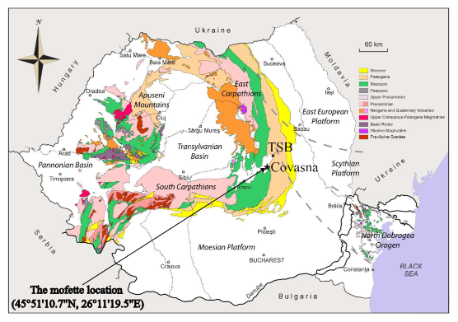
A mofette is a vent from which CO2 and other gases escape from the earth in a last stage of volcanic activity. Buildings are built around these vents for medical purposes to releave certain circulatory problems. A measurement device was placed in such a building and we’re working on a dataset produced by the device. The device has 20 STC31 sensors that measure CO2 concentration and temperature. These sensors were placed 5 cm apart vertically. There were 4 additional such sensors on the side of the device. Besides that, there were also 2 BMP280 sensors measuring barometric pressure and temperature on the top and bottom of the device and 2 DHT11 humidity sensors also on the top and on the bottom of the device.

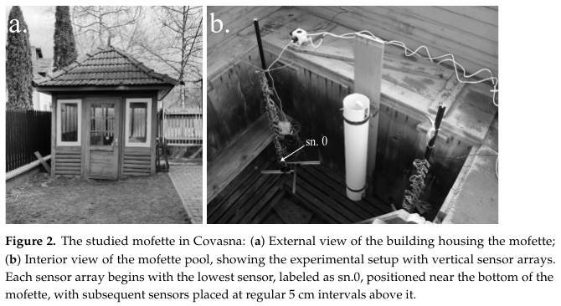

Data

The data represent the monitoring period from the 8th of April, 2022, to the 7th of November, 2022. The dataset spans over 200 days and has 17.3 million recordings in it. Measurements were taken second by second. We got access to a file named ‘new_device_column1.txt’ which had alternating lines of timestamps and measurement data. The raw text file was around 6 GB. The entries in the text file looked like this: 1st line – timestamp, 2nd line – barometric pressure, humidity, temperature on the top, barometric pressure, humidity, temperature on the bottom, then CO2 and temperature of main STC31 sensors 1 to 20, then the CO2 and temperature values of the STC31 sensors from the side (1 to 4).

Example Lines from the Data File
1649455396.5622404 b'93512.25 65.00 9.34 93925.87 89.00 8.37 75.60 8.38 74.48 8.48 72.94 8.53 70.99 8.59 69.48 8.74 67.15 8.91 65.19 9.17 62.17 9.46 59.56 9.75 56.56 9.69 52.60 9.47 48.85 9.38 45.32 9.26 40.85 9.28 35.84 9.29 29.83 9.32 23.54 9.26 8.60 9.33 15.15 9.34 4.57 9.46 48.37 8.94 55.18 8.83 61.56 8.77 66.92 8.60 \r\n' 1649455396.5795734 b'93512.25 65.00 9.34 93925.70 89.00 8.37 75.62 8.40 74.51 8.48 72.96 8.55 71.04 8.61 69.43 8.75 66.89 8.90 65.19 9.20 62.06 9.45 59.33 9.73 56.30 9.72 52.24 9.41 48.61 9.40 45.13 9.29 40.63 9.28 35.68 9.27 29.63 9.29 23.34 9.26 8.37 9.34 14.93 9.33 4.52 9.43 48.25 8.92 55.13 8.80 61.44 8.78 66.76 8.58 \r\n'

Example 1: b'93512.25 65.00 9.34 ... 66.92 8.60 \r\n'
93512.25 - Barometric pressure (topmost BMP280)
65.00 - Humidity (topmost DHT11)
9.34 - Temperature (topmost BMP280)
93925.87 - Barometric pressure (bottommost BMP280)
89.00 - Humidity (bottommost DHT11)
8.37 - Temperature (bottommost BMP280)
75.60 8.38 ... 29.63 9.29 - CO2 concentrations and temperatures from STC31 sensors in the main stack
48.37 8.94 55.18 8.83 61.56 8.77 66.92 8.60 - CO2 concentrations and temperatures from STC31 sensors in the side tube

Preprocessing

Method

Validation and demonstration

Results

Comparison and parameter effects

Discussion and limitations

Conclusion

Code and reproducibility

References

