**ADELEKE UNIVERSITY**

**ADELEKE UNIVERSITY P.M.B 250, LOOGUN-OGBERIN ROAD,**

**EDE, OSUN STATE.**

**A REPORT ON STUDENT INDUSTRIAL WORK**

**EXPERIENCE SCHEME (SIWES) TRAINING PROGRAMME**

**COMPLETED**

**AT**



**CVHUB4AFRICA NO 4 COMPUTER VILLAGE IKEJA, LAGOS STATE.**

**EMAIL: CVHUB4AFRICA@GMAIL.COM**

**BY**

**OYEWOLE CHARITY BUSAYO**

**16/0779**

**DEPARTMENT OF COMPUTER SCIENCE,**

**FACULTY OF SCIENCE,**

**IN**

**PARTIAL FULFILLMENT FOR THE REQUIREMENT OF THE**

**AWARD OF BACHELOR OF SCIENCE IN COMPUTER SCIENCE.**

**SEPTEMBER, 2018.**

**CERTIFICATION**

I, OYEWOLE CHARITY BUSAYO with matriculation number 16/0779 hereby certify that all that is written in the report is factual and based on the experience I gained during my STUDENT INDUSTRIAL WORK EXPERIENCE SCHEME (SIWES) training.

Dr Akinboro ……………………….

H.O.D Computer Science Date & Signature

Dr Olatunji Alao ………………………

Supervisor 1 Date & Signature

**DEDICATION**

It is of massive pleasure that I dedicate this SIWES report to God Almighty, whose love, mercy, strength and salvation has guided me through my life and academic pursuit to this stage irrespective of the challenges and obstacles

I would also like to dedicate it to my Parents, for their love and support and everyone else that contribute towards making my SIWES training a fun and successful one.

**ACKNOWLEDGEMENT**

Thank be to Almighty God for his blessing, guidance, protection, the courage

and the opportunity given to me to the successful completion of my SIWES program, may his protection and blessing continue to be with us (Amen).

I express my thanks to my beloved parents for their moral and support toward the completion of this program.

My last acknowledge the effort of my supervisors Mr. Austin Agbakor and the entire staff of Information Technology department for their relevant suggestion and contribution toward the completion of this program.

**ABSTRACT**

In the earlier stage of science and technology education in Nigeria, students were graduating from their respective institution without any technical knowledge or working experience. It was in this view that students undergoing science and technology related courses in various institutions were mandated to engage in industrial training in the view of widening their horizons so as to enable them have technical knowledge or working experience before graduating from their various institutions.

The Student Industrial Work Experience Scheme (SIWES) was established by the Industrial Training Found (ITF) 1973 to enable students of tertiary institutions have basic technical knowledge of industrial work base on their courses of study before the completion of their program in their respective institutions. The scheme was designed to expose the students to industrial environment and enable them develop occupational competencies so that they can readily contribute their quota to national economic and technological development after graduation.

The relevant production skills remain a part of the recipient of industrial training as life-long assets which cannot be taken away from them. This is because the knowledge and skills acquired through training are internalized and become relevant when required to perform jobs or functions.

I can therefore say that the training achieved the purpose of its establishment which is to have an idea of what is required of me as a Computer Science student. This report explains my experience at the CVHUB4AFRICA, Lagos from February to July. It contains detailed information about the organization and the department in which I worked, the knowledge I acquired, and also my recommendations.

**TABLE OF CONTENT**

Certification…………………………………………………………………………...1

Dedication……………………………………………………………………………2

Acknowledgement……………………………………………………………………..3

Abstract…………………………………………………………………………….......4

Table of Content……………………………………………………………….…….5

**Chapter 1**

Introduction…………………………………………………………………….…..….1

Purpose of SIWES ………………………………………………….………….……...6

Aims and objectives of SIWES……………………………………………………….8

**Chapter 2**

Description of the establishment of the attachment…………………………………..10

Objectives and vision of CVHUB4AFRICA…………………………………….......10

Company’s area of specialization……………………………………………….….11

Departments in the company…………………………………………………….....11

Organization Structure (Organogram)…………………………………………….....11

**Chapter 3**

Industrial Experience…………………………………………………………………2

Information technology department…………………………………………….........12

Definition of terms……………………………………………………………….....12

PHP and its properties………………………………………………………….…...13

Running php file on WAMP server…………………………………………………13

W3.CSS its properties……………………………………….………………….…...16

Website design using HTML and W3.CSS……………………………………….....19

JavaScript work using HTML, w3.CSS and JavaScript……………………………..31

Designs with HTML, w3.CSS, JavaScript, and PHP…...............................................42

**Chapter 4**

Conclusion……………………………………………………………………….....46

Recommendations……………………………………………………………............46

**CHAPTER ONE**

**INTRODUCTION**

**1.1 SIWES (STUDENT INDUSTRIAL WORK EXPERIENCE SCHEME)**

The student industrial training is the training programme which forms part of the academic standards in the various degree programmes for all Nigeria Tertiary Institutions. It seeks to bridge the gap existing between technology and other professional education programmes in Nigeria Tertiary Institutions.

**1.2 BRIEF HISTORY OF SIWES**

The government’s decree No.47 of 8th October 1971 as amended in 1990 highlighted the capacity building of human resources in industry, commerce by government through training and retaining of workers to effectively provide high quality goods and services in our economy. The decree led to the establishment of the industrial training fund (ITF) in 1973.

As a result of the crave and imminent need for a rapid industrial, scientific and technological growth in Nigeria, various universities and other related tertiary institutions in the country were established with the aim of providing students with necessary theoretical knowledge and skill required for technological innovations, invention and advancement as well as self-reliance. With a view to achieving these objectives, the students’ Industrial Work Experience, SIWES was introduced into the professional program of the various Nigerian tertiary institutions.

The students Industrial Work Experience Scheme (SIWES) was designed to bridge the divide between the theoretically acquired knowledge by undergraduates in the university and its practical application. This curriculum more-so brings to bear the various lessons taught at the various staged of the student’s educational upbringing in their various field of vocation.

**1.3 PURPOSE OF SIWES**

The student industrial work experience scheme (SIWES) was established in1973 by ITF to tackle the problem of inadequate skills as concerning the graduates of Nigeria higher institutions which had become a growing concern amongst industries.

**1.4 AIMS AND OBJECTIVES OF SIWES**

* It provide students with the opportunities to apply their educational knowledge in real work situations, thereby bridging the gap between theory and practice.
* To determine the area of challenges in the programme and proffer solutions to the observed challenges.
* To create conditions and circumstances, which can be as close as possible to the actual workflow.
* To prepare specialists who will be ready for any working situations immediately after graduation.
* To enlist and strengthen employers involvement in entire educational process of preparing university graduates for employment.

**CHAPTER TWO**

**1.0 DESCRIPTION OF THE ESTABLISHMENT OF THE ATTACHMENT**

The establishment is called CVHUB4AFRICA; CVHUB4AFRICA is an international development center on a mission to empower Nigerians digitally.

A fully equipped with the right combination of tech professionals, tech resources and tech community. Co-Learning, Co-Workspace, Co-development, Collaboration.

They take time to map client’s business processes and through experience, help them achieve the best practices in their areas of business.

**1.1 OBJECTIVES OF CVHUB4AFRICA.**

Inspiring students to achieve potential and personal goals through activities that are developmentally appropriate, individually paced, and personalized to each student’s academic performance and interest.

**1.2 VISION OF CVHUB4AFRICA**

Extending values beyond the classroom by making sure skills and concepts taught in the classroom are authentically useful in the world beyond school.

**1.3 DEPARTMENTS IN THE COMPANY**

1. Marketing department
2. Hardware Engineering department
3. Programming department
4. Functional department
5. Networking department

**1.4 PERSONAL INPUT TO THE COMPANY (CVHUB4AFRICA)**

* + - Teaching and assisting students through their lessons
    - Designed student application form for the company
    - Help in installing various development applications to colleagues and client
    - Assist students with their codes when not running

**1.4 ORGANIZATION STRUCTURE (ORGANOGRAM)**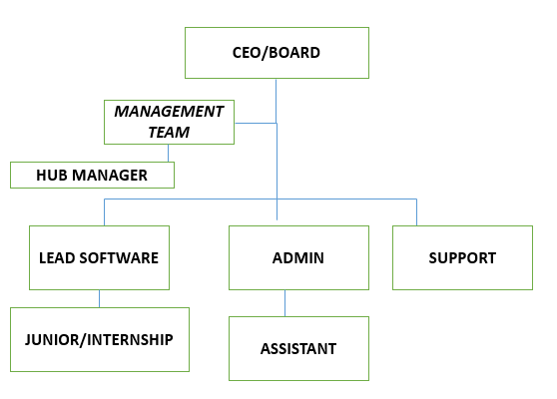

**CHAPTER THREE**

**2.0 INDUSTRIAL EXPERCIENCE: PROGRAMMING DEPARTMENT**

This department was where my Industrial Training took place where I was grounded and expose to the web and software development world especially the creation of websites taking me step by step with practical all through the process and also provide necessary support and required ICT infrastructure and tools for staff to carry out their day to day function with the ultimate aim of ensuring that the Commission’s goals and objectives are achieved.

**2.1 DEFINITON OF TERMS**

The following are terms that were made use of, in this department

1. **WEBSITE:** is a central location of various [web pages](https://www.computerhope.com/jargon/w/webpage.htm) containing content such as texts, images, videos, audios, etc. that are all related and can be accessed by visiting the [home page](https://www.computerhope.com/jargon/h/homepage.htm) of the website using a [browser](https://www.computerhope.com/jargon/b/browser.htm)**.**
2. **HTTP:** This stands for Hyper Text Transfer Protocol which is the set of rules for transferring files (text, graphic, images, sound, video, and other multimedia files) on the World Wide Web.
3. **URL:** This stands for Universal Resource Locator and as the name suggests, it provides a way to locate a resource on the web, the hypertext system that operates over the internet.

**2.3 PHP AND ITS PROPERTIES**

PHP stands for Hypertext Preprocessor. PHP is a server-side scripting language, which can be embedded in HTML. By default, PHP documents end with the extension ***.php*.** When a web server encounters this extension in a requested file, it automatically passes it to the PHP processor. The PHP script can be placed anywhere in the document. The PHP script starts with <?php and ends with ?>

**2.3.1 WHAT PHP CAN DO?**

* PHP can generate dynamic page content
* PHP can create, open, read, write, delete, and close files on the server
* PHP can collect form data
* PHP can send and receive cookies

**2.3.2 PHP SYNTAX**

<?php

//PHP code goes here

?>

**2.3.2 PHP ARRAYS**

Arrays in PHP is a type of data structure that allows us to store multiple elements of similar data type under a single variable thereby saving us the effort of creating a different variable for every data. The arrays are helpful to create a list of elements of similar types, which can be accessed using their index or key.  An array is created using an **array()** function in PHP.

There are basically three types of arrays in PHP:

* **Indexed or Numeric Arrays:** An array with a numeric index where values are stored linearly.

**// One way to create an indexed array**

**$name_one = array("Zack", "Anthony", "Ram", "Salim", "Raghav");**

* **Associative Arrays:** An array with a string index where instead of linear storage, each value can be assigned a specific key. For example;

**// One way to create an associative array**

**$name_one = array("Zack"=>"Zara", "Anthony"=>"Any",**

**"Ram"=>"Rani", "Salim"=>"Sara",**

**"Raghav"=>"Ravina");**

* **Multidimensional Arrays:** An array which contains single or multiple array within it and can be accessed via multiple indices. For example;

**// Defining a multidimensional array**

**$favorites = array(**

**array(**

**"name" => "Dave Punk",**

**"mob" => "5689741523",**

**"email" => "davepunk@gmail.com",**

**),**

**array(**

**"name" => "Monty Smith",**

**"mob" => "2584369721",**

**"email" => "montysmith@gmail.com",**

**),**

**array(**

**"name" => "John Flinch",**

**"mob" => "9875147536",**

**"email" => "johnflinch@gmail.com",**

**)**

**);**

**2.3.3 PHP SUPER GLOBAL**

They are built-in variable that are always available in all scope. They are:

* $_POST
* $_GET
* $_SESSION

**$_POST:** is a PHP super global variable which is used to collect form data after submitting an HTML form with method="post". $_POST is also widely used to pass variables.

**Code view: <html>  
<body>  
<form method="post" action="<?php echo $_SERVER['PHP_SELF'];?>">  
  Name: <input type="text" name="fname">  
  <input type="submit">  
</form>  
<?php  
if ($_SERVER["REQUEST_METHOD"] == "POST") {  
    // collect value of input field  
    $name = $_POST['fname'];  
    if (empty($name)) {  
        echo "Name is empty";  
    } else {  
        echo $name;  
    }  
}  
?>  
  
</body>  
</html>**

**$_GET:** is a PHP super global variable which is used to collect form data after submitting an HTML form with method="get".

**Code View: <html>  
<body>  
<?php  
echo "Study " . $_GET['subject'] . " at " . $_GET['web'];  
?>  
  
</body>  
</html>**

**$_REQUEST:** is a PHP super global variable which is used to collect data after submitting an HTML form.

**Code View: <html>  
<body>  
<form method="post" action="<?php echo $_SERVER['PHP_SELF'];?>">  
  Name: <input type="text" name="fname">  
  <input type="submit">  
</form>  
<?php  
if ($_SERVER["REQUEST_METHOD"] == "POST") {  
    // collect value of input field  
    $name = $_REQUEST['fname'];  
    if (empty($name)) {  
        echo "Name is empty";  
    } else {  
        echo $name;  
    }  
}  
?>  
</body>  
</html>**

**2.3.4 PHP OPERATORS**

Operators are symbols that tell the PHP processor to perform certain actions. For example, the addition (+) symbol is an operator that tells PHP to add two variables or values, while the greater-than (>) symbol is an operator that tells PHP to compare two values.

PHP Arithmetic Operators

The arithmetic operators are used to perform common arithmetical operations, such as addition, subtraction, multiplication etc. Here's a complete list of PHP's arithmetic operators:

|  |  |  |  |
| --- | --- | --- | --- |
| **Operator** | **Decription** | **Example** | **Result** |
| + | Addition | $x+$y | Sum of $x and $y |
| - | Subtraction | $x-$y | Difference of $x and y |
| * | Multiplication | $x*$y | Product of $x and $y |
| / | Division | $x/$y | Quotient of $x and $y |
| % | Modulus | $x % $y | Remainder of $x divided by $y |

**PHP Assignment Operators**

The assignment operators are used to assign values to variables.

## PHP Comparison Operators

The comparison operators are used to compare two values in a Boolean fashion.

**PHP Incrementing and Decrementing Operators**

The increment/decrement operators are used to increment/decrement a variable's value.

**PHP Logical Operators**

The logical operators are typically used to combine conditional statements.

|  |  |  |  |
| --- | --- | --- | --- |
| **Operator** | **Name** | **Example** | **Result** |
| And | And | $x and $y | True if both $x and &y are true |
| Or | Or | $x or $y | True if either $x or $y are true |

**2.3.5 RUNNING THE PHP FILES ON WAMP SERVER**

**STEP 1**: Download the wamp server set up and install

**Step 2:** Run wamp server by this selction;  
start->All programs->Wamp server->Start wamp server

**Step 3: Create PHP file**  
Let us create our php file first. E.g index.php  
Open text editor and type the php code.  
save the file inside this folder

c://wamp/www/

**Step 4: Start the server**  
Left click on the wamp icon in system tray.  
It will display list of options.  
Select “start all services”.

**STEP 5: Run**

Now all services(especially php) is running.  
Open the browser and type localhost in address bar. (http://localhost/index.php)  
Hit enter  
It will show the default page of wamp server.

Now include this index.php (my php file name) at the end of the url.

**2.4 W3.CSS AND ITS PROPERTIES**

W3.CSS is a modern CSS framework with built-in responsiveness. It supports responsive mobile first design by default, and it is smaller and faster than similar CSS frameworks. Supports modern responsive design (mobile first) by default. Provides CSS equality for all browsers. Chrome, Firefox, IE, Safari, and more.

W3.CSS can also speed up and simplify web development because it is easier to learn, and easier to use than other CSS frameworks

**2.4.1 W3.CSS container**

The [**w3-container**](https://www.w3schools.com/w3css/w3css_containers.asp) class is the most important of the W3.CSS classes. It provides equality like:

* Common margins
* Common paddings
* Common vertical alignments
* Common horizontal alignments
* Common fonts
* Common colors

The w3-container class is typically used with HTML container elements.

**2.4.2 W3.CSS BUTTONS**

The w3.css buttons can be expressed as w3-btn and which w3-button add button-behavior to any HTML elements

W3.CSS provides the following classes for buttons:

|  |  |
| --- | --- |
| **Class** | **Defines** |
| W3-btn | A rectangular button with a shadow hover effect |
| W3-button | A rectangular button with a grey hover effect. |
| W3-bar | A horizontal bar that can be used to group buttons together. |
| W3-block | Class that can be used to define a full width (100%) button |
| W3-circle | Can be used to define a circular button |
| W3-ripple | Can be used to create a ripple effect |

**2.4.3 W3.CSS Table Classes**

W3.CSS provides the following classes for tables:

|  |  |
| --- | --- |
| **Class** | **Defines** |
| W3-table | Container for an HTML table |
| W3-striped | Striped table |
| W3-border | Bordered table |

**2.4.4 W3.CSS ANIMATIONS**

It allows the animation of HTML elements without using JavaScript or Flash.

W3.CSS provides the following classes for animations:

|  |  |
| --- | --- |
| **Class** | **Defines** |
| W3-animate-top | Slides in an element from the top (-300px to 0) |
| W3-animate-bottom | Slides in an element from the bottom(-300px to 0) |
| W3-animate-left | Slides in an element from the left(-300px to 0) |
| W3-animate-right | Slides in an element from the right(-300px to 0) |

**2.5 JAVASCRIPT AND PROPERTIES**

JavaScript can be implemented using JavaScript statements that are placed within the <script>…………..</script> HTML tags in a web page. You can place the <script> tags, containing your JavaScript, anywhere within your web page, but it is normally recommended that we should keep it within the <head> tags

## 2.5.1 What You Can Do with JavaScript

There are lot more things you can do with JavaScript.

* You can modify the content of a web page by adding or removing elements.
* You can change the style and position of the elements on a web page.

**2.5.2 JS SYNTAX**

The syntax of JavaScript is the set of rules that define a correctly structured JavaScript program.

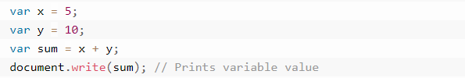

**2.5.3 JAVASCRIPT VARIABLES**

**What is a variable?**

Variables are used to store data, like string of text, numbers, etc. The data or value stored in the variables can be set, updated, and retrieved whenever needed.

A variable can be created with the ***var*** keyword, whereas the assignment operator ***(=)*** is used to assign value to a variable, like this: ***var varName = value;***for example;

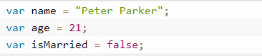

**PARTICIPATION IN THE ICT TRAINING DEPARTMENT**

As a front-end developer I was able to designed the following

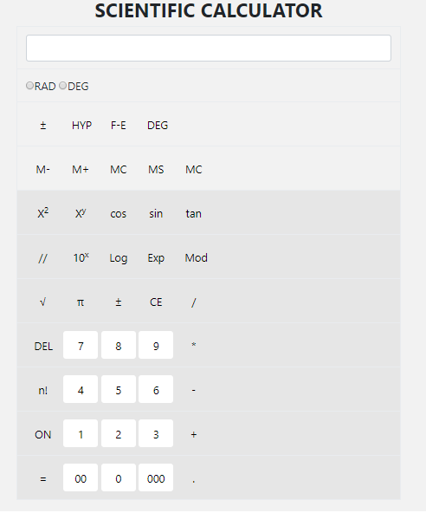

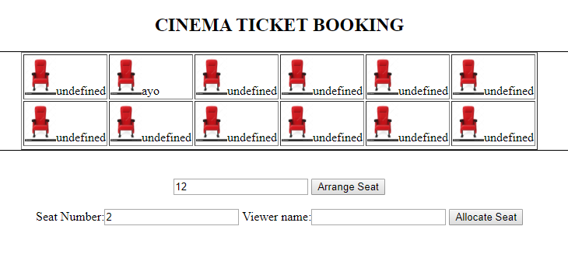



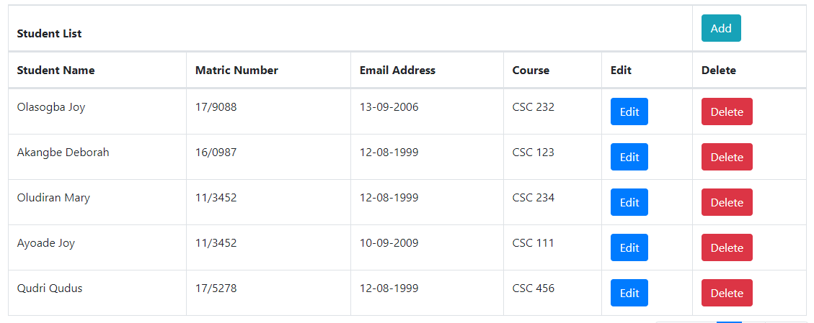

**CHAPTER FOUR**

**CONCLUSION AND RECOMMENDATIONS**

**4.0 CONCULSION**

The training experience is very mandatory and important for all students in tertiary institution like science and technology, engineering and school of environmental studies. It should be encourage at any time in all institution of learning so every student should take it serious for themselves.

**4.1 RECOMMENDATIONS**

I recommend that the (I.T) program its continuity in all tertiary institution because it help so many students in practical aspect and academic performance as well as work experience.

In other to make this SIWES training easy, student should look for interested place where they are practical orient.

I also recommended that the government and the school authority should assist the student in securing a good place for their (I.T) program, because some students found it difficult in securing a place.