# CHAPTER FOUR

**RESULTS AND DISCUSSION**

## 4.1 Results of The Developed File Checker System

This result of the developed file checker system was on windows 10 64-bit operating system HP, with Intel(R) Core(TM) i7-2620M CPU @ 2.70GHz, 4GB Random Memory Access (RAM) and a 500GB. The source code and other assets used for the project are presented in the Appendix.

To make this application and optimize it to work in fastest and best manner, the declarative style of programming was used and DDD (Domain Driven Design) architecture has been used for faster iteration process unlike some industry standards that uses imperative style of programming and MVC (Model View Controller) architecture. I found out that the iteration process using does pattern were tedious and slow. Most of the work (programming) is done by PHP language because of the flexibility AOT (Ahead of Time) Compilation and the numbers of platforms it allows the user (programmer) to target. In line with PHP language which is the main backend language used, I used bootstrap for the frontend of the application in other to ensure a beautiful and a well user-friendly frontend design. JavaScript and jQuery library was also used to ensure user interactivity.

## 4.2 Application Views

The application was structured to have three (2) different views the users views and the admin views. The users’ views and tutors’ views also share some views together such as login, sign up page, feature page etc.

## 4.2.1 Homepage Views

The home page is the initial (index) page or entry point of the application, the entry point for both tutors and students. This page shows users both students and tutors what might interest them, such as the navigation bar which show them call to action buttons to sign up, register or be a teacher, the sliders for advertisement of features, the course categories for learners to select and more.



*Figure 4.2.2 - Sign up and Login page on phone viewport.*

## 4.2.2 Authentication Views

The authentication views include the login page the sign-up page and the forget password page. All these pages ensure that users are authenticated and validated before they can use any integral parts of the application. For example, a user can’t see a full course details or tutor’s dashboard pages unless they are authenticated, simply put at any route the users navigate to, we check to find out if they are and allowed to view the page or not, if not they are rerouted to another page with an error detail notification telling them why so. Its important to note that the homepage (initial entry point) of the app for example does not requires users to be authenticated before viewing the page but instead the functionality of the app are inhibited i.e., an unauthenticated user cannot view fully a particular course but can see the course previews enough to give them details about the course.

The figure 4.2.2 below show how the users are authenticated either when they want to login or sign up. Aside’s email and password users can login or sign up via their other social account such as Twitter, Google, or GitHub. This was possible by connecting to their respective API (Application program Interface).

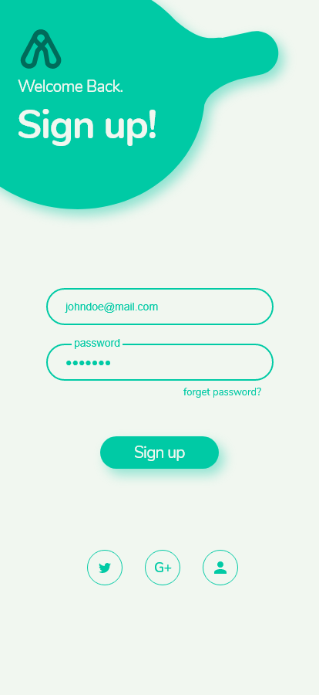 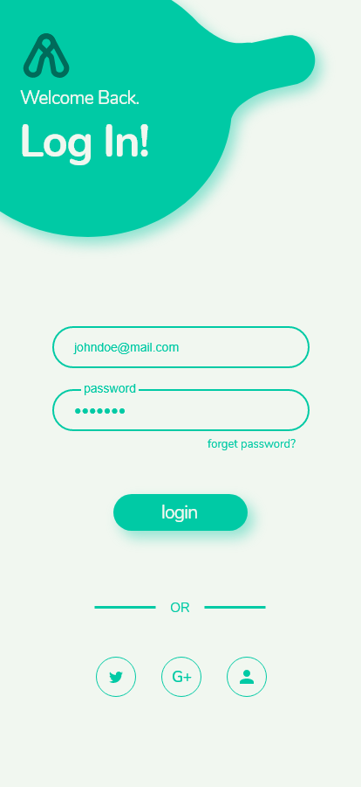

*Figure 4.2 - Sign up and Login page on phone viewport.*

On the course of signing up users are validated by sending an email token to their account to ensure that the email given exist. After that they are routed to the login page.



The figure above is the forget password page, if a user forgets their password, we ask them to put in their email address. With this provided email address we will cross check to know if the email exists in our database, and if it does, we send them an email and follow up procedures to recovery and create a new password for their account without losing their already existing data.

## 4.2.2 User Course Views

The user course views are views for users who registered as wanting to learn. The pages include the user dashboard page, the course syllabus page, and the course page. All these pages ensure that users are authenticated and validated. The figure below shows how the dashboard page looks like. The dashboard page shows the user. All the list of courses they have registered for and their progress so far in each course. When one clicks on a particular course it takes them to a to the course syllabus page.

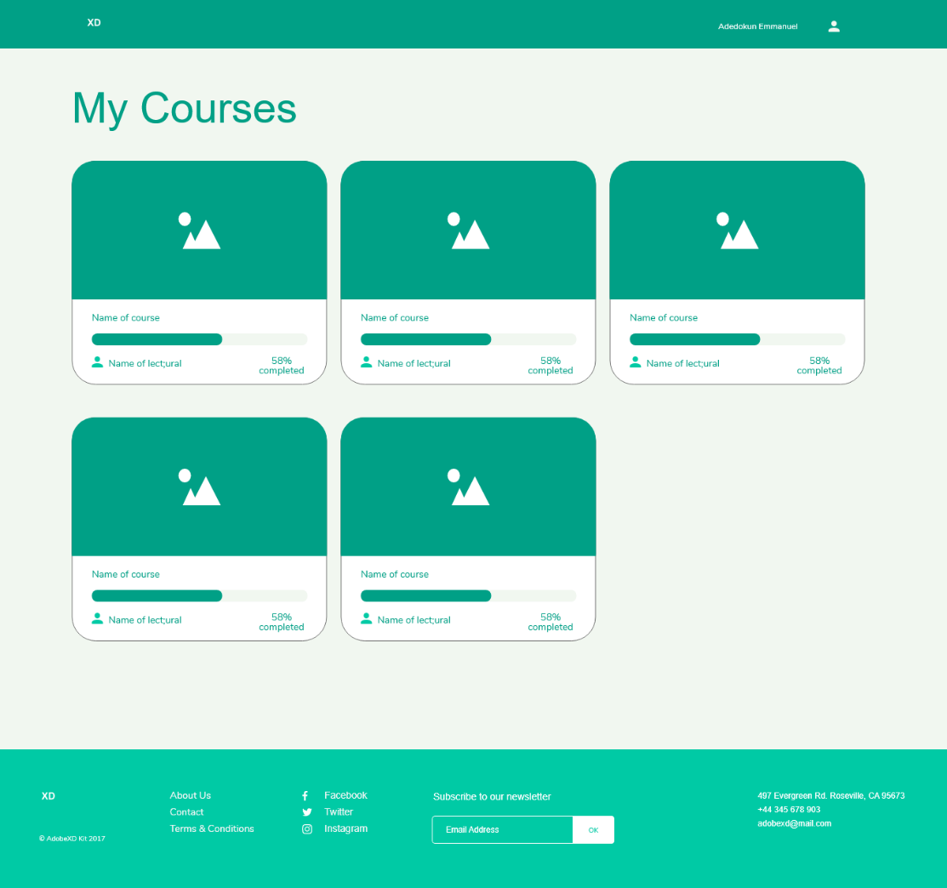

*Figure 4.4 – The learner’s dashboard on desktop viewport.*

The figure below is the course syllabus page. It shows the learners more details about the course. When the drawer is opened it show the user their course progress. While the main page highlights the full syllabus, it shows them the type of materials available for each subsection of the course and show them if they have completed it or not.

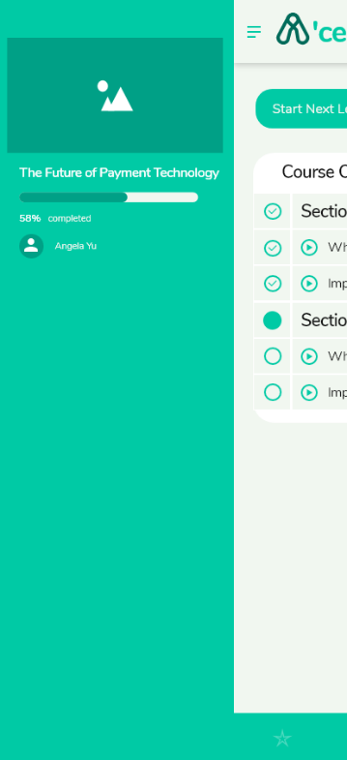 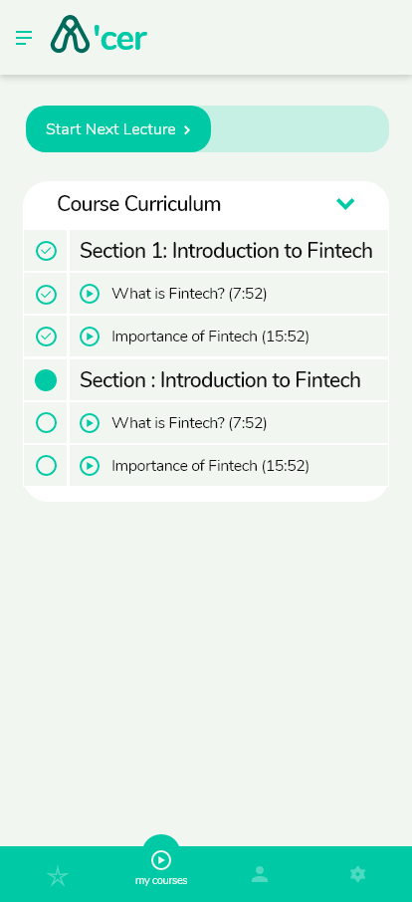

*Figure 4.4 – The learner’s course syllabus page on phone viewport.*

The next figure below is the course page where most of the activity of the users are done. Where a user clicks on a subsection in the course syllabus page, it takes them to the course page. The course page shows them the content of what they have clicked, most of the time they are mostly video content, but their also other format. The three (3) tabs below, are the other section of the screen that further engages the user. The first tab is the resource section which allows the user to see other resource that are made available by the tutors for further comprehension on the topic at hand. The resource could be links to articles, pictures documents or audio files. The next tab is the question-and-answer tab short for Q/A. The section allows the tutor and all leaners taking the course, to chat in real time with themselves irrespective of their local time and geographical region. The last Tab is the announcement tab. At this tab the tutor can write any announcement that he or she wants to pass to the fellow learners taking the course at each subsection.

