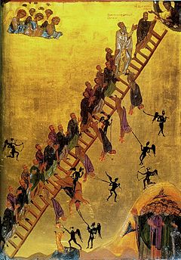

Biographic footnotes of heroes

Legend of life desighn

Dualimage driven impetus of world /cononicle meaning, purpose and cause of the primary exercises and practices in the tutelage of the cononicle world primary concept of sociality through philosiphic studies in the balanced inertia of life‘ world authentication for topology of the statutory human erogronomic reasource of anthropic mitigation datadiversity life information are to be carried over the cononicle network protocols of anthopologys neural/ organic binary network evolution in modernday creations algorhythm of life form and life origin in orthodox compliance of fundamental foundations world life forwarth comings of prophecys manifestations and salvations coordinate to life Paradox.

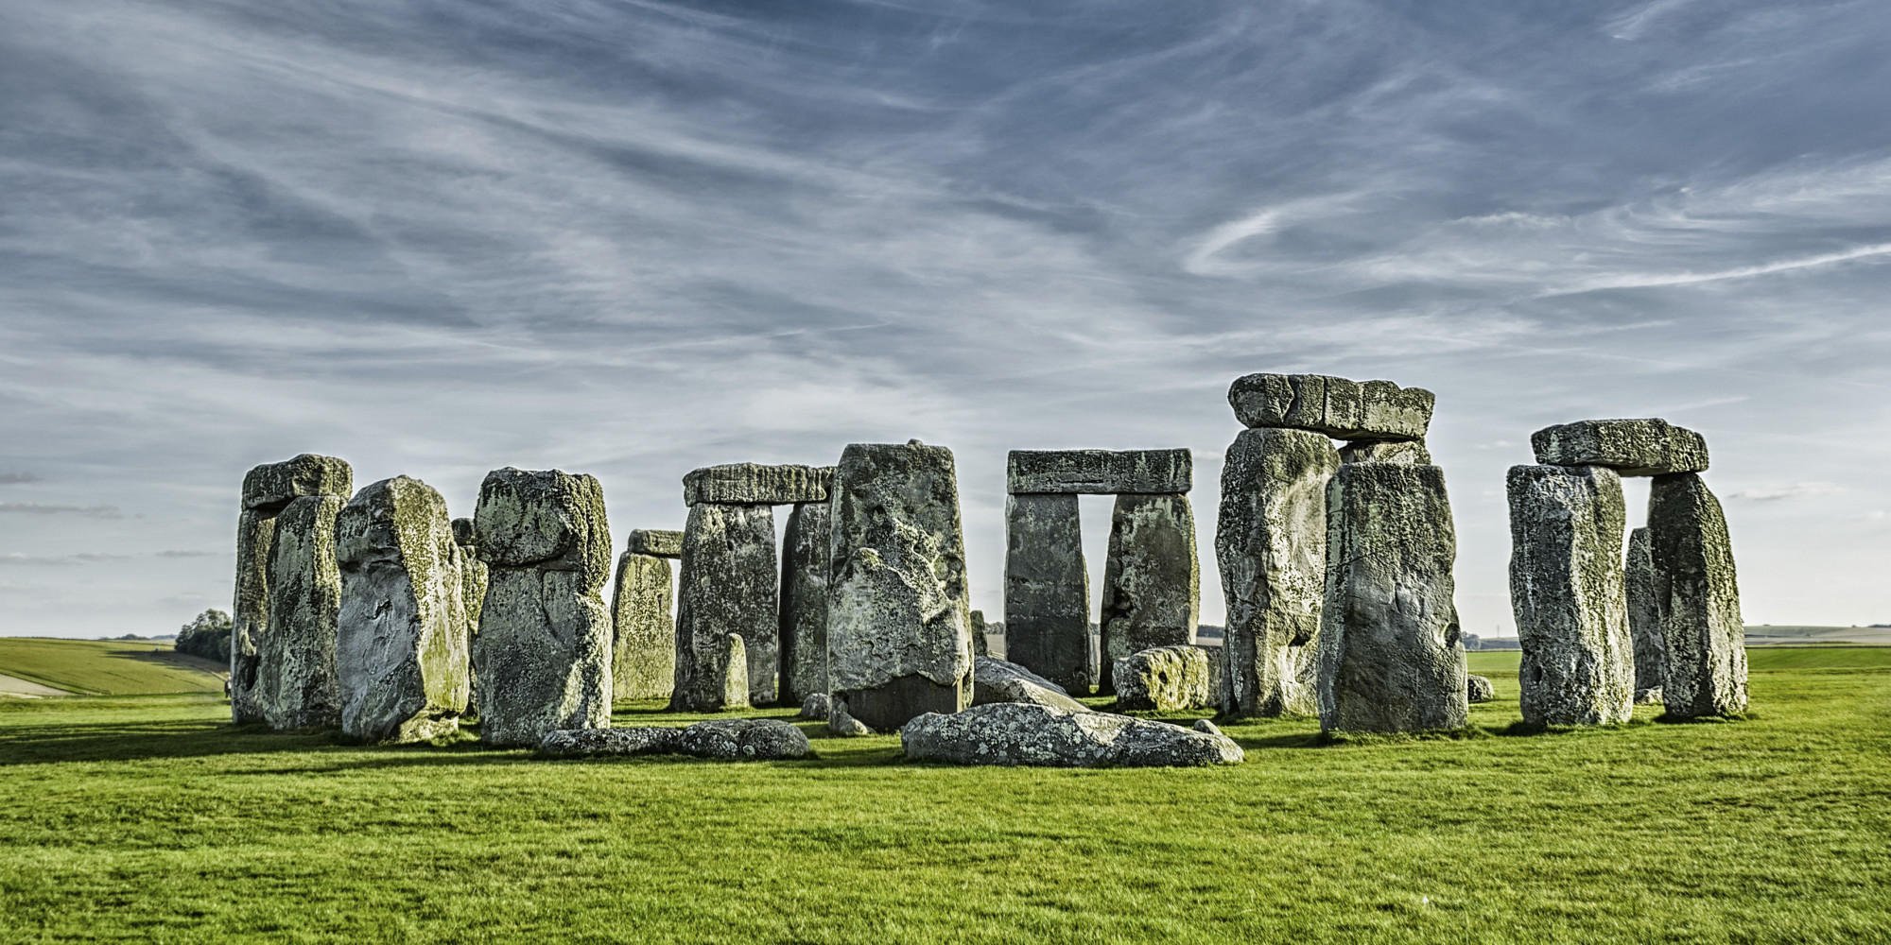

inner-external social enterprise endeer image world prodigy of creations universe resources and instrumental alighnment, eclipse of constant statutory provisions of the observatory(hengestone) in methodology to compile alighnment of civilizations matrix, ‘of life parallel life ideology for construct of dominating continents facillitating psychic oracle and archeologic trade visions of world inherited decadents manuscripts . The Genesis of creations algorithmic libedum and equalibrium constant, to forsee future and planning for destiny of man, guided through psychological conscious, world diversity of life,’implementing the parrallel census self sustenance information/ Intel and states quo of man /machine of the mind and logical truth of the serrenity salvation and manifest in the hope of natural mechanologys, ‘will preserve the methodology of ‘world social affairs’, trending out, the burden of old world practices ‘to unleash moral probability constant, to acheive max potenciality with collective social geographic architecture /synthesis,’in the Anthropologic communication linguistic and statutory constant of ecological and cosmic world interconnection to erogronomic junction and coordinates of the second and third party sector in cononical elite, social precision, fundamental foundations physics and principals of statutory.

Recreated symbols hieroglyphic manuscripts



The new testaments ontological transcripts in psuedo scientific world genesis of authentic creations encouraging spiritual goals of the intuition for lifes new world puzzle of the connonicle gospels ontological transcripts of logos venture, into ‘the mitigation of the worlds elemental principals underlying in the forms of lifes fundemental world virtues,’securing varification of the methodological intelligence of diverse ecological trades and brands to identify the lifes salvations sequencial-generic providence of unity in ethics of ecological world “fiduciarys”(economics, cultural society) evolving from origin of life to a relative parrallel sector of geographic world enterprise architectural coordinates of the celestrial exposition and celebration of value and qualitys in man of hieroglyphic world serrenity to new beggining of profficient social ethic emotions and are variable factor to implicating the coordinates of providence connecting survival and exsistence objectives, “marketplace ‘scenario’ in alighnment /placendo or inheritance of the cononicle gift of life methodological natural intuition that interface with world diversive mechanologys/engineering of best intrest :Presbyterian, estoric Quantum ,Quram spiritual world alignment to world map configuration of mistletoe /psuedo science , creations Industry of reimaging the architecture mechanology led under the tuteledge of one creators practices (connotation) .Technology of parable reasources, and of life ondemand in cononicle gospel and in culturally popular economic and diversity topics applied into the stratedgy ethics or methods of the ancient decendance in their ascention of the topological compliance to the implemented geomenue of mechanologys life Anthropologic methodology in life virtual reality of the connected lifes divine-virtue in the cononicle gospel. Dual image world prodogy.

Part 2.

INHERITANCE, ARMEGGEDON, HUMAN REASOURCES AND CENSUSES FOR CIVILIZATION OF TOMMORROW. {youngsociety ln naturally inheritant employment curriculum/psuedoscientific pyramidsevolution of generations}.

Tribute to the inheritance of elite world conciousness of censuses social ethic methodology process, developedment and growth evolve through virtual world priveledge and opportunity to exercise customary tribute to earths magnificents of life innovation redeem the economic parity of opposite geographic poles relative to the socialethic life vocation of world linguistics generic/hereditary life ideology of noble proffesions ,chronological events of pedogogal inheritance of the cononicle ontology with witness to varify instrument of functionality in unique anatomic charisma of human world prodigy via ecological intercontinent regiemen and nationality symbols as an exercise and practices for the geographic biological and anthropic sequencial hereditary and generic rituals of worlds life endeavor. and social ethic cononicle permission for mechanical adaptivity of algorithm of life vocations connection to the probability of lifes productive goals (unionjack) of trades contributing good to union of network .

Part 3.

Render the laminate of world image compilation ; By paradism of intergrated mind and the cause and effect of geographic life manifestation,’ the salvation as had interpret and restored methodologic regiemen of nexus in branch anthropology of providence to statutory science in stewardship enterprise sector of mechanologys mythologic world fundemental foundation and hightened stimulus of world enlightenedment unification with geographic implimentation nexus of lifes matrix construct and desighn in build compilation of lifes world provisional essentials and nessesitys of ecological manifestation to justify poetically interpret mathematical compilation for varification to accuracy of truth /and realitys of life cause and purpose of logos information infrastructure of world archeaic networks in world wonders comulative instrument for triangulated observation to anatomic/chronological world perfection and precision map geographic . Capital of

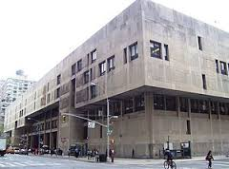

Part 3

Testing : Anthropologic phoneomic Alphabet, Stratedgy, tactics / Censuses, humanitys essentials nessesitys , Economics -infrastructure , anthropic networks - intel information,

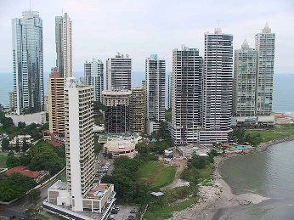

Part .4

Our conclusion to the choreographic harmony established between the operation of world designated unified balance theory and sequencial generic garden of eden geographic ontology on the transition of life eminating intelligence energy and forces of life power from the geneologic order of creations ecological binary architecture and synchronize the inheritance of the world unified scriptures variable information /intel establishes chronological connection with unified architectural methodology of world fundamental foundation on rituals defined from the manuscript unified linguistic on subsistence social ethic diversity in whole and complete’ uncensored cononicle administration recieved by believers in the moral constitution of life fundemental foundation of prophecy where translation to the hieroglyphic personelle of natural law and ecological foodchain theory, ‘inspire the interactive experience of unified world sequencial-generic creations ‘constant of world’/ideology .

Interesting how the world implies and wonder how it never made best for mankind in the poll opinion on the designated care and purpose of life innovation and wonder how it never made best for mankind in the poll opinion.