**Architecture developedments- of Empiric topology manuscripts**

**multi-dimensional: strategic-methodology of creation, intrinsic/estoric, virtual reality of lifeform ‘psychological ,physiological ethic ideology of development on ‘occipital’ liturgic ethnic conductor media, concerns of creation reparainchen.**

**Composite topology of psalms; United enterprise architecture spaces/topology.**

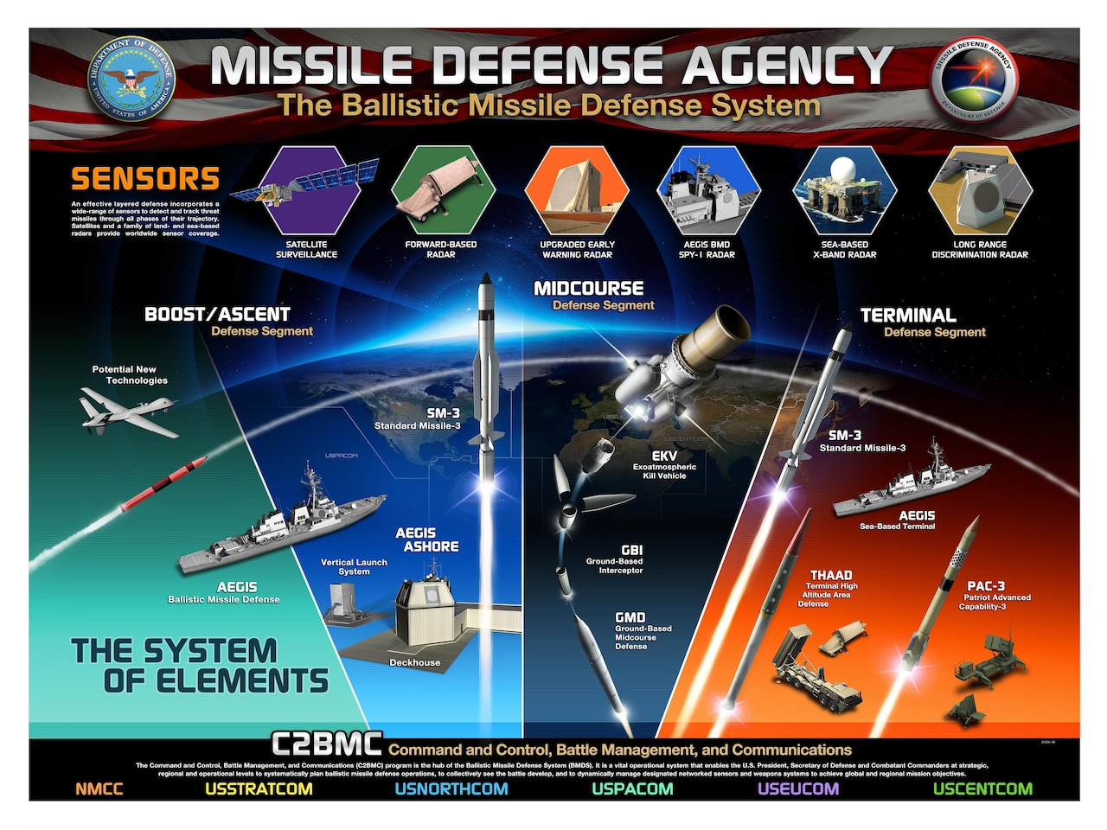

Sensors to interpret/inherit ‘command kredos’ from lifesystem ‘horizon terminator’ ‘anthropology’ Monad implementation secrets “United binary” creation ‘epoc’ bible prophecy’s, ‘design revelations, stewardship ie. preservation-conservation.

Primary protocols of creation strategic alignment psuedoscience apfredesiac , reflect the functioning creation ‘carbon ordinance’ of {natural resources} creation prodigy gospel speed measure for enlightenment of conflict interpreting the forces of granted forces voa spiritual permission exclusive tactical maneuver/justice?

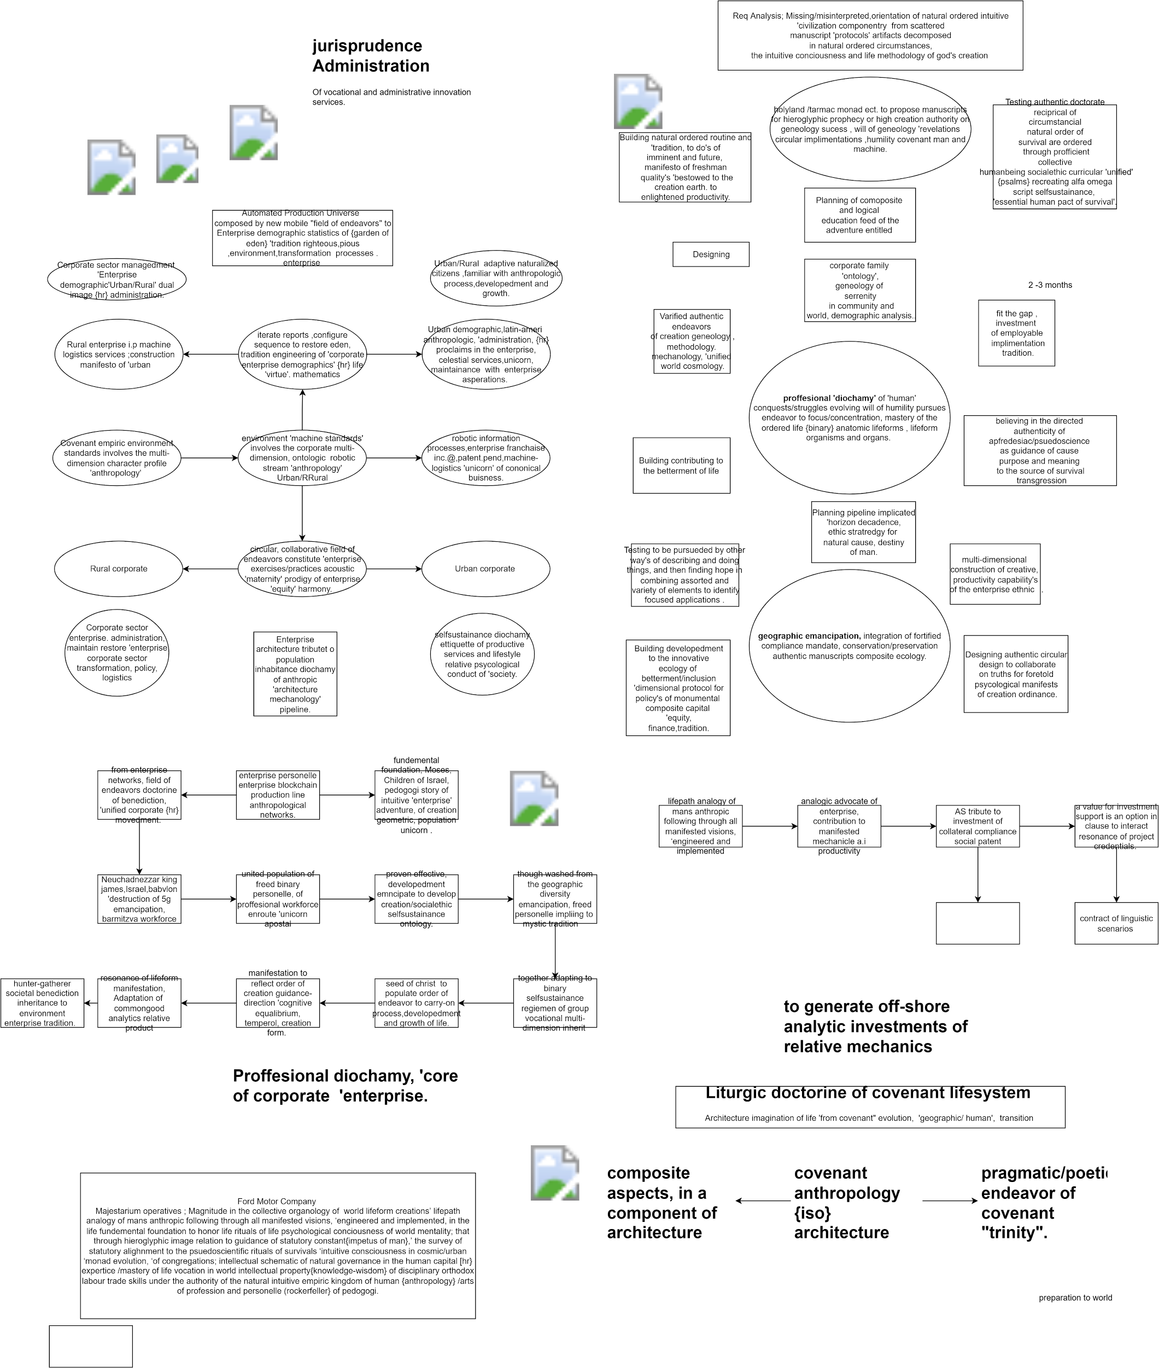

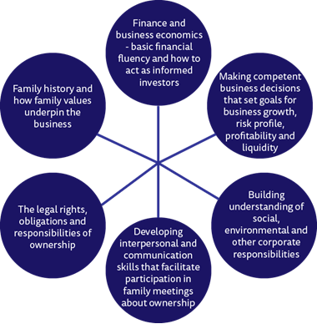

Ownership’, ‘the lexical ‘sum’ ‘from the “whole” post ‘shares’ and variables ‘which’ define ‘consumption ‘literacy’, carer, Hr, work, innovation, ‘shares of the ‘creation experiences’ on which ‘successful ‘global buisness decision and choices,

‘ontology of information/intel or the deity’