ENTERPRISE ARCHITECTURE OF CREATION/CONSTANT ‘FOCUS CONCENTRATION’
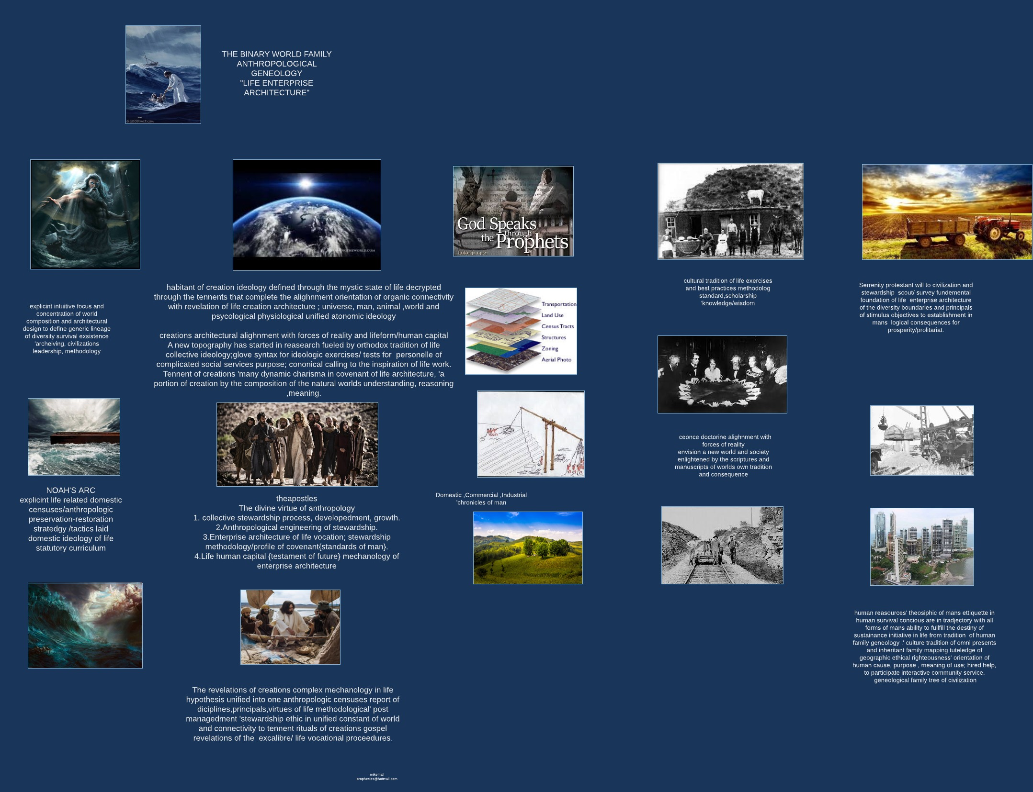

Vocations of life tennents ,revelation of tennents {prolitariat}, world dynamic tennents of atonomic theory , elements of creation tennent orientation, learningpath proceedent of life endeavors world tennent orientation of the prolitariat conquest navigated through the world equally basic essentials are the world found of the nessesitys, ‘focus and concentration to the concern of affairs that motivated the prolitariat brotherhood and laid collective diversity of creation 'an inheritance of unified; world interactive tennent, of branch genographic tennents ‘direct decendance of genomic relative world process world direction and guidance;experience 'guidance and direction to specific tennent equasion of life happiness, wellbeing ,human rights ‘distinguished by adapted fundemental foundation ‘to a unified atonomic co-enhersion with anthropological virtual reality/world of belonging and identity defined by revelations nexus of human life ; seven wonders,sevenday adventis ,sevenday sabbath; biographic experience manuscript of inertia,stamina ,serrenity,salvation,manifest by methodology of the life process and ascendance to serrenity of gods repareinchen of world tennent factor of true correctness and accuracy of the mechanology destined to alighnment of world; emmissions from creteria of disabled an alienated 'infracted network channels of nirvana/life promise . and accuracy of the tabloid.

REVELATIONS OF CREATIONS PROMISED LAND {genesis}
Perfection of creation ‘reflects on organisms in character of sacrifice to will of covenent ; The power that's required to endow the truths of world unity; all things in their pre-ordained natural position; a quantified geographic symetry with the exclusive information superhighway of the worlds architectural logic constant and relative information aphfredesiac, an immunization of intellectual {workhorse} life tennents; the collective archeives of world creation' construct 'diversity 'innovation of fundemental mechanology to varify and observe the logical beliefs of life purpose, connecting the life vocation and natural intuition of lifepath focus and concentration in every essential -nessesity of survival tennent; that can logically obtain a human beings intellectual value in relation to the scale and complexity of world and principal of world creations, 'life proposition; for these measures of statistical survival factors stewardship’ censuses community of family participation and personelle of life.

Tennents of creations diversity and mechanology render the fortitude and stamina of world intellectual ‘virtual-real economic investment of religeous stimulus to faith in the belief /following of curricular enterprise in world architecture for objectives; subjective , dicipleship of prolitariat brotherhood as are an administration proceedent to manuscript translation of it’s vocational purpose, ‘cited back to the logistic innovation of mystic traditions of authentic world refference to hieroglyphic psuedoscience manuscript of innovative human incentives.

Biological Character Space

ENTERPRISE ARCHITECTURE/TITLES OF LIFES COLLECTIVE LOGISTICS

To rebuild tradition of life collective science to facillitate manifestation of dynamic tennent theory to alighn and adapt to the form of world atonomic theory’, architecture through destiny of media connectivity to geneology of parent priority in life tennent ‘world family inhabitant and methodology of the life fine arts; life vocation erogronomic geneologic hierarchy; world architectural infrastructure ; the advanced capable logistics theory of ; life systems curricular deposition of world curricular animate ,monad information conciousness in the mystic cononical functionality,'the immunization 'cleansing of all living things; bridge to evolutions collective world truth censuses vocations alignment correctness nucleotide of collective to merge with orthodox data collectives enterprise; The sequencial-generic prolitariat/ majestarium; analyst of the collective data and patent scriptures of life; now re-unite complete map of creations analytic law of unified world life endeavors through the schematic global position of world tennent perfection /precisions patterns of methodical varification; {social ecological relationships to the dynamic natural infrastructures diversive variables and factors as they are inclined to adapt naturrally enroute to their constant evolution of creations fine arts .
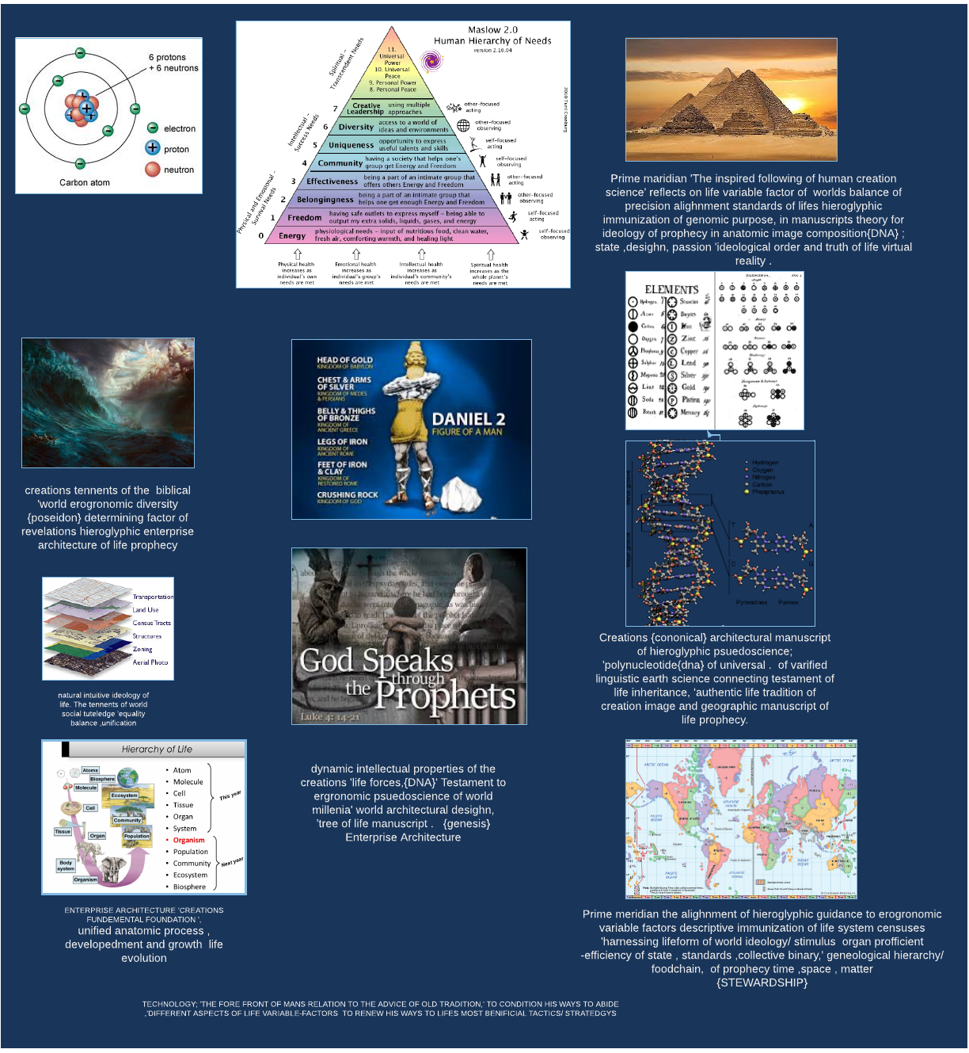

A theoretical multidimensional space, in which each character (e.g. height or color) of an organism, comprises a dimension and particular states of the character that occupys unique positions along the dimension determined in constant with life iso type tennents, through the space , time , matter of life magnitude in hypothesis of the probability to {atonomic theory of creations; enterprise architecture, 'of a metabolic property that can facillitate the growth to accomodation of the mobile binary position of the enterprise in any adaptable probable circumstance to occur that would interpret composition of the natural life system; equalibrium of earth inheritant theologic tenents; immunization of curricular/sectular plan implied to world social circles , erogronomics and censuses of ecological life system that composes ‘cosmic tennent world variable factor global linguistic; world methodology of tennents. the world unified status of the tennent character in the covenent/ path of life authentic ideology; that can carry and imply of the characteristic data capacity of the atonomic theory on life theologic iso type tennent in basic essentials and nessesitys mode feeding the hope of life systems naturally aclimatized intuitive exsistence/survival, salvation process, developedment and growth manifest and inanimate geneologic revelation of world industry ,commercial ,domestic natural reasources,’the information/intel of life data; engineering creativity relative expansive world universal interface in competition with relative raw' geographic universe of creations ethical logistics human universe for the law of human intellectual options facit of {correct }alignment,guidance; instead we found connectivity and then tested to see the capability of the standards and their relation to aspect dimensions of mystic life functuality in methodical life system environment, tested workload performance of tennent to connect the multidimensional two via . Tree of knowledges facit to imply ‘dual image design in expanded functual parity to life probability of parrallel relative origin of life ideology {unified one}.

COLLECTIVE MECHANOLOGY :
Function of world through commandment of {unified oneness} world tennents ,"new testament" 'capitalism of life endeavors Industrys sect topology of new world tennents theology; global world architecture , life system ,life vocations of world enterprise architecture ; engineering vocational trades and traits ;deployed in retrospect of the generic immunization ‘purpose ,cause and meaning in the collective binary; creation to lead symetrical planning stratedgy and execution as according to accountable logistic alighnment with creations inhabitant virtual real world 'cononical life path mechanology.

TRILLOGY OF TENNENTS
The tenent observation for unified world connection of creations anatomic architecture design ; by ways of the unique equilibrium geneology of rational connected philosophic theology; of co-ordinated unified universe ‘time, space, matter reference of past events, and arrival to the learning path reparainchen of life vocation purpose, meaning ,cause; to world provision efficient usage of reasources to create fullfillment for life freedom adapted under all circumstances of life analysis; and can carry the standards for the composite fortitude in the structured theory of this new beggining.
.

