Міністерство освіти і науки України
Національний технічний університет України
«Київський політехнічний інститут імені Ігоря Сікорського»
Факультет інформатики та обчислювальної техніки
Кафедра обчислювальної техніки

Лабораторна робота №6
з дисципліни
«Об’єктно-орієнтоване програмування»
на тему
«Побудування програмної системи з множини
об’єктів, керованих повідомленнями»

Виконав: Перевірив:
студент групи ІМ-54 Рекечинський Д.О.
Бондаренко Олег Романович
Номер в списку - 4

Київ 2026
Завдання:
1. Створити у середовищі MS Visual Studio C++ проект типу Windows Desktop Application з ім’ям Lab6..
2. Написати вихідний текст програми згідно варіанту завдання.
3. Скомпілювати вихідний текст і отримати виконуваний файл
програми.
4. Перевірити роботу програми. Налагодити програму.
5. Проаналізувати та прокоментувати результати та вихідний текст
програми.
6. Оформити звіт.

Завдання згідно варіанту:
Ж mod 4 = 4 mod 4 = 0
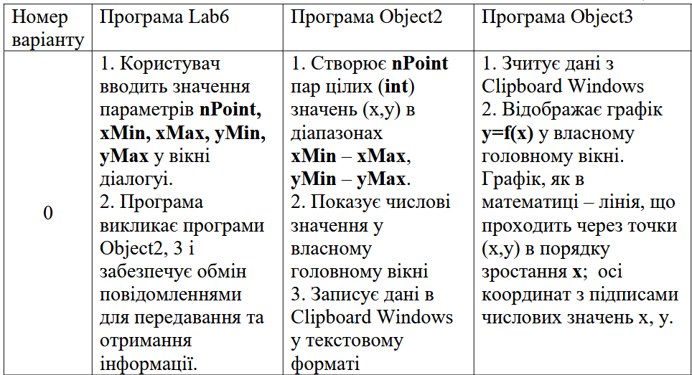
Код програми:
SharedData.h
#pragma once
#include <windows.h>

// Потрібні параметри згідно мого варіанту
struct PointParams {
int nPoint;
int xMin;
int xMax;
int yMin;
int yMax;
};

// Ідентифікатор типу даних для COPYDATASTRUCT::dwData
// Для того щоб переконатися, що отримані саме параметри точок
constexpr ULONG_PTR CD_POINT_PARAMS = 0x1001;

// Системні користувацькі повідомлення
constexpr UINT WM_UPDATE_GRAPH = WM_USER + 1; // Object1 -> Object3 (оновлення графіка)
constexpr UINT WM_DATA_READY = WM_USER + 2; // Object2 -> Object1 (точки в буфері обміну)
constexpr UINT WM_OBJECT2_READY = WM_USER + 3; // Object2 -> Object1 (вікно Object2 створено)

// Для зручного пошуку через FindWindow
constexpr const wchar_t* OBJECT1_CLASS = L"IDC_OBJECT1";
constexpr const wchar_t* OBJECT2_CLASS = L"IDC_OBJECT2";
constexpr const wchar_t* OBJECT3_CLASS = L"IDC_OBJECT3";

Object1.h
#pragma once

#include "Resource.h"

Object2.h
#pragma once

#include "Resource.h"

Object3.h
#pragma once

#include "Resource.h"

set.h
#pragma once

#include "Resource.h"

#include "../SharedData.h"

class Object1
{
private:
static Object1* p_instance;

Object1() {};
~Object1() {};

Object1(const Object1&) = delete;
Object1& operator=(const Object1&) = delete;
public:
int nPoint = 0;

int xMin = 0;
int xMax = 0;

int yMin = 0;
int yMax = 0;

static Object1* getInstance();

void Open(HWND hWnd);
void Close();
};

generator.h
#pragma once

#include "Resource.h"

#include "../SharedData.h"

#define BUF_HEADER_CHARS 128
#define BUF_POINT_CHARS 64
#define BYTES_PER_POINT_LINE 32

#define UI_HEADER_X 20
#define UI_HEADER_Y 15
#define UI_LIST_START_X 20
#define UI_LIST_START_Y 45
#define UI_LIST_LINE_HEIGHT 20
#define UI_LIST_COL_WIDTH 140
#define UI_MARGIN_BOTTOM 25
#define UI_WAIT_MSG_X 20
#define UI_WAIT_MSG_Y 20

class Object2
{
private:
static Object2* p_instance;

PointParams params;
POINT* points;
int pointCount;
bool hasData;

Object2();
~Object2();

Object2(const Object2&) = delete;
Object2& operator=(const Object2&) = delete;

void GeneratePoints();
int PutTextToClipboard(HWND hWnd, const char* src);
public:
static Object2* getInstance();

void OnCreate(HWND hWnd);
BOOL OnCopyData(HWND hWnd, WPARAM wParam, LPARAM lParam);
void OnPaint(HWND hWnd);
void OnCommand(HWND hWnd, WPARAM wParam);
void OnDestroy(HWND hWnd);
};

graph.h
#pragma once

#include "Resource.h"

#include "../SharedData.h"

#define CLIPBOARD_BUF_SIZE 16384
#define LABEL_BUF_SIZE 32

#define GRAPH_MARGIN_LEFT 65
#define GRAPH_MARGIN_RIGHT 35
#define GRAPH_MARGIN_TOP 35
#define GRAPH_MARGIN_BOTTOM 45
#define GRAPH_TICK_SIZE 5
#define GRAPH_NUM_TICKS 5
#define GRAPH_POINT_RADIUS 3

#define COLOR_AXIS RGB(60, 60, 60)
#define COLOR_GRID RGB(220, 220, 220)
#define COLOR_GRAPH_LINE RGB(20, 100, 220)
#define COLOR_POINT_FILL RGB(220, 40, 40)

class Object3
{
private:
static Object3* p_instance;

POINT* points;
int pointCount;
BOOL hasData;

long minX, maxX;
long minY, maxY;

Object3();
~Object3();

Object3(const Object3&) = delete;
Object3& operator=(const Object3&) = delete;

BOOL ReadFromClipboard(HWND hWnd);
void SortPoints();
void CalculateBounds();

POINT MathToScreen(long x, long y, const RECT& plotRect);
public:
static Object3* getInstance();

void OnCreate(HWND hWnd);
void OnUpdateGraph(HWND hWnd);
void OnPaint(HWND hWnd);
void OnCommand(HWND hWnd, WPARAM wParam);
void OnDestroy(HWND hWnd);
};

Object1.cpp
// Lab6.cpp : Defines the entry point for the application.
//

#include "pch.h"
#include "framework.h"
#include "Object1.h"

#include "../SharedData.h"
#include "set.h"

#define MAX_LOADSTRING 100

// Global Variables:
HINSTANCE hInst; // current instance
WCHAR szTitle[MAX_LOADSTRING]; // The title bar text
WCHAR szWindowClass[MAX_LOADSTRING]; // the main window class name

// Forward declarations of functions included in this code module:
ATOM MyRegisterClass(HINSTANCE hInstance);
BOOL InitInstance(HINSTANCE, int);
LRESULT CALLBACK WndProc(HWND, UINT, WPARAM, LPARAM);
INT_PTR CALLBACK About(HWND, UINT, WPARAM, LPARAM);

int APIENTRY wWinMain(_In_ HINSTANCE hInstance,
_In_opt_ HINSTANCE hPrevInstance,
_In_ LPWSTR lpCmdLine,
_In_ int nCmdShow)
{
UNREFERENCED_PARAMETER(hPrevInstance);
UNREFERENCED_PARAMETER(lpCmdLine);

// TODO: Place code here.

// Initialize global strings
LoadStringW(hInstance, IDS_APP_TITLE, szTitle, MAX_LOADSTRING);
LoadStringW(hInstance, IDC_LAB6, szWindowClass, MAX_LOADSTRING);
MyRegisterClass(hInstance);

// Perform application initialization:
if (!InitInstance(hInstance, nCmdShow))
{
return FALSE;
}

HACCEL hAccelTable = LoadAccelerators(hInstance, MAKEINTRESOURCE(IDC_LAB6));

MSG msg;

// Main message loop:
while (GetMessage(&msg, nullptr, 0, 0))
{
if (!TranslateAccelerator(msg.hwnd, hAccelTable, &msg))
{
TranslateMessage(&msg);
DispatchMessage(&msg);
}
}

return (int)msg.wParam;
}

//
// FUNCTION: MyRegisterClass()
//
// PURPOSE: Registers the window class.
//
ATOM MyRegisterClass(HINSTANCE hInstance)
{
WNDCLASSEXW wcex;

wcex.cbSize = sizeof(WNDCLASSEX);

wcex.style = CS_HREDRAW | CS_VREDRAW;
wcex.lpfnWndProc = WndProc;
wcex.cbClsExtra = 0;
wcex.cbWndExtra = 0;
wcex.hInstance = hInstance;
wcex.hIcon = LoadIcon(hInstance, MAKEINTRESOURCE(IDI_LAB6));
wcex.hCursor = LoadCursor(nullptr, IDC_ARROW);
wcex.hbrBackground = (HBRUSH)(COLOR_WINDOW + 1);
wcex.lpszMenuName = MAKEINTRESOURCEW(IDC_LAB6);
wcex.lpszClassName = OBJECT1_CLASS;
wcex.hIconSm = LoadIcon(wcex.hInstance, MAKEINTRESOURCE(IDI_SMALL));

return RegisterClassExW(&wcex);
}

//
// FUNCTION: InitInstance(HINSTANCE, int)
//
// PURPOSE: Saves instance handle and creates main window
//
// COMMENTS:
//
// In this function, we save the instance handle in a global variable and
// create and display the main program window.
//
BOOL InitInstance(HINSTANCE hInstance, int nCmdShow)
{
hInst = hInstance; // Store instance handle in our global variable

HWND hWnd = CreateWindowW(OBJECT1_CLASS, szTitle, WS_OVERLAPPEDWINDOW,
CW_USEDEFAULT, // x
0, // y
400, // width
300, // height
nullptr, nullptr, hInstance, nullptr);

if (!hWnd)
{
return FALSE;
}

ShowWindow(hWnd, nCmdShow);
UpdateWindow(hWnd);

return TRUE;
}

//
// FUNCTION: WndProc(HWND, UINT, WPARAM, LPARAM)
//
// PURPOSE: Processes messages for the main window.
//
// WM_COMMAND - process the application menu
// WM_PAINT - Paint the main window
// WM_DESTROY - post a quit message and return
//
//
LRESULT CALLBACK WndProc(HWND hWnd, UINT message, WPARAM wParam, LPARAM lParam)
{
switch (message)
{
case WM_OBJECT2_READY:
{
HWND hWndObj2 = (HWND)wParam;
Object1* obj = Object1::getInstance();

if (obj && obj->nPoint > 0 && hWndObj2 && IsWindow(hWndObj2))
{
PointParams params;
params.nPoint = obj->nPoint;
params.xMin = obj->xMin;
params.xMax = obj->xMax;
params.yMin = obj->yMin;
params.yMax = obj->yMax;

COPYDATASTRUCT cds;
cds.dwData = CD_POINT_PARAMS;
cds.cbData = sizeof(PointParams);
cds.lpData = &params;

SendMessage(hWndObj2, WM_COPYDATA, (WPARAM)hWnd, (LPARAM)&cds);
}
break;
}
case WM_DATA_READY:
{
HWND hWndObj3 = FindWindowW(OBJECT3_CLASS, NULL);
if (hWndObj3)
{
PostMessage(hWndObj3, WM_UPDATE_GRAPH, 0, 0);
}
else
{
WinExec("Object3.exe", SW_SHOW);
}
break;
}
case WM_COMMAND:
{
int wmId = LOWORD(wParam);
// Parse the menu selections:
switch (wmId)
{
case IDM_ABOUT:
DialogBox(hInst, MAKEINTRESOURCE(IDD_ABOUTBOX), hWnd, About);
break;
case ID_ACTIONS_SET:
Object1::getInstance()->Open(hWnd);
break;
case IDM_EXIT:
DestroyWindow(hWnd);
break;
default:
return DefWindowProc(hWnd, message, wParam, lParam);
}
}
break;
case WM_PAINT:
{
PAINTSTRUCT ps;
BeginPaint(hWnd, &ps);
// TODO: Add any drawing code here...
EndPaint(hWnd, &ps);
}
break;
case WM_DESTROY:
PostQuitMessage(0);
break;
default:
return DefWindowProc(hWnd, message, wParam, lParam);
}
return 0;
}

// Message handler for about box.
INT_PTR CALLBACK About(HWND hDlg, UINT message, WPARAM wParam, LPARAM lParam)
{
UNREFERENCED_PARAMETER(lParam);
switch (message)
{
case WM_INITDIALOG:
return (INT_PTR)TRUE;

case WM_COMMAND:
if (LOWORD(wParam) == IDOK || LOWORD(wParam) == IDCANCEL)
{
EndDialog(hDlg, LOWORD(wParam));
return (INT_PTR)TRUE;
}
break;
}
return (INT_PTR)FALSE;
}

Object2.cpp
// Object2.cpp : Defines the entry point for the application.
//

#include "pch.h"
#include "framework.h"
#include "Object2.h"

#include "../SharedData.h"
#include "generator.h"

#define MAX_LOADSTRING 100

// Global Variables:
HINSTANCE hInst; // current instance
WCHAR szTitle[MAX_LOADSTRING]; // The title bar text
WCHAR szWindowClass[MAX_LOADSTRING]; // the main window class name

// Forward declarations of functions included in this code module:
ATOM MyRegisterClass(HINSTANCE hInstance);
BOOL InitInstance(HINSTANCE, int);
LRESULT CALLBACK WndProc(HWND, UINT, WPARAM, LPARAM);
INT_PTR CALLBACK About(HWND, UINT, WPARAM, LPARAM);

int APIENTRY wWinMain(_In_ HINSTANCE hInstance,
_In_opt_ HINSTANCE hPrevInstance,
_In_ LPWSTR lpCmdLine,
_In_ int nCmdShow)
{
UNREFERENCED_PARAMETER(hPrevInstance);
UNREFERENCED_PARAMETER(lpCmdLine);

// TODO: Place code here.

// Initialize global strings
LoadStringW(hInstance, IDS_APP_TITLE, szTitle, MAX_LOADSTRING);
LoadStringW(hInstance, IDC_OBJECT2, szWindowClass, MAX_LOADSTRING);
MyRegisterClass(hInstance);

// Perform application initialization:
if (!InitInstance (hInstance, nCmdShow))
{
return FALSE;
}

HACCEL hAccelTable = LoadAccelerators(hInstance, MAKEINTRESOURCE(IDC_OBJECT2));

MSG msg;

// Main message loop:
while (GetMessage(&msg, nullptr, 0, 0))
{
if (!TranslateAccelerator(msg.hwnd, hAccelTable, &msg))
{
TranslateMessage(&msg);
DispatchMessage(&msg);
}
}

return (int) msg.wParam;
}

//
// FUNCTION: MyRegisterClass()
//
// PURPOSE: Registers the window class.
//
ATOM MyRegisterClass(HINSTANCE hInstance)
{
WNDCLASSEXW wcex;

wcex.cbSize = sizeof(WNDCLASSEX);

wcex.style = CS_HREDRAW | CS_VREDRAW;
wcex.lpfnWndProc = WndProc;
wcex.cbClsExtra = 0;
wcex.cbWndExtra = 0;
wcex.hInstance = hInstance;
wcex.hIcon = LoadIcon(hInstance, MAKEINTRESOURCE(IDI_OBJECT2));
wcex.hCursor = LoadCursor(nullptr, IDC_ARROW);
wcex.hbrBackground = (HBRUSH)(COLOR_WINDOW+1);
wcex.lpszMenuName = MAKEINTRESOURCEW(IDC_OBJECT2);
wcex.lpszClassName = OBJECT2_CLASS;
wcex.hIconSm = LoadIcon(wcex.hInstance, MAKEINTRESOURCE(IDI_SMALL));

return RegisterClassExW(&wcex);
}

//
// FUNCTION: InitInstance(HINSTANCE, int)
//
// PURPOSE: Saves instance handle and creates main window
//
// COMMENTS:
//
// In this function, we save the instance handle in a global variable and
// create and display the main program window.
//
BOOL InitInstance(HINSTANCE hInstance, int nCmdShow)
{
hInst = hInstance; // Store instance handle in our global variable

HWND hWnd = CreateWindowW(OBJECT2_CLASS, szTitle, WS_OVERLAPPEDWINDOW,
CW_USEDEFAULT, // x
0, // y
1000, // width
800, // height
nullptr, nullptr, hInstance, nullptr);

if (!hWnd)
{
return FALSE;
}

ShowWindow(hWnd, nCmdShow);
UpdateWindow(hWnd);

return TRUE;
}

//
// FUNCTION: WndProc(HWND, UINT, WPARAM, LPARAM)
//
// PURPOSE: Processes messages for the main window.
//
// WM_COMMAND - process the application menu
// WM_PAINT - Paint the main window
// WM_DESTROY - post a quit message and return
//
//
LRESULT CALLBACK WndProc(HWND hWnd, UINT message, WPARAM wParam, LPARAM lParam)
{
switch (message)
{
case WM_CREATE:
Object2::getInstance()->OnCreate(hWnd);
break;

case WM_SIZE:
InvalidateRect(hWnd, NULL, TRUE);
break;

case WM_COPYDATA:
return Object2::getInstance()->OnCopyData(hWnd, wParam, lParam);

case WM_PAINT:
Object2::getInstance()->OnPaint(hWnd);
break;

case WM_COMMAND:
{
int wmId = LOWORD(wParam);
// Parse the menu selections:
switch (wmId)
{
case IDM_ABOUT:
DialogBox(hInst, MAKEINTRESOURCE(IDD_ABOUTBOX), hWnd, About);
break;
case IDM_EXIT:
Object2::getInstance()->OnCommand(hWnd, wParam);
break;
default:
return DefWindowProc(hWnd, message, wParam, lParam);
}
}
break;

case WM_DESTROY:
Object2::getInstance()->OnDestroy(hWnd);
break;

default:
return DefWindowProc(hWnd, message, wParam, lParam);
}
return 0;
}

// Message handler for about box.
INT_PTR CALLBACK About(HWND hDlg, UINT message, WPARAM wParam, LPARAM lParam)
{
UNREFERENCED_PARAMETER(lParam);
switch (message)
{
case WM_INITDIALOG:
return (INT_PTR)TRUE;

case WM_COMMAND:
if (LOWORD(wParam) == IDOK || LOWORD(wParam) == IDCANCEL)
{
EndDialog(hDlg, LOWORD(wParam));
return (INT_PTR)TRUE;
}
break;
}
return (INT_PTR)FALSE;
}

Object3.cpp
// Object3.cpp : Defines the entry point for the application.
//

#include "pch.h"
#include "framework.h"
#include "Object3.h"

#include "graph.h"
#include "../SharedData.h"

#define MAX_LOADSTRING 100

// Global Variables:
HINSTANCE hInst; // current instance
WCHAR szTitle[MAX_LOADSTRING]; // The title bar text
WCHAR szWindowClass[MAX_LOADSTRING]; // the main window class name

// Forward declarations of functions included in this code module:
ATOM MyRegisterClass(HINSTANCE hInstance);
BOOL InitInstance(HINSTANCE, int);
LRESULT CALLBACK WndProc(HWND, UINT, WPARAM, LPARAM);
INT_PTR CALLBACK About(HWND, UINT, WPARAM, LPARAM);

int APIENTRY wWinMain(_In_ HINSTANCE hInstance,
_In_opt_ HINSTANCE hPrevInstance,
_In_ LPWSTR lpCmdLine,
_In_ int nCmdShow)
{
UNREFERENCED_PARAMETER(hPrevInstance);
UNREFERENCED_PARAMETER(lpCmdLine);

// TODO: Place code here.

// Initialize global strings
LoadStringW(hInstance, IDS_APP_TITLE, szTitle, MAX_LOADSTRING);
LoadStringW(hInstance, IDC_OBJECT3, szWindowClass, MAX_LOADSTRING);
MyRegisterClass(hInstance);

// Perform application initialization:
if (!InitInstance (hInstance, nCmdShow))
{
return FALSE;
}

HACCEL hAccelTable = LoadAccelerators(hInstance, MAKEINTRESOURCE(IDC_OBJECT3));

MSG msg;

// Main message loop:
while (GetMessage(&msg, nullptr, 0, 0))
{
if (!TranslateAccelerator(msg.hwnd, hAccelTable, &msg))
{
TranslateMessage(&msg);
DispatchMessage(&msg);
}
}

return (int) msg.wParam;
}

//
// FUNCTION: MyRegisterClass()
//
// PURPOSE: Registers the window class.
//
ATOM MyRegisterClass(HINSTANCE hInstance)
{
WNDCLASSEXW wcex;

wcex.cbSize = sizeof(WNDCLASSEX);

wcex.style = CS_HREDRAW | CS_VREDRAW;
wcex.lpfnWndProc = WndProc;
wcex.cbClsExtra = 0;
wcex.cbWndExtra = 0;
wcex.hInstance = hInstance;
wcex.hIcon = LoadIcon(hInstance, MAKEINTRESOURCE(IDI_OBJECT3));
wcex.hCursor = LoadCursor(nullptr, IDC_ARROW);
wcex.hbrBackground = (HBRUSH)(COLOR_WINDOW+1);
wcex.lpszMenuName = MAKEINTRESOURCEW(IDC_OBJECT3);
wcex.lpszClassName = OBJECT3_CLASS;
wcex.hIconSm = LoadIcon(wcex.hInstance, MAKEINTRESOURCE(IDI_SMALL));

return RegisterClassExW(&wcex);
}

//
// FUNCTION: InitInstance(HINSTANCE, int)
//
// PURPOSE: Saves instance handle and creates main window
//
// COMMENTS:
//
// In this function, we save the instance handle in a global variable and
// create and display the main program window.
//
BOOL InitInstance(HINSTANCE hInstance, int nCmdShow)
{
hInst = hInstance; // Store instance handle in our global variable

HWND hWnd = CreateWindowW(OBJECT3_CLASS, szTitle, WS_OVERLAPPEDWINDOW,
CW_USEDEFAULT, // x
0, // y
800, // width
600, // height
nullptr, nullptr, hInstance, nullptr);

if (!hWnd)
{
return FALSE;
}

ShowWindow(hWnd, nCmdShow);
UpdateWindow(hWnd);

return TRUE;
}

//
// FUNCTION: WndProc(HWND, UINT, WPARAM, LPARAM)
//
// PURPOSE: Processes messages for the main window.
//
// WM_COMMAND - process the application menu
// WM_PAINT - Paint the main window
// WM_DESTROY - post a quit message and return
//
//
LRESULT CALLBACK WndProc(HWND hWnd, UINT message, WPARAM wParam, LPARAM lParam)
{
switch (message)
{
case WM_CREATE:
Object3::getInstance()->OnCreate(hWnd);
break;

case WM_UPDATE_GRAPH:
Object3::getInstance()->OnUpdateGraph(hWnd);
break;

case WM_SIZE:
InvalidateRect(hWnd, NULL, TRUE);
break;

case WM_PAINT:
Object3::getInstance()->OnPaint(hWnd);
break;
case WM_COMMAND:
{
int wmId = LOWORD(wParam);
// Parse the menu selections:
switch (wmId)
{
case IDM_ABOUT:
DialogBox(hInst, MAKEINTRESOURCE(IDD_ABOUTBOX), hWnd, About);
break;
case IDM_EXIT:
DestroyWindow(hWnd);
break;
default:
return DefWindowProc(hWnd, message, wParam, lParam);
}
}
break;
case WM_DESTROY:
Object3::getInstance()->OnDestroy(hWnd);
break;
default:
return DefWindowProc(hWnd, message, wParam, lParam);
}
return 0;
}

// Message handler for about box.
INT_PTR CALLBACK About(HWND hDlg, UINT message, WPARAM wParam, LPARAM lParam)
{
UNREFERENCED_PARAMETER(lParam);
switch (message)
{
case WM_INITDIALOG:
return (INT_PTR)TRUE;

case WM_COMMAND:
if (LOWORD(wParam) == IDOK || LOWORD(wParam) == IDCANCEL)
{
EndDialog(hDlg, LOWORD(wParam));
return (INT_PTR)TRUE;
}
break;
}
return (INT_PTR)FALSE;
}

set.cpp
#include "pch.h"
#include "framework.h"
#include "set.h"

HWND hWndDlg = NULL;
HWND hWndOther = NULL;

INT_PTR CALLBACK DlgProc(HWND hDlg, UINT message, WPARAM wParam, LPARAM lParam);
void Populate(HWND hDlg);
bool ReadAndValidate(HWND hDlg, Object1& out);

Object1* Object1::p_instance = nullptr;

Object1* Object1::getInstance()
{
if (!p_instance)
{
p_instance = new Object1();
}
return p_instance;
}

void Object1::Open(HWND hWnd)
{
if (hWndDlg)
{
PostMessage(hWndDlg, WM_SYSCOMMAND, SC_CLOSE, 0);
hWndDlg = NULL;
return;
}

hWndDlg = CreateDialog((HINSTANCE)GetWindowLongPtr(hWnd, GWLP_HINSTANCE), MAKEINTRESOURCE(IDD_DIALOG1), hWnd, DlgProc);

if (hWndDlg)
{
ShowWindow(hWndDlg, SW_SHOW);
UpdateWindow(hWndDlg);
}
}

void Object1::Close()
{
if (hWndDlg)
{
DestroyWindow(hWndDlg);
hWndDlg = NULL;
return;
}
}

INT_PTR CALLBACK DlgProc(HWND hDlg, UINT message, WPARAM wParam, LPARAM lParam)
{
switch (message)
{
case WM_INITDIALOG:
hWndDlg = hDlg;
Populate(hDlg);
return (INT_PTR)TRUE;

case WM_SYSCOMMAND:
if (wParam == SC_CLOSE)
{
DestroyWindow(hDlg);
return (INT_PTR)TRUE;
}
break;

case WM_COMMAND:
if (LOWORD(wParam) == IDOK)
{
Object1* obj = Object1::getInstance();

if (ReadAndValidate(hDlg, *obj))
{
HWND hWndMain = GetParent(hDlg);

PointParams params;
params.nPoint = obj->nPoint;
params.xMin = obj->xMin;
params.xMax = obj->xMax;
params.yMin = obj->yMin;
params.yMax = obj->yMax;

COPYDATASTRUCT cds;
cds.dwData = CD_POINT_PARAMS;
cds.cbData = sizeof(PointParams);
cds.lpData = &params;

hWndOther = FindWindowW(OBJECT2_CLASS, NULL);
if (hWndOther)
{
SendMessage(hWndOther, WM_COPYDATA, (WPARAM)hWndMain, (LPARAM)&cds);
}
else
{
WinExec("Object2.exe", SW_SHOW);
}

InvalidateRect(hWndMain, NULL, TRUE);
}
return (INT_PTR)TRUE;
}
if (LOWORD(wParam) == IDCANCEL)
{
DestroyWindow(hDlg);
return (INT_PTR)TRUE;
}
break;

case WM_DESTROY:
InvalidateRect(GetParent(hDlg), NULL, TRUE);
hWndDlg = NULL;
return (INT_PTR)TRUE;
}

return (INT_PTR)FALSE;
}

void Populate(HWND hDlg) {
Object1* obj = Object1::getInstance();

SetDlgItemInt(hDlg, IDC_EDIT1, (UINT)obj->nPoint, FALSE);
SetDlgItemInt(hDlg, IDC_EDIT2, (UINT)obj->xMin, TRUE);
SetDlgItemInt(hDlg, IDC_EDIT3, (UINT)obj->xMax, TRUE);
SetDlgItemInt(hDlg, IDC_EDIT4, (UINT)obj->yMin, TRUE);
SetDlgItemInt(hDlg, IDC_EDIT5, (UINT)obj->yMax, TRUE);
};

static bool Fail(HWND hDlg, int ctrlId, const wchar_t* msg)
{
MessageBox(hDlg, msg, L"Input Error", MB_OK | MB_ICONWARNING);

HWND hCtrl = GetDlgItem(hDlg, ctrlId);
SetFocus(hCtrl);

SendMessage(hCtrl, EM_SETSEL, 0, -1); // виділити текст

return false;
}

bool ReadAndValidate(HWND hDlg, Object1& out)
{
BOOL ok;

int nPoint = (int)GetDlgItemInt(hDlg, IDC_EDIT1, &ok, FALSE);
if (!ok || nPoint < 2)
return Fail(hDlg, IDC_EDIT1, L"Point count must be a number greater than 2");

int xMin = (int)GetDlgItemInt(hDlg, IDC_EDIT2, &ok, TRUE);
if (!ok) return Fail(hDlg, IDC_EDIT2, L"Invalid min x");

int xMax = (int)GetDlgItemInt(hDlg, IDC_EDIT3, &ok, TRUE);
if (!ok) return Fail(hDlg, IDC_EDIT3, L"Invalid max x");

int yMin = (int)GetDlgItemInt(hDlg, IDC_EDIT4, &ok, TRUE);
if (!ok) return Fail(hDlg, IDC_EDIT4, L"Invalid min y");

int yMax = (int)GetDlgItemInt(hDlg, IDC_EDIT5, &ok, TRUE);
if (!ok) return Fail(hDlg, IDC_EDIT5, L"Invalid max y");

if (xMin >= xMax)
return Fail(hDlg, IDC_EDIT3, L"Max x must be greater than min x");
if (yMin >= yMax)
return Fail(hDlg, IDC_EDIT5, L"Max y must be greater than min y");

int xRange = xMax - xMin + 1;
int yRange = yMax - yMin + 1;
int possibleRange = xRange * yRange;

if (possibleRange < nPoint)
return Fail(hDlg, IDC_EDIT5, L"Point count should not be bigger than possible range");

out.nPoint = nPoint;
out.xMax = xMax; out.xMin = xMin;
out.yMax = yMax; out.yMin = yMin;
return true;
}
generator.cpp
#include "pch.h"
#include "framework.h"
#include "generator.h"

#include <stdio.h>

Object2* Object2::p_instance = nullptr;

Object2::Object2() : points(nullptr), pointCount(0), hasData(FALSE)
{
memset(&params, 0, sizeof(params));
srand((unsigned int)GetTickCount64());
}

Object2::~Object2()
{
if (points)
{
free(points);
points = nullptr;
}
}

Object2* Object2::getInstance()
{
if (!p_instance)
{
p_instance = new Object2();
}
return p_instance;
}

void Object2::OnCreate(HWND hWnd)
{
HWND hWndObj1 = FindWindowW(OBJECT1_CLASS, NULL);
if (hWndObj1 && IsWindow(hWndObj1))
{
PostMessage(hWndObj1, WM_OBJECT2_READY, (WPARAM)hWnd, 0);
}
}

void Object2::GeneratePoints()
{
if (points)
{
free(points);
points = nullptr;
}

pointCount = params.nPoint;
if (pointCount <= 0) return;

points = (POINT*)malloc(pointCount * sizeof(POINT));
if (!points) return;

int xRange = (params.xMax - params.xMin) + 1;
int yRange = (params.yMax - params.yMin) + 1;

if (xRange <= 0) xRange = 1;
if (yRange <= 0) yRange = 1;

if (pointCount > xRange)
{
pointCount = xRange;
}

for (int i = 0; i < pointCount; ++i)
{
int candidateX;
BOOL exists;

do
{
candidateX = params.xMin + (rand() % xRange);
exists = FALSE;

for (int j = 0; j < i; ++j)
{
if (points[j].x == candidateX)
{
exists = TRUE;
break;
}
}
} while (exists);

points[i].x = candidateX;
points[i].y = params.yMin + (rand() % yRange);
}
}

int Object2::PutTextToClipboard(HWND hWnd, const char* src)
{
HGLOBAL hglbCopy;
BYTE* pTmp;
long len;

if (src == NULL) return 0;
if (src[0] == 0) return 0;

len = (long)strlen(src);
hglbCopy = GlobalAlloc(GHND, len + 1);
if (hglbCopy == NULL) return 0;

pTmp = (BYTE*)GlobalLock(hglbCopy);
if (pTmp == NULL)
{
GlobalFree(hglbCopy);
return 0;
}

memcpy(pTmp, src, len + 1);
GlobalUnlock(hglbCopy);

if (!OpenClipboard(hWnd))
{
GlobalFree(hglbCopy);
return 0;
}

EmptyClipboard();
SetClipboardData(CF_TEXT, hglbCopy);
CloseClipboard();

return 1;
}

BOOL Object2::OnCopyData(HWND hWnd, WPARAM wParam, LPARAM lParam)
{
COPYDATASTRUCT* cds = (COPYDATASTRUCT*)lParam;
if (!cds || cds->dwData != CD_POINT_PARAMS || cds->cbData < sizeof(PointParams))
{
return FALSE;
}

params = *(PointParams*)cds->lpData;
hasData = TRUE;

GeneratePoints();

size_t bufSize = (size_t)pointCount * BYTES_PER_POINT_LINE + BYTES_PER_POINT_LINE;
char* textBuffer = (char*)malloc(bufSize);
if (textBuffer)
{
int offset = sprintf_s(textBuffer, bufSize, "x\ty\r\n");
for (int i = 0; i < pointCount; ++i)
{
offset += sprintf_s(textBuffer + offset, bufSize - offset, "%ld\t%ld\r\n", points[i].x, points[i].y);
}

PutTextToClipboard(hWnd, textBuffer);
free(textBuffer);
}

InvalidateRect(hWnd, NULL, TRUE);

HWND hWndCaller = (HWND)wParam;
if (hWndCaller && IsWindow(hWndCaller))
{
PostMessage(hWndCaller, WM_DATA_READY, 0, 0);
}

return TRUE;
}

void Object2::OnPaint(HWND hWnd)
{
PAINTSTRUCT ps;
HDC hdc = BeginPaint(hWnd, &ps);

if (!hasData || !points)
{
const wchar_t* msg = L"Waiting for Object1 coordinates...";
TextOutW(hdc, UI_WAIT_MSG_X, UI_WAIT_MSG_Y, msg, lstrlenW(msg));
}
else
{
wchar_t szHeader[BUF_HEADER_CHARS];
wsprintfW(szHeader, L"Points: %d X: [%d; %d] Y: [%d; %d]",
params.nPoint, params.xMin, params.xMax, params.yMin, params.yMax);
TextOutW(hdc, UI_HEADER_X, UI_HEADER_Y, szHeader, lstrlenW(szHeader));

RECT rc;
GetClientRect(hWnd, &rc);

int availableHeight = (rc.bottom - rc.top) - UI_LIST_START_Y - UI_MARGIN_BOTTOM;
int maxRowsPerCol = availableHeight / UI_LIST_LINE_HEIGHT;
if (maxRowsPerCol < 1)
{
maxRowsPerCol = 1;
}

for (int i = 0; i < pointCount; ++i)
{
int col = i / maxRowsPerCol;
int row = i % maxRowsPerCol;

wchar_t szPoint[BUF_POINT_CHARS];
wsprintfW(szPoint, L"%d) (%ld, %ld)", i + 1, points[i].x, points[i].y);
TextOutW(hdc, UI_LIST_START_X + col * UI_LIST_COL_WIDTH,
UI_LIST_START_Y + row * UI_LIST_LINE_HEIGHT,
szPoint, lstrlenW(szPoint));
}
}

EndPaint(hWnd, &ps);
}

void Object2::OnCommand(HWND hWnd, WPARAM wParam)
{
int wmId = LOWORD(wParam);
if (wmId == IDM_EXIT)
{
DestroyWindow(hWnd);
}
}

void Object2::OnDestroy(HWND hWnd)
{
PostQuitMessage(0);
}

graph.cpp
#include "pch.h"
#include "framework.h"
#include "graph.h"

#include <stdio.h>

Object3* Object3::p_instance = nullptr;

Object3::Object3() :
points(nullptr),
pointCount(0),
hasData(FALSE),
minX(0), maxX(0),
minY(0), maxY(0)
{
}

Object3::~Object3()
{
if (points)
{
free(points);
points = nullptr;
}
}

Object3* Object3::getInstance()
{
if (!p_instance)
{
p_instance = new Object3();
}
return p_instance;
}

static int ComparePointsX(const void* a, const void* b)
{
const POINT* ptA = (const POINT*)a;
const POINT* ptB = (const POINT*)b;
if (ptA->x < ptB->x) return -1;
if (ptA->x > ptB->x) return 1;
return 0;
}

void Object3::SortPoints()
{
if (points && pointCount > 1)
{
qsort(points, pointCount, sizeof(POINT), ComparePointsX);
}
}

void Object3::CalculateBounds()
{
if (!points || pointCount <= 0) return;

minX = maxX = points[0].x;
minY = maxY = points[0].y;

for (int i = 1; i < pointCount; ++i)
{
if (points[i].x < minX) minX = points[i].x;
if (points[i].x > maxX) maxX = points[i].x;
if (points[i].y < minY) minY = points[i].y;
if (points[i].y > maxY) maxY = points[i].y;
}

if (minX == maxX) maxX = minX + 1;
if (minY == maxY) maxY = minY + 1;
}

BOOL Object3::ReadFromClipboard(HWND hWnd)
{
if (!IsClipboardFormatAvailable(CF_TEXT)) return FALSE;
if (!OpenClipboard(hWnd)) return FALSE;

HGLOBAL hglb = GetClipboardData(CF_TEXT);
if (!hglb)
{
CloseClipboard();
return FALSE;
}

char* lptstr = (char*)GlobalLock(hglb);
if (!lptstr)
{
CloseClipboard();
return FALSE;
}

if (points)
{
free(points);
points = nullptr;
pointCount = 0;
}

int estimatedPoints = 0;
const char* scan = lptstr;
while (*scan)
{
if (*scan == '\n') estimatedPoints++;
scan++;
}

if (estimatedPoints <= 0)
{
GlobalUnlock(hglb);
CloseClipboard();
return FALSE;
}

points = (POINT*)malloc(estimatedPoints * sizeof(POINT) + sizeof(POINT));
if (!points)
{
GlobalUnlock(hglb);
CloseClipboard();
return FALSE;
}

const char* line = lptstr;
pointCount = 0;

while (line && *line)
{
long xVal = 0, yVal = 0;
if (sscanf_s(line, "%ld\t%ld", &xVal, &yVal) == 2)
{
points[pointCount].x = xVal;
points[pointCount].y = yVal;
pointCount++;
}

line = strchr(line, '\n');
if (line) line++;
}

GlobalUnlock(hglb);
CloseClipboard();

if (pointCount > 0)
{
SortPoints();
CalculateBounds();
hasData = TRUE;
return TRUE;
}

return FALSE;
}

POINT Object3::MathToScreen(long x, long y, const RECT& plotRect)
{
POINT pt;
double scaleX = (double)(plotRect.right - plotRect.left) / (double)(maxX - minX);
double scaleY = (double)(plotRect.bottom - plotRect.top) / (double)(maxY - minY);

pt.x = plotRect.left + (LONG)((x - minX) * scaleX);
pt.y = plotRect.bottom - (LONG)((y - minY) * scaleY);
return pt;
}

void Object3::OnCreate(HWND hWnd)
{
if (ReadFromClipboard(hWnd))
{
InvalidateRect(hWnd, NULL, TRUE);
}
}

void Object3::OnUpdateGraph(HWND hWnd)
{
if (ReadFromClipboard(hWnd))
{
InvalidateRect(hWnd, NULL, TRUE);
}
}

void Object3::OnPaint(HWND hWnd)
{
PAINTSTRUCT ps;
HDC hdc = BeginPaint(hWnd, &ps);

if (!hasData || pointCount < 2)
{
const wchar_t* msg = L"Waiting for buffer update";
TextOutW(hdc, 20, 20, msg, lstrlenW(msg));
EndPaint(hWnd, &ps);
return;
}

RECT rc;
GetClientRect(hWnd, &rc);

RECT plotRect;
plotRect.left = rc.left + GRAPH_MARGIN_LEFT;
plotRect.top = rc.top + GRAPH_MARGIN_TOP;
plotRect.right = rc.right - GRAPH_MARGIN_RIGHT;
plotRect.bottom = rc.bottom - GRAPH_MARGIN_BOTTOM;

if (plotRect.right <= plotRect.left || plotRect.bottom <= plotRect.top)
{
EndPaint(hWnd, &ps);
return;
}

HPEN hGridPen = CreatePen(PS_DOT, 1, COLOR_GRID);
HPEN hOldPen = (HPEN)SelectObject(hdc, hGridPen);

for (int i = 0; i <= GRAPH_NUM_TICKS; ++i)
{
int x = plotRect.left + i * (plotRect.right - plotRect.left) / GRAPH_NUM_TICKS;
int y = plotRect.top + i * (plotRect.bottom - plotRect.top) / GRAPH_NUM_TICKS;

MoveToEx(hdc, x, plotRect.top, NULL);
LineTo(hdc, x, plotRect.bottom);

MoveToEx(hdc, plotRect.left, y, NULL);
LineTo(hdc, plotRect.right, y);
}

HPEN hAxisPen = CreatePen(PS_SOLID, 2, COLOR_AXIS);
SelectObject(hdc, hAxisPen);
DeleteObject(hGridPen);

MoveToEx(hdc, plotRect.left, plotRect.top, NULL);
LineTo(hdc, plotRect.left, plotRect.bottom);
LineTo(hdc, plotRect.right, plotRect.bottom);

SetBkMode(hdc, TRANSPARENT);

for (int i = 0; i <= GRAPH_NUM_TICKS; ++i)
{
int xPos = plotRect.left + i * (plotRect.right - plotRect.left) / GRAPH_NUM_TICKS;
long mathX = minX + i * (maxX - minX) / GRAPH_NUM_TICKS;

MoveToEx(hdc, xPos, plotRect.bottom, NULL);
LineTo(hdc, xPos, plotRect.bottom + GRAPH_TICK_SIZE);

wchar_t xText[LABEL_BUF_SIZE];
wsprintfW(xText, L"%ld", mathX);
TextOutW(hdc, xPos - 10, plotRect.bottom + 8, xText, lstrlenW(xText));

int yPos = plotRect.bottom - i * (plotRect.bottom - plotRect.top) / GRAPH_NUM_TICKS;
long mathY = minY + i * (maxY - minY) / GRAPH_NUM_TICKS;

MoveToEx(hdc, plotRect.left - GRAPH_TICK_SIZE, yPos, NULL);
LineTo(hdc, plotRect.left, yPos);

wchar_t yText[LABEL_BUF_SIZE];
wsprintfW(yText, L"%ld", mathY);
TextOutW(hdc, plotRect.left - GRAPH_MARGIN_LEFT + 15, yPos - 8, yText, lstrlenW(yText));
}

HPEN hGraphPen = CreatePen(PS_SOLID, 2, COLOR_GRAPH_LINE);
SelectObject(hdc, hGraphPen);

POINT ptStart = MathToScreen(points[0].x, points[0].y, plotRect);
MoveToEx(hdc, ptStart.x, ptStart.y, NULL);

for (int i = 1; i < pointCount; ++i)
{
POINT pt = MathToScreen(points[i].x, points[i].y, plotRect);
LineTo(hdc, pt.x, pt.y);
}

HBRUSH hPointBrush = CreateSolidBrush(COLOR_POINT_FILL);
HBRUSH hOldBrush = (HBRUSH)SelectObject(hdc, hPointBrush);

for (int i = 0; i < pointCount; ++i)
{
POINT pt = MathToScreen(points[i].x, points[i].y, plotRect);
Ellipse(hdc, pt.x - GRAPH_POINT_RADIUS, pt.y - GRAPH_POINT_RADIUS,
pt.x + GRAPH_POINT_RADIUS, pt.y + GRAPH_POINT_RADIUS);
}

SelectObject(hdc, hOldPen);
SelectObject(hdc, hOldBrush);
DeleteObject(hAxisPen);
DeleteObject(hGraphPen);
DeleteObject(hPointBrush);

EndPaint(hWnd, &ps);
}

void Object3::OnCommand(HWND hWnd, WPARAM wParam)
{
int wmId = LOWORD(wParam);
if (wmId == IDM_EXIT)
{
DestroyWindow(hWnd);
}
}

void Object3::OnDestroy(HWND hWnd)
{
PostQuitMessage(0);
}

Діаграма класів:
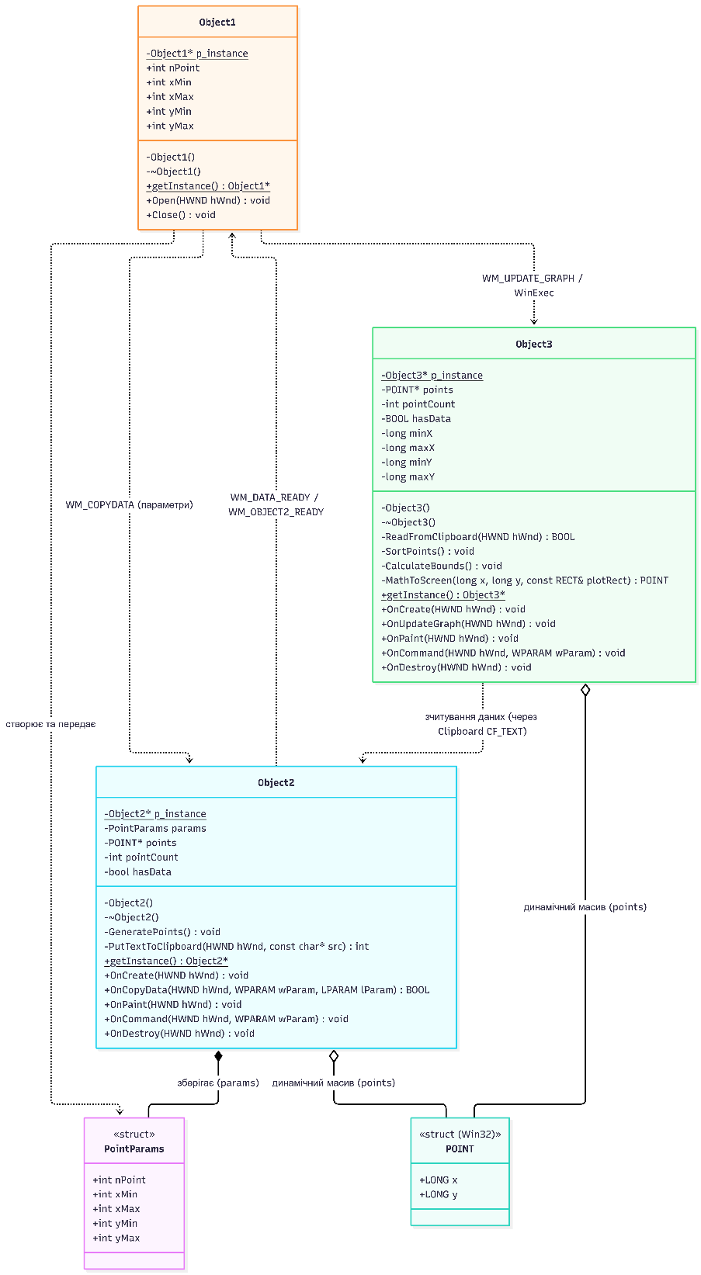

Скріншоти:
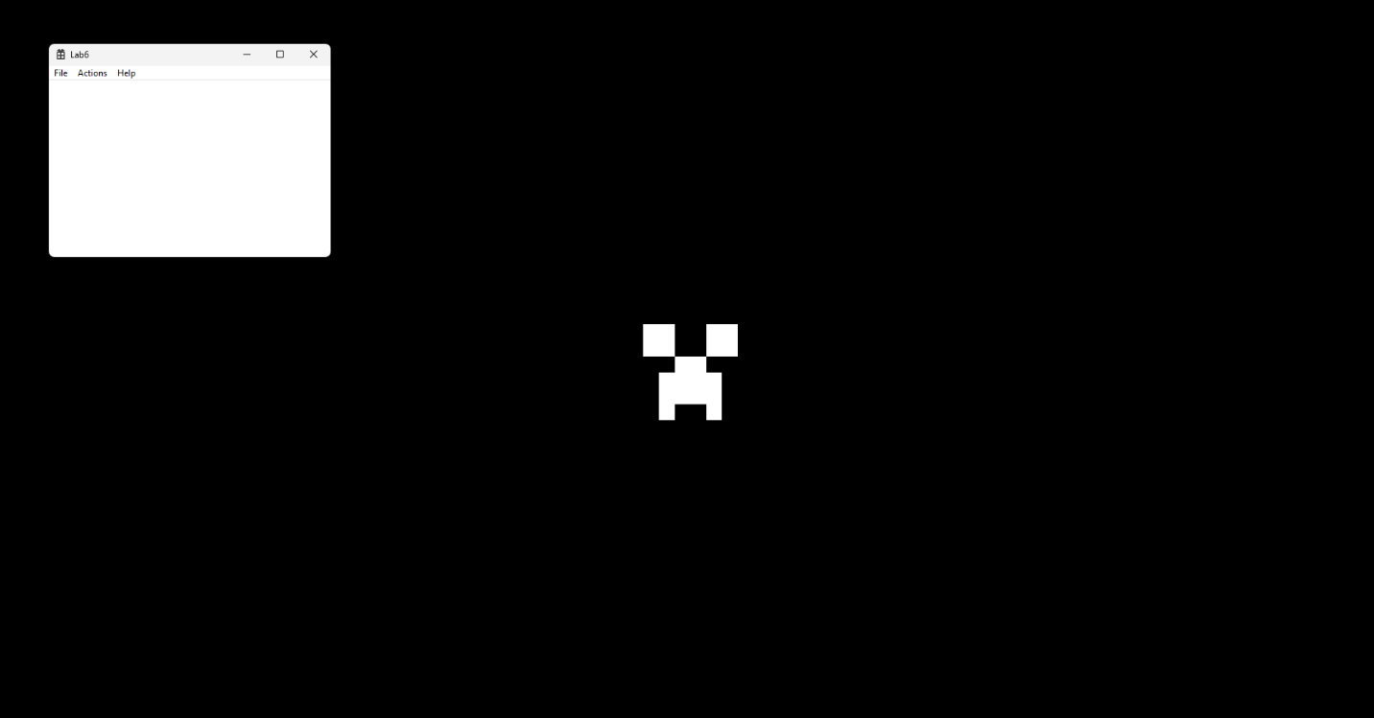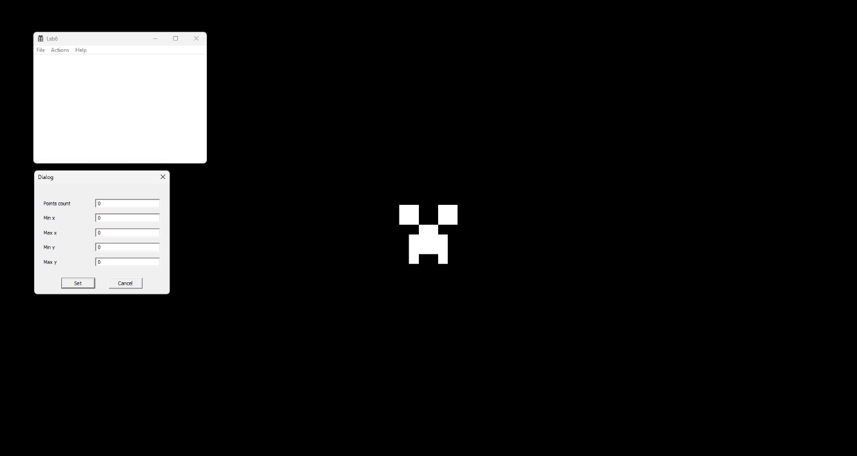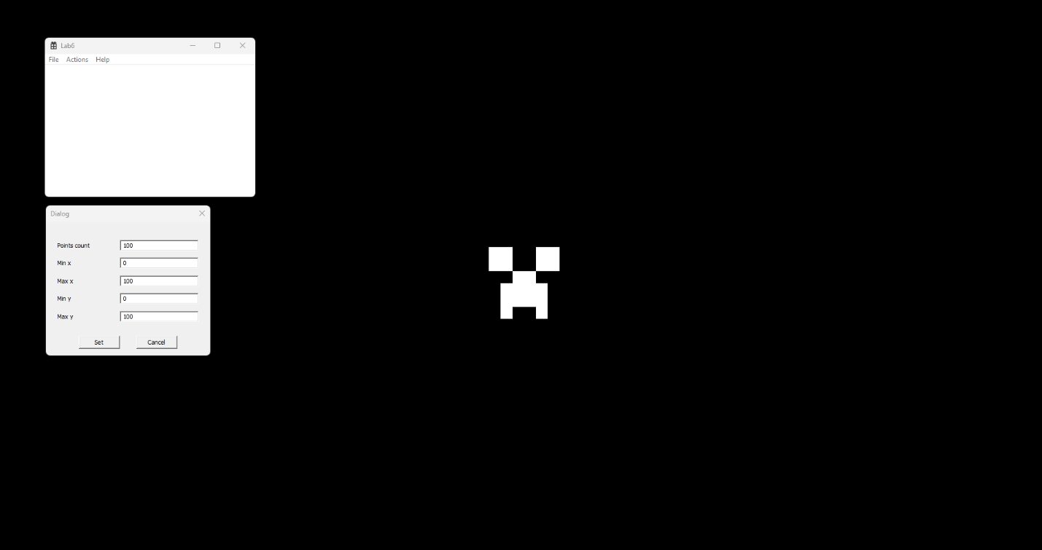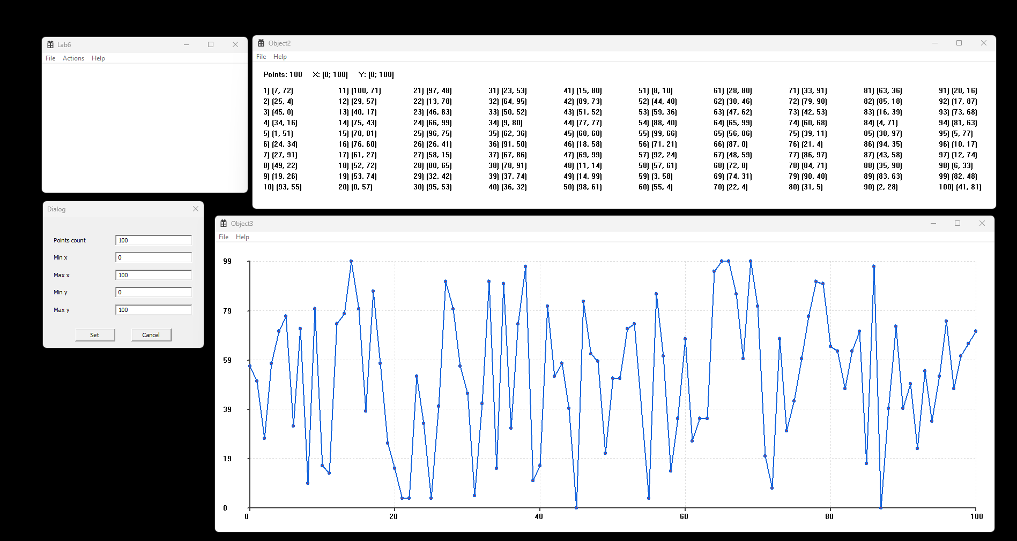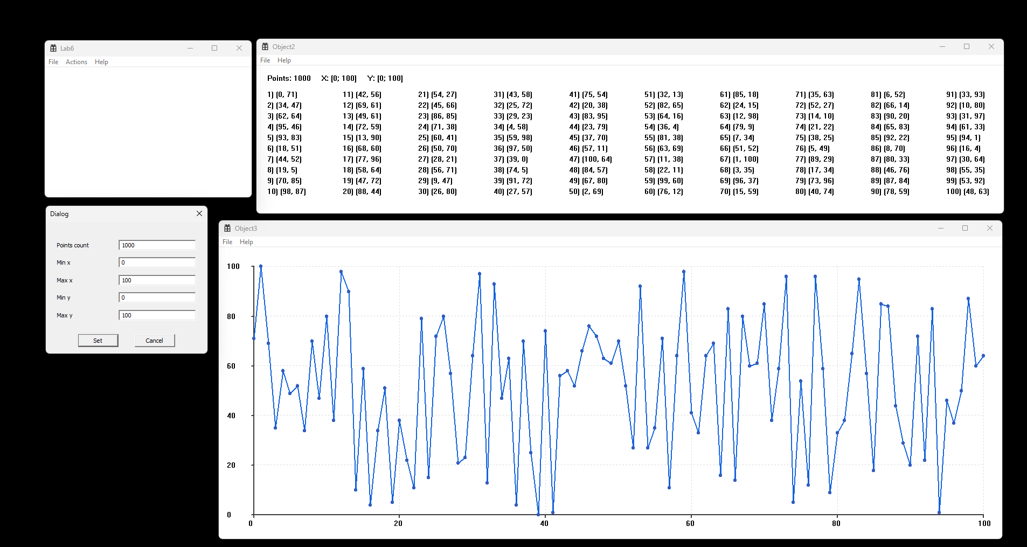

Висновки:
Лабораторна робота 6 була менш цікавою за попередні, проте показала, що дані з буферу обміну віндовс можна використовувати наліво і направо. Загалом мені сподобався курс лабораторних, проте я не дуже помітив навчання ООП, а більше помітив навчання C++ і алгоритмам відмальовки. Якби я обрав будь-який інший фреймворк, мені б було банально простіше зробити буквально те саме. Чисто для себе я вирішив зробити усі три класи сінглтонами щоб показати, що я справді їх навчився використовувати. По відмальовці, я малював просто прямі лінії і еліпси на місцях точок. Також я додав трохи валідацій, щоб програма не ламалась. Очевидно, що точок не може бути більше ніж іксів, тому я ввів таке обмеження, що при випадковій генерації точок ікси мають бути завжди унікальними, а от на ігрики однаково. Список виводжу просто текстаутом, проте для цікавості додав перемальовку колонок, що залежить від висоти вікна.

