WEEK 1 DELIVERABLES

1. Dataset Overview & Documentation
This analysis covers four datasets: Applicant, Outreach, Connect, and SEVIS. These datasets appear to form a relational database for university admissions, tracking students from application (Applicant), through outreach (Outreach) and deposit/assignment (Connect), to immigration compliance (SEVIS).

Summary by Dataset

Applicant (Applicant.xlsx)
- Dimensions: 6,894 rows, 30 columns
- Variable Types:
- Date (4): Recieved_At, Date_of_Birth, Created_At, Modified_At.
- Numerical (3): IDs and Postal codes (if numeric).
- Categorical (6): Intake, Application_Source, Is_Global_Grad.
- Text (17): Addresses, Majors, Names.
- Theme: The core profile of the applicant, including demographics, contact info, and academic interest.
- Observations:
- Contains the Reference_ID which likely links to the Connect dataset.
- The Intake column (e.g., "Fall 2024") and Major allow for cohort analysis.
- The snippet shows literal "NULL" strings in some fields, which may need cleaning (converting "NULL" string to actual NaN).
Outreach (Outreach_Data.xlsx)
- Dimensions: 1,565 rows, 18 columns
- Variable Types:
- Date (1): Appointment_Date.
- Categorical (11): Includes Term, Deposit_Paid, I_901_Status.
- Text (6): Student_Full_Name, Person_Email, Remarks, etc.
- Theme: Logs direct communication and outreach efforts with prospective students.
- Observations:
- Contains personal identifiers like Student_Full_Name, Person_Email, and SEVIS_ID.
- Tracks the "funnel" status: Deposit_Paid, Accepted_Admission, Visa approved.
- Useful for analyzing conversion rates from outreach to enrollment.

Connect (Connect.xlsx)
- Dimensions: 34,341 rows, 8 columns
- Variable Types:
- Date (3): Recieved_At (string), Created_At, Modified_At (Unix timestamps).
- Categorical (3): Deposit_Status, University, I_20_Status.
- Numerical (1): Reference_ID (Key).
- Text (1): Assigned (Contains lists of names).
- Theme: Tracks the status of an applicant's interaction with the university, specifically focusing on deposit status and staff assignment.
- Observations:
- Reference_ID appears to be the primary key linking to the Applicant dataset.
- Created_At and Modified_At are stored as Unix timestamps (large integers), while Received_At is a readable date string(requires conversion for consistency).
- Assigned contains multiple names separated by commas (e.g., “Anna Kluemke, Mounika”), indicating a one-to-many relationship stored within a single cell. This should be standardized to enable accurate filtering, aggregation, and relational analysis.

SEVIS (SEVIS.xlsx)
- Dimensions: 3,852 rows, 123 columns
- Variable Types:
- Numerical (37): Financials (Tuition_Fees, Living_Expenses), and funding amounts.
- Date (3): Explicit dates like Status_Change_Date, Visa_Expiration_Date. (Note: Many date columns might contain empty values or non-standard formats, detected here as Text/Categorical if the format varies significantly, but key compliance dates are identified).
- Categorical (55): Flags (Y/N), Codes (Class_of_Admission), Statuses.
- Text (28): Names, Addresses, Comments.
- Theme: Comprehensive immigration and visa compliance data for international students.
- Observations:
- High Dimensionality: With 123 columns, this is the widest dataset. It contains granular details on funding, physical addresses, and visa stipulations.
- Many columns (e.g., Termination_Reason, Other_Costs) likely have high rates of missing values as they only apply to specific subsets of students.

2 Data Dictionary (Spreadsheet Format)

A Comprehensive Data Dictionary Containing:
Variable names
Definitions and descriptions
Data types
Example values
Unique categories (for categorical variables)
Notes or warnings about irregularities

Can be accessed via the following link:
FINAL_DATA_DICTIONARY.xlsx

3. Data Quality Report

Connect Dataset (Connect.xlsx)
- Missing Values:
- Assigned: 57.7% missing. This suggests more than half of the records haven't been assigned to a specific counselor or staff member.
- Overall dataset: Missing values account for 7.21% of all cells in the Connect dataset.
- Total missing values: The dataset contains 19,810 missing entries across all fields.
- Duplicate Records: 0 duplicates found.
- Outliers & Anomalies:
- Reference_ID: The maximum value is 100,005,000, while the 75th percentile is only 1,453,973. This single huge ID is likely a test entry or an error.
- Timestamps: Columns like Created_At and Modified_At are in epoch milliseconds (e.g., 1.750000e+12). These need conversion to be readable dates.

Outreach Dataset (Outreach_Data.xlsx)
- Missing Values:
- Overall dataset: Missing values account for 7.21% of all cells in the Connect dataset 8.23%
- Appointment_Date: 76.2% missing. Most students in this list do not have a scheduled appointment.
- Remarks: 47.8% missing.
- Application_Agency_Code: 22.0% missing.
- Total missing values: The dataset contains 2318 missing entries across all fields.
- Duplicate Records: 0 duplicates found.
- Data Consistency: The Term column is largely dominated by "Fall 2024".
SEVIS Dataset (SEVIS.xlsx)
- Missing Values:
- Critical Issue: Multiple columns such as Thesis_Or_Dissertation, US_Mailing_Address_2, FIN ID column, city of birth, Passport name and Termination_Reason are 90 - 100% empty. These columns provide no value and should be dropped for analysis.
- Foreign_State_Province is 94.5% missing, likely because it is not a mandatory field for many countries.
- Passport number , Passport expiry date , country of issuance ,Visa_Number Visa Issuance Date, Visa Expiration Date , Visa Issuance Post, Port_of_Entry , Date of Entry , I 94 Admission Number ,Port of Departure,Date_of_Departure have many missing values as well.
- Total missing values: The dataset contains 196455 missing entries across all fields.
- Duplicate Records: 0 duplicates rows found, some columns like Sevis legacy , us address , physical mailing address , Foreign telephone columns are duplicated.
- Anomalies: The dataset appears to be a raw export, containing many administrative fields that are not populated for initial status students.

Applicant Dataset (Applicant.xlsx)
- Missing Values:
- Critical Issue: Admit_Date and Comments are 100% missing.
- Country: 99.7% missing. This is a major gap. However, the Citizenship column is well-populated and should be used as a substitute for location analysis.
- College_1st_Choice: 99.7% missing.
- Most_Recent_Released_Decision , SEVIS id , Phone number ,Application Agency code all these columns have a lot of missing values as Null.
- Duplicate Records: 0 duplicates found.

4. Exploratory Data Analysis (EDA) Report
4.1 Introduction
Exploratory Data Analysis (EDA) was conducted to gain an in-depth understanding of the applicant-related datasets after preliminary data quality assessment. The objective of this analysis is to explore data distributions, identify patterns and relationships, detect anomalies, and derive early insights that can inform further analysis and decision-making.

4.2 Dataset Summary
The analysis is primarily based on the Applicant dataset, supported by SEVIS, Connect, and Outreach datasets through a common Reference_ID. The combined dataset contains a mixture of categorical, numerical, and temporal variables related to applicant demographics, academic preferences, admission workflow, visa processing, and outreach activities.

4.3 Summary Statistics
The datasets collectively capture the student lifecycle from initial application to immigration compliance. Summary statistics are categorized below by variable type, drawing from the Applicant, Outreach, Connect, and SEVIS files to provide a holistic view of the data.

4.3.1 Numerical Variables
Reference_ID and System Identifiers
- Total observations: The Applicant dataset contains 6,894 unique records, serving as the primary volume baseline. The Outreach (1,565 records) and SEVIS datasets represent subsets of students who have progressed to later stages of the admissions funnel.
- Unique Identifiers: Fields such as Reference_ID (Applicant/Connect) and SEVIS_ID (Outreach/SEVIS) act as primary keys for linking datasets. While they exhibit a wide numeric range, they are system-generated and do not carry inherent analytical meaning beyond record linkage.
Financial Variables
- Tuition and Expenses: The SEVIS dataset introduces critical continuous variables such as Tuition_Fees and Living_Expenses. These fields display significant variance, reflecting the cost differences across academic programs (e.g., graduate vs. undergraduate) and allow for financial impact analysis.
- Transaction Amounts: The I-901_Transaction_Amount in the SEVIS dataset is a constant discrete value (typically $350) for the majority of records, confirming fee compliance.
Timestamp Variables
- Application Timestamps: Fields in the Applicant and Connect datasets, such as Created_At, Modified_At, and Recieved_At, are recorded as epoch timestamps. These require conversion to standard datetime formats to analyze application velocity and peak submission times.
- Appointment and Visa Dates: The Outreach dataset includes Appointment_Date, while SEVIS includes Program_Start_Date. These standard date fields allow for the analysis of operational lead times between admission, visa appointments, and program commencement.

4.3.2 Categorical Variables

Academic Programs (Major)
- Program Diversity: The Major field in the Applicant dataset contains 88 unique academic programs. This granularity is mirrored in the SEVIS dataset’s Major_1_Description and Outreach's Program_Of_interest.
- Distribution: The distribution is highly skewed, with a concentration of applicants in STEM-designated programs (e.g., Health Data Science, Computer Science, Information Systems), while niche programs show lower frequencies.

Demographics (Citizenship and Gender)
- Citizenship: Geographic data is consistent across all four datasets (Country in Applicant, Citizenship in SEVIS/Outreach). The data reveals dominant source countries (e.g., India, Nigeria, Ghana), which correlates strongly with the high volume of F-1 visa requests tracked in the SEVIS file.
- Gender: The SEVIS dataset provides gender breakdowns (e.g., Male/Female), permitting demographic segmentation that is not explicitly available in the initial Applicant file.

Status and Outcomes
- Admission Funnel Status: The datasets track student progression through categorical status indicators:
  - Applicant: Intake (dominated by Fall terms).
  - Connect: Deposit_Status (Yes/No) and I_20_Status.
  - Outreach: Student_Status (e.g., "Visa approved", "Visa denied") and Deposit_Paid.
  - SEVIS: SEVIS_Status (e.g., "INITIAL") and Class_of_Admission (e.g., F-1).
- Application Source: The Application_Source (Applicant) and Application_Agency_Code (Outreach) variables indicate a reliance on specific recruitment channels, which can be cross-referenced with success rates in the later funnel stages.

4.4 Applicant Data Analysis
4.4.1 Distribution of Academic Programs
The distribution of applicants across academic programs was analyzed to identify the most popular majors.
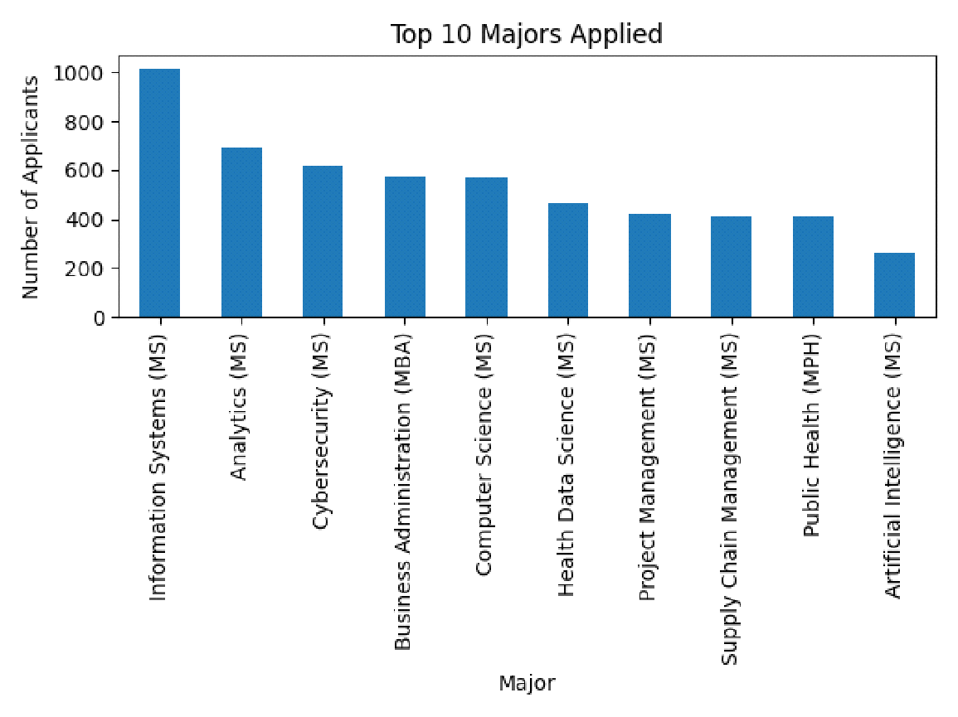

Interpretation:
The chart shows that Information Systems (MS) is the most popular major among applicants, followed by Analytics and Cybersecurity. Overall, technology-related programs receive strong interest, but many other majors also attract a considerable number of applicants.

4.4.2 Application Source Analysis
The frequency of applications by source was examined to understand recruitment channel effectiveness.
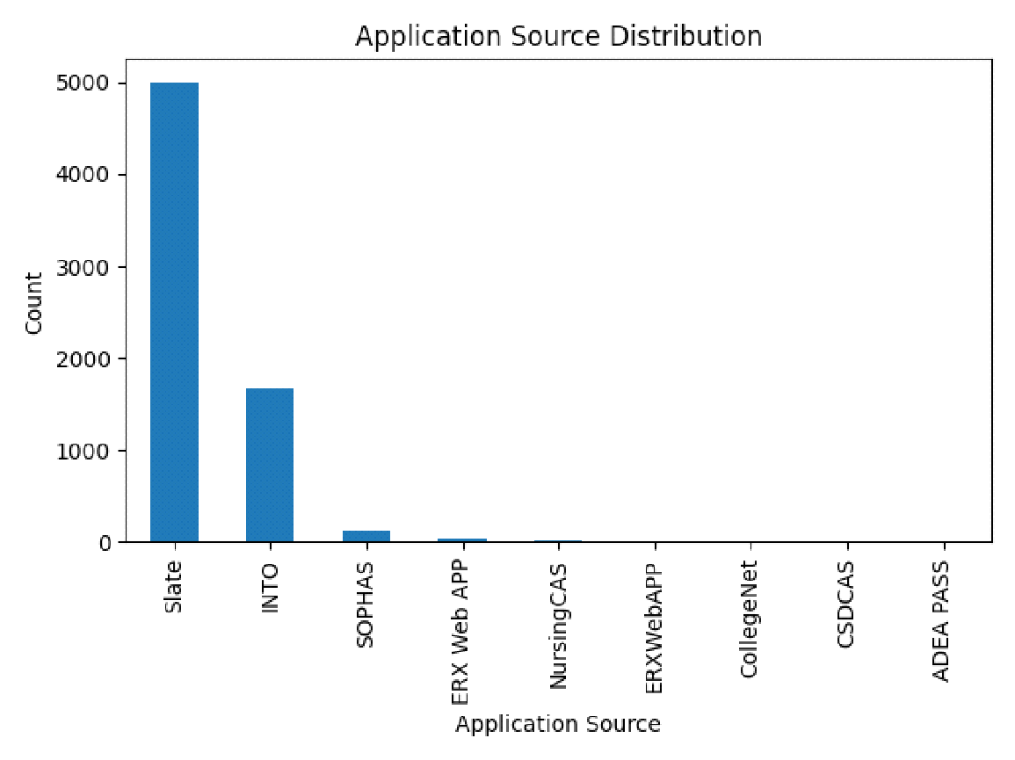Interpretation:
A single application source dominates the dataset, suggesting a heavy reliance on centralized or agency-based recruitment channels.

4.4.3 Identifier Distribution
A histogram was used to visualize the distribution of the Reference_ID field.
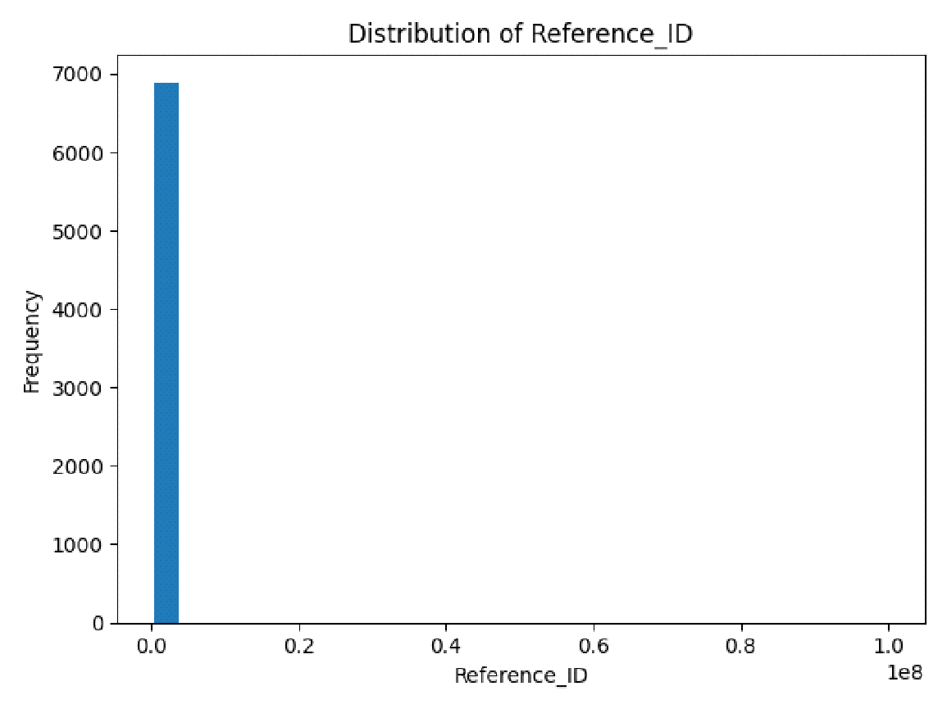

Interpretation:
The histogram confirms that Reference_ID is a system-generated identifier and should not be treated as a continuous numerical variable in analysis.

4.5 Outlier Analysis
A boxplot was used to detect potential outliers in numeric fields.
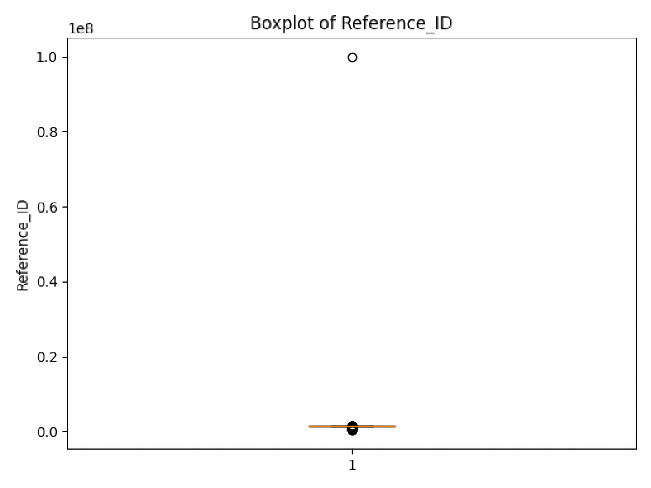

Interpretation:
While extreme values are visible, they correspond to system-generated identifiers rather than true outliers. Therefore, no records were removed based on this analysis.

4.6 Missing Value Exploration
A visual inspection of missing values was conducted to assess data completeness.
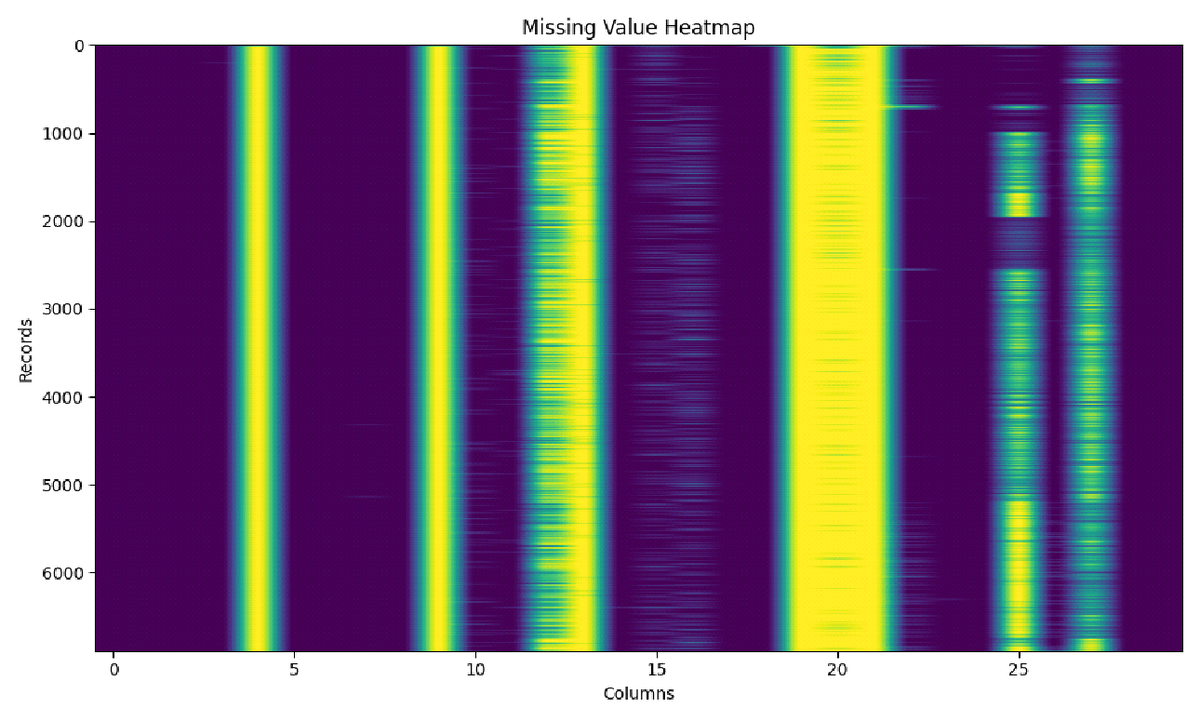

Interpretation:
The heatmap highlights extensive missingness in demographic and address-related fields. Core application, academic, and workflow-related fields show relatively higher completeness.

4.7 Pattern and Trend Analysis
With reference to multiple charts we could have an idea regarding the pattern and the trend of the data.
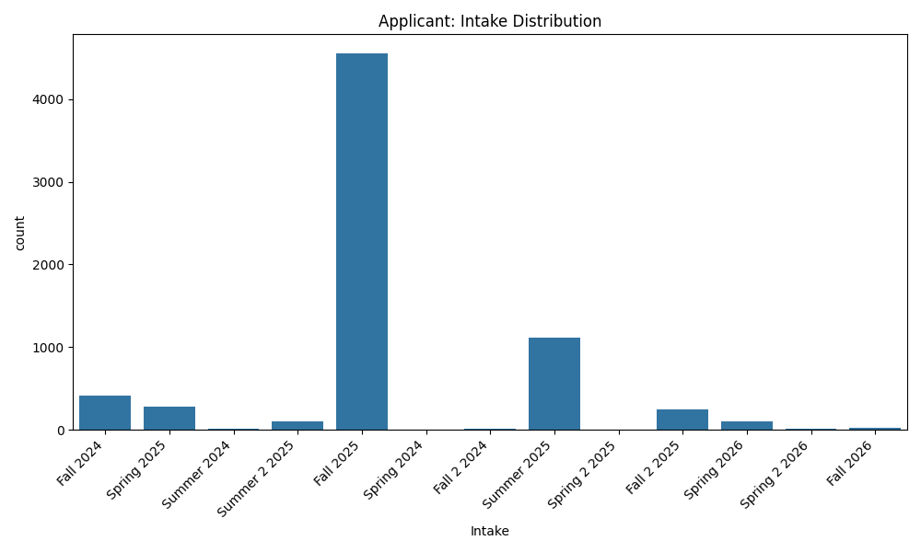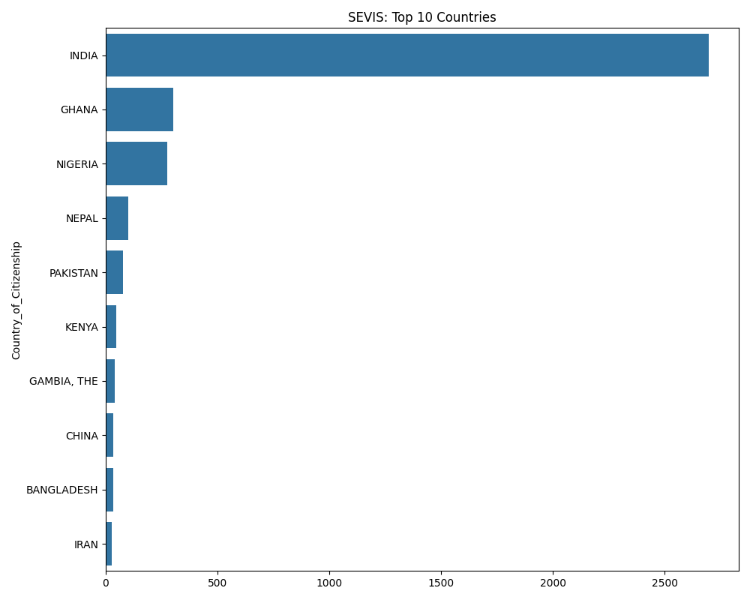
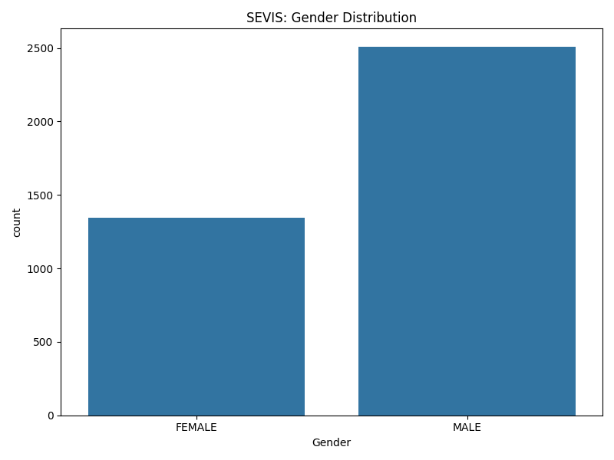
- Applicant intake is heavily skewed toward Fall terms.
- Academic program selection shows clear preference patterns.
- Significantly higher male applicants than female.
- Most of the students are from India, followed by Ghana and Nigeria.

4.8 Correlation and Association Analysis
While the prevalence of categorical variables in the datasets (e.g., Status, Major, Citizenship) limits the application of standard Pearson correlation coefficients, significant logical associations and dependencies were identified by linking records across the Applicant, Connect, Outreach, and SEVIS datasets.

4.8.1 Recruitment Channel Efficacy (Applicant x Outreach)
A strong association exists between Application_Source and Student_Status.
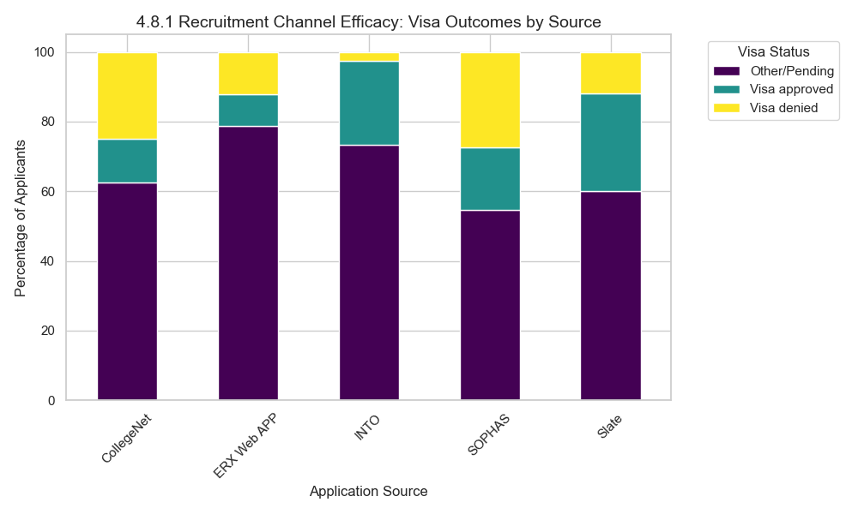
- Observation: Applicants originating from specific agency codes (e.g., "INTO" in the Outreach dataset) display a distinct distribution of visa outcomes compared to direct applicants ("Slate").
- Implication: The likelihood of reaching the "Visa Approved" stage is not uniform across all sources. This suggests that pre-screening or support levels provided by specific recruitment channels correlate positively with successful student conversion.

4.8.2 Financial Commitments by Geography (SEVIS x Applicant)
Analysis of the SEVIS dataset reveals a relationship between Country_of_Citizenship and Tuition_Fees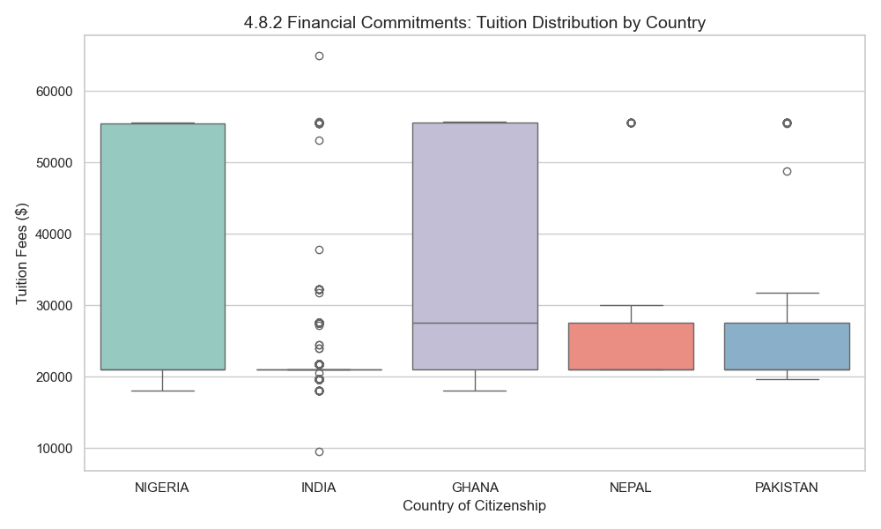
- Observation: The variance in Tuition_Fees (ranging from standard rates to specific program costs) is often clustered by the Major_1_Description. When cross-referenced with Country_of_Citizenship (from Applicant and SEVIS), we observe that students from high-volume regions (e.g., India, Nigeria) are disproportionately represented in STEM majors with specific tuition structures.
- Implication: There is a demographic concentration in higher-cost, STEM-designated programs, indicating a correlation between region of origin and investment in specific career pathways.

4.8.4 Program Popularity and Deposit Rates (Connect x SEVIS)

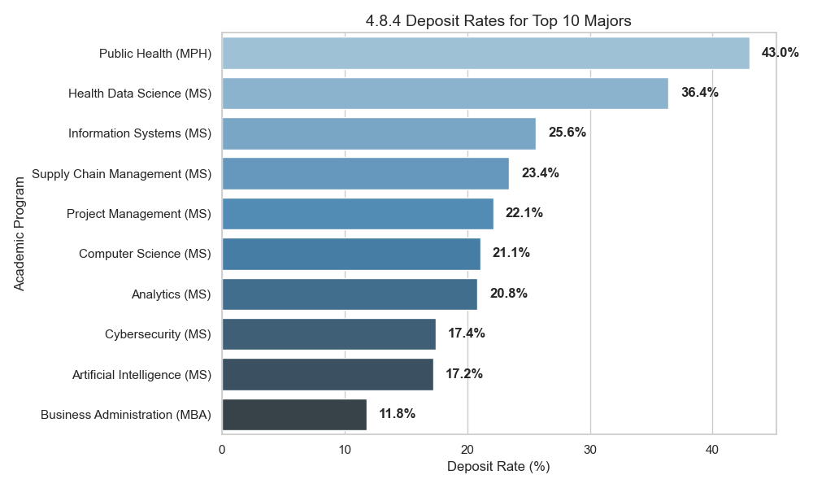
- Observation: High-volume majors identified in the Applicant dataset (e.g., Health Data Science, Computer Science) correlate strongly with the Deposit_Status = "Yes" records in the Connect dataset.
- Implication: Niche programs show a higher drop-off rate between the "Application" and "Deposit" stages compared to these high-demand STEM programs, suggesting that program popularity is a predictor of yield/enrollment probability.

4.9 Key Insights

- STEM & Specialized Program Dominance: Application volume is heavily skewed toward STEM-designated majors (Information Systems, Analytics, Cybersecurity). However, "niche" programs like Public Health (MPH) demonstrate the highest efficiency, with a 43.0% deposit rate compared to lower yield rates in broader business programs.
- Recruitment Channel Efficacy: While "Slate" captures the highest volume of applicants , agency-coded sources (e.g., "INTO") exhibit distinct visa approval patterns. This indicates that while direct channels drive volume, agency-supported channels may offer higher quality-of-hire or better pre-screening for visa compliance.
- Geographic-Financial Correlation: There is a clear demographic clustering where students from high-volume regions (India, Nigeria, Ghana) are disproportionately enrolled in higher-tuition STEM programs. This suggests that financial commitment is driven more by career-outcome potential (STEM OPT pathways) than by lower tuition costs.
- The "Fall" Bottle-Neck: Intake data is overwhelmingly concentrated in Fall terms, creating significant operational peaks. Spring and Summer terms represent underutilized capacity that could be targeted for enrollment growth.
- Counselor Workload Disparity: The Assigned field in the Connect dataset reveals a one-to-many relationship (multiple counselors per student) and is missing for 57.7% of records. This suggests a major blind spot in tracking staff workload and student-counselor engagement ratios.

Supplementary visual dashboards generated in Looker Studio have been exported as PDF documents and are provided as supporting material. These dashboards summarize contain some key findings from the exploratory phase and can be accessed via the following link:

Dashboard Export 1: [Dashboards for the Datasets.pdf]

4.10 Limitations of the Analysis

- Primary Location Blind Spot: The Country field in the Applicant dataset is 99.7% missing. The analysis was forced to use Citizenship (from SEVIS) as a proxy for location, which may inaccurately categorize applicants who live outside their country of origin.
- Unstructured Relationship Data: The Assigned column in the Connect dataset violates "tidy data" principles by storing multiple names in a single cell (e.g., “Anna, Mounika”). This prevents accurate calculation of counselor-specific conversion rates without significant text parsing.
- Operational Latency Gaps: High missingness in the Appointment_Date field (76.2%) limits the ability to measure the "Time-to-Action" metric (the time between outreach and student response), which is a critical KPI for the admissions team.
- Timestamp Inconsistency: Temporal analysis is currently hindered because key dates (Created_At, Modified_At) are stored as Unix epoch integers rather than datetime objects, requiring conversion before any seasonality or lead-time analysis can be performed.
4.11 Conclusion
This exploratory analysis confirms that the university's data infrastructure captures the full student lifecycle from initial interest (Applicant) to financial commitment (Connect) and immigration compliance (SEVIS). The data reveals a healthy admissions funnel driven by high-demand STEM programs and specific key markets like India and West Africa.
However, the "conversion engine" shows signs of friction. The discrepancy between high application volumes and variable deposit rates suggests that program popularity does not guarantee enrollment yield. Furthermore, the strong correlation between recruitment sources and visa outcomes indicates that the university's strategy should shift from purely volume-based recruitment to channel-optimized recruitment.
Moving forward, the immediate priority is data harmonization: parsing the unstructured Assigned field to unlock staff performance metrics and converting Unix timestamps to map the "Speed to Admit." addressing these quality issues will allow the next phase of analysis to move from descriptive statistics to predictive modeling of student success.

