Project Report: Week 2 deliverable of Data Visualization Intern by Excelerate

Team : 06

Date of Submission: 16.02.2026

Project Title:
Unified Admissions Intelligence: Integrating & Visualizing Saint Louis University Applicant Data

Executive Summary

This project attempts to unify fragmented admissions data from four disparate sources into a single, reliable PostgreSQL warehouse, enabling real-time strategic decision-making for the first time. By cleaning and standardizing over 6,800 application records, resolving critical issues like scientific notation errors and missing data, we constructed a live Looker Studio dashboard that reveals a healthy 37.8% admission rate and a robust $13.4 million in potential tuition revenue. The analysis highlights a strong 58% yield from admitted students but exposes a significant dependency on two key markets (India and Nigeria) and a data quality gap where 90%+ of applicant location data (Country) is missing, necessitating an immediate shift to tracking Citizenship for accurate regional targeting.
1. Functional Looker Studio Dashboard

This Dashboard presents key information regarding the combined dataset of the Applicants.
Link to the Dashboard: [https://lookerstudio.google.com/reporting/82aa2ea5-513e-4153-aeb2-1f4627d318b7]
Dashboard Overview (Screenshot):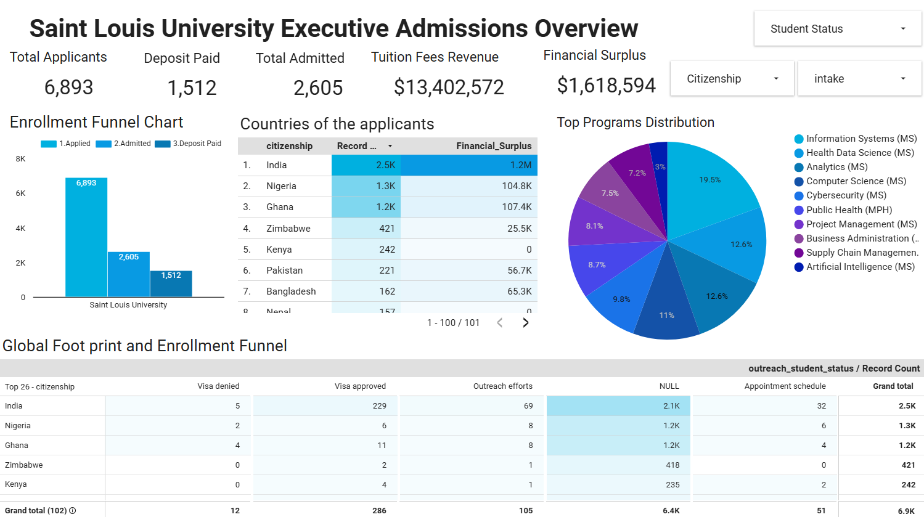
2. Data Management
Primary Database System: PostgreSQL (pgAdmin 4)
Connection: Uploaded CSV to Looker Studio.
Final Master Dataset: Master Dataset for Applicants
Raw Sources: Applicant.csv, Connect.csv, Outreach_Data.csv, SEVIS.csv.

Connection & Cleaning Steps:
The following pipeline was executed to ensure data integrity:
- Staging: Created raw tables (applicant_raw, connect_raw, etc.) to load CSVs "as-is" to prevent import errors.
- Data Cleaning:
  - Scientific Notation Fix: Converted Unix timestamp integers (e.g., 1.75E+12) into readable timestamps using TO_TIMESTAMP(column::NUMERIC / 1000).
  - NULL Handling: Used NULLIF(column, 'NULL') to convert text-string "NULLs" into true database NULLs to allow for correct mathematical calculations.
  - Date Standardization: Forced all dates into YYYY-MM-DD string format using TO_CHAR to prevent Looker Studio from misinterpreting date formats (e.g., MDY vs DMY).
- Integration (The Master Join):
  - Used LEFT JOINS starting from the Applicant table (the spine) to ensure no applicants were lost, even if they lacked SEVIS or Connect data.
- Deduplication:
  - Addressed the "One-to-Many" relationship issue (where one student had multiple Outreach rows).
  - Used DISTINCT ON (Reference_ID) and STRING_AGG to consolidate multiple remarks into a single history field while keeping only the latest status.
- Connection to Looker Studio: exported the final dataset from pgAdmin and then imported it as a csv file into Looker Studio
Link to the SQL Queries used for cleaning the dataset: https://drive.google.com/file/d/1SgMl2kfA6vmasOdV7JK9Mohwr10jniwb/view?usp=sharing
Challenge | Impact | Resolution
Scientific Notation | Dates appeared as 1.75E+12 in raw CSVs. | Applied SQL math transformation: TO_TIMESTAMP(value / 1000).
Missing "Country" Data | The Country column in the Applicant table was predominantly NULL. | Pivot: Switched to using Citizenship (which was 99.9% complete) for geographic visualization.
Negative Funding Gaps | Cost - Funds resulted in negative numbers, confusing stakeholders. | Created a calculated field Financial_Surplus (Funding_Gap * -1) to visualize "Extra Funds" instead of "Deficit."
Funnel Accuracy | "Deposit Paid" counts appeared higher than "Admitted" due to bucket logic. | Created three independent binary flags (Count_Applied, Count_Admitted, Count_Deposit) and summed them side-by-side.

3. Dashboard Design Summary

Chart Strategy & Rationale
- Scorecards (High-Level KPIs):
  - Metrics: Total Applicants, Admitted, Deposits, Tuition Fees, Financial Surplus.
  - Why: To provide executives with an immediate "Pulse Check" on the campaign's volume and financial health ($13.4M Potential Revenue).
- Funnel Chart (Conversion Analysis):
  - Visual: Column Chart (Applied → Admitted → Deposit).
  - Why: To identify the sharpest drop-off point in the recruitment pipeline. Currently highlights the gap between Admission and Deposit.
- Donut Chart (Program Distribution):
  - Visual: A percentage-based Donut Chart showing the top majors.
  - Why: Selected to clearly illustrate the market share of specific programs. It instantly highlights that just two programs (Information Systems & Health Data Science) account for over 36% of the entire applicant pool, indicating a heavy reliance on STEM streams.
- Citizenship Leaderboard (Table with Heatmap):
  - Visual: A ranked table with bar indicators for Record Count and Financial Surplus.
  - Why: Switched from Country (due to NULLs) to Citizenship. A table was chosen over a map to provide precise numerical rankings. It allows stakeholders to compare the "Volume" (Count) vs. "Value" (Surplus) of top markets side-by-side, revealing that while India provides the most students, it also brings the highest financial surplus ($1.2M).

Interactivity & Theme
- Theme: Default (Classic) was chosen to make the data pop and give a fresh aesthetic suitable for a university data presentation.
- Interactivity: The whole Dashboard is connected with each other so clicking an element in one chart will also show the related numbers in the other charts. For example, clicking on a semester of a program will give the stakeholders an idea of the revenue generated from it, number of applicants and where did they apply from.
- Filters:
  - Program Filter in the Pie chart: Allows stakeholders to know about specific majors (e.g., "Show me only Computer Science applicants").
  - Intake Filter: Enables comparison between Fall 2024 and Spring 2025 cohorts.

4. Visual Insights Report

Key Patterns & Trends
- Recruitment Funnel Efficiency:
  - 37.8% Admit Rate: Out of 6,893 applicants, 2,605 were admitted.
  - 58% Yield Rate: Out of 2,605 admitted, 1,512 paid deposits. This is a strong yield, suggesting that once admitted, students are highly motivated to join.
- Geographic Concentration:
  - The Citizenship Table confirms that recruitment is heavily reliant on South Asia (India) and West Africa (Nigeria/Ghana). These regions represent the largest volume of applicants.
- Financial Health:
  - The "Financial Surplus" metric indicates that for the majority of admitted students, their proven funds exceed the university's cost of attendance. This reduces the risk of visa denials on financial grounds.

Anomalies & Data Constraints
- The "Country" Void: The raw application data failed to capture the physical address (Country) for a vast majority of leads. This forces reliance on Citizenship, which may differ from residence.
- Program Dominance:The Program Distribution chart reveals that Information Systems (20.5%) and Health Data Science (15.9%) alone comprise nearly 40% of all interest. This indicates a "Key Person Risk" regarding specific departments.

Recommendations for Week 3 (Validation)
- Visa correlation: Cross-reference the Financial_Surplus data with Visa_Issuance status (from the SEVIS table) to confirm if higher surplus actually correlates with higher visa approval rates.
- Outreach Analysis: Analyze the Outreach_Remarks (using the concatenated history field) for the 1,093 students who were Admitted but did not pay a deposit. Are there common keywords like "Loan," "Competitor," or "Scholarship"?
- Admission factors: What are the primary factors that affected admission? Like citizenship, financial surplus, the funding type or something else?

