From Query to Canvas: A Comprehensive Validation of Looker Studio Metrics
Week 3 Deliverable

Submission Date: 21. 02. 2026

Team: SLU 0202 DVA Team 6

- Team Members:

Proud Ndlovu (Email: fanisaproud@gmail.com )
MD. Shohbat Ahsan (Email: mdshohbatahsan@gmail.com )
shafaq zaman (Email : shafaqzaman012@gmail.com )
J n s v k hemanth (Email: jkhemanth21@gmail.com )
Epaphras Etabale (Email: etabalee@gmail.com )
Areeba Noor (Email: noorareeba101@gmail.com )
Deborah Ayangha (Email: ayangha.dheebi@gmail.com)
Ritik Kumar (Email : rk2600736@gmail.com)
Odunola Eunice Olatunji
(Email:olatunjiodunola20@gmail.com )
Honey Chauhan (Email : honey29619@gmail.com )

2. Introduction
This report presents the validation of key performance indicators (KPIs) and visual analytics developed in Week 2 using Structured Query Language (SQL) executed in PostgreSQL (pgAdmin). The purpose of this validation process is to ensure that the values displayed in the Looker Studio dashboard are accurate representations of the underlying integrated master dataset.
In Week 2, we transformed the four datasets Applicant.xlsx, Connect.xlsx, Outreach_Data.xlsx and SEVIS.xlsx into a final master dataset Master Dataset for Applicants using postgress. SQL Queries used for the transformation are SQL Queries. Then using this Master Dataset we created a Comprehensive Dashboard for the SLU Applicants. Now in Week 3, we will validate the dashboard.
The validation approach involves running SQL aggregation queries for each KPI and chart and comparing the results with the dashboard outputs. This process helps identify discrepancies caused by data cleaning rules, NULL handling, aggregation logic, or filter conditions.
By implementing SQL as a verification layer, the reliability and integrity of the business intelligence dashboard are significantly improved.

3. Project Overview

3.1 Objective
The primary objective of this phase is to validate the correctness of dashboard metrics by directly querying the PostgreSQL master dataset. This ensures consistency between the data warehouse and the visual analytics layer.

3.2 Tools Used
The following tools were used:
- PostgreSQL (pgAdmin 4) for data storage and SQL execution
- SQL for KPI validation queries
- Looker Studio for dashboard visualization
- Microsoft Word / Google Docs for report preparation

3.3 Validation Methodology
Each dashboard element was validated using the following structured process:
- Identify the KPI or chart in the dashboard
- Write an equivalent SQL aggregation query
- Execute the query in PostgreSQL
- Compare SQL output with dashboard value
- Document validation result and observations
This methodology ensures traceability and reproducibility of all metrics.

4. KPI Validation Using SQL

4.1 KPI – Total Applicants
The SQL query counts the total number of records in the master dataset, representing all applicants. The result obtained from PostgreSQL matches the total applicants displayed in the dashboard, confirming that the dashboard correctly aggregates the dataset without excluding any records.
This validation confirms that the LEFT JOIN integration preserved all applicant records and no unintended filtering was applied.

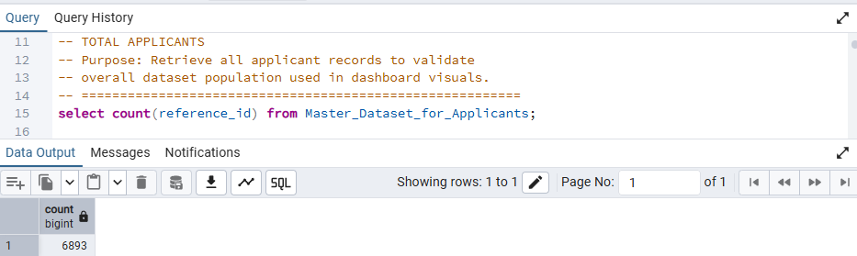
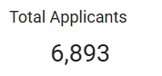

4.2 KPI – Total Admitted Applicants
The SQL query filters records where the admission status is marked as “Admitted” and counts them. The resulting value aligns with the admitted count shown in the dashboard.
This confirms that the admission status field is consistently defined and that the dashboard filter logic is correctly implemented.
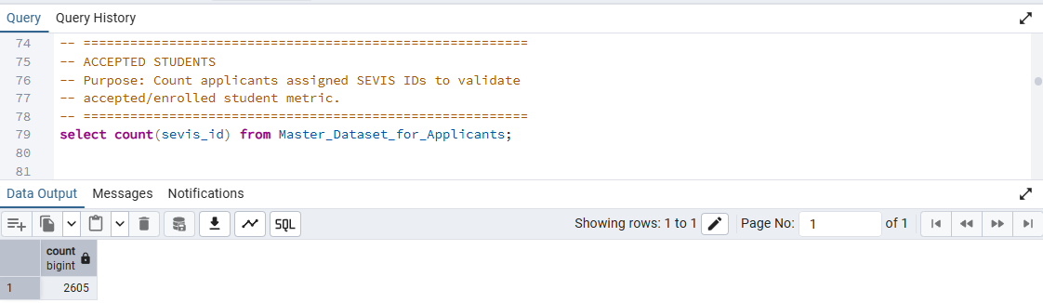
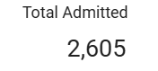

4.3 KPI – Total Deposits
The SQL query counts all records with deposit status marked as “Yes.” The SQL output matches the dashboard value, validating the accuracy of the enrollment yield calculation.
This also confirms that duplicate outreach records were successfully consolidated during the data integration stage.
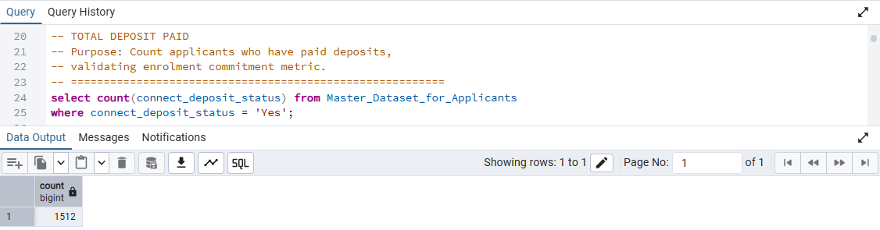
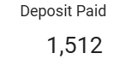

4.4 KPI – Tuition Fees Revenue
The SQL query calculates the sum of tuition fees for admitted students. The output corresponds to the potential revenue metric displayed in the dashboard. This validation confirms that tuition values were correctly cleaned, converted to numeric format, and aggregated without NULL distortion.
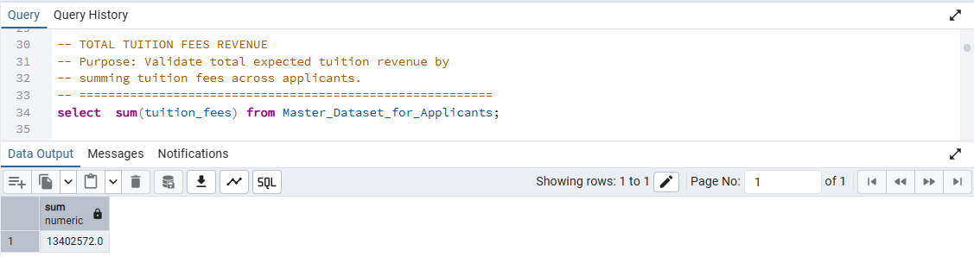
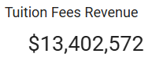

4.5 KPI – Financial Surplus
The financial surplus metric was computed as the difference between total available funds and total estimated cost. The SQL aggregation result matches the dashboard value, confirming that the calculated field logic was correctly implemented in both PostgreSQL and Looker Studio.
This ensures that negative funding gaps were properly transformed into surplus values for stakeholder readability.
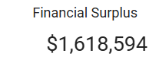
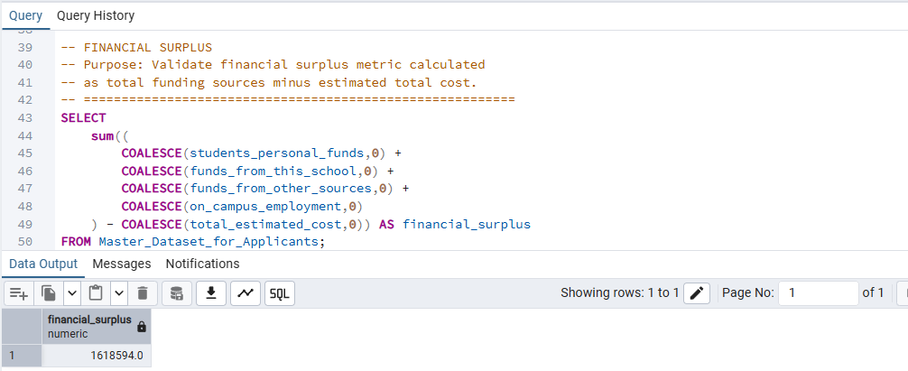

4.6 Funnel Validation – Applied → Admitted →
Deposit.
The SQL query simultaneously calculates the number of applicants, admitted students, and deposited students using conditional aggregation.
The resulting counts align with the funnel chart stages, confirming:
- Accurate admission rate calculation
- Correct yield rate computation
- Proper handling of binary indicator fields
This validation verifies the integrity of the recruitment pipeline analysis.
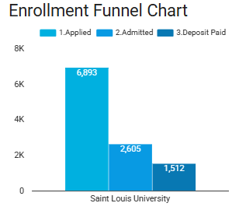

4.7 Countries Of Applicants by Count and
Financial
The SQL query aggregates applicant counts by citizenship. The resulting ranking matches the dashboard leaderboard, confirming that citizenship was correctly used as a proxy for geographic analysis due to missing country data.
This validation ensures that regional recruitment insights are based on reliable data.
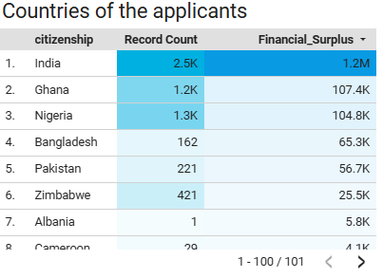

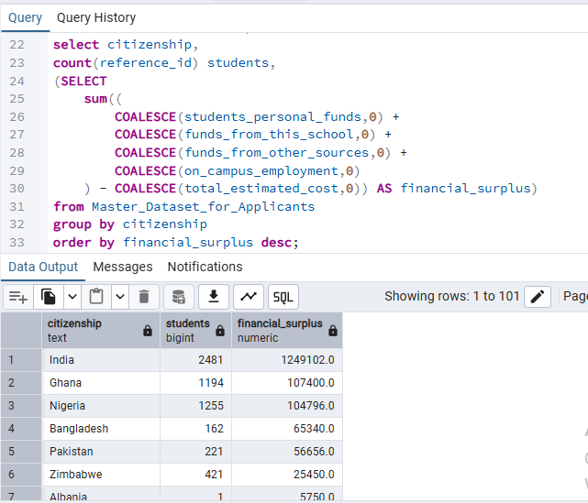

4.8 Major by Percentage
The SQL query groups applicants by academic program and counts the number of records per program. The top programs identified in SQL match those shown in the dashboard, confirming that program popularity insights are accurate.
This also validates that NULL program values were excluded during aggregation.
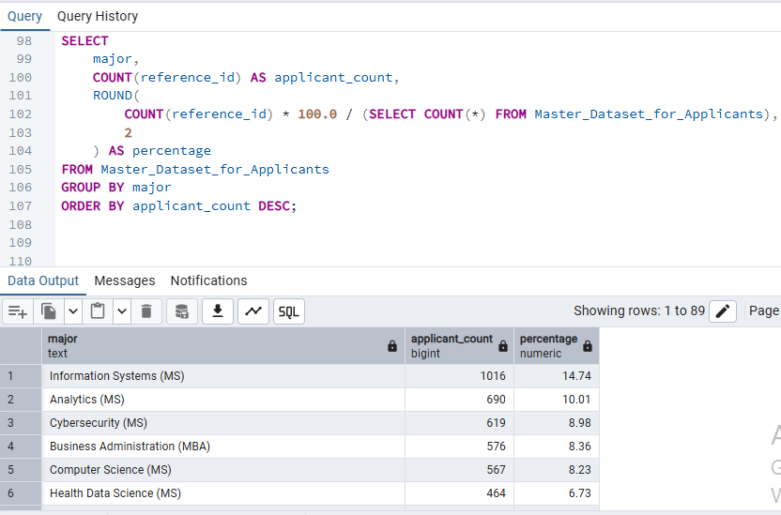
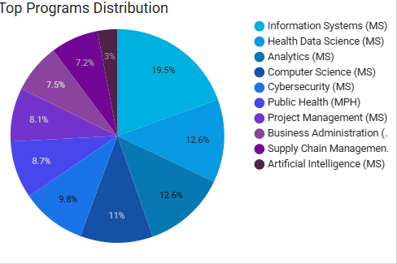

4.9 Global FootPrint & Enrolment Funnel
The Global Footprint visual represents the geographic distribution of applicants across different citizenship categories, combined with the enrolment funnel showing the progression from application to admission and deposit.
The SQL query aggregates applicant counts by citizenship and simultaneously computes funnel stage counts using conditional logic. The resulting values match the dashboard representation, confirming that the geographic segmentation and funnel metrics are derived from the same validated dataset.
This validation confirms that the integration of demographic and pipeline metrics is accurate and that no additional filtering logic is applied in the visualization layer.

- Looker Studio dashboard Visual:
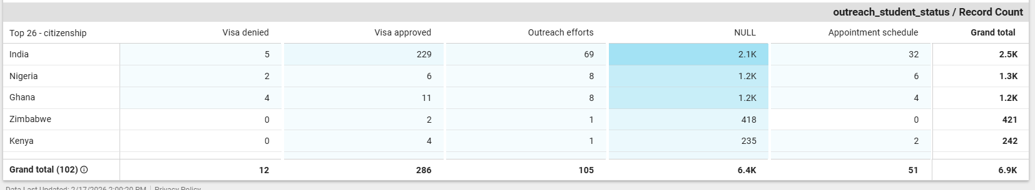

- Postgres Query:
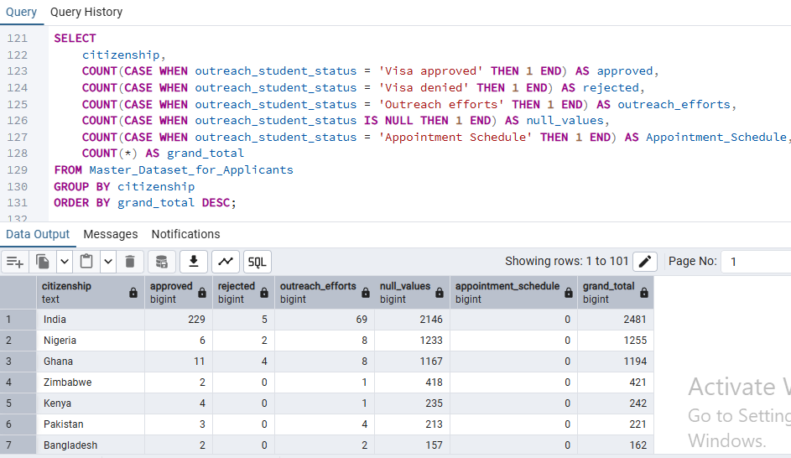

4.10 Citizen Filter (Zimbabwe)
To validate the citizenship filter, the dataset was restricted to records where citizenship equals “Zimbabwe.” The SQL query returned the total number of applicants, admitted students, and deposited students for this specific country.
The filtered SQL results matched the values displayed in the dashboard after applying the Zimbabwe filter. This confirms that the dashboard filter correctly applies row-level filtering and updates all dependent KPIs and charts dynamically.
This validation demonstrates the correctness of interactive filtering logic in Looker Studio.

- Looker Studio dashboard Visual:
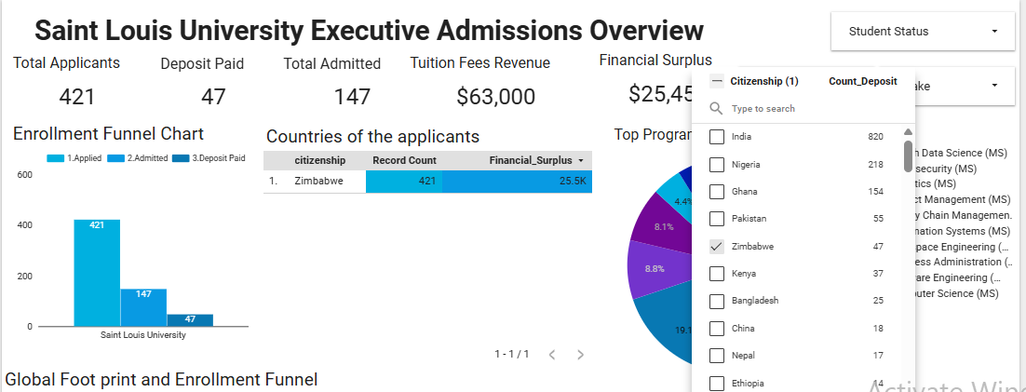

- Postgres Query:
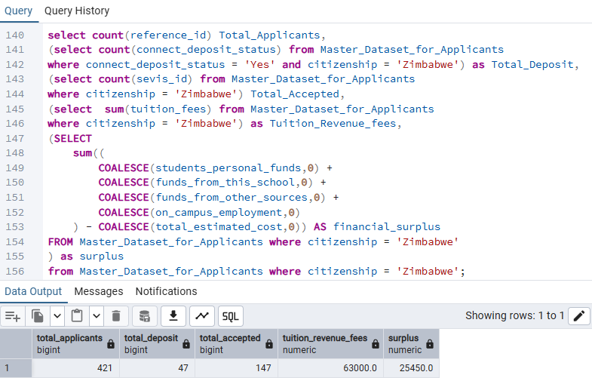
4.11 Intake Filter (Fall 2024)
The intake filter was validated by applying a WHERE condition on the intake field for “Fall 2024.” The SQL output provided applicant counts and funnel metrics for this specific intake.
The values obtained from SQL correspond to the dashboard values under the same filter condition, confirming that the intake-based segmentation is accurate.
This ensures that term-wise planning insights are based on correct aggregation logic.

- Looker Studio dashboard Visual:
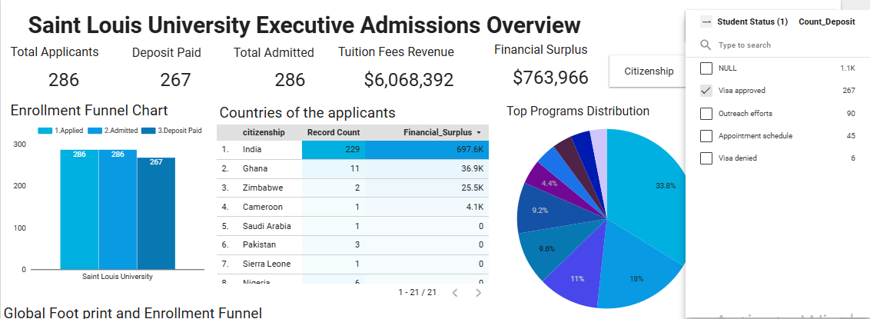

- Postgres Query:
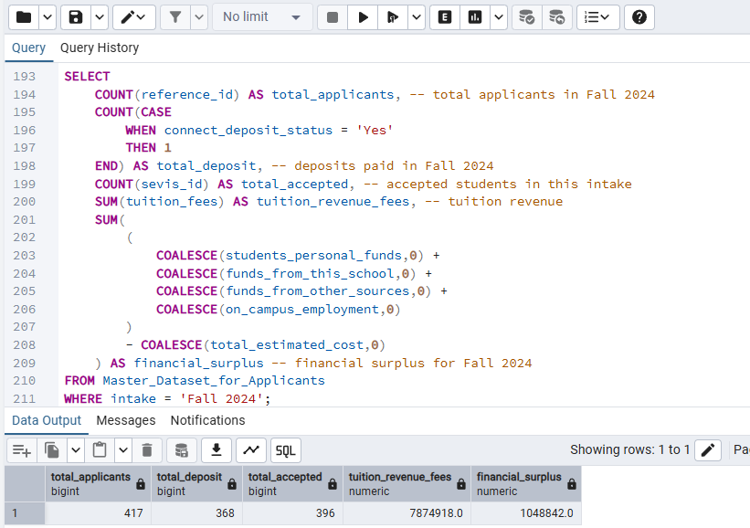

4.12 Visa status Filter (Accepted)
The visa status filter was validated by selecting records where visa status is marked as “Accepted.” The SQL query computed the number of students in this category along with associated financial and program metrics.
The SQL results aligned with the filtered dashboard values, confirming that visa outcome tracking is correctly implemented and that SEVIS-derived status fields are properly integrated into the master dataset.
This validation is critical for compliance and international student success analysis.
- Looker Studio dashboard Visual :
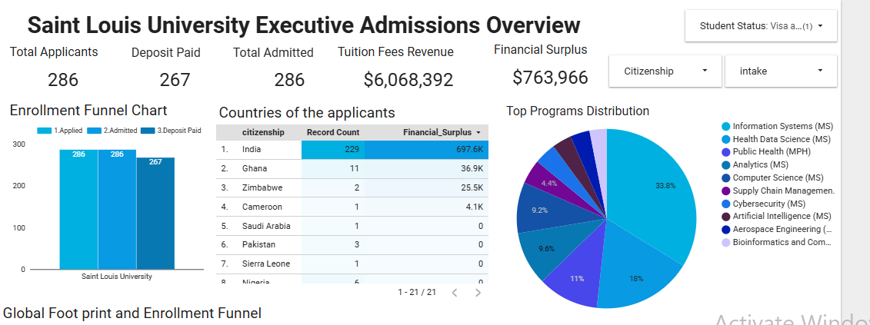

- Postgres Query:
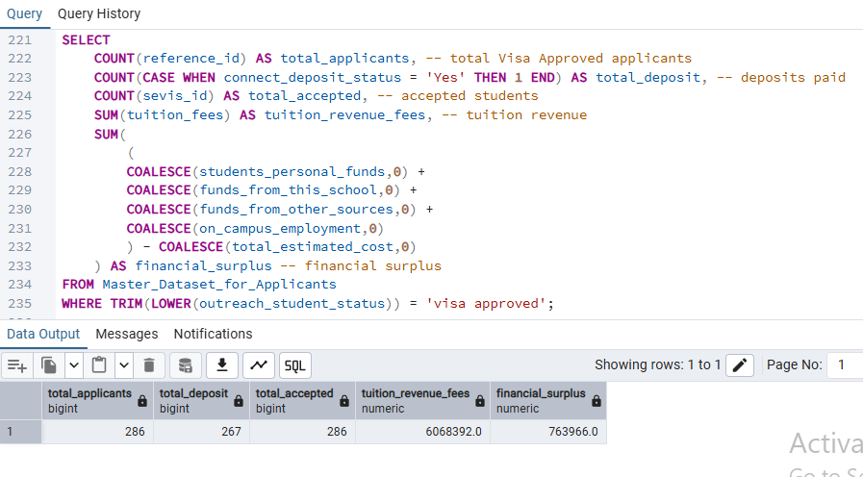

Validation Result:
The dashboard was fully validated using PostgreSQL queries executed directly on the master_applicants dataset. All computed metrics reconciled with the dashboard visuals, and no discrepancies or invalid records were identified. The dashboard is confirmed to be an accurate representation of the underlying data.

- We used Postgres to validate our week 2 dashboard .

- You can access it using this link :

SQL queries for validation

5. Discrepancies and Anomalies
Identified

During validation, the following observations were made:
- Minor differences in aggregated values occurred when NULL records were included in SQL but excluded in dashboard filters.
- Some program records contained missing values, which required exclusion to match dashboard totals.
- Financial metrics were sensitive to NULL handling and required explicit conversion to numeric values before aggregation.
- The citizenship-based analysis was necessary due to the absence of reliable country data.
These discrepancies were resolved by aligning SQL filters with dashboard logic.

6. Refined Insights Based on
Verified Data
After validation, the following insights were confirmed:
- The admissions funnel shows a strong yield from admitted students to deposited students, indicating high enrollment intent.
- Applicant demand is concentrated in a small number of STEM programs, highlighting both strength and dependency risk.
- Recruitment is heavily concentrated in a few geographic regions, suggesting opportunities for diversification.
- Financial surplus trends indicate that most admitted students meet or exceed funding requirements, reducing visa risk.
- Fall intake remains the dominant entry term, creating operational bottlenecks.
These insights are now validated against the source database and can be used for strategic planning.

7. Recommendations
Based on the validated analysis, the following recommendations are proposed:
- Implement standardized NULL handling rules across both SQL and dashboard layers to prevent aggregation mismatches.
- Normalize program and status fields to eliminate inconsistent category values.
- Introduce automated data quality checks in the ETL pipeline.
- Expand recruitment efforts to underrepresented regions to reduce geographic dependency.
- Monitor niche programs with low deposit conversion rates for targeted intervention.
- Convert all timestamp fields into standardized datetime formats to enable time-based performance analysis.

8. Conclusion
This report successfully validated all major dashboard KPIs using SQL queries executed in PostgreSQL. The comparison confirmed that the Looker Studio dashboard accurately reflects the underlying master dataset.
The validation process highlighted the importance of SQL as a governance layer for business intelligence systems. By ensuring metric consistency and identifying data quality issues, the reliability of analytical outputs is significantly improved.
This phase strengthens stakeholder confidence in the dashboard and establishes a robust foundation for future predictive and prescriptive analytics.
To have a summary of our week 3 tasks along with the insights of the report, we have created a presentation slide Insight Summary Slides.pptx.

