HireHub
The Professional Network for Maritime Crew

PROJECT DELIVERABLES REPORT
Phase 1 & Phase 2 — Complete Visual Documentation

April 2026 | Confidential
Includes all mockups, personas, flows, and design specifications

Table of contents

1. Project roadmap
The HireHub project follows a five-phase development roadmap. Phase 1 (Foundation & Information Architecture) and Phase 2 (UX/UI Design) are now complete. The roadmap below shows the full plan from conception to launch.

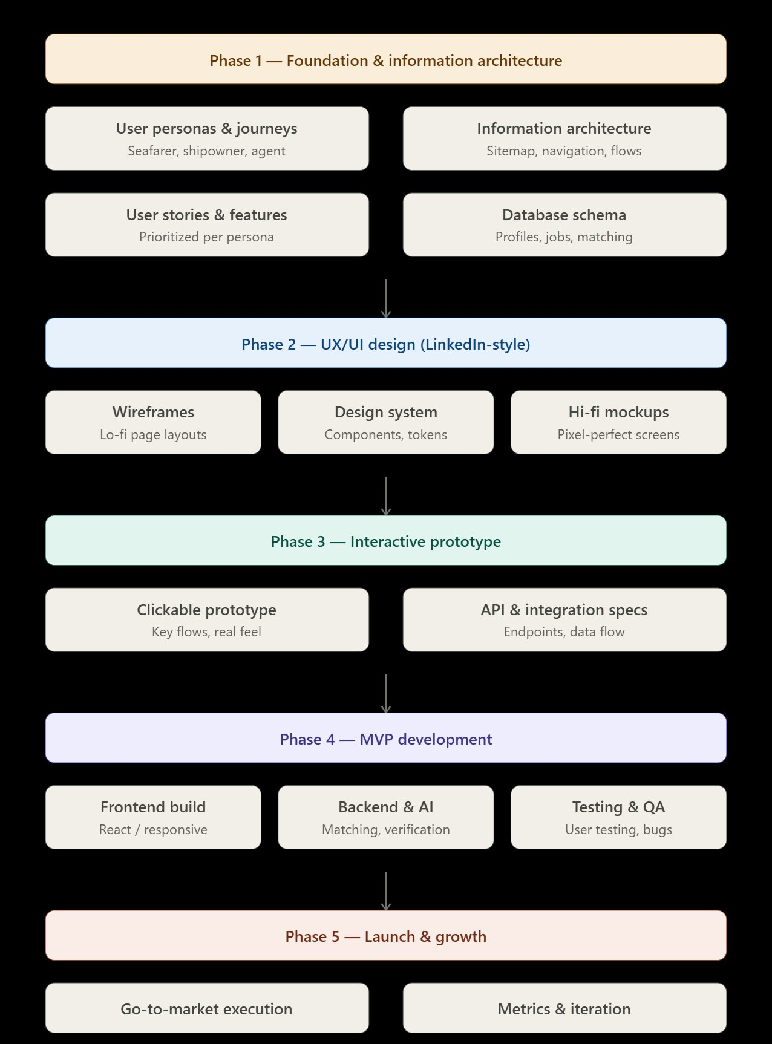
Figure 1: HireHub five-phase project roadmap

Phase | Deliverables | Status
Phase 1 | User Personas, IA, Legal Assessment, Core Flow | COMPLETED
Phase 2 | Design System, Hi-Fi Mockups (6 screens) | COMPLETED
Phase 3 | Clickable Prototype, API Specs, DB Schema | NEXT
Phase 4 | Frontend (React), Backend & AI, Testing | Planned
Phase 5 | Go-to-Market, Metrics & Iteration | Planned

2. User personas
Three core personas drive the HireHub platform. Each was developed based on maritime industry research, pain point analysis, and the platform’s core value proposition. The personas define who uses the platform, what they need, and what features serve them.

2.1 Persona 1 — The seafarer
The seafarer is the heart of HireHub. A Filipino officer with 4 years of tanker experience, he depends on “backer” connections for work, has no visibility to shipowners, and faces fake CV issues. HireHub gives him verified credentials, global exposure, and career tools.
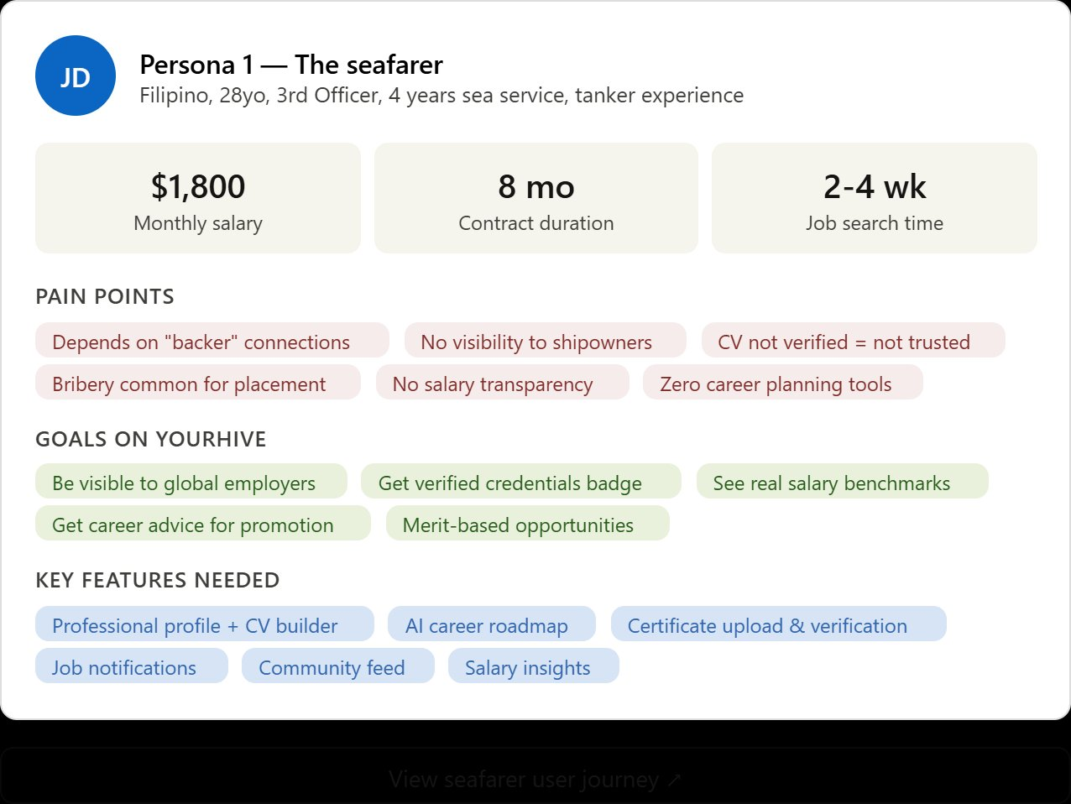
Figure 2: Seafarer persona — pain points, goals, and key features needed

2.2 Persona 2 — The shipowner / fleet manager
The Greek shipowner managing 12 vessels is blind to the talent market. He depends 100% on manning agents, receives unverified CVs, and can’t compare candidates. HireHub gives him direct access to a searchable talent database with AI matching and verified badges.
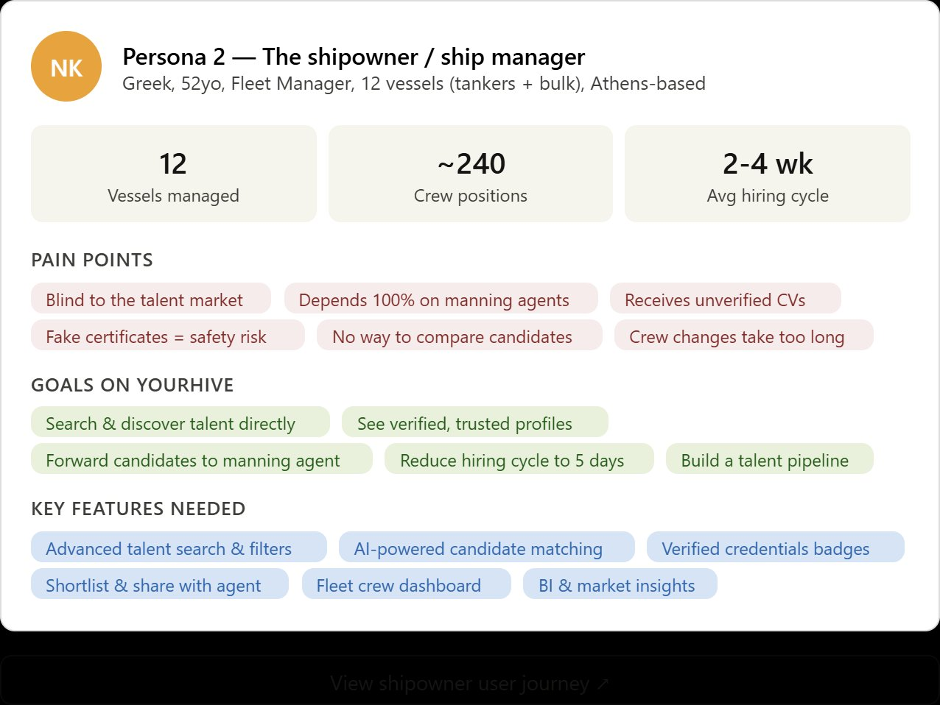
Figure 3: Shipowner persona — the primary paying customer

2.3 Persona 3 — The manning agent
The Manila-based manning agent serves 8 principals and handles 500+ deployments per year. He drowns in unverified CVs and faces pressure for faster turnaround. HireHub sends him pre-vetted candidates directly from shipowners — enhancing his pipeline, not replacing his role.
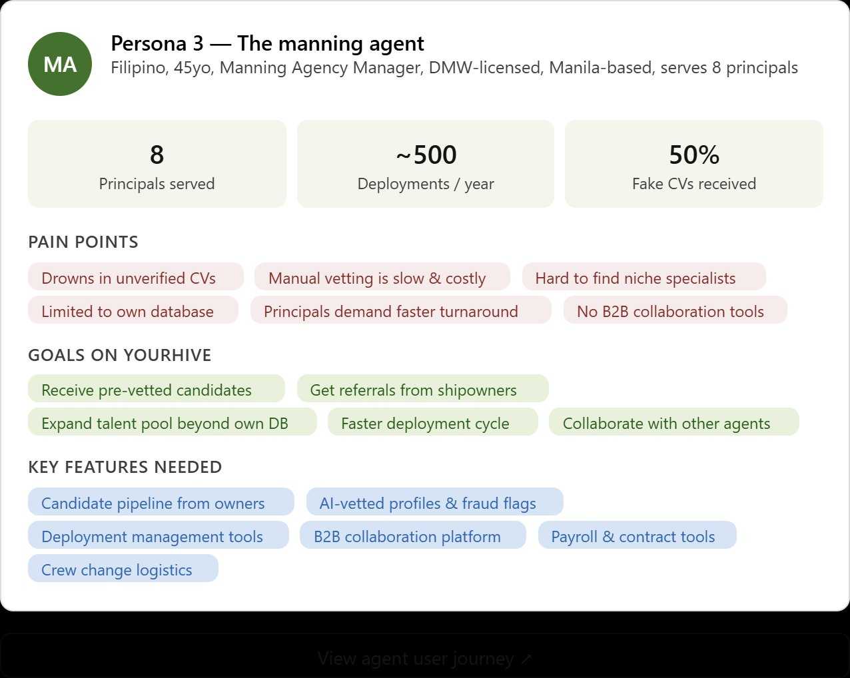
Figure 4: Manning agent persona — receives pre-vetted candidates from owners

3. Core platform flow
The fundamental flow of HireHub follows five steps that maintain full compliance with Philippine maritime law. The seafarer creates a profile, the shipowner searches and shortlists, and the manning agent executes deployment. HireHub remains a visibility platform at every step.

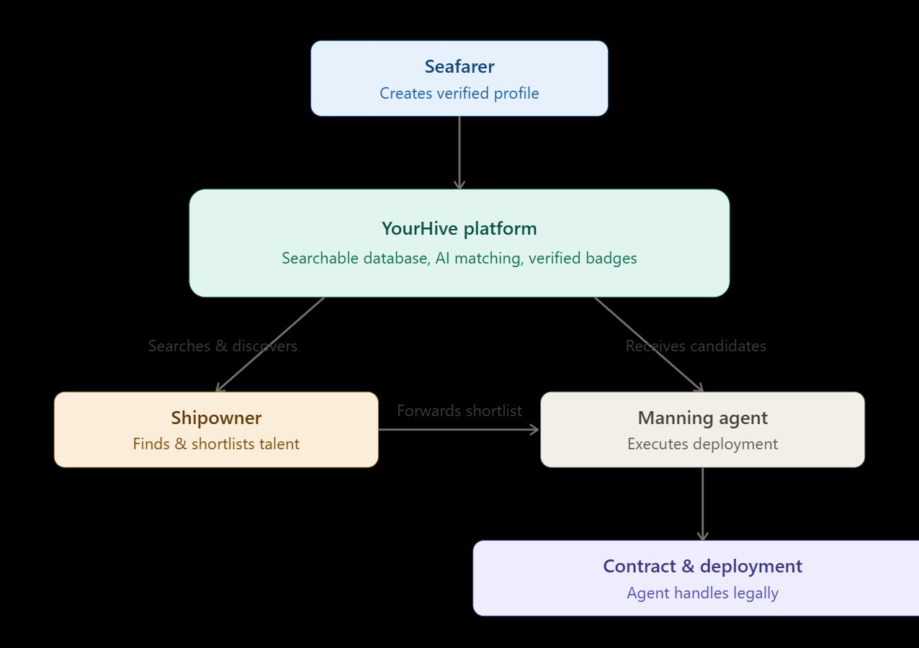
Figure 5: Core platform flow — Seafarer → HireHub → Shipowner → Manning Agent → Deployment

Key legal principle: HireHub never recruits, places, promises employment, collects placement fees, or executes contracts. All recruitment activity flows through DMW-licensed manning agents, in full compliance with R.A. 8042/10022, R.A. 12021 (Magna Carta of Filipino Seafarers), and R.A. 10173 (Data Privacy Act).

Step | Description
Step 1 | Seafarer creates a verified professional profile on HireHub (voluntary)
Step 2 | Shipowner searches the HireHub database using filters and AI matching
Step 3 | Shipowner creates a shortlist of candidates
Step 4 | Shipowner forwards shortlist to their DMW-licensed manning agent
Step 5 | Manning agent executes contract and deployment (outside HireHub)

4. Legal compliance summary
A comprehensive legal compliance check was conducted against Philippine maritime and data privacy law. The full assessment is available as a separate document (HireHub_Legal_Compliance_Assessment.docx).

Status | Area | Summary
PASS | Illegal Recruitment Test (5 checks) | No canvassing, no promising employment, no placement fees, no contracts, no deployment processing
PASS | Manning Agent Relationship | Agent role preserved, not bypassed. No solidary liability assumed. Compliant with R.A. 12021.
PASS | Data Privacy (R.A. 10173) | Consent-based processing, cross-border safeguards, DPO designation, breach procedures.
CAUTION | AI Matching Framing | Must be “talent discovery” for employer, NOT “job referral” to seafarer.

VERDICT: THE MODEL IS LEGALLY VIABLE. Formal legal opinion from a Philippine maritime law firm is recommended before launch.

5. Information architecture
The HireHub sitemap follows a LinkedIn-inspired navigation pattern with role-based visibility. Each user type sees a tailored experience. The interactive sitemap below shows all pages organized by navigation group, with role indicators for each feature.

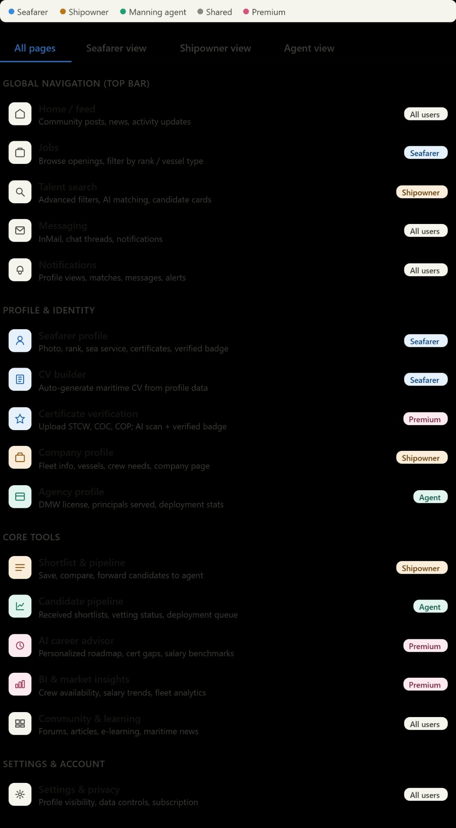
Figure 6: HireHub information architecture — interactive sitemap with role-based visibility

The sitemap covers 16 pages/features organized into four groups: Global Navigation (Home, Jobs, Talent Search, Messaging, Notifications), Profile & Identity (Seafarer Profile, CV Builder, Certificate Verification, Company Profile, Agency Profile), Core Tools (Shortlist & Pipeline, Candidate Pipeline, AI Career Advisor, BI & Market Insights, Community & Learning), and Settings & Account.

6. UI/UX mockups
Six high-fidelity mockups were designed following the LinkedIn visual pattern with HireHub brand colors. Each mockup is shown below with detailed design commentary.

6.1 Seafarer profile
The most important page on HireHub. This is what the shipowner sees when they click on a candidate from search results. Designed as a direct analog to the LinkedIn profile page with maritime-specific sections: sea service record (timeline), certificates with valid/expiring badges, skills tags, and an AI compatibility score visible only to the searching shipowner. Three action buttons drive the core flow: “Add to Shortlist”, “Message”, and “Download CV”.

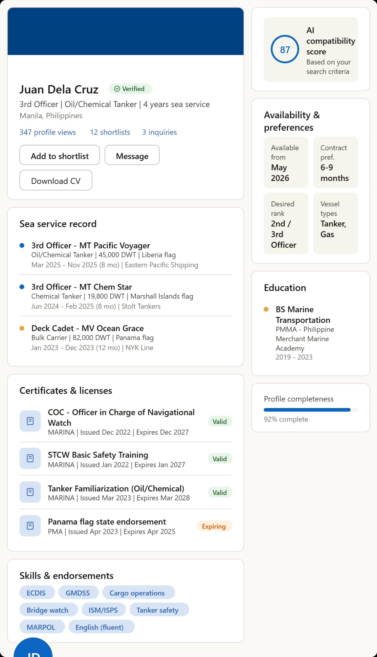
Figure 7: Seafarer profile page — the heart of HireHub

6.2 Talent search
The primary interface for shipowners. The left panel provides filters for rank, vessel type, sea service, nationality, availability, and credential status. Results appear as candidate cards ranked by AI compatibility score. Each card shows name, verified badge, headline, nationality, certificates, availability, and a “+ Shortlist” button. An AI matching banner confirms that results are algorithmically sorted. The search is talent discovery — not job referral — maintaining legal compliance.

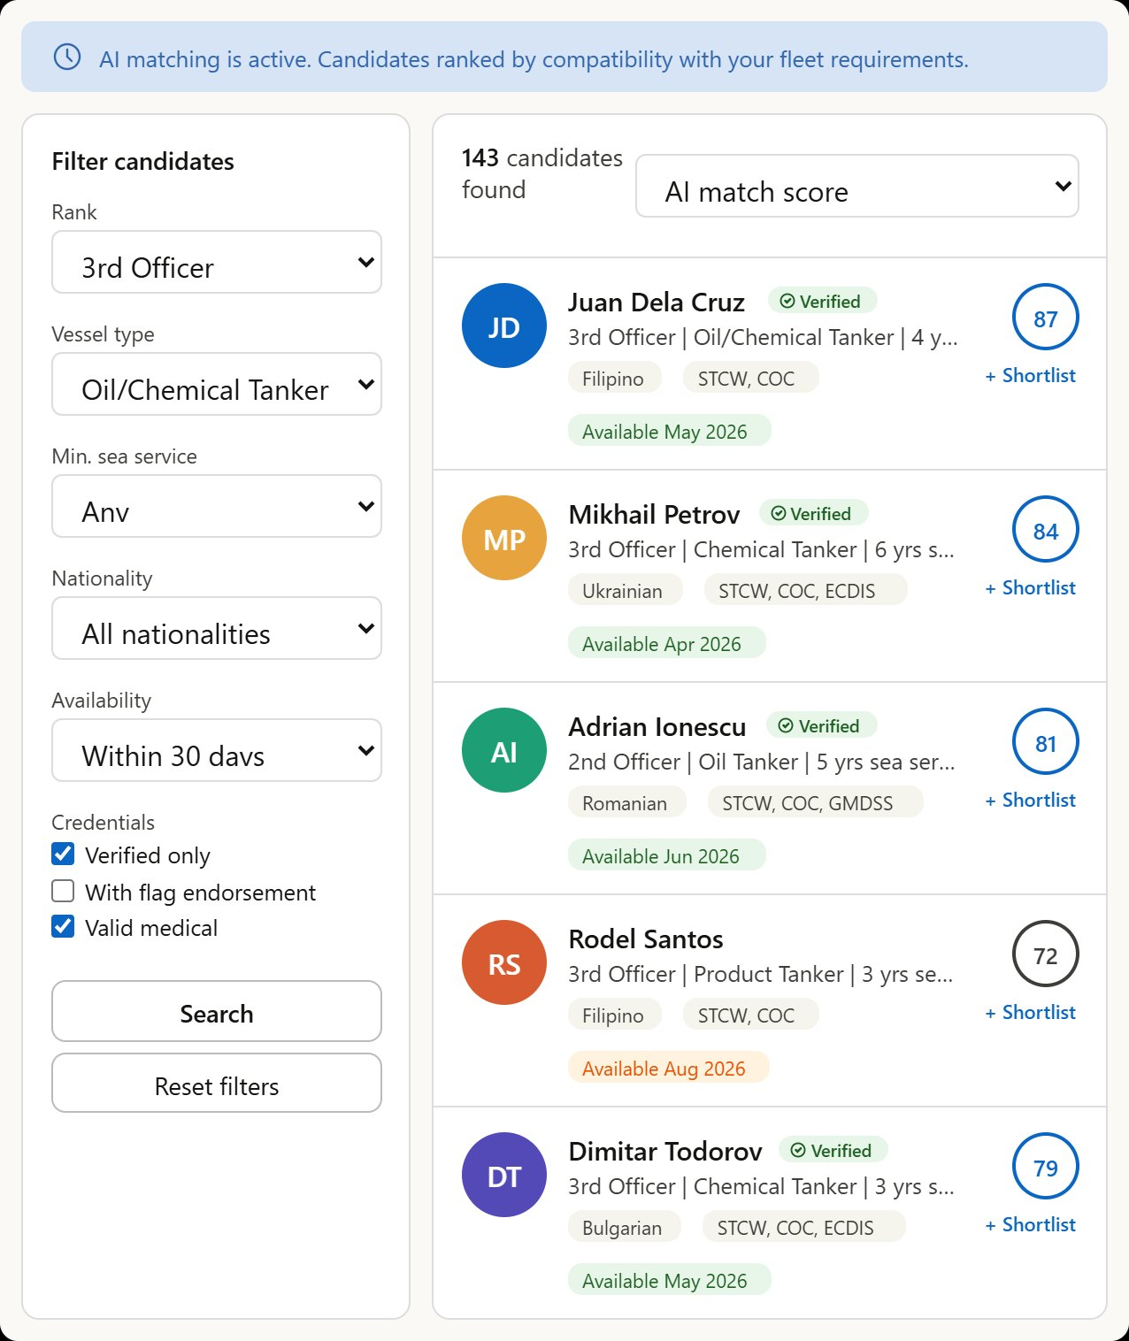
Figure 8: Talent search page — the shipowner’s discovery engine

6.3 Shortlist & pipeline
The bridge between discovery and deployment. The shipowner manages selected candidates through pipeline stages (Shortlisted → Under Review → Sent to Agent). Each candidate row shows name, summary, AI score, status badge, and action icons. The bottom panel shows the connected manning agent (with DMW license number) and summary metrics. The “Forward to Agent” button is the critical handoff point — where HireHub’s role ends and the licensed agent’s work begins.

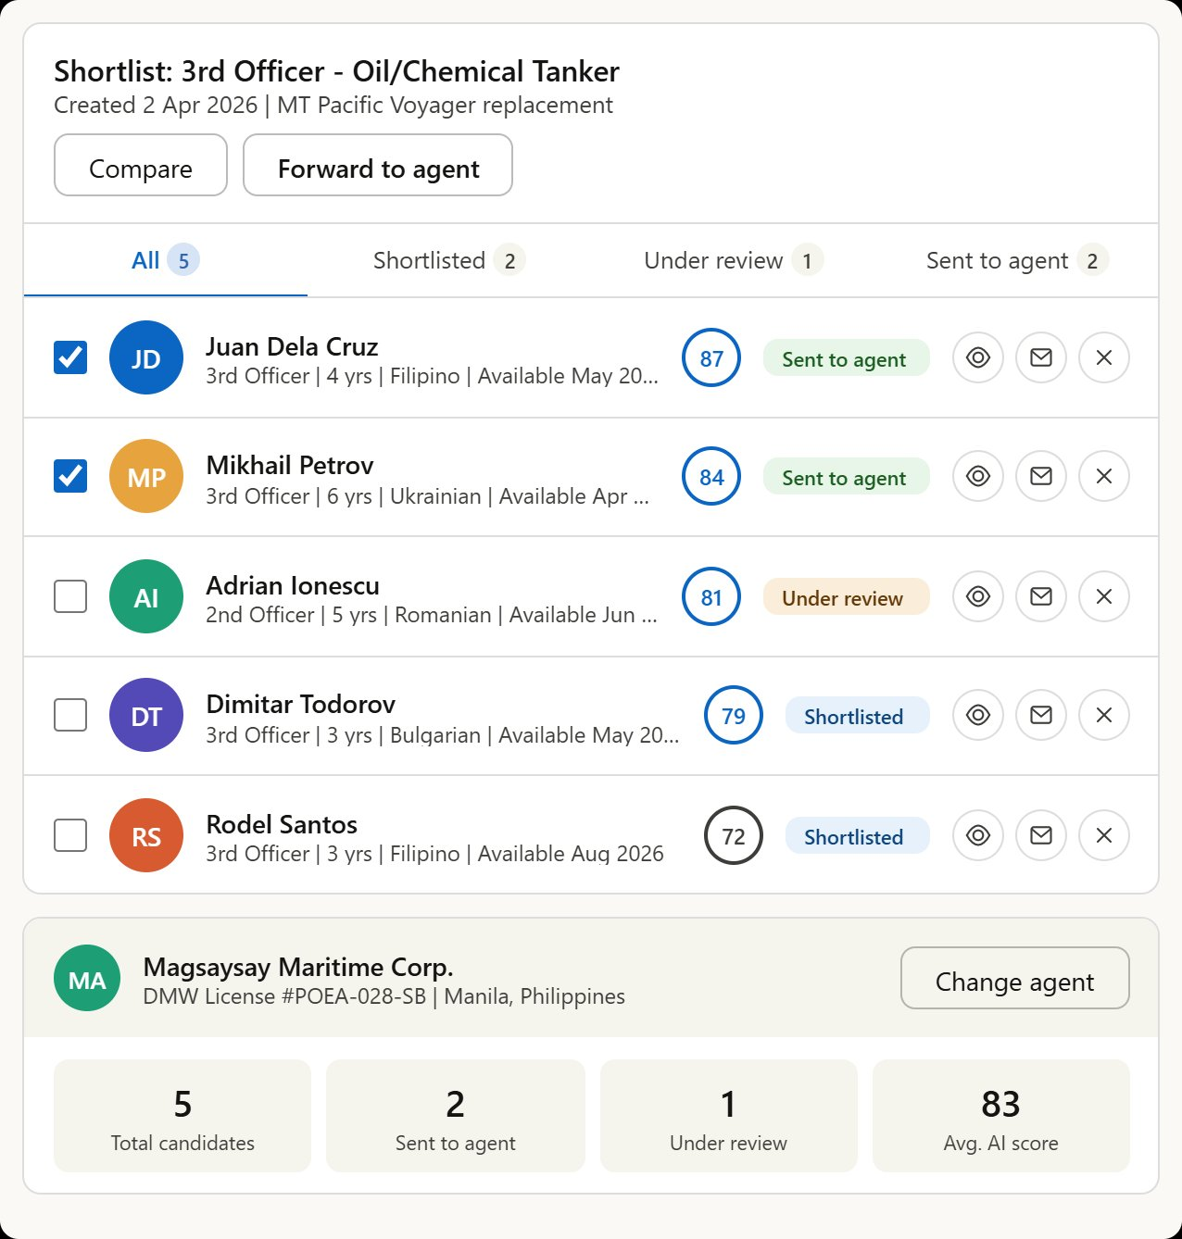
Figure 9: Shortlist & pipeline — connecting shipowner to manning agent

6.4 Manning agent dashboard
The agent’s command center. Incoming shortlists from shipowners (Tsakos Energy Navigation, Diana Shipping, Capital Ship Management) appear with candidate details, vessel information, and urgency levels. The dashboard shows 4 key metrics (new requests, active pipelines, candidates in review, placement rate) and a deployment pipeline overview tracking candidates from Received through Vetting, Contract, and Deployment stages. Greek shipping companies are featured as principals.

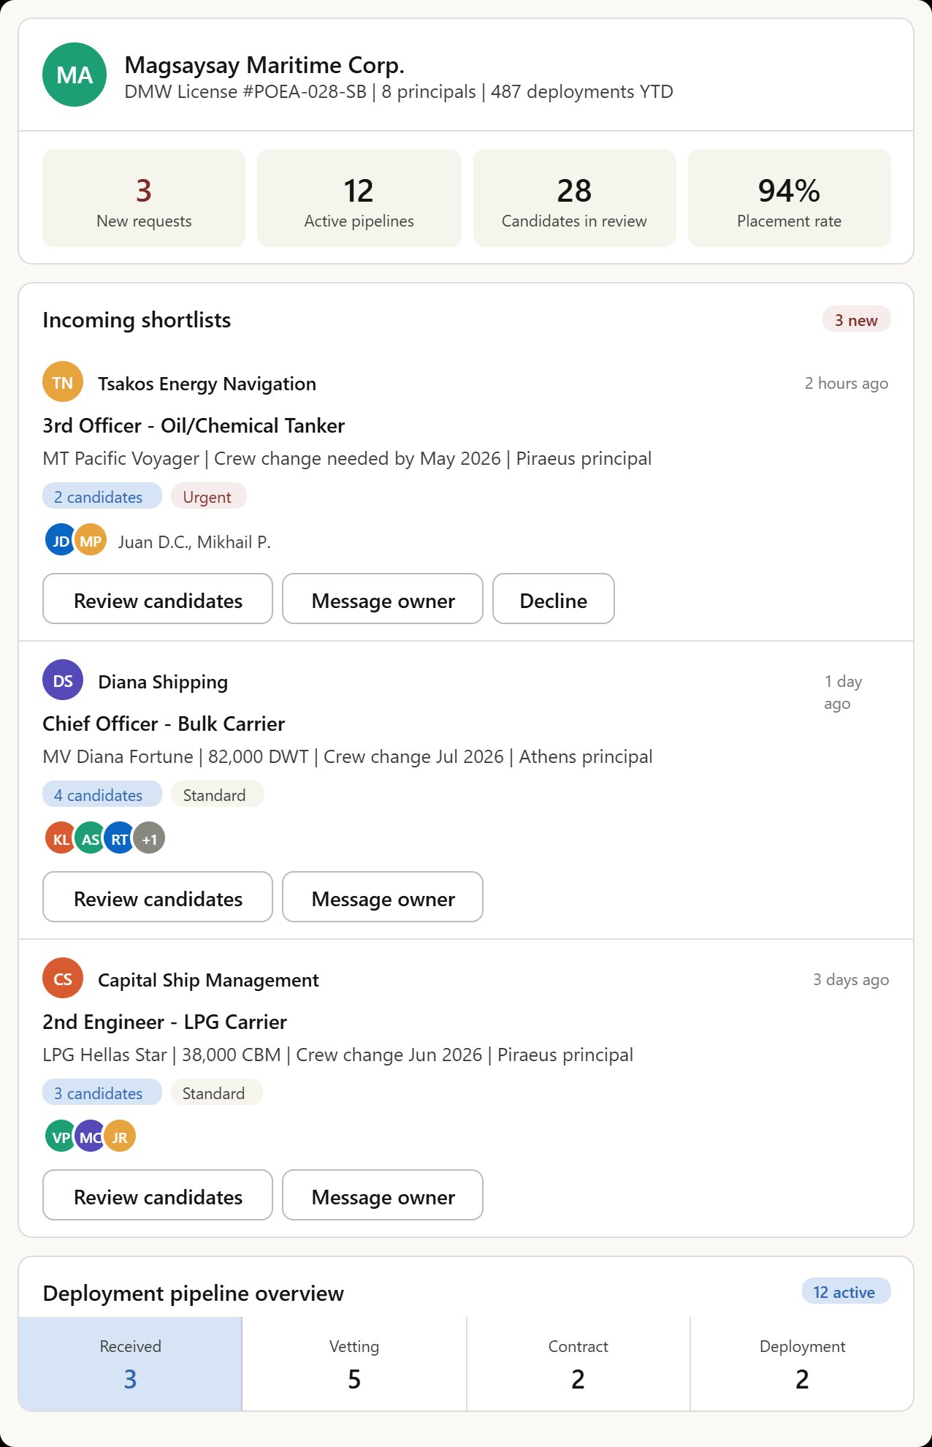
Figure 10: Manning agent dashboard — receiving shortlists from shipowners

6.5 Home feed
The community hub and daily engagement screen. A LinkedIn-style feed with maritime content: training announcements from STCW centers, career milestone posts from captains, and industry news. The “Start a post” bar includes a maritime-specific “Certificate” option alongside Photo and Article. The right sidebar shows trending maritime topics (ECDIS, Red Sea routing, decarbonization) and latest job openings from Greek shipping companies.

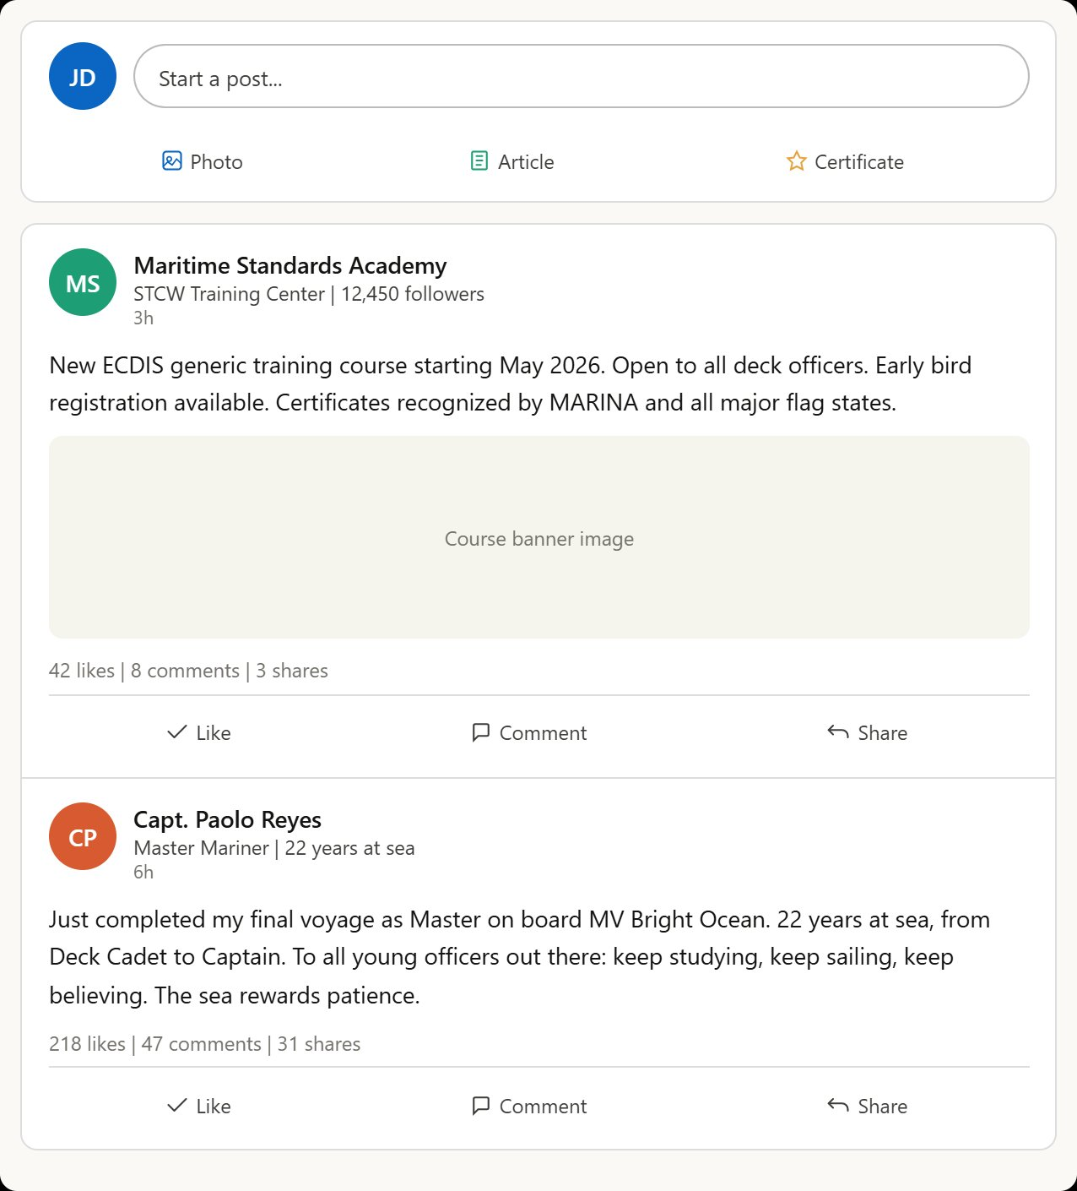
Figure 11: Home feed — maritime community and engagement

6.6 Messaging
The communication layer connecting all three personas. LinkedIn InMail-style interface with two panels: thread list (left) and active conversation (right). A context banner above the chat shows “Juan is on your shortlist for MT Pacific Voyager (3rd Officer)” — linking the conversation to the recruitment pipeline. The sample conversation demonstrates the legal flow: the shipowner mentions they will forward details to the manning agent for processing.

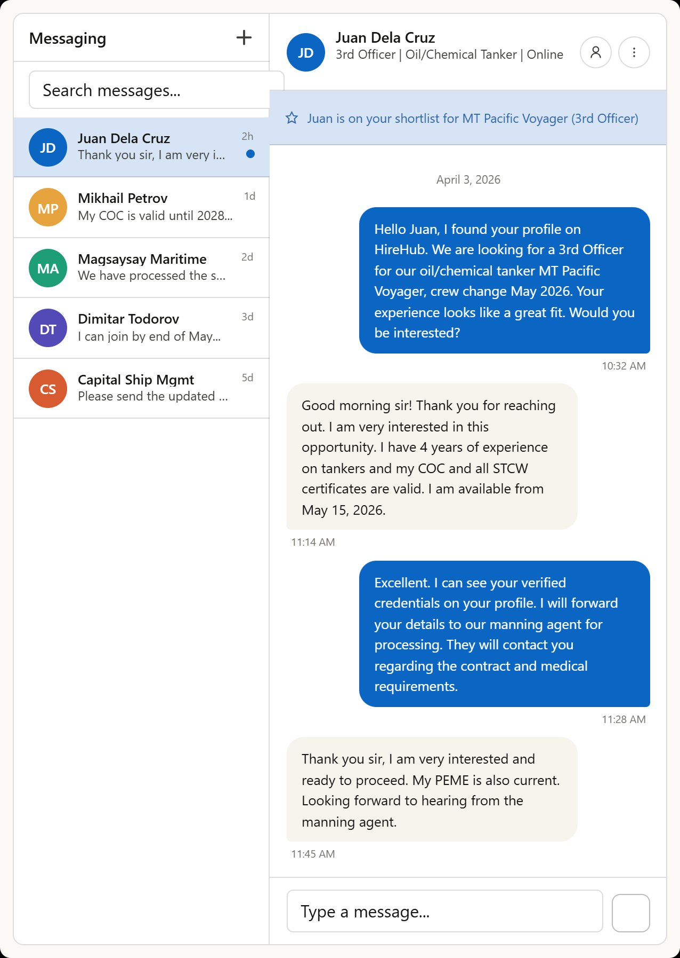
Figure 12: Messaging — context-aware InMail with pipeline integration

7. Design system
The HireHub Design System ensures visual consistency across all screens. It defines the complete color palette (primary blue, accent gold, semantic colors, neutrals), typography scale (H1 through Caption), spacing system (4px to 48px), border radius tokens, button styles (primary, secondary, tertiary, disabled), badge variants (Verified, Premium, Urgent, New, Expiring, Agent), form elements, avatar sizes, card components, metric cards, and AI compatibility score rings with color-coded tiers.

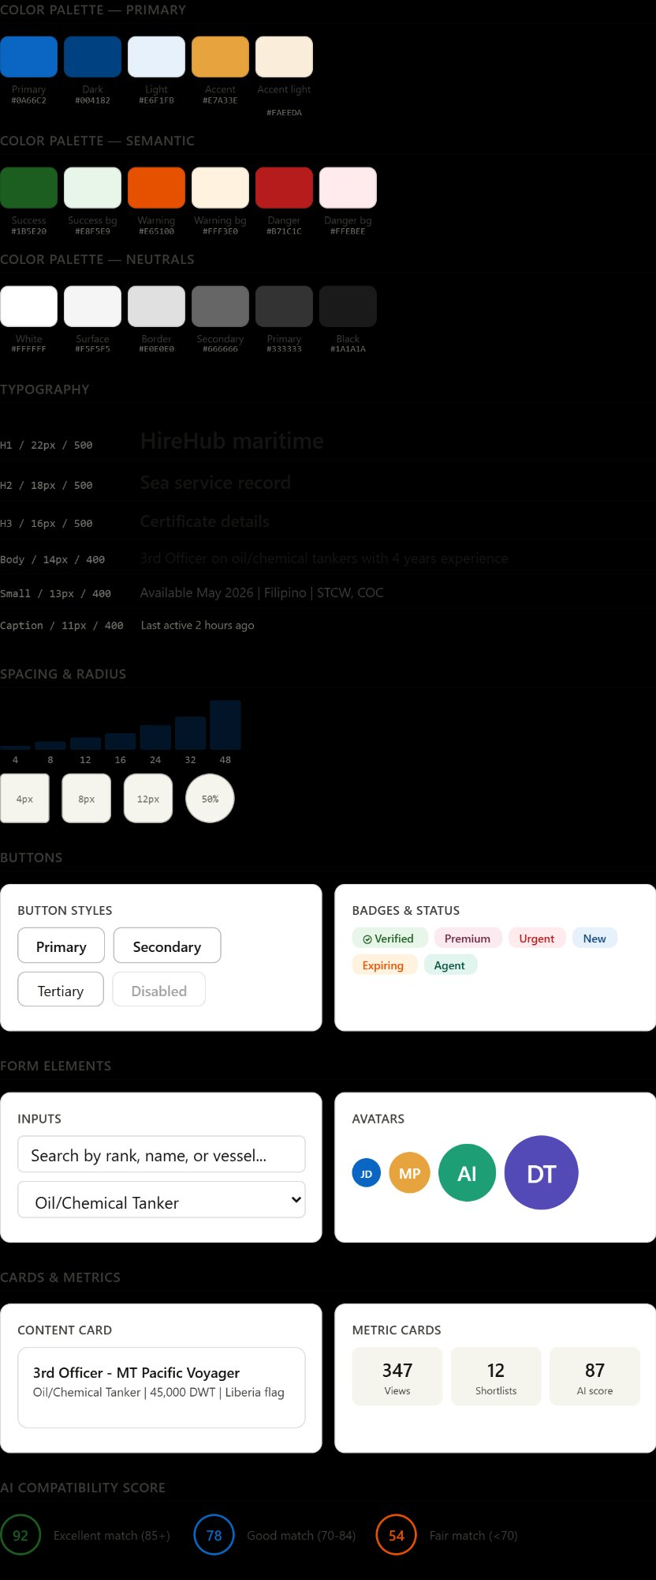
Figure 13: HireHub design system — colors, typography, components, and tokens

8. Next steps — Phase 3
With Phase 1 and Phase 2 complete, the following deliverables are queued for Phase 3:

Deliverable | Description
Database Schema / ERD | Entity-relationship diagram: Users, Profiles, Sea Service, Certificates, Companies, Shortlists, Messages, AI Scores
API Specifications | RESTful API endpoints for authentication, profile CRUD, search, matching, shortlist management, messaging, agent integration
Clickable Prototype | Interactive React prototype connecting all 6 screens. Ready for investor demos and early user testing.
Formal Legal Opinion | Engagement with Philippine maritime law firm for written legal certification before launch.

© 2026 HireHub — All rights reserved | Confidential

