1. Fill in the blanks for the following Grötzsch graph.
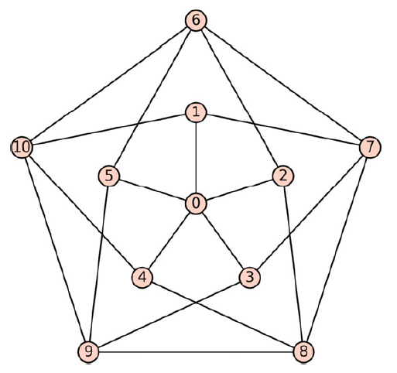

 | VALUE |  | TRUE/FALSE
Vertice Count |  | Is it regular?
Edge Count |  | Is it directed?
Radius |  | Is it connected?
Girth |  | Is it weighted?
Diameter

2. For the graph with the adjacency matrix below, find the
(a) adjacency list,
(b) incidence matrix and
(c) a drawing of it.

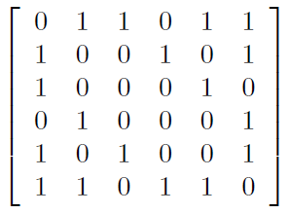

3.
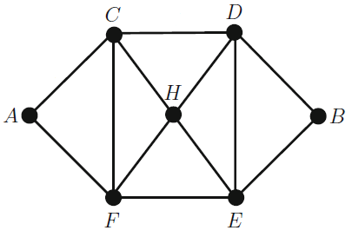
Modify the following Python code to visualize the graph above. Paste the resulting graph drawing.

import networkx as nx
import matplotlib.pyplot as plt

G = nx.Graph()

G.add_edge(0, 2)
G.add_edge(1, 2)
G.add_edge(1, 3)
G.add_edge(5, 3)
G.add_edge(3, 4)
G.add_edge(1, 0)

nx.draw_networkx(G)
plt.show()

4. Calculate the following properties for the graph given in question 3.

nx.eccentricity(G)
nx.diameter(G)
nx.radius(G)
nx.periphery(G)
nx.center(G)

5. Modify the following interactive network graph to visualize the graph in question 3. Paste the resulting graph drawing.

#!pip install pyvis

from pyvis import network as net
from IPython.core.display import display, HTML

G=net.Network(height='400px', width='50%',heading='',notebook=True, cdn_resources='in_line')

G.add_node(1)
G.add_node(2)
G.add_node(3)
G.add_edge(1,2)
G.add_edge(2,3)

G.show('mygraph.html')
display(HTML('mygraph.html'))

6. Execute the following Python code. Paste the resulting graph drawing.

import networkx as nx

G = nx.Graph()
G.add_edge(0,1,color='r',weight=20)
G.add_edge(1,2,color='g',weight=40)
G.add_edge(2,3,color='b',weight=6)
G.add_edge(3,4,color='y',weight=30)
G.add_edge(4,0,color='m',weight=10)

colors = nx.get_edge_attributes(G,'color').values()
weights = nx.get_edge_attributes(G,'weight').values()

pos = nx.circular_layout(G)
nx.draw(G, pos,
edge_color=colors,
width=list(weights),
with_labels=True,
node_color='orange')

