- Starting from Vertex A, traverse the following graphs with the BFS algorithm. Draw the resulting Breadth-First Trees.

- Traverse the graphs in Q1 with the DFS algorithm.

- Modify the following Python code to find the BF traversal of the graph given below.
Hint: Discard the self-loops and the parallel edges.

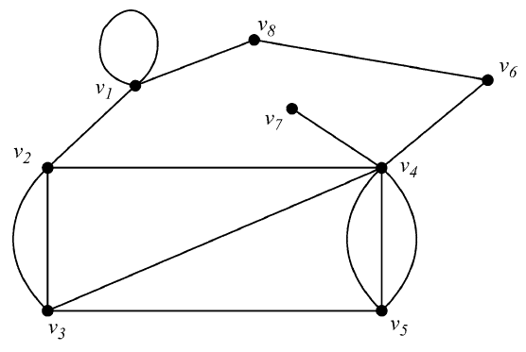

# Using a Python dictionary to act as an adjacency list
graph = {
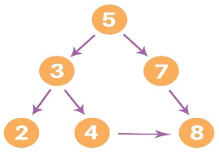
'5' : ['3','7'],
'3' : ['2', '4'],
'7' : ['8'],
'2' : [],
'4' : ['8'],
'8' : []
}

visited = [] # List for visited nodes.
queue = [] #Initialize a queue

def bfs(visited, graph, node): #function for BFS
visited.append(node)
queue.append(node)

while queue: # Creating loop to visit each node
m = queue.pop(0)
print (m, end = " ")

for neighbour in graph[m]:
if neighbour not in visited:
visited.append(neighbour)
queue.append(neighbour)

# Driver Code
print("Following is the Breadth-First Search")
bfs(visited, graph, '5') # function calling

- Modify the following Python code to find the DF traversal of the graph given below.

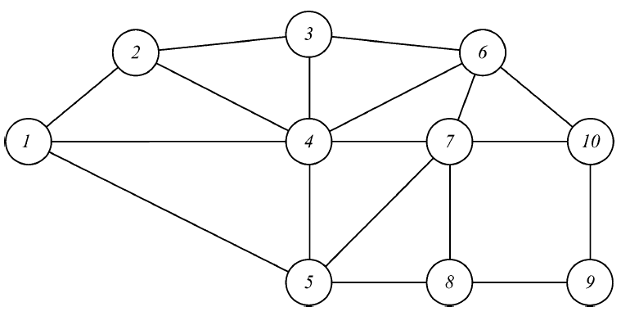

graph = {

'5' : ['3','7'],
'3' : ['2', '4'],
'7' : ['8'],
'2' : [],
'4' : ['8'],
'8' : []
}

visited = set() # Set to keep track of visited nodes of graph.

def dfs(visited, graph, node): #function for dfs
if node not in visited:
print (node)
visited.add(node)
for neighbour in graph[node]:
dfs(visited, graph, neighbour)

# Driver Code
print("Following is the Depth-First Search")
dfs(visited, graph, '5')

- Modify the following Python code to find the topological sort of the graph given below. Paste your final code and output.

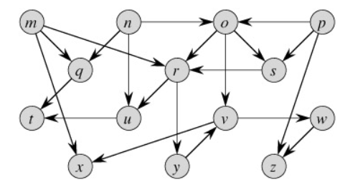

import networkx as nx
import matplotlib.pyplot as plt

DAG = nx.DiGraph()

DAG.add_edge(0, 2)
DAG.add_edge(1, 2)
DAG.add_edge(1, 3)
DAG.add_edge(5, 3)
DAG.add_edge(3, 4)
DAG.add_edge(1, 0)

nx.draw_networkx(DAG)
plt.show()

order = list(nx.topological_sort(DAG))
print(order)

## Too many results migth be returned #orders = list(nx.all_topological_sorts(DAG))
#print(orders)

