1. In the graph given below use Dijkstra's algorithm to find shortest paths from A to other nodes.
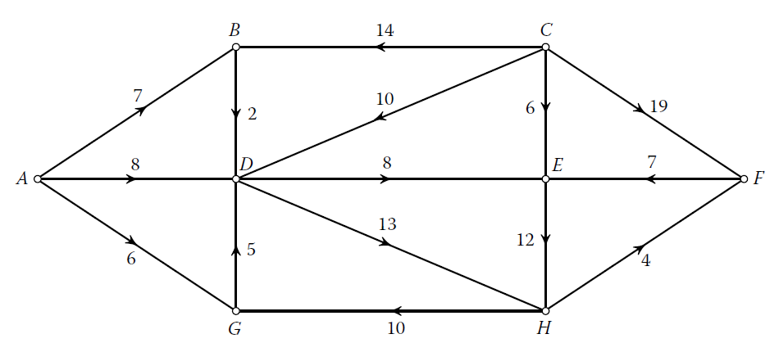

2. In the following graph use Bellman-Ford algorithm to find shortest paths from $υ_{1}$ to other nodes.
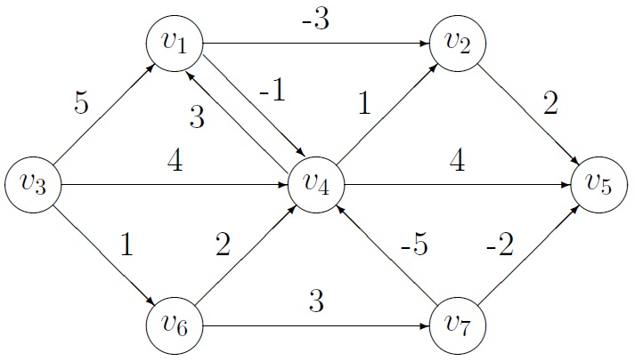

3. Test the Floyd-Warshall Algorithm on:
https://algorithms.discrete.ma.tum.de/graph-algorithms/spp-floyd-warshall/index_en.html

- Create a graph from “Create Graph” tab. Modify the default graph to the graph given in Q1.
- To create a node, make a double-click in the drawing area.
- To create an edge, first click on the output node and then click on the destination node.
- The edge weight can be changed by double clicking on the edge.
- Right-clicking deletes edges and nodes.

- Execute the algorithm as following:

Ready – Run the Algorithm! | → | Let's go! | → | next

- Paste the final distance matrix.
