1. Determine the vertex- and edge-connectivity of the given graphs.

 | Vertex-connectivity | Edge-connectivity
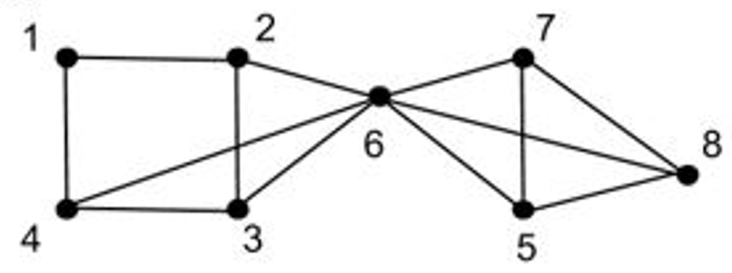 | 1 | 3
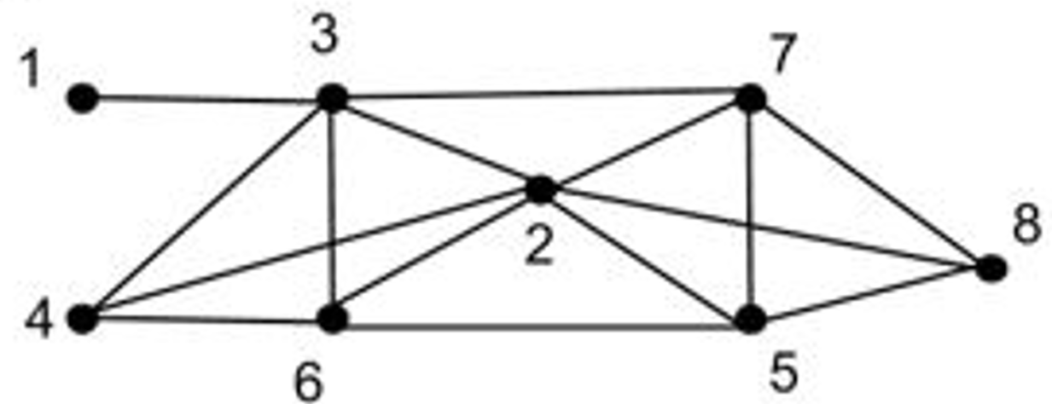 | 1 | 1
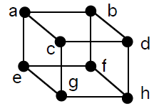 | 3 | 3
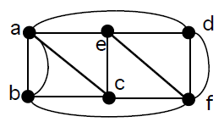 | 3 | 4

2. Which of the following is/are Euler Graphs? Draw an Euler trail if it’s possible.
Hint: If all the vertices of a graph are of even degree, then the graph is an Euler Graph otherwise not.
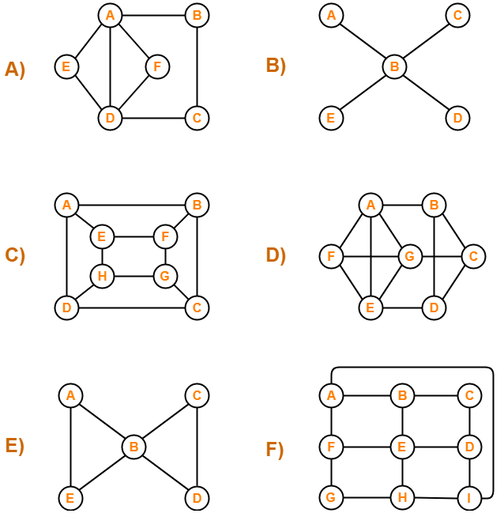

3. The following figure shows a diagram of a modern art museum that is divided into 15 exhibition rooms. At the end of each day, a security officer enters the reception room by the front door and checks each exhibition room to make certain that everything is in order. It would be most efficient if the officer could visit each room only once and return to the reception room. Can this be done?

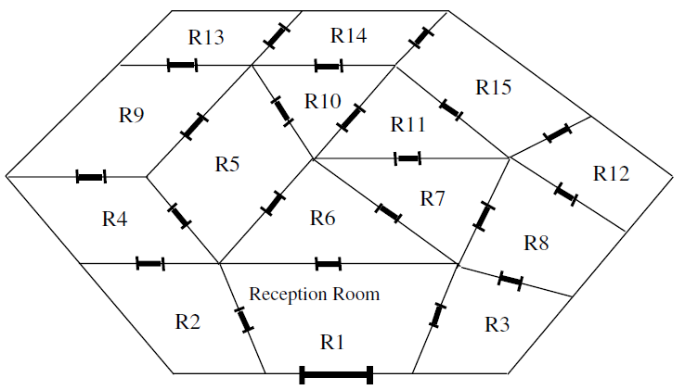

4. Modify the following Python code to find the Hamiltonian cycle of the graph constructed for the Icosian game. Paste your final code and output.
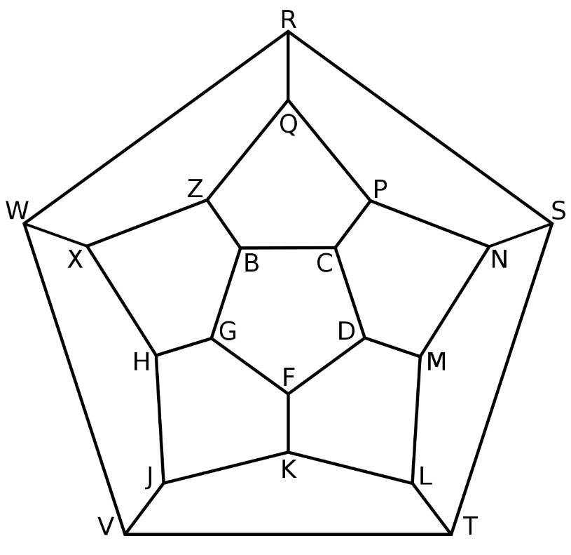
import networkx as nx
import matplotlib.pyplot as plt

def hamilton(G):
F = [(G,[list(G.nodes())[0]])]
n = G.number_of_nodes()
while F:
graph,path = F.pop()
confs = []
neighbors = (node for node in graph.neighbors(path[-1]) if node != path[-1]) #exclude self loops
for neighbor in neighbors:
conf_p = path[:]
conf_p.append(neighbor)
conf_g = nx.Graph(graph)
conf_g.remove_node(path[-1])
confs.append((conf_g,conf_p))
for g,p in confs:
if len(p)==n:
return p
else:
F.append((g,p))
return None

G = nx.Graph()
edges = [('A', 'B'), ('B', 'C'), ('C', 'D'), ('D', 'A'), ('A', 'C')]
G.add_edges_from(edges)

nx.draw_networkx(G)
plt.show()

hamilton(G)

