1. For the graph given below use Kruskal's algorithm to find a minimum spanning tree.
Hint: You can use the tool at https://algorithms.discrete.ma.tum.de/graph-algorithms/mst-kruskal/index_en.html
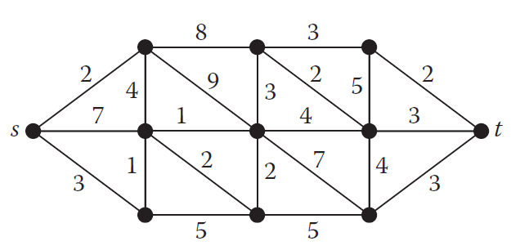

2. For the following graph use Prim's algorithm to find a minimum spanning tree.
Hint: You can use the tool at https://algorithms.discrete.ma.tum.de/graph-algorithms/mst-prim/index_en.html
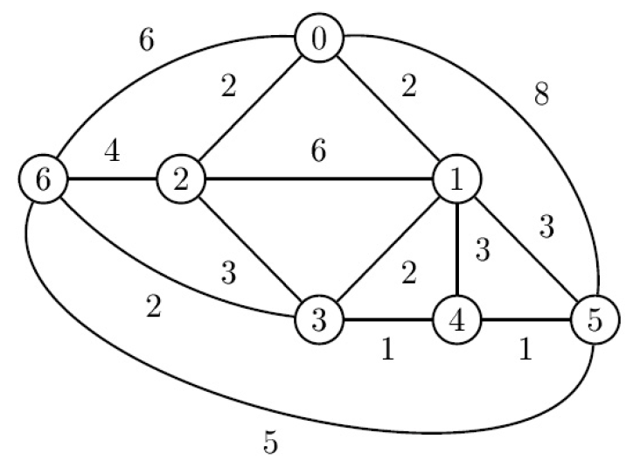

3. HA30 dataset describes the airline distances, in hundreds of miles, between 30 international cities. Using the Python code below find the shortest airway system that connects all the cities, using only straight paths from one city to another.

import networkx as nx
import matplotlib.pyplot as plt
import numpy as np

from google.colab import drive
drive.mount('/content/drive')
from google.colab import files

#dataset from https://people.sc.fsu.edu/~jburkardt/datasets/cities/cities.html

#https://people.sc.fsu.edu/~jburkardt/datasets/cities/ha30_dist.txt
distanceMatrix = np.loadtxt('/content/drive/My Drive/Colab Notebooks/CME4422/ha30_dist.txt')

#https://people.sc.fsu.edu/~jburkardt/datasets/cities/ha30_dist.txt
positions = np.loadtxt('/content/drive/My Drive/Colab Notebooks/CME4422/ha30_xyz.txt')

#https://people.sc.fsu.edu/~jburkardt/datasets/cities/ha30_name.txt
text_file = open('/content/drive/My Drive/Colab Notebooks/CME4422/ha30_name.txt', "r")
cityList = text_file.readlines()

G = nx.Graph()
for i in range(len(cityList)):
G.add_node(cityList[i], pos=(positions[i,0], positions[i,1]))

for i in range(G.number_of_nodes()):
for j in range(i + 1, G.number_of_nodes()):
G.add_edge(cityList[i], cityList[j], weight=distanceMatrix[i][j])

pos=nx.get_node_attributes(G,'pos')
nx.draw(G, pos, with_labels=True)
plt.show()

T = nx.minimum_spanning_tree(G)

pos=nx.get_node_attributes(T,'pos')
nx.draw_networkx(T, pos, with_labels=True)
plt.show()

for u,v,a in T.edges(data=True):
print (u,v,a)

print("Total", sum([T[i][j]['weight'] for (i,j) in T.edges()]))

4. Find the non-isomorphic tree count of order 7 by using the Python code given below.

import networkx as nx
import matplotlib.pyplot as plt

order = 4
GList = nx.nonisomorphic_trees(order, create='graph')

#print("Non-isomorphic tree count of order ", order, " is ", len(list(GList)))

for G in GList:
nx.draw_networkx(G)
plt.show()

5. How many different isomers exist for the chemical formula C_{n}H_{2n+2} when n is 7.

