Peter Hsiung
English Instructor
Tel: +82 01058629004/ Email: phsiungus@gmail.com / Kakaotalk ID: PeterHsiung

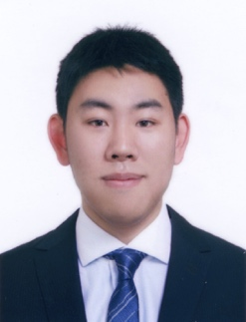

About me
◉ 5 + Years of ESL Teaching Experience
◉ F-2-7 visa holder
◉ US Citizen

Education
TEFL Course Diploma- 120-hour online certification course (completed January 2015)
BridgeTEFL

Bachelor of Arts in International Studies (completed May 2013)
The Ohio State University, Columbus, Ohio U.S.A.

Teaching Experience

English Teacher ( March 2023 to present)
Uljin Office of Education Uljin-gun,Korea
- Taught elementary students from 3rd to 6h grade
- Focus is on reading, listening, speaking and writing
- Teach after school classes from 1st to 2nd grade focusing on basic English words, numbers and phonics

English Teacher ( March 2021 to February 2023)
Suncheon Sinheung Elementary School Suncheon, Korea
- Native English Teacher that taught elementary students from 3rd to 6th grade
- Conducted classes that focused on reading, listening, speaking and writing
- Assisted Korean teachers with lesson planning
- Taught summer and winter camp on various topics

Native English Teacher (March 2019 – February 2020) Gwangju-si,Korea
Kyeongan Elementary School
- Native English Teacher that taught elementary students from 3rd to 6th grade
- Conducted afterschool classes of English focusing on the topic of Storytelling and Board games
- Assisted with sports day and workshops for elementary school students
- Lead summer camp for grades 3-5 based on Superhero theme

EPIK Native English Teacher (September 2015 –September 2017) Seogwipo-si, Korea
Jeju Provincial Office of Education
- Native English Teacher that taught students from elementary to adult students at 2-3 schools per week
- Conducted afterschool classes of English focusing on creative topics with 6 students 1 time per week
- Created specialized lessons plans on different topics with classes of 30 students
- Lead Winter and Summer camps for 2-3 school’s students based on different themes
- Assisted with weekend activities with elementary to middle school students of up to 10 different schools across Jeju Island

