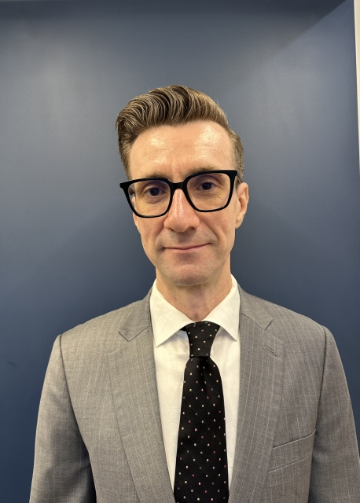
Ryan Oakley

Saman Studio 2000, Apt. 206, Jung 2(i)-dong,
Haeundae-gu, Busan, South Korea

010-8428-4271
ryan.oakley@gmail.com

KAKAO ID: RyanOakley

Professional Summary

An award-winning, energetic, and reliable English instructor with two years of experience in teaching. A patient and adaptable instructor with a proven ability to improve student grades and fluency while connecting with students in an engaging classroom setting. Additionally, a traditionally published and award-nominated science fiction author with an education in anthropology, Korean studies, and evolutionary medicine. Has also acted as an editor and a beta-reader for professional writers, helping their work to be published in book form, prestigious magazines, and anthologies. Seeking a position that will utilize my experience in teaching, writing, editing, and public speaking to prepare students for academic and professional success.

Education

Bachelor of Arts in Anthropology | 4.0 GPA | 2024
Arizona State University
Summa Cum Laude
Phi Beta Kappa Honors Society

Evolutionary Medicine (Certificate) | 4.0 GPA | 2024
Arizona State University
Summa Cum Laude

Associate of Arts in Korean Studies | 4.0 GPA | 2024
West Los Angeles Community College
Summa Cum Laude

Arizona State University TESOL Certification | 2024

Google Professional Certification in Data Analytics | 2024

Work Experience

Teacher | Milestone Institute | 2024 – Present

- Taught elementary students at various levels of English fluency. Subjects included writing, grammar, in-depth reading, 21st Century Communication, debate, speech, novel, and science. Also taught critical reading and TOEFL and was chosen to act as debate coach for the academy’s highest level grade five students.

- Administrative duties included daily and weekly reports on students, twice a semester progress reports, grading essays and tests, checking and making power-point slides for classes, and overseeing a number of projects both for students and the school.

- Won The Best Teacher award and bonus three times.

Author, Writer, Editor | Freelance | 2006 – Present

- My science fiction novel “Technicolor Ultra Mall” was shortlisted for best novel by Canada’s two top science fiction awards. (EDGE Science Fiction and Fantasy Publishing, 2012)

Research Apprentice | Arizona State University Institute of Human Origins | 2023 – Present

- Coded field notes from field observations of wild chimpanzees to help build and digitize The Gombe Chimpanzee Database – a powerful and important relational database of chimpanzee data built from The Jane Goodall Institute Gombe Research Archive.

- Checked and corrected the coding of field-notes by undergraduate students and cleaned the data. Also received training in the use of R (an open source statistics program) and training in various research methodologies.

Personal Interests

I enjoy reading, music, and the arts. I also love animals and the outdoors. I enjoy swimming and I’m an avid long distance runner, enjoying jogging in the hills around Busan. I love trying new foods, bird-watching, and learning about different cultures.

