6177 | 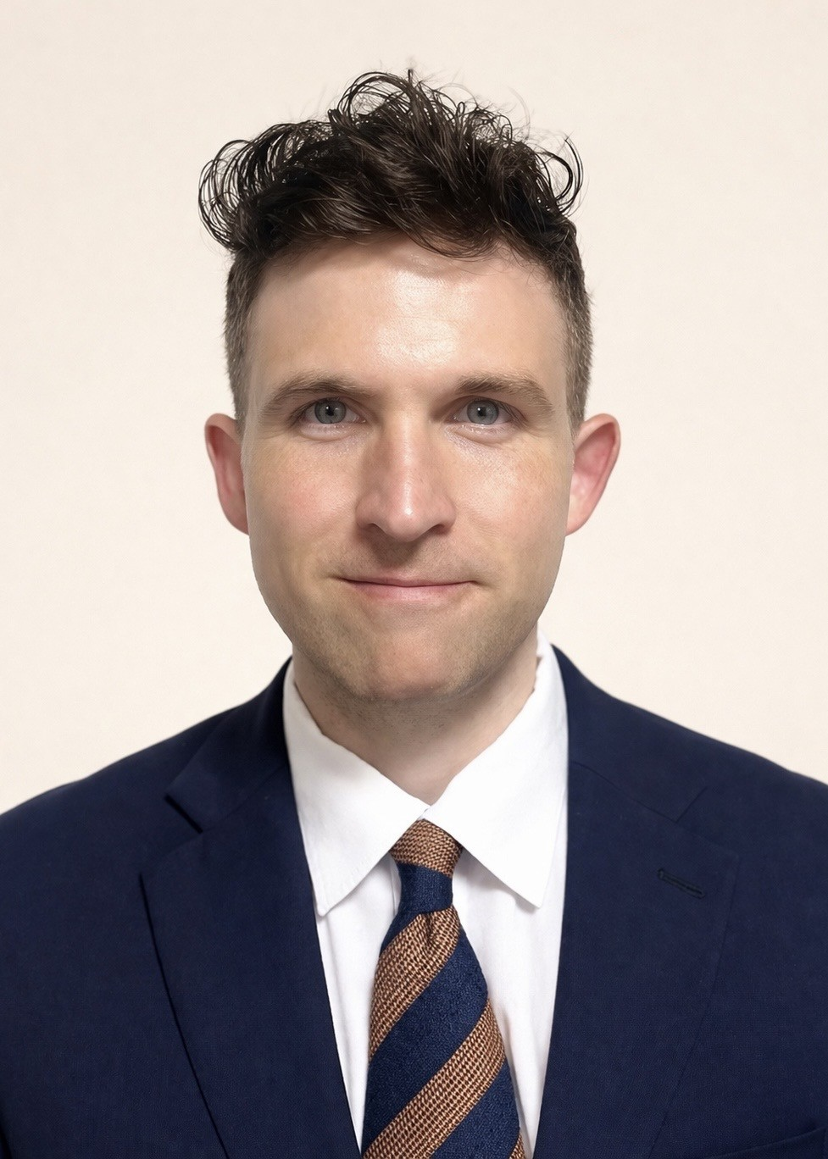
Caleb
-si, -do, 12777

To whom it may concern,

I am writing to express my interest in continuing my employment as an English teacher in South Korea for a second year through Bridge Recruitment. Having taught full time at the Honguk Institute of Foreign Studies (HIFS) in Yongin for the past year, years of tutoring native Korean speakers while I lived in the United States, as well as my doctoral research in Korean classical music makes me an excellent candidate to teach continue teaching English in South Korea to help Korean students develop their English ability while continuing to experience and develop a deeper understanding and immersion of South Korea.

Since August of 2025, I have taught English language classes at HIFS to students ages 5-7. I have taught language, phonics, world geography, problem solving, as well as physical education and activity based outdoor classes. This wide variety of ages and subjects has given me a diverse background of teaching English through different topics. I have been able to develop various pedagogical techniques through student-based activities, as well as methods of teaching to scaffold the material and help improve retention. All my 5- and 6-year-old language students passed and advanced to the next class at the end of the semester, and the average test score increased by three points over the previous graduating classes. Many of my 7-year-olds tested into the HIFS Elementary school and are currently continuing their education there.

During my classes, I like to create a fun and low-pressure environment for the classroom. I approach the class more as a guided open discussion, making students comfortable to speak freely and provide their opinions, experiences, and ask questions as they come up. This open dialogue has made many shy students speak up in my classes, as I show interest in what they have to say rather than silencing them and forcing to only listen to a lecture. I also form personal connections to each individual student, learning about them as we spend more time together and remembering their experiences, likes and dislikes, hobbies, and other things that I can add into my teaching to further engage them in a personalized manner. In a culturally sensitive approach, I want students to feel free to express themselves without the fear of making mistakes or feeling shy to participate. Understanding Korean students generally have high expectations, I create a classroom that helps to learn a second language in a way that makes it an enjoyable experience rather than another burden to an already busy schedule. Whether it is the use of games, media, or group work, the students will remain engaged throughout the entire class.

I hold three degrees, with my highest being a Doctor of Musical Arts degree in Music Performance and Literature from Michigan State University. I also hold a 120 Hour TESOL & TEFL certification from the Uni-Prep Institute. Having this extensive education has allowed me to learn numerous pedagogical skills and techniques for critical thinking, developing lesson plans, collaborating with a diverse classroom, and teaching students of all language proficiency levels. Through my classroom and private tutoring experiences, I developed a student activity-based approach that focuses on communication, the use of English in real life scenarios, and activities that the students can learn from each other with guidance from the teacher.

Thank you for considering my application as an English teacher in South Korea. I am excited for the opportunity to discuss in more detail how I can continue my career teaching in South Korea and helping students’ English language development and for them to succeed in the classroom and beyond.

Sincerely,
Caleb

