6257 | 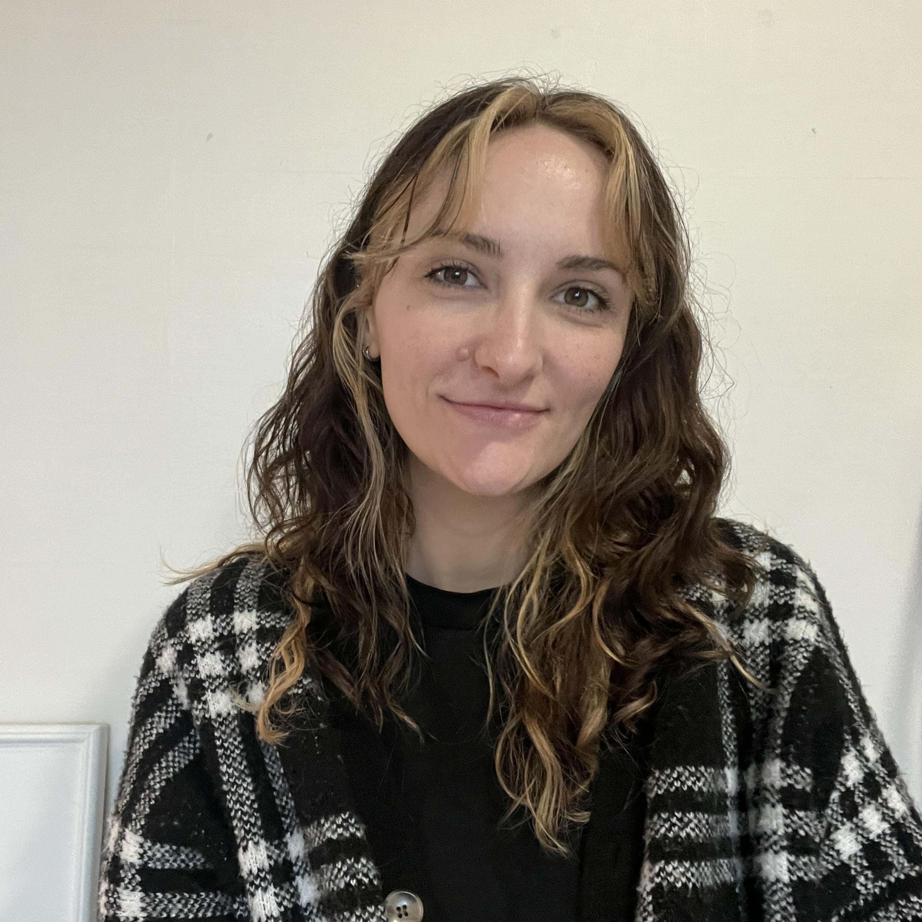

Visa Status: E-2
Citizenship: United States of America

Professional Summary
Professional English as a Foreign Language teacher with nearly four years of teaching experience in public schools as well as private English academies in South Korea. Proven track record of teaching speech and debate, reflected in students’ strong performance and awards in academic competitions. Experienced in teaching writing with a focus on clarity and argumentative rigor.

Education and Certificates
- myTEFL January 2021
120 Hour Comprehensive Online Course

- EASTERN KENTUCKY UNIVERSITY
Bachelor of Science, Psychology Graduated 2016

Relevant Experience
PLATO AP ENGLISH ACADEMY September 2025-Present
English as a Foreign Language Teacher Seodaemun-gu

- Taught reading and writing classes tailored to students with varying proficiency levels, from beginner through advanced.
- Facilitated student-centered discussions based on textbooks and novels by asking comprehension and critical thinking questions.
- Instructed students in both foundational and advanced debate techniques, including formal Parliamentary-style argumentation for higher-level learners.
- Researched and analyzed a wide range of debate topics to enhance lesson quality and support informed classroom discussions.
- Tracked and analyzed student grade data over the semester, implementing targeted teaching adjustments to improve overall performance.
- Designed and led daily interactive activity-based lessons for kindergarten students, incorporating science experiments, crafts, and cooking to promote engagement and experiential learning.

English ENGLISH ACADEMY August 2024-August 2025
English as a Foreign Language Teacher -gu

- Facilitated over 24 engaging speech and debate classes per week for elementary and middle school students, encouraging communication and critical thinking skills.
- Planned and taught specialized writing clinics and online conversation classes.
- Adapted teaching approaches and methods to students’ different interests and ability levels.
- Tracked and analyzed student grade data over the semester, implementing targeted teaching adjustments to improve overall performance.
- Collaborated with a partner teacher to assess student development and implement strategies for continuous improvement.

PROVINCIAL OFFICE OF EDUCATION August 2021-August 2023
English as a Foreign Language Teacher Yanggu-gun, -do

- Taught English as a foreign language to over 200 South Korean students in multiple public elementary and middle schools.
- Planned and led over 25 lessons per week that consisted of skill-building techniques for reading, writing, listening, and speaking a foreign language.
- Created effective and dynamic lesson materials using Microsoft PowerPoint, Microsoft Publisher, and Canva.
- Collaborated with South Korean coworkers in a bilingual environment to maintain healthy work culture and ensure a safe and effective environment for students’ learning.
- Attended professional development workshops to remain informed about the best techniques and strategies for English Language Learners.
- Assisted with English translations for school faculty on an as-needed basis.

BARNES AND NOBLE BOOKSELLERS November 2023-August 2024
Bookseller , USA

- Offered personalized book recommendations based on customer interests and reading levels, and stayed current on new book releases and author backlists to deliver knowledgeable, tailored recommendations.
- Processed transactions and incoming shipments.
- Wrote in-store book reviews to promote titles and enhance customer engagement.
- Planned and executed in-store promotional events and curated visually appealing book displays.

Additional previous experience can be given upon request.

Skills & Core Competencies:
Excellent Communication and Interpersonal Skills | Attention to Detail | Adaptability | Intermediate Korean Language Skills

