6297 | 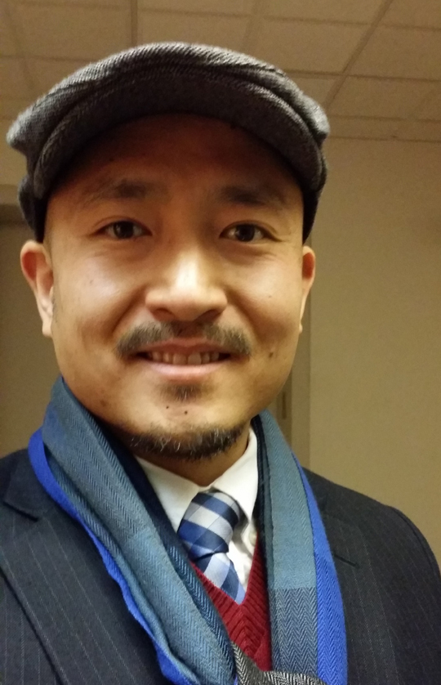

Dear Sir/Madame:

Enclosed, please find a copy of my resume, as I submit it with great interest in becoming a teacher in your school. It is my hope that you will review my resume and find my credentials suitable for an interview.

I have more than fourteen years of ESL/TOEFL teaching experience in Korea as well as twenty years of various teaching position ranging from Teacher’s Assistant in college to being a private English and art tutor as well as being a certified 200 hour yoga instructor. I have been a private English tutor for over 19 years with students ranging from pre-kindergarten through grade school, university students and adult English learners. I have helped many Korean students prepare to study abroad in America and other English speaking countries. In addition, I have helped adults and Business professionals improve their English skills and build their confidence as English speakers. I worked as an English teacher at Elementary School in Gunpo, South Korea for 3 years from 2009 to 2012. I worked for one of the most reputable English academies in Korea, Chung Dahm Institute (English) from 2007 to 2009 and again from 2017 to 2021. I taught every level at English and their April programs ranging from their lowest levels to their highest levels in Master. I have mentored and assisted college students as a Teacher’s Assistant while in college. In addition, I was a freshmen and transfer student Orientation Leader for 3 years in college. I was also a College Connector to Japanese college students who were studying abroad in the Boston Showa program.

Through my years of experience in teaching, I have come to understand the fragility and resolve that varies from student to student. It is with compassion and dedication that I have come to know the differences between each student and how to nurture their individual needs while maintaining an engaging and stimulating learning environment for the entire class. I know the importance of sharing knowledge and promoting growth of character as well as skills and techniques. As an assistant to professors in college, I gained a lot of experience in knowing how to connect with students as fellow artists and not only in a student/ teacher relationship. I bring the same methodology when teaching English and Art to students.

Some of the most influential people in my life have been my art teachers and professors. They did not simply just teach methods of painting and drawing, but rather life lessons that have left a positive impression on my character. It was through their understanding and support that I have come to be the teacher that I am today. I have come to cherish the wonderful and rewarding responsibility of being a teacher who can help influence young minds and pass on the wealth of knowledge from my own personal experiences along with what I have acquired from my mentors. I believe that I have attained the knowledge, aptitude, and motivation to become an integral part of your school. With my passion and dedication, I would love the opportunity to inspire your students and perform the necessary responsibilities as a teacher.

Thank you for your consideration and I look forward to your reply.

Sincerely,

Nicholas McCarthy-Donovan

Education
MassachusettsCollegeof Art,Boston, MA
Bachelor of Fine Art 2006

Teaching Experience in Korea andAmerica

Private English Instructor / Tutor: Boston,MA and Korea 2004 – 2026

Atlantis Academy of the Palm Beaches: West August 2023 - July 2024
- High School English Teacher 9th-12th grade
- Teach English to high school students: reading, writing, critical thinking, poetry, literature, debate, cursive writing and calligraphy

Chung Dahm Learning/ April Program: South Korea July 2017- May 2021
English school, South Korea
English Teacher
- Teach English to elementary, middle and high school students
- Listening & Speaking and Reading & Writing Skills for Intermediate and High level students
- Debate for Eagle through Master level classes

English school, South Korea
- Teach English to elementary school students
- Prepare Lesson Plans and teach grades 3, 4, 5 and 6
- Focus on Grammar, Reading, Listening and Speaking
- Motivating and encouraging these students to have fun learning and gaining confidence in speaking English
- Teach Advanced and Exceptional English classes for after school programs – Art projects, etc.
- Help organize and assist with various English Festivals and English contests held at the school.

Saint PaulIcheon, South KoreaPreparatory Academy: / February 2009-July 2009
- Teach English to middle and high school students
- TOEFL Listening & Speaking and Grammar for higher level students
- Focus on Grammar, Reading, and Speaking for lower level students
- Motivating and encouraging ESL students to develop confidence with their English speaking skills
- Art Instructor – Prepare Lesson Plans and teach middle and high school students fundamentals of art.

Chung Dahm Institute: Ansan, South Korea January 2007-January 2009
English Teacher
- Teach English to elementary and middle school students
- Listening & Speaking and Reading & Writing Skills for Intermediate and High level students
- TOESL Listening & Speaking and Grammar

Arirang New Leadership English Camp July 2006-August 2006
English Teacher
- Teach English in the areas of Grammar, Speaking & Listening, and Reading & Writing
- Prepare daily lessons, and quizzes and tests

MassachusettsCollegeBoston, MAof Art: September 2004–May 2006
Teacher’s Assistant for Anatomy Drawing Class, Open Drawing Sessions
- Assist Professor with daily set-up of model stand and classroom setting
- Assist model with poses and timing poses
- Assess and evaluate students’ progress
- Help students with gesture drawing warm-ups, and drawing techniques for shorter and longer poses

University: July2001 - September 2001
Teacher’s Assistant for Pre-Semester Program
- Assist professor with daily class preparations
- Help students with drawing technique
- Help students with project concepts and design process
- Assess and evaluate students’ progress

Activities and Awards

Korea
- Myeong Dong Gallery Art Exhibition 2009-2012
- Golmok Gallery Art Exhibition 2012
- Myeong Dong Gallery Artists Member 2009-2012
- Jankura Art Studio Artists Member 2011-2020

University2000-2006
- College Student Orientation Leader 2001, 2002, 2003 2001-2003
- University Connector Program, Boston Branch: 5 Semesters 2001-2004
Assist Japanese students to experience American college life
- Private Art Tutor 2004-2006
- Published in CMYK Magazine vol. 26, Summer 2004
2003 North American Review Cover Competition 2003
Recognition by Gary Kelley, Roy Behrens
- Illustration Department Art Exhibition Show 2003, 2004
- Colleges of the Fenway Intramural Soccer Team Champions 2002, 2003, 2005

Hopedale High School
- National Honor Society Member 1998-2000
- High School Yearbook Editor 2000
- Boys State MassachusettsMember 1999
Nominated and selected by teachers at High School
- Religious Education Teacher 1998-2000
Taught Catechism to 2nd and 4th grade students
- High School Jazz Band and regular Band member 1996-2000
Lead Alto Saxophone
- High School Varsity Soccer Team 1996-2000
Co-Captain of Club Soccer Team 1997-2000

