6311 | 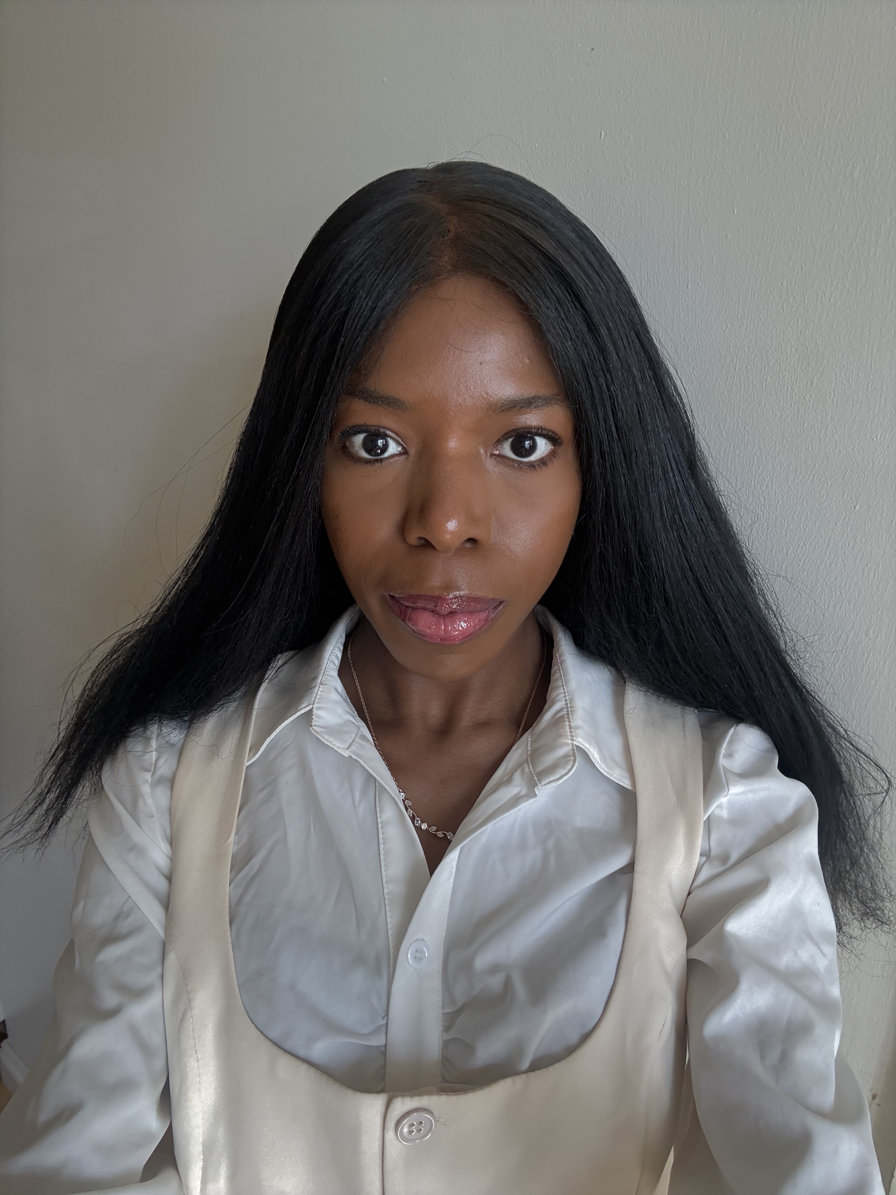
Dear Bridge Recruitment Team,

I am eager to teach English as a foreign language in South Korea.
I am a British 25-year-old. I have a master’s degree. I have taught English on an on called ‘Preply’ to foreigners whereby I had to plan and create interactive lessons. I have also taught English on the Native Camp on I am currently enrolled on a 120-hour TEFL course under Teacher Record.
I have experience working with children from volunteering at a nursery where I did storytelling and taught the children nursery rhymes. Furthermore, I also have teaching experience from when I was a teacher for a small language class of university students as part of a language society at my university. In these language classes, I mentored the students in beginners Korean.
My interest in Korean culture began in 2016. I self-taught myself Korean through use of on In 2023, I studied abroad at Korea University whereby I undertook a Korean language programme. I have explored Seoul whilst I was living abroad in South Korea. I am currently TOPIK level 3 in Korean. I am also an alumna of the London Korean Cultural Centre where I have taken part in programmes and field trips related to Korean culture.
One of the essential qualities of a good ESL teacher is someone who values patience. I am a gentle and caring individual. I am confident in delivering lessons. I am enthusiastic. I have excellent speaking skills, and I am good at delivering presentations. I am someone who is very interested in English Literature, and I am keen to help students with their writing and reading. I particularly enjoy creative writing. I am happy to provide structured lessons. I enjoy working with children. I have volunteered for a charity called KEEN London where I did play-based activities with children. I am someone who enjoys travelling and exchanging cultures. I am ready to use my skills to be an ESL teacher in Korea.

Kind regards,

