6313 | 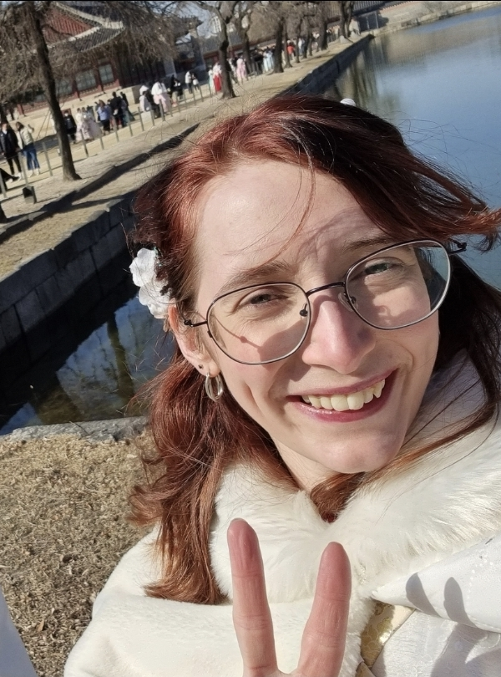
Curriculum Vitae

20th of September 1996

(South Korea)

University of Salford

2:1

(BA Hons) English and Drama

I studied with getTEFL on a 120-hour on to teach in South Korea.

I have been teaching in South Korea since December 2018, during which time I have worked at several hagwonEnglish
My first teaching position in Korea was at Language Academy in Dongbaek, where I worked from December 2018 to February 2020.

Before coming to Korea, my last job was at Crealy Adventure and Theme Family Park. I worked the 2019 Halloween period as a scare actor. I was informed that I was a very convincing undead porter. During the Summer of 2019, I worked in the Clarks shoe store in Plymouth. These jobs were to save up for coming to South Korea. Whilst at University I worked at the AlldayPA call center from the end of 2016 to my graduation in July 2018. I also worked doing some promotion work for a Club called IllumiNaughty, we filmed a promotional trailer for their event “Day of the Dead”. From November 2014 to January 3rd 2015, I worked at Tesco, Roborough at the Kiosk, I also worked at Primark as a retail sales assistant, in Drake’s Circus, Plymouth in 2015. All of this was a great customer service experience. In the Summer of 2014, I worked in St. Minerva, Rock, Cornwall, I worked in housekeeping, keeping the caravans, lodges and chalets clean.
Cwooten.edupro@gmail.comWhilst in school, before moving to Plymouth, I worked the Sunday paper round in Dartmouth when I was eleven years old. Reference Contact: Headmaster: Christina
twinkle.jaysonteacher@gmail.comPrinciple: Jayson Phillips

I am a positive girl who arrives on time and I will strive to give 100% in all the jobs I am given, I want to better myself as a person and broaden my horizons-- and whilst doing this I hope to broaden the horizons and improve the minds and lives of others. I am strict, but there is a time for playing games and a time for learning. Learning is fun, and I will always try to make the lessons fun and safe whilst ensuring that the children are learning.

I have a dog, his name is Little Mo. He was rescued from Pound in -do, . I also have my own apartment, so will not be looking to move, but to get a housing allowance.

