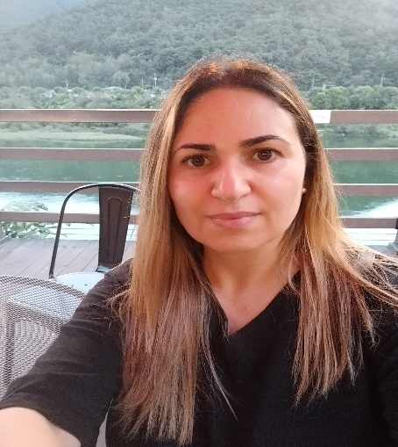
Marina Melissinou
Changdong, Seoul, South Korea
Mobile: 010 6636-2967 Marina2917@hotmail.com

EXPERIENCE

Uchon Kindergarten Mar 2025-Present
English Teacher
- Teaching a class of 19 students age 3
- Preparing phonics material including worksheets, power points and games
- Preparing weekly arts and crafts material
- Teaching songs, stories and manners class

SLP Seongbuk

English Teacher Mar 2023-Feb 2024
- Kindergarten homeroom teacher of two classes/year 1 (ages 5-6) and elementary classes
- Morning greeting and morning worksheets
- English Language, Phonics and Story book
- Homework
- Trimester report cards

SLP Uijeongbu Mar 2022-Feb 2023

English Teacher
- Kindergarten home room teacher of two classes/year 1 (ages 5-6) and elementary classes
- Morning greeting and morning worksheets
- Circle time
- English Language and Story book
- Math
- Science
- Arts
- Hessed Education
- Homework
- Wrap Up
- Trimester report cards

CEIN Dublin School Toledo, Spain Jan 2021 to Feb 2022

English Teacher
- Exam prep for levels B1, B2 and C1.
- Prepared lesson plans according to class level and needs.
- Taught levels from Starters to C1 including adult classes.
- Used online methods of teaching to accommodate students that learned from home
- Exam invigilator

Oxford Elementary School Bielsko, Poland Sep 2019-Dec 2021

English Teacher
- Worked with primary students ages 6-14.
- Prepared lesson plans and conducted activities that target confidence, perception, vocabulary building, pronunciation practice and grammar.
- Adopted the Montessori method to create lesson plans that were student-centered and self-directed.
- Maintained student records in accordance with school policy and school’s online platform.

Law Offices of Kanner & Pintaluga Boca Raton, Fl Sep 2017-Aug 2019

Legal Assistant/Paralegal
- Called clients to introduce them to the litigation department and explain the litigation process.
- Communicated with clients to get medical updates and helped them schedule medical appointments.
- Prepared legal documents and articles required for case preparation and e-filed with Florida Court system.
- Scheduled depositions, CMEs and Mediation, coordinated with clients and opposing cancel, scheduled court reporters and translators.
- Prepared outgoing RFP, RFA, Interrogatories and NPNPs.
- Drafted motions and scheduled hearings with the court system.

Angelo's Pizza New York, NY July 2010-Sep 2017

Manager
- Controlled operational costs and identified measures to cut waste
- Created detailed reports on weekly, monthly and annual revenues and expenses
- In charge of hiring and on-boarding process that included, but not limited to interviewing and training of staff, motivating them through coaching, acknowledgment of hard work, achievements and leading by example
- Coordinated daily Front of the House and Back of the House restaurant operations

Athens Café Astoria, NY Aug 2001 to Aug 2010

Manager
- Oversaw employee work in front and back of house to ensure compliance with company policies, regulations, and food safety guidelines.
- Performed facility walk-through to assess cleanliness and preparedness at beginning and end of shifts.
- Completed restaurant opening and closing procedures and managed deposits. Produced monthly reports detailing sales trends and forecasts.
- Consistently exceeded daily, weekly, and monthly sales targets while maintaining costs and keeping employee turnover low.
- Management and supervision of an average of 60 employees.

EDUCATION
- Teach Now (Moreland University)
Teacher Preparation Certificate Program Present
- International House Milan April, 2019
CELTA Certificate
- Florida Atlantic University July, 2018
Certificate in Paralegal Studies
- John Jay College of Criminal Justice June, 2004 Bachelor of Arts in Forensic Psychology

SKILLS
- Microsoft Office
- Smart Board
- Excellent planning and organizational skills
- Cultural sensitivity, tolerance and patience
- Fluent in English, Spanish, Greek

