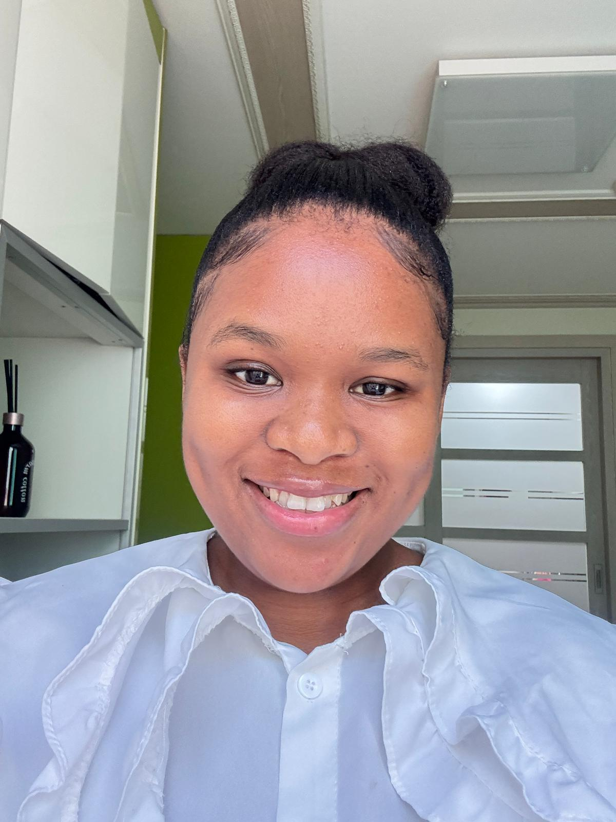
THANDEKA MJWARA

  CONTACTS    +82 10-2685-6626    tmjwara14@gmail.com  South Korea  Kakao Talk: 821026856626  DETAILS  Date of Birth: 1997.03.06  Nationality: South African  Languages: English  Gender: Female  INTRODUCTION  I am a motivated educator and life-long leader who has dedicated years to improving the education, culture and climate of the school community. I love working with children and contributing to their cognitive development. I have been recognized for my work in enhancing the learning experience for learners and enabling learners of all ages to get the most comfortable with inclusivity and accommodating their learning abilities and needs.  SKILLS  - Good interpersonal skills, punctual, hardworking and good ethical behaviour  - Physical Stamina, Mental Alertness and Stress Management  - Applied strategic thinking, conflict resolution/problem solving and people management  - Team player, good communication skills (fluent in English)  - Attention to detail/ accuracy, Proposal and report writing  - Good observation skills and administration. |  | EXPERIENCE  Teacher | Hillside Collegiate  ( 2025 - Current)  Teacher | Yonsei International Academy (South Korea)  (January 2024 to October 2025)  Teacher | Ukukhanya Primary School  (February 2022 to August 2023)  Substitute Teacher | The Mossie Primary School  (February 2020 to December 2021)  - Present lessons comprehensively and use visual/audio means to facilitate learning and interactive learning with individualized instructions.  - Participated in SBST (School Based Support Team).  - Plan and deliver engaging lessons aligned with the curriculum.  - Create a positive and inclusive classroom environment.  - Assess students’ progress and provide grades and feedback.  - Collaborate with other teachers, parents and stakeholders and participate in regular meetings and issue progress reports.  - Allocate and grade homework, assignments, and tests.  - Keeping records of attendance, grades, and other relevant student data.  - Engaging in ongoing self-assessment and professional growth.  - Provide constructive feedback and guidance to students.  - Communicate with parents and guardians about student progress.  - Maintain accurate records of attendance, grades, and other relevant data.  EDUCATION  Bachelor of Education (Intermediate and Senior Phase) (2019)  University of Zululand  National Senior Certificate (2015)  Menzi High School  REFERENCES  Educator Ms. Nyide  The Mossie Primary School  079 478 8091  Educator Ms. Sibiya  The Mossie Primary School  071 228 4901

