Wendy Veronie
📧 ichigo.milk@me.com | 📍 Louisiana, United States
337-257-6895

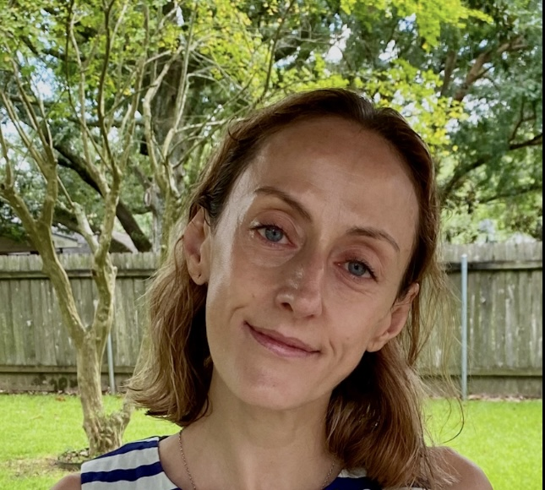
Professional Summary
Dedicated and results-driven ESL educator with 20+ years of international experience teaching English to children and adults across diverse cultural contexts. Proven ability to design engaging, task-based curricula and deliver impactful instruction online and in person. Skilled in five languages and passionate about student-centered learning, cultural exchange, and professional development.

Key Skills
- Curriculum Design: Tailored lesson plans for diverse learners
- Business English: Specialized instruction for professionals
- EdTech Platforms: Voxy, Cambly, Open English Jr., GEAD, and more
- Cross-Cultural Communication: Experience across Latin America, Asia, and Europe
- Student Engagement: Interactive, adaptive teaching style
- Languages: Fluent in English; proficient in Spanish, French, Italian, and Japanese

Professional Experience
GEAD — ESL Teacher (Business English)
April 2025 – Present | Remote (Chile)
- Teach Business English to adult professionals in Chile through live online classes
- Design customized lessons focusing on workplace communication, presentation skills, and professional vocabulary
- Provide actionable feedback and coaching, helping clients meet career-specific language goals
Cambly — English Teacher
2018 – present | Remote
- Conducted personalized, conversation-based sessions with children and adults worldwide
- Helped regular students improve scores on English proficiency exams
Voxy — English Teacher
2021 – 2025| Remote
- Delivered dynamic task-based lessons to adults at various proficiency levels
- Developed customized content for business clients, boosting student communication and retention
- Maintained top-tier student ratings and contributed to measurable retention increases
English First — English Teacher
2020 – 2021 | Remote
- Taught virtual English classes for children and adults, emphasizing real-world applications
- Co-developed new content, contributing to a 20% rise in student satisfaction
Open English Jr. — English Teacher
2017 – 2019 | Remote
- Taught English to Latin American children using interactive online methods
- Created engaging, multimedia-rich lessons to improve comprehension and retention
Cosmos Lan — English Teacher
2015 – 2019 | Queretaro, Mexico (Hybrid)
- Provided both online and in-person instruction to adult learners
- Developed individualized study plans that improved retention and learner outcomes
Earlier Experience (Condensed):
- American School (Mexico) – Librarian, led educational programs and managed resources (2014–2015)
- Carden English (China) – English Teacher, increased classroom engagement via immersive methods (2009–2011)
- YBM (South Korea) – Business English Teacher, corporate-focused ESL training (2007–2008)
- Inlingua (Italy) – English Teacher, culture-integrated language learning (2005–2006)
- Idiomas Internacional (Costa Rica) – Hospitality English Teacher (2004)
- ECC (Japan) – ESL Teacher, taught children and adults (2002–2004)

Education & Certification
BA in Philosophy
University of New Orleans, 2000
TEFL Certification (120 hrs.)
TEFL UK, 2020

Languages
- English: Native
- Spanish: Conversational
- Italian: Elementary
- Japanese: Elementary

