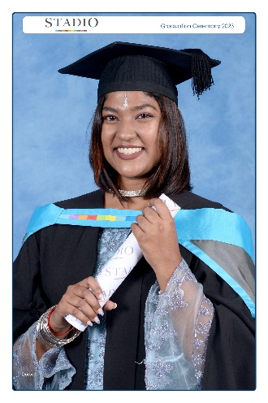
Curriculum Vitae

Name: Tamica Govender Gender: Female Address: Cheongju, Osong

Phone: 01026707433 Email: govendertamica111@gmail.com

Profile Summary: Self-sufficient and organised teacher, using various teaching methods to engage and encourage students to learn; with almost 3 years of experience in all aspects of the classroom and different schooling environments.
Education:
Bachelor Degree of Education in Intermediate Phase at Stadio (formerly known as Embury). Majors: Math, Science and English.
Other Certifications and Training: Security Awareness Certificate (SABIS 2023)
Child Protection Certificate (SABIS 2023)
Office Management Certificate (SABIS 2023)
Experience:
- Currently completing my second year teaching contract with High Zone Academy in Cheongju, June 2024-June 9th 2026.
- August 2023-October 2023 (Short term contract): The International School of Choueifat Sharjah. KG2 Homeroom teacher, in charge of admin and all work in correspondence with class such as teaching Math, Science, English using the UK and US curriculum (SABIS Curriculum). Grade 2 Computing teacher. Participates in marking, exam invigilation, excursions, lesson plans.
- January 2023-July 2023: Atholton Primary School as a substitute teacher in Grades 3-7 for subjects Math, English, Science in South African CAPS Curriculum. Participated in marking, excursions, exam invigilation and lesson plans. Aftercare assistant for Pre-primary (KG), takes care of the children until parents pick them up.
- July 2022-September 2022: Taught Autistic learner’s how to read, write and speak in West Park Special Needs School using US curriculum.
- February 2022-April 2022: Student teacher in Greenheights Primary School. Taught Math and English for Grades 4-6. Assisted in marking and lesson plans.
- December 2021 – March 2022: Educator Assistant for Greenbury Primary School. Assisted in admin work, substituted for KG1-Grade7 in all subjects. Assisted in marking, lesson plans and admin work. UK Curriculum.
- March 2021- May 2021: Student teacher in Greenbury Primary School. Taught Grades 3-7 Math, Science, English. Assisted in marking and lesson plans.
- In February 2020 – March 2020: Student teacher in Greenbury Primary School For grades 4-6 Math, Science, English before the schools closed of Covid.
- In February 2019 – April 2019: Student teacher at Seaview Primary School for the Grade 4’s Math, Science and English. Assisted in marking and lesson plans. US Curriculum.
Overall, I have almost 3 years of working experience (2 years being in Korea).
Skills:
- Extremely outspoken with the ability to connect with individuals and form harmonious relationships.
- Mediator among the students but can relate to them as well.
- Can work efficiently in teams as well as individually and can improve skills based on constructive criticism.
- Receives instructions well and will achieve what is required by adapting to the environment and circumstances.

Extra:
- Assisted as an escort and Marshall in the Seaview Primary Fun Run situated at Bellair Primary School, to help support the learner’s and encourage them in the race.
- Volunteered at Ithembalethu assisting with the care of HIV positive babies in 2014 with feeding, playtime monitoring and care, to support the overworked staff and raise awareness for the children’s home.
- Volunteered at Clayhaven Primary’s Feeding Scheme to gain sponsors for food hampers to assist the children.
- Stayed until 10pm in Seaview Primary helping with the school’s concert and the days before, helping the teachers with the student’s practice.

