


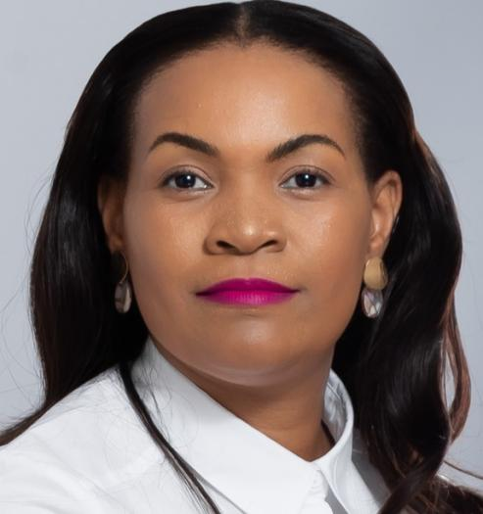
ABOUT ME
Hope Whitby Nkosi
+27 66 339 7085

whitbyh@gmail.com
46319 Boiketlo Street ,Doornkop . Sace Registration number C12990325
With three years of experience, I specialize in English grammar and literature. I have taught both Senior and Further Education and Training Phases (Grade 8-12), navigating the complexities of the Curriculum and Assessment Policy Statement (CAPS) and International Baccalaureate frameworks (IB). I am currently in my third year of full-time teaching, producing lesson plans and serving on the senior phase curriculum coordination team. I can employ a hybrid teaching approach, promoting inclusion, and differentiated learning.

EXPERIENCE
2024-2026 CURRO ACADEMY WILGEHEUWEL

High School Educator
Teaching Subjects English & Life Orientation Grade 8- 12

My teaching experience covers the exam level for students in Grades 8–12. Teaching English Grammar, literature, and Life Orientation. Curro Academy Wilgeheuwel is a large private school network in South Africa, offering an enriched International Baccalaureate frameworks (IB) curriculum. Classroom size is limited to 35 learners and lesson are all driven by technology. The student community is among the most diversified in the world because of the eleven official languages and diverse cultures of South Africa. All students receive instruction in English as their first language. I have achieved a 97% pass rate in the examination. Among the extracurricular activities I participate in are debate, library management, and girls' soccer.

2023 EDUCATION FIRST ( EF)
ESL online Educator Teaching English as foreign Language / Conversational & Business English
EF is a global organization that provides educational travel, language programs, and academic programs. My teaching experience ranges from 15-year-old learners to adults. Offering language programs at 50 recognized international language campuses across the world, including a South African site where I taught English to students from China, Indonesia, Germany, Italy, and Saudi Arabia.
I have conducted Live Teacher-Led Classes: Students can participate in 1:1 private lesson or join live group classes, allowing for real-time interaction with teachers and peers from around the world. These classes focus on practical conversation skills and are available 24/7. Real-Life Scenario Simulations: Utilizing the Efekta Method learners engage in simulated real-life scenarios that mimic situations they might encounter in English-speaking environments, such as workplace interactions or everyday conversations.

2022 MASAKHANE TUTORING SERVICE
Tutoring Tutoring subjects English, Mathematics & Life Skills
The tutoring service aimed to enhance English, Math, and Life Skills for grades 1-3. It focused on developing reading, comprehension, grammar, problem-solving, interpersonal skills, emotional intelligence, and social relationships through engaging stories, creative writing, games, exercises, and practical scenarios. The tutor also taught students about vocabulary, grammar rules, and problem-solving through role-playing and group activities.

EDUCATION
2024 STADIO HIGHER LEARNING INSTITUTE

South Africa Subjects
Post Graduate Certificate in Education (PGCE) English & Life Orientation Grade 8-12

2011 UNIVERSITY OF SOUTH AFRICA

South Africa

CERTIFICATION
BA Psychology

2024 TEFL & EILTS CERTIFIED
2024 SOUTH AFRICAN COUNCIL FOR EDUCATORS

EXPERTISE
SKILLS SUMMARY

Lesson Planning - The ability to design structured, educational and goal orientated lesson.
Classroom Management - Effective strategies to maintain an environment conducive to learning.
Differentiated Instruction - Tailoring teaching method and resources to cater to unique needs of each student.
Assessment- Conducting regular, effective, and reliable evaluation of students’ progression and understanding.
Inclusive Education- Ensuring that all students, regardless of ability or background, have equal learning opportunities.
Technology integration - Utilizing technology in educational activities in the classroom.

REFERANCES
Pravisha Piyaralall – Curro Academy Head of Department
Pravisha.p@curro.co.za +27 83 213 9871 Natily Moodley - Curro Academy Grade Coordinator
natily.m@curro.co.za +27 72 588 8164 Modiba Mahlatse – Head of School
mahlatse.m@curro.co.za +27 72 022 3105
91%
71%
78%
85%
89%
92%

