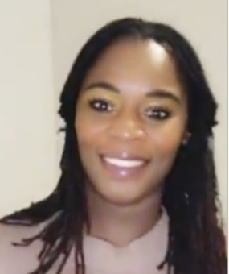
QUATESHA CLARKE
Knightdale, North Carolina, USA | 919-520-4307 | clarkequatesha@gmail.com
Available for International Relocation – July or August 2026

PROFESSIONAL SUMMARY
- Higher education professional with 15 years of experience supporting students and campus operations at Wake Technical Community College.
- Taught hybrid college-level Criminal Justice courses and maintained a calm, professional classroom environment.
- Experienced in student support, staff supervision, hiring, interviewing, and structured learning environments.
EDUCATION & CERTIFICATIONS  - Master's Degree in Criminal Justice - South University, Savannah, Georgia  - Bachelor's Degree in Criminal Justice - University of Mount Olive, North Carolina  - 220-Hour Advanced TEFL Certification | CORE STRENGTHS  - Classroom management  - Student engagement  - Professional communication  - Staff supervision  - Hiring & interviewing  - Technology support

TEACHING EXPERIENCE
Criminal Justice Instructor (Adjunct | Hybrid Instruction) Wake Technical Community College - Raleigh, NC | Aug 2012 - Dec 2012
- Taught hybrid college-level Criminal Justice courses for adult learners.
- Delivered lessons using established curriculum and led class discussions.
- Evaluated student work, provided feedback, and maintained a respectful learning environment.

HIGHER EDUCATION EXPERIENCE

ITS Inventory & Logistics Technician (IT Procurement)
Wake Technical Community College - Raleigh, NC | 2023 - Present
- Process institutional technology procurement orders and track campus inventory.
- Train staff on eProcurement procedures and compliance requirements.
- Coordinate logistics and support technology distribution for students and staff.

Open Computer Lab Supervisor & Logistics Technician
Wake Technical Community College - Raleigh, NC | 2012 - 2023
- Recruited, interviewed, and supervised student lab assistants.
- Supported daily operations of a high-traffic academic computer lab.
- Maintained a structured, productive environment for students and staff.

Test Proctor
Wake Technical Community College - Raleigh, NC | 2011 - 2012
• Administered academic exams, ensured testing security, and maintained an organized testing environment.

