DATABASE DESIGN AND IMPLEMENTATION

Student Marketplace
Task 09 | Week 09
A PostgreSQL database for student-to-student listings and purchases

Student ID | Team member | Project responsibility | Oral focus
24B032081 | Tynyshtyk Alis | Systems Analysis and Requirements | Main action and tables
24B070509 | Medetkhan Aruzhan | Application and Development | Primary keys and data rules
24B031631 | Alkhan Yerdaulet | Testing, Analytics and Integration | Foreign keys and relationships
24B032053 | Tanirberdi Daulet | Data and Database | ERD and repeated data
24B032016 | Sembayev Zharas | Architecture and Security | SQL, decisions, security, transactions

Team name: Student Marketplace Team
Prepared for the practical database presentation. Sample student accounts and marketplace records are fictional.

1. Project overview
Student Marketplace lets students list items they no longer need and find items offered by other students. A seller creates one listing with a category, name, description, price, condition, and availability status. A buyer can complete a purchase while the database preserves a sale record.

Purpose and scope
- Bring used textbooks, electronics, and dorm essentials into one searchable marketplace.
- Show buyers current listings with clear prices, condition, category, and seller.
- Keep student, category, listing, and purchase facts in separate related tables.
- Reject missing or invalid values and prevent a listing from being recorded as purchased twice.

Main entities
Table | What it stores | Example identifier
Students | Student account and study details | student_id
Categories | Reusable listing categories | category_id
Products | One marketplace listing per row | product_id
Purchases | One completed sale per row | purchase_id

Project status
The schema, sample data, classroom query, validation checks, ERD, and purchase operation are included in this project. Before presenting, run the SQL in a new PostgreSQL database, confirm the result, and capture the required database screenshots.

2. Tables and data rules
Each table has a generated primary key. Foreign keys make sure that every listing belongs to an existing seller and category, and every purchase refers to an existing buyer and listing.
Table | Field | Type | Rule and meaning
Students | student_id | INTEGER | Primary key; generated identity
Students | student_number | VARCHAR(20) | Required; unique
Students | full_name | VARCHAR(100) | Required; cannot be blank
Students | email | VARCHAR(120) | Required; unique; lowercase format
Students | study_program | VARCHAR(80) | Required
Students | study_year | SMALLINT | Required; from 1 to 4
Categories | category_id | INTEGER | Primary key; generated identity
Categories | category_name | VARCHAR(60) | Required; unique; not blank
Categories | description | VARCHAR(200) | Required; not blank
Categories | is_active | BOOLEAN | Required; default TRUE
Categories | created_at | TIMESTAMP | Required; default current time
Products | product_id | INTEGER | Primary key; generated identity
Products | seller_id | INTEGER | Required; foreign key to Students
Products | category_id | INTEGER | Required; foreign key to Categories
Products | product_name | VARCHAR(120) | Required; not blank
Products | description | TEXT | Required; not blank
Products | price | NUMERIC(10,2) | Required; greater than zero
Products | item_condition | VARCHAR(20) | New, Like New, Good, or Fair
Products | status | VARCHAR(20) | Available, Sold, or Removed
Products | listed_at | TIMESTAMP | Required; default current time
Purchases | purchase_id | INTEGER | Primary key; generated identity
Purchases | buyer_id | INTEGER | Required; foreign key to Students
Purchases | product_id | INTEGER | Required; unique foreign key to Products
Purchases | purchase_date | TIMESTAMP | Required; default current time
Purchases | agreed_price | NUMERIC(10,2) | Required; greater than zero
Purchases | payment_method | VARCHAR(20) | Cash or Bank Transfer

3. Validation and database design

Validation rules
Rule | Database control | Why it matters
Required values | NOT NULL | A listing or account cannot be saved without essential information.
No blank names | CHECK (btrim(name) <> '') | Whitespace is not a meaningful product, student, or category name.
Positive prices | CHECK (price > 0) | Prevents zero or negative asking and agreed prices.
Valid values | CHECK constraints for condition, status, payment method, and year | Keeps values consistent for queries and reports.
No duplicates | PRIMARY KEY and UNIQUE constraints | Prevents duplicate identifiers, student number, email, category name, and purchase per listing.
Valid relationships | FOREIGN KEY constraints | Prevents references to missing students, categories, or products.

Design choices
The four tables each hold one kind of fact. Category details are entered once and referenced by listings. Student contact and study details are held in Students rather than copied into every listing or purchase. Purchases.product_id is UNIQUE because this simplified project treats one listing as one sale.
A product listing can have zero or one purchase. A student can have many listings and many purchases. The design does not model a checkout cart or an order containing multiple products, so it does not need a bridge table.

Data-quality problem and next action
Problem | Risk | Resolution | Owner / deadline
Imported row may have a blank Product_Name; duplicate product IDs may appear in source data. | Buyers cannot identify a blank listing; duplicate IDs can point a sale at the wrong item. | Require a non-blank product_name, use product_id as the primary key, clean imported rows, and test invalid records. | Student 2 and Student 4; before the practical presentation.

4. Entity relationship diagram
The diagram shows each table, its key fields, and how the foreign keys connect. The relationship from Products to Purchases is optional on the purchase side and limited to one sale per listing by the UNIQUE constraint.
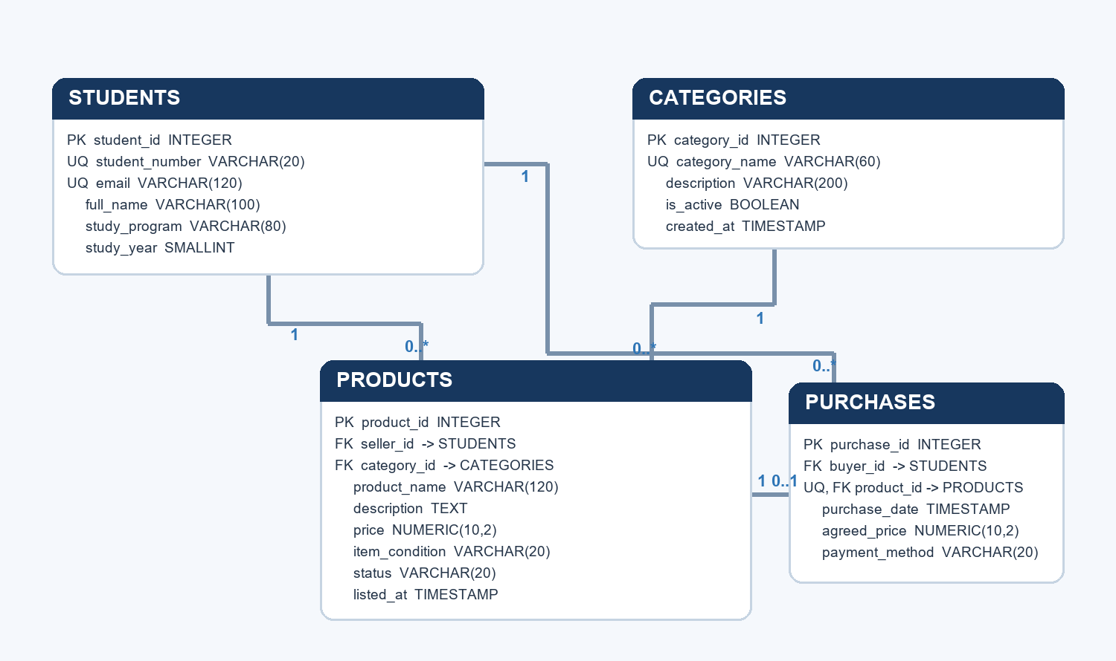
Relationship | Cardinality | Meaning
Students to Products | 1 to many | A student can list many products; each listing has one seller.
Categories to Products | 1 to many | A category can contain many listings; each listing has one category.
Students to Purchases | 1 to many | A student can make many purchases; each purchase has one buyer.
Products to Purchases | 1 to 0 or 1 | A listing may be unsold or have one completed purchase.

5. SQL query and business use
The main query shows only available listings, joins each offer to its category and seller, and sorts from the lowest asking price to the highest.
SELECT p.product_id, p.product_name, c.category_name, p.price,
p.item_condition, s.full_name AS seller_name
FROM products AS p
JOIN categories AS c ON c.category_id = p.category_id
JOIN students AS s ON s.student_id = p.seller_id
WHERE p.status = 'Available'
ORDER BY p.price ASC, p.product_id ASC;

Expected result from the included sample data
Product | Category | Price (KZT) | Condition | Seller
Scientific Calculator | Electronics | 2,500.00 | Good | Dana Omar
Java Programming Textbook | Books and Study | 3,500.00 | Like New | Dana Omar
Wireless Mouse | Electronics | 5,500.00 | Good | Ayan Bek
Desk Lamp | Dorm Essentials | 6,000.00 | Good | Amir Sadyk

Business use: students can compare available items by price and condition. A marketplace manager can review current offers without showing listings that have already been sold or removed.
The output above is the expected result from the fictional sample rows. It must be confirmed by executing the SQL in PostgreSQL before class.

6. Purchase transaction, privacy, and access

Safe purchase sequence
- Find the buyer and lock the selected product row with SELECT ... FOR UPDATE.
- Confirm the product is still Available and the buyer is not the seller.
- Insert the purchase using the listing price, then change the listing status to Sold.
- Commit when both changes succeed. An error aborts the function call so a half-finished sale is not stored.
The included purchase_listing function performs these steps and returns the new purchase ID. The row lock serializes competing buyers. The UNIQUE constraint on purchases.product_id provides a second safeguard against duplicate sale records.

Example call
BEGIN;
SELECT purchase_listing('2026002', 1, 'Cash');
COMMIT;
Run the example only after reviewing the available-listing query: it changes product 1 from Available to Sold. If the function raises an error inside an explicit transaction, issue ROLLBACK.

Privacy and role access
Role | Appropriate access
Marketplace user | Read public listing details such as product name, price, condition, category, and status.
Seller | Create listings and edit or remove only their own listings.
Buyer | View their own purchase history; other students’ history and private contact details are not public by default.
Administrator | Moderate listings and resolve reported problems.

A deployed application should enforce these permissions in its application layer or with database roles and row-level security. The classroom schema describes the access policy but does not include production account authentication.

7. Team presentation roles
Each person should speak for about two minutes and point to the relevant tables, ERD, or query. The contribution lines below are suggested wording based on the assigned focus; each student should edit that one line to describe work they actually completed.

Student 1 - Tynyshtyk Alis
MAIN ACTION AND TABLES
Our project is Student Marketplace. It helps students sell items they no longer need and buy items offered by classmates. A seller creates a product listing and another student can purchase it. We designed four tables. Students stores student numbers, names, email addresses, study programs, and study years. Categories groups listings such as Electronics or Books and Study. Products stores each listing, including its seller, category, name, price, condition, and status. Purchases records the buyer, product, date, agreed price, and payment method. We keep these facts in separate tables because each table represents a different thing. For example, a category description is stored once and referenced by many products. Our sample data shows four available listings in price order. Before class, we will run the database script and confirm the query output.
Suggested contribution: I explained the marketplace action and the purpose of each table.
Decision: We used separate tables for students, categories, products, and purchases because each stores one type of fact.
Unfinished part: The PostgreSQL run and screenshot confirmation remain to be completed.
Next action: Run the script and confirm that the four tables and sample records are created.

Student 2 - Medetkhan Aruzhan
PRIMARY KEYS AND DATA RULES
Each table has a primary key: student_id, category_id, product_id, and purchase_id. A primary key uniquely identifies a row and cannot be empty. We also require unique student numbers, email addresses, and category names. Product names and descriptions cannot be blank, prices must be greater than zero, and the study year must be from one to four. Condition, status, and payment method each accept only defined values. These rules help buyers rely on listing details and make reports consistent. Our data-quality example is an imported row with no product name or a repeated product ID. The database constraints reject those cases, and imported rows should be checked before loading. The SQL includes negative checks for a blank name, zero price, duplicate email, and invalid seller reference. We will run those checks and confirm each invalid record is rejected.
Suggested contribution: I reviewed the primary keys, unique fields, and validation rules.
Decision: We made product_name required and non-blank, and product_id the primary key.
Unfinished part: The PostgreSQL run and screenshot confirmation remain to be completed.
Next action: Run the negative checks and confirm the database rejects each invalid record.

Student 3 - Alkhan Yerdaulet
FOREIGN KEYS AND RELATIONSHIPS
Foreign keys connect the marketplace tables. In Products, seller_id refers to Students, and category_id refers to Categories. In Purchases, buyer_id refers to Students and product_id refers to Products. This means a product cannot point to a seller or category that does not exist, and a purchase cannot point to a missing buyer or product. One student can list many products, and one category can contain many products, so those are one-to-many relationships. One student can also make many purchases. A product listing may have no completed purchase yet or one purchase. We made product_id unique in Purchases to stop the same listing being sold twice in the records. PostgreSQL checks these references when data is inserted or updated. We will compare the foreign keys in the created tables with the ERD and test an invalid seller reference.
Suggested contribution: I checked how the foreign keys connect the tables.
Decision: We added foreign keys so every seller, buyer, category, and purchased product must already exist.
Unfinished part: The PostgreSQL run and screenshot confirmation remain to be completed.
Next action: Try inserting a product with a seller_id that does not exist and confirm that PostgreSQL rejects it.

Student 4 - Tanirberdi Daulet
ERD AND REPEATED DATA
Our ERD shows Students, Categories, Products, and Purchases. Each student and category is stored once, and Products holds each listing once. Purchases stores the completed sale. This avoids copying the seller’s study and contact information into every listing or sale record. If a student changes their program, the value is updated in one place. Likewise, many products can refer to one category without repeating its description. The relationships are marked one-to-many, except Products to Purchases, where a listing has zero or one purchase. This simpler design does not include a checkout order with several products, so a bridge table is not needed. We will compare every ERD connection with the foreign keys created by the SQL script and make sure the diagram and database agree.
Suggested contribution: I prepared the ERD explanation and checked where each fact belongs.
Decision: We store each category once and reference it from product listings.
Unfinished part: The PostgreSQL run and screenshot confirmation remain to be completed.
Next action: Check that each ERD line matches the foreign keys created by the SQL script.

Student 5 - Sembayev Zharas
SQL, BUSINESS USE, SECURITY, AND TRANSACTIONS
Our SELECT query joins Products with Categories and Students. It returns the product name, category, price, condition, and seller for available listings, from lowest price to highest. Students can use that result to compare offers, and a manager can see what remains for sale. Our access policy keeps public listing details separate from private purchase history and contact information. Sellers should edit their own listings, buyers should see their own purchase history, and administrators can moderate listings. A purchase must be safe if two buyers try at once. Our purchase function locks the product row, checks that it is Available, creates the purchase row, and marks the listing Sold. The unique product_id in Purchases adds another protection. If a step fails, the function call is rolled back. We will execute the SQL and compare the result with the expected four listings.
Suggested contribution: I prepared the SELECT query and explained its business use, security, and transaction steps.
Decision: We use a row lock and a unique product purchase to prevent duplicate sales.
Unfinished part: The PostgreSQL run and screenshot confirmation remain to be completed.
Next action: Execute the SQL, compare the query result with the expected output, and save a screenshot.

8. Runbook and final submission checklist

Run the project in PostgreSQL
- Create or select a new, empty practice database in PostgreSQL.
- Open Student_Marketplace_Task09.sql in pgAdmin Query Tool or psql and execute it once.
- Confirm the four tables, primary keys, foreign keys, unique constraints, and checks were created.
- Review the four rows from the available-listing SELECT query.
- Confirm the negative validation checks complete without an error. They pass only when invalid rows are rejected.
- Optionally inspect the purchase_listing function; run its example only if you want to change product 1 to Sold.
- Capture screenshots of the created tables/constraints and query results for the teacher.
- Practise the five presentation roles and edit each suggested personal-contribution sentence to reflect actual work.
- Submit one team Word document to the teacher.

Teacher questions
Question | Answer
What makes a primary key unique and required? | The PRIMARY KEY constraint enforces uniqueness and NOT NULL.
What happens if a product name is blank? | The NOT NULL and non-blank CHECK rules reject it.
What if a foreign key points to a missing student? | PostgreSQL rejects the insert or update because the referenced student does not exist.
Why is product_id unique in Purchases? | One listing can be recorded as purchased no more than once.
What does the SELECT query show? | Available products, their categories, prices, conditions, and sellers.
Who should see private purchase information? | A student should see their own history; other students do not see it by default.
What if a purchase step fails? | The call is rolled back so a half-finished sale is not saved.
What remains before presentation? | Run the SQL in PostgreSQL, check constraints and output, and save screenshots.

Submission package
The Word report contains the project overview, five team members and roles, table plan and rules, ERD, query and expected results, data-quality action, access policy, transaction design, presentation scripts, teacher questions, and runbook. The separate PostgreSQL script creates the schema, fictional sample data, classroom query, validation checks, and safe purchase function.

