To use AppAnalytics Silverlight please execute following:

1. Make sure that you have required frameworks installed: .NET 4.5+ (incluing .NET for Windows Phone, Silverlight 5)
2. Add dll as reference to Visual Studio project.
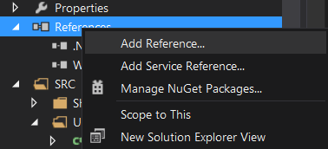
3. To include namespace write:
using AppAnalytics;

4. In main page constructor add string:
AppAnalytics.Detector.init(" YOUR_APP_KEY"); // where YOUR_APP_KEY
// is string (Length == 32)

Compatible with both WP8.0 and WP8.1 silverlight apps.

