Library Building Guide

- Set build configuration
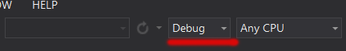
- Debug : will generate additional debug output to output window in your debugger, also will be bigger and slower than Release Library.

- Release : no output will be generated.

- Build or rebuild AppAnalytics project.

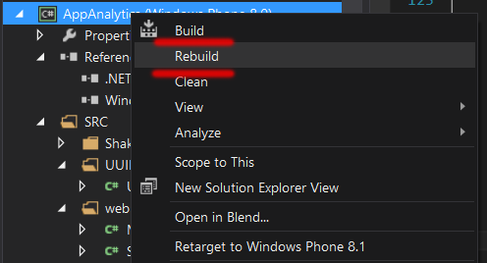

- After that you can find library in "Library" folder within solution (not project) folder:
..\AppAnalytics\Library\Release\AppAnalytics.dll – for release
..\AppAnalytics\Library\Debug\AppAnalytics.dll – for debugging
Universal version:
..\AppAnalytics\Library\ReleaseRT\AppAnalytics.dll – for release
..\AppAnalytics\Library\DebugRT\AppAnalytics.dll – for debugging

4. Library is ready to use. To test it simply set project that reffer AppAnalytics.dll
as StartUp project :
