AppAnalytics API references (.Net version)

iteration 2

Contents:
0. Introduction...................................................1
1. Structure of soulution.........................................2
2. Design of library..............................................4
3. Windows Runtime version........................................6
4. Silverlight version............................................8
5. Known issues...................................................9

Introduction

The Library itself is a Portable Class Library (PCL) in Windows Runtime version and Class Library in Silverlight version. The Library is written on C# using .Net 4.5 framework, Silverlight (SL version only) and Windows Phone SDK.
There is no other additional external dependences. There is shake recognition library which is integrated into library and porter for Windows Runtime (see known issues for more information).

OS Version Support:

OS\Library | Windows Runtime version | Silverlight
Windows Phone 8 | no | yes
Windows Phone 8.1 | yes | yes
Windows 8.1 | Tested not enough* | -

*tested with mouse and Wacom graphic tablet (as input device), but not with real multitouch device.

A library is built in Debug and Release mode (Any CPU configuration). It also may be build for ARM with no changes.

Debug version: may provide additional output is AppAnalytics.API.DebugLogEnabled is set to true.
Release version: no debug output will be generated anyways, even with AppAnalytics.API.DebugLogEnabled == true because of Debug.WriteLine logic (Trace.WriteLine is not available for WP apps).

Structure of Solution

The solution was created in Visual Studion 2013 (Update 4) and contains both Silverlight and Runtime (universal) projects.

Each project folder have project and Testing sud-folder. “Testing” contains projects of application which were used for debugging.

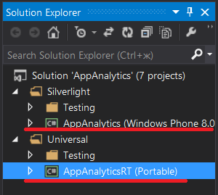
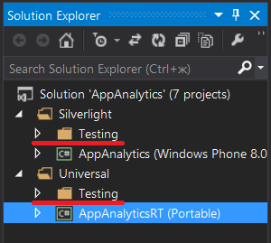
Picture 1.1 – Solution structure

As you can see there is no 3rd party references used in projects.

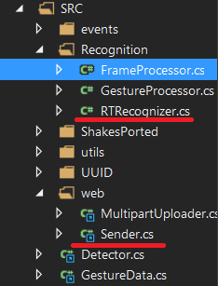
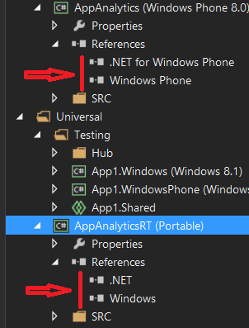
Picture 1.2 – References and source files

Also Picture 1.2 shows that projects are using references to shared code (physical location: %lib_dir%/SharedSRC/*).

All code that is platform-independent is shared between projects. To make code portable between two projects I'm using preprocessor directive #if, #else, #nedif and conditional compilation symbols such as SILVERLIGHT (defined in SL version) and UNIVERSAL (defined in Runtime version).
* there is also warning-disabling directives for fire-and-forget methods.
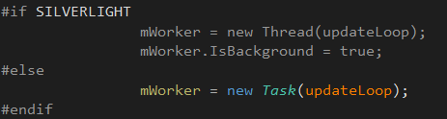

Picture 1.3 – Detector.init method

Folder structure:

%RootFolder%/LibSilverlight – SL version of Library project (with non-shared platform specific code);
%RootFolder%/LibUniversal - RT version (with non-shared platform specific code);
%RootFolder%/Library – Library DLLs (both RT and SL versions), documentation
%RootFolder%/SharedSRC – shared code
%RootFolder%/TestProjects – projects that were used for testing

%RootFolder%/AppAnalytics.sln – VS13 solution file.
Design of library

The main library namespace is AppAnalytics which contains API static-class (the only visible to client class).
Also client can see TransactionState enumeration as exception.
The simplified version of class design presented below (some classes are missing):
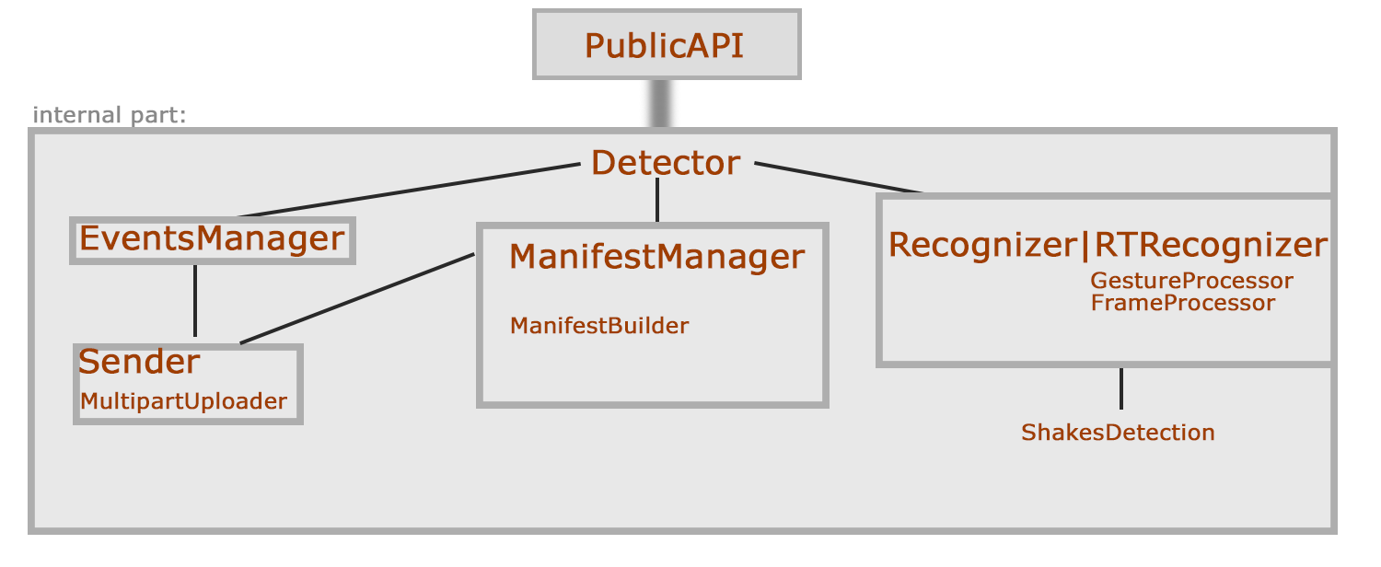
Details:
- API is a static class that contains visible to client API-functions. Shared.
- Detector is a static class, which contains main loop of a Library (update loop) and common functions. Shared.
- Senders responsibility is to check if connection is available, pass data to MultipartUploader and clean samples/manifest/events after sending. Shared.
- MultipartUploader works with HttpRequests and creates multipart/form-data put-requests. Shared.
- EventsManager contains all the Events handling logic and Event samples itself. Shared.
- ManifestManager is working with Samples and Manifests logic, contains samples/manifests. Serializes/deserializes data.
- UUIDGen class that works with SessionID and UDID.
- ManifestBuilder converts GestureData to binary format, creates manifests in binary format.
- Recognizer(SL only) provides gesture recognition. (more details below)
- RTRecognizer(RT only) provides gesture recognition.
- GestureProcessor(RT only) creates samples, recognize gestures.
- FrameProcessor (RT only) works with double-triple taps recognition (legacy class, can be removed in future).
- Defaults is a static util-class with app-level constants. Shared.
*There is also shakes detection classes, which is ported from MSDN sample with small changes.
**GestureData and Event simply store data.
***Plus there is SerializableDictionary. Used for XML serialization of dictionary with List<byte[]> as value.

- When client call AppAnalytics.API.init(%key%) Detector creates background worker (thread in SL version or task in RT version). Also in same time we are reading UDID (if there is no such thing we will generate it – it means that application wasn't installed and this is first launch). We read Events, Samples and Manifests if something left from previous sessions. Plus we are binding our callbacks/handlers.

- Notice that we cannot create thread in PCL, so all thing that shouldn't block UI thread/Update loop are implemented as Tasks.

- Update loop is a method that used for time measurement (initiates sending samples and things like that periodically).

- The Library use tasks / async methods where it is expedient. For example serialization of events is asynchronous. In some cases it is fire-and-forget, sometimes we are waiting for result. Windows Runtime forces us to use asynchronous methods for sending data, reading from storage, etc.

- When client is adding events they are simply moved to buffer (because we don't want to block UI thread) and then they will be added in update loop (background thread).

Windows Runtime

When API is stating we are creating our instance of gesture recognizer(.Net class) in our RTRecognizer singleton and adding our pointer event handlers to Frame.

MSDN>Frame: Displays Page instances, supports navigation to new pages, and maintains a navigation history to support forward and backward navigation.

We are adding our handlers this way:
frame.AddHandler(UIElement.PointerMovedEvent, new PointerEventHandler(onPMoved), true);

Last argument means that we are able to handle events that were handled before.
Note, that GestureRecognizer is sealed so we cannot inherit from it.

Picture 3.1 shows logic of recognition.

Frame Events
(pointer pressed, moved, up..)

Gesture Recognizer
GestureProcessor
Getting element that
triggered event first
as Source parameter
of event args.

Storing contacts into
Dictionary (id as key)
Sample
Shake gestures

We are passing touch contacts to GestureRecognizer -
mRecognizer.ProcessMoveEvents(ps);

Where ps is List of PointerPoints (var ps = e.GetIntermediatePoints(null);)

And listen to events that fire mRecognizer. Unfortunately GestureRecognizer is very limited. For example he does not know how many fingers were used in gesture or cannot recognize triple tap. But its manipulation events such as mRecognizer.ManipulationInertiaStarting provides information about scale, translation and rotation. GestureProcessor uses this information to recognize full set of required Gestures. And also recognize fingers count.
FrameProcessor class is a legacy class. It is used for triple tap recognition.

We are using modified version of MSDN Sample for shakes detection library because build-in accelerator event Shaken will NEVER be fired on WP platform. Proof: https://msdn.microsoft.com/en-us/library/windows/apps/windows.devices.sensors.accelerometer.shaken
MSDN> Windows Phone 8: The accelerometer sensor does not raise the Shaken event on the Windows Phone 8 platform. If you add an event handler for the Shaken event in your Windows Phone 8 app, no error is raised, but the code in the event handler won’t run.

Same goes to WP8.1 too (tested).

* Note: XNA cannot be used for gesture recognition on Windows Runtime platform. We can add reference to XNA framefork and project will built successfully but when we try to get gestures from TouchPanel we will get an exception.

** GestureRecognizer is relatively new and is still in-dev. In future there may be more high-level function.

*** See Known Issues (9). In some cases we won't receive events when there is control that uses DirectManipulation.

Silverlight

We are not using same approach for gesture recognition as we did in RT version because GestureRecognizer is
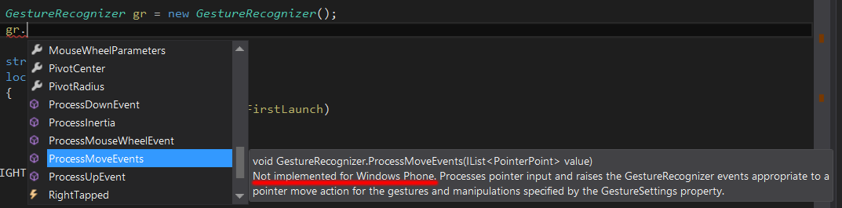
We are not using XNA Touch Panel because of performance issues () and because of limited number of supported gestures.
Also it is officially “not supported” (but somehow works) for WindowsPhone SL apps.

In the Library (SL) implemented low-level approach which is based on modified MSDN sample of gesture recognition (SL).

Touch.FrameReported += new TouchFrameEventHandler(touchFrameReported);

This is an App Level event so we won't get same issues as with WinRT DirectManipualtion controls. In the line above we just add our custom handler to System.Windows.Input.Touch static class event. We are getting TouchPointsCollection from event argument. Each touch TouchPoint contais info about whether is it up, down, moved, etc. We are using it to recognize full set of required gestures. For example to detect is that zoom or flick we are looking on move vectors v1 and v2 (blue points are previous frame contacts).
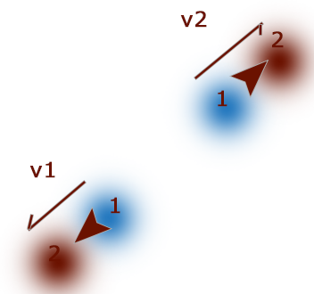

As we can see sum of v1 and v2 will be near to zero, when distance ( (v1-v2).Length ) is much bigger. Also we can see that angle is almost the same. So we decide to mark this event as Zoom. Same goes for other gestures.

Known Issues

Windows Runtime:
- Shakes is much more insensitive than SL version. Reason: I've ported SL version of shakes library to RT. Calibration was disabled because it is not easy to port. It probably may be fixed but it will take some time.
- Unable to get OS version. It is by design and cannot be fixed.
- When there is control with DirectManipulation (such as ScrollView) we have no way to get our pointer events. ScrollViewer takes over the pointer handling to run its scrolling. Once the ScrollViewer is in charge it handles all of the pointer and manipulation events without the app having its own chance at them.
This means that if an app needs to handle pointer events inside a scrolling control then it needs to disable the ScrollViewer (which is unacceptable for the library). Thing that we tried to do to fix it:
- Global hooks. Not working on phones because of kernel32.dll is not available. User32.dll is not enough.
- Message pump. Same as above. Because of platform limitations we cannot get pointer messages on app level (maybe there is difference between C# API and C++/CLI). Those code samples that I found simply lead to exceptions and makes program unstable. So for now solution is not found.
- CoreWindow class. MSDN simply lies () about this class. CoreWindow won't get moved events when there is ScrollViewer that already capture input. I've talk with Microsoft support about this but looks like even they don't know why CoreWindow does not work as expected. Some answers from them:
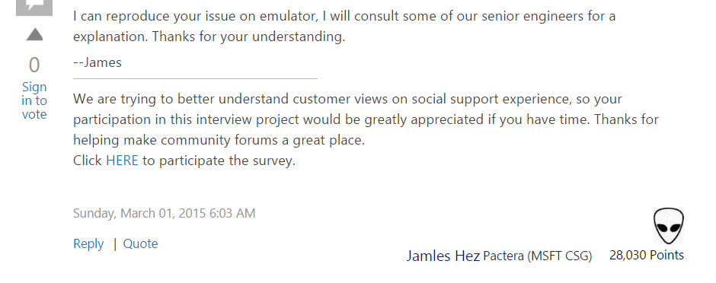
And this one:
Unfortunately there is no good solution if the app needs both scrolling and gestures (for example, to detect CrossSlides against the scrolling). In this case the only option to get the Pointer messages everywhere is to disable Direct Manipulation everywhere, but that disables scrolling as well. To get that back the app will need to detect the scrolling gestures itself and then navigate the ScrollViewer to the new location with ScrollToHorizontalOffset or ScrollToVerticalOffset or by updating the SelectedIndex. This is tricky and will be noticeably slower than letting the ScrollViewer do its thing. It should be avoided if at all possible.--Rob
4. There is an option to use DirectX for this purpose but I'm not sure if it fix the issue.

