1.Application with no library

Case: Touches and navigation
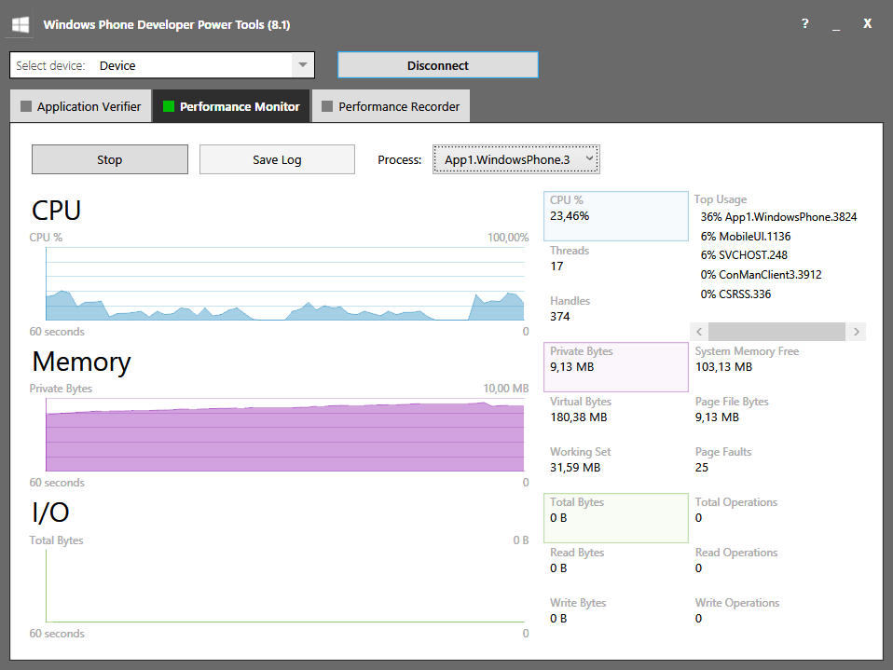
Case: Rest:
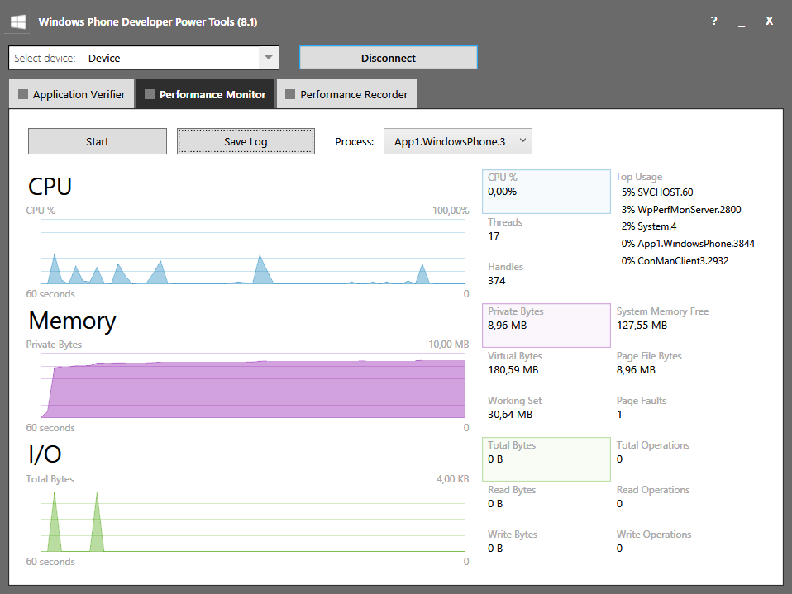

2. Library influence:

Case: Benchmark 100 events + 100 samples per second

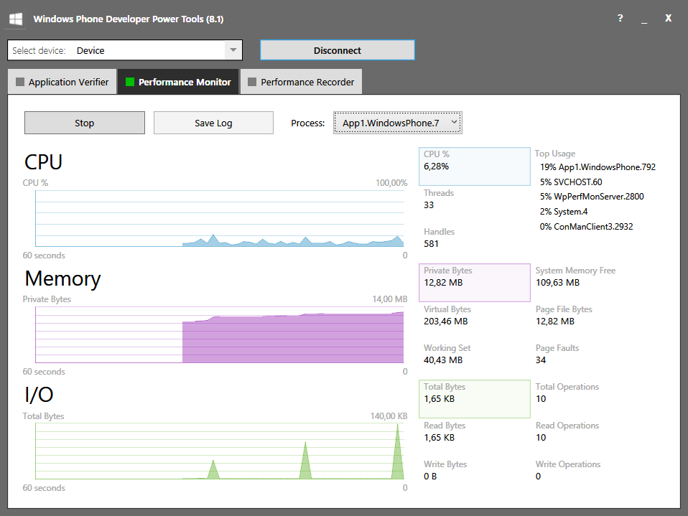

Case: Big amount of data at once – 45000 events (These peaks are storing actions).

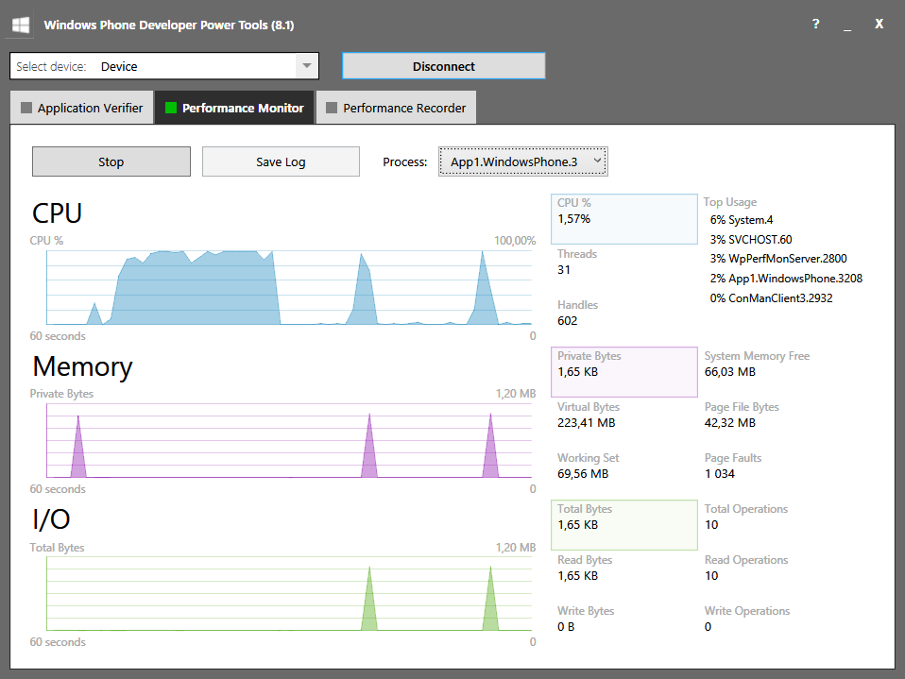

Case: Rest with touches and navigation:

